**QUESTIONS AND ANSWERS**

***QUES:- Linux operating system uses***

(A) Affinity Scheduling (B) Fair Preemptive Scheduling(yes)

(C) Hand Shaking (D) Highest Penalty Ratio Next

**Explanation:**

Linux uses two process-scheduling algorithms:

1. A time-sharing algorithm for fair preemptive scheduling between multiple processes

2. A real-time algorithm for tasks where absolute priorities are more important than fairness

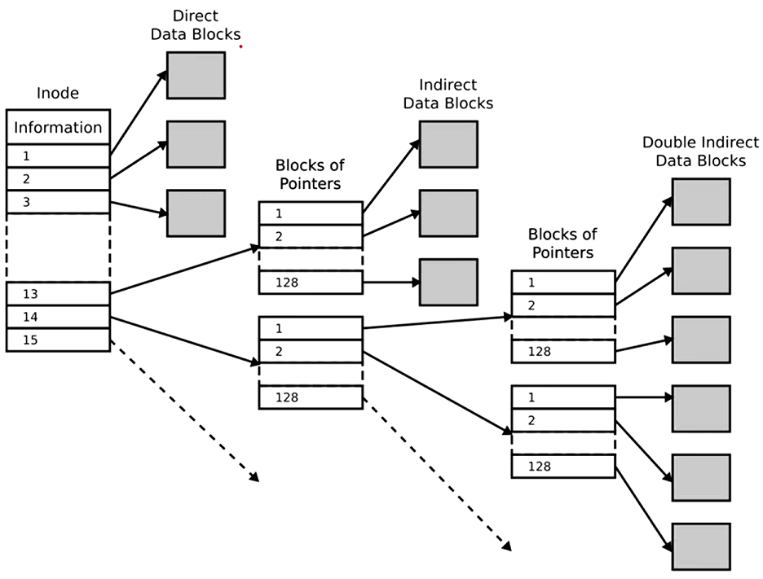

***QUES:- How large can a file be with 1KB blocks?***

• Single indirect block:– Assuming 32-bit addresses, we have 4 bytes per block pointer, so 1KB/4 = 256 blocks So … 256 * 1 KB = 256 KB

• Double-indirect block: – 256 * 256 * 1 KB = 64 MB

• Triple Indirect block: – 256 * 256 * 256 * 1 KB = 16 GB

• Total: ~16 GB

Ref: https://www.youtube.com/watch?v=vzlfvNg1dCo&ab_channel=ComputerShastra

***QUES:- How large can a file be with 4KB blocks?***

• Single indirect block:– Assuming 32-bit addresses, we have 4 bytes per block pointer, so 4 KB/4 = 1024 B blocks. So … 1024 * 4 KB = 4 MB

• Double-indirect block: 1024 * 1024 * 4 KB = 4 GB

• Triple Indirect block:–1024 * 1024 * 1024 * 1 KB = 4 TB

• Total: ~4 TB

Ref:https://www.youtube.com/watch?v=vzlfvNg1dCo&ab_channel=ComputerShastra

**QUES:- What is the largest possible file size. Assume that disk blocks are 8K bytes and that each pointer to a *disk block requires 4 bytes*.**

Number of ptrs / block = 8K / 4 = 2048

(12 * 8KB) + (2048 * 8KB) + (2048 * 2048 * 8KB) + (2048 * 2048 * 2048 * 8KB)

Ref: https://www.youtube.com/watch?v=vzlfvNg1dCo&ab_channel=ComputerShastra

***A Unix-style i-node has 10 direct pointers and one single, one double and one triple indirect pointers. Disk block size is 1 Kbyte, disk block address is 32 bits, and 48-bit integers are used. What is the maximum possible file size ?(Gate 2004)***

(A) 224 bytes (B) 232 bytes (C) 234 bytes (D) 248 bytes

***Suppose you have a Linux file system where the block size is 2K bytes, a disk address is 32 bits, and an i-node contains the disk addresses of the first 12 direct blocks of file, a single indirect block, and a double indirect block. Approximately, what is the largest file that can be represented by an i-node? (ugc – jul -2020)***

(1) 513 Kbytes (2) 513 Mbytes(yes) (3) 537 Mbytes (4) 537 KBytes

***QUES:- The aging algorithm with a=0.5 is used to predict run times. The previous four runs from oldest to most recent are 40, 20, 20 and 15 msec. The prediction for the next time will be: (UGC – 2007 Dec II)***

(A) 15 msec (B) 25 msec (yes) (C) 39 msec (D) 40 msec

**Exp:-** If take all four previous run times into consideration, the prediction

is (((40 + 20) / 2 + 40) / 2 + 15) / 2 = ((30 + 40) / 2 + 15) /2 = (35 + 15) / 2 = 25

**Or** if take only two previous run times into consideration, the prediction is (40 + 15) /2 = 27.5

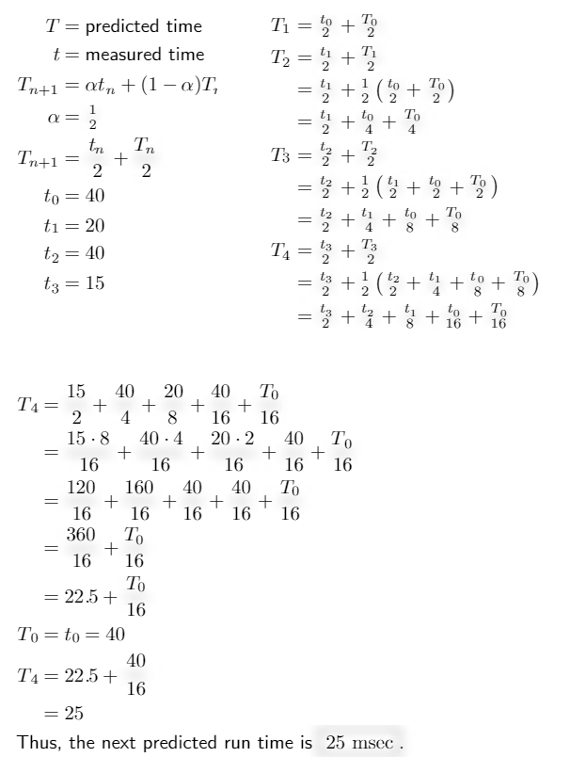

***How much space will be required to store the bit map of a 1.3 GB disk with 512 bytes block size?***

a)332.8 KB(yes) b)83.6 KB c)266.2 KB d)256.6 KB

**Expl :-** We need a bit for each block. Number of blocks = disk size/ block size = 1.3 GB / 512 B

more expl get figure from http://internetnotes.in/q49-p2-d13-how-much-space-will-be-required-to-store-the-bit-map-of-a-1-3-gb-disk-with-512-bytes-block-size/

***QUES:- How much space will be required to store the bit map of a 1.3 GB disk with 512 bytes block size ?***

(A) 332.8 KB|(Ans)     (B) 83.6 KB (C) 266.2 KB      (D) 256.6 KB

**Explanation:**block size=29bytes (512 bytes)

disk size=1.3×230bytes (1.3 GB)

1.3 GB = 1.3 * 1024 * 1024 * 1024 bytes. = 1.3 * 230 bytes

n=1.3×230/29=1.3×221 bits=1.3×210x28x23 bits=1.3×28 Kilo Bytes

=332.8 KB

***QUES:- There are n processes in memory. A process spends a fraction p of its time waiting for I/O to complete. The CPU utilization is given by :***

(A) pn (B)1-pn(yes) (C)(1-p)n  (D)1-np

***QUES:- Files that are related to input/output and are used to model serial I/O devices such as terminals, printers and networks are called :***

(A) regular files (B) character special files

(C) directories (D) block special files(yes)

***QUES:- What is the most appropriate function of Memory Management Unit (MMU) ?***

(A) It is an associative memory to store TLB

(B) It is a technique of supporting multiprogramming by creating dynamic partitions

(C) It is a chip to map virtual address to physical address(yes)

(D) It is an algorithm to allocate and deallocate main memory to a process

***QUES:- Function of memory management unit is :(NET-Dec-2015)***

(A) Address translation(yes) (B) Memory allocation

(C) Cache management (D) All of the above

***QUES:- In _____ method, the word is written to the block in both the cache and main memory, in parallel.***

(1) Write through(YES) (2) Write back (3) Write protected (4) Direct mapping

***QUES:- Consider a system which have ‘n’ number of processes and ‘m’ number of resource types. The time complexity of the safety algorithm, which checks whether a system is in safe state or not, is of the order of:***

(A) O(mn) (B) O(m2n2) (C) O(m2n) (D) O(mn2)Yes

**On a disk with 1000 cylinders (0 to 999) find the number of tracks, the disk arm must move to satisfy all the requests in the disk queue. Assume the last request service was at track 345 and the head is moving toward track 0. The queue in FIFO order contains requests for the following tracks: 123, 874, 692, 475, 105, 376 (Assume scan algorithm) (NET – 2012 – June)**

**a)2013 b)1219 c)1967 d)1507**

**Explanation:-**

FIRST LOOK AT THIS :http://www.cs.iit.edu/~cs561/cs450/disksched/disksched.html

ANS IS OPTION B .1219

345-----123(222)

-------------------105(18)--------0(105) .-----------------376(376)-------------475(99)-----------692(217)------------874(182)

SO TOTAL ARM MOVE = 222+18+105+376+99+217+182=1219

**QUES:-*Consider a disk queue with requests for I/O to blocks on cylinders 47, 38, 121, 191, 87, 11, 92, 10. The C-LOOK scheduling algorithm is used. The head is initially at cylinder number 63, moving towards larger cylinder numbers on its servicing pass. The cylinders are numbered from 0 to 199. The total head movement (in number of cylinders) incurred while servicing these requests is:***

(A) 346 (B) 165(yes) (C) 154 (D) 173

**Explanation:** The head movement would be :

63 => 87 24 movements

87 => 92 5 movements

92 => 121 29 movements

121 => 191 70 movements

191 --> 10 0 movement

10 => 11 1 movement

11 => 38 27 movements

38 => 47 9 movements

Total head movements = 165

***Consider a disk queue with request for input/output to block on cylinders 98, 183, 37, 122, 14, 124, 65, 67 in that order. Assume that disk head is initially positioned at cylinder 53 and moving towards cylinder number 0. The total number of head movements using Shortest Seek Time First (SSTF) and SCAN algorithms are respectively***

(A) 236 and 252 cylinders (B) 640 and 236 cylinders

(C) 235 and 640 cylinders (D) 235 and 252 cylinders

Answer: 236 and 208 cylinders

**Explanation:-**

SSTF-

Initial head position =53

The closest queue to initial head position=65

head moves from 53 to 65=12

head moves from 65 to 67=2

head moves from 67 to 37=30

head moves from 37 to 14=23

head moves from 14 to 98=84

head moves from 98 to 122=24

head moves from 122 to 124=2

head moves from 124 to 183=59

Total head movement=236

SCAN-

53---37-----14----0-------65----67-----98---122----124----183

Acc to SCAN 53 to 37 then to 14 and then to 0 (16+23+14=53) now direction will be reversed so 0 to 65 then to 67 then to 98,122,124,183 ( 65+2+31+24+2+59=183) total head movements=183+53=236

***Consider a disk system having 60 cylinders. Disk requests are received by a disk drive for cylinders 10,22,20,2,40,6 and 38, in that order. Assuming the disk head is currently at cylinder 20, what is the time taken to satisfy all the requests if it takes 2 milliseconds to move from one cylinder to adjacent one and Shortest Seek Time First (SSTF) algorithm is used? (ugc – 2020)***

a)240 milliseconds b)96 milliseconds c)120 milliseconds d)112 milliseconds

Explanation:-

Disk requests with head at 20

2 6 10 20 22 38 40

20--->22---->10--->6---->2------>38------>40 total head movements (2+12+4+4+36+2) =60

time= 60x2= 120ms option 3 is the ans

***A specific editor has 200 K of program text, 15 K of initial stack, 50 K of initialized data, and 70 K of bootstrap code. If five editors are started simultaneously, how much physical memory is needed if shared text is used ? (NET-2014-Dec-II)***

(A) 1135 K (B) 335 K(yes) (C) 1065 K (D) 320 K

**Explanation:-** 5 editor works simultaneously. Each editor must have separate code in each. But they could share initial stack, initialized data and bootstrap code.Text is shared. So no need to multiply text 200 with 5. So, total memory required is 200+15+50+70=335

***Object modules generated by assembler that contains unresolved external references are resolved for two or more object module by a/an***

(A) Operating system (B) Loader (C) Linker(yes) (D) Compiler

***Which command allows you to view your file 24 lines at a time ?***

(A) More(yes) (B) Cat (C) Pg (D) None of the above

***Block or Buffer caches are used to***

(A) improve disk performance (B) handle interrupts

(C) increase the capacity of main memory

(D) speed up main memory Read operations(yes)

***Which of the following can be accessed by transfer vector approach of linking ?***

(A) External data segments (B) External subroutine(yes)

(C) Data located in other procedure (D) All of the above

***A file organization component VSAM file is***

(A) Relative records data set (B) Keyed sequential data set

(C) Entry sequential data set (D) All of the above(yes)

**Explanation:-** VSAM stands for Virtual Storage Access Method. It is also relative, keyed sequential data set.

***Virtual memory is***

(A) related to virtual reality (B) a form of ROM

(C) a form of RAM(yes) (D) None of the above

***A relationship between processes such that each has some part (critical section) which must not be executed while the critical section of another is being executed, is known as***

(A) Semaphore (B) Mutual exclusion(yes) (C) Multiprogramming (D) Message passing

***Thrashing can be avoided if***

(A) pages, belonging to the working set of the programs, are in main memory(yes)

(B) speed of CPU is increased (C) speed of I/O processor is increased

(D) all of the above

***The system administrator can hunt for all files owned by ‘‘Kamal’’, and larger than 2000 blocks; by;***

(A) grep / – user Kamal – a + 2000 – print

(B) find / – user Kamal + 2000 – print

(C) find / \ C-user Kamal – a – size + 20000 \) – print(yes)

(D) none of the above

***Which command is used to change protection mode of files starting with the string emp and ending with 1, 2 or 3?***

(A) chmod u x emp [1 –3](yes) (B) chmod 777 emp

(C) chmod u r ??? emp (D) chmod 222 emp?

***A virtual memory based memory management algorithm partially swaps out a process. This is an example of***

(A) short term scheduling (B) long term scheduling

(C) medium term scheduling(yes) (D) mutual exclusion

***The mv command changes***

(A) the inode (B) the inode-number

(C) the directory entry(yes) (D) both the directory entry and the inode

**Explanation:-**

The mv command, say. try x y is not going to change the tile content, the i-node number or other information in the i-node. Only the file name is going to change. The file name is present only in the directory.

***Consider a paging hardware with a TLB. Assume that the entire page table and all the pages are in the physical memory. It takes 10 milliseconds to search the TLB and 80 milliseconds to access the physical memory. If the TLB hit ratio is 0.6, the effective memory access time (in milliseconds) is (Gate - 2014)***

**Explanation:-**

EMAT=TLB hit × (TLB access time + memory access time) + TLB miss(TLB access time + page table access time+memory access time)

=0.6(10+80)+0.4(10+80+80)

=54+68

=122msec

***Let the page fault service time be 10 millisecond(ms) in a computer with average memory access time being 20 nanosecond(ns). If one page fault is generated for every 106 memory accesses, what is the effective access time for memory ? (gate 2011)***

(A) 21 ns (B) 23 ns (C) 30 ns(yes) (D) 35 ns

given that one page fault for every 106 memory access, so the probability of page fault is p-> 1/106

effective access time would be = p * page fault service time + (1-p) * memory access time

Here P is the probability of page fault.

1millisecond = 10,00,000 nano second

1 second = 1000 milli second

1 second = 1,00,00,00,000 nano second

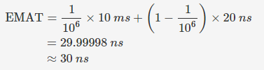

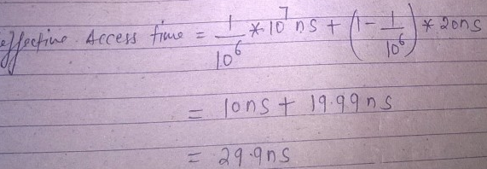

***The hit ratio of a Translation Look Aside Buffer (TLB) is 80%. It takes 20 nanoseconds (ns) to search TLB and 100 ns to access main memory. The effective memory access time is ______.***

(A) 36 ns (B) 140 ns (C) 122 ns (D) 40 ns

Effective access time = hit ratio * time during hit + miss ratio * time during miss

hit ratio = 80/100 = 0.8%

EAT = 0.8 * ( 20 + 100) + 0.2( 20 + 100 + 100)

if no tlb miss occur then search into tlb (20ns) than access the main memory 100ns

if tlb miss occur then searching for tlb (20ns) + 100ns for page table + 100ns for ram

***A hierarchical memory system that uses cache memory has cache access time of 50 nano seconds, main memory access time of 300 nano seconds, 75% of memory requests are for read, hit ratio of 0.8 for read access and the write-through scheme is used. What will be the average access time of the system both for read and write requests ?(2014-Dec)***

(A) 157.5 n.sec. (B) 110 n.sec. (C) 75 n.sec. (D) 82.5 n.sec.

**Explanation:-**

cache access time = 50 ns; main memory access time = 300 ns.

Since the system is hierarchical:

tread = hit ratio * cache access time + (1 - hit ratio) *(main memory access time + cache access time) = 0.8 * 50 + 0.2 * (300 + 50) = 110 ns

twrite = 1 * max(main memory access time, cache access time) = 1 * max(300,50) = 1* 300 = 300 ns.

read frequency = 75%:; write frequency = 25%. Now, average access time for both read and write requests = read frequency * tread + write frequency * twrite 0.75 * 110 + 0.25 * 300 = 157.5 ns So, option (A) is correct.

***In a demand paging memory system, page table is held in registers. The time taken to***

***service a page fault is 8 m.sec. if an empty frame is available or if the replaced page is not***

***modified, and it takes 20 m.secs., if the replaced page is modified. What is the average***

***access time to service a page fault assuming that the page to be replaced is modified 70%***

***of the time ? (NET – Dec – 2014 – II paper)***

(A) 11.6 m.sec. (B) 16.4 m.sec (C) 28 m.sec. (D) 14 m.sec.

**Explanation:-**

Page fault service time(PFST) = 8 msec (empty frame)

Page fault service time(PFST) = 20 msec( page is modified)

Page replacement frequency = 70% = 0.7

Page not modified = 100 – 70 = 30% = 0.3

Average access time = (0.3 * 8) + (0.7 * 20) = 2.4 + 14 = 16.4 m.sec

***If an instruction takes ‘i’ microseconds and a page fault takes an additional ‘j’ microseconds. The effective instruction time, if on the average a page fault occurs every k instructions, is***

***NET-2012(IIIPaper), GATE-1998***

(A) i + j/k (B) i + j * k (C) (i + j)/k (D) (i + j) * k

Exp:- Ref https://gateoverflow.in/1691/Gate-cse-1998-question-2-18-ugcnet-june2012-iii-48

***Given memory access time as p nanoseconds and additional q nanoseconds for handling the page fault. What is the effective memory access time if a page fault occurs once for every 100 instructions? (NET-2022)***

***Given memory access time as p nanoseconds and additional q nanoseconds for handling the page fault. What is the effective memory access time if a page fault occurs once for every 100 instructions? (NET - 2021 )***

a) P + Q/100 (yes) b) (P+Q)/100 c) P + Q d) P/100 + Q

***For the implementation of a paging scheme, suppose the average process size be x bytes, the page size be y bytes, and each page entry requires z bytes. The optimum page size that minimizes the total overhead due to the page table and the internal fragmentation loss is given by***

1. x/2 (B) (xz)/2 (C) sqrt(2xz)(yes) (D)sqrt(xz)/2

**Application:-**

So for example, if the average segment size were 256K, and the page table entry size were 8 bytes, the optimum page size, to minimise overhead due to page table entries and internal fragmentation, would be sqrt(2 × 256K × 8) = 2048 = 2K.

***Consider a system with a two-level paging scheme in which a regular memory access takes 150 nanoseconds, and servicing a page fault takes 8 milli seconds. An average instruction takes 100 nanoseconds of CPU time, and two memory accesses. The TLB hit ratio is 90%, and the page fault rate is one in every 10,000 instructions. What is the effective average instruction execution time?(Gate – 2004)***

***Ans:*** Ref https://www.youtube.com/watch?v=koyVeqPYv1w

1) 645 ns 2) 1050 ns 3) 1215 ns 4) 1230 ns

***If an instruction takes ‘i’ microseconds and a page fault takes an additional ‘j’ microseconds. The effective instruction time, if on the average a page fault occurs every k instructions, is***

(A) i + j/k(yes) (B) i + j * k (C) (i + j)/k (D) (i + j) * k

**Explanation:-**page fault rate=1/k

page hit rate=1 – 1/k

service time=i

page fault service time= I +j

now effective memory access time=1/k*(i+j)+(1-1/k)*i

= (i+j)/k+i-i/k

=i/k+j/k+i-i/k=i+j/k

***If an instruction takes i microseconds and a page fault takes an additional j microseconds, the effective instruction time if on the average a page fault occurs every k instruction is:***

a) i+jk b) i+(j×k) c)i+jk d)(i+j)×k

**Explanation:-**

Best answer

Page fault rate =1k

Page hit rate =1−1k

Service time =i

Page fault service time =i+j

Effective memory access time,

=1k×(i+j)+(1−1k)×i

=(i+j)k+i−ik

=ik+jk+i−ik

=i+jk

So, option (A) is correct.

<https://gateoverflow.in/1691/Gate-cse-1998-question-2-18-ugcnet-june2012-iii-48>

More Exercise Refer

<https://www.gatevidyalay.com/page-fault-paging-practice-problems/>

***Some of the criteria for calculation of priority of a process are :***

a. Processor utilization by an individual process.

b. Weight assigned to a user or group of users.

c. Processor utilization by a user or group of processes

In fair share scheduler, priority is calculated based on :

(1) only (a) and (b) (2) only (a) and (c)

(3) (a), (b) and (c)(yes) (4) only (b) and (c)

***One of the disadvantages of user level threads compared to Kernel level threads is***

(1) If a user level thread of a process executes a system call, all threads in that process are blocked.(yes)

(2) Scheduling is application dependent.

(3) Thread switching doesn’t require kernel mode privileges.

(4) The library procedures invoked for thread management in user level threads are local procedures.

***Linking :***

(A) cannot be performed before relocation

(B) cannot be performed after relocation(yes)

(C) can be performed both before and after relocation

(D) is not required if relocation is performed

***A system has 3 processes sharing 4 resources. If each process needs a maximum of 2 units, then***

A) Deadlock can never occur(YES)

B) Deadlock may occur

C) Deadlock has to occur

D) None of these

**EXPLANATION:-**

If the system is deadlocked, it implies that each process is holding one resource and is waiting for one more. Since there are 3 processes and 4 resources, one process must be able to obtain two resources. This process requires no more resources and therefore it will return its resources when done.

Hence,Option(A)deadlock can never occur.

**Explanation:** A condition for deadlock can not occur: P(n-1) + 1 <= R where, P = number of processes ; n = max requirement of each process ; R = Total number of available resources So, if a system has 3 processes sharing 4 resources and each process needs a maximum of 2 units then: P = 3, n = 2 and R = 4 =3(2-1) + 1 <= 4, deadlock can never occur.

***Consider a system having ‘m’ resources of the same type. These resources are shared by three processes P1, P2and P3 which have peak demands of 2, 5 and 7 resources respectively. For what value of ‘m’ deadlock will not occur ? (2016 - Aug)***

(A) 70 (B) 14 (C) 13 (D) 7

Explanation: To avoid deadlock ‘m’ >= peak demands(P1 + P2 + P3)

i.e. m >= peak demands(2 + 5 + 7)

m >= peak demands(14)

So, option (B) is correct.

***Consider a system having m resources of the same type. These resources are shared by 3 processesA, B and C which have peak demands of 3, 4 and 6 respectively. For what value of m deadlock will not occur ?***

(A) 7 (B) 9 (C) 10 (D) 13(yes)

***If holes are half as large as processes, the fraction of memory wasted in holes is***

A) 2/3 B) 1/2 C) 1/3(yes) D) 1/5

**EXERCISE REGARDING SHORTEST JOB FIRST**

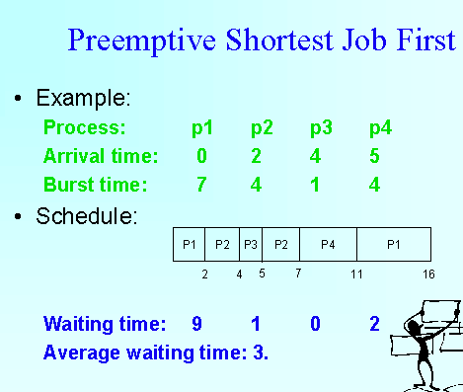

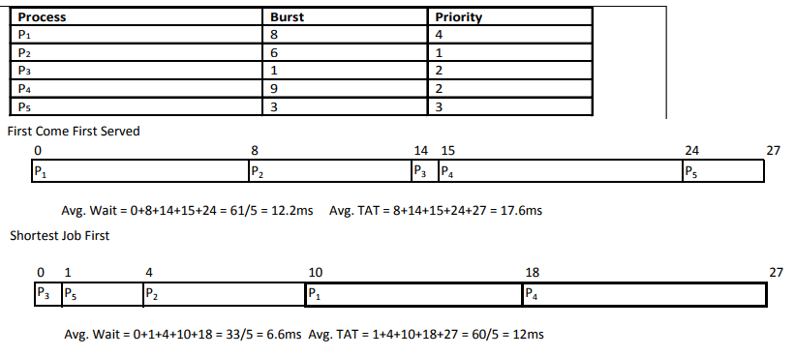

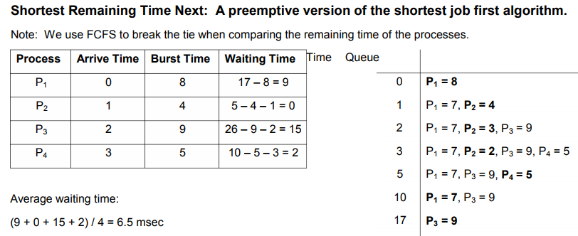

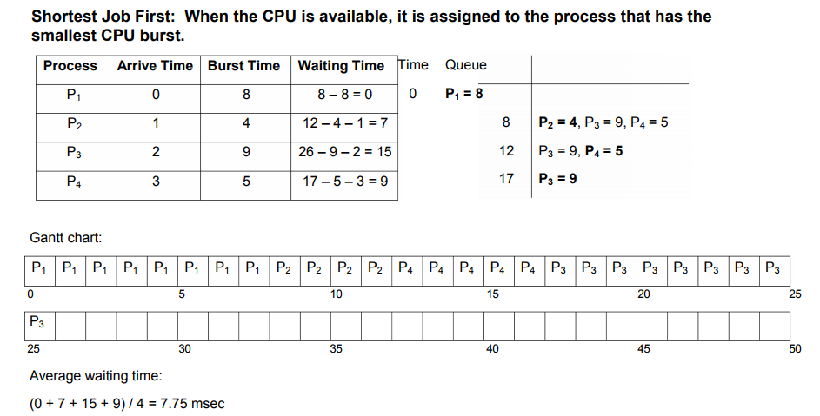

***Consider a disk with 16384 bytes per track having a rotation time of 16 msec and average seek time of 40 msec. What is the time in msec to read a block of 1024 bytes from this disk?***

A) 57 msec B) 49 msec C) 48 msec D) 17 msec

**Explanation1:-**

Transfer time = ((1024 bytes *16 ms)/ (16384 bytes )) = 1 msec

Rotational letency = 16 msec / 2 = 8 msec

total time = seek + rotational letency + transfer time

= 40 + 8 + 1 = 49 msec

**Explanation2:-**

Time in msec to read a block of 1024 bytes (Access time or Disk Latency) = seek time + average rotational delay + transfer time.

If there are 16384 bytes per track there are 1024/16384 tracks to be read for this block.

Seek time = 40 msec

Rotational delay = 16 msec

Transfer time = (sectors_read/sectors per rev.) x rotational delay

= (1024/16384) x 16 = 1

average rotational delay = rotational delay/2 = 16/2 = 8

access time = 40 + 8 + 1 = 49 msec

***If a disk has a seek time of 20 msec, rotates 20 revolutions per second, has 100 words per block, and each track has capacity of 300 words. Then the total time required to access one block is***

1) 60 2) 45 3) 50 4) 40

**Explanation 1:-**

Time taken to access one block = seek time + rotational delay + block transfer time

Seek time = 20 ms (given)

Rotational delay = on an average taken to be the time to rotate by half = 1/2 X time for 1 rotati X 1/20 sec s = 25 ms

Block Transfer time = block size / transfer rate = 100 / transfer rate

Now, transfer rate = Track capacity / rotation rate = 300 / ( 1/ 20) = 6000 word per sec = 6 word per ms

Block Transfer time = block size / transfer rate = 100 / 6 ~ 16.67 ms per block

Time taken to access one block = seek time + rotational delay + block transfer time= 20 + 25 + 16.67 = 61.67 ms

**Explanation 2:-**

Time taken to access one block = seek time + rotational delay + block transfer time

Seek time = 20 ms (given)

Rotational delay = on an average taken to be the time to rotate by half = 1/2 X time for 1 rotation = 1/2 X 1/20 seconds = 1/40 s = 25 ms

Block Transfer time = block size / transfer rate = 100 / transfer rate

Now, transfer rate = Track capacity / rotation rate = 300 / ( 1/ 20) = 6000 word per sec = 6 word per ms

Block Transfer time = block size / transfer rate = 100 / 6 ~ 16.67 ms per block

Time taken to access one block = seek time + rotational delay + block transfer time= 20 + 25 + 16.67 = 61.67 ms

**Ques:-Consider three CPU-intensive processes, which require 10, 20 and 30 time units and arrive at times 0, 2 and 6, respectively. How many context switches are needed if the operating system implements a shortest remaining time first scheduling algorithm? Do not count the context switches at time zero and at the end. (Gate-2006 – ISRO-2009 – NET – 2019 – p2)**

1) 2(yes) 2) 3 3) 5 4) 4

**Explanation :-** Let three process be P0, P1 and P2 with arrival times 0, 2 and 6 respectively and CPU burst times 10, 20 and 30 respectively. At time 0, P0 is the only available process so it runs. At time 2, P1 arrives, but P0 has the shortest remaining time, so it continues. At time 6, P2 arrives, but P0 has the shortest remaining time, so it continues. At time 10, P1 is scheduled as it is the shortest remaining time process. At time 30, P2 is scheduled. Only two context switches are needed. P0 to P1 and P1 to P2

The below image is for context switch problem

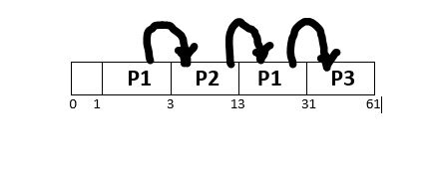

***Consider three CPU intensive processes P1, P2, P3 which require 20, 10 and 30 units of time, arrive at times 1, 3 and 7 respectively. Suppose operating system is implementing Shortest Remaining Time first (preemptive scheduling) algorithm, then _____ context switches are required (suppose context switch at the beginning of Ready queue and at the end of Ready queue are not counted). (NET –AUG-2016-P2)***

(1) 3(yes) 2) 2 3) 4 (4) 5

***Consider the two statements.***

***(a) A network operating system, the users access remote resources in the same manner as local resource.***

***(b) In a distributed operating system, the user can access remote resources either by logging into the appropriate remote machine or transferring data from the remote machine to their own machine.***

***Which of the statement is true?***

1) (a) true, (b) false 2) (b) true, (a) false

3) Both (a) and (b) false (ANS) 4) Both (a) and (b) true

***There are three processes P1, P2 and P3 sharing a semaphore for synchronising a variable. Initial value of semaphore is one. Assume that negative value of semaphore tells us how many processes are waiting in queue. Processes access the semaphore in following order:***

P2 needs to access

P1 needs to access

P3 needs to access

P2 exits critical section

Pi exits critical section

The final value of semaphore will be:

A) 0 B)1 C)-1 D)-2

**Explanation:-**

Explanation: Initial value of semaphores S=1

P2 needs to access decreases semaphore by 1, new value will be 0 (no one is waiting)

P1 needs to access decreases semaphore by 1, new value will be -1 (one process is waiting)

P3 needs to access decreases semaphore by 1, new value will be -2 ( 2 process are waiting)

P2 exits critical section increases semaphore by 1, new value will be -1 ( one process is waiting)

P1 exits critical section increases semaphore by 1, new value will be 0 ( no process is waiting)

So, option (A) is correct

***Consider a disk with a sector size of 512 bytes, 2000 tracks per surface, 50 sectors per track, five double-sided platters, and average seek time of 10 msec.***

1. What is the capacity of a track in bytes? What is the capacity of each surface?

What is the capacity of the disk?

2. How many cylinders does the disk have?

3. Give examples of valid block sizes. Is 256 bytes a valid block size? 2048? 51200?

4. If the disk platters rotate at 5400 rpm (revolutions per minute), what is the

maximum rotational delay?

5. If one track of data can be transferred per revolution, what is the transfer rate?

**Answer**

1. bytes/track = bytes/sector × sectors/track = 512 × 50 = 25600 bytes = 25600 / 1024 = 25Kbytes/surface = bytes/track × tracks/surface = 25K × 2000 = 50, 000K

bytes/disk = bytes/surface× surfaces/disk = 50, 000K × 5 × 2 = 500, 000K

2. The number of cylinders is the same as the number of tracks on each platter,

which is 2000.

3. The block size should be a multiple of the sector size. We can see that 256 is not a valid block size while 2048 is. 51200 is not a valid block size in this case because block size cannot exceed the size of a track, which is 25600 bytes.

4. If the disk platters rotate at 5400rpm, the time required for one complete rotation, which is the maximum rotational delay, is (1/rpm) * 60 = 1/5400× 60 = 0.011seconds. The average rotational delay is half of the rotation time, 0.006 seconds.

5. The capacity of a track is 25K bytes. Since one track of data can be transferred

per revolution, the data transfer rate is 25K/0.011= 2, 250Kbytes/second

***Assuming that the system call fork ( ) never fails, consider the following C programs P1 and P2 executed on a UNIX / Linux system : (ugc –jul – 2020)***

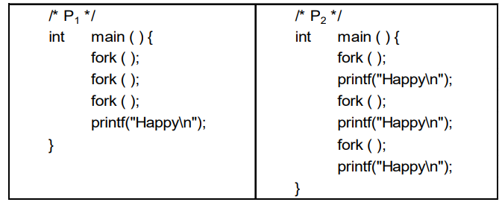

***Statement-I : P1 displays "Happy" 8 times.***

***Statement-II : P2 displays "Happy" 12 times.***

***In the light of the above statements, choose the correct answer from the options given below***

(1) Both Statement-I and Statement-II are true

(2) Both Statement-I and Statement-II are false

(3) Statement-I is correct but Statement-II is false (yes)

(4) Statement-I is incorrect but Statement-II is true

​***To overcome difficulties in Readers-Writers problem, which of the following statement/s is/are true ? (NET 2018 Dec II)***

a) Writers are given exclusive access to shared objects

b) Readers are given exclusive access to shared objects

c) Both readers and writers are given exclusive access to shared objects.

Choose the correct answer from the code given below:

(A) 1 only(yes) (B) Both 2 and 3 (C) 2 only (D) 3 only

**Explanation:** In Readers-Writers Problem, since readers do not modify values, so these can be allowed with other readers. But writers are given exclusive access to shared objects.

***Dirty bit is used to show (UGC - NET - 2018 - Dec)***

A. Page with corrupted data

B. Wrong page in memory

C. Page that is modified after being loaded in the cache memory (YES)

D. page that is less frequently accessed

***Suppose a system has 12 instances of some resource with n processes competing for that resource. Each process may require 4 instances of the resources. The maximum value of n for which the system never enters into deadlock is (NET - DEC - 2021)***

a) 4 b) 3 (yes) c) 5 d) 6

**Explanation:-**

Let every process acquired 3 resources now we need 1 more resource to complete one of them so that system will not face deadlock

3n+1<=12

3n<=11

n<=3.66

n=3

***An operating system using banker’s algorithm for deadlock avoidance has ten dedicated devices (of same type) and has three processes P1, P2 and P3 with maximum resource requirements of 4, 5 and 8 respectively. There are two states of allocation of devices as follows: Ref: UGCNET-June2013-III: 61 Which of the following is correct?***

State 1 is unsafe and State 2 is safe (yes)

State 1 is safe and State 2 is unsafe

Both State 1 and State 2 are safe

Both State 1 and State 2 are unsafe

***Consider a system with five processes P0 through P4 and three resource types R1, R2 and R3. Resource type R1 has 10 instances, R2 has 5 instances and R3 has 7 instances. Suppose that at time T0, the following snapshot of the system has been taken : Ref 2014-June-p2 state resulting after this allocation will be***

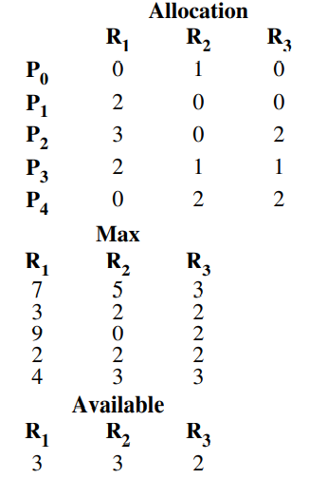

***Assume that now the process P1requests one additional instance of type R1 and two instances of resource type R3. The state resulting after this allocation will be***

(A) Ready state (B) Safe state(yes) (C) Blocked state (D) Unsafe state

***Consider a system with five processes P0 through P4 and three resource types A, B and C. Resource type A has seven instances, resource type B has two instances and resource type C has six instances suppose at time T0 we have the following allocation Ref 2017-Nov - p3. If we implement Deadlock detection algorithm we claim that system is __________.***

(1) Semaphore (2) Deadlock state (3) Circular wait (4) Not in deadlock state

***A computer system supports 32 bit virtual address as well as 32 bit physical addresses. Since the virtual address space is of same size as that of physical address space, if we want to get rid of virtual memory, which one of the following is true ? (NET - 2012 - July)***

(A) Efficient implementation of multiuser support is no longer possible.

(B) The processor cache can be made more efficient.

(C) Hardware support for memory management is not needed. (yes)

(D) CPU scheduling can be made more efficient.

***Consider a disk with a sector size of 512 bytes, 2000 tracks per surface, 50 sectors***

***per track, five double-sided platters, and average seek time of 10 msec. (NET - 2020)***

1. What is the capacity of a track in bytes? What is the capacity of each surface?

What is the capacity of the disk?

2. How many cylinders does the disk have?

3. Give examples of valid block sizes. Is 256 bytes a valid block size? 2048? 51200?

4. If the disk platters rotate at 5400 rpm (revolutions per minute), what is the

maximum rotational delay?

5. If one track of data can be transferred per revolution, what is the transfer rate?

Answers:-

1. bytes/track = bytes/sector × sectors/track = 512 × 50 = 25K

bytes/surface = bytes/track × tracks/surface = 25K × 2000 = 50, 000K

bytes/disk = bytes/surface× surfaces/disk = 50, 000K × 5 × 2 = 500, 000K

2. The number of cylinders is the same as the number of tracks on each platter,

which is 2000.

3. The block size should be a multiple of the sector size. We can see that 256 is not

a valid block size while 2048 is. 51200 is not a valid block size in this case because

block size cannot exceed the size of a track, which is 25600 bytes.

4. If the disk platters rotate at 5400rpm, the time required for one complete rotation, which is the maximum rotational delay, is 1/5400× 60 = 0.011seconds. The average rotational delay is half of the rotation time, 0.006 seconds.

5. The capacity of a track is 25K bytes. Since one track of data can be transferred

per revolution, the data transfer rate is 25K/0.011= 2, 250Kbytes/second

Ref : https://www.cs.colostate.edu/~cs430dl/yr2015su/more_examples/Ch9/Exercise9_5.pdf

Ref : <https://gateoverflow.in/349581/Ugcnet-oct2020-ii-92>

***Consider a machine with 64 MB physical memory and a 32-bit virtual address space. If the page size is 4KB, what is the approximate size of the page table?(GATE - 2001)***

(A) 16 MB (B) 8 MB(C) 2 MB(yes)(D) 24 MB

Explanation:-

Physical Address Space = 64MB = 2^26B

Virtual Address = 32-bits, ∴ Virtual Address Space = 2^32B

Page Size = 4KB = 2^12B

Number of pages = 2^32/2^12 = 2^20 pages.

Number of frames = 2^26/2^12 = 2^14 frames.

No of entries in Page Table = No of pages in a process

No of entries in page table = 2^20

Page Table Size = No of entries in page table * bits represent frame Number

∴ Page Table Size = 2^20×14-bits ≈ 2^20×16-bits ≈ 2^20×2B = 2MB.

Ref: https://stackoverflow.com/questions/24095769/calculating-size-of-the-page-table

Ref: https://gateoverflow.in/739/Gate-cse-2001-question-2-21

Ref: <https://www.youtube.com/watch?v=30P73tWmU0s&ab_channel=GateSmashers>

**QUES:- *A memory management system has 64 pages with 512 bytes page size. Physical memory consists of 32 page frames. Number of bits required in logical and physical address are respectively*** *:*

(1) 14 and 15 (2) 14 and 29 (3) 15 and 14(yes) (4) 16 and 32

**Explanation:-**

we know that Number of pages = virtual memory space / page size.

and Number of frames = physical memory space / frame size.

and page size is equal to frame size.

According to question and given data:

virtual memory space = Number of pages * page size

i.e. virtual memory space = 64 * 512 Bytes

virtual memory space = 26 * 29 Bits

i.e. = 215 Bits

So, 15 bits are required for virtual memory space.

physical memory space = Number of frames * frame size.

physical memory space = 32 * 512 Bytes

physical memory space = 25 * 29 Bits

i.e. = 214 Bits

So, 14 bits are required for virtual memory space.

**Consider a paging system with page size of 8 KB. If a process of size 34 KB is in logical address space, find the internal fragmentation in Kbytes.**

a) - 4 b)- 5 c) -6(yes) d) -7

Explanation: <https://gateoverflow.in/69335/Os-memory-management>

**Dirty bit is used to show the**

(1) page with corrupted data

(2) page with low frequency occurrence

(3) page that is modified after being loaded into cache memory(yes)

(4) wrong page

***Which of the following is correct?***

I. Two phase locking is an optimistic protocol.

II. Two phase locking is pessimistic protocol

III. Time stamping is an optimistic protocol.

IV. Time stamping is pessimistic protocol.

(A) I and III (B) II and IV (C) I and IV (D) II and III(yes)

***Which of the following is false ?***

(A) Every binary relation is never be in BCNF. (yes)

(B) Every BCNF relation is in 3NF.

(C) 1 NF, 2 NF, 3 NF and BCNF are based on functional dependencies.

(D) Multivalued Dependency (MVD) is a special case of Join Dependency (JD).

**Explanation:-**

Every binary relation(a relation with only 2 attributes) is always in BCNF. because If both attributes form the primary key, the relation is in BCNF. If one of the attributes is a primary key, the other must be determined by it and thus the relation is in BCNF.

***For switching from a CPU user mode to the supervisor mode following type of interrupt is***

***most appropriate***

(A) Internal interrupts (B) External interrupts

(C) Software interrupts(yes) (D) None of the above

**Explanation:-**

as internal interrupts occur due to some internal error (like division by zero)

external interrupts occur due some h/w event like power failure etc

software interrupts or system calls are the most appropriate method for switching from a user mode to kernel mode

***Consider a uniprocessor system where new processes arrive at an average of five processes per minute and each process needs an average of 6 seconds of service time. What will be the CPU utilization ? (2014 - June)***

(A) 80% (B) 50% (C) 60% (D) 30%

Explanation:-

Utilization = BusyTime / (BusyTime + IdleTime);

Utilization = 6 / 12 * 100 = 50%

***Which methods are utilized to control the access to an object in multi-threaded programming? (Dec-2014)***

(A) Asynchronized methods (B) Synchronized methods(yes)

(C) Serialized methods (D) None of the above

***Which of the following methods are used to pass any number of parameters to the operating system through system calls?***

a) Registers b) Block or table in main memory

c) Stack d) Block in main memory and stack(yes)

Explanation:-

<https://selfstudy365.com/qa/which-of-the-following-methods-are-used-to-pass-any-number-of-paramete-5ecd3aa5f60d5d024b9ceb0f#:~:text=Therefore%2C%20methods%20used%20to%20pass,pass%20ANY%20NUMBER%20of%20parameters>.

***A classic software-based solution to the critical-section problem is known as(KVS-PGT-2018)***

1. Peterson's solution 2. process synchronization

3. coordination 4. race condition