**------------------------------------------QUESTION & ANSWER------------------------------------**

***Quest:-Assume that a program will experience 200 failures in infinite time. It has now experienced 100 failures. The initial failure intensity was 20 failures/CPU hr. Then the current failure intensity will be***

(A) 5 failures/CPU hr (B) 10 failures/CPU hr.

(C) 20 failures/CPU hr (D) 40 failures /CPU hr

Ans:- B

**Explanation**:- The formula for Current Failure Intensity =

Initial Failure intensity X [ 1 – Experienced failures/Failures in infinite time ]

= 20 X [ 1 – 100 / 200 ]

=20 X (100/200)

=10 failures /CPU hr

***Quest:- Water fall model for software development is:***

(A) a top down approach.

(B) a bottom up approach.

(C) a sequential approach.

(D) a consequential approach.

Answer: C

***Quest:- In software development, value adjustment factors include the following among others:***

(A) the criticality of the performance and reusability of the code.

(B) number of lines of code in the software.

(C) number of technical manpower and hardware costs.

(D) time period available and the level of user friendliness.

Answer: A

***Quest:-While designing the user interface, one should:***

(A) use as many short cuts as possible.

(B) use as many defaults as possible.

(C) use as many visual layouts as possible.

(D) reduce the demand on short-term memory.

Answer: D

***Quest:-In software cost estimation, base estimation is related to:***

(A) cost of similar projects already completed.

(B) cost of the base model of the present project.

(C) cost of the project with the base minimum profit.

(D) cost of the project under ideal situations.

Answer: A

***Quest:-In clean room software engineering:***

(A) only eco-friendly hardware is used.

(B) only hired facilities are used for development.

(C) correctness of the code is verified before testing.

(D) implementation is done only after ensuring correctness.

Answer: D

***Requirements prioritization and negotiation belongs to:***

(A) Requirements validation (B) Requirements elicitation(yes) (C) Feasibility Study (D) Requirement reviews

***Quest:-What is the first activity of a prototype model?***

1) Designing of the test model 2) Requirement gathering

3) Testing of Model(yes) 4) none of these

***Quest:-Which of the following are external qualities of a software product ?***

(A) Maintainability, reusability, portability, efficiency, correctness.

(B) Correctness, reliability, robustness, efficiency, usability.(yes)

(C) Portability, interoperability, maintainability, reusability.

(D) Robustness, efficiency, reliability, maintainability, reusability.

***Quest:-A company needs to develop digital signal processing software for one of its newest inventions. The software is expected to have 40000 lines of code. The company needs to determine the effort in person-months needed to develop this software using the basic COCOMO model. The multiplicative factor for this model is given as 2.8 for the software development on embedded systems, while the exponentiation factor is given as 1.20. What is the estimated effort in person-months?***

(A) 234.25(yes) (B) 932.50 (C) 287.80 (D) 122.40

**Explanation:** In the Constructive Cost Model (COCOMO), following is formula for effort applied

Effort Applied (E) = ab(KLOC)bb [ person-months ]

= 2.8 x (40)**1.20**

= 2.8 x 83.65

= 234.25

***Quest:-A software company needs to develop a project that is estimated as 1000 function points and is planning to use JAVA as the programming language whose approximate lines of code per function point is accepted as 50. Considering a=1.4 as multiplicative factor, b=1.0 as exponention factor for the basic COCOMO effort equation and c=3.0 as multiplicative factor, d=0.33 as exponention factor for the basic COCOMO duration equation, approximately how long does the project take to complete? ( NET – 2017- JAN)***

(A) 11.2 months (B) 12.2 months (C) 13.2 months (D) 10.2 months

**Solution:**

Total loc = 1000 x 50 = 50000 = 50 KLOC

Effort = a(KLOC)b= 1.4(50)= 70

Time of Development = c(Effort)d = 3(70)0.33 = 12.2

***A simple stand - alone software utility is to be developed in ’C’ programming by a team of software experts for a computer running Linux and the overall size of this software is estimated to be 20,000 lines of code. Considering (a, b) = (2.4, 1.05) as multiplicative and exponention factor for the basic COCOMO effort estimation equation and (c, d)=(2.5, 0.38) as multiplicative and exponention factor for the basic COCOMO development time estimation equation, approximately how long does the software project take to complete ? (NET – NOV – 2017 )***

(1) 10.52 months (2) 11.52 months (3) 12.52 months (4) 14.52 months

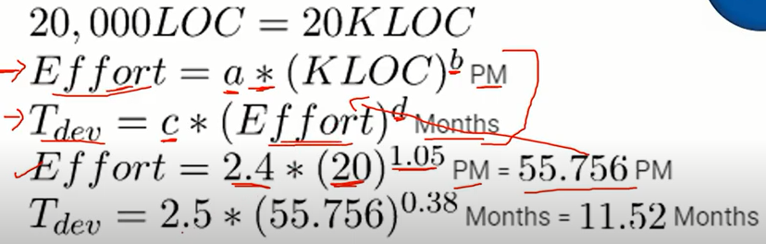

***Quest:-A program P calls two subprograms P1 and P2. P1 can fail 50% times and P2 40% times. Then P can fail***

(A) 50% (B) 60% (C) 10% (D) 70%(yes)

**Explanation:-**

Program P fails when either P1 fails or P2 fails, i.e. failure of P1 + failure of P2.

But this will also contain the case when both P1 and P2 fails at the same time, i.e. failure of P1 ∩ failure of P2, since this case will be already be counted on (P1+P2).

Therefore, our final answer will be failure of P1 + failure of P2 - (failure of P1 ∩ failure of P2)

= (50/100) + (40/100) -(50/100∗40/100)

= (90/100) - (2000/10000)

= (90/100) - (20/100)

= (70/100)(70/100)

= 70%

***Quest:-…………… establishes information about when, why and by whom changes are made in a software.***

(A) Software Configuration Management. (B) Change Control.

(C) Version Control. (D) An Audit Trail(yes)

***Which one of the following set of attributes should not be encompassed by effective software metrics ?***

(A) Simple and computable (B) Consistent and objective

(C) Consistent in the use of units and dimensions

(D) Programming language dependent(yes)

***The software _________ of a program or a computing system is the structure or structures of the system, which comprise software components, the externally visible properties of those components, and the relationships among them.***

(A) Design (B) Architecture(yes) (C) Process (D) Requirement

***Requirement Development, Organizational Process Focus, Organizational Training, Risk Management and Integrated Supplier Management are process areas required to achieve maturity level***

(A) Performed (B) Managed (C) Defined(yes) (D) Optimized

***Which of these are the 5 generic software engineering framework activities ?***

(A) Communication, planning, modelling, construction, deployment(yes)

(B) Communication, risk management, measurement, production, reviewing

(C) Analysis, designing, programming, Debugging, maintenance

(D) Analysis, planning, designing, programming, testing

***Which one of the items listed below is not one of the software engineering layers ?***

(A) Process (B) Manufacturing(yes) (C) Method (D) Tools

Explain:- software engineering layers are tools, methods, process, quality focus

***While estimating the cost of software, Lines of Code (LOC) and Function Points (FP) are used to measure which one of the following?***

(A) Length of code (B) Size of software(yes)

(C) Functionality of software (D) None of the above

***Which of the following statement TRUE with regard to software testing ?***

I. Regression testing technique ensures that the software product runs correctly after the changes during maintenance.

II. Equivalence partitioning is a white-box testing technique that divides the input

domain of a program into classes of data from which test cases can be derived.

(1) only I (yes) (2) only II (3) both I and II (4) neither I nor II

***Which of the following are facts about a top-down software testing approach ?***

I. Top-down testing typically requires the tester to build method stubs.

II. Top-down testing typically requires the tester to build test drivers.

(1) only I (yes) (2) Only II(3) Both I and II (4) Neither I nor II

***Software Cost Performance index (CPI) is given by:***

(A) BCWP/ACWP (yes) (B) None of the above

(C) BCWP−ACWP D) BCWP−BCWS

Where: BCWP stands for Budgeted Cost of Work Performed

BCWS stands for Budget Cost of Work Scheduled

ACWP stands for Actual Cost of Work Performed

**Explain:-** Cost performance index (CPI): The ratio of budgeted costs to actual costs (BCWP/ACWP) and CPI is often used to predict the magnitude of a possible cost overrun.

***Which possibility among the following is invalid in case of a Data Flow Diagram?***

(A) A process having in-bound data flows more than out-bound data flows

(B) A data flow between two processes

(C) A data flow between two data stores(yes)

(D) A data store having more than one in-bound data flows

***The Object Modelling Technique (OMT) uses the following three kinds of model to describe a system***

(A) Class Model, Object Model and Analysis Model.

(B) Object Model, Dynamic Model, and Functional Model.(yes)

(C) Class Model, Dynamic Model and Functional Model.

(D) Object Model, Analysis Model and Dynamic Model

***If a program in its functioning has not met user requirements is some way, then it is***

1) an error 2) a failure 3) a fault 4) a defect (yes)

***For a program of k variables, boundary value analysis yields ______ test cases.***

(1) 4k – 1 (2) 4k (3) 4k + 1(YES) (4) 2k – 1

**EXPLANATION:-**

boundary value analysis 4n+1

No automatic alt text available.

Robustness testing 6n+1

worst case testing 5n

***A Software project was estimated at 864 Function Points. A six person team will be assigned to project consisting of a requirement gathering person, one designer, two programmers and two testers. The salary of the designer is Rs. 70,000 per month, requirement gatherer is Rs. 50,000 per month, programmer is Rs. 60,000 per month and a tester is Rs. 60,000 per month. Average productivity for the team is 12 FP per person month. Which of the following represents the projected cost of the project? (June – 2020)***

1. Rs. 33,20,000 B)Rs. 43,20,000 C) Rs. 33,10,000 D)Rs22,10,000

one requirement gathering person salary = 50000

one designer salary = 70000

two programmers salary = 2x60000=120 000

two testers salary = 2x60000=120 000

Total salary (of 6 persons )Per month = 360 000

Average productivity for the team is 12 FP per person month

Total productivity per month by 6 member team = 72FP

Total project size 864 FP

Duration to complete = 864 / 72 = 12 months

Total project cost = 12 x 360 000 = 43 20 000

***A software project was estimated at 352 Function Points (FP). A four person team will be assigned to this project consisting of an architect, two programmers, and a tester. The salary of the architect is ` 80,000 per month, the programmer ₹ 60,000 per month and the tester ₹ 50,000 per month. The average productivity for the team is 8 FP per person month. Which of the following represents the projected cost of the project ? (2017 – Jan)***

(A) ₹ 28,16,000 (B) ₹ 20,90,000 (C) ₹ 26,95,000 (D) ₹ 27,50,000

***Explanation:*** In given question we have total 352 Function Points (FP)

Average FP = 8 per person per month

4 person team is assigned to the project which is consist of an architect(₹ 80,000 per month), two programmers(₹ 60,000 per person per month), and a tester(₹ 50,000 per month).

So, 352 / (8 * 4) = 11 months

projected cost of the project = (1 architect + 2 programmer + 1 tester) * 11

= (80000 + 2 * 60000 + 50000) * 11

= ₹ 2750000.

***Improving processing efficiency or performance or restructuring of software to improve changeability is known as (UGC -SEP-2013)***

(1) Adaptive maintenance (2) Corrective maintenance

(3) Perfective maintenance(YES) (4) Preventive maintenance

***Modifying the software by restructuring is called (UGC -JUN -2020)***

(1) Adaptive maintenance (2) Corrective maintenance

(3) Perfective maintenance (4) Preventive maintenance(YES)

***A company needs to develop a strategy for software product development for which it has a choice of two programming languages L1 and L2. The number lines of code (LOC) developed using L2 is estimated to be twice of the LOC developed with L1. The product will have to be maintained for five years. Various parameters for the company are given in the table below. (ugc-2020)***

|  |  |  |
| --- | --- | --- |
| ***Parameter*** | ***Language L1*** | ***Language L2*** |
| Man years needed for development | LOC/10000 | LOC/10000 |
| Development Cost per man year | र 10, 00,000 | र 7, 50, 000 |
| Maintenance Time | 5 years | 5 years |
| Cost of maintenance per year | र 1,00,000 | र 50, 000 |

***Total cost of the project includes cost of development and maintenance. What is the LOC for L1 for which of the cost of the project using L1 is equal to the cost of the project using L2?***

1. 4000 B. 5000 C. 4333 D.4667

***Explanation:-***

Let L1 = x and L2 = 2x  
Then, (x*1000000)/10000 + 5*100000 = (2x*750000)/10000 + 5*50000  
=> x*100 + 5*100000 = 2x*75 + 5*50000  
=> 50x = 250000  
=> x = 5000

***Which of the following is NOT desired in a good Software Requirement Specifications (SRS) document?***

(A) Functional Requirements (B) Non-Functional Requirements

(C) Goals of Implementation (D) Algorithms for Software Implementation

**Explanation:**

"An SRS document should clearly document the following aspects of a system: Functional Requirements,

Non-Functional Requirements and Goals of implementation."

-Rajib Mall (Fundamentals of Software Engineering)

***In PERT/CPM, the merge event represents___________ of two or more events. (DEC – 2018)***

(A) splitting (B) completion(yes) (C) beginning (D) joning

***Explanation:*** PERT -> Program (Project) Evaluation and Review Technique

CPM -> Critical Path model

***Which of the following statements is/are ​false ? (NET 2018 – DEC)***

***P: The clean-room strategy to software engineering is based on the incremental software process model.***

***Q: The clean-room strategy to software engineering is one of the ways to overcome “unconscious” copying of copyrighted code.***

***Choose the correct answer from the code given below:***

(A) Neither P and Q(yes) (B) P only

(C) Both P and Q (D) Q only

**Explanation:** The cleanroom software engineering process is a software development process intended to produce software with a certifiable level of reliability. The focus of the cleanroom process is on defect prevention, rather than defect removal.

The Cleanroom approach to software development is based on five key strategies Formal specification, Incremental development, Structured programming, Static verification, and Statistical testing of the system.

So, none given statements are false.

***Which of the following is not a key strategy followed by the clean room approach to software development? (NET 2018 - JULY)***

A)Formal specification B) Dynamic verification(yes)

C)Incremental development D) Statistical testing of the system

***EXPLANATION:-***

Cleanroom software development is a software development philosophy that is based on avoiding software defects by using formal methods of development and a rigorous inspection process. The name ‘Cleanroom’ was derived by analogy with semiconductor fabrication units. In these units (cleanrooms) defects are avoided by manufacturing in an ultra-clean atmosphere. The objective of this approach to software development is zero-defect software.

***The Cleanroom approach to software development is based on five key strategies:***

***Formal specification*** The software to be developed is formally specified. A state-transition model which shows system responses to stimuli is used to express the specification.

***Incremental development*** The software is partitioned into increments which are developed and validated separately using the Cleanroom process. These increments are specified, with customer input, at an early stage in the process.

***Structured programming*** Only a limited number of control and data abstraction constructs are used. The program development process is a process of stepwise refinement of the specification. A limited number of constructs are used and the aim is to apply correctness-preserving transformations to the specification to create the program code.

***Static verification*** The developed software is statically verified using rigorous software inspections. There is no unit or module testing process for code components.

***Statistical testing*** of the system The integrated software increment is tested statistically (see Chapter XX), to determine its reliability. These statistical tests are based on an operational profile which is developed in parallel with the system specification.

***For a software project, the spiral model was employed. When will the spiral stop? (ISRO - 2014 )***

(A) When the software product is retired

(B) When the software product is released after Beta testing

(C) When the risk analysis is completed

(D) After completing five loops

**Explanation**: Generally, process models end when software is delivered but the spiral model can be adapted to apply throughout the life of the computer software. The spiral model can be characterized in a way that it can remain operative until the software is retired.

Option (A) is correct.

***Which of the following are external qualities of a software product? (Aug – 2016)***

(A) Maintainability, reusability, portability, efficiency, correctness.

(B) Correctness, reliability, robustness, efficiency, usability.(yes)

(C) Portability, interoperability, maintainability, reusability.

(D) Robustness, efficiency, reliability, maintainability, reusability.

**Explanation:** External qualities of a software product:

Correctness, Reliability, Robustness, Efficiency, Usability

Internal qualities of a software product:

Maintainability,Reusability,Portability,Interoperability

***QUES:- An Operating System (OS) crashes on the average once in 30 days, that is, the Mean Time Between Failures (MTBF) = 30 days. When this happens, it takes 10 minutes to recover the OS, that is, the Mean Time To Repair (MTTR) = 10 minutes. The availability of the OS with these reliability figures is approximately?***

(1) 96.97% (2) 97.97% (3) 99.009% (4) 99.97%

**Explanation:-**

MTBF = 30 days

MTTR = 10 min = 0.17 hours = 0.007 day

MTTF = 29.993 days

Availability is 29.993/30 * 100 = 99.97%

***A signal processor software is expected to operate for 91.25 days after repair, and the mean software repair time is expected to be 5 minutes. Then, the availability of the software is : (2017 – NOV)***

(1) 96.9862% (2) 97.9862% (3) 98.9962% (4) 99.9962%

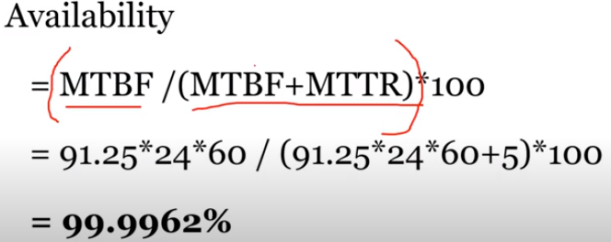

In a software project, COCOMO (Constructive Cost Model) is used to estimate

1, effort and duration based on the size of the software

2, size and duration based on the effort of the software

3, effort and cost based on the duration of the software

4, size, effort and duration based on the cost of the software

The basic COCOMO equations take the form

**Effort Applied (E)** = ab(KLOC)bb **[**[**person-months**](http://en.wikipedia.org/w/index.php?title=Person-month&action=edit&redlink=1)**]**

**Development Time (D)** = cb(Effort Applied)db **[months]**

**So A is the correct option.**

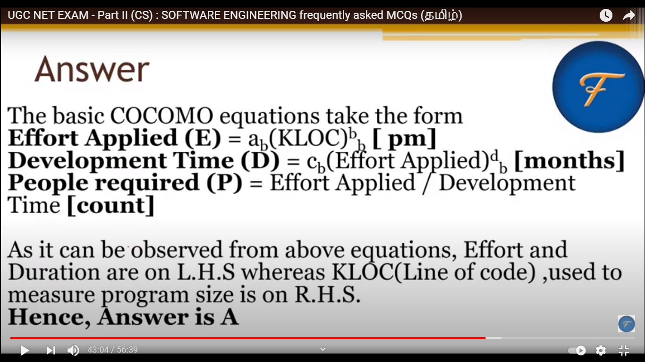

***While unit testing a module, it is found that for a set of test data, maximum 90% of the code alone were tested with a probability of success 0.9. The reliability of the module is?***

***(DRDO – 2018)***

a, at least greater than 0.9

b, equal to 0.9

c, at most 0.81

d, at least 0.81

Explanation:-

Code tested maximum 0.90%

probability of success is 0.9

So, reliability of the module atmost 0.9 * 0.9 =0.81

Ref <https://www.youtube.com/watch?v=SsimLYgXUfQ&ab_channel=TerranceFrederick>

***Which of the following UML 2.0 diagrams capture behavioural aspects of a system?***

(A) Use Case Diagram, Object Diagram, Activity Diagram, and State Machine Diagram

(B) Use Case Diagram, Activity Diagram, and State Machine Diagram

(C) Object Diagram, Communication Diagram, Timing Diagram, and Interaction diagram

(D) Object Diagram, Composite Structure Diagram, Package Diagram, and Deployment Diagram

Answer: (B)

***The extent to which a software performs its intended functions without failures, is termed as (2016 – Aug)***

(A) Robustness (B) Correctness (C) Reliability(yes) (D) Accuracy

**Explanation:**

The extent to which a software performs its intended functions without failures, is termed as reliability.

Robustness: The ability to withstand or overcome adverse conditions or rigorous testing.

Correctness: the quality or state of being free from error; accuracy.

Accuracy: the degree to which the result of a measurement, calculation, or specification conforms to the correct value or a standard.

***The extent to which a software tolerates the unexpected problems, is termed as***

(1) Accuracy (2) Reliability (3) Correctness (4) Robustness(yes)

The cyclomatic complexity metric V(G) of the following control flow graph?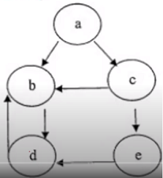 (ISRO – 2015)

1. 3 b) 4 c) 5 d) 6

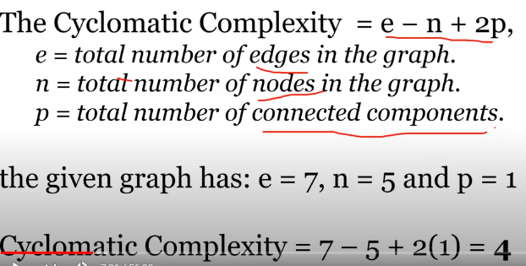

2018 - JULY

Assume the following regarding the development of a software system P :

-Estimated lines of code of P : 33, 480

-LOC - Average productivity for P : 620 LOC per person-month

-Number of software developers : 6

-Average salary of a software developer : 50,000 per month

If E, D and C are the estimated development effort (in person-months), estimated development time (in months), and estimated development cost (in Lac) respectively, then (E, D, C) = ________.

(1) (48, 8, 24) (2) (54, 9, 27) (3) (60, 10, 30) (4) (42, 7, 21

Match the following in Software Engineering :

List-I List-II

(a) Product Complexity (i) Software Requirements Definition

(b) Structured System Analysis (ii) Software Design

(c) Coupling and Cohesion (iii) Validation Technique

(d) Symbolic Execution (iv) Software Cost Estimation

Codes :

(a) (b) (c) (d)

(1) (ii) (iii) (iv) (i)

(2) (iii) (i) (iv) (ii)

(3) (iv) (i) (ii) (iii)(yes)

(4) (iii) (iv) (i) (ii)

Which one of the following is not typically provided by Source Code Management Software?

(1) Synchronisation (2) Versioning and Revision history

(3) Syntax highlighting(yes) (4) Project forking

A software system crashed 20 times in the year 2017 and for each crash, it took 2 minutes to

restart. Approximately, what was the software availability in that year?

(1) 96.9924% (2) 97.9924% (3) 98.9924% (4) 99.9924%

Match the 5 CMM Maturity levels/CMMI staged representations in List-I with their characterizations

in List-II :

List-I List-II

(a) Initial (i) Processes are improved quantitatively and continually.

(b) Repeatable (ii) The plan for a project comes from a template for plans.

(c) Defined (iii) The plan uses processes that can be measured quantitatively.

(d) Managed (iv) There may not exist a plan or it may be abandoned.

(e) Optimizing (v) There’s a plan and people stick to it.

Codes :

(a) (b) (c) (d) (e)

(1) (iv) (v) (i) (iii) (ii)

(2) (i) (ii) (iv) (v) (iii)

(3) (v) (iv) (ii) (iii) (i)

(4) (iv) (v) (ii) (iii) (i)(yes)

Coupling is a measure of the strength of the interconnections between software modules. Which

of the following are correct statements with respect to module coupling?

P : Common coupling occurs when one module controls the flow of another module by

passing it information on what to do.

Q : In data coupling, the complete data structure is passed from one module to another

through parameters.

R : Stamp coupling occurs when modules share a composite data structure and use only

parts of it.

Codes :

(1) P and Q only (2) P and R only

(3) Q and R only (4) All of P, Q and R(yes)

A software design pattern often used to restrict access to an object is :

(1) adapter (2) decorator (3) delegation (4) proxy(yes)

Reasons to re-engineer a software include :

P : Allow legacy software to quickly adapt to the changing requirements

Q : Upgrade to newer technologies/platforms/paradigm (for example, object-oriented)

R : Improve software maintainability

S : Allow change in the functionality and architecture of the software

Codes :

(1) P, R and S only (2) P and R only

(3) P, Q and S only (4) P, Q and R only(yes)

Which of the following is not a key strategy followed by the clean room approach to software

development?

(1) Formal specification (2) Dynamic verification(yes)

(3) Incremental development (4) Statistical testing of the system

Which of the following statements is/are True ?

P : Refactoring is the process of changing a software system in such a way that it does not

alter the external behavior of the code yet improves the internal architecture.

Q : An example of refactoring is adding new features to satisfy a customer requirement

discovered after a project is shipped.

Codes :

(1) P only(yes) (2) Q only

(3) Both P and Q (4) Neither P nor Q

DECEMBER - 2018

Software coupling involves dependencies among pieces of software called modules. Which of

the following are correct statements with respect to module coupling ?

P : Common coupling occurs when two modules share the same global data.

Q : Control coupling occurs when modules share a composite data structure and use only parts

of it.

R : Content coupling occurs when one module modifies or relies on the internal working of

another module. Choose the correct answer from the code given below :

Code :

(1) P and Q only (2) Q and R only

(3) All of P, Q and R (4) P and R only

***Software products need perfective maintenance for which of the following reasons ?***

(1) To overcome wear and tear caused by the repeated use of the software.

(2) To rectify bugs observed while the system is in use. ( corrective maintenance)

(3) When the customers need the product to run on new platforms. (adaptive maintenance)

(4) To support the new features that users want it to support.(yes)

Which of the following statements is/are true ?

P : Software Reengineering is preferable for software products having high failure rates, having

poor design and/or having poor code structure.

Q : Software Reverse Engineering is the process of analyzing software with the objective of

recovering its design and requirements specification.

Choose the correct answer from the code given below :

Code :

(1) Both P and Q(yes) (2) Neither P nor Q (3) P only (4) Q only

The Software Requirement Specification(SRS) is said to be _________ if and only if no subset of individual requirements described in it conflict with each other.

(A) Correct (B) Consistent(yes) (C) Unambiguous (D) Verifiable

Explanation:

SRS is said to be correct if it covers all the requirements that are actually expected from the system.

Requirements in SRS are said to be consistent if there are no conflicts between any set of requirements. Examples of conflict include differences in terminologies used at separate places, logical conflicts like time period of report generation, etc.

An SRS is said to be unambiguous if all the requirements stated have only 1 interpretation.

An SRS is verifiable if there exists a specific technique to quantifiably measure the extent to which every requirement is met by the system.

***Match each UML diagram in List-I to its appropriate in List-Il.***

List-I List-II

(a) State Diagram (i) Describes how the external entities (people,devices) can interact with the system.

(b) Use-Case Diagram (ii) Used to describe the static or structural view of a system.

(c) Class Diagram (iii) Used to show the flow of a business process,the steps of a use-case or the logic of an object behaviour.

(d) Activity Diagram (iv) to the dynamic behaviour of objects and could also be used to describe the entire system behaviour.

Code :

(a) (b) (c) (d)

(1) (iv) (ii) (i) (iii)

(2) (iv) (i) (ii) (iii)(yes)

(3) (i) (iv) (iii) (ii)

(4) (i) (iv) (ii) (iii)

***A legacy software system has 940 modules. The latest release required that 90 of these modules be changed. In addition, 40 new modules were added and 12 old modules were removed. Compute the software maturity index for the system.***

(1) 0·849 (2) 0·923 (3) 0·725 (4) 0·524

***Explanation:-***

SMI = [ Mt – ( Fa + Fc + Fd) ] / Mt, Where

SMI – is the Software Maturity Index value

Mt – is the number of software functions/modules in the current release

Fc – is the number of functions/modules that contain changes from the previous release

Fa – is the number of functions/modules that contain additions to the previous release

Fd – is the number of functions/modules that are deleted from the previous release.

SMI =(940 - (40 + 90 + 12 )) / 940

=0.8489

=0.849

**2019 - JUNE**

***In the context of software testing, which of the following statements is/are NOT correct ?***

P : A minimal test set that achieves 100% path coverage will also achieve 100% statements

coverage.

Q : A minimal test set that achieves 100% path coverage will generally detect more faults than one that achieves 100% statement coverage.

R : A minimal test set that achieves 100% statement coverage will generally detect more faults than one that achieves 100% branch coverage.

(1) R only (2) Q only (3) P and Q only (4) Q and R only

***Which of the following are the primary objectives of risk monitoring in software project tracking?***

P : To assess whether predicted risks do, in fact, occur

Q : To ensure that risk aversion steps defined for the risk are being properly applied

R : To collect information that can be used for future risk analysis

(1) Only P and Q (2) Only P and R

(3) Only Q and R (4) All of P, Q, R(yes)

***Which of the following statements is/are true ?***

P : In software engineering, defects that are discovered earlier are more expensive to fix.

Q : A software design is said to be a good design, if the components are strongly cohesive and

weakly coupled.

Select the correct answer from the options given below :

(1) P only (2) Q only (yes)

(3) P and Q (4) Neither P nor Q

***Match List-I with List-II***

List-I List-II

(Software Process Models) (Software Systems)

(a) Waterfall model (i) e-business software that starts with only the basic functionalities and then moves on to more advanced features

(b) Incremental development (ii) An inventory control system for a supermarket to be developed within three months

(c) Prototyping (iii) A virtual reality system for simulating vehicle navigation in a highway

(d) RAD (iv) Automate the manual system for student

record maintenance in a school

Choose the correct option from those given below :

Codes :

(a) (b) (c) (d)

(1) (ii) (iv) (i) (iii)

(2) (i) (iii) (iv) (ii)

(3) (iii) (ii) (iv) (i)

(4) (iv) (i) (iii) (ii) (yes)

***Which of the following terms best describes Git ?***

(1) Issue Tracking System

(2) Integrated Development Environment

(3) Distributed Version Control System

(4) Web-based Repository Hosting Service

**Explain:-** Distributed Version Control System should be the answer. As GIT is a type of Version control system which does not limit on local machine. It works in distributed network.

***Software reuse is***

(1) The process of analysing software with the objective of recovering its design and

specification

(2) The process of using existing software artifacts and knowledge to build new software(yes)

(3) Concerned with reimplementing legacy system to make them more maintainable

(4) The process of analysing software to create a representation of a higher level of abstraction

and breaking software down into its parts to see how it works

***The M components in MVC are responsible for***

(1) User interface

(2) Security of the system

(3) Business logic and domain objects(yes)

(4) Translating between user interface actions/events and operations on the domain objects

Software validation mainly checks for inconsistencies between

(1) Use cases and user requirements

(2) Implementation and system design blueprints

(3) Detailed specifications and user requirements(yes)

(4) Functional specifications and use cases

***Software products need adaptive maintenance for which of the following reasons ?***

(1) To rectify bugs observed while the system is in use

(2) When the customers need the product to run on new platforms(yes)

(3) To support the new features that users want it to support

(4) To overcome wear and tear caused by the repeated use of the software

**2019 - DECEMBER**

***In a system for a restaurant, the main scenario for placing order is given below :*** ;

(a) Customer reads menu

(b) Customer places order

(c) Order is send to kitchen for preparation

(d) Ordered items are served

(e) Customer requests for a bill for the order

(f) Bill is prepared for this order

(g) Customer is given the bill

(h) Customer pays the bill

A sequence diagram for the scenario will have atleast how many objects among whom the

messages will be exchanged.

(A) 3 (B) 4 (C) 5 (yes) (D) 6

**Explanation:-**

There are five objects among whom the message will be exchanged :

1) Customer 2) Person who takes the order 3) Chef 4) Serving person 5) Cashier

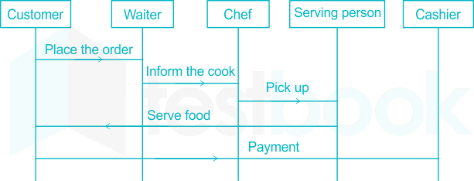

***Match the Agile Process models with the task performed during the model :***

List-I List-II

(a) Scrum (i) CRC cards

(b) Adaptive software development (ii) Sprint backlog

(c) Extreme programming (iii) <action> the <result> <by/for/of/to> a(n)<object>

(d) Feature-driven development (iv) Time box release plan

Codes :

(a) (b) (c) (d)

(A) (ii) (iv) (i) (iii)

(B) (i) (iii) (ii) (iv)

(C) (ii) (i) (iv) (iii)(yes)

(D) (i) (iv) (ii) (iii

***According to the ISO-9126 Standard Quality Model, match the attributes given in List-I with their definitions in List-II :***

List-I List-II

(a) Functionality (i) Relationship between level of performance and amount of resources

(b) Reliability (ii) Characteristics related with achievement of purpose

(c) Efficiency (iii) Effort needed to make for improvement

(d) Maintainability (iv) Capability of software to maintain performance of software

Codes :

(a) (b) (c) (d)

(A) (i) (ii) (iii) (iv)

(B) (ii) (i) (iv) (iii)

(C) (ii) (iv) (i) (iii) (yes)

(D) (i) (ii) (iv) (iii)

***An _____ chart is a project schedule representation that presents project plan as a directed graph. The critical path is the ______ sequence of _____ tasks and it defines project______.***

(A) Activity, Shortest, Independent, Cost

(B) Activity, Longest, Dependent, Duration(yes)

(C) Activity, Longest, Independent, Duration

(D) Activity, Shortest, Dependent, Duration

***The sequence diagram given in Figure 1 for the Weather Information System takes place when an external system requests the summarized data from the weather station. The increasing order of lifeline for the objects in the system are :***

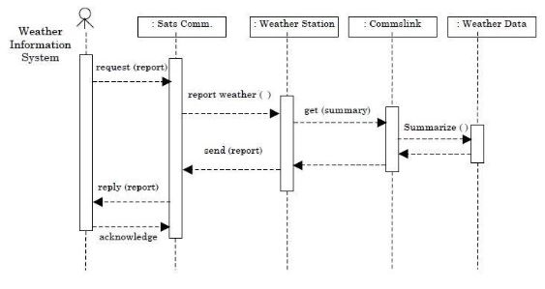

(A) Sat comms -> Weather station -> Comms link -> Weather data

(B) Sat comms -> Comms link -> Weather station -> Weather data

(C) Weather data -> Comms link -> Weather station -> Sat Comms

(D) Weather data -> Weather stations -> Comms link -> Sat Comms

***Answer the following question (91-95) based on flow graph F.***

***A flow graph F with entry node (1) and exit node (11) is shown below :***

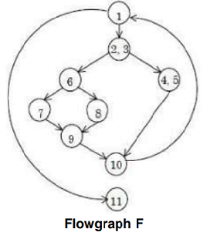

***91. How many regions are there in flowgraph F?***

(A) 2 (B) 3 (C) 4 (yes) (D) 5

***92. How many predicate nodes are there and what are their names?***

(A) Three : (1, (2, 3), 6)(yes) (B) Three : (1, 4, 6)

(C) Four : ((2, 3), 6, 10, 11) (D) Four : ((2, 3), 6, 9, 10)

***93. How many nodes are there in the longest independent path?***

(A) 6 (B) 7 (C) 8(yes) (D) 9

***94. What is the cyclomatic complexity of flowgraph F?***

(A) 2 (B) 3 (C) 4(yes) (D) 5

***95. How many nodes are there in flowgraph F?***

(A) 9 (yes) (B) 10 (C) 11 (D) 12

***A company needs to develop a strategy for software product development for which it has a choice of two programming languages L1 and L2. The number of lines of code (LOC) developed using L2 is estimated to be twice the LOC developed with Ll. The product will have to be maintained for five years. Various parameters for the company are given in the table below. (Gate – 2015)***

|  |  |  |
| --- | --- | --- |
| ***Parameter*** | ***Language L1*** | ***Language L2*** |
| ***Man years needed for development*** | ***LOC/10000*** | ***LOC/10000*** |
| ***Development cost per man year*** | ***Rs. 10,00,000*** | ***Rs. 7,50,000*** |
| ***Maintenance time*** | ***5 years*** | ***5 years*** |
| ***Cost of maintenance per year*** | ***Rs. 1,00,000*** | ***Rs. 50,000*** |

***Total cost of the project includes cost of development and maintenance. What is the LOC for L1 for which the cost of the project using L1 is equal to the cost of the project using L2? (Gate – 2011)***

***(A) 4000 (B) 5000 (C) 4333 (D) 4667***  
  
**Explanation:**  Let LOC of L1 = x, so LOC of L2 = 2x  
Now,

(x/10000) * 1000000 + 5 * 100000 = (2x/10000) * 750000 + 5 * 50000

Solving for x, we get x = 5000

JUNE - 2020

Modifying the software by restructuring is called

(1) Adaptive maintenance (2) Corrective maintenance

(3) Perfective maintenance(yes) (4) Preventive maintenance

Which of the following is/are behavioral testing technique(s)?

(A) Equivalence Partitioning (B) Graph-Based Testing Method

(C) Boundery Value Analysis (D) Data flow Testing

(E) Loop Testing

Choose the correct answer from the options given below :

(1) (B) and (D) only (2) (A), (B) and (C) only

(3) (D) and (E) only (4) (A), (C) and (E) only

Match List-I with List-II

With reference to CMM developed by Software Engineering Institute (SEI)

List-I List-II

(a) Initial (i) Process measurement

(b) Repeatable (ii) Process definition

(c) Defined (iii) Project management

(d) Managed (iv) ADHOC

Choose the correct answer from the options given below :

(1) (a)-(iii), (b)-(iv), (c)-(ii), (d)-(i) (2) (a)-(iv), (b)-(iii), (c)-(i), (d)-(ii)

(3) (a)-(iv), (b)-(iii), (c)-(ii), (d)-(i) (4) (a)-(iii), (b)-(iv), (c)-(i), (d)-(ii)

44. Given below are two statements :

Statement-I : Quality control involves the series of inspections, reviews and tests used throughout the software process, to ensure each work product meets the requirements placed upon it.

Statement-II : Quality assurance consists of auditing and reporting functions of management.

In the light of the above statements, choose the correct answer from the options given below

(1) Both Statement-I and Statement-II are true

(2) Both Statement-I and Statement-II are false

(3) Statement-I is correct but Statement-II is false

(4) Statement-I is incorrect but Statement-II is true

To create an object-behavioral model, the analyst performs the following steps :

(A) Evaluates all use-cases

(B) Builds state transition diagram for the system

(C) Reviews the object behaviour model to verify accuracy and consistency

(D) Identifies events that do not derive the interaction sequence

Choose the correct answer from the options given below :

(1) (A), (B) and (C) only (2) (A), (B) and (D) only

(3) (B), (C) and (D) only (4) (A), (C) and (D) only

A Software project was estimated at 864 Function Points. A six person team will be assigned to

project consisting of a requirement gathering person, one designer, two programmers and two

testers. The salary of the designer is 70,000 per month, requirement gatherer is 50,000 per

month, programmer is 60,000 per month and a tester is 60,000 per month. Average productivity

for the team is 12 FP per person month. Which of the following represents the projected cost

of the project?

(1) 33,20,000 (2) 43,20,000 (3) 33,10,000 (4) 22,10,000

***Which of the following UML diagrams has a static view?***

(1) Collaboration diagram (2) Use-Case diagram

(3) State chart diagram (4) Activity diagram

***A Company has a choice of two languages L1 and L2 to develop a software for their client. Number of LOC required to develop an application in L2 is thrice the LOC in language L1. Also, software has to be maintained for next 10 years. Various paramenters for two languages are given below to decide which language should be preferred for development.***

***PARAMETER L1 L2***

***Man-year needed for development LOC/1000 LOC/1000***

***Development cost Rs. 70,000 Rs. 90,000***

***Cost of Maintenance per year Rs. 1,00,000 Rs. 40,000***

***Total cost of project include cost of development and maintenance. What is the LOC for L1 for which cost of developing the software with both languages must be same?***

(1) 2000 (2) 6000 (3) 3000(yes) (4) 5000

***In CRC based design, a CRC Team consists of: (NET-2015-Dec)***

(a)one or two users representatives (b)several programmers

(c)project co-ordinators (d)one or two system analysts

(A) (a) and (c) (B) (a), (b), (c) and (d)

(C) (a), (c) and (d) (yes) (D) (a), (b) and (d)

**Explanation:** In Critical review committe(CRC) based design, a CRC Team consists of one or two users representatives, project co-ordinators, one or two system analysts.

There is no programmer in Critical review committe.

So, option (C) is correct.