**SOFTWARE TESTING :-**

**Fault**: It is a condition that causes the software to fail to perform its required function.

**Error** : Refers to difference between Actual Output and Expected output.

**Failure** : It is the inability of a system or component to perform required function according to its specification.

**IEEE Definitions** 

* **Failure:**External behavior is incorrect
* **Fault:** Discrepancy in code that causes a failure.
* **Error:**Human mistake that caused fault

Error leads to fault and fault leads to failure

**Beta testing**:-

It is the last stage of testing, and normally can involve sending the product to beta test sites outside the company for real-world exposure or offering the product for a free trial download over the Internet.

**Top down Testing:-**

In this approach testing is conducted from main module to sub module. if the sub module is not developed a temporary program called STUB is used for simulate the submodule.

**Bottom up testing :-**

In this approach testing is conducted from sub module to main module, if the main module is not developed a temporary program called DRIVERS is used to simulate the main module.

**Regression Testing:-**

Regression testing is a type of software testing which verifies that software which was previously developed and tested still performs correctly after it was changed or interfaced with other software. Changes may include software enhancements, patches, configuration changes, etc.

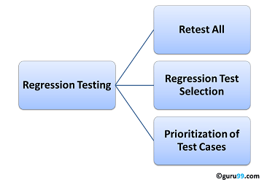

**Black box testing:-**

Testing, either functional or non-functional, without reference to the internal structure of the component or system.

**BLACK BOX TESTING TECHNIQUES:-**

**1.Equivalence partitioning**: It is a software test design technique that involves dividing input values into valid and invalid partitions and selecting representative values from each partition as test data.

**2.Boundary Value Analysis:** It is a software test design technique that involves determination of boundaries for input values and selecting values that are at the boundaries and just inside/ outside of the boundaries as test data.

**3.Cause Effect Graphing or Decision Tables:** It is a software test design technique that involves identifying the cases (input conditions) and effects (output conditions), producing a Cause-Effect Graph, and generating test cases accordingly. Based on if, else condition also.

**4.Exploratory Testing:**

**5.Error Guessing:** It is used to find bugs in software application based on tester prior’s experience.

**6.State Transaction:**

**Equivalence partitioning Testing:-**

Equivalence partitioning or equivalence class partitioning (ECP) is a software testing technique that divides the input data of a software unit into partitions of equivalent data from which test cases can be derived. In principle, test cases are designed to cover each partition at least once.

It is a black box testing technique.

**The 3 main White Box Testing Techniques are:**

1. Statement Coverage

2. Branch Coverage(conditional coverage)

3. Path Coverage

**1) Statement coverage:**

Hence “Statement Coverage”, as the name itself suggests, it is the method of validating whether each and every line of the code is executed at least once.

**2) Branch Coverage(conditional coverage):**

“Branch” in a programming language is like the “IF statements”. An IF statement has two branches: True and False.

we validate whether each branch is executed at least once.

**3) Path Coverage**

Path coverage tests all the paths of the program. This is a comprehensive technique which ensures that all the paths of the program are traversed at least once. Path Coverage is even more powerful than Branch coverage. This technique is useful for testing the complex programs.

**ALPHA AND BETA TESTING:-**

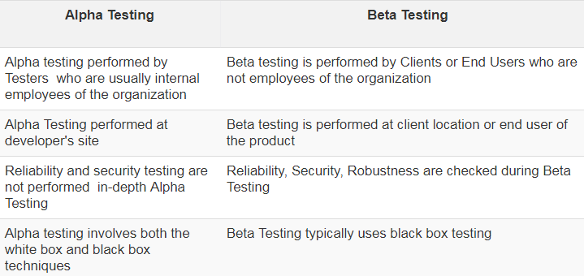

**Unit testing:** the smallest testable parts of an application, called units, are independently checked. This stage checks whether data flows properly,data structure works correctly, etc.

**Integration testing:** A few modules are combined and tested as a group. It occurs after unit testing.

**System testing:** System testing is done with full system implementation and environment to determine whether the system meets all customer requirements

**Regression Testing:** When a software is corrected, a part of the software configuration (code/documentation/data) may change. Regression testing ensures that such changes do not introduce additional errors. It is a maintenance testing.

**Functional Testing**: is a type of software testing that validates the software system against the functional requirements/specifications.

**Volume Testing:** Testing under the huge amount of data. Volume testing is also called flood testing and it is a type of performance testing.

**Requirements Analysis**

Requirement analysis is a software engineering task that bridges the gap between system level requirements engineering and software design.

**The Prototyping Model** is a systems development method (SDM) in which a prototype (an early approximation of a final system or product) is built, tested, and then reworked as necessary until an acceptable prototype is finally achieved from which the complete system or product can now be developed.

The prototype model is used when the requirements are unclear. It is used when the customer is unclear about the details of the input, process and the output needs of the software

**Evolutionary prototyping:-**

Build an initial small requirement specifications, code it, then “evolve” the specifications and code as needed.

**RAD model** is Rapid Application Development model. It is a type of incremental model. In RAD model the components or functions are developed in parallel as if they were mini projects. The developments are time boxed, delivered and then assembled into a working prototype.

**The spiral model** is a risk-driven process model generator for software projects. Based on the unique risk patterns of a given project, the spiral model guides a team to adopt elements of one or more process models, such as incremental, waterfall, or evolutionary prototyping.

Assess risks at each step; do most critical action first.

**Incremental Modal:-**

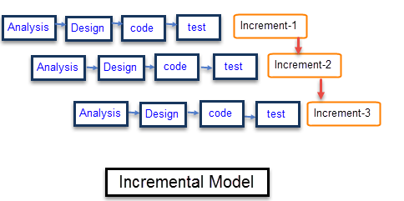

**Water Fall Modal:-**

It is a linear-sequential life cycle model. In a waterfall model, each phase must be completed fully before the next phase can begin. This type of software development model is basically used for the project which is small and there are no uncertain requirements

**ITERATIVE MODEL(Iterative Enhancement Modal):-**

It has 3 phases.

**SCRUM MODEL :-**

-Scrum is a subset of Agile.

-Time boxed delivery means delivered in short period of time. That is within 2 week not more than a month.

**VERIFICATION AND VALIDATION**

Verification is the process of evaluating products of a development phase to find out whether they meet the specified requirements.

Validation is the process of evaluating software at the end of the development process to determine whether software meets the customer expectations and requirements.

Validation confirms the right product and verification confirms if the product is built in a right way.

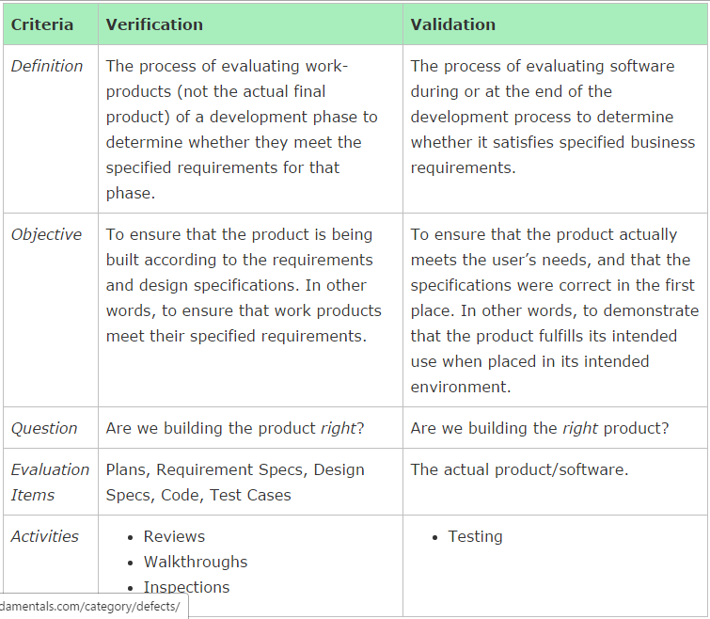

**SOFTWARE MATURITY INDEX:-**

The Software Maturity Index (SMI) is defined as

SMI = [Mf – (Fa + Fc + Fd)] / Mf Where

Mf = the number of modules in the current release.

Fa = the number of modules in the current release that have been added.

Fc = the number of modules in the current release that have been changed.

Fd = the number of modules in the current release that have been deleted.

**FUNCTION POINT ANALYSIS**

In function point analysis, the number of complexity adjustment factors is 14

VAF = 0.65 + [ (Ci) / 100] .i = is from 1 to 14 representing each GSC.

FP = UAF * VAF

GSC = General System Characteristic

UAF = Unadjusted Function Point

VAF = Value Adjustment Equation (VAF)

Ci = degree of influence for each General System Characteristic

**CYCLOMATIC COMPLEXITY**

As a software developer, we perform coding in any programming language. Once we are done with the coding part, we do assume that our part is over. But, that's not true in a real scenario. Our job does not end here. We need to look back to our code and take care of the below points.

1. Keep your code simple to understand.

2. Less complexity while using If…else statement or Switch case or any conditional statement.

3. Is this code manageable in future for any kind of changes or new development?

- In General, Cyclomatic Complexity tells how complex your code is.

- It is a quantitative measure of the number of linearly independent paths through a program's source code.

4. Independent path is defined as a path that has at least one edge which has not been traversed before in any other paths.

|  |  |  |
| --- | --- | --- |
| **Score** | **Cyclomatic** | **Risk Type** |
| 1 to 10 | Simple | Not much risk |
| 11 to 20 | Complex | Low risk |
| 21 to 50 | Too complex | Medium risk, attention |
| More than 50 | Too complex, | Can't test , high risk |

**Cyclomatic complexity = E - N + 2*P**

where,

E = number of edges in the flow graph.

N = number of nodes in the flow graph.

P = number of nodes that have exit points

= number of connected components

The complexity of the program can be defined as –

**V(G) = E - N + 2**

Where,

E - Number of edges

N - Number of Nodes

**V (G) = P + 1**

Where P = Number of predicate nodes (node that contains condition)

The easiest way is to sum the number of binary decision statements (e.g. if, while, for, etc.) and add 1 to it.

Example Diagram Below

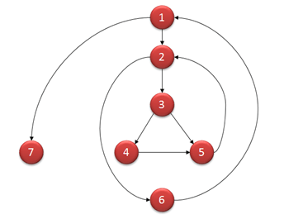

**Computing mathematically,**

* V(G) = 9 - 7 + 2 = 4
* V(G) = 3 + 1 = 4 (Condition nodes are 1,2 and 3 nodes)
* Basis Set - A set of possible execution path of a program
* 1, 7
* 1, 2, 6, 1, 7
* 1, 2, 3, 4, 5, 2, 6, 1, 7
* 1, 2, 3, 5, 2, 6, 1, 7

**Risk Exposure**,

RE, determined using:

RE = P x C

P is the probability of occurrence for a risk

C is the the cost to the project should the risk occur.

C = Average Componenent 100 LOC * Amount * Components to be developed

**COUPLING AND COHESION:-**

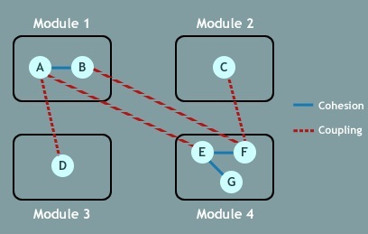

|  |  |
| --- | --- |
| **Cohesion** | **Coupling** |
| within module. | Coupling is the indication of the relationships between modules. |
| Cohesion shows the module’s relative functional strength. | Coupling shows the relative independence among the modules. |
| Cohesion is a degree (quality) to which a component / module focuses on the single thing. | Coupling is a degree to which a component / module is connected to the other modules. |
| While designing you should strive for ***high cohesion*** i.e. a cohesive component/ module focus on a single task (i.e., single-mindedness) with little interaction with other modules of the system. | While designing you should strive for ***low coupling***i.e. dependency between modules should be less. Cohesion is the indication of the relationship |
| Cohesion is the kind of natural extension of data hiding for example, class having all members visible with a package having default visibility. | Making private fields, private methods and non public classes provides loose coupling. |
| Cohesion is Intra – Module Concept. | Coupling is Inter -Module Concept. |

**REFACTORING:-**

"Refactoring is the process of changing a software system in such a way that it does not alter the external behavior of the code yet improves its internal structure." -- MartinFowler

Changing the code only not the external behaviour or adding new feature.

**DIFFERENT TYPES OF COUPLING:-**

**Data Coupling**

Two modules are data coupled if they communicate by passing parameters. This has been told to you as a "good design principle" since day one of your programming instruction.

Diagram

**Stamp Coupling**

**DEFINITION1**

Two modules are stamp coupled if they communicate via a passed data structure that contains more information than necessary for them to perform their functions.

**DEFINITION2**

Two modules are stamp coupled if they communicate using composite data items such as structure, objects, etc. When the module passes non-global data structure or entire structure to another module, they are said to be stamp coupled. For example, passing structure variable in C or object in C++ language to a module.

**Control Coupling**

Control Coupling exists among two modules if data from one module is used to direct the structure of instruction execution in another.

**Common Coupling**

Two modules are common coupled if they both share the same global data area. Another design principle you have been taught since day one: don't use global data.

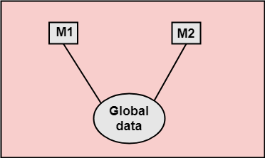

**Content Coupling**

Two modules are content coupled if:

one module changes a statement in another (Lisp was famous for this ability)

one module references or alters data contained inside another module

one module branches into another module

It is the worst model and best model is data coupling.

**DIFFERENT TYPE OF COHESION:**

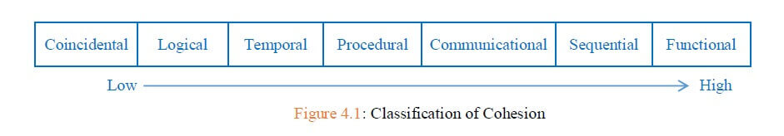

**CMM's(Capability Maturity Model) Five Maturity Levels of Software Processes**

1. **Initial Level:-** work is performed informally

At the initial level, processes are disorganized, even chaotic. Success is likely to depend on individual efforts, and is not considered to be repeatable, because processes would not be sufficiently defined and documented to allow them to be replicated.

A software development organization at this level is characterized by AD HOC activities (organization is not planned in advance.)

2.**Repeatable:-** work is planned and tracked

At the repeatable level, basic project management techniques are established, and successes could be repeated, because the requisite processes would have been made established, defined, and documented.

This level of software development organization has a basic and consistent project management processes to TRACK COST, SCHEDULE, AND FUNCTIONALITY. The process is in place to repeat the earlier successes on projects with similar applications.

Processes are characterized by projects and are frequently reactive.

**3.Definded:-** Work is well defined

At the defined level, an organization has developed its own standard software process through greater attention to documentation, standardization, and integration.

Processes are well-characterized and well-understood. The organization is more proactive than reactive, and there are organization-wide standards that provide guidance.

At this level the software process for both management and engineering activities are DEFINED AND DOCUMENTED.

**4.Managed:-** Work is quantitatively controlled

At the managed level, an organization monitors and controls its own processes through data collection and analysis.

Processes are characterized by projects and are frequently reactive.

Implementing Software Quality Management and Quantitative Process Management

**5.Optimizing:-** Work is based on continuous improvement

At the optimizing level, processes are constantly being improved through monitoring feedback from current processes and introducing innovative processes to better serve the organization's particular needs.

Processes are stable and flexible. The organizational focus is on continued improvement and responding to changes.

The key characteristic of this level is focusing on CONTINUOUSLY IMPROVING PROCESS performance.

Ref <https://www.bmc.com/blogs/cmmi-capability-maturity-model-integration/>

Ref https://www.geeksforgeeks.org/levels-of-capability-maturity-model-cmm/

**Functional requirements are** those which are related to the technical functionality of the system.

**Non-Functional requirement** is a requirement that specifies criteria that can be used to judge the operation of a system in particular conditions, rather than specific behaviors.

For example if you consider a shopping site, adding items to cart, browsing different items, applying offers and deals and successfully placing orders comes under functional requirements.

Whereas performance of the system in peak hours, time taken for the system to retrieve data from DB, security of the user data, ability of the system to handle if large number of users login comes under non functional requirements.

**Some of the more typical functional requirements include:-**

Business Rules, Transaction corrections, adjustments and cancellations, Administrative functions, Authentication, Authorization levels, Audit Tracking, External Interfaces, Certification Requirements, Reporting Requirements, Historical Data, Legal or Regulatory Requirements.

**Some typical non-functional requirements are**:

Performance – for example Response Time, Throughput, Utilization, Static Volumetric Scalability, Capacity, Availability, Reliability, Recoverability, Maintainability, Serviceability, Security, Regulatory, Manageability, Environmental, Data Integrity,Usability, Interoperability

**Type of software maintenance:-**

Adaptive, corrective, perfective and preventive are the four types of software maintenance.

**Corrective maintenance:-**

It is concerned with fixing errors that are observed when the software is in use.

**Adaptive Maintenance:-**

The modification of the software to match changes in the ever changing environment, falls under adaptive category of software maintenance

Modification of a software product performed after delivery to keep a software product usable in a changed or changing environment.

**Perfective maintenance:-**

Perfective maintenance: Modification of a software product after delivery to improve performance or maintainability. It is concerned with the change in the software that occurs while adding new functionalities in the software.

**Preventive maintenance**

It involves implementing changes to prevent the occurrence of errors. The distribution of types of maintenance by type and by percentage of time consumed. This includes modifications and updations to prevent future problems of the software

For Eg optimization

**Quality assurance as well as Quality control Factor:-**

**Reliability**

Measure if product is reliable enough to sustain in any condition. Should give consistently correct results.

Product reliability is measured in terms of working of project under different working environment and different conditions.

**Maintainability**

Different versions of the product should be easy to maintain. For development its should be easy to add code to existing system, should be easy to upgrade for new features and new technologies time to time.

**Usability**

This can be measured in terms of ease of use. Application should be user friendly. Should be easy to learn. Navigation should be simple.

**EXTERNAL AND INTERNAL QUALITIES OF THE SOFTWARE PRODUCT**

**INTERNAL QUALITIES:-**

**MAINTAINABILITY**:- Easy with which you can repair, improve and understand software code

**REUSABILITY**:- It is the use of existing assets in some form within the software product

**PORTABLITY**:- Usability of the same software in different platforms.

I**NTEROPERABILITY**:- The ease with which a software is used with other software systems.

**EXTERNAL QUALITIES:-**

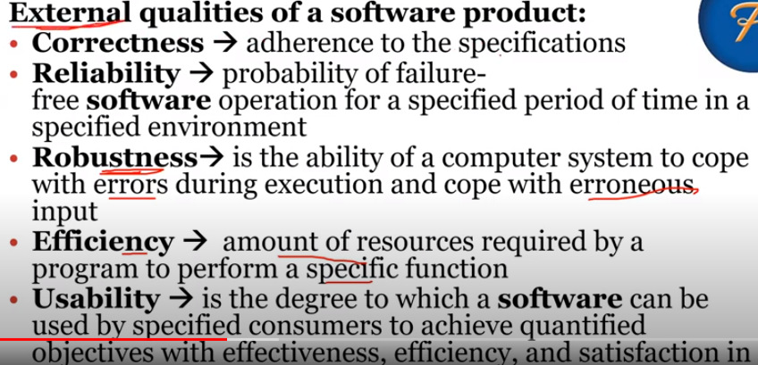

**Reverse Engineering:-**

Designers then do reverse engineering by looking at the code and try to get the design. With design in hand, they try to conclude the specifications. Thus, going in reverse from code to system specification.

**UMBRELLLA ACTIVITY:-**

umbrella activities that persist across the entire software process. These umbrella activities include:

software project management, formal technical reviews, software quality assurance

• software configuration management

• reusability management

• measurement

• document preparation and production

• risk management

**SERVER AVAILABILITY(**MTTF, MMTR and MTBF):-

MTTF is mean time to failure

MTTR is mean time to repair

1/MTTF is failure rate

MTTBF, the mean time between failures, is MTBF = MTTF + MTTR

**SERVER AVAILABILITY:-**

Availability Measured by (MTTF)/(MTTF + MTTR) = MTTF/MTBF – MTTR is very important A good MTTR requires that we detect quickly the failure

**EXAMPLE:-**

A server crashes on the average once a month. When this happens, it takes 12 hours to reboot it. What is the server availability ?

ANSWER:-

• MTBF = 30 days

• MTTR = 12 hours = ½ day

• MTTF = 29 ½ days

• Availability is 29.5/30 * 100 =98.3 %

**There are five generic software engineering process framework activities:**

1. Communication:

The software development starts with the communication between customer and developer.

2. Planning:

It consists of complete estimation, scheduling for project development and tracking.

3. Modeling:

Modeling consists of complete requirement analysis and the design of the project like algorithm, flowchart etc.

The algorithm is the step-by-step solution of the problem and the flow chart shows a complete flow diagram of a program.

4. Construction:

Construction consists of code generation and the testing part.

Coding part implements the design details using an appropriate programming language.

Testing is to check whether the flow of coding is correct or not.

Testing also check that the program provides desired output.

5. Deployment:

Deployment step consists of delivering the product to the customer and take feedback from them.

If the customer wants some corrections or demands for the additional capabilities, then the change is required for improvement in the quality of the software.

**SOFTWARE ENGINEERING LAYERED APPROACH**

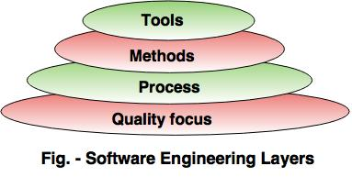

**UNIFIED MODELING LANGUAGE(UML)**

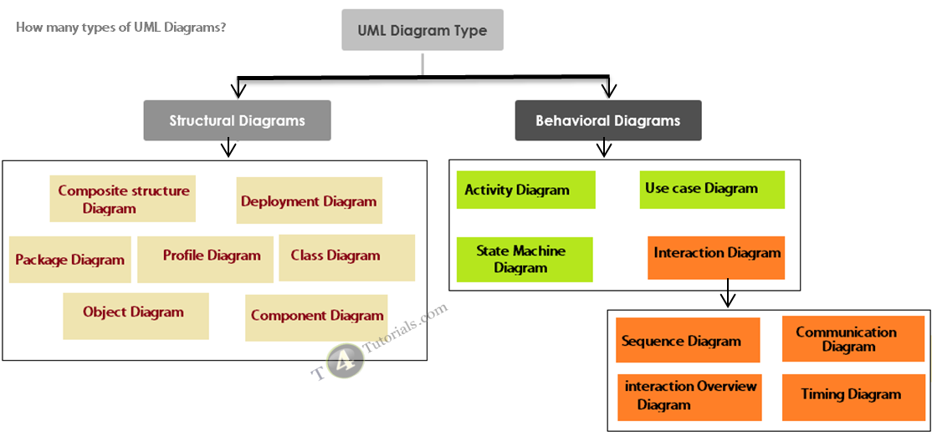

***QUALITY CONTROL AND QUALITY ASSURANCE***

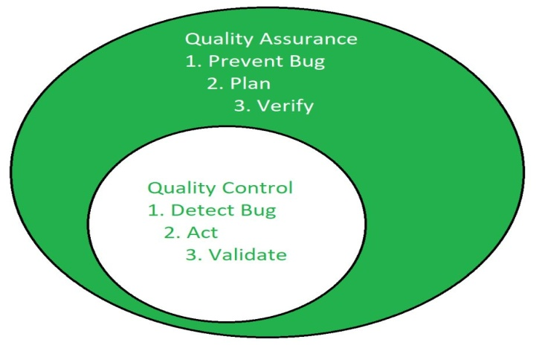

* Quality Assurance is aimed to avoid the defect whereas Quality control is aimed to identify and fix the defects.
* Quality Assurance provides assurance that quality requested will be achieved whereas Quality Control is a procedure that focuses on fulfilling the quality requested.
* Quality Assurance is done in software development life cycle whereas Quality Control is done in software testing life cycle.
* Quality Assurance is a proactive measure whereas Quality Control is a Reactive measure.
* Quality Assurance requires the involvement of all team members whereas Quality Control needs only testing team.
* Quality Assurance is performed before Quality Control.

**COCOMO MODEL:-**

The COCOMO (Constructive Cost Model) is one of the most popularly used software cost estimation models i.e. it estimates or predicts the effort required for the project, total project cost and scheduled time for the project. This model depends on the number of lines of code for software product development.

There are three modes of software development projects that depend on complexity

**1. Organic Project**:- It belongs to simple and small projects

**2. Semidetached Project**:- It is a intermediate project(in terms of size and complexity).

**3. Embedded Project**:- High complexity with a large team size.

The Basic COCOMO:-

Effort (E) = a*(KLOC)b Man Months

Scheduled Time (D) = c*(E)d Months(M)

Where,

E = Total effort required for the project in Man-Months (MM).

D = Total time required for project development in Months (M).

KLOC = the size of the code for the project in Kilo lines of code.

a, b, c, d = The constant parameters for a software project.

**Object Modeling Technique**

It consists of 1. Object Model 2. Dynamic Model 3. Functional Model

OM - Objects and their relationships

DM - Interactions among objects

FM - data transformations

**Object Modeling**:- The object model describes the static structure of a system in terms of objects and relationships

**Dynamic Modeling**:- The dynamic model describes the control structure of a system in terms of events and states.

**Functional Modeling**- The functional model describes the computational structure of a system in terms of values and funcitons.

It is represented with Data flow diagrams