**Install wordpress on AWS Amazon Linux**

I launched one ec2 and connected via ssh

ssh -i /path/to/your-key.pem ec2-user@your-ec2-public-ip

Sudo yum update –y

Apache

Sudo yum install –y httpd

I have to install packages : php, httpd, msql  wordpress,

## Php

sudo amazon-linux-extras enable php7.4  - not worked

cat  /etc/os-release

On Amazon Linux 2, the amazon-linux-extras package should be installed by default. If it's missing, you can install it using the package manager yum:

sudo yum install -y amazon-linux-extras      -

 The error message **Error: Unable to find a match: amazon-linux-extras** occurs because the amazon-linux-extras tool is not available on **Amazon Linux 2023**. As mentioned earlier, **Amazon Linux 2023** uses the dnf package manager (similar to Fedora), and the amazon-linux-extras command was specific to **Amazon Linux 2**.

sudo dnf install -y epel-release

Last metadata expiration check: 12:01:26 ago on Sun Nov 10 06:41:52 2024.

No match for argument: epel-release

Error: Unable to find a match: epel-release

sudo dnf install -y https://rpms.remirepo.net/enterprise/remi-release-9.rpm

sudo yum install -y php php-cli php-fpm php-mysqlnd php-opcache php-gd php-xml php-mbstring php-json –worked , installed php 8.3

php –v

sudo service php-fpm start

sudo service php-fpm enable

sudo service php-fpm status

## Mysql

sudo yum install -y mysql-server

sudo rpm -Uvh https://dev.mysql.com/get/mysql80-community-release-el7-3.noarch.rpm

sudo yum install -y mysql-community-server

sudo yum install -y https://dev.mysql.com/get/mysql57-community-release-el7-11.noarch.rpm

sudo yum install -y mysql-community-server

Completely Remove MySQL 8.0 and Reinstall MySQL 5.7

sudo rpm -e mysql80-community-release-el7-3.noarch

sudo yum remove mysql-community-server mysql-community-client mysql-community-common mysql-community-libs mysql-community-devel

sudo yum remove mysql80-community-release

sudo yum clean all

wget https://dev.mysql.com/get/mysql57-community-release-el7-11.noarch.rpm

sudo rpm -ivh mysql57-community-release-el7-11.noarch.rpm

sudo yum install -y mysql-community-server

These all are not worked

## instead of mysql i tried to install Mariadb

sudo curl -o /etc/yum.repos.d/MariaDB.repo https://downloads.mariadb.com/MariaDB/mariadb-10.5/repositories/rhel8-amd64/mariadb-10.5.13-rhel8-x86_64.rpm

ls /etc/yum.repos.d/

sudo dnf install -y mariadb-server

Not worked so

Instead of trying to install the repository file,  **create the repository configuration file** manually.

sudo dnf makecache

sudo dnf install -y mariadb-server

sudo rm -f /etc/yum.repos.d/MariaDB.repo

sudo tee /etc/yum.repos.d/MariaDB.repo <<EOF

[mariadb]

name = MariaDB

baseurl = https://yum.mariadb.org/10.6/rhel8-amd64

gpgkey = https://yum.mariadb.org/RPM-GPG-KEY-MariaDB

gpgcheck = 1

enabled = 1

EOF

sudo dnf makecache

sudo dnf install -y mariadb-server

**MariaDB 10.6** packages depend on **OpenSSL 1.1**, but your **Amazon Linux 2023** system might have a newer version of **OpenSSL** (such as OpenSSL 3.0) or missing older OpenSSL libraries.

sudo dnf install -y compat-openssl11

sudo dnf groupinstall "Development Tools"

sudo dnf install -y gcc openssl-devel

wget https://www.openssl.org/source/openssl-1.1.1u.tar.gz

tar -xvzf openssl-1.1.1u.tar.gz

cd openssl-1.1.1u

./config --prefix=/usr/local/openssl --openssldir=/usr/local/openssl

make

sudo make install

sudo ln -sf /usr/local/openssl/bin/openssl /usr/bin/openssl

sudo ldconfig

These are not worked .

Finallay i created a mysql rds database instance with name wordpress-database

## Working with EC2

To install the MariaDB mysql command line client on Amazon Linux 2023, run the following command:

sudo dnf install mariadb105

mysql -h your-rds-endpoint -u your-username -p

CREATE DATABASE wordpress CHARACTER SET utf8;

-- Step 1: Create the user 'wordpress' with a password

CREATE USER 'wordpress'@'%' IDENTIFIED BY 'wordpress';

-- Step 2: Grant all privileges on the 'wordpress' database to the user 'wordpress'

GRANT ALL PRIVILEGES ON wordpress.* TO 'wordpress'@'%';

-- Step 3: Reload privileges to apply changes

FLUSH PRIVILEGES;

Quit;

Create a new user in ec2

sudo useradd -m -s /bin/bash wordpress

su wordpress

cd /var/www/html

sudo wget https://wordpress.org/latest.tar.gz

For security reasons, the password you type will not be visible.

[sudo] password for wordpress:

After typing password shows: wordpress is not in the sudoers file.

The error message "wordpress is not in the sudoers file" typically occurs when the user you're logged in as doesn't have the necessary permissions to use sudo (which is a command that allows users to execute commands as a superuser or another user with higher privileges).

sudo usermod -aG sudo wordpress

wordpress is not in the sudoers file.again shows this

If you're still having issues, you can edit the sudoers file to give the wordpress user sudo permissions manually.

sudo visudo

At the end of file type

wordpress ALL=(ALL) NOPASSWD:ALL

Save and exit the editor (in visudo, press CTRL+X, then Y to confirm changes, and Enter to save).

Once you've made the changes, you can test the sudo access by logging in as the wordpress user and trying to run a command with sudo, for example:

sudo whoami

If everything is set up correctly, this should return root.

## Download the wordpress

cd /var/www/html

sudo wget https://wordpress.org/latest.tar.gz

sudo tar -xvzf latest.tar.gz

How to remove wordpress:bcz i have installed wordpress on root

cd /var/www/html

sudo find / -name "wp-config.php"

sudo rm -rf /var/www/html/*

Su wordpress    
enter password

Sudo systemctl start httpd

Sudo systemctl status httpd

Again Download the wordpress

cd /var/www/html

sudo wget https://wordpress.org/latest.tar.gz

sudo tar -xvzf latest.tar.gz

**Set the Correct Permissions**

Make sure the WordPress directory and files are owned by the wordpress user just created:

sudo find /var/www/html/wordpress -type d -exec chmod 755 {} \;

sudo find /var/www/html/wordpress -type f -exec chmod 644 {} \;

sudo chmod -R 775 /var/www/html/wordpress/wp-content

sudo chown -R wordpress:www-data /var/www/html/wordpress : this is for given access to webserver apache , but then i see this error:

sudo chown -R wordpress:www-data /var/www/html/wordpress

chown: invalid group: ‘wordpress:www-data’

On many Linux distributions (especially Ubuntu and Debian), www-data is the default group for the web server user (Apache/Nginx). But it’s possible that the group doesn't exist or is named differently on your system.

**Check if the www-data Group Exists**

On many Linux distributions (especially Ubuntu and Debian), www-data is the default group for the web server user (Apache/Nginx). But it’s possible that the group doesn't exist or is named differently on your system.

can check if www-data exists as a group by running:

getent group www-data 

* If the group exists,  see output similar to:

www-data:x:33: 

* If the group doesn't exist, won't see any output.

**Verify the Web Server Group**

Depending on web server and Linux distribution, the web server user may belong to a different group. Here's how to verify the web server user and its group:

* For **Apache** on Ubuntu/Debian, the web server user is usually www-data.
* For **Apache** on CentOS/Red Hat, the web server user is usually apache.
* For **Nginx**, the user might be www-data (Ubuntu/Debian) or nginx (CentOS/Red Hat).

check the web server user and group by running:

ps aux | grep apache

apache     64092  0.0  0.4  17028  4536 ?        S    05:30   0:00 /usr/sbin/httpd -DFOREGROUND

apache     64093  0.0  0.7 1084992 7584 ?        Sl   05:30   0:00 /usr/sbin/httpd -DFOREGROUND

apache     64094  0.0  0.7 1248896 7584 ?        Sl   05:30   0:00 /usr/sbin/httpd -DFOREGROUND

apache     64095  0.0  0.7 1084992 7584 ?        Sl   05:30   0:00 /usr/sbin/httpd -DFOREGROUND

apache     64271  0.0  0.7 401160  7436 ?        S    05:30   0:00 php-fpm: pool www

apache     64272  0.0  0.7 401160  7436 ?        S    05:30   0:00 php-fpm: pool www

apache     64273  0.0  0.7 401160  7436 ?        S    05:30   0:00 php-fpm: pool www

apache     64275  0.0  0.7 401160  7436 ?        S    05:30   0:00 php-fpm: pool www

apache     64276  0.0  0.7 401160  7436 ?        S    05:30   0:00 php-fpm: pool www

wordpre+   71049  0.0  0.2 222312  2072 pts/0    S+   06:30   0:00 grep --color=auto apache

* The **web server user** on my system is apache, not www-data.
* The **group ownership** should be changed to apache to allow the web server to interact with the WordPress files.
* Use the following command to set ownership:

sudo chown -R wordpress:apache /var/www/html/wordpress

To configure  **WordPress** installation to use  **Amazon RDS MySQL** database

To update the wp-config.php file in WordPress installation directory with the RDS database details.

**Edit the wp-config.php File**

Once  located wp-config.php, open it for editing with a text editor like nano or vim. For example, to open it with nano:

sudo nano /var/www/html/wp-config.php

define('DB_NAME', '  ');  // The name of the database that created

define('DB_USER', '  ');  // The username that created

define('DB_PASSWORD', ‘   ');  // The password for the user

define('DB_HOST', '  ');  // Replace with  RDS endpoint and port

Install mysql client to interact with rds

sudo apt install mysql-client-core-5.7

mysql -h RDS endpoint -u RDS username -p RDS password

mysql -h mydb.xxxxxxxxxxxx.us-west-2.rds.amazonaws.com -u admin –p

Enter password

SHOW DATABASES;

## Appache configuration

Sudo systemctl enable httpd   
sudo nano /etc/httpd/conf.d/wordpress.conf

    <VirtualHost *:80>

    ServerAdmin webmaster@localhost

    ServerName 54.91.189.19

    DocumentRoot /var/www/html/wordpress

    <Directory /var/www/html/wordpress>

        Options Indexes FollowSymLinks MultiViews

        AllowOverride All

        Require all granted

    </Directory>

    SetHandler "proxy:fcgi://127.0.0.1:9000"

    ErrorLog /var/log/httpd/wordpress_error.log

    CustomLog /var/log/httpd/wordpress_access.log combined

    ErrorDocument 404 /404.html

    ErrorDocument 500 /500.html

</VirtualHost>

sudo apachectl configtest

AH00526: Syntax error on line 3 of /etc/httpd/conf.d/wordpress.conf:

ServerName takes one argument, The hostname and port of the server

Removed # Use EC2 instance public IP, then error gone

Add one inbound rule :

* Go to the AWS Management Console.
* Open the **EC2 Dashboard**.
* Select  EC2 instance, and check the **Security Group** associated with it.
* Ensure an inbound rule allowing **HTTP** (port 80) and **HTTPS** (port 443), with the source set to **0.0.0.0/0** (allowing traffic from any IP) or  specific IP range.

In rds do some changes :

* Go to the **AWS Management Console**.
* Navigate to **RDS** (under Services).
* Find and select **RDS database instance**.
* Under **Connectivity & Security**, check if the option **Publicly Accessible** is set to **Yes**.
* If it's set to **No**, change it to **Yes**.
* **Publicly Accessible** means  RDS instance can accept connections from outside AWS, like EC2 instance.

When i browse the url : 54.91.189.19/wp-admin/setup-config.php

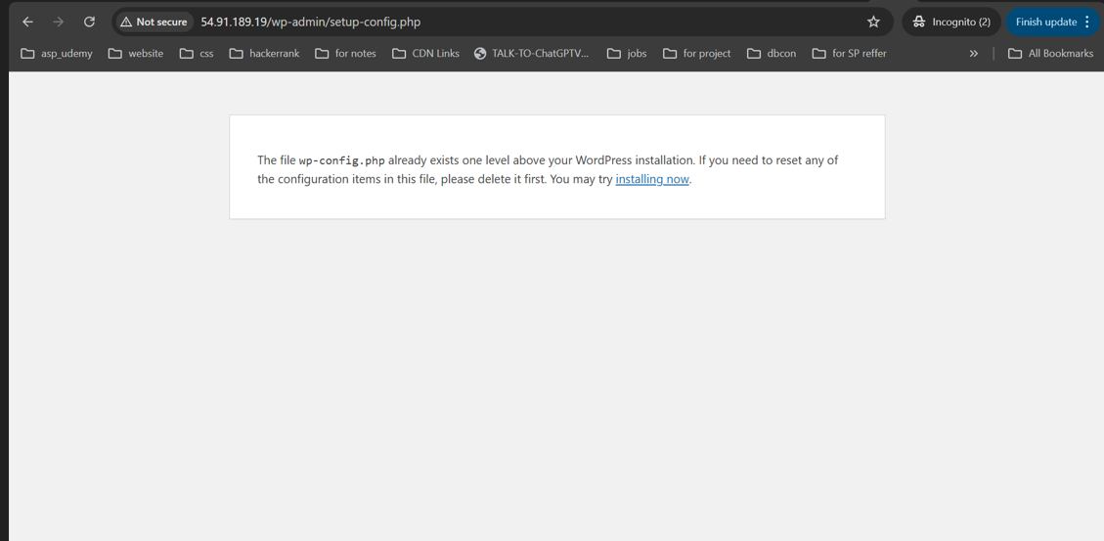

Then i have renamed wp-config.php to wp-config-backup.php

Then again i broswe the url: 54.91.189.19/wp-admin/setup-config.php

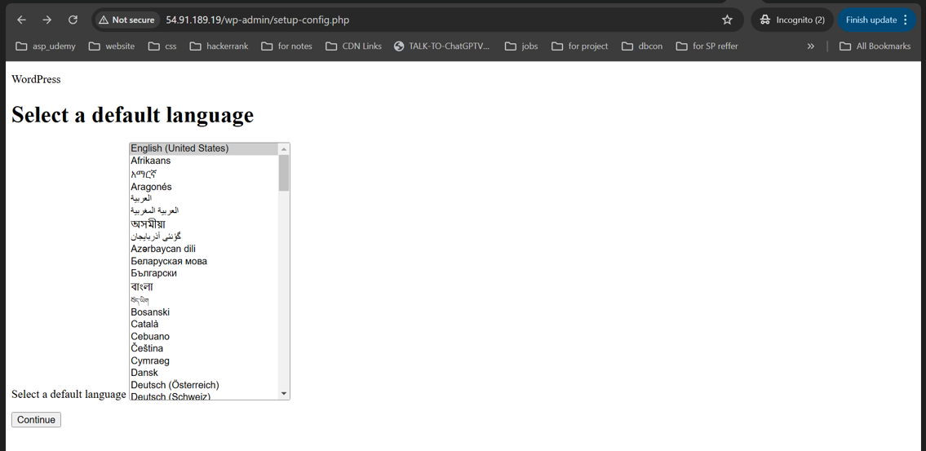

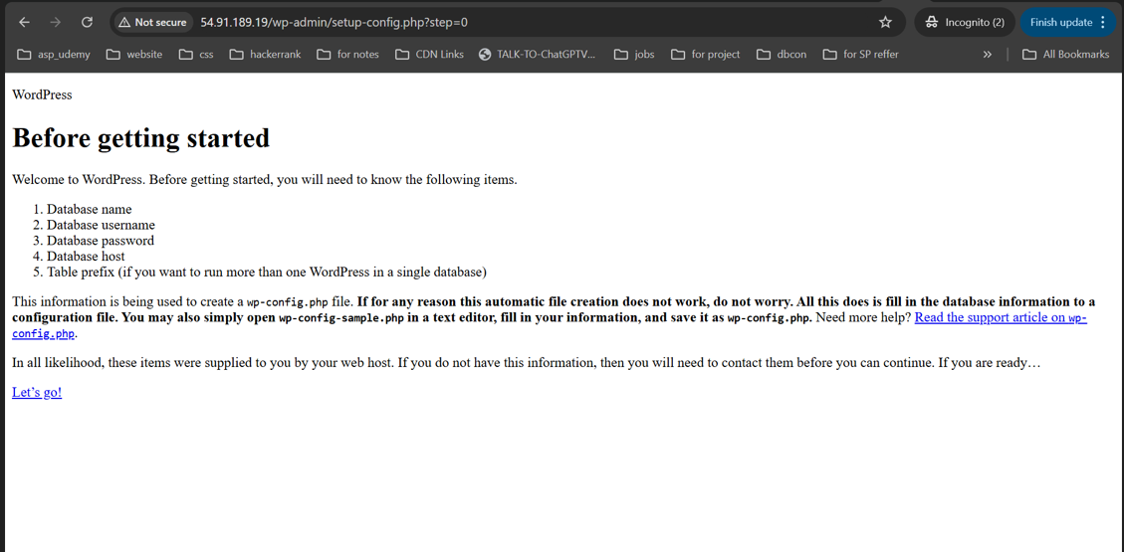

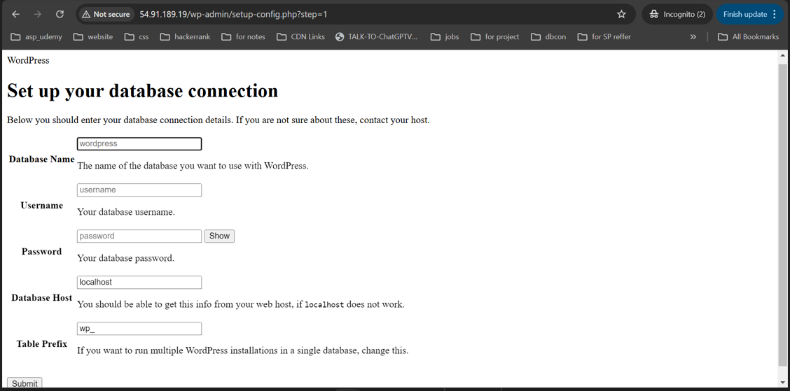

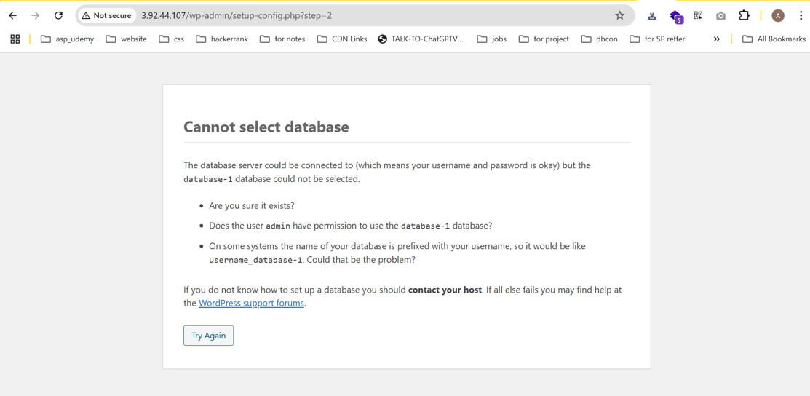

I have stoped my ec2 for a while , then i started aftersome time then i got new ip address for my ec2 . I browse again then I got error bcz of wrong credentials , then again i put correct credentials

