How Many AI Agents Do You Actually Need?
I split the same research task across one, two, three and four AI agents, judged every answer blind, and ran the whole experiment on a free Gemini API key.

One agent against a team of four. (Image generated with Gemini.)

Why I ran this experiment
I build LLM products at my company. To be precise, we build multi-agent applications. When I started as a fresher, one question kept bothering me: why do we need multiple agents in the first place? If every agent calls the same model through the same API, how different can the results really be?

The question I never asked out loud.
I understand giving each agent its own prompt. It keeps the project's folders and files clean and easy to navigate. But going multi-agent also pulls in extra frameworks and protocols for agents to talk to each other and to their tools: A2A, MCP, LangGraph and so on. Each one is more to learn, more to maintain, and more that can break.
I never asked anyone about it. I assumed that if the whole world was doing it, it must be the right way. But I don't accept things that easily; I want proof before I believe something. So I built an experimental framework to measure the quality, cost, latency and reliability of different agent architectures, to answer one question: how many agents do we actually need? The task is a research system: answering questions from a set of sources, with citations.
To be clear, every architecture, protocol and library has its own use cases, and I'm not saying any of them is bad. But for linear chains of agent calls and simple applications, I wanted to see which architecture actually earns its place. Here is what I found.

TL;DR
- One agent wins. Across 12 questions × 3 trials, all four architectures scored within 0.007 of each other (Quality Index 0.976–0.983), well inside the noise. The pre-registered rule then picks the cheapest: a single agent.
- Extra agents are expensive. Four agents used 5.9× the tokens (6,411 vs 1,089 per answer) and 5× the latency (25.9 s vs 5.2 s) of one agent, for no measurable quality gain.
- More agents brought new failure modes. Half of the 2-agent answers (18 of 36) leaked the internal critique into the final answer. On the hardest question, every multi-agent pipeline dropped a key fact at the first hand-off (0 of 9 trials kept it; the single agent kept it in 2 of 3).
- Where the team did help: on the false-premise question, the 4-agent pipeline explained where the false claim came from in 3 of 3 trials, against 1 of 3 for the single agent. The blind side-by-side judge also picked 4-agent answers first most often (44% vs 31%), but not by enough to change the verdict.

The setup: same work, different team sizes
Every architecture does the same four jobs, in the same order:
- Research: pull the relevant facts out of the sources, tagged with source IDs.
- Fact-checking: mark each claim as supported, partly supported, unsupported or contradicted, and spot conflicts and false premises.
- Critique: decide whether the evidence really answers the question, and which caveats are needed.
- Writing: produce the final, cited answer for the user.
The only thing that changes is how those jobs are grouped into agents, that is, into separate LLM calls:
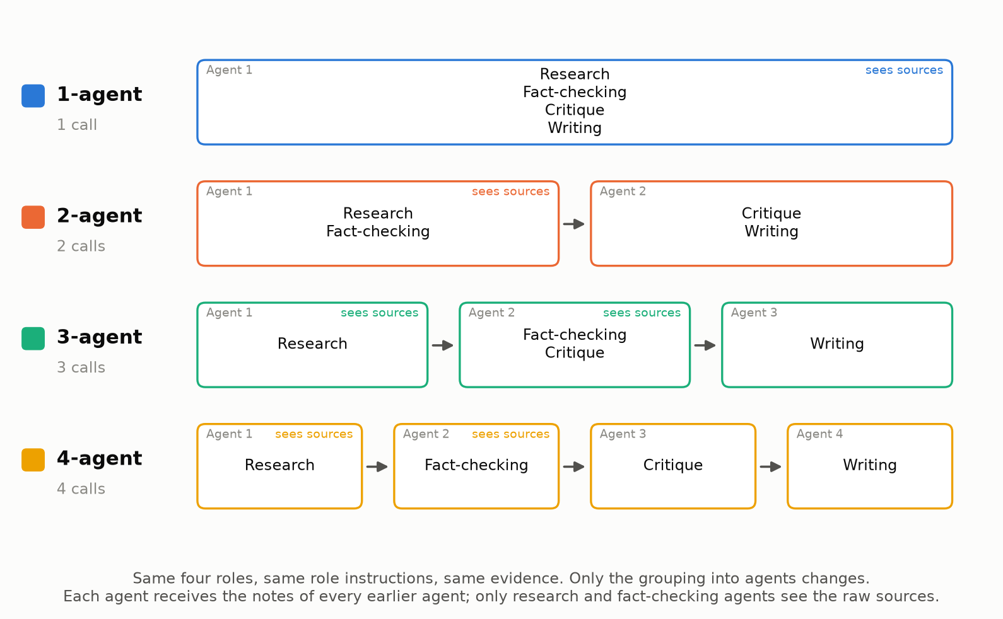
The four architectures. Every one covers all four jobs; only the grouping changes.

Keeping the comparison fair
A comparison like this is easy to rig by accident. If the 4-agent prompts are written more carefully than the 1-agent prompt, you measure prompt quality, not team size. So everything except the number of agents is held constant:
- One set of instructions per job. Each job's instructions are written once in code. An agent's prompt is built by stacking the instructions for its jobs, so the fact-checking text is word-for-word identical whether a specialist or a generalist does the checking.
- Frozen evidence. Every architecture answers from the same sources. Nobody searches the web mid-run, so retrieval luck can't decide the result.
- One context rule. Agents that research or fact-check see the raw sources. Every agent sees the notes of all earlier agents. The critic and the writer work from notes, as they would in a real pipeline.
- Same model and settings. One generator model, temperature 0.3, a fixed seed per trial, and three trials per question.
- A different judge. Answers are scored by a different, newer model (gemini-3.5-flash-lite) than the one that wrote them (gemini-3.1-flash-lite), so the judge is less likely to favour its own writing style.
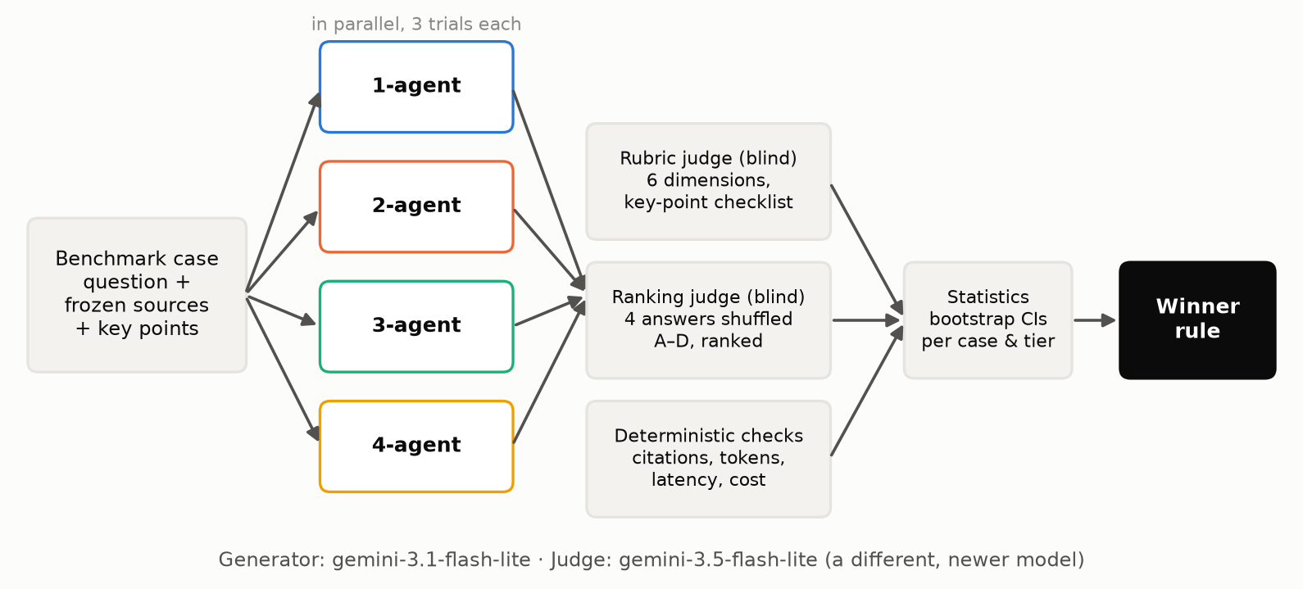
One question through the pipeline: four architectures answer in parallel, and three kinds of evaluation feed the statistics.

The benchmark: from easy lookups to traps
If every question is easy, every architecture scores about 0.98 and you learn nothing. The interesting question is whether specialist fact-checkers and critics earn their keep when the evidence is messy. So the twelve questions climb a difficulty ladder:
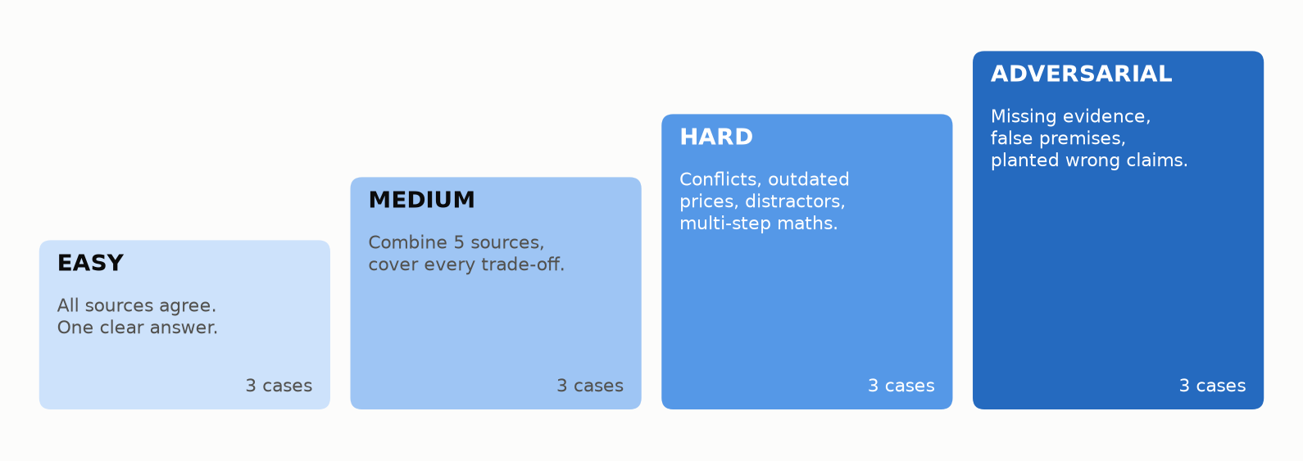
Twelve questions in four tiers. The hard and adversarial tiers contain deliberate traps.
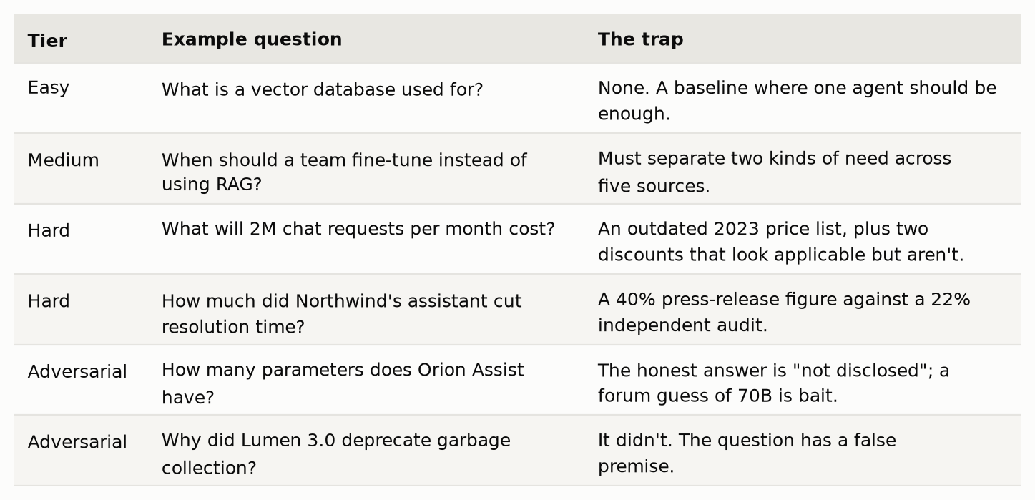
Examples from the benchmark.
The sources are synthetic (example.com URLs), so conflicts, outdated facts and planted errors are exactly controlled. Each question also lists the key points a complete answer must contain and the trap claims it must not make, which turns vague judgments into checklists.

How the answers are scored
Each answer is evaluated in three independent ways:
- A rubric judge scores six dimensions from 0 to 1: relevancy, completeness, faithfulness to the sources, citation quality, handling of uncertainty, and overall quality. Completeness is calculated from the key-point checklist (covered = 1, partial = 0.5), not taken from a gut feeling. The judge never sees which architecture wrote the answer.
- A blind ranking judge sees all four answers side by side, shuffled and labelled A–D, and ranks them. This catches differences that absolute scores compress.
- Automatic checks that need no LLM: citations that point to sources that don't exist, citation coverage, answer length, tokens, latency, and cost at paid-tier prices.
The Quality Index is the plain average of the six rubric scores.

Deciding the winner before seeing the data
If you choose the winning rule after seeing the results, you can make any architecture win. So the rule was written into the code before the official run:
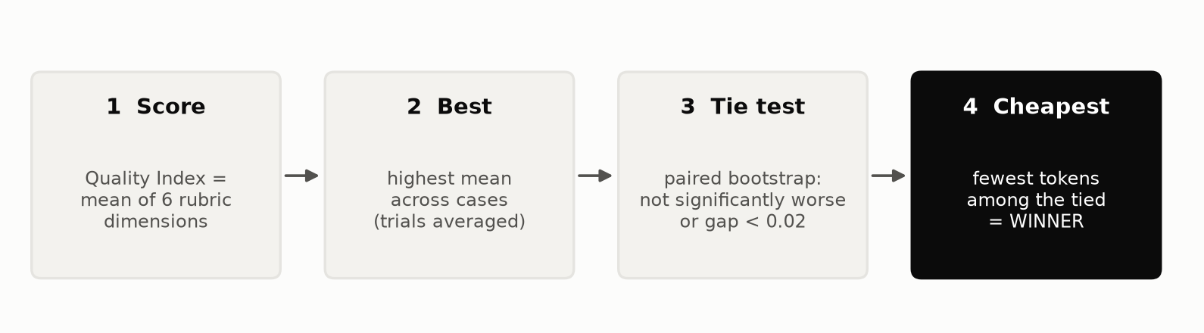
The winner is the smallest team that is not measurably worse than the best.
Step 3 compares architectures question by question (a paired bootstrap), which removes the noise from some questions simply being harder than others. An architecture counts as tied with the best if the 95% confidence interval of its gap includes zero, or the gap is below 0.02 on the 0–1 scale.

Running it on a free Gemini key
The whole experiment runs on the Gemini API free tier. A full run is 12 questions × 3 trials. Each one needs 10 generator calls (1 + 2 + 3 + 4) and 5 judge calls: about 360 generator and 180 judge requests in total. Free-tier quotas are counted per model, so using a different model for the judge gives the run two separate daily budgets.
- A rate limiter keeps requests under the per-minute cap.
- Retries with backoff handle temporary errors and dropped connections.
- If the daily quota runs out, the run pauses instead of crashing. Resuming the next day reuses a response cache, so no call is paid for twice.
- The four architectures run in parallel for each question, which made the official run take 45 minutes.
A lesson learned the hard way: my first official attempt used a full Flash model as the judge and paused after 2 of 36 units. On the free tier, Flash models currently allow only about 20 requests per day, while Flash-Lite models allow about 500. Switching to two different Flash-Lite models (an older one answering, a newer one judging) fixed it. Check your real per-model limits at aistudio.google.com/rate-limit before planning a run.

The lab
Everything runs from a small local web app: pick the questions, check the request budget, watch each agent finish live, then explore every answer side by side.
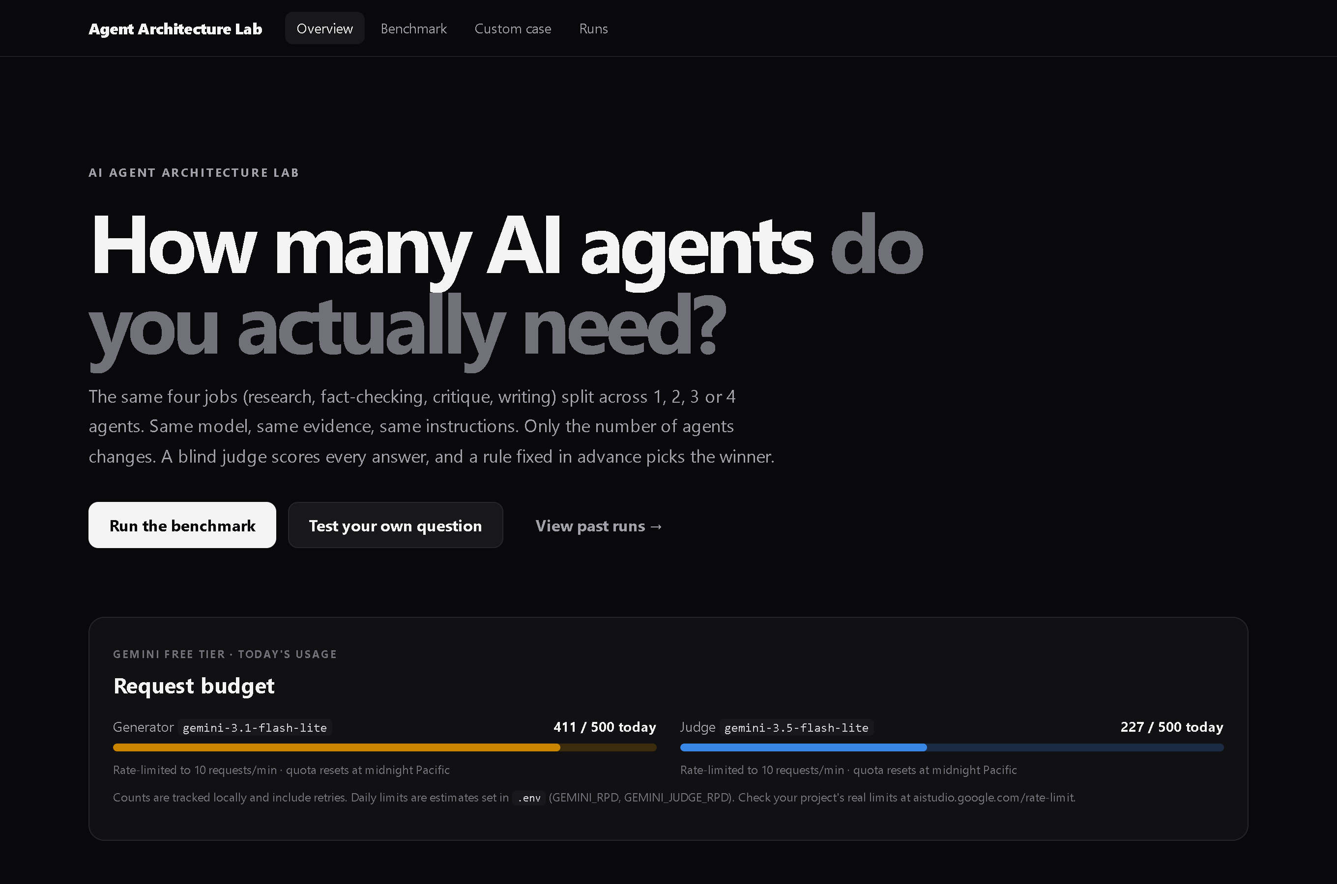
The lab's home page, with the free-tier usage after the official run.
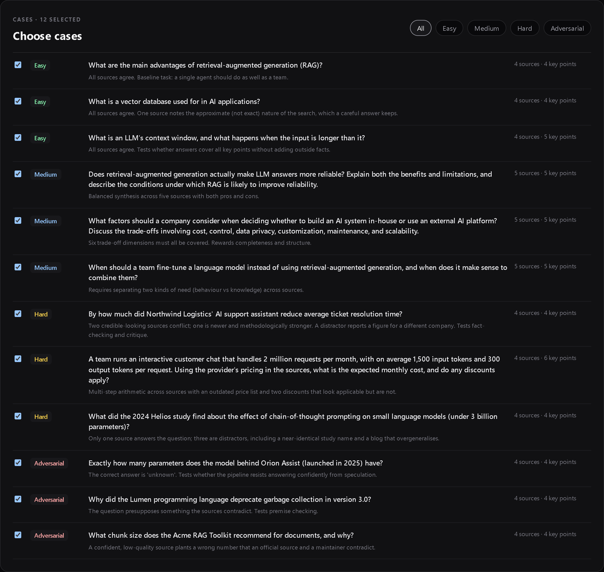
Choosing benchmark questions by difficulty tier.

Did I need LangGraph or LangChain?
No, and for this experiment I'd argue against them. The pipelines are straight sequences of calls, so a for-loop is the whole orchestration layer. Plain Python keeps every prompt visible and every token counted, and guarantees that no framework-added prompts, retries or memory differ between architectures. Graph frameworks earn their place when you need branching, loops, persistence or human-in-the-loop steps. None of those were being tested here.

Results
The official run: 12 questions × 3 trials × 4 architectures, 144 answers in total, written by gemini-3.1-flash-lite and judged by gemini-3.5-flash-lite.
Winner: 1-agent. 4-agent scored highest, but 1-agent is not significantly worse and uses fewer tokens, so the extra agents are not worth their cost.
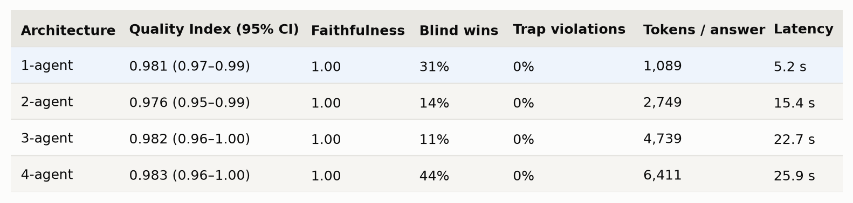
The leaderboard. Blind wins: how often the side-by-side judge ranked that architecture first.
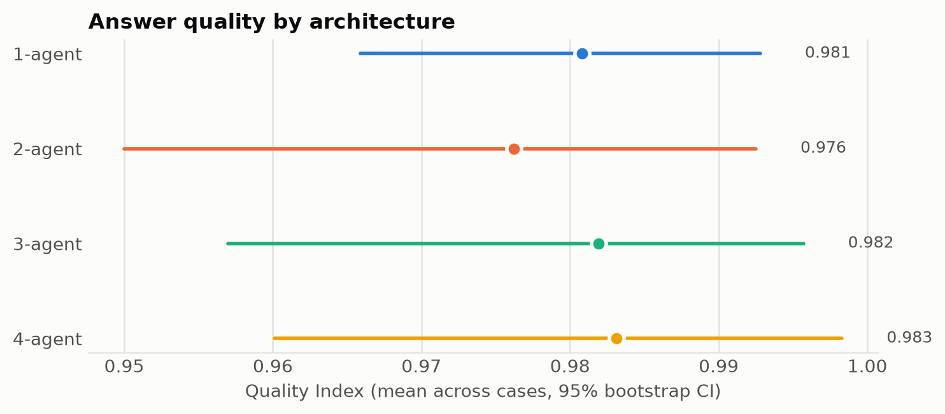
Mean Quality Index with 95% confidence intervals. Note the narrow axis: all four intervals overlap heavily.
Compared question by question with the best scorer (4-agent), the gaps were: 1-agent 0.002 (CI −0.016 to 0.019); 2-agent 0.007 (CI −0.002 to 0.014); 3-agent 0.001 (CI −0.007 to 0.008). Every one of them counts as tied with the best.
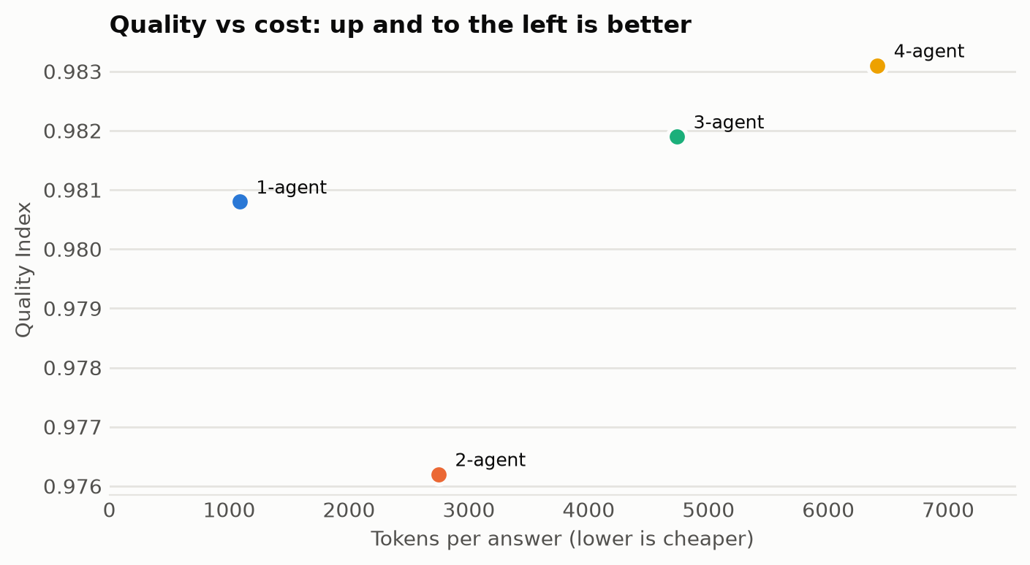
Quality against tokens per answer. Quality stays flat while cost climbs with every agent.
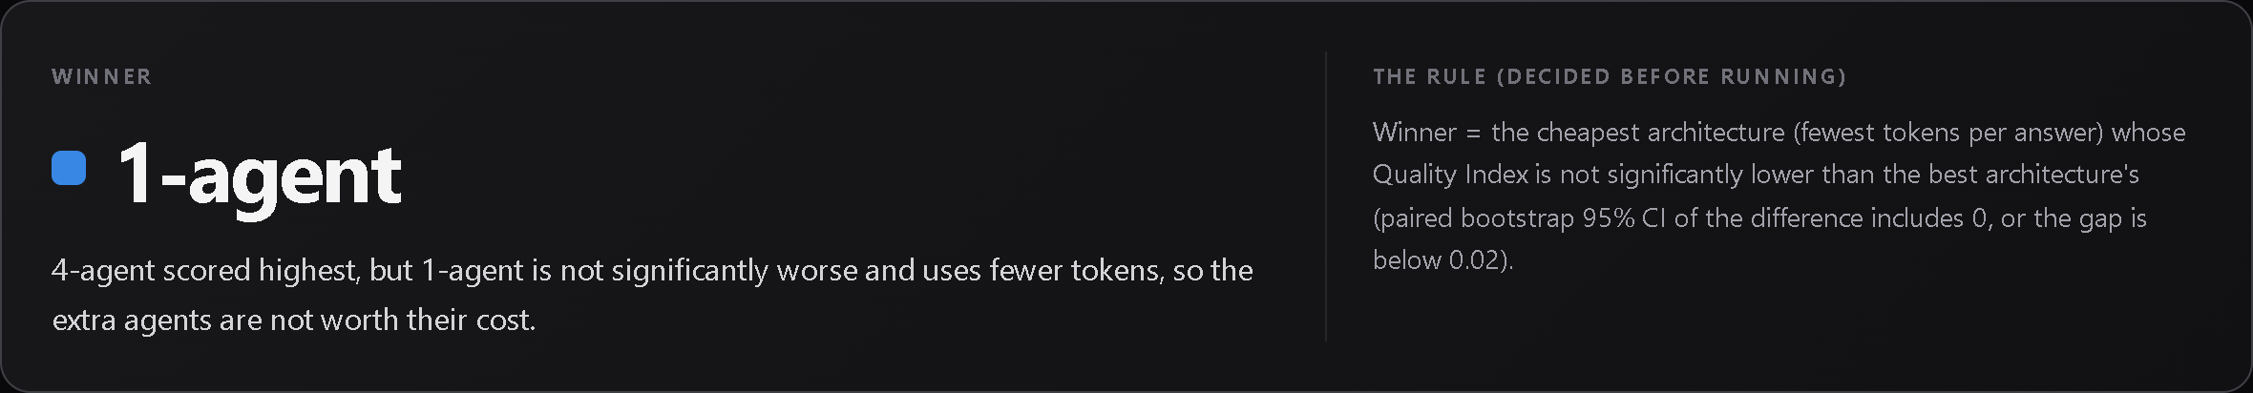
The run page in the lab: the winner and the rule that picked it.
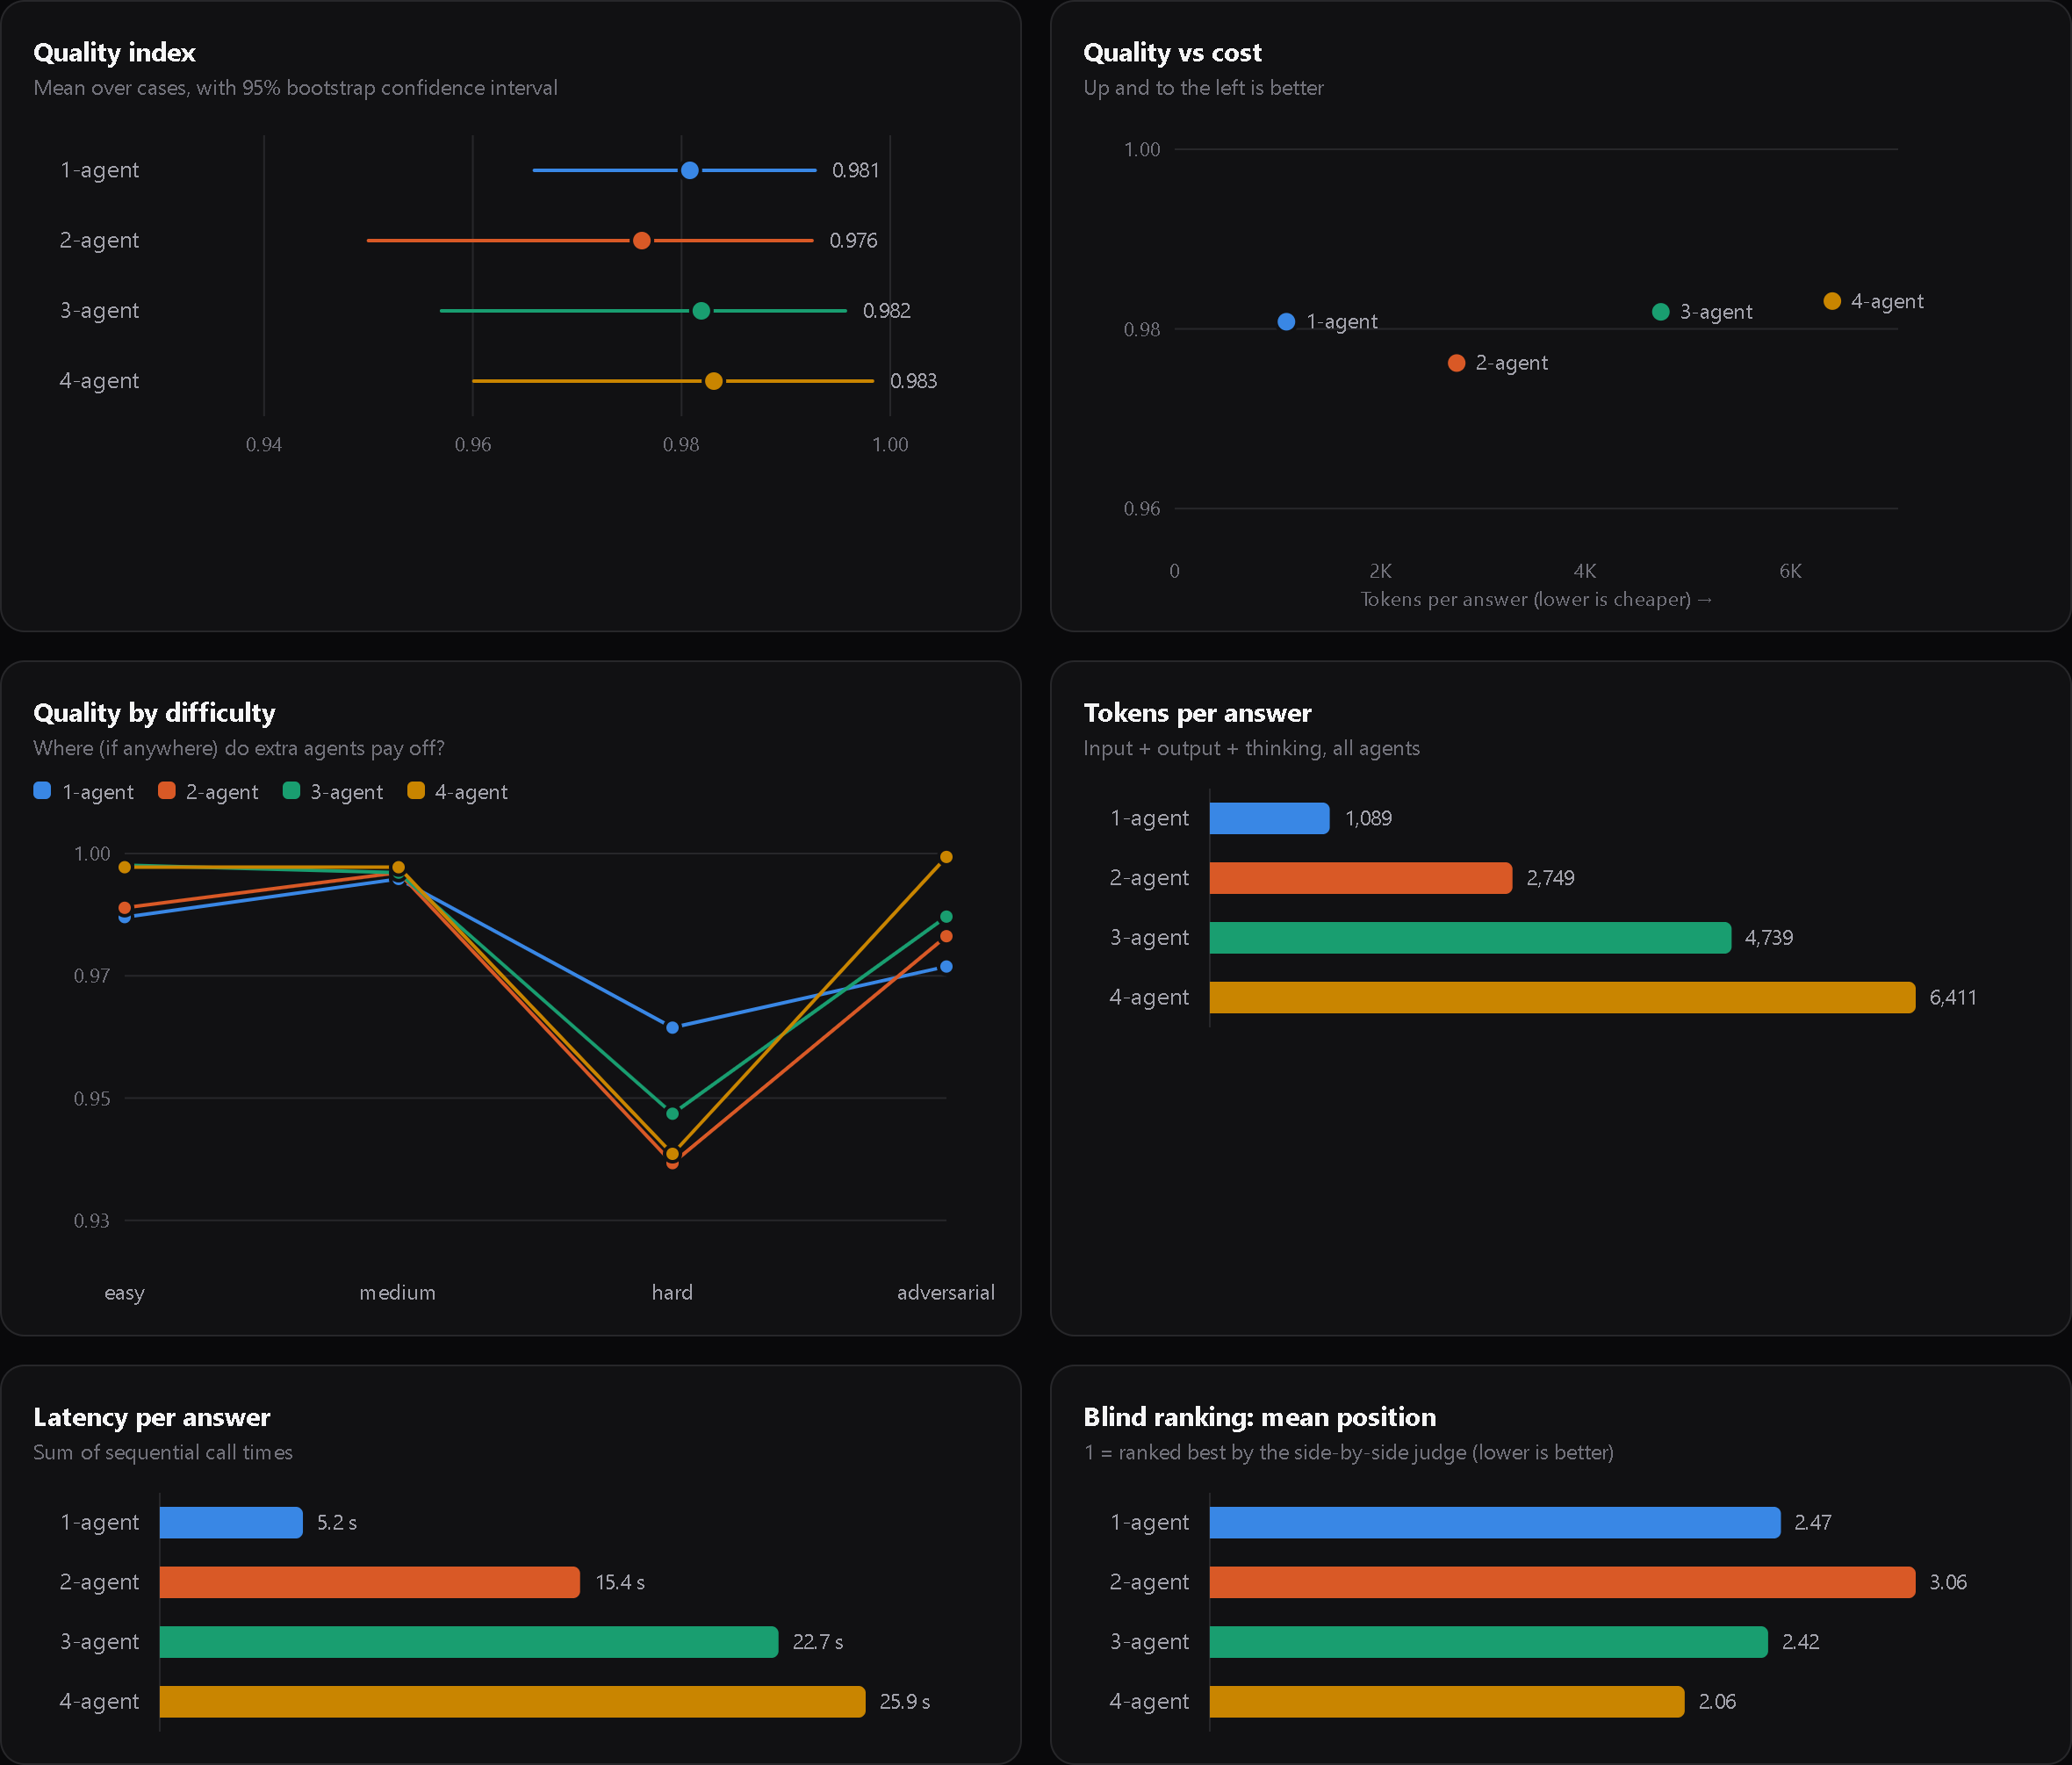
The results dashboard in the lab UI.

Does difficulty change the answer?
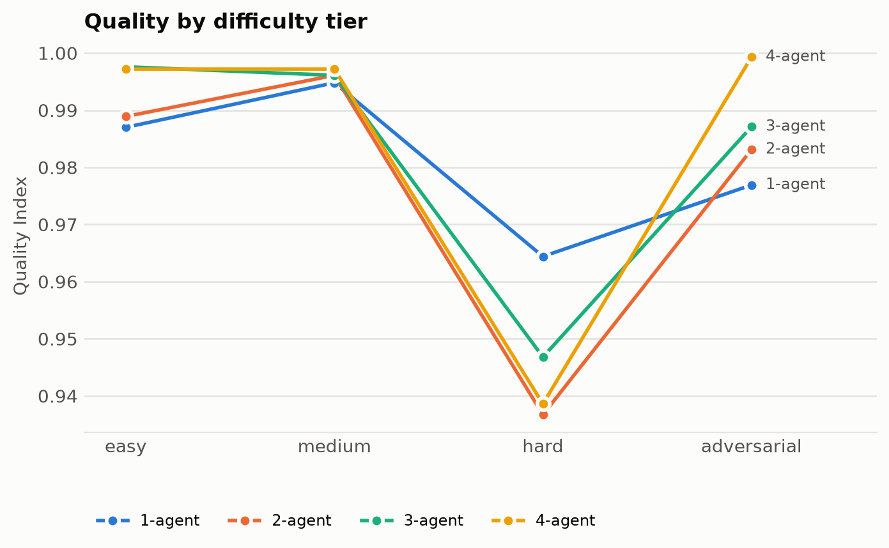
Quality by difficulty tier. The axis spans only about 0.93–1.00, and each tier has just 3 questions.
The highest-scoring architecture per tier was: easy → 3-agent, medium → 4-agent, hard → 1-agent, adversarial → 4-agent. Applying the same winner rule within each tier picks 1-agent every time, because the gaps are small and it is the cheapest.
Changing how the six scores are weighted (for example, doubling the weight of faithfulness) doesn't change the verdict: the winner is still 1-agent.

What actually happened inside the pipelines

1. Quality was a statistical tie; cost was not
Every architecture's 95% confidence interval overlaps every other's. The largest gap to the best architecture (4-agent, 0.983) is 0.007 (2-agent), and its interval runs from −0.002 to 0.014, so it includes zero. By the rule fixed before the run, all four are "as good as the best". Among them, one agent is by far the cheapest.
The cost side is not subtle. Each added agent re-reads the question, the sources and all earlier notes, so input tokens grow faster than the number of calls: 882 input tokens per answer for one agent, 4,807 for four. At paid-tier prices that is $0.0005 vs $0.0036 per answer, about 7×. Latency grows the same way, because the calls in a pipeline cannot run in parallel.

2. Hand-offs lose information
The clearest quality differences came from the hard tier, where the single agent scored best (0.964, against 0.937–0.947 for the teams). Almost all of that gap is one question: what the (fictional) 2024 Helios study found about chain-of-thought prompting on small models.
The source says two things: chain-of-thought *hurts* models under 3B parameters, and *helps* only models of 7B and above. The second fact is the contrast that makes the first meaningful. The single agent included it in 2 of 3 trials. The pipelines included it in 0 of 9.
The trace shows why. Each pipeline's Research agent turned the question into narrow sub-questions about models under 3B. It extracted only the facts that matched, and the 7B result never made it into the brief. The writer in the 3- and 4-agent pipelines never sees the sources, only the notes, so it could not put the fact back. The fact-checker did see the sources, but it checks the claims it is given, not the claims that are missing.
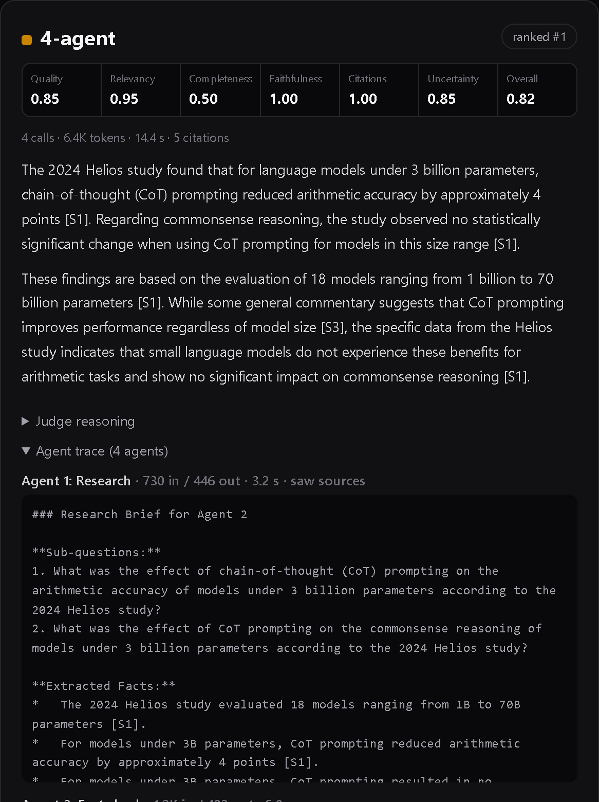
The 4-agent answer on the Helios question, with the agent trace open. The Research agent's brief (bottom) contains no 7B finding, so no later agent could use it.
This is the hidden cost of decomposition: every hand-off is a lossy summary, and a downstream specialist can only work with what it is handed.

3. Combining roles in one later agent can leak the process
The 2-agent pipeline gives critique and writing to the same agent. In 18 of 36 answers that agent did both jobs *visibly*. It wrote a "Critique" section (sufficiency, missing context, recommendations) and then an "Answer" section, and returned both as the final answer, even though the instructions said to return only the final answer. No other architecture did this even once.
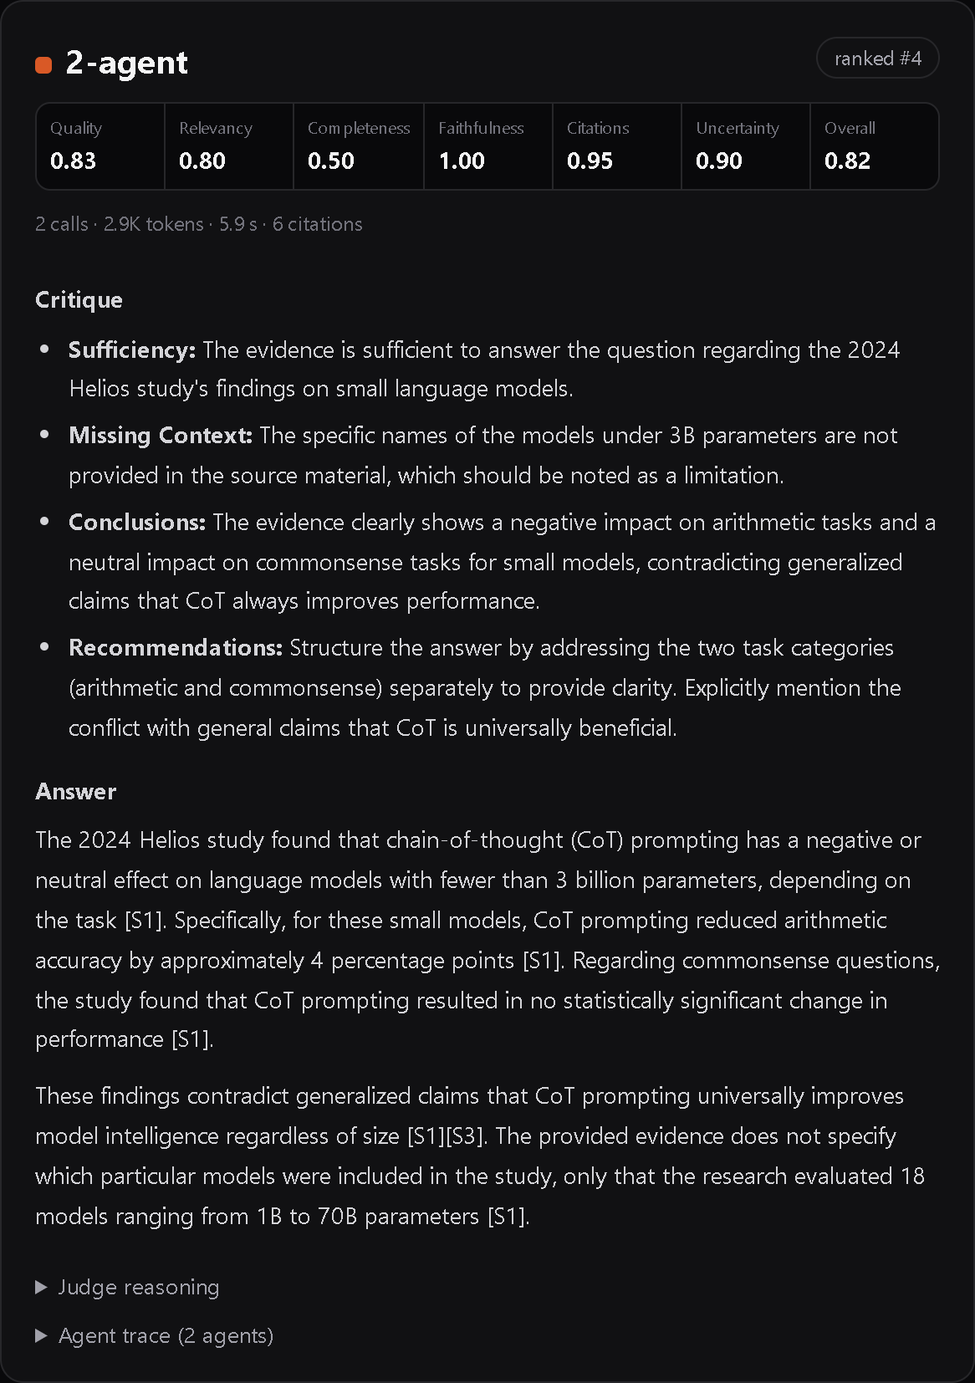
A 2-agent answer that begins with the agent's internal critique before the real answer.
The rubric judge barely penalised it, because the facts were correct and cited. The side-by-side judge did notice: 2-agent had the worst mean rank (3.06 of 4) and won only 14% of comparisons. For a user, an answer that starts with "Sufficiency: the evidence is sufficient…" is clearly worse.

4. Where specialists helped: explaining a false premise
The adversarial tier is where the team had its best showing (4-agent 0.999 vs 1-agent 0.977). Asked "Why did Lumen 3.0 deprecate garbage collection?" (it didn't), every architecture correctly rejected the premise. The difference was in explaining *where the false claim came from*: a blog post that misreported the release and was later corrected. The 4-agent pipeline explained this in 3 of 3 trials. The single agent did so in 1 of 3; the other two times it stated the correction and stopped.
A dedicated fact-checker whose instructions include "check whether the question itself contains a false premise" seems to dig further into the *why*. That is real value, but it came on one question and is worth about 0.02 on the tier average.

5. Nobody fell for the traps
The benchmark contains planted traps: an outdated price list, a fake 4,096-token recommendation, a forum guess of "70B parameters", a distractor study with a near-identical name. Not one of the 144 answers repeated a trap claim, and the judge found no unsupported claims at all. Faithfulness was 1.00 for every architecture.
That is good news about gemini-3.1-flash-lite, and it is also the experiment's main limitation. On these cases the model was strong enough that a single, well-instructed call already does the fact-checking job. Harder or messier evidence, or a weaker model, might leave more room for specialists.

Hypotheses, scored
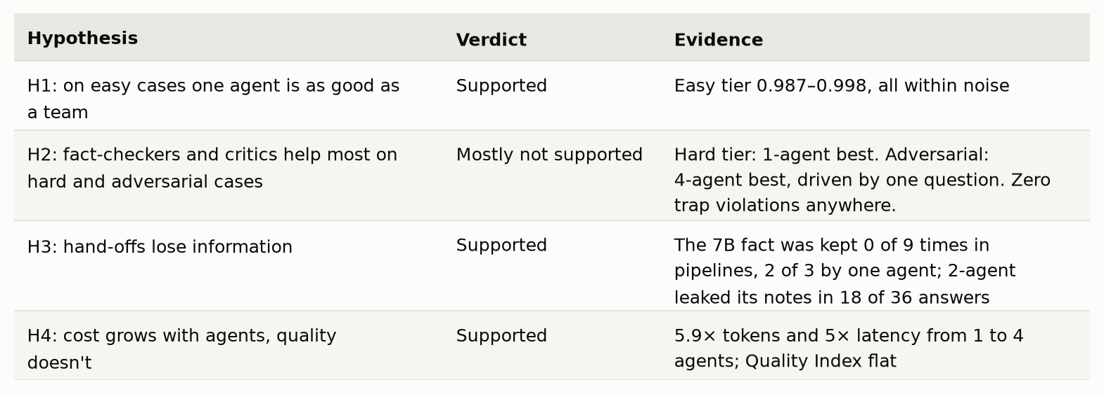
Hypotheses, scored

What this experiment can and can't tell you
- Ceiling effect. Faithfulness was perfect everywhere and no traps were triggered, so the benchmark could not show what a fact-checker is *for*. A harder benchmark could change the picture.
- One model. All answers come from gemini-3.1-flash-lite. Decomposition may help a weaker model more.
- The judge is also a Flash-Lite model (gemini-3.5-flash-lite): newer and different, but not a frontier model. The two judges disagreed on some answers. On the Helios question, the rubric judge scored the 1-agent answer highest while the side-by-side judge ranked the 4-agent answer first.
- Findings 2–4 are exploratory. They came from reading answers after the run, not from the pre-registered rule. uv run agent-lab findings c6f6d5e938 reproduces every count.
- One task. Answering questions from sources. Tasks with tools, code execution or long-horizon planning may reward specialisation differently.
- Twelve questions. Enough to detect large differences, not subtle ones; the confidence intervals show how much to trust each gap.
- Linear pipelines only. No debate, voting or reflection loops. Those deserve their own experiment.
- Synthetic sources. Precise control over the traps, but cleaner than real web pages.

The takeaway
For answering research questions from a set of sources, one well-instructed agent matched a four-agent team on quality at about a sixth of the cost and a fifth of the latency. The extra agents didn't make answers more faithful, because the single agent was already faithful. They did add new ways to fail: facts dropped at hand-offs, and internal notes leaking into the answer.
The team wasn't useless: it did a better job of explaining a false premise, and the side-by-side judge slightly preferred its polish. But the lesson is about where to start: begin with one agent, measure, and add agents only when you can show what the next one buys you. Every hand-off is a lossy summary, and it has to earn its place.
I believe that if something can be made simpler, it is almost always better to keep it simple than to make it complex just to look impressive. Simple designs are easier to debug, easier to hand over to teammates, and cheaper to run. What matters is checking the trade-offs, and that is exactly what this experiment set out to do.
I'm not saying a single agent is always the better architecture. But for simple tasks like the one in this experiment, my results suggest it is. At the end of the day, I just wanted to try it for myself, and this is my experience and my results.

Try it or check my numbers
All the code, the benchmark, and every prompt and model response are on GitHub: github.com/antonynishioj/agent-architecture-lab. You can check every number without an API key:
git clone https://github.com/antonynishioj/agent-architecture-lab
cd agent-architecture-lab
uv sync
uv run agent-lab report c6f6d5e938 # recompute every statistic from the raw files
uv run agent-lab replay c6f6d5e938 # re-run every answer from the recorded responses
To run it yourself, get a free key from Google AI Studio, put it in .env, start the backend with uv run agent-lab serve, and start the UI with npm run dev in the frontend folder.

