MongoDB Basic Practice
Assignment
Title: Employee Management System using MongoDB

1. Introduction

MongoDB is a NoSQL document-oriented database that stores data as flexible, JSON-like documents called BSON (Binary JSON). Unlike relational databases with rigid tables and rows, MongoDB allows each document to have a different structure.

This assignment focuses on performing basic CRUD operations (Create, Read, Update, Delete) and using query operators — demonstrated through an Employee Management System for a company's HR department.

2. Database & Collection Setup

Start the MongoDB shell by typing mongosh in your terminal. Then use these commands to create your database and collection.

Create / Switch to Database
use employeeDB

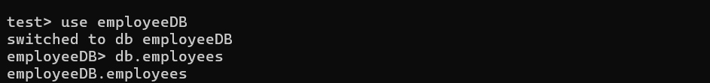

3. Insert Operations

Insert One Document
db.employees.insertOne({
name: "Ananya Krishnan",
age: 28,
department: "IT",
designation: "Software Engineer",
salary: 72000,
status: "active",
joinedAt: new Date()
})

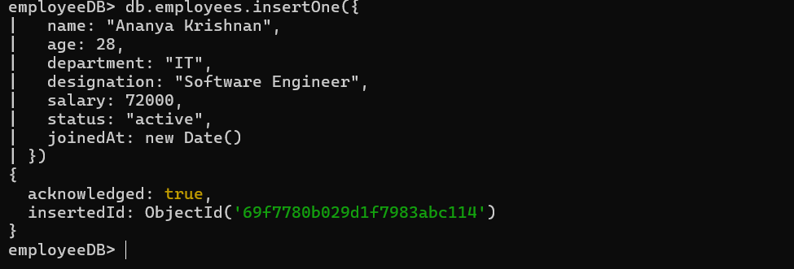
Insert Multiple Documents
db.employees.insertMany([
{ name: "Rohan Mehta", age: 32, department: "HR",
designation: "HR Manager", salary: 65000, status: "active",
joinedAt: new Date() },
{ name: "Divya Nair", age: 26, department: "IT",
designation: "Frontend Developer", salary: 58000, status: "active" },
{ name: "Kiran Patel", age: 40, department: "Finance",
designation: "Finance Lead", salary: 90000, status: "inactive" },
{ name: "Sruthi Varma", age: 30, department: "IT",
designation: "Backend Developer", salary: 75000, status: "active" }
])
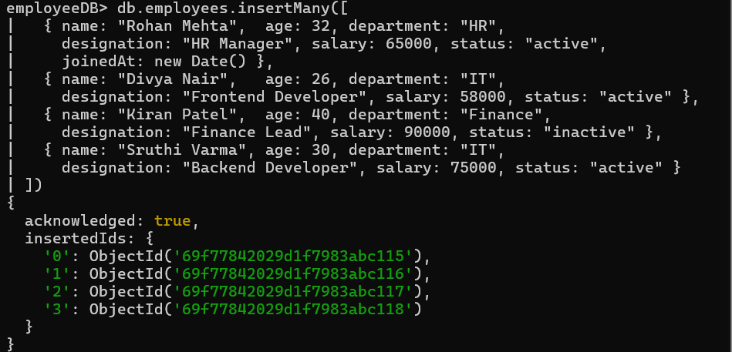

4. Read Operations

Fetch All Documents
db.employees.find()

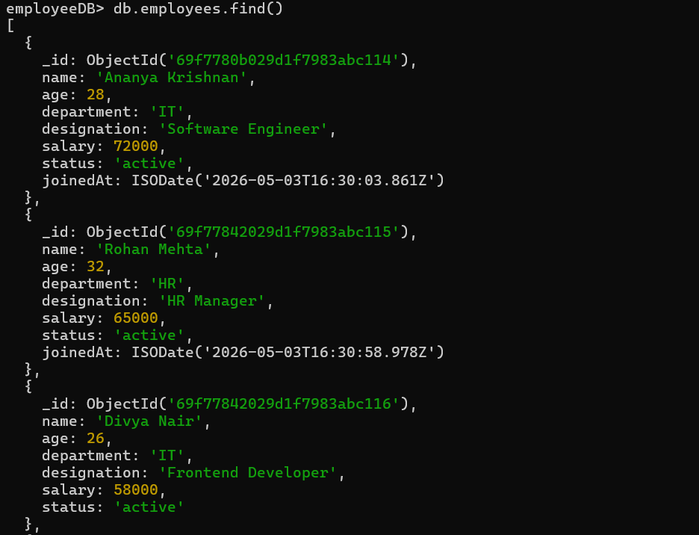
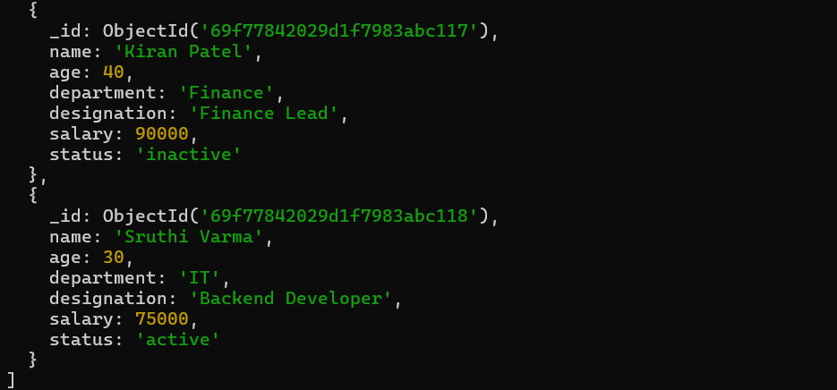Filter Employees by Department
db.employees.find({ department: "IT" })

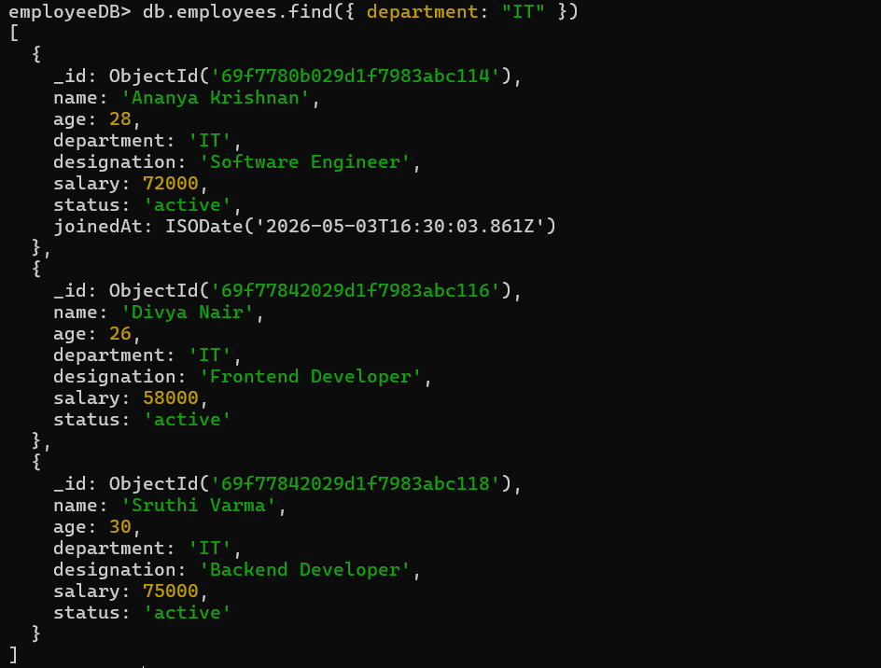
Filter by Multiple Conditions
db.employees.find({
department: "IT",
status: "active"
})

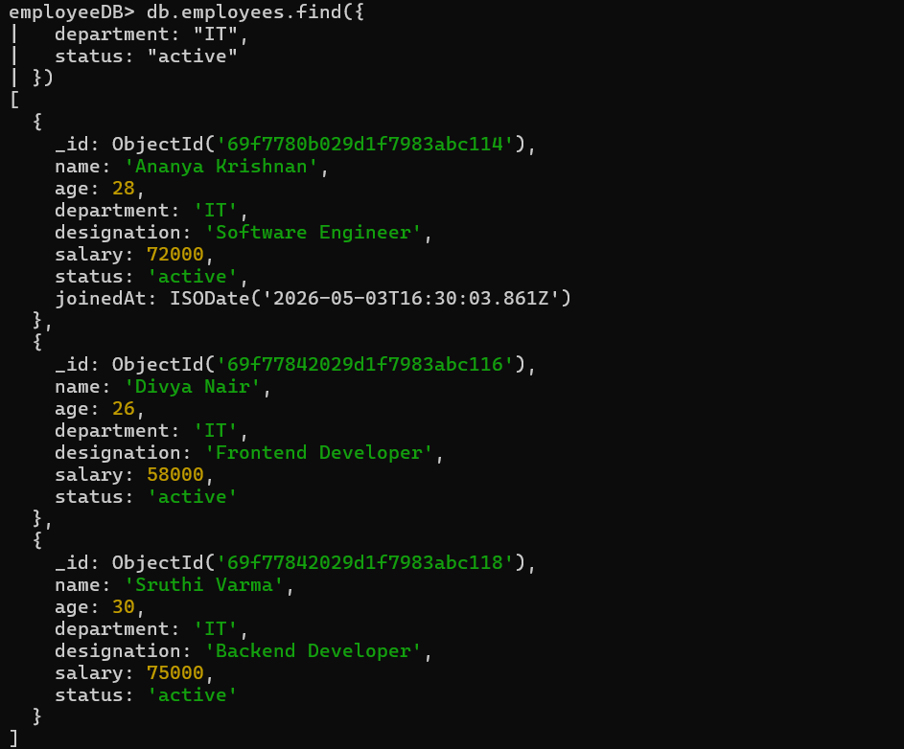

5. Update Operations

Update One Document
Update the status of employee "Kiran Patel" from inactive to active.
db.employees.updateOne(
{ name: "Kiran Patel" },
{ $set: { status: "active" } }
)
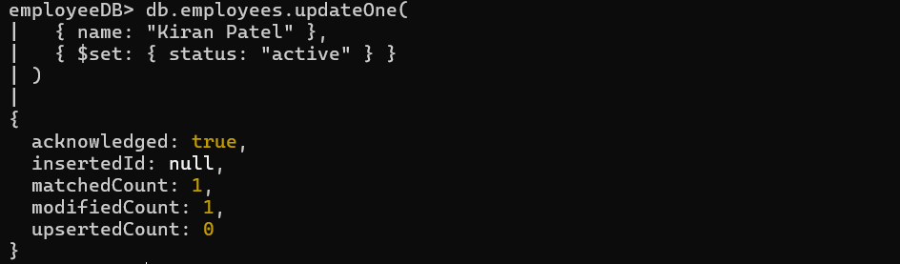
Update Multiple Documents
Give all IT department employees a salary increment of 5000 using $inc.
db.employees.updateMany(
{ department: "IT" },
{ $inc: { salary: 5000 } }
)

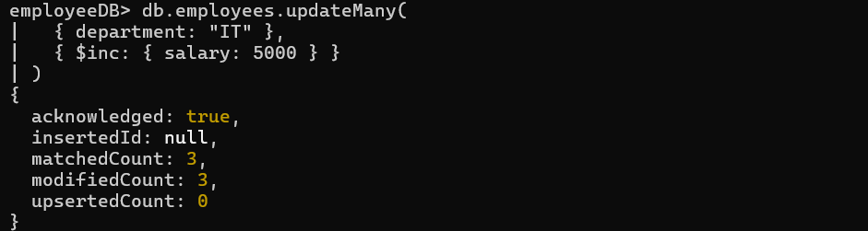

6. Delete Operations

Delete One Document
Remove the employee record with the name "Rohan Mehta".
db.employees.deleteOne({ name: "Rohan Mehta" })

Delete Multiple Documents
Remove all employees with status "inactive" from the collection.
db.employees.deleteMany({ status: "inactive" })

7. Query Operators

MongoDB provides powerful query operators to filter and retrieve documents with precision. Below are the key operators with examples from the Employee Management System.
Greater Than ( $gt )
db.employees.find({ salary: { $gt: 60000 } })

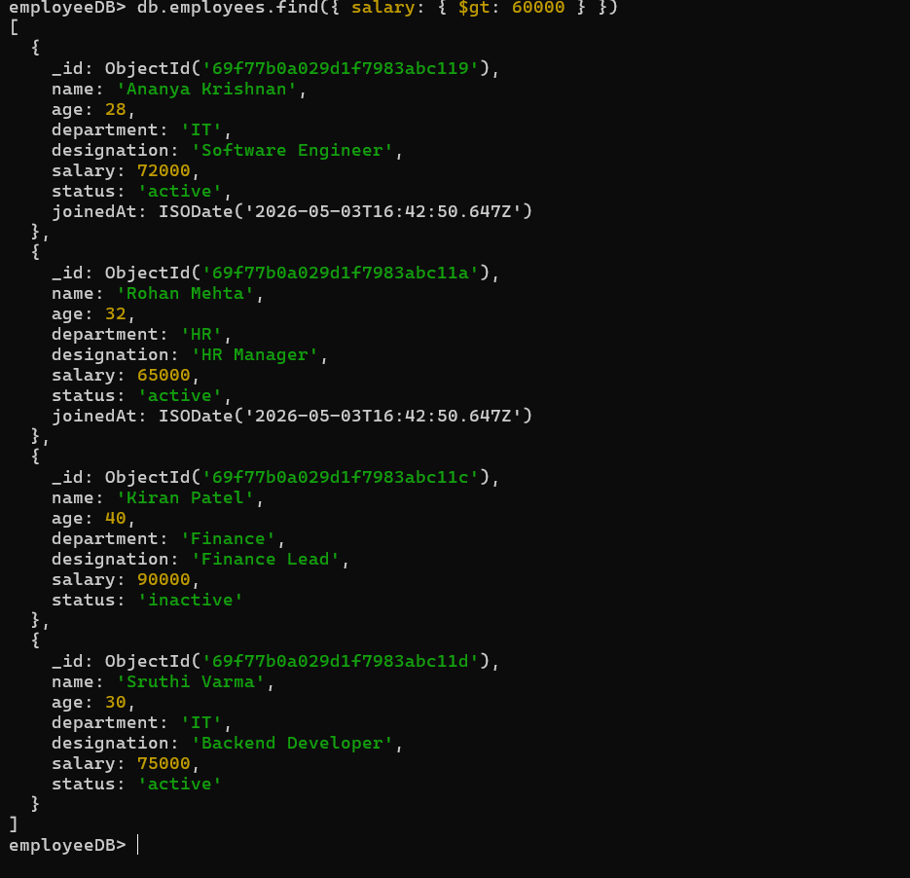
Less Than ( $lt )
db.employees.find({ age: { $lt: 30 } })
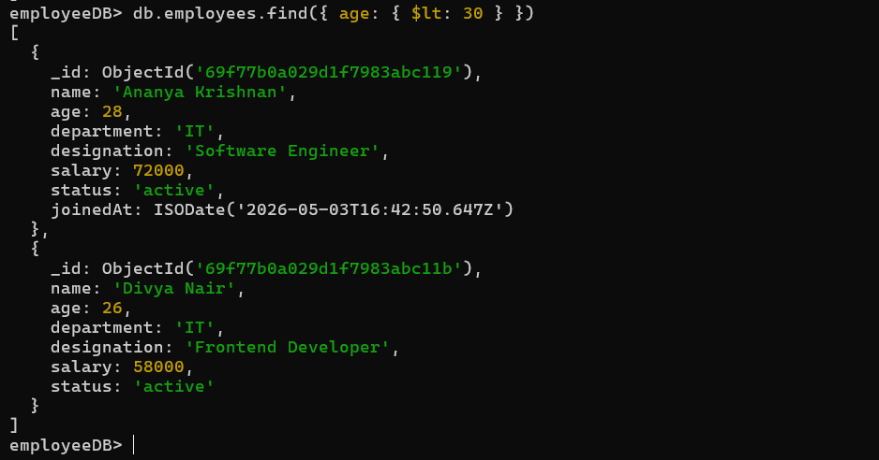
In Operator ( $in )
db.employees.find({
department: { $in: ["IT", "Finance"] }
})

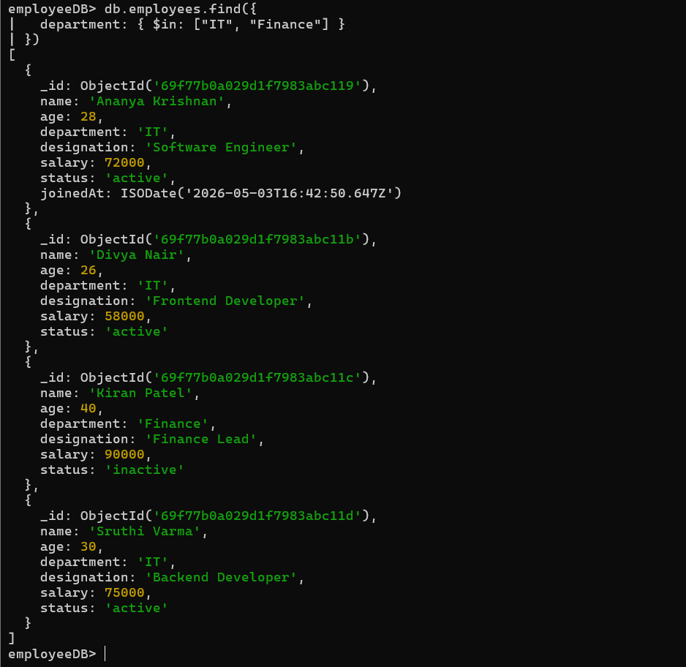
AND Operator ( $and )
db.employees.find({
$and: [
{ department: "IT" },
{ salary: { $gt: 70000 } }
]
})

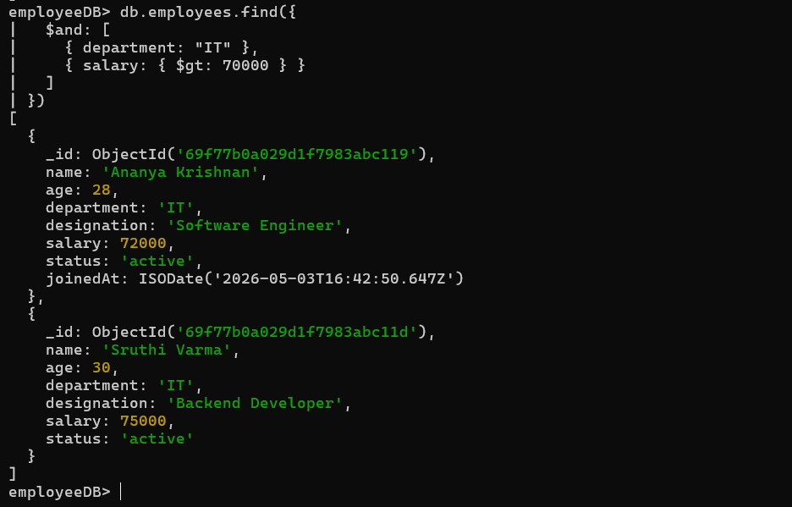
OR Operator ( $or )
db.employees.find({
$or: [
{ status: "inactive" },
{ department: "Finance" }
]
})

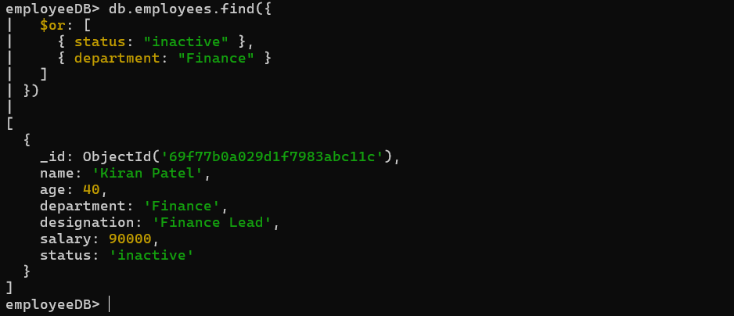
Exists Operator ( $exists )
db.employees.find({
joinedAt: { $exists: true }
})

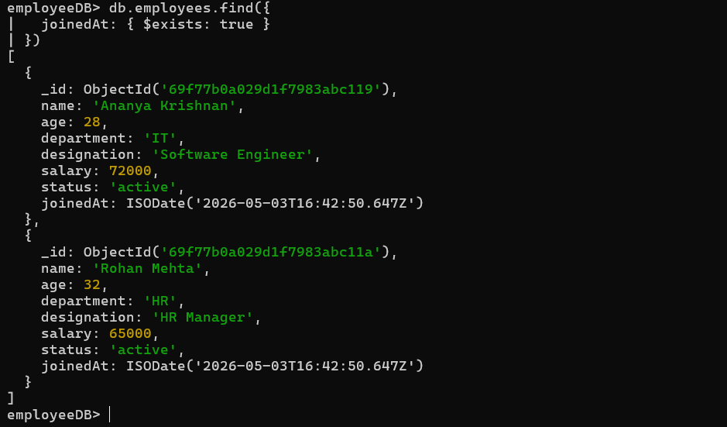

8. Use Case: Employee Management System

This system models how a company's HR department manages its employee data using MongoDB.

- Employee records are created when a new hire joins the company.
- Each record stores name, age, department, designation, salary, and status.
- HR can filter employees by department, designation, or employment status.
- Salary updates and promotions are applied using update operations.
- Resigned or terminated employees are removed using delete operations.
- Query operators help HR generate reports like high earners or department-wise lists.

This demonstrates how MongoDB can power real-world HR and enterprise platforms efficiently without a rigid schema.

