Antony Ross
CSci 226 Fall 2013
Assignment 4

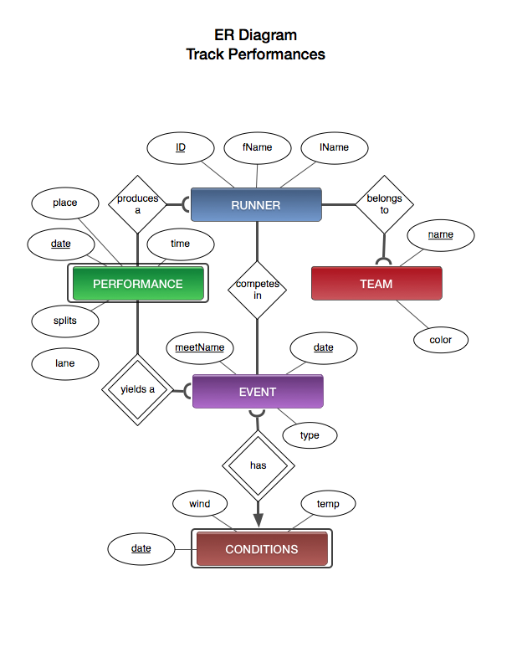

Entity-Relationship Diagram
Track Performances Database

This is my database for Track Performances. The first and main entity set is Runners. It contains the attributes for first name, last name, and ID, which is it’s primary key. I don’t anticipate names and even affiliation to be unique enough so I chose to use an auto incremented runner ID to identity unique entities. Runner shares a one-to-many relationship with the Performance entity set. A performance must belong to one runner (a referential integrity constrain) but a runner may have many performances. The attributes of the Performance entity set are time, splits, lane, place, and date (part of a composite key). Performance is actually a weak entity set as it depends on identifying the Event in addition to its date key to be uniquely identified.

Runner also shares a many-to-many relationship with the Event entity set. A runner may compete in many events and an event may have many runners. The Event entity set has the attributes date and meetName as its composite key, along with the attribute meet type. I originally had a Meet entity set but decided it might be simpler if I just added the attribute meetName to the Event entity instead (since I wasn’t gathering the meet city/state or other related data).

The Conditions entity set shares a one-to-one relationship with Event. However, an event may have one Conditions entity associated with it but the Conditions entity must have one Event associated with it as a referential integrity constraint. The Conditions entity set has the date as part of its composite key but, like Performance, it is dependent upon the Event to be uniquely identified making it a weak entity set. Conditions’ other attributes are temperature and wind conditions.

Lastly, the Team entity set shares a one-to-many relationship with the Runner entity set. A runner must belong to one team (a referential integrity constraint) but a team may have many runners. Team has the attribute name as a primary key and also a color attribute. Color will be used to aid in visualizing the data.

I should also note that the Event entity set will probably have subclasses representing the various event distances (e.g. 400Event, 1500Event).

