**Written Exam – Responses**

Position: Economist: Selection:20-DFO-PAC-EA-Policy-282518

**QUESTION 1**

1. **Methods to estimate the (2016) value of the commercial fishing licences**

The three methods reference the datasets in the attached excel worksheet:

* 1. It is the product of the individual licenses in dataset 1, and the respective sample value of catch for each holder shown on dataset 2;
  2. It is the product of dataset 1, the 2016 average catch quantity per license, and the 2016 price harvesters received, both shown on dataset 3.;
  3. It is the product of dataset 1 and the average price per license for each year on dataset 6, divided by the deflation factors in dataset 7 to arrive at real 2016 values.

1. **The value of licences distributed to each holder;,**

The values on Fig.1 are based on methods 1 and 2 described above.

**Fig.1 Value of licences (in 2016 dollars)**

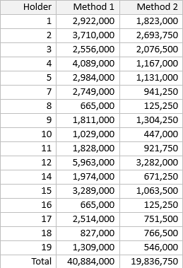

(Source: excel worksheet attached)

1. **Comparing the methodologies and results**

As summarised on Fig1 above, the total values for method 1 are twice as high as method 2. Possible reasons for the differences may include:

* Method 1 could be an over-estimate if the sampled catch values were more representative of higher value licenses (as method 1 depends on sampling)
* Method 2 could be an under-estimate if the average catch per license in 2016 under-estimated the respective values for an average year. As well it could, be an under-estimate if the average price received in 2016 under estimated respective values for an average year (method 2 extrapolates the 2016 values on all the years.)
* Although method 3 was not used, it would better reflect the values of licenses for each year (as it first applies the nominal values for licenses each year and then brings them to 2016 values).

**QUESTION 2.**

1. **The long term trend and monthly variation in landed value:**

The top panel on Fig 2 shows the values for licences between 2010-2019 (in nominal dollars with respective exponents). The middle and bottom panels disaggregate the values into the long-term trend and monthly variations, respectively:

* The long-term trend appears to be stationary, with the exception of three increases in 2011, 2015 and 2018 (middle panel).
* Monthly variation rises in the summer and ebbs in winter consistently (bottom panel)

**Fig2. Landed value (in nominal dollars with respective exponents)**

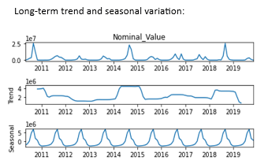

(Source: python notebook attached)

**The impact of the (2019) restrictions on landed value for gears and areas:**

* Based on gear, the steepest declines in landed values were in ‘seines’ (Fig 3)
* Based on area, the steepest declines were in B and D. There were no values for E and H in 2019 (Fig 4)

**Fig. 3 Landed values based on gear (nominal $)**

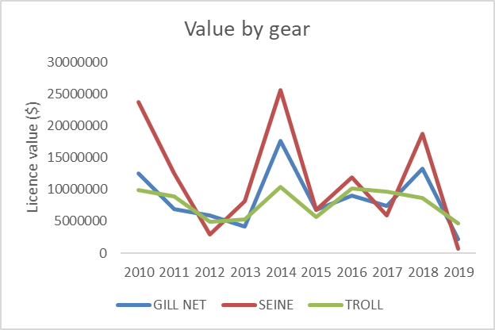

(Source: excel worksheet attached)

**Fig. 4 Landed values based on area (nominal $)**

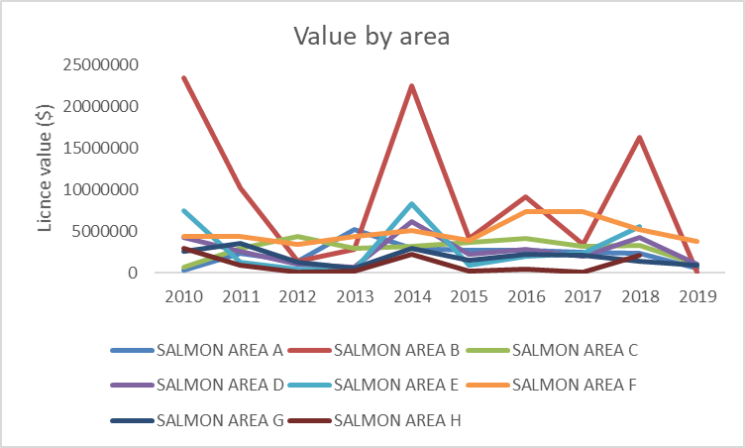

(Source: excel worksheet attached)

1. **Participation rate of the commercial vessels**

Based on Fig 5, annual participation declined by 30 per cent between 2018 and 2019

**Fig 5.Annual participation of commercial vessels**



(Source: python notebook attached)

1. **Changes in economic impacts (GDP, Employment and household Income)**

Harvesting and processing between 2010-2019 generated 3750 jobs, $286 million in household income (real terms), and $393 million in (real) GDP (Fig 6.)

**Fig.6 Employment, household Income, and GDP (both in real terms)**

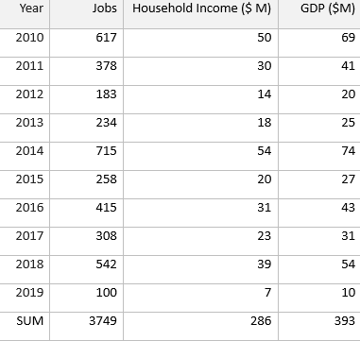

(Source: excel worksheet attached)

1. **Areas in which restrictions could be eased (and rationale):**

Consider easing restrictions in areas D, B and C based on the following:

* Areas D, B, and C show the greatest declines in vessel participation numbers (Fig. 6).
* As mentioned in a section ‘a’ above, areas D and B showed the steepest declines in landed values (Fig. 4 above).
* Easing restrictions in these areas will result in the most beneficial outcome in terms of sustaining long-term fisheries stocks.

**Fig 6. Vessel participation numbers by area**

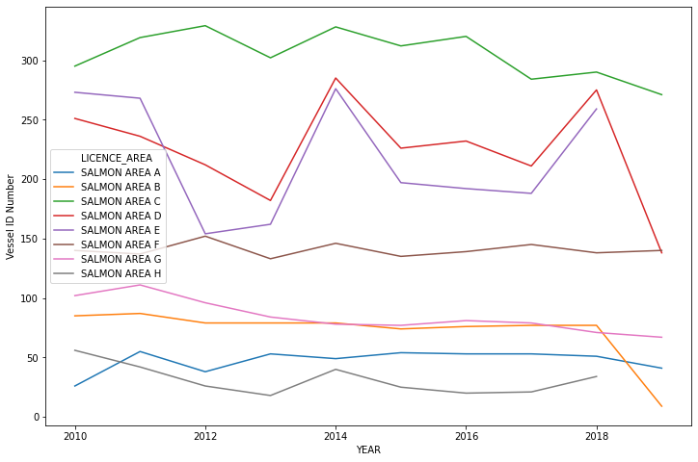

(Source: python notebook attached)

**QUESTION. 3**

1. **Describing Individual transferable quotas (ITQs):**

ITQs are policy instruments that enable fishing capacity to be transferable from fishers that have high costs (poor profitability) to those with lower costs (greater profitability)[1]. The following helps distinguish ITQs from open access fisheries systems or other regulated systems:

* ITQs divide the total annual catch into small individual transferable portions, enabling fishers to sell/lease their ITQ assets or buy.
* The ITQs create the incentives for the fishers to adjust harvest to changing biological and economic environments.
* The ITQ assets are initially allocated by the administrator of fisheries management. Allocation is usually based on historic catch. (ITQs have a history in New Zealand, US, Canada, Iceland, Italy, the Netherlands and South Africa[2])

1. **ITQs improve economic efficiency due to the following:**

Evidence from places like New Zealand have shown that ITQs have enabled structural change among fishers[3]. The changes include minimization of costs, maximization of price received for their catch. The changes helped reduce competition between fishers and improved conservation. ITQs reduced risk for fishers by improving the ability to plan. The following helps describe specific gains in efficiency:

* Fishers benefit as ITQs have led to viability of the industry. This fact is underscored by the most efficient fishers (e.g., low cost or more profitable) being able to compensate less efficient fishers (eg. high cost or less profitable) in return for ITQ assets.
* Conservation goals are met as the fisheries administrator set the total allowable catch at the outset.[4]
* Fisheries administrators benefits as the ITQs reduce the compliance and enforcement costs. The quota administrator does not have to actively manage or enforce the reduction of harvest[5].

1. **The potential factors that could contribute to the rise in asset valuation.**

The price paid for ITQ asset are an important signal to fishers and administrators of ITQ:

* Economic shifts, such as increase in demand for fish could lead to greater demand for ITQ assets and drive asset prices higher;
* Biological shifts, which lead to restricted supply of fishing stock could lead to reduced supply, and drive asset prices higher; and
* If fishers are confident about higher profitability in the future they could bid the ITQ asset price upward[6].

**QUESTION 4**

**Issues related to Aboriginal fisheries in the Pacific region:**

Very broadly it is important to consider the context of traditional Aboriginal knowledge, and their connections to resource stewardship. The following are specific issues related the Pacific region:

1. Wild Pacific salmon is integral to the economic and social fabric of coastal communities, and their stewardship is fundamental to Aboriginal communities across British Columbia. Culturally, Chinook (salmon) is an important species for many BC First Nations.
2. As well, the Southern and Northern Resident Killer Whales hold a special significance to Aboriginal people. As well, these whales also play an apex role in food chains.
3. The Haida Nation and the Government of Canada are protecting the ‘SGaan Kinghlas’ protected zone in the ocean and its marine life. This is an area where the Haida have a historical, spiritual and cultural connection. This effort illustrates a shared commitment by the Council of the Haida Nation and the Government of Canada to conserve and protect this part of the ocean.

**QUESTION 5**

**A framework to undertake an analysis for a regulatory change for the** **Marine Protected Area** (**MPA):**

A Marine Protected Area (MPA) is designed to protect unique biodiversity and biological productivity, as well as to facilitate the recovery of certain species at risk (e.g., protecting ‘SGaan Kinghlas’). MPAs usually select areas under pressure from human activities for protection. The following will be considered in developing an analysis for regulatory change for a MPA framework:

1. The analysis will consider Aboriginal people’s interest in fishing for food and ceremonial purposes. Some of the MPAs in BC have significance to Aboriginal people from a stewardship point of view and as a source of food and livelihood (e.g., protecting ‘SGaan Kinghlas’ has significance to the Haida from a cultural point of view). Their communities may be consulted through the process.
2. The analysis may consider costs associated with curtailing of oil and gas activities, discharge of wastewater and grey water. The analysis may include the loss of revenue, jobs as well as costs to seek alternative means to divert municipal water. Several industries and communities could be affected, and as such they will be engaged to seek potential solutions or alternatives.
3. The analysis may consider activities that other MPAs in Canada allowed. For example, MPAs in Quebec/Gaspe allowed traps, long line or hand line fishing. Other MPAs have been established in Nova Scotia and other regions. Their successes and failures will be examined.

The public will be consulted based on the above considerations. They would include Aboriginal groups, commercial and private fishers, related municipalities and other economic sectors (e.g., oil and gas) . As well, affected communities may include industry, academia, Environmental Non-Government Organizations, and provincial and federal government regulators.

**QUESTION 6**

**Factors to consider in developing a regional policy to support the process around distribution of licences (and why they would be important)**

The overarching considerations may have to be cognisant of traditional Aboriginal knowledge, and their need for a decision making role. Their connections to resource stewardship will also be considered. Key considerations would also recognize Aboriginal rights, respect, cooperation, and partnership. More specifically the following factors would be included in the policy process:

* Cultural significance will be a consideration. As an example, Aboriginal communities along the migratory route of Fraser salmon have a long-standing relationship with the salmon. As well, Chinook are an important species for many BC First Nations. Their conservation will be a high priority in the policy process.
* Stewardship has been embedded with Aboriginal people for millennia. They have been stewards of the land and water. The policy development process will pay homage to this fact and will be guided by Aboriginal peoples’ knowledge. This fact implies the need to develop programs alongside Aboriginal people who best understand the stewardship function.
* The need for an Aboriginal decision making role is vital. This implies a need to include First Nations people who best understand what is required to build capacity within their communities and institutions. They will be involved in co-developing and co-delivering programs.

The intent of establishing a collaborative governance structure is to increase participation of Aboriginal peoples in the policy process regarding allocation of licenses.

1. Stage 2016. The economics of the Swedish ITQ system
2. Eugene 1995. ITQs in fisheries management
3. Dewees 1989. Assessment of implementation of ITQs in New Zealand
4. Soliman 2020. Impact of ITQs on Canadian Sablefish Fisheries. UBC
5. Hoshino et al, 2020. ITQ in achieving multiple objectives
6. Stage 2016. Ibid