**Report on Emissions and Energy Use across BC (2007-2012)**

What follows compares the most emission-intensive regions with the least intensive ones. That in turn, is followed by a comparison of sectoral differences.

**Regional Differences in Emissions:**

Among the top emissions-intensive local government-types are regional municipalities, island trusts, and regional districts with unincorporated areas. The least emission-intensive government types include cities, island municipalities and towns (Fig. 1 shows a complete list).

* Taking a ‘local government-type’ view **helps inform how policy is delivered**.

Among the most emissions-intensive regional districts include places such as Peace River and Northern Rockies (Appendix Fig 1 has a complete list). The least emission-intensive regional districts include Metro-Vancouver, Nanaimo and the Sunshine coast (Appendix Fig). The emissions-intensive regional districts derive their second highest emissions from the ‘community solid waste’ sub-sector, due landfill gasses (Appendix Fig2).

* **Policy may have a role** in assisting emissions-intensive regions with mitigating landfill emissions (improvements to the methodology of emission estimations may be a starting point).

**Regional Differences in Energy Sources**:

The emissions-intensive regional districts are more likely to use emission-intensive energy sources such as wood and heating oil, compared with less emissions-intensive regional districts (Appendix Fig 3). Heating oil produces more emissions per unit of energy, compared with natural gas or electricity (Appendix Fig 4 compares emissions per unit of energy).

* **Policy may have a role** in helping communities adopt less emission-intensive energy sources. Social drivers would be considered.

**Fig.1 Emissions by Local Government Type (t/CO2 E per capita)**

|  |  |  |  |
| --- | --- | --- | --- |
| **Local government type** | **2007** | **2010** | **2012** |
| Regional Municipality | 1.52 | 1.44 | 0.69 |
| Island Trust Area | 0.31 | 0.32 | 0.33 |
| Regional District Unincorporated Areas | 0.29 | 0.28 | 0.27 |
| Indian Government District | 0.36 | 0.33 | 0.2 |
| Village | 0.37 | 0.37 | 0.19 |
| Regional District | 0.2 | 0.17 | 0.17 |
| District Municipality | 0.23 | 0.21 | 0.17 |
| Town | 0.32 | 0.32 | 0.16 |
| Island Municipality | 0.21 | 0.2 | 0.12 |
| City | 0.17 | 0.16 | 0.12 |

**Sectoral Emissions:**

Based on 2012 data, the sector-based emissions, in descending order are (Fig.2):

1. Buildings
2. ‘On-road’ transport
3. Community solid waste (landfill gases)
4. Agriculture, and
5. Land-use change from deforestation (switched rank with Agriculture since 2007)

* **Community solid waste:** gasses from landfills have slightly increased. The bespoke emission-intensive regions are more likely to be driving this trend**.**
* **Land-use change from deforestation**: while emissions *appear* to have declined between 2007-2012, **baseline 2007 data is missing** (with NAs)**.** Without complete data we would not know the underlying drivers to design mitigating policy. From what we know, emissions attributed to municipal and agricultural purposes declined by more than 90 % since 2007 (Appendix Fig 5).
* **Transportation**: the top-three drivers of a rising emissions trend are heavy-duty trucks, SUVs/vans, large passenger cars. P**olicy may have a role,** supporting developing of affordable electric-vehicle (EV) equivalent models and/or supporting their adoption.
* **Buildings**: emissions from residential and commercial buildings are declining (Appendix Fig 6)
* **Agriculture:** a singular category, enteric fermentation (cattle belching), has declined

**Fig. 2 Sector emissions, 2007 and 2012 (t/CO2 E)**

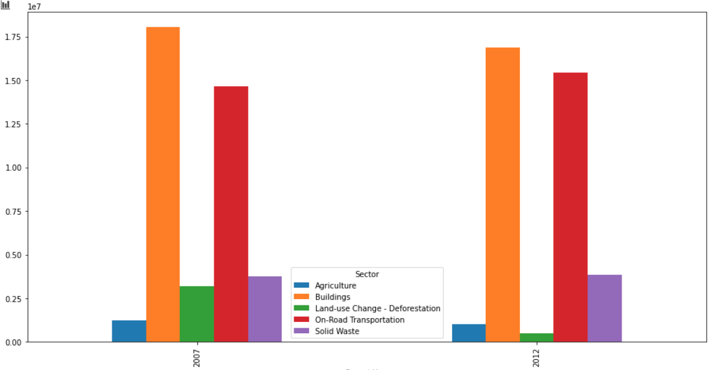

**Summary of Policy Implications:**

1. Emission-intensive regional districts could receive support in mitigating landfill emissions. Improvements on how emissions are estimated could be a start. The said regions could receive supports to transition from using emission-intensive energy sources (heating oil), by considering appropriate social drivers. Taking a ‘local government-type’ view of the bespoke communities helps inform how policy is delivered
2. A rising trend in transportation sector emissions is driven by greater use of heavy-duty trucks, SUVs/vans, and large passenger cars (transportation is the second highest emitting sector after buildings.) A consideration maybe to incent developing affordable EV equivalent models; and/or supporting adoption.
3. Policies to mitigate emissions from ‘land-use change from deforestation’ will take place once a complete dataset is available

**APPENDIX**

**Fig.1 Top-10 most emission intensive regions (left) v least emission- intensive (right) (t/CO2 E per capita) in 2012**

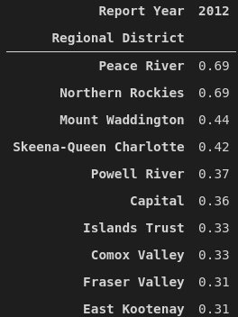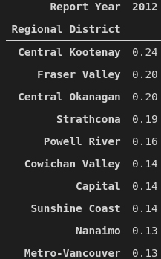

**Fig.2 Ranking of the top-10 sub-sectors of emissions (in desc. order), between the bespoke most emission-intensive (left) and least intensive regional districts (right)**

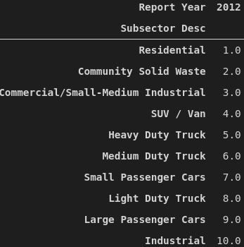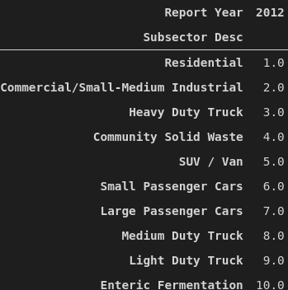

**Fig. 3 Ranking of the top-10 sources of emissions (in desc. order), between the most emission-intensive districts (left) and least intensive regional districts (right)**

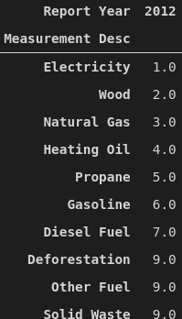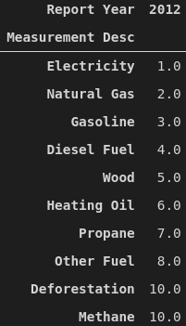

**Fig. 4 Emissions per unit of energy, from lowest to highest (t/CO2E per GJ) -- electricity being cleanest; and diesel being the largest emitter**

* There is zero energy use for deforestation and solid waste denominators, hence infinity

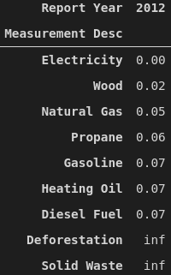

**Fig. 5 Land-use change emissions, 2007 and 2012 (MT/CO2 E)**

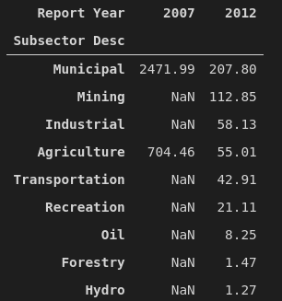

**Fig.6 Transportation Emissions, 2007 and 2012 (t/CO2E)**

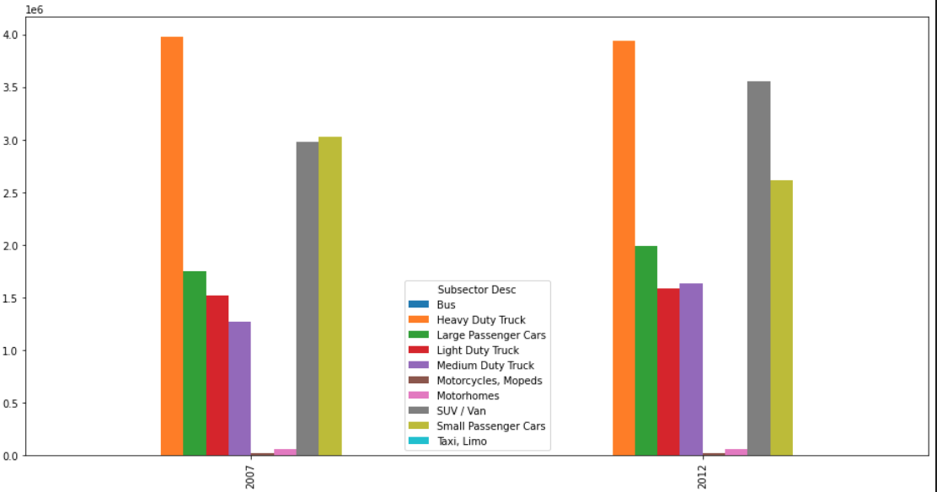

**Fig. 7 Building Emissions 2007 and 2012 (t/CO2E)**

