SOFTWARE REQUIREMENTS SPECIFICATION FOR

Implementation of Toxic Twitter comment classification system

Prepared by
Anirudh Thiagarajan Trichy(241IT009)
Antony Thaikadavil(241IT010)
KV Akash(241IT036)

DEPARTMENT OF INFORMATION TECHNOLOGY
NATIONAL INSTITUTE OF TECHNOLOGY KARNATAKA SURATHKAL

Table of Contents
1. Introduction
1.1 Purpose...........................................................................................................3
1.2 Scope..............................................................................................................3
1.3 Definitions, Acronyms and Abbreviations...........................................................3
1.4 References.......................................................................................................4
1.5 Overview..........................................................................................................4
2. Overall Description
2.1 Product Perspective..........................................................................................5
2.2 Product Functions............................................................................................5
2.3 User Classes....................................................................................................6
2.4 Constraints......................................................................................................6
2.5 Assumptions and Dependencies.......................................................................6
3. Specific Requirements
3.1 Functional Requirements...............................................................................7
3.2 External Interface Requirements
3.2.1 User Interfaces......................................................................................9
3.2.2 Hardware Interfaces..............................................................................10
3.2.3 Software Interfaces...............................................................................10
3.2.4 Communications Interfaces...................................................................10
3.3 Other Non-Functional Requirements................................................................10
3.4 Constraints.....................................................................................................11
Appendix A.........................................................................................................12
Index.....................................................................................................................13

1. Introduction
1.1 Purpose
The purpose of this document is to specify the software requirements for the Toxic Twitter Comment Classification System, a web-based platform that fetches comments from a designated (dummy) Twitter/X account's feed and returns an automated classification of whether each comment is toxic. This Software Requirements Specification (SRS) is intended for the course instructor/evaluator, the development team, and any future maintainers of the system. It describes the functional and non-functional requirements the system must satisfy, without prescribing how those requirements are to be implemented.
1.2 Scope
The software product to be developed is the Toxic Twitter Comment Classification System. The system shall:
- Allow users to register and log in securely, with two-factor authentication.
- Allow administrators to register, log in, and manage the platform separately from regular users.
- Provide a landing page introducing the system to first-time visitors.
- Allow authenticated users to fetch comments from a designated (dummy) Twitter/X account’s feed and receive an automated toxicity classification result for each comment.
- Record every significant user and admin action in a persistent log for auditing purposes.
The system shall not, in its current scope:
- Classify content in languages other than English.
- Analyze non-text content (images, video).
- Retrieve comments from any Twitter/X account other than the single designated dummy account, or from any other external platform; the system shall not post, reply, or otherwise write back to Twitter/X.
1.3 Definitions, Acronyms, and Abbreviations
Term/Acronym | Definition
API | Application Programming Interface
2FA | Two-Factor Authentication — a second verification step required at login, in addition to a password
Toxicity Classification | The process of labeling a submitted comment as toxic or non-toxic (and optionally, a subcategory)
Confidence Score | A numerical indication of how certain the system is in its classification output
Admin | A user role with elevated privileges to manage users and view system-wide activity logs
Activity Log | A recorded entry describing a user or admin action, including a timestamp

1.4 References
[1] IEEE Std 830-1998, IEEE Recommended Practice for Software Requirements Specifications, Institute of Electrical and Electronics Engineers, 1998.
[2] Jigsaw and Google, Toxic Comment Classification Challenge, Kaggle, 2018. [Online]. Available: https://www.kaggle.com/c/jigsaw-toxic-comment-classification-challenge
1.5 Overview
The remainder of this document is organized as follows: Section 2 provides an overall description of the system, including its perspective, main functions, intended users, and constraints. Section 3 specifies detailed functional and non-functional requirements, including external interface requirements. Appendices provide supporting diagrams and a glossary index.

2. Overall Description
2.1 Product Perspective
The Toxic Twitter Comment Classification System is a new, standalone, self-contained software product. It is not a component of any larger pre-existing system and does not extend or replace any existing software. The system follows a client-server model, where users interact with the system through a web-based client, and all authentication, classification, and logging logic is handled by a backend server.
The system is composed of the following logical components:
- A user-facing web client for registration, login, and viewing the classified feed of comments.
- A backend service responsible for authentication, two-factor verification, request handling, and activity logging.
- A feed retrieval component responsible for fetching comments from a designated (dummy) Twitter/X account via the Twitter/X API, and a classification component responsible for analyzing the fetched text and returning a toxicity determination.
- A persistent data store for user accounts, activity logs, and classification records.
A high-level block diagram of these components and their interactions is provided in Appendix A.
2.2 Product Functions
The major functions provided by the system are summarized below. Detailed functional requirements are provided in Section 3.1.
- User Account Management - Registration and login for regular users.
- Admin Account Management - Separate registration and login for administrators, with elevated privileges.
- Two-Factor Authentication - An additional verification step required at login for both users and admins.
- Landing Page - A public-facing introductory page describing the system's purpose.
- Feed Comment Classification - Fetches comments from a designated (dummy) Twitter/X account's feed and returns a toxicity classification result for each comment.
- Activity Logging - Records all significant user and admin actions, including timestamps, for auditing purposes.
- Admin Oversight - Allows administrators to view system-wide activity logs and manage user accounts.
2.3 User Classes
The system supports two distinct classes of users, each with different privileges and interaction patterns:
- Regular User — A registered individual who submits text comments for classification and views their own classification history. Regular users are assumed to have general computer literacy but no specialized technical expertise.
- Administrator — A privileged user responsible for overseeing platform activity. Administrators can view system-wide activity logs and manage user accounts. Administrators are assumed to have a higher level of familiarity with the system's operation than regular users.
2.4 Constraints
- The system shall be accessible via standard modern web browsers; no additional software installation shall be required on the client side.
- The system shall support the English language only for comment classification.
- The system shall require every user and admin action to be logged; no significant transaction shall bypass the logging mechanism.
- The system shall enforce two-factor authentication for all user and admin logins.
- The system shall be developed and delivered within the timeline and evaluation criteria specified by the software engineering course.
2.5 Assumptions and Dependencies
- It is assumed that users have access to a device capable of running a modern web browser and, for two-factor authentication, a means of receiving or generating a verification code.
- It is assumed that all comments submitted for classification will be in English; classification accuracy for non-English text is not guaranteed.
- It is assumed that comments are retrieved from a single designated (dummy) Twitter/X account via the Twitter/X API; the system depends on the availability of that API connection to fetch feed comments and does not connect to any other external platform.
- The system's classification component is assumed to be trained using the Jigsaw Toxic Comment Classification dataset [2]; changes to the underlying dataset or labeling scheme may require corresponding updates to this specification.
- It is assumed that a persistent data store will be available and accessible to the backend at all times during system operation.
- Internet connectivity is assumed to be available for both users and administrators to access the system.

3. Specific Requirements
3.1 Functional Requirements
F.1 User Registration
Description: The system shall allow a new user to register for an account by providing a valid email address and password.
Input: Email address, password, password confirmation.
Output: Confirmation of successful registration, or an error message if registration fails (e.g., email already in use, invalid password format).
F.2 User Login
Description: The system shall allow a registered user to log in using their registered email address and password.
Input: Email address, password.
Output: Successful authentication proceeds to two-factor verification (F.5); failed authentication returns an error message.
F.3 Admin Account Provisioning
Description: Administrator accounts shall be provisioned directly by system setup (e.g., via a seed process) rather than through a public-facing registration flow. No user-facing "Admin Registration" interface shall be provided.
Input: N/A (performed outside the application's user interface, as part of system deployment/setup).
Output: A valid administrator account is created in the system, usable via Admin Login
F.4 Admin Login
Description: The system shall allow a registered administrator to log in using their registered email address and password, distinct from the regular user login flow.
Input: Admin email address, password.
Output: Successful authentication proceeds to two-factor verification (F.5); failed authentication returns an error message.
F.5 Two-Factor Authentication
Description: The system shall require a second verification step for both users and administrators after successful password authentication, before granting access to the system.
Input: A verification code provided by the user/admin.
Output: Access is granted upon correct verification; access is denied and an error is shown upon incorrect or expired verification.
F.6 Landing Page Display
Description: The system shall present a landing page to all visitors, describing the purpose and functionality of the system, prior to login or registration.
Input: None (page load/navigation).
Output: Display of introductory content and navigation options to register or log in.
F.7 Feed Comment Retrieval
Description: The system shall allow an authenticated user to request a fetch of comments from a designated (dummy) Twitter/X account's feed via the Twitter/X API, for classification.
Input: A feed fetch request from the user; the response returned by the Twitter/X API.
Output: The set of retrieved feed comments, queued for classification.
F.8 Comment Classification
Description: The system shall analyze each comment retrieved from the feed (F.7) and classify it as toxic or non-toxic. If classified as toxic, the system shall additionally identify the applicable toxicity sub-category or sub-categories (e.g., insult, threat, obscene, identity-based hate).
Input: A comment retrieved from the feed.
Output: A primary classification result (toxic/non-toxic), applicable sub-category labels (if toxic), and an associated confidence score for each.
F.9 Classification Result Display
Description: The system shall display the classification result for each fetched comment to the user on the same page where the feed was requested.
Input: Classification result and confidence score from F.8.
Output: A visible, clearly labeled result shown to the user.
F.10 Activity Logging
Description: The system shall record every significant user and admin action - including registration, login, login attempts (successful and failed), feed fetch requests, classification results, and admin actions - as a timestamped log entry.
Input: Action performed by a user or admin.
Output: A persisted log entry containing the actor, action type, timestamp, and relevant details.
F.11 Admin Log Review
Description: The system shall allow an administrator to view activity logs across all users.
Input: Admin request to view logs (optionally filtered by user, date, or action type).
Output: A list of matching log entries displayed to the admin.
F.12 Admin User Management
Description: The system shall allow an administrator to view registered user accounts and manage their status (e.g., activate/deactivate an account).
Input: Admin request specifying a user account and desired action.
Output: Confirmation of the action taken, and an updated account status.

3.2 External Interface Requirements
3.2.1 User Interfaces
Description: The system shall provide a graphical, web-based user interface accessible through a standard browser. The interface shall include the following distinct views:
- Landing Page - Displays introductory information about the system's purpose and provides navigation to registration and login.
- Registration Page - Allows a new user to create an account (email, password, password confirmation).
- Login Page - Allows a registered user or administrator to enter credentials and proceed to two-factor verification.
- Two-Factor Verification Page - Prompts the user/admin to enter a verification code before granting system access.
- Homepage / Classification Page - Allows an authenticated user to fetch the designated Twitter/X account's feed and view the resulting classification for each comment (toxic/non-toxic, sub-category breakdown if applicable, and confidence score).
- User Activity History View - Allows a user to view their own past feed fetches and classification results.
- Admin Dashboard - Allows an administrator to view system-wide activity logs and manage user accounts.
All user-facing text shall be presented in English. Error messages (e.g., invalid login, invalid input) shall be clearly displayed to the user at the point of failure.
3.2.2 Hardware Interfaces
Description: The system does not require any specialized hardware. The system shall operate on any client device (desktop or mobile) capable of running a standard modern web browser and connecting to the internet. No direct hardware interfacing (e.g., sensors, peripherals) is required.
3.2.3 Software Interfaces
Description: The system shall interface with the following categories of software components:
- A persistent data store for storing user accounts, admin accounts, classification records, and activity logs.
- A text classification component responsible for evaluating fetched feed comments and returning toxicity classification results.
- The Twitter/X API, used to retrieve feed comments from the single designated (dummy) Twitter/X account.
- A client web browser, through which the user interface is rendered and interacted with.
3.2.4 Communications Interfaces
Description: The system shall support communication between the client interface and the backend system over a standard web protocol (HTTP/HTTPS), and between the backend and the Twitter/X API. All data exchanged - including login credentials, fetched feed comments, and classification results - shall be transmitted over an encrypted connection to protect against interception. The system shall respond to a classification request within a reasonable time frame, as further specified in the performance requirements (Section 3.3).

3.3 Other Non-Functional Requirements
NF.1 Performance
Description: The system shall return a classification result for a submitted comment within 3 seconds under normal operating conditions.
NF.2 Security - Authentication
Description: The system shall never store user or admin passwords in plaintext. The system shall enforce two-factor authentication for all login attempts, for both users and administrators, before granting access to any protected functionality.
NF.3 Security - Access Control
Description: The system shall restrict access to admin-only functionality (e.g., viewing system-wide logs, managing user accounts) to authenticated administrator accounts only.
NF.4 Logging Integrity
Description: The system shall log every significant user and admin action, including registration, login attempts, comment submissions, classification results, and administrative actions. Each log entry shall include, at minimum, the actor, the action type, and a timestamp.
NF.5 Usability
Description: The system's interface shall be understandable and operable by a user with general computer literacy and no specialized technical training. Error messages shall be presented in plain, non-technical language.

3.4 Constraints
C.1 Language Constraint
The system's classification functionality shall be limited to comments written in English. Classification accuracy for non-English input is not guaranteed and is out of scope.
C.2 Input Method Constraint
The system shall retrieve comments only from a single designated (dummy) Twitter/X account via the Twitter/X API. The system shall not retrieve or ingest comments from any other Twitter/X account or any other external platform, and shall not post, reply, or otherwise write back to Twitter/X.
C.3 Authentication Constraint
Every user and administrator shall be required to complete two-factor authentication before accessing any protected system functionality. This requirement shall not be bypassed under any user role or configuration.
C.4 Audit Constraint
No significant transaction (registration, login, comment submission, classification, or administrative action) shall be permitted to occur without a corresponding entry being recorded in the system's activity log.
Appendix A
A.1 Block Diagram
The diagram below illustrates the overall workflow of the proposed system. The process begins with a user accessing the landing page and registering or logging in. Upon successful password authentication, the user completes two-factor verification before gaining access to the system. The authenticated user requests a feed fetch through the homepage; the system retrieves comments from the designated (dummy) Twitter/X account via the Twitter/X API, and each comment is processed by the classification component to produce a toxicity result. The results are displayed to the user as a classified feed, and the action is recorded in the activity log. Administrators, following a similar login and verification process, can access the admin dashboard to review system-wide activity logs and manage user accounts.
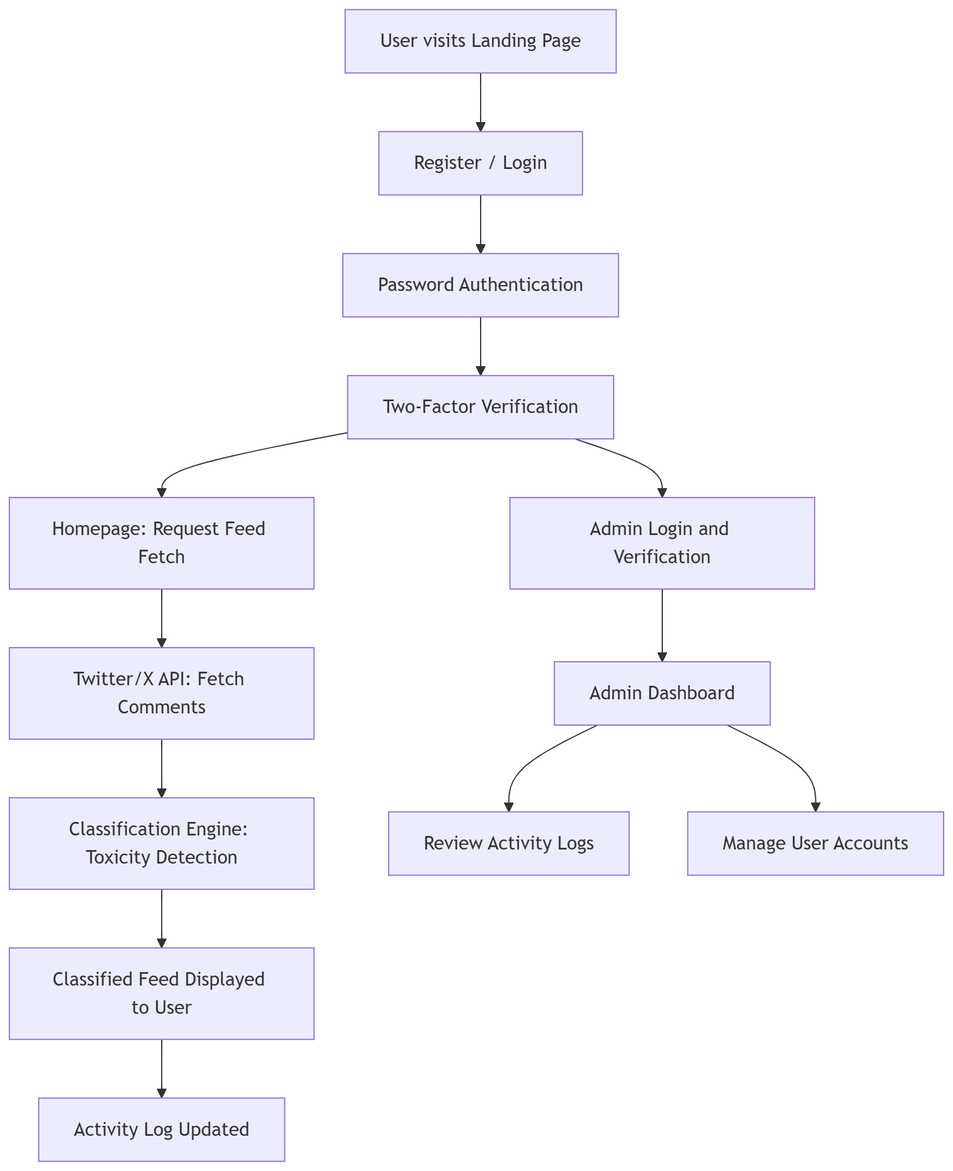

Index
A
Activity Log - 3.1 (F.10), 3.3 (NF.4), 3.4 (C.4)
Admin - 1.3, 2.3, 3.1 (F.3, F.4, F.11, F.12)
Admin Dashboard - 3.2.1, Appendix A
API - 1.3
Authentication - 3.1 (F.2, F.4, F.5), 3.3 (NF.2)
C
Classification Engine - 2.1, 3.1 (F.8), Appendix A
Confidence Score - 1.3, 3.1 (F.8, F.9)
Constraints - 2.4, 3.4
F
Functional Requirements - 3.1
J
Jigsaw Toxic Comment Classification Dataset - 1.4, 2.5
L
Landing Page - 2.2, 3.1 (F.6), 3.2.1, Appendix A
Logging Integrity - 3.3 (NF.4)
S
SRS - 1.1, 1.3
System Interfaces - 3.2
T
Two-Factor Authentication (2FA) - 1.3, 2.2, 2.4, 3.1 (F.5), 3.3 (NF.2), 3.4 (C.3)
Toxicity Classification - 1.3, 2.2, 3.1 (F.8, F.9)
U
User Classes - 2.3
User Interfaces - 3.2.1

Version History
Version | Last Updated | Reason for Change
1.0 | 02-08-2026 | Initial draft

Level 0 DFD Model – Abstract Overview
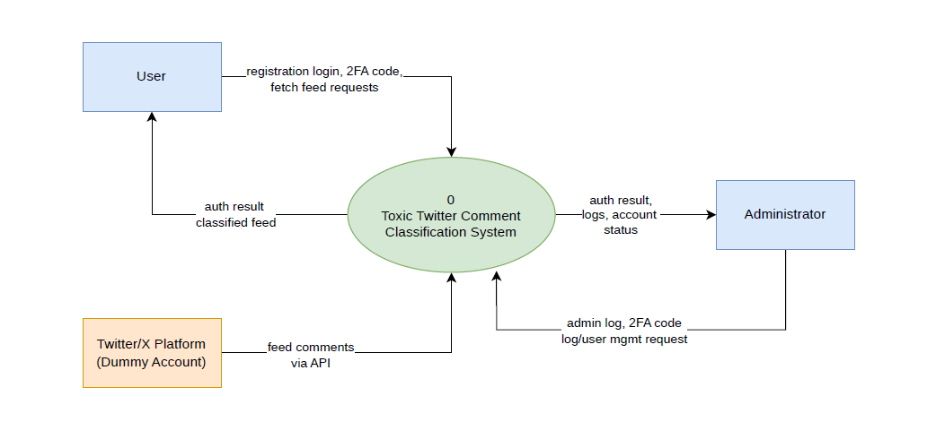

Level 1 DFD Model
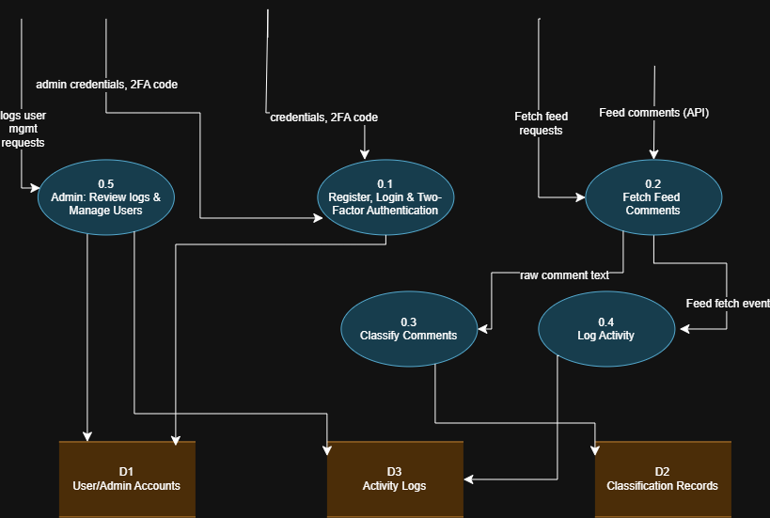

Level 2 DFD Model – Login/Auth Processes
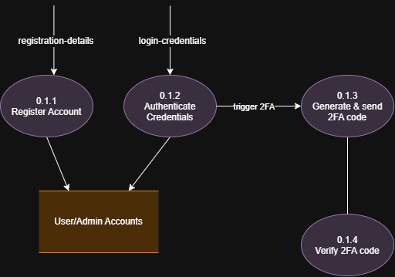

Level 2 DFD Model – Fetch twitter feed
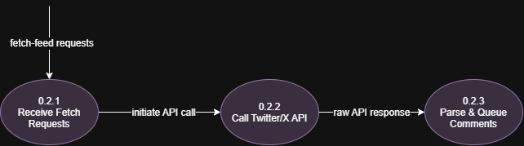

Level 2 DFD Model – Classification Process
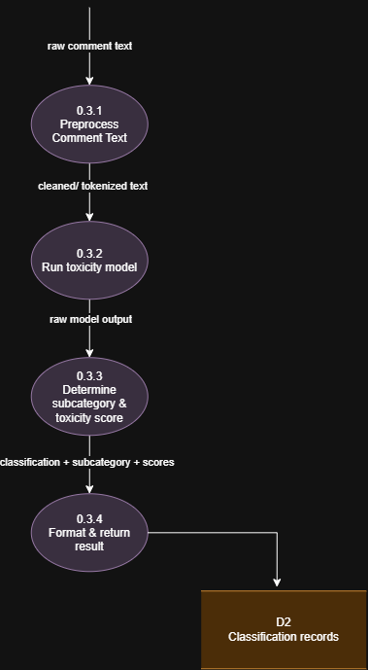

Level 2 DFD Model – Activity Log
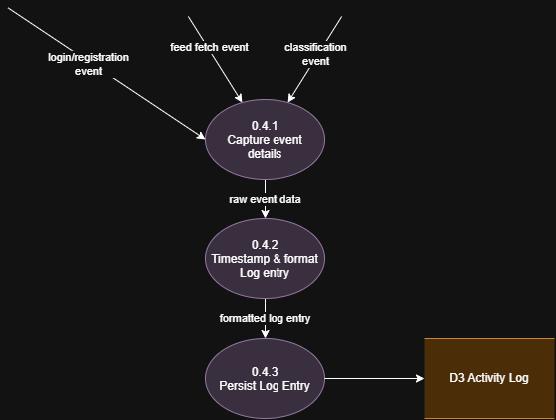

Level 2 DFD Model – Admin Processes
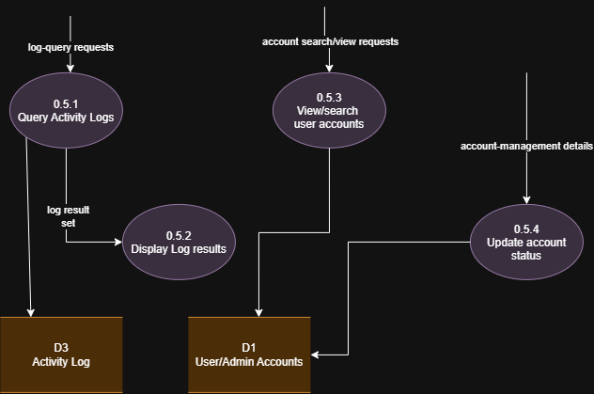

Structure Chart
