**Sushi-Runner**

*Efficient solution for comfortable delivery systems management*

Application for sushi delivery services accelerating the ordering process. System is divided into Administrator, Moderator, Customer, and Delivery subsystems. Customer can easily order several products listed in the application, Moderator specifies details and confirms orders and then, order is being delivered. Administration subsystem allows to manage available meals and track the status of the orders. Convenient tools provided by Sushi Runner simplifies order processing for the whole sushi delivery business.

**Subsystems**

**Moderator Management**

|  |  |  |  |
| --- | --- | --- | --- |
| **№** | **Use Case** | **Description** | **Action Method** |
| MM1 | Review order | Reviews order details | - |
| MM2 | Change order | Edits order details | - |
| MM3 | Confirm order | Confirms that all order details are correct and valid and is applicable for processing | - |

**Customer Management**

|  |  |  |  |
| --- | --- | --- | --- |
| **№** | **Use Case** | **Description** | **Action Method** |
| CM1 | Search meal | Searches if the specific meal is present and available | - |
| CM2 | Add meal to order | Adds meal to order | - |
| CM3 | Place order | Confirms the list of meals in order and places it | - |

**1. Use case diagrams**

**1.1. General use case diagram**



**1.2. Customer use case diagram**

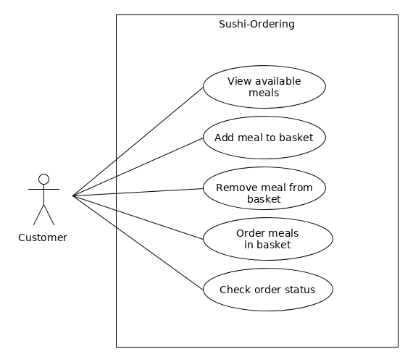

**1.4. Moderator use case diagram**



**2. Sequence diagram**

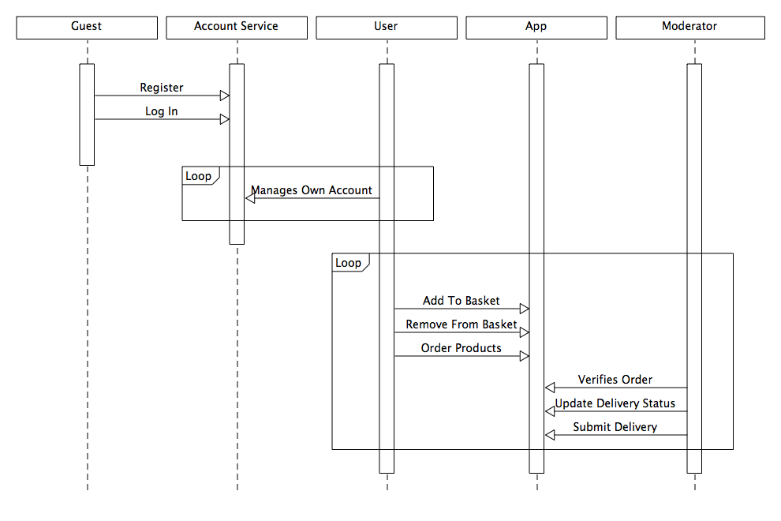

**3. Class diagram**

