RAMAIAH INSTITUTE OF TECHNOLOGY
(Autonomous Institute Affiliated to VTU)
Department of Information Science and Engineering


Apr 2017

APPLIED CS WITH ANDROID PROJECT
JAVA AND J2EE LAB - IS624L

Department of Information Science and Engineering

MUSIC PLAYER PROJECT
Submitted in partial fulfillment of the CIE for the subject

by
ANTHONY PRAJWAL P (1MS14IS015)

ANIRUDH NADGOD (1MS14IS012)

MUSIC PLAYER

Abstract
The following is a Music player that which is implemented using the featues and concepts of Swings, Awt, Jdbc,Threads.It is basically used to play mp3 and .wav songs from your computer.

It is implemented using the JLayer MP3 Library.

Features
1. It searches the user seleced directory recursively for media of MP3 type, retrieves the ID3 Tags and enters the values into the database.
2. It Displays all the mp3 files present in based on album, artist and track name.
3. When the a particular song is selected it start to play.It provides an option to pause or stop the song.
4. Each song is run on a separate Thread to allow the song to run in the Background.
5. When ever the songs are read all the songs Details are Entered into the MySql Database for Further Retrival.

User-Interface and Screenshots
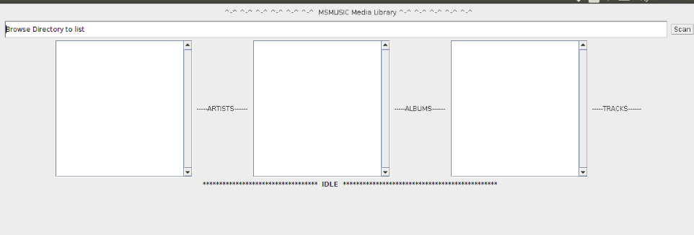
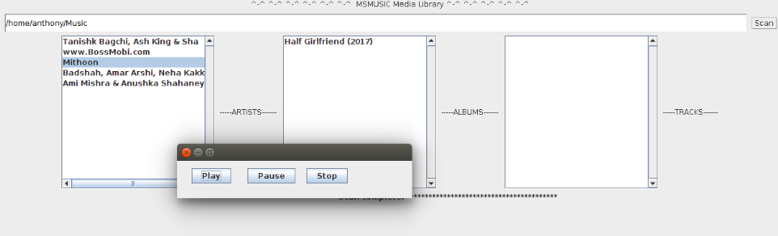
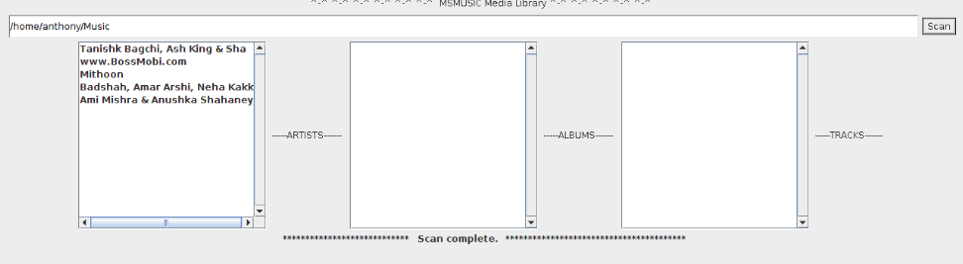
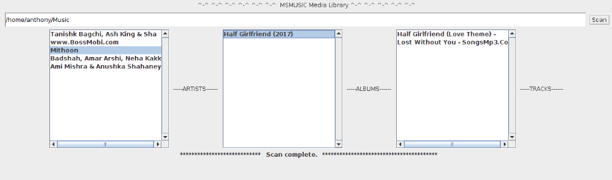
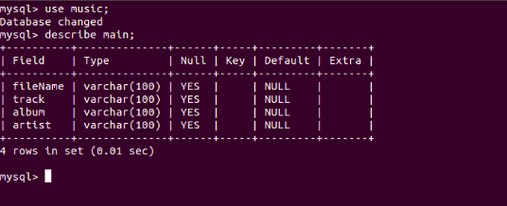
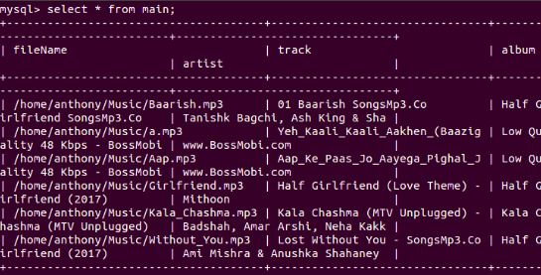

Implementation Details

1. Project Configuration:

For Configuration of the Project we were needed to add some of the jar files.

The Jar Files add were:

1.jid3lib-0.5.1.jar : This was added to achieve the fuction of retriving the ID Tags of mp3 files when we are searching for them.

2.jid3-0.46.jar : This was added to achieve the fuction of retriving the Mp3 and Wac music files.

3.mysql-connector-java-5.0.8.jar : This is used to connect the Music Player to MySql Database.

4.basicplayer3.0.jar : This is used to implement the Play the Mp3 song using Java Swing Program.

2. Creation of Database:

We have created the database in MySql Database called music.
The database music consists of the table named main which
consists of filename , artist , album, track.

The queries used for the create of required database and table are:

mysql> create database music;

mysql> use music;

mysql> create table main( filename varchar(50) not null
primary key, artist varchar(50), album varchar(50),
track varchar(50));

3. Project Description:
JLayer 1.0 is a popular open source MP3 player for Java. Is has all kinds of features.It is used in the implementation of the Music Player.

It plays the MP3 file in a separate thread, so you are free to perform other computation while the song plays.

In order to compile and execute it, you need to put the file jl1.0.jar in your current working directory.

The User Interface is implemented using the Traditonal Awt and Swing Components.

The User needs to provide the path of the Directory to be searched for the mp3 files.

The Implementation of recursive calls all the folders within the Directory is searched to find all the mp3 files.

The Jlayer Library consists of Packages:

javazoom.jl.converter
javazoom.jl.decoder
javazoom.jl.player
javazoom.jl.player.advanced

Here the javazoom.jl.player Packages consists of interface that provides an abstraction for a device capable of sounding audio samples.

The Package consists of the class Player which is used by us to play the mp3 songs.

The methods used for this implementation are play(), close(), getPosition() etc.

4. References:

1. http://www.javazoom.net/javalayer/docs

2. https://thiscouldbebetter.wordpress.com/2011/07/04/pausing-an-mp3-file-using-jlayer/

