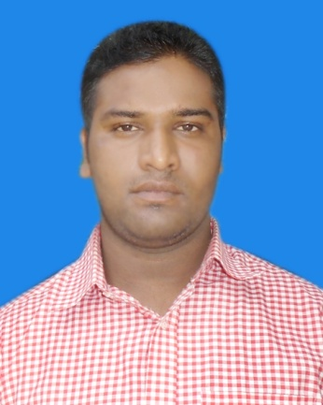**Shafiqul Islam**

**Diploma in Engineer (Electronics)**

Email: shafiqul565754@gmail.com

Call: +8801982565754

***Career Objective:***

To hold a suitable job where nice working environment, decision making opportunities, qualities and good career can be a assured. Wish to enter in a position where I would like to utilize my educational. Professional and logical exposure as a basic for growth of the organization. I also am willing to take challenging career.

***Educational Qualification:***

**Diploma in Engineering:**

Group : Electronics

Result : 3.38

Institution : Munshiganj Polytechnic Institute, Munshiganj

Board : Bangladesh Technical Education Board, Dhaka

Session : 2014-15

Duration of Course : Four Year

**Secondary School Certificate (S.S.C)**

Institution : Muksudpur High School

Group : Science

Result : GPA: 4.50 (Out of 5.00)

Session : 2012

Passing Year : 2014

Board : Dhaka

***Industrial Attachment:***

* Betelco LImited
* Mahtab center (11th Floor) 177, Shahd Nazrul Islam Sarani Bijoynagor.
* Dhaka-100
* Duration : Three Month

***Language Skill:***

Excellent listening, reading, writing and speaking skill both Bengali and English.

***Job experience:***

Job Continuous

Best Tycoon

Vivo Mobile Factory

Kusabo, Rupgonj, Narayangonj

Joinong Date: 21/07/2019

***Computer Knowledge:***

* Course complete on computer Application (Microsoft Office)
* Adobe Photoshop, Illustrator,
* Have good knowledge of using internet & email.
* Hardware.

***Personal Details:***

Name : Md. Shafiqul Islam

Father’s Name : Md. Akbor Ali

Mother’s Name : Sufia Begum

Permanent Address : Village: Nondir Para, Post: Muksudpur,

P.S: Sherpur sador, Dist: Sherpur.

Date of Birth : 31/12/1997

Nationality : Bangladeshi (By Birth)

Religion : Islam

Marital Status : Unmarried

Sex : Male

Blood Group : AB+

Height : 5 Feet 9 Inches

Weight : 70Kg.

***Application Declaration:***

I hereby declare that the information given above is correct to the best of my knowledge.

***Signature***

*Shafiqul*