|  |  |
| --- | --- |
| ***Introduction To Database*** | **Project Fall**  **2019-20** |

**Project Name: Cineplex Management System**

Course Teacher**: REZWAN AHMED**

**Group Members**

|  |  |
| --- | --- |
| Name | ID |
| SHEKH ARIFUL ISLAM | **18-36623-1** |
| ISLAM,MD SHAFIKUL | **18-38348-2** |
| AHMED,FARDIN | **18-39264-3** |
| RAHMAN,ANIK | **19-40191-1** |

**Table of content**

1. Scenario

2. ER diagram

3. Normalization

4. Table creation

5. Data input

6. Query Question

7. Relational Algebra

1. **Scenario**

Star Cineplex is the first multiplex cinema theatre in Bangladesh. Multiplex is a movie theatre complex with multiple screens. Star Cineplex has a strong management for maintaining the whole system. The whole system manages by a manager. The attributes of manager include MID, Mname, address, phone, email. In this management system there are many employees. The attributes of employees include EID, Ename, address, phone, mail, salary, age. Manager manages all employees. Some employees work to sell ticket. The attributes of tickets include TID, Tname, price. Tickets for show and show has some attributes include SID, Sname, Sdate, Start_ time, End _time. One show will run at a time. One ticket can be sold from only one show. One manager can manage many employees.

1. **ER diagram**

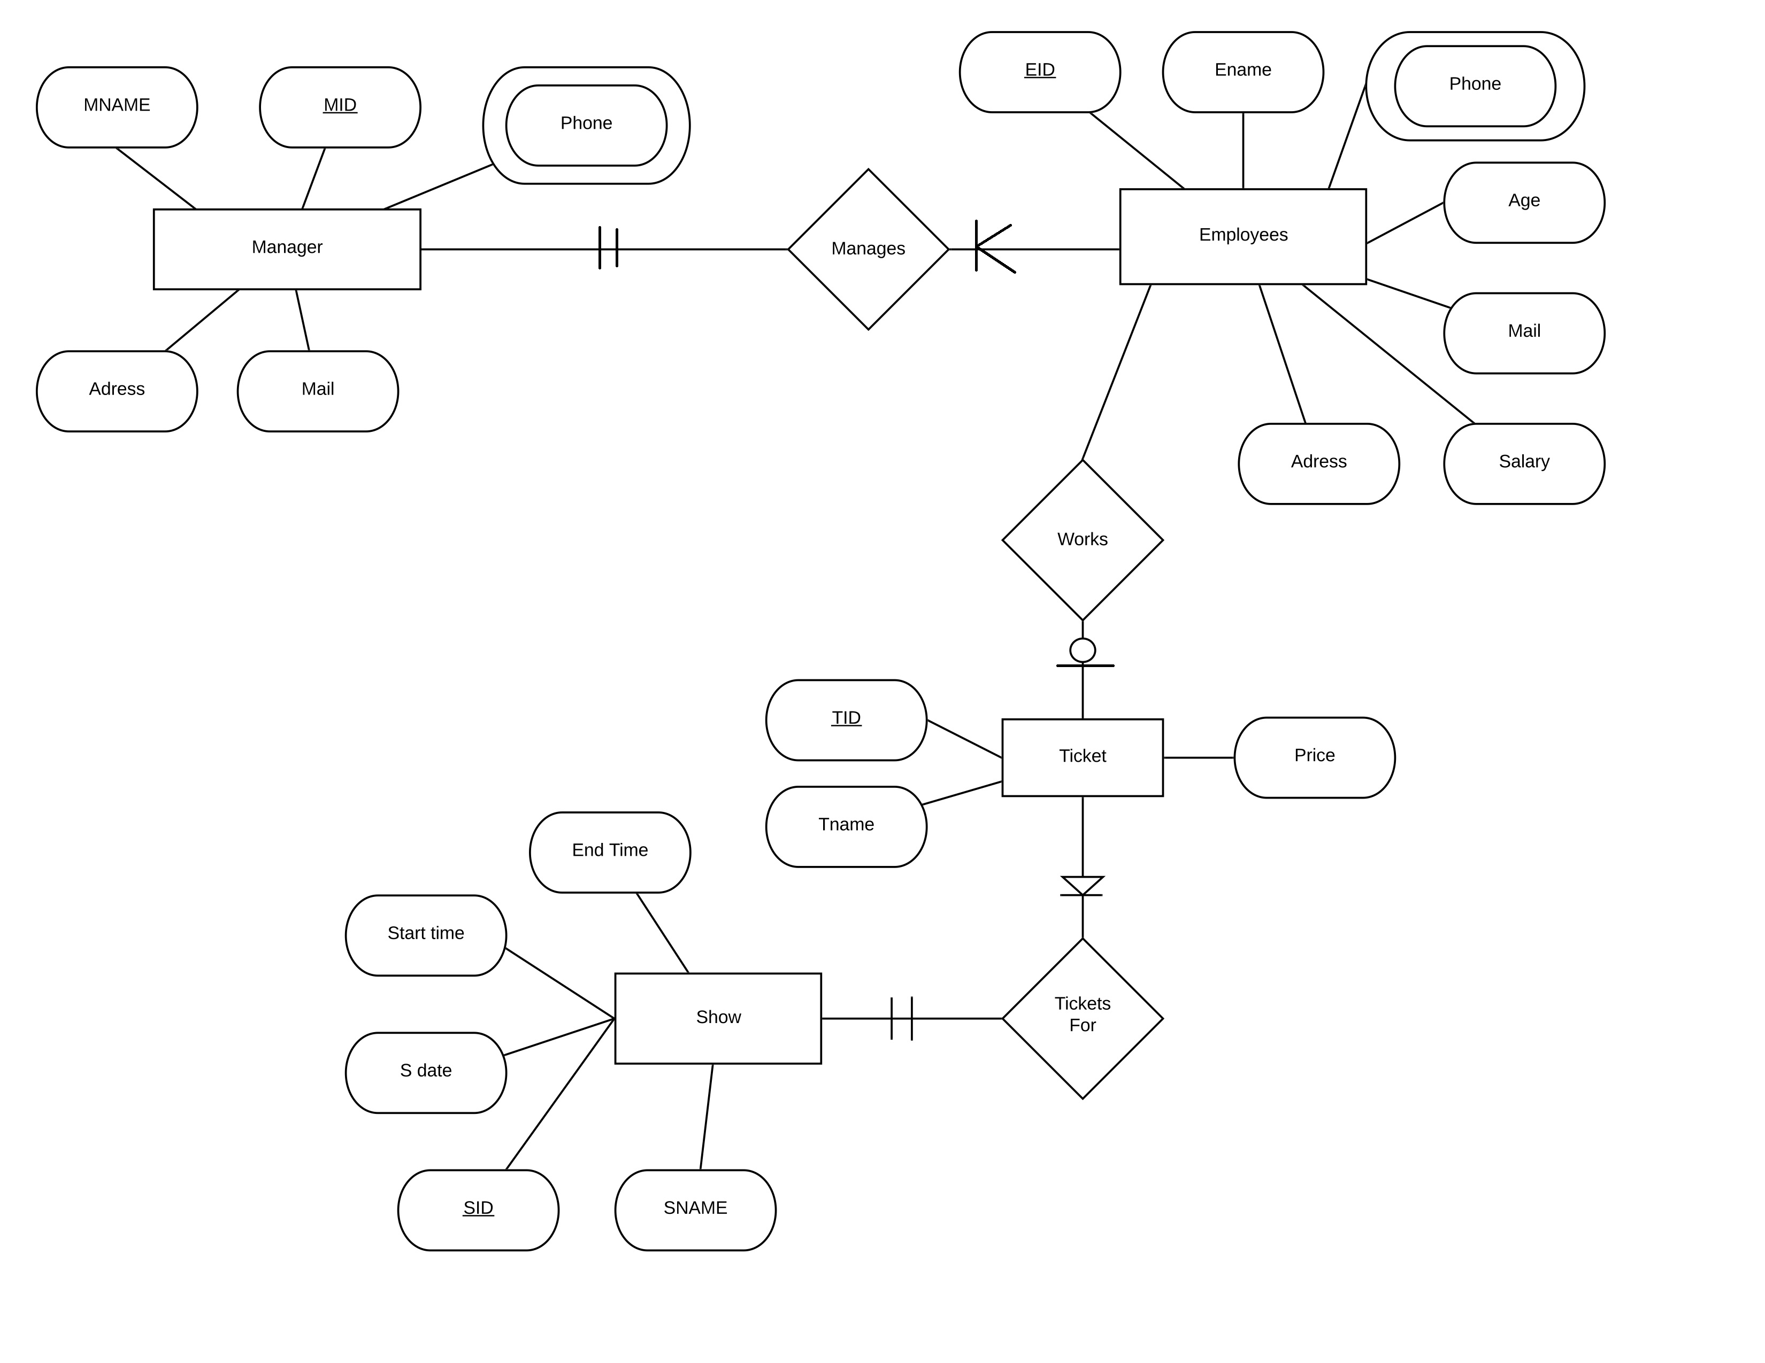

1. **Normalization**

***Manages:***

UNF: MID, Mname, Mail, Address, Phone, EID, Ename, Address, Phone, Age, Mail, Salary

1NF: 1st: MID, EID Mname, Mail, Address, Phone, Ename, Address, Phone, Age, Mail, Salary

2NF: 1st: MID, Mname, Mail, Address, Phone

2nd: EID, Ename, Address, Phone, Age, Mail, Salary, MID

3NF: 1st: same as 2NF

***Works:***

UNF: EID, Ename, Address, Phone, Age, Mail, Salary, TID, Tname, price

1NF: 1st: EID, TID, Ename, Address, Phone, Age, Mail, Salary, Tname, price

2NF: 1st: TID, Tname, price, EID

2nd: EID, Ename, Address, Phone, Age, Mail, Salary

3NF: 1st: same as 2NF

***Ticket for:***

UNF: TID, Tname, price, SID, Sname, Sdate, Start_time, End_time

1NF: 1st: TID, SID, Tname, price, Sname, Sdate, Start_time, End_time

2NF: 1st: TID, Tname, price, SID

2nd: SID, Sname, Sdate, Start_time, End_time

3NF: 1st: same as 2NF

***FINAL TABLE:***

1st: MID, Mname, Mail, Address, Phone

2nd: EID, Ename, Address, Phone, Age, Mail, Salary, MID

3rd: TID, Tname, price, EID

4th: TID, Tname, price, SID

5th: SID, Sname, Sdate, Start_time, End_time

1. **Table Creation query**

create table manager

(

MID varchar2(5) constraint MID_pk primary key,

Mname varchar2(25) not null,

address varchar2(30) not null,

phone number(11) unique,

email varchar2(25) unique

)

desc manager

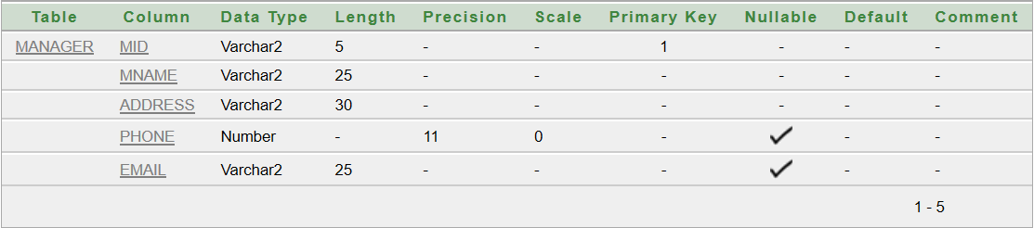

create table employees(

EID varchar2(5) constraint EID_pk primary key,

Ename varchar2(25) not null,

address varchar2(30) not null,

phone number(11) unique,

email varchar2(25) unique,

salary number(6) constraint employees_salary_ck check(salary>5000),

age number(2) not null,

MID varchar2(5) constraint employees_MID_fk references manager(MID)

)

desc employees

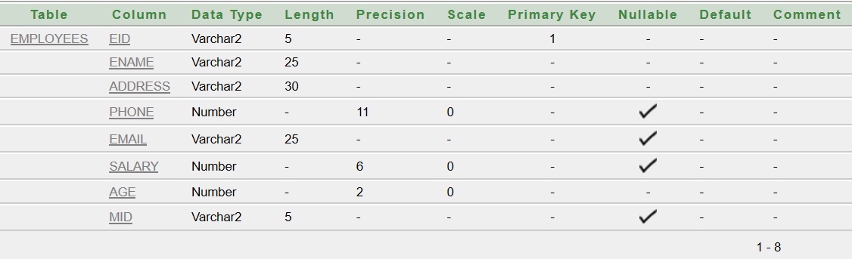

create table Shows(

SID varchar2(5) constraint SID_pk primary key,

Sname varchar2(25) not null,

Sdate date,

start_time varchar2(6) not null,

end_time varchar2(6) not null

)

desc shows

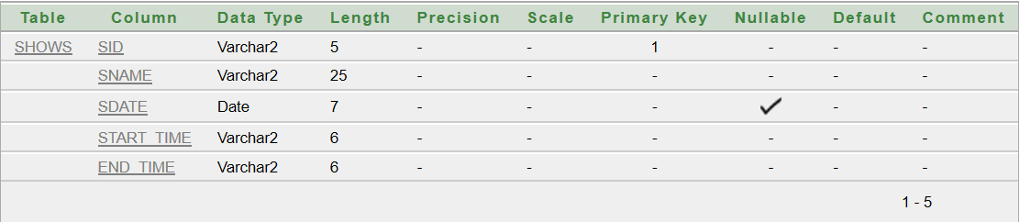

create table ticket_shows

(

TID varchar2(5) constraint TID_pk primary key,

Tname varchar2(25) not null,

price number(5) default 350,

EID varchar2(5) constraint ticket_shows_EID_fk references employees(EID)

)

desc ticket

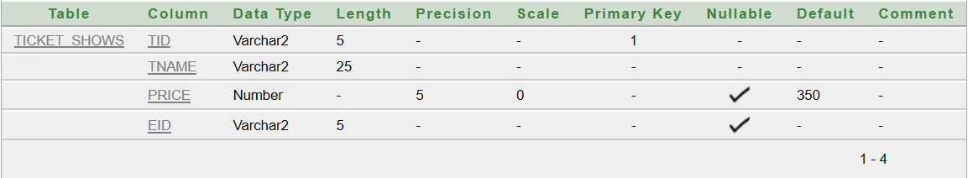

create table ticket_employees

(

TID varchar2(5) constraint ticket_employees_TID_pk primary key,

Tname varchar2(25) not null,

price number(5) default 350,

EID varchar2(5) constraint employees_EID_fk references employees(EID)

)

desc ticket_employees

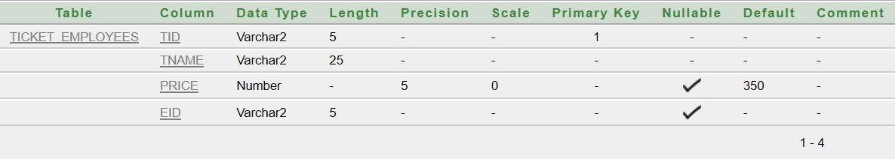

1. **Tables screenshot with data**

For manager

insert into manager (MID,Mname,address,phone,email) values(1,'Rahman

Hasan','Mirpur-10,Dhaka',01726425894,'rhasan@gmail.com')

insert into manager (MID,Mname,address,phone,email) values(2,'kabir

Hasan','Mirpur-2,Dhaka',01348565894,'khasan@gmail.com')

insert into manager (MID,Mname,address,phone,email) values(3,'Anik

Paul','Nikunja-2,khilkhet',01700123894,'anikp@gmail.com')

insert into manager (MID,Mname,address,phone,email,email) values(4,'Ashik

Rahman','Mirpur-1,Dhaka',01935478294,'ashik695@gmail.com')

insert into manager (MID,Mname,address,phone,email) values(5,'Shawon

Zaman','Nikunja-2,khilkhet',01621594242,'szaman@gmail.com')

select * from manager

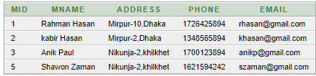

For empolyees

insert into employees

(EID,Ename,address,phone,email,salary,age,MID)

values(1,'Mahmudul Zaman','Nikunja2,khilkhet',01523654142,'mzaman@gmail.com',25000,35,1)

insert into employees

(EID,Ename,address,phone,email,salary,age,MID) values(2,'Durjoy

Sarkar','Mirpur-2,Dhaka',01852524142,'sarkard@gmail.com',30000,39,4)

insert into employees

(EID,Ename,address,phone,email,salary,age,MID)

values(3,'Chowdhury

Hasan','Banani,Dhaka',01935475365,'chowdhury253@gmail.com',35000,40,1)

insert into employees

(EID,Ename,address,phone,email,salary,age,MID) values(4,'Shaan

Sheikh','Dhanmondi,Dhaka',01641854142,'shaan@gmail.com',37000,30,3)

insert into employees

(EID,Ename,address,phone,email,salary,age,MID) values(5,'Tanvir

Ahmed','Nikunja-2,khilkhet',01995654142,'tanvir515@gmail.com',45000,35,2)

select * from employees

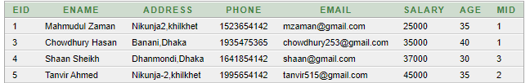

For shows

insert into shows (SID,Sname,Sdate,start_time,end_time)

values(1,'Opening-1','18-Aug-2019','9-30','12-30')

insert into shows (SID,Sname,Sdate,start_time,end_time)

values(2,'Opening-2','18-Aug-2019','12-30','3-30')

insert into shows (SID,Sname,Sdate,start_time,end_time)

values(3,'Royal','19-Aug-2019','3-00','6-00')

insert into shows (SID,Sname,Sdate,start_time,end_time)

values(4,'Exposure','19-Aug-2019','5-30','8-30')

insert into shows (SID,Sname,Sdate,start_time,end_time)

values(5,'VIP','20-Aug-2019','12-00','3-00')

select * from shows

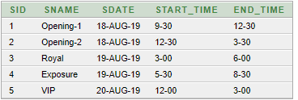

For ticket_shows

insert into ticket_shows (TID,Tname,price,SID) values(1,’VIP Ticket’,1000,2)

insert into ticket_shows (TID,Tname,price,SID) values(2,’General Ticket’,400,3)

insert into ticket_shows (TID,Tname,price,SID) values(3,’General Ticket’,400,1)

insert into ticket_shows (TID,Tname,price,SID) values(4,’Open Ticket’,500,4)

insert into ticket_shows (TID,Tname,price,SID) values(5,’KIDS Ticket’,300,5)

select * from ticket_shows



For ticket_employees

insert into ticket_employees(TID,Tname,price,EID) values(1,'VIP Ticket',1000,2)

insert into ticket_employees(TID,Tname,price,EID) values(2,'General Ticket',400,3)

insert into ticket_employees(TID,Tname,price,EID) values(3,'General Ticket',400,1)

insert into ticket_employees(TID,Tname,price,EID) values(4,'Open Ticket',500,4)

insert into ticket_employees(TID,Tname,price,EID) values(5,'KIDS Ticket',300,5)

select * from ticket_employees



1. **Query with data screenshot**

**Sub quary**

1.Write a query to display the name and salary for all employees who earn more than employee id 3 (Employees table)

🡪 select ename,salary from employees where salary>(select salary from employees where eid=3)



2. Write a query to display the employee id, name and salary for all employees who earn more than the minimum salary (Employees table).

🡪 select eid,ename,salary from employees where salary>(select min(salary) from employees)



**Group Function**

3. Write a query to display average salary, maximum salary, minimum salary, sum of salary for employees table

🡪 select avg(salary),max(salary),min(salary),sum(salary) from employees



**View**

4. Write a query to create a view named empmanvu to find employees id, employees name, manager id and manager name

🡪create or replace view empmanvu as select e.eid,e.ename,m.mid,m.mname from employees e,manager m where e.mid=m.mid

select * from empmanvu



**Joining**

5.. Write a query to display the manager name and employees name for each employee using join

🡪 select e.ename,mname from employees e,manager m where e.mid=m.mid



6. Write a query to display employee id, employee name and counter name for each employee using join

🡪 select e.eid,e.ename,c.cname from employees e,counter c where e.employee_id=c.eid



7. Write a query to display movie id, movie name, theatre name and language for all Benglai movies using join

🡪 select m.mid,m.mname,t.tname,m.language from movies m,theatre t where m.mid=t.mid and m.language='Bengali'



1. **Relational Algebra**

1.Select all from employees

Soln:(employees)

2.Select ename from employees where salary > 5000

Soln:salary>5000(employees))

3.Select the ticket name where price is 1000

Soln: price=1000(ticket_employees))

4.Select the total salary of all employees

Soln: *eid g****sum****(balance)* ***as*** *sum_balance* (employees)

5.Select eid ,ename of employees whose age is between 30 to 40

Soln: age between(30,40)(employee))

6.Select manager name and id who live in Mirpur-10

Soln: address=’Mirpur-10,Dhaka’(manager))