

**American International University-Bangladesh (AIUB)**

**Faculty of Science and Technology (FST)**

**Department of Computer Science (CS)**

**SDPM Group Project, Summer 2022**

**Project Title: One-time renting app**

**Section: C**

**Submitted by**

|  |  |
| --- | --- |
| Name | ID |
| Alamin Sheikh | 18-39230-3 |
| Ahammed, Md. Nafiz | 18-39278-3 |
| Ahmed, Fardin | 18-39264-3 |
| Khan, Roman | 18-37962-2 |

**1.0 Introduction:**

In modern days, the usefulness of renting is very essential. Nowadays people are very concerned about whatever they rent. There are various types of ways by renting something one time or several times. Renting something using the one-time renting app is very effective. According to this project, our main purpose is to rent the emergent needed for a very short time. So, it will be a great opportunity for the people who are wanted or badly needed for something according to rent.

**2.0 Project Title:** One-time renting app

**3.0 Objectives:**

We already mention that this project will going to be a renting something by the using of apps. Basically, there are three actors according to our project. Such as: - Owner, Customer and Admin. These three actors have their particular actions to perform. We want to communicate between two people who want to rent that small tool.

The software main goal is to bull up a correspondence between two individuals who need to lease that little device and who needs to give that apparatus to him and there must be an admin, customer and seller. This is basically a renting app. We all know about Daraz app where there is a group and another group is sales. Where the customer can buy, the things they need and the seller with the help of an offer sells their products. Admin mainly head of the software who rent the app

**4.0 Justification:**

Our endeavor is a rental project. We occasionally need to purchase items that we just use once. Therefore, our goal is to develop software that will enable us to decrease this kind of issue. Essentially, the project is managed by

***Building the Product:*** In this SDLC step, the real development process begins and the

created a product at this point, the programming code is created in accordance with DDS. If the layout is

Code creation may be carried out easily if it is done in a comprehensive and systematic way.

Programming tools including compilers, interpreters, debuggers, and other similar tools are used to produce the code, and developers must adhere to the coding standards established by their business. Different high level programming languages are used for coding, including C, C++, Pascal, Java, and PHP. The sort of software being produced affects the choice of programming language.

***Testing the Product:*** In most current SDLC models, testing activities are largely integrated into each stage of the SDLC, making this stage a subset of all the others. However, this stage simply relates to the product's testing phase, during which product flaws are discovered, monitored, corrected, and retested until the product satisfies the SRS's quality requirements.

***Deployment in the Market and Maintenance:*** After a product has been thoroughly tested and is prepared for deployment, it is formally released in the relevant market. Depending on the organization's business plan, product deployment may occasionally take place in phases. The product could initially be made available to a small market segment and evaluated there. The product may then be released as is or with proposed improvements in the intended market group depending on the response. After a product is put on the market, maintenance is carried out for the clientele already in place.

The SDLC offers a set of procedures to be followed in order to produce software products quickly. The steps in the SDLC framework are as follows:

***Communication:*** The user makes the initial request for the desired software product at this phase. He makes contact with the service provider and attempts to work out a deal. He makes a written request to the company offering the service.

***Gathering Requirements:*** From this point on, the software development team works to complete the project. The team speaks with different stakeholders in the issue domain in an effort to learn as much as it can about their needs. User requirements, system requirements, and functional requirements are considered and separated from the requirements.

**5.0 Systems Overview: (Includes Use case diagram)**

The developers decide on a roadmap for their strategy at this stage and work to identify the optimal software model for the project. Understanding the constraints of software products, learning about impending system-related issues or modifications that must be made to current systems, recognizing and resolving the project's effects on the organization and its employees, and other tasks are all included in system analysis. The project team evaluates the project's scope and adjusts the timeline and resources as necessary.

***Scope:*** Setting a clearly defined scope for a project is impotant.it defines the expectations for the project and ensures that all parties understand these expectations. Clearly outlining our scope within our project management system can help top avoid scope creep, in which a client or stakeholders attempts to add new elements without corresponding allowances.

***Schedule:*** Setting a timeline is an important step for any project plan. The system components system helps to manage scheduling throughout the execution of a project by providing timelines for both the overall project and individual elements within its execution.

***Budget:*** Keeping a project on budget is an important task for a project manager. In a system, components can help our track both the overall spending on a project and help and we allocate our budget efficiently.

***Staff Management plan:*** A staff management plan provides guidance for human resources professionals within an organization. It can be a valuable part of a system component system by helping to provide structure to human resources staff working with staff on the project.

***Stakeholders***: The stakeholders on a project are those who have an invested interest in its success. This may include both outside investors and ownership within an organization. The stakeholders’ sections list whom the stakeholders are for a project as well as their levels of control, which may vary from being active participant to simply benefiting from the results of a successful operation

***Risk Assessment:*** Understanding the risks of a project is a key piece of planning effectively in order to minimize our exposure. The risk section of a project management system analyzes both the potential cost of risks we face on the project and the likelihood of encountering them in order to determine the overall risk they present. Risks we may include in this component can include time-based, quality-based and financial.

**FUNCTIONAL REQUIREMENT**

There are many software requirements specifications included in the functional requirements of the OTR System, which contains various process, namely Registration, Check out, Report Generation, and Database.

**Adding User**

* Admin enables the include new user to the system.
* Assigning an ID to the user
* Information of the User
* Availability of the product
* Mandatory User Information
* Updating User Information

**APPS Rules**

* Transaction corrections, adjustments, and cancellations.
* Administrative functions.
* Authentication.
* Authorization levels.
* APP Tracking.
* External Interfaces.

**NON-FUNCTIONAL REQUIREMENT**

*Security requirement:*

* User Identification: The system needs the patient to recognize her or himself using the phone.
* Logon ID: Any users who make use of the system need to hold a Logon ID and password.
* Modifications: Any modifications like insert delete, update, etc. for the database can be
* synchronized quickly and executed only by the ward administrator.
* Administrator rights: The administrator can view as well as alter any information in the System.

*Performance*

* Response Time: The system provides acknowledgment in just one second once the users are checked.
* Capacity: The system needs to support at least 1000 people at once.
* User-Interface: The user interface acknowledges within five seconds.
* Conformity: The system needs to ensure that the guidelines of the Microsoft accessibilities are followed.

*Maintainability*

* Back Up: The system offers the efficiency for data backup.
* Errors: The system will track every mistake as well as keep a log of it.

*Reliability*

* Availability: The system is available all the time

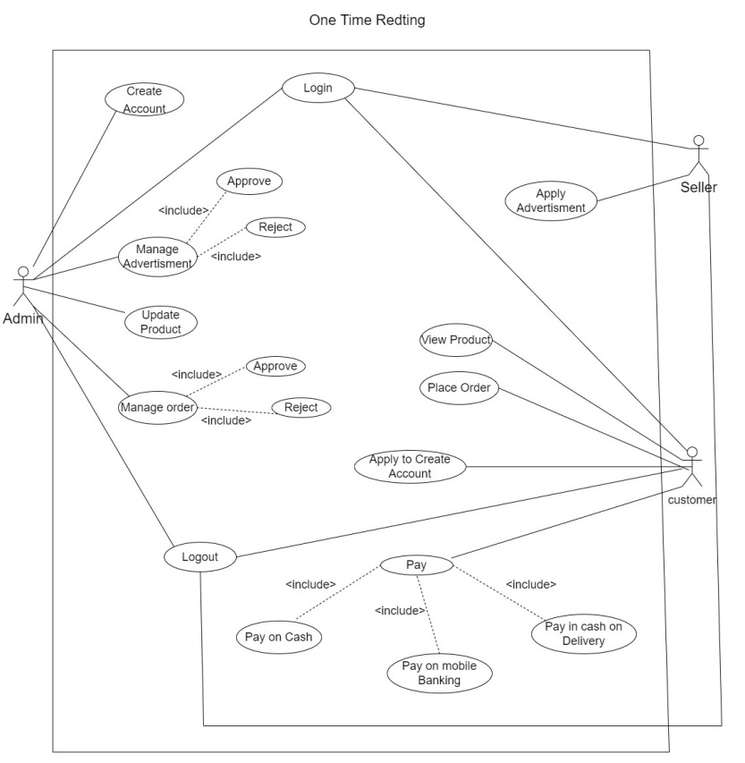

**Fig: Use-case diagram**

**6.0 Stakeholders analysis:**

Primary stakeholders

**Who get directly benefit from this project?**

**those are, Our Primary stakeholders are,**

* The owner,
* Employees,
* Users and
* Business Partner.

Secondary stakeholders

**Whom get directly benefit from this project those are,**

* Online Sellers,
* Competitors,
* Suppliers and
* vendors

External stakeholders

* Local communities and
* Government

Identify Stakeholders and Users:

Stakeholder analysis is critical to the success of any project. In this step, we need to list all parties that are positively or negatively affected by the project outcome; referred to as Stakeholders. Every stakeholder should be identified along with his/her influence, role in the project, and the mechanism to leverage or mitigate his/her influence. On the other hand, user groups should be identified in terms of their responsibilities with respect to the system (product), the stakeholder group they relate to, and how they define the success of the solution to be developed.

**7.0 Feasibility study:**

A feasibility analysis is used to assess an idea's viability, such as confirming that a project is both technically and legally possible and economically justifiable. It reveals whether a project is cost-effective. Well-designed research should provide a background on the company or project's history, such as a summary of the good or service, financial statements, information about the management and activities, financial information, regulatory requirements, tax regulations, and marketing studies and policies, the viability Analysis assesses the project's likelihood of success; as a result, perceived objectivity is crucial. In the study's validity for prospective investors and lending organizations.

Both technical & financial feasibility showing below:

**Technical Feasibility:** The technical resources that the organization has access to are the main focus of this study. Organizations can use it to assess whether their technical resources are adequate and whether their technical staff is capable of turning concepts into functional systems. Evaluations of the proposed system's hardware, software, and other technical requirements are also a part of the technical feasibility process. Our project focuses on the hardware and software components. In terms of technical labor, we put a lot of effort into testing analysis, finding bugs early on and fixing them. Programmers put forth a lot of effort to fix the system's oddity.

**Financial Feasibility:** Before allocating financial resources, this assessment often includes a cost and benefits analysis of the project to help businesses analyze the project's viability, costs, and benefits. Additionally, it improves project credibility and serves as an impartial project evaluation, assisting decision-makers in identifying the favorable economic benefits that the proposed project will bring to the business. Our budget estimation for the project is complete. We estimate our project's budget using the COCOMO model, and we are aware of the number of programmers involved and the project's duration. Making a whole project also requires a lot of money. Any initiative must be economically feasible.

**8.0 Systems component:**

* **Scope:** Setting a clearly defined scope for a project is impotant.it defines the expectations for the project and ensures that all parties understand these expectations. Clearly outlining our scope within our project management system can help top avoid scope creep, in which a client or stakeholders attempts to add new elements without corresponding allowances.
* **Schedule:** Setting a timeline is an important step for any project plan. The system components system helps to manage scheduling throughout the execution of a project by providing timelines for both the overall project and individual elements within its execution.
* **Stakeholders:** The stakeholders on a project are those who have an invested interest in its success. This may include both outside investors and ownership within an organization. The stakeholders’ sections list whom the stakeholders are for a project as well as their levels of control, which may vary from being active participant to simply benefiting from the results of a successful operation.
* **Risk Assessment:** Understanding the risks of a project is a key piece of planning effectively in order to minimize our exposure. The risk section of a project management system analyzes both the potential cost of risks we face on the project and the likelihood of encountering them in order to determine the overall risk they present. Risks we may include in this component can include time-based, quality-based and financial.

**9.0 Process Model to be followed:**

For designing our project, we select agile model.

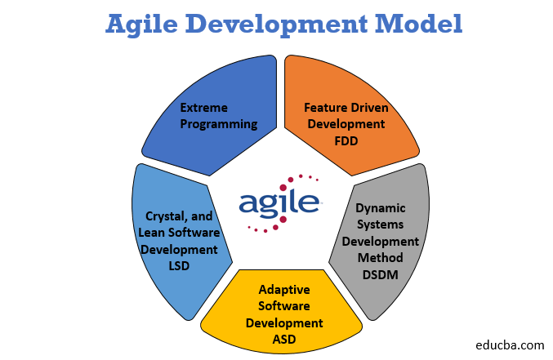

**Fig: agile process model**

**Why we choose agile model for our project?**

* Suitable for small to medium
* Extreme Programming
* Can accommodate changes at any time.
* Dynamic System
* Effective for the dynamic
* Development Method development environment.

**a. Diagrams**

* Use-case diagram:



**Fig: Use-case diagram**

* Activity diagram:

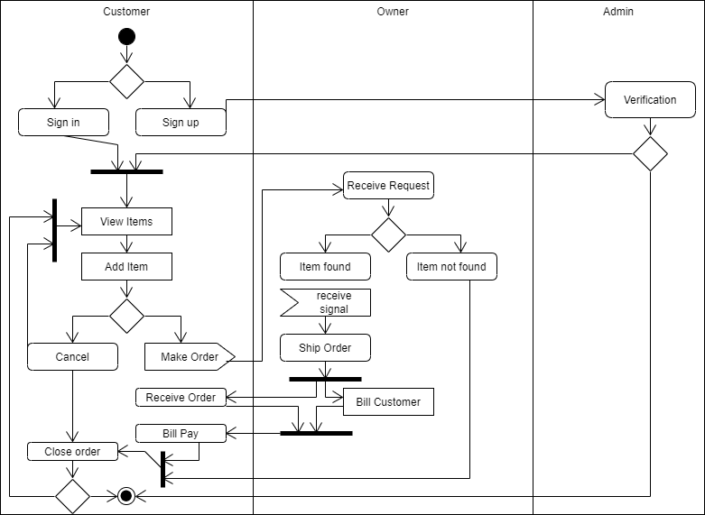

Fig 6: Activity Diagram

* Class diagram

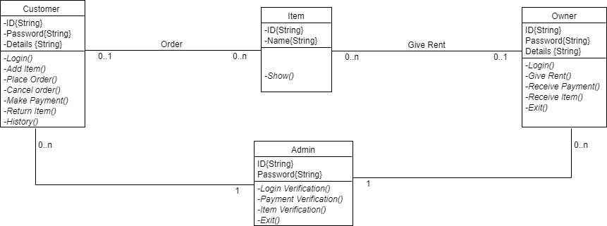

Fig 7: Class Diagram

**10.0 Efforts estimation:**

One time renting app is not that much big, so we can say it is an organic model, and let us assumes we will develop in java language.

so, Source lines of code, SLOC=12000.

We know Effort =PM=Coefficient*(SLOC/1000) ^P.

For organic project type,

Coefficient = 2.4, P = 1.05, T = 038.

So,

Effort =PM =2.4*(12) ^1.05 [SLOC/1000=12000/1000=12]

=32.61 staff-months

=33 staff-months

Development time = DM = 2.50*(PM)^T

= 2.50*(33) ^0.38

= 9.44 month

Let take it as 9 months

Required number of people=ST=PM/DM

= 33/9=3.67 = 4

Working hours per day for a single person=8 hours

per person salary in a month=85,000

Per hour salary for a person in a month=85,000/180 [In a month working hours= 180]

=472.22

In 9 months’, number working days=180

Hours =180*8

=1440 hours

So, Charge for the project 1440*472.22

=679996=680000

Requirement analysis =15days*8hours

=120hour

Charge for requirement analysis=120*300=36000

Travel expense=20000

Office rent expense=30000*9=270000.

Electricity & Gas bill=2000*9=18000

Training and hardware cost=100000

Maintenance for 9 months=9*8=72 hours

Maintenance cost=72 hours*1500

=108000

Utility cost:

Per month cost 5000 Taka

Total = 9 months*5000 =45000 tk

Total cost=680000+36000+20000+270000+18000+100000+108000+45000

=1007000

Bill=Total cost+20%=1007000+201400=1208400=1208400.

**11. 0 Activity Diagram:**

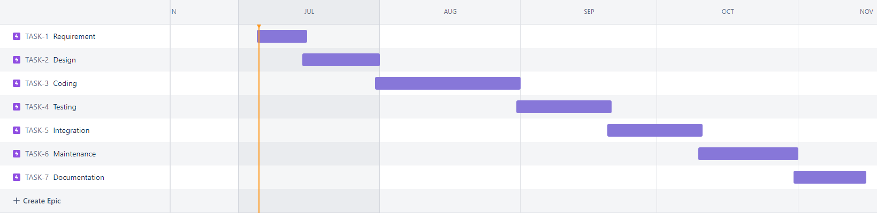

|  |  |  |
| --- | --- | --- |
| Activity | Preceding Activity | Duration(In weeks) |
| Requirement | - | 2 |
| Design | A | 3 |
| Coding | B | 2 |
| Testing | C | 2 |
| Integration | D | 1 |
| Maintenance | E | 2 |
| Documentation | E,F | 1 |

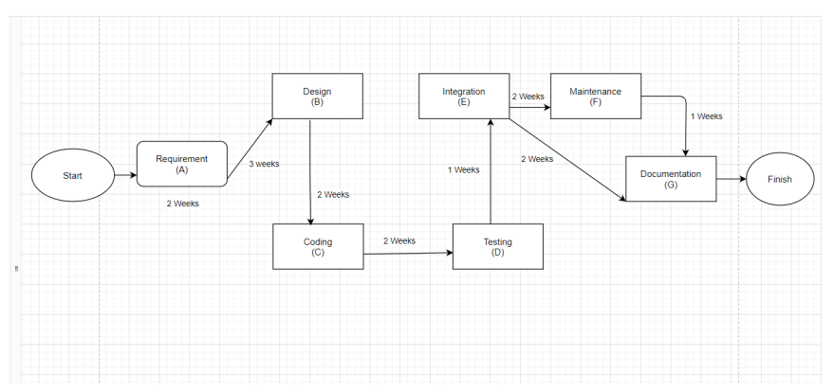

Fig 1: **Networking diagram with preceding node**

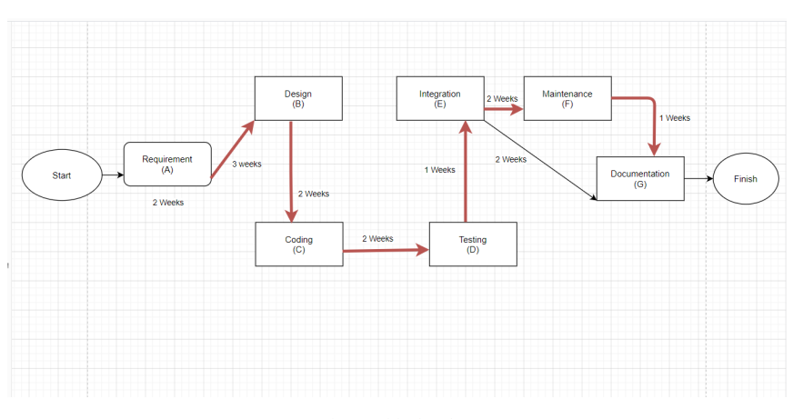

Fig 2: **Critical path**

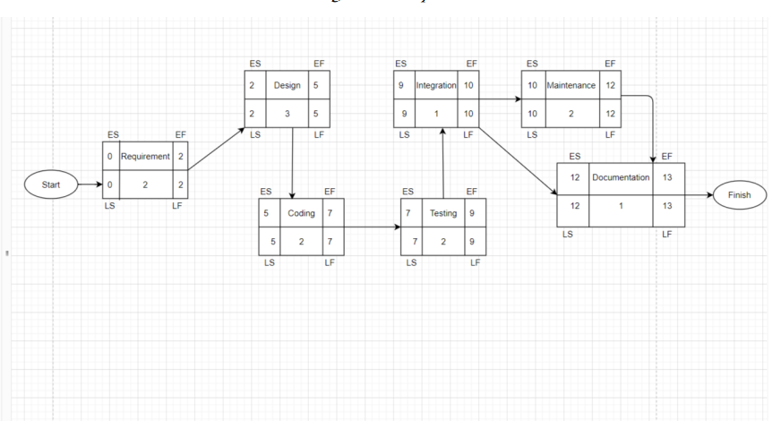

Fig 3: **Earliest Start, Earliest Finish, Latest Start, Latest Finish Calculation with Forwarding and Back warding method.**

**Work Breakdown Structure:**

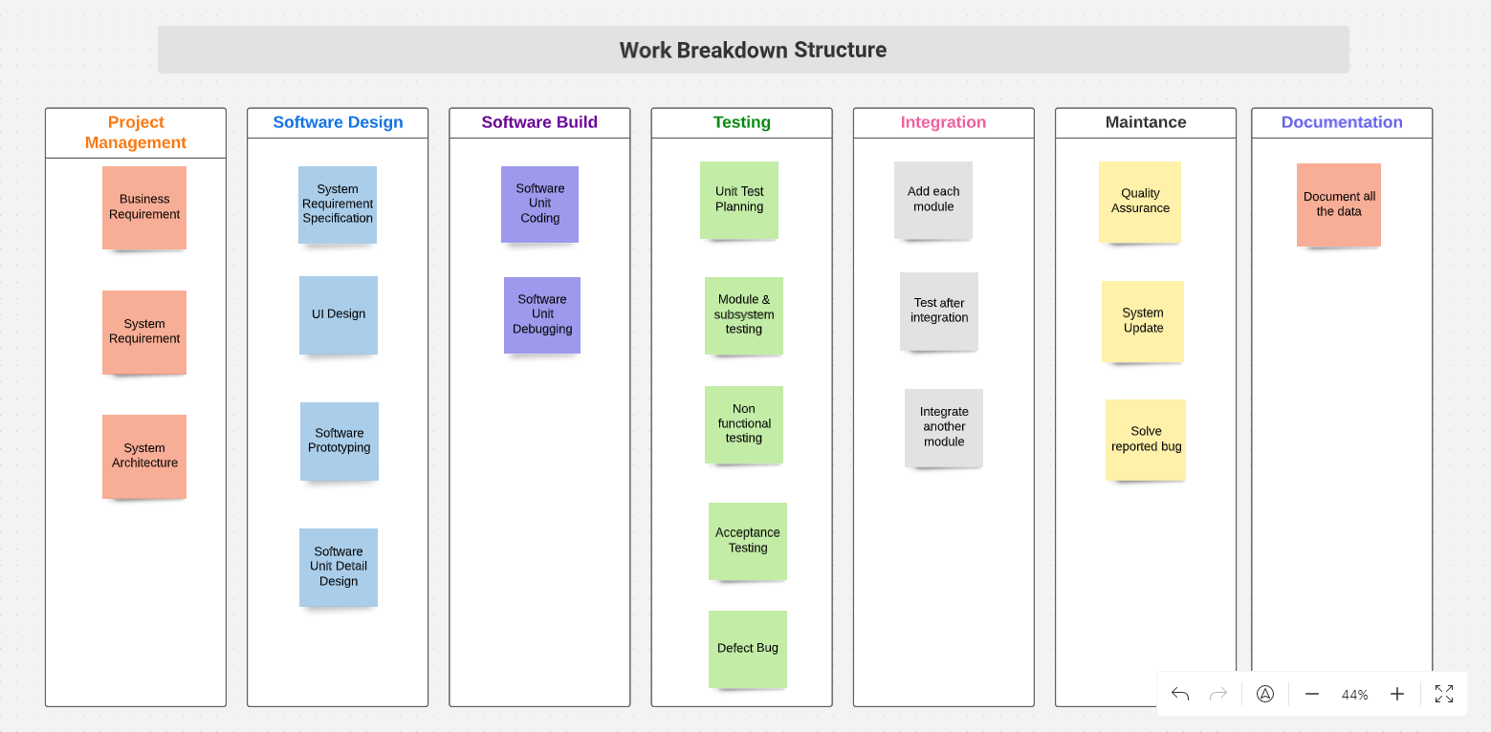

**12.0 Risk Analysis:**

Containing and reducing risks is what risk management entails. The first recognition of a plan is necessary. Must be ready to take action when a risk presents itself at that moment, utilizing the knowledge and expertise of the entire team to reduce any adverse effects on the project.

* Defect in planning: If any mistakes are discovered in the project plan while it is still being carried out, the project's duration may increase.
* Communication Gaps: There is a chance that the team and its fanatics will not always be in touch. A lag in performance might result if this happens. If that happens, we will try our best to contact the colleague if they become temporarily unavailable. The task schedule will change.
* Find the correct payment processor: The ideal credit card processing supplier will provide me outstanding risk management assistance and help me grasp the specific e-commerce fraud risk and responsibilities. We'll also want to consider the company's proficiency with customer data security before making our choice.
* Budget Overrun: When clients demand more than what the project has, there are few resources available. Other project risks, such as plan and execution, may follow cost risk.
* Performance: A project team may complete the task on time and within the allotted budget, yet they may still fail to deliver the desired outcomes. Furthermore, a project that did not succeed costs the business time and money.
* Use fraud prevention tools: To help lower risk exposure, a range of fraud prevention technologies are offered. The most often used card security features are Address Verification Service (AVS), Card Security Codes (CVV2, CVC 2, and CID), Verified by Visa, and MasterCard Secure Code.
* Data Security: Users are required to take reasonable precautions to guarantee that personal account information is properly protected. E-commerce businesses get particular consideration. They must include a Privacy Policy, Terms and Conditions policy statement, and an SSL-secured payment acceptance form on their websites, which are subject to strict inspection.
* Hardware impossibility: Company employees may trip or fall before, during, or after installing our product. No agreement will materialize if this happens. It suggests that this endeavor will not be suitable to transmit to the support. We shall start right immediately with the necessary recovery measures.

In project management, risk analysis is a crucial component of the feasibility study where a variety of risks and uncertainties are discovered in order to be evaluated, prioritized, and pinpointed in which areas they are most likely to occur. In project management, risk analysis is a crucial component of the feasibility study where a variety of risks and uncertainties are discovered in order to be evaluated, prioritized, and pinpointed in which areas they are most likely to occur.

In Project, management risk can be represented as following: Risk = Potential Negative Event + Impact + Probability of Occurrence We can also demonstrate the risk of our project in the following way

|  |  |  |  |  |  |
| --- | --- | --- | --- | --- | --- |
| No. | Risk Event | Probability/100 | Impact | Score | Risk Migration Plan |
| 1 | Delayed development of data management system | 0.50 | 180 Hours | 90 Hours | Appoint a manager tracking development's progress and alerting management if there are any delays |
| 2 | Major supplier failure | 0.20 | 80 Hours | 16  Hours | Make a list of potential suppliers who might provide the things you need. |
| 3 | Late delivery of procurement  items | 0.35 | 60 Hours | 21  Hours | Make a timetable for early deliveries |
|  |  |  | Total Risk | 127 Hours |  |

13.0 Budget for the project

**14.0 Conclusion:**

The rent app significantly impacts society. Users have been found to save time and money by renting app goods. According to a newspaper's analysis, ninety-five percent of consumers have to buy many things twice using two times. They may use this app to rent items for as many hours or days as possible. They can use the goods they require while saving money as an outcome. Rent some of your things and keep some on hand in case you need them. If we decide to rent our product, it can also provide us with some cash. Because we don't have to buy things for single uses, we can also reduce waste. In addition, those with lesser incomes must wait before purchasing necessities. From this app, you may rent various items. Older folks can occasionally be spotted walking improperly. Therefore, using this app is a practical answer for them if they only purchase any product for one-time use. This is how our service affects society.

…