**Head of Web Application:**

Employee Database or Employee Records: 2

Documents & CV’s 4

Forms & Template 5

Links & Collections 6

Photo Gallery 6

NRECA World Map 6

Notice Board 6

Administration 7

**The Web Application:**

**Access:**

1. Super Admin – Can be control all user and admin
2. Admin – Can be control only users
3. Users- Will have access to user only the admin or super admin will assign.

**USERS:**

**Welcome Screen:**

**Login**

|  |
| --- |
| **User ID** |
| **Password** |

**Create an account or contact authority**

**Registration Requirements:**

* Employee ID and company email address are mandatory for registration.
* Required fields: Employee ID, Email, Full Name, Phone Number, Password (entered twice for confirmation).

**Approval Process:**

* After submission, Admin will check the validity of the information and approve it.
* Once approved, the user will see the tables to input their information.

**Access and Control:**

* Super Admin and Admin should have full access and control to create a profile for a user, record the information, set a one-time password, and send it to the user's company email address for login and password change.
* Super Admin and Admin should also have the capability to reset user passwords.

# Employee Database or Employee Records:

* Downloadable Information: The information should be downloadable as an EXCEL file. Downloads can be made for an individual ID, a group of IDs, or all records.
* Attachments: Users should be able to upload the following attachments: Photo, National ID (NID), Passport, Signature, and TIN Certificate.
* Should have a search button where can search with the ID and Email Address.
* All employee record should be preview in the system.
* Attachment Management: Implement a system to handle and securely store these attachments.

**Fields: (Tables)**

**Company Information:**

1. Employee ID
2. Employee Name
3. Designation
4. Department - Collection
5. Project Name - Collection
6. Company Email
7. Phone Number
8. Date of Birth
9. Gender
10. Nationality
11. Employee Type:
    1. Full-Time
    2. Short time
    3. Contracted Personnel
    4. Consultant
12. Joining Date
13. Contract end Date
14. Employee Status:
    1. Active
    2. Inactive
    3. Terminated

**Personal Information:**

1. Personal Phone No
2. Personal Email Address
3. National ID No
4. Passport No
5. TIN Certificate No
6. Emergency Contact Number
7. Relationship of Emergency Contact
8. Present Address
9. Permanent Address

Banking Information:

1. Account Title: Md Example Name
2. Account No: X121500001250002 [Here, ‘X’ is default]
3. Bank Name:
4. Branch Name:
5. Routing Number: X5484587 [Here, ‘X’ is default]
6. Email

Attachment or upload able:

1. Photo, (JPEG)
2. NID, (PDF)
3. Passport, (PDF)
4. TIN, (PDF)
5. Signature ((JPEG, PNG)

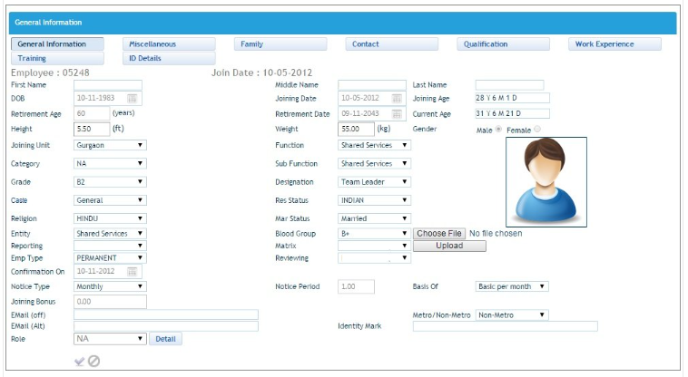**Just an idea for the individual profile:**

------------------------------------------------

# Documents & CV’s

* **Documents**
  + Employee’s CV
    - NRECA Employee CV’s
    - Other Resources’ CV’s
  + Company Policies
  + Training Materials
  + Others

Guide:

**CV’s Input:**

1. Full name
2. **Field [Collection]**
   1. MIS & IT
   2. GIS
   3. Environment and Gender
   4. Economist & Finance
   5. Capacity Building & Training
   6. Administration & Finance
   7. Consultant
3. **Expertise Field [Collection]**
   1. Civil Engineering
   2. Electrical Engineering
   3. Computer Engineering
   4. SCADA (Supervisory Control and Data Acquisition)
   5. Automation Engineering
   6. Design Engineering
   7. Installation Engineering
   8. Testing Engineering
   9. Commissioning Engineering
   10. Project Management (Technical)
   11. General & Management
4. Experience
   1. Start Date to End Date
5. Total Year of Experience [Auto calculation start to end date]
6. Last workstation [[ Free space to write]
7. Short Note [ Free space to write]
8. Photo
9. Store in
   1. NRECA Employee CV’s
   2. Other Resources CV’s
10. Upload CV

All field will show in the system, Uploaded CV will show as DOWNLOAD CV

Company Policies:

1. Policy Number
2. Name of the policy
3. Upload Policy

Example:

|  |  |  |  |
| --- | --- | --- | --- |
| ID No | Policy Number | Name of the Policy | Download |
| 1 | BG 234 | Admin Policy | Admin Policy [234].pdf |

For the.

* Training Material and Other will same just name will be different.

===============

# Forms & Template

Example:

**Travel Related:**

* Advance Form
* Travel Expenses Report
* Local Conveyance

**Leave Form:**

* Leave Application Form

Input:

* Head: Travel Related
* Form Name: Travel Expenses
* **Upload**

**Links Suggestion:**

https://premierbankltd.com/pbl/download-forms/

https://icmab.gov.bd/download-forms/

https://www.dpp.gov.bd/bfpo/index.php/document/forms/295/order/120

====================

# Links & Collections

* Collection Links (for collecting information)
* Useful External Links (NRECA)
  + Social Media Links
    - ----
    - ----
    - ---
    - --
  + Project Related Link
    - ------
    - -------
    - ---
    - ----
* Internal Resources
  + -------------
  + ------------
  + ------------

===================

# Photo Gallery

* Employee Photos
* Event Photos
* Office Photos

A suitable Photo Gallery a like a stock photo frame

===================

# NRECA World Map

* Currently A jpeg file will be displayed

========================

# Notice Board

* Notices
* Upcoming Events

Just a Suggestion: <https://www.nu.ac.bd/recent-news-notice.php>

===================

# Administration

* User Management
* Access Control
* System Settings