Software Requirements Specification (SRS)
Project Title: GigShield AI – Smart Parametric Insurance for Gig Workers

1. Introduction
1.1 Purpose
Our team is striving to create and build an AI-based parametric insurance application that can help the gig economy workers to protect their income against any external interference (weather, and other environment-related aspects). We will automate the process of risk assessment, claims and payouts and have high levels of fraud prevention.
1.2 Problem Statement
Particularly among the gig workers like the delivery partners, their survival is pegged on daily income. Nevertheless, they may be unable to work as a result of external interference like heavy rains, floods, excessive heat, and pollution, as well as unexpected limitations. Such disruptions lead to the loss of 20-30 per cent of their weekly earnings.
In its turn, a stable insurance system protecting gig workers against such loss of income does not exist at the moment. Furthermore, recent parametric insurance solutions are prone to fraudsters, who are capable of spoofing GPS locations and making false claims, resulting in huge losses.
1.3 Proposed Solution
Our team proposes GigShield AI, an intelligent parametric insurance platform that:
- Provides weekly subscription-based insurance plans
- Uses AI for risk assessment and disruption prediction
- Automatically triggers claims based on real-time conditions
- Processes instant payouts without manual intervention
- Implements advanced anti-spoofing and fraud detection mechanisms
Our goal is to create a system that is secure, scalable, and fair for both workers and insurers.

2. Overall System Description
2.1 Product Perspective
Our system will function as a web/mobile application consisting of:
- Frontend interface for workers
- Backend services for processing
- AI modules for risk prediction and fraud detection
- Integration with external APIs (weather, pollution, etc.)
2.2 Target Users
Our system is designed for:
- Amazon delivery partners
- Food delivery workers (Swiggy, Zomato)
- Gig-based logistics workers
These users rely on daily work and are vulnerable to disruptions.
2.3 Assumptions
- Workers will provide accurate registration data
- External APIs provide reliable data
- Disruptions are measurable through defined parameters
3. System Features
3.1 User Registration
Our system will allow workers to:
- Register and create profiles
- Enter delivery platform and location details
- Provide average weekly income
- Select insurance plans
3.2 Risk Assessment
We will use AI models to:
- Analyze environmental risk factors
- Assign a risk score to each user
- Recommend suitable insurance plans
3.3 Weekly Insurance Plans
Our team will implement a weekly subscription model:
Plan | Weekly Premium | Coverage
Basic | ₹30 | ₹1000
Standard | ₹50 | ₹1500
Premium | ₹70 | ₹2000
Coverage is calculated based on expected income loss .
3.4 Real-Time Disruption Monitoring
Our system will monitor:
- Weather conditions
- Pollution API
- Government alerts
Example triggers:
- Rainfall above threshold
- Extreme temperature
- High pollution levels
3.5 Automated Claim Processing
We will implement a parametric insurance model:
- No manual claim required
- Automatic trigger when conditions are met
- Instant claim initiation
3.6 Payment System
We will integrate:
- UPI payments
- Bank transfer systems
- Mock payment gateway for prototype
4. Adversarial Defense & Anti-Spoofing Strategy
4.1 Problem
We identified a critical vulnerability where malicious users can spoof GPS locations to fake their presence in disruption zones and claim insurance payouts fraudulently.
4.2 Our Approach
We will implement a multi-layer fraud detection sys
4.3 Differentiation (Real vs Fake Worker)
We will differentiate genuine workers from fraudulent users using:
- Movement consistency (real delivery vs static location)
- Delivery activity logs
- Time-based activity patterns
- Route tracking and behavior analysis
Real workers will show natural movement and activity, whereas spoofed users will exhibit abnormal patterns.
4.4 Data Points Used
Our system will analyze multiple data sources:
- GPS location (baseline)
- Speed and movement patterns
- Order delivery data (number of deliveries, timestamps)
- Device sensor data (motion detection)
- Network signal consistency
- Historical activity
This multi-source approach ensures higher accuracy in fraud detection.
4.5 AI-Based Fraud Detection
We will implement:
- Anomaly detection algorithms
- Behavior analysis models
- Pattern recognition for coordinated attacks
Our AI model will identify suspicious patterns such as:
- Multiple users in identical fake locations
- Unusual inactivity during claimed disruption
- Repeated claims from same region
4.6 UX Balance (Fairness for Genuine Users)
We will ensure fairness using:
- Flagging suspicious claims instead of immediate rejection
- Delayed verification for uncertain cases
- Manual or secondary verification steps
- Allowing claims during network failures with fallback checks
This ensures genuine users are not penalized.
5. System Architecture
Our system will consist of:
Frontend (React)
↓
Backend API (Node.js / Express)
↓
Core Modules:
- Risk Assessment Engine
- Disruption Monitoring System
- Fraud Detection Engine
↓
Database (MongoDB)
↓
External APIs:
- Weather API
- Pollution API
↓
Payment Gateway
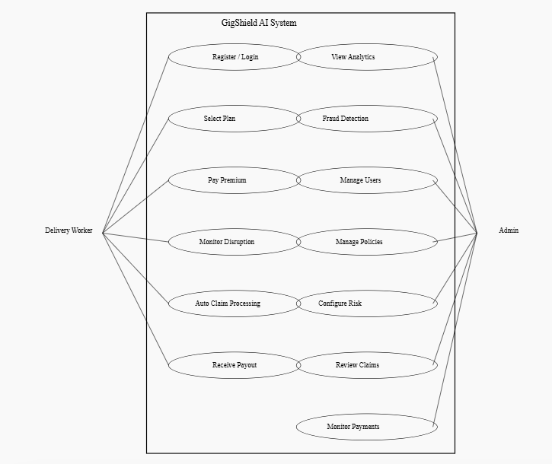
6. System Workflow
Our system follows a complete automated workflow:
- User registers on the platform
- AI performs risk assessment
- System recommends insurance plan
- User selects plan and pays weekly premium
- System continuously monitors environmental conditions
- Disruption trigger is detected
- Fraud detection module verifies user authenticity
- Income loss is calculated
- Claim is approved or flagged
- Payout is processed instantly

7. Technology Stack
Frontend:
- React.js
- HTML, CSS
Backend:
- Node.js
- Express.js
Database:
- MongoDB
AI/ML:
- Python
- Scikit-learn
APIs:
- Weather API
- Air Quality API
8. Future Enhancements
Our team plans to enhance the system with:
- Integration with delivery platforms
- Advanced AI prediction models
- Real-time alerts for workers
- Blockchain-based claim transparency

9. Conclusion
We aim to build a secure, intelligent, and scalable insurance platform that protects gig workers from income loss while preventing fraud. By combining AI-based risk assessment, parametric triggers, and multi-layer fraud detection, our system ensures reliability, fairness, and financial sustainability.

