AWS PROJECT ASSIGNMENT
Amazon EC2 + Apache HTTP Server + Amazon DynamoDB

PROJECT DOCUMENT
This project demonstrates hosting a secure static website using Amazon S3 and Amazon CloudFront CDN. The web assets (index.html) are stored in an S3 bucket named aws-project-antra-2026 and distributed globally via CloudFront for low-latency delivery.
​To enforce security, direct public access to the S3 bucket is restricted using Origin Access Control (OAC), ensuring traffic routes exclusively through CloudFront. The distribution uses index.html as the Default Root Object and enforces HTTPS by automatically redirecting HTTP requests.
AWS Component | Configuration / Role | Evidence
Amazon EC2 | Linux virtual server hosting Apache | EC2 terminal screenshots
Apache HTTP Server | Serves custom HTML page on port 80 | httpd status + curl output
Amazon DynamoDB | NoSQL database: StudentManagement | DynamoDB console screenshots
AWS CloudShell | AWS CLI database operations | Put/Get/Scan/Update screenshots
EC2 Security Group | Inbound TCP 80, 443 and 22 | Security group screenshot

1. OBJECTIVES
- Deploy a basic web server on Amazon EC2.
- Configure Apache HTTP Server to serve a custom webpage.
- Create a DynamoDB table for student information.
- Use StudentID as the DynamoDB partition key.
- Insert, retrieve, scan and update student records using AWS CLI.
- Verify the implementation with screenshots and functional tests.
- Document the AWS architecture, configuration and results in one submission-ready file.

2. ARCHITECTURE DIAGRAM
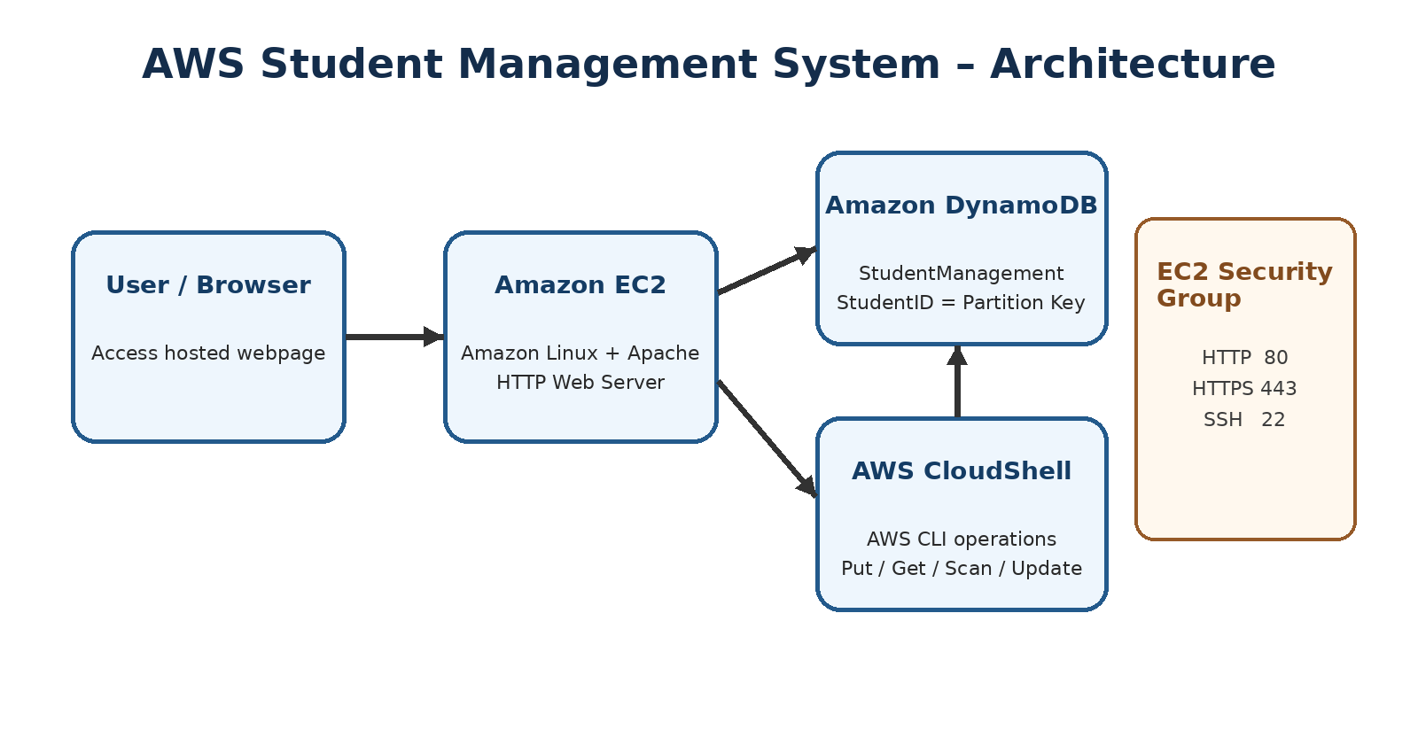
Figure 2: Architecture of the implemented AWS Student Management System.
The browser reaches the web server through the EC2 security group. Apache runs on the EC2 Linux instance and serves the HTML page. Student records are stored in DynamoDB. AWS CloudShell provides the command-line interface used to perform database operations.

3. IMPLEMENTATION AND CONFIGURATION

3.1 Amazon EC2 and Apache
The EC2 terminal evidence shows the Apache service (httpd) in an active/running state. The server is configured to listen on port 80. A local curl request returns a custom webpage titled 'AWS EC2 Web Server' with the message 'Welcome to My EC2 Web Server'.
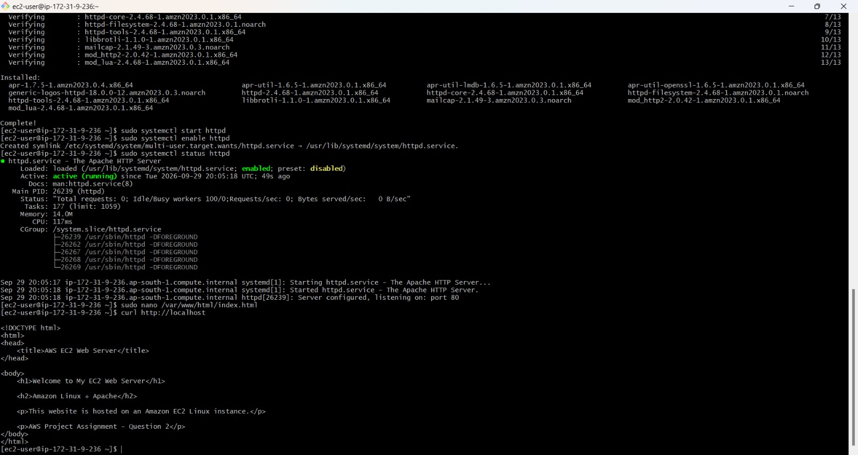
Figure 3: EC2 terminal showing Apache/httpd service status and web-server response.
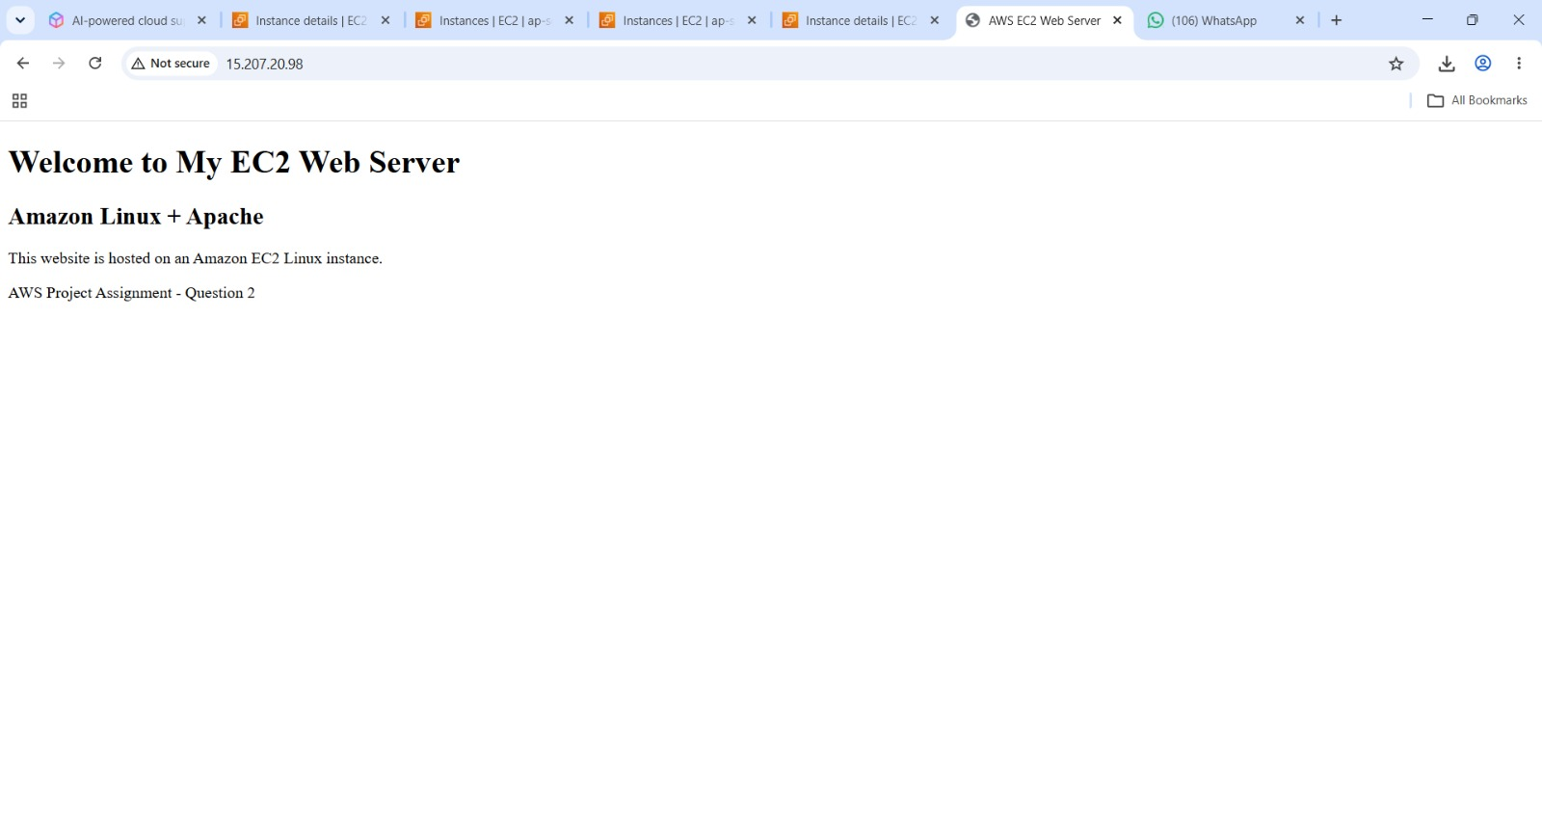
Figure 4: Browser view of the custom EC2-hosted webpage.

3.2 DynamoDB Table Configuration
The DynamoDB console shows the StudentManagement table as Active in the Asia Pacific (Mumbai) region. The partition key is StudentID with String data type. The table uses on-demand capacity.
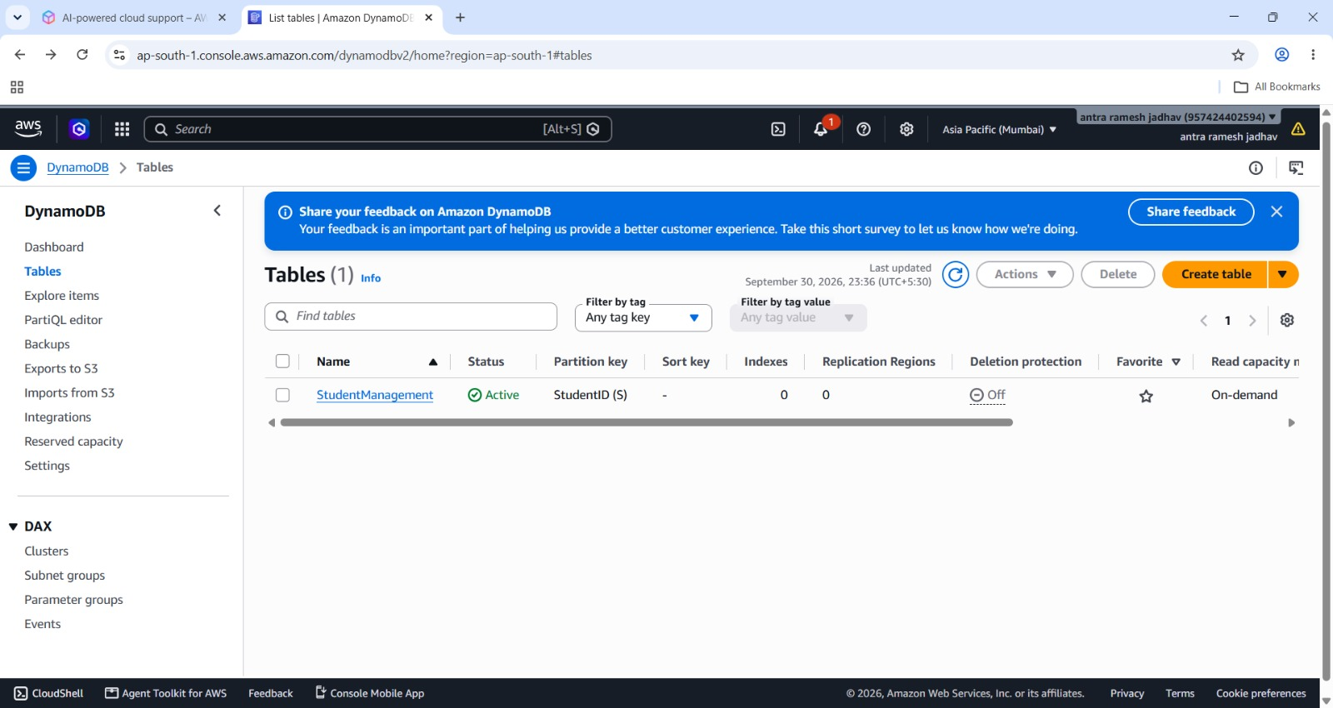
Figure 5: DynamoDB Tables page showing StudentManagement as Active.
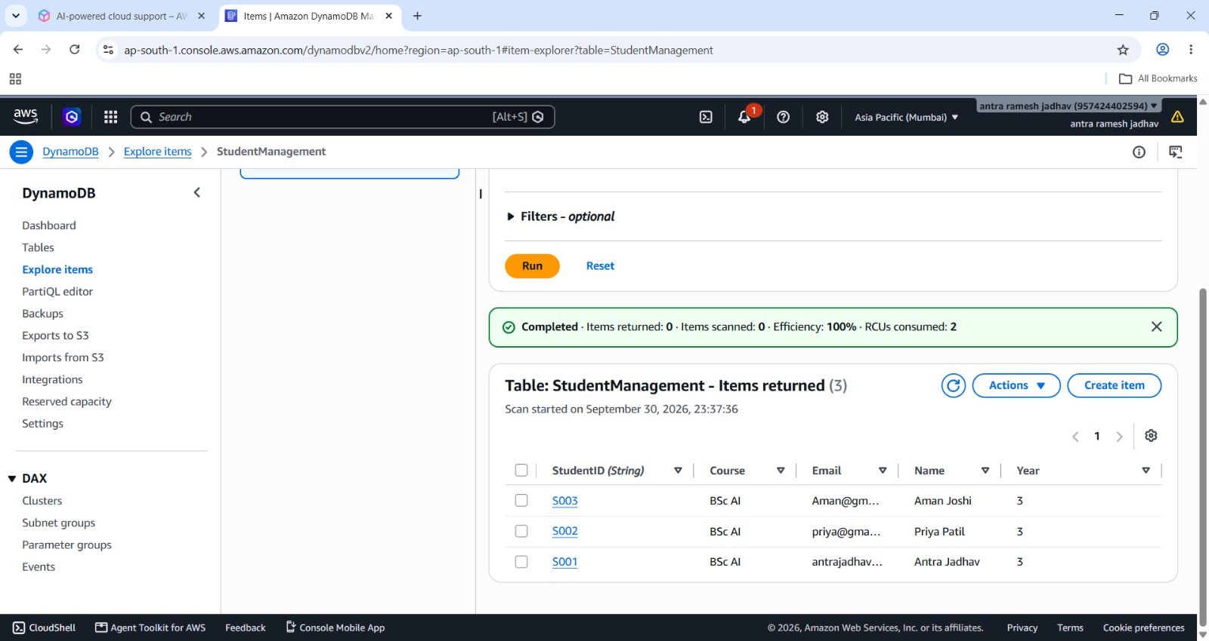
Figure 6: DynamoDB Explore Items page showing student records.

3.3 Student Data Model
Attribute | DynamoDB Type | Purpose
StudentID | String | Unique partition key
Name | String | Student name
Course | String | Course / program
Year | Number | Academic year
Email | String | Student email address

3.4 AWS CloudShell / DynamoDB CLI
The screenshots demonstrate the following operations:
- PutItem – adds student records to StudentManagement.
- GetItem – retrieves a specific record using StudentID.
- Scan – retrieves multiple records from the table.
- UpdateItem – changes an attribute of an existing record.
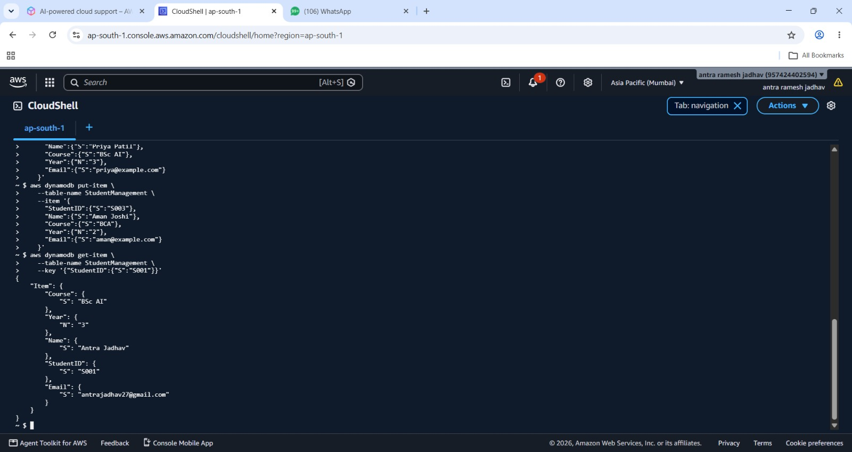
Figure 7: AWS CloudShell showing DynamoDB table data / scan output.
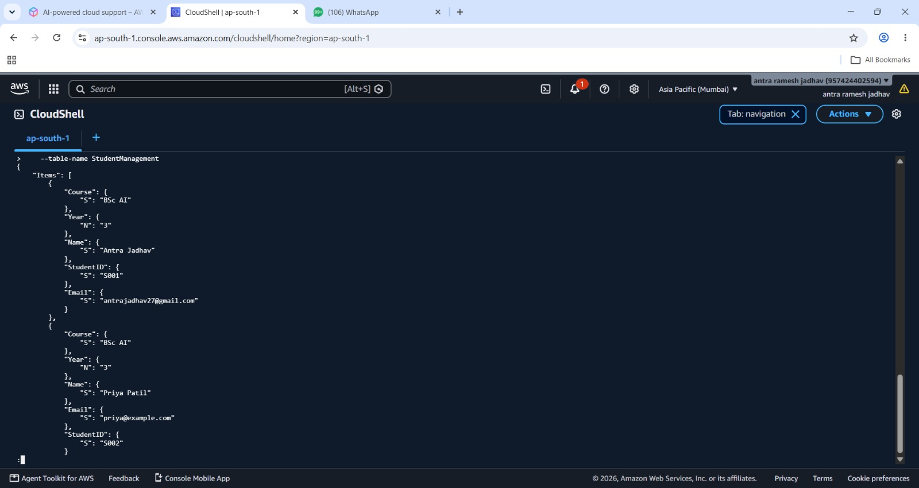
Figure 8: AWS CloudShell showing DynamoDB item output.
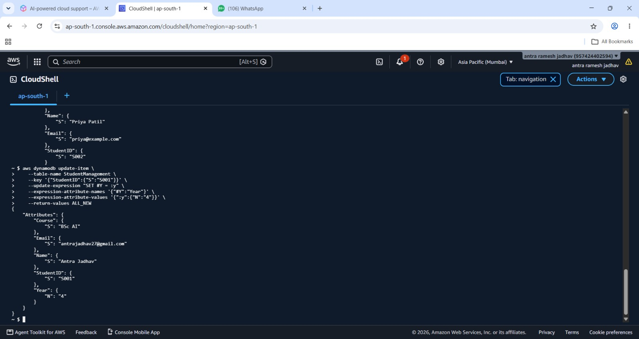
Figure 9: AWS CloudShell showing DynamoDB item output.
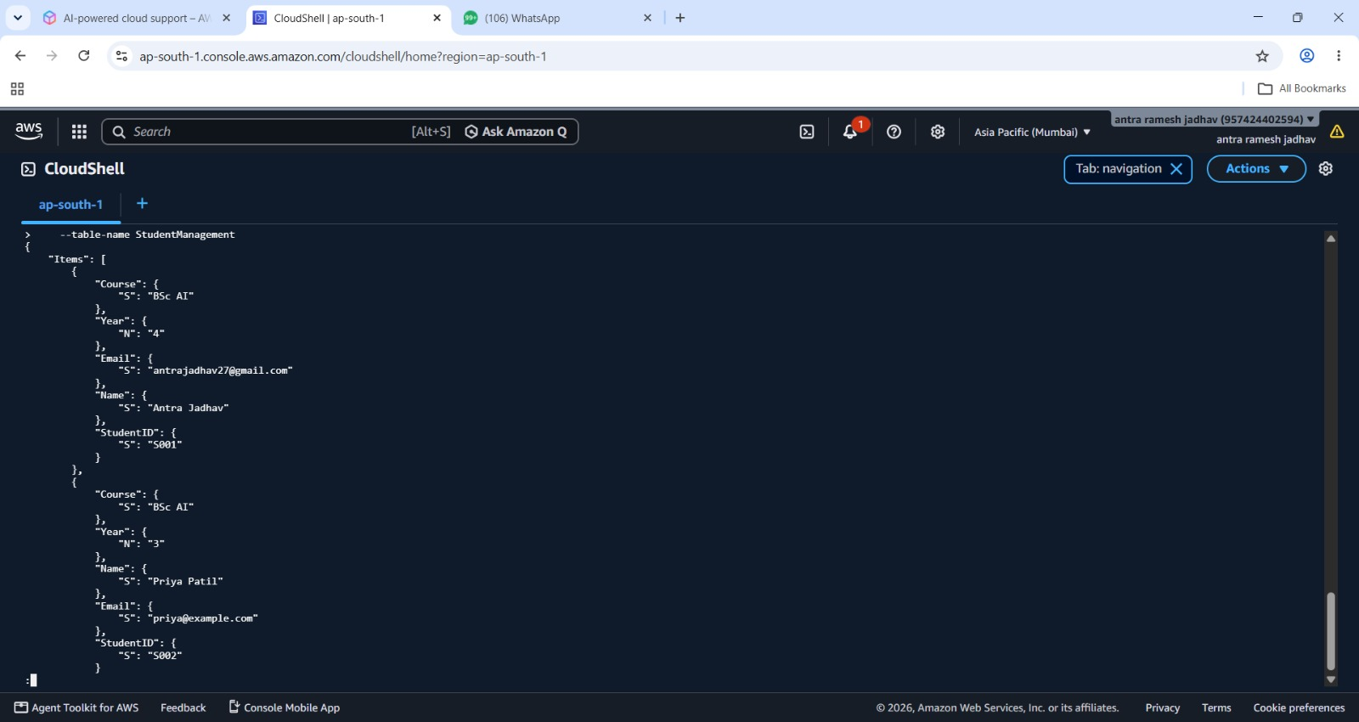
Figure 10: AWS CloudShell showing the updated StudentManagement data.

4. CONFIGURATION DETAILS
Configuration Item | Observed / Used Configuration
AWS Region | Asia Pacific (Mumbai) — ap-south-1
Compute | Amazon EC2 Linux instance
Web Server | Apache HTTP Server (httpd)
Web Port | TCP 80 / HTTP
Database | Amazon DynamoDB
Table | StudentManagement
Partition Key | StudentID (String)
Capacity Mode | On-demand
CLI Environment | AWS CloudShell
Security Group | HTTP 80, HTTPS 443, SSH 22

5. SAMPLE AWS CLI COMMANDS USED
The following command patterns correspond to the operations visible in the screenshots.
aws dynamodb get-item --table-name StudentManagement \
--key '{"StudentID":{"S":"S001"}}'
aws dynamodb scan --table-name StudentManagement
aws dynamodb update-item \
--table-name StudentManagement \
--key '{"StudentID":{"S":"S001"}}' \
--update-expression "SET #y = :y" \
--expression-attribute-names '{"#y":"Year"}' \
--expression-attribute-values '{":y":{"N":"4"}}' \
--return-values ALL_NEW

6. SECURITY GROUP CONFIGURATION
The supplied EC2 security-group screenshot shows three inbound rules. HTTP port 80 supports the Apache webpage, HTTPS port 443 is available for secure web traffic, and SSH port 22 supports remote administration.
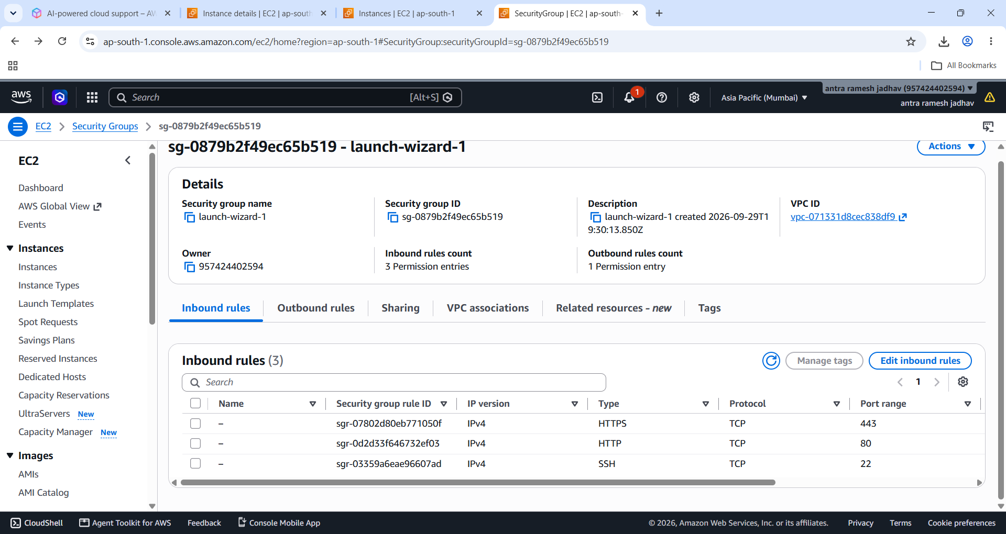
Figure 11: EC2 security group inbound rules (HTTP 80, HTTPS 443 and SSH 22).

6. TESTING PLAN AND RESULTS
Test Case | Procedure | Expected Result | Observed Result
T1 – Apache service | Check httpd service status | Service is active/running | Active/running shown in screenshot
T2 – Web page | Run curl to localhost | HTML page is returned | Custom AWS EC2 Web Server page returned
T3 – DynamoDB table | Open StudentManagement | Table is Active | Active table shown
T4 – Read item | Run GetItem for S001 | Student record returned | S001 record returned
T5 – Scan table | Run Scan | Multiple student records returned | Student records displayed
T6 – Update item | Update Year for S001 | Updated value returned | Year shown as 4
T7 – Network access | Check security group | Required ports configured | 80, 443 and 22 shown

7. RESULTS
- Apache was verified as running on the EC2 instance.
- The custom HTML page was successfully served by the EC2 web server.
- The StudentManagement DynamoDB table was created and shown as Active.
- Student records were visible through DynamoDB Explore Items.
- DynamoDB records were accessed using AWS CLI through CloudShell.
- An existing student record was successfully updated.
- The EC2 security group contained HTTP, HTTPS and SSH inbound rules.
- Verify that the updated record contains the new Year value.

8. LIMITATIONS AND FUTURE ENHANCEMENTS
- The current demonstration uses a basic HTML page rather than a full student-management frontend.
- Authentication and role-based access are not demonstrated.
- For production, SSH access should be restricted to trusted IP addresses.
- HTTPS should be configured with a valid TLS certificate before production use.
- CloudWatch monitoring, automated backups and deployment automation can be added.
- A backend API can be added to connect the web interface directly with DynamoDB.

9. CONCLUSION
This project demonstrates a complete basic AWS workflow for a cloud-hosted Student Management System. Amazon EC2 provides the virtual server, Apache provides web hosting, DynamoDB stores student data, and AWS CloudShell provides CLI-based database management. The supplied screenshots provide evidence for the implementation, configuration and testing of the major components. This document combines those materials into a single submission-ready project report.

