|  |
| --- |
| e-PG Pathshala logo.png  **Information Technology** |
| **Mobile Computing**  **Module: Spread Spectrum Technology: Frequency Hopped Spread Spectrum** |
|  |

## **Learning Objectives**

* History of spread spectrum technology
* Difference between Narrow band and Spread Spectrum Signal
* Understand the advantage of Spread Spectrum Technology over narrow band
* Discuss types of Spreading techniques
* Introduction to Frequency Hopped Spread Spectrum and its working
* Understand the variants of Frequency Hopped Spread Spectrum

## **Introduction**

A famous Hollywood actress, HedyLamaar along with film music composer George Antheil, patented “Secret Communication System” in 1942 which received U.S. Patent #2.292.387. The Spread Spectrum communication technology was introduced. The invention was believed to be quite ahead of time and was not taken seriously until 1980’s when U.S. military declassified it and since then it is foundation of today’s wireless technologies like CDMA, Wireless LAN, IMT-2000, Bluetooth, 3G and Global Positioning Systems(GPS).Narrow band signals transmit at a very constant frequency for eg. FM radio will always transmit at the frequency allocated to it say 98.3. The receiver has to tune onto this frequency to get the broadcast. Since the narrow band transmission always uses the same and predefined frequency, it is very easy to intercept, interfere and jam. It also requires high power to transmit. Spread Spectrum technology offers a solution to these problems. Spread spectrum devices transmit at varied frequencies occupying greater bandwidth but less power. Transmission on different frequencies makes the transmission hard to intercept and interfere. Spread Spectrum technology is a technique that spreads the narrow band signal to a broad range of frequencies. This is done by using different spreading techniques mainly Frequency Hopped Spread Spectrum and Direct Sequence Spread Spectrum. This module explains the Spread Spectrum technology, various spreading techniques and the technologies implementing it.

## **History of Spread Spectrum Technology**

Spread spectrum use is on the verge of potentially explosive commercial development, especially in relation to the internet. what's is surprising is that the inventor behind this amazing process is an incredibly beautiful and talented actress of the 1940's! .Her name is Hedy Lamarr, known as "The Most Beautiful Girl in The World"



She with American composer George Antheil, came up with was an idea for a sophisticated anti-jamming device for use in radio-controlled torpedos during world war II. Lamarr and Antheil realized that radio-controlled torpedoes, which could be important in the naval war, could easily be jammed, thereby causing the torpedo to go off course. If pianos could be synchronized to hop from one note to another, why couldn't radio signals - steering a torpedo - hop as well? Their inventive partnership was born. Hedy's idea was if you could make both the transmitter and the receiver simultaneously jump from frequency to frequency, then someone trying to jam the signal wouldn't know where it was.They designed a frequency-hopping system that would continually change the radio signals sent to the torpedo.

They were awarded U.S. Patent Number 2,292,387 on August 11, 1942, under the name "Hedy Keisler Markey" and George Antheil for a "Secret Communications System."

Who would have known that a glamorous female movie star of the 1940's would defy all stereotypes and create a communications system that was decades ahead of its time and is only now coming into widespread use. The invention could not be implemented during World War II and only came into use 20 years later during the 1962 Cuban Missile Crisis their patent catalyzed the use of Spread Spectrum, which is a highly efficient way of using radio frequencies at the same time, without interfering with each other. This is the basis for the cellular phones, faxes, and other wireless communications systems in widespread use today and is foundation of today’s wireless technologies like CDMA, Wireless LAN, IMT-2000, Bluetooth, 3G and Global Positioning Systems (GPS).

## **Narrow band Signal**

In a transmission system, the information is modulated with a carrier signal and then transmitted. When transmitted, all the power transmitted is centered around a particular frequency. This frequency represents a specific channel and has a narrow band. This narrow band signal has certain disadvantages like:

1. Since the transmission is always on a constant frequency, it is easy to intercept
2. It requires more power to overcome the noise
3. Suffers from interference
4. Prone to jamming and tapping

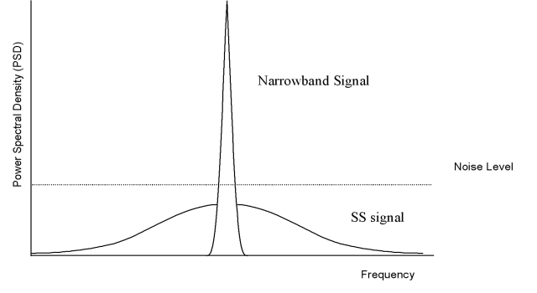

Figure 1: Narrow band vs Spreaded signal

## **Spread Spectrum signal**

Spread Spectrum technology is a technique that spreads the narrow band signal to a broad range of frequencies. Spread spectrum devices transmit at varied frequencies occupying greater bandwidth but less power. Transmission on different frequencies makes the transmission hard to intercept and interfere. Spread spectrum modulation spreads out the modulated signal bandwidth so it is much greater than the message bandwidth.

A signal that occupies a bandwidth of B, is spread out to occupy a bandwidth of Bss (Fig 2). Spread spectrum increases BW of message signal by a factor N, known as Processing Gain

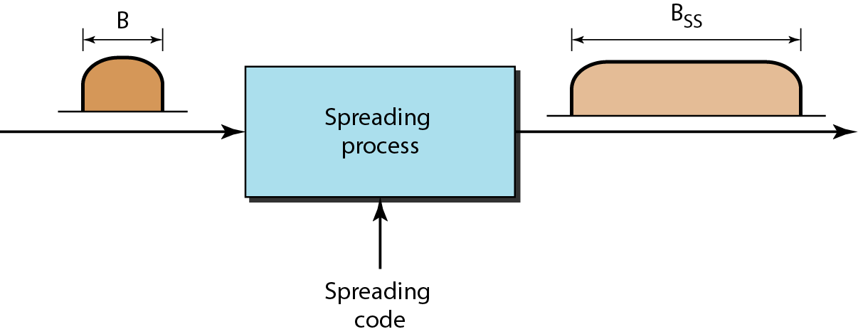

Figure 2: Signal Spreading



## **Advantages of Spreaded Signal**

There are several advantages of the scheme which prima face appears as wastage of bandwidth they are:

1. **Hard to Intercept:**  Figure 1 shows narrow band signal as well as the spreaded signal. It can be seen that power level of spreaded signal is much less than the original narrow signal. It can also be lower than background noise and thus hard to detect.
2. **Power requirement is low:** During transmission it is always possible that some atmospheric noise will creep into the transmission which can be misinterpreted as radio signals. To overpower this noise, the narrow band signals need to be transmitted with high power than noise. Spreading the signal over frequency can lower the power requirements. For instance if narrow band signal requires 10 watts to transmit 1 MHz, a spread spectrum signal may require only 100 miliwatts to transmit 20 MHz signal.
3. Used for hiding and encrypting signals because only a recipient who knows the spreading code can recover the coded information
4. Reduces narrow band interference
5. Since the transmission is on varied frequencies, it is difficult to jam the signal, the inherent property for which it was used in military applications
6. Several users can independently use the same Bandwidth with very little interference
7. Has built-in security

## **Spread Spectrum techniques**

The spread spectrum system is a two-step process:

1. Data is modulated
2. Carrier is modulated causing it spread over a large bandwidth

The signal can be spreaded in many ways. Some of the spreading techniques are mentioned below

1. **DSSS**: Used for digital information transmission. The information is spreaded by the means of a code. The information is transmitted along with a pseudo random code known as chipping sequence.
2. **Frequency Hopping**: The Frequency of carrier is changed many times within a fixed time period. Hence instead of transmitting on a single frequency, varied frequencies are used
3. **Chirp**: The Carrier is swept over a range of frequencies known as chirp spread spectrum. It is mainly used in radar systems and ranging devices.
4. **Time Hopping**: The carrier is ON-OFF keyed in a pseudo noise sequence.
5. **Hybrid**: Takes best points of 2 or more spread spectrum systems

Only FHSS and DSSS are available for commercial and amateur use. Rest are reserved for military and space sciences.In this module we will discuss FHSS in detail

## **Frequency hopped Spread Spectrum**

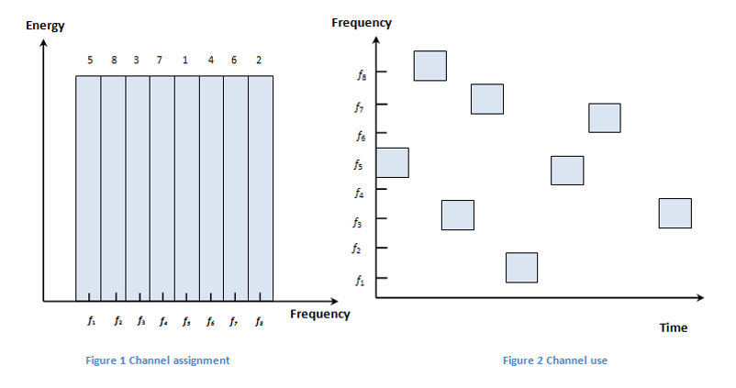In this spread spectrum technique, the total available bandwidth is divided into many channels of smaller bandwidth with guard spaces between them. Transmitter transmits by changing or hopping from one frequency to another in a pseudorandom but predictable manner. The technique spreads the original signal as well as provide immunity to interference. The receiver as to synchronize itself to the pseudorandom sequence in order to despread the signal.

Figure 3Frequency hopped Spread Spectrum

**Advantages of FHSS over standard FDMA**

* Resistant to narrowband interference.
* Difficult to intercept. An eavesdropper would only be able to intercept the transmission if they knew the pseudorandom sequence.
* If the hop sequence of two transmitters are different and never transmit the same frequency at the same time, then there will be no interference among them hence allowing multiple access(Fig 5).

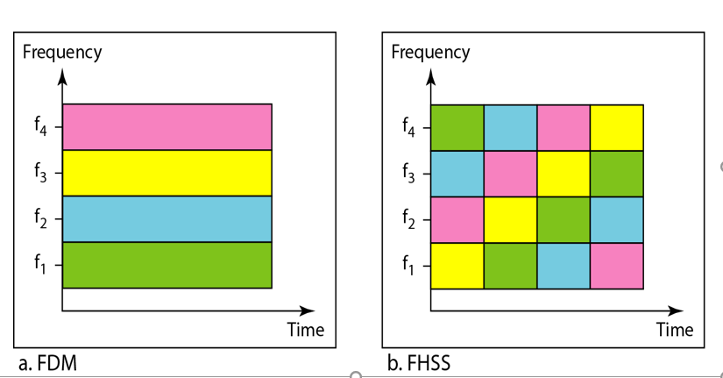

Figure 4Multiple access via FHSS

## **Technologies using FHSS**

The original standard for IEEE 802.11 popularly known as Wi-Fi defines 13 hopping channels for North America and Europe and 23 hopping channels for Japan each with band of 1 MHz in 2.4 GHz ISM band.

For IEEE 802.11b

* U.S. allows the use of channels 1 thru. 11
* U.K. can use channels 1 through 13
* Japan allows the use of all 14 channels

Bluetooth uses 79 channels for frequency hopping in the unlicensed ISM band at 2.4 -2.4835 GHz.Each device performs frequency hopping with 1600 hops/sec. Collection of devices with same hopping sequence forms a piconet. Master of piconet determines the hopping pattern and the slaves have to synchronized to this pattern.

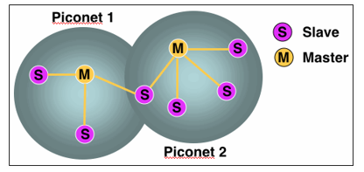

Figure 5 Bluetooth Technology

## **Components of FHSS**

* **Hopset:** Set of different frequencies over which the hopping occurs. The bandwidth of channel used in hopset is called instantaneous bandwidth. Total bandwidth over which hopping occurs is called total hopping bandwidth. In the Fig4 Frequencies f1 to f8 forms the hopset.
* **Hopping Sequence:** Sequence of channels used is dictated by a spreading code. Both transmitter and receiver should use the same code to tune into sequence of channels for synchronization. Fig 7 shows the hopping sequence
* **Hop Time:** Small amount of time during a frequency change in which no transmission takes place
* **Dwell Time:** Time spent on a particular channel with a carrier frequency.

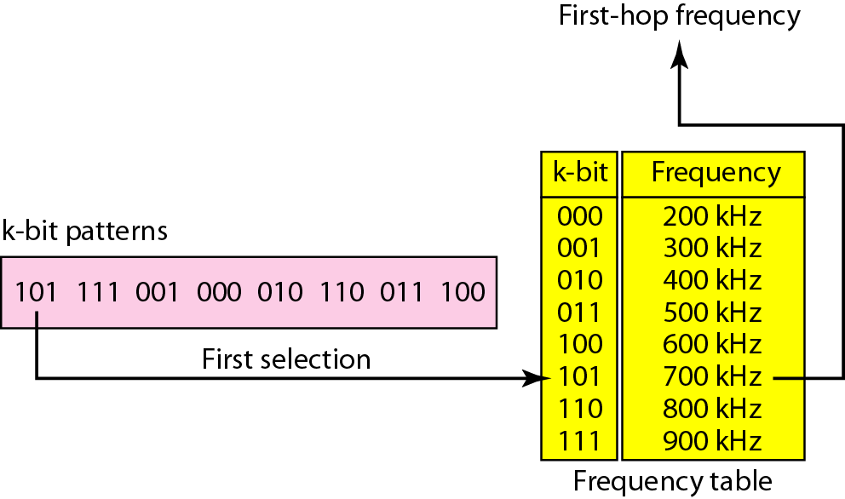

Figure 6 Hop set and hopping sequence

## **Variants of FHSS**

According to the dwell time, there are two variants of Frequency Hopped Spread Spectrum namely:

**Slow Hopping:** The transmitter remains on one frequency channel during transmission of many bits. Like the dwell time for GSM is 4.2 ms. Features of this scheme are:

* Cheaper to implement
* Too much of synchronization among sender and receiver is not required
* Low immunity to narrow band interference.
* Very slow hopping is as good as FDMA

**Fast Hopping:**The transmitter hops to many frequency channels during the transmission of a single bit. Eg Bluetooth.Features of this scheme are:

* Complex Implementation
* Precise Synchronization required
* Low narrow band interference.

The two variants are illustrated in the diagram given below

**tb**

User data

t

0

1

f

0

1

1

0

0

Slow hopping (4 bits/hop)

Slow hopping (4 bits/hop)

Slow hopping (4 bits/hop)

t

t

Figure 7 slow and fast hopping

f4

f3

f2

**td**

f3

f4

f2

f1

f

**td**

Fast hopping (4 hops/bit)

The above figure demonstrates slow and fast frequency hopping. To understand the figure let us understand the following terms:

Tb= bit period = time required to transmit 1 bit

Td = dwell time

The figure shows transmission of user data bits 0 1 0 1 1 0. The available bandwidth is divided into 4 parts f1, f2, f3 and f4.

In the slow hopping part we can see that the transmission remains on frequency channel f2 for transmission of three bits. The dwell time td = 3* tb

Similarly we can see in second case that during transmission of a single bit, the transmission has changed 4 times in a sequence f1 f4 f3 f2.

The dwell time td = tb/4

**Signal**

**Narrow band**

**Transmit spreaded signal**

**Spread Spectrum Modulation**

**Frequency synthesizer**

**Modulator**

**Binary Data**

Figure 8 Block diagram of frequency hopped spread spectrum sender

**Step1**: Modulation according to digital-to-analog modulation technique.It results in a narrow band signal

**Step2**: Modulation according to digital-to-analog modulation technique. It results in a narrow band signal

**Step 3**: Frequency hopping is performed based on hopping sequence

**Step 4**: The hopping sequence is fed into frequency synthesizer to generate the carrier frequencies and the narrow band signal is spreaded. The spreaded signal is transmitted

**Frequency synthesizer**

**Narrow band**

**Demodulator**

**Received signal**

**Signal**

**Demodulator**

**Binary data**

Figure 9 Block diagram of Frequency hopped spread Spectrum Sender

**Step 1**: The receiver knows the hopping sequence via frequency synthesizer

**Step 2**: It dispreads the spreaded signal using the hoping sequence. Narrow band signal is achieved

**Step 3**: Narrow band signal is demodulated again to obtain the user data

**Summary**

* Spread Spectrum technology was conceived by Hady Lamaar
* It spreads the required bandwidth via different techniques to reduce interference and to provide protection against jamming and tapping
* FHSS is a spread the total available bandwidth is divided into many channels of smaller bandwidth with guard spaces between them. Transmitter transmits by changing or hopping from one frequency to another in a pseudorandom but predictable manner. The technique spreads the original signal as well as provide immunity to interference
* Two variants of FHSS are slow hopping and fast hopping