
Information Technology
Mobile Computing
Module: Multiple Access Techniques in wireless networks

Learning Objectives
- Understand need of medium access control in wireless environment
- Understand multiple access schemes used in cellular systems in four dimensions
- SDMA: Understand the need and implementation of multiple access in space domain
- FDMA: Understand the need and implementation of multiple access in frequency domain
- TDMA: Understand the need and implementation of multiple access in time domain
- CDMA: Understand the need and implementation of multiple access using pseudo-random code

Introduction
Medium Access Control is protocol of data link layer. It is used to regulate the control of access among different users without or very less collisions. The transmission medium in wireless communication is air or atmosphere which is shared by multiple users or subscribers. In such a situation, simultaneous access by multiple users can lead to collisions. A good MAC algorithm should minimize the number of collisions hence increasing the throughput at the same time maintain fairness among the users.
Medium Access Control, allow several users to share a common medium of communication simultaneously. An efficient MAC technique should have goal of maximum channel utilization with minimum interference and collisions and provide reliable point-to-point or multipoint connection between different devices on medium. The common MAC algorithms existing in wired networks cannot be simply replicated in wireless networks due to situations like Hidden and Exposed terminal problem and near and far terminal problem. Due to these problems, the existing MAC algorithms like CSMA/CD fails in wireless scenario. In the previous module these problems were discussed and the motivation behind need of specialized MAC algorithms in wireless scenario was presented. In the previous module we discussed some of the alternative algorithms to CSMA/CD which works well in the wireless environment like MACA, MACAW and virtual carrier sense. In this module we present different multiple access techniques used in cellular systems and other wireless communication systems. The multiple access can be regulated in four dimensions namely SPACE, FREQUENCY, TIME and CODE. This module presents various ways in which these multiple access techniques are implemented and used.

Multiple Access Schemes for Cellular systems
Let us consider two real life situations which demand for an efficient multiple access mechanisms and different ways in which they are handled.
Analogy: Let us assume two analogous situations to wireless communications.
- First is a Highway which is used by many vehicles. Maximum number of vehicles should use the highway without collisions.
- Second is Hall of people whose conversations are to be regulated so that maximum people can talk without interference.

The goal is common: Collisions should be less and utilization should be maximum.

Highway Problem: Maximum vehicles should pass without collision. Some of the solutions are:
- Divide the common highway into number of lanes (Space division). Every vehicle can use a single lane. But the problem is that number of vehicles which can pass without collision is limited to the number of lanes. So its not an efficient utilization of the available space.
- The subsequent solution is that we allow more than one vehicle to pass the same lane provided they move with different speeds (Frequency division) hence avoiding collisions. Here the problem is that vehicles moving with same speed in same lane would collide
- To solve above stated problem, vehicles moving with same speed in same lane should arrive at different time (Time division).
Hall of people Problem: Second situation is conversation between people sitting in a hall. Some of the ways in which more and more people can talk without interference are:
- One way to reduce interference amongst their conversation to divide people among separate groups and make them sit at a substantially far distance from each other (Space Division).
- To avoid interference amongst the group, they can be restricted to talk with different pace and at different time (Frequency and time division)
- Another way which allows all the people to speak at the same place with same pace at same time is conversation in different languages. That is all people speak in different languages with the constraint that languages should be separable from each other; there should be very less correlation between the languages. For example Hindi and Gujarati are very much similar to each other therefore signals received from two people speaking in Hindi and Gujarati are not separable from each other. At the same time care should be taken that people close to the receiver should not drain the signals of people sitting far away.
Motivated from the above scenario, Multiple Access for Wireless Communications is regulated in four dimensions i.e. Space, Frequency, Time and code. Accordingly, there are four schemes:
- SDMA: Space Division Multiple Access
- FDMA: Frequency Division Multiple Access
- TDMA: Time Division Multiple Access
- CDMA: Code Division Multiple Access
In next four sections, we will discuss these schemes one by one

Space Division Multiple Access
In this scheme the different users sharing the bandwidth are physically separated from each other by allocating them a separate space. The users should be sufficiently separated from each other so as to avoid interference. For eg Cell formations in cellular systems, FM radio transmission implemented using Space division multiplexing. In cellular systems the geographical area is divided into different spaces called cells. Each cell is associated with a unique frequency/set of frequencies. Same frequency is allocated to different cells if they are at a sufficient distance from each other to avoid interference. Hence facilitating frequency reuse (Fig 1).

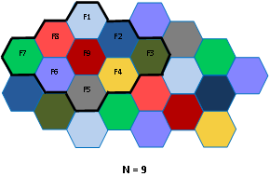
Figure 1: Space division multiple access by Cell formations
Additional separation is provided by the use of directional antennas. The cells are further divided into 3 sectors of 120 ⁰ each by the use of sectorized antennas (Fig. 2). New technologies like smart antennas or adaptive arrays use dynamic beamforming to shrink signals into narrow beams that can be focused on specific users, excluding all others. This technology further decreases interference and increases the capacity. Satellite dish antennas are highly directional that allow transmit signals to many zones on the earth's surface using duplicate frequencies for different zones (Fig. 3).

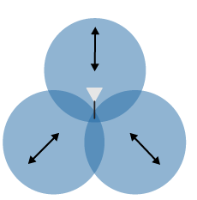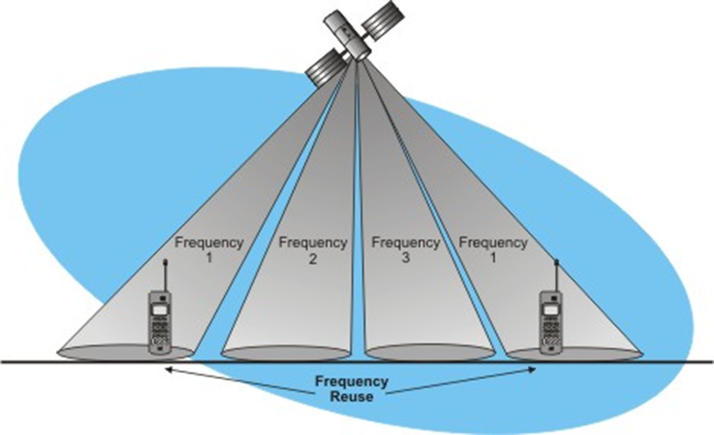

Figure 2: Sector formation Figure 3: Directional Antennas
Polarization division multiple access (PDMA), is a variant of SDMA in which signals are separated by using different polarizations of the antennas. Two different signals then can use the same frequency, one transmitting a vertically polarized signal and the other transmitting a horizontally polarized signal. The signals won’t interfere with one another even if they’re on the same frequency because they’re orthogonal and the antennas won’t respond to the oppositely polarized signal. Separate vertical and horizontal receiver antennas are used to recover the two orthogonal signals. This technique is widely used in satellite systems
Limitation of SDMA
This scheme clearly offers wastage of bandwidth because the channel remains with the user whether it uses it or not as in the case of radio stations. Another problem arises when more than one user wish to transmit in the same space. Like more than one station wants to transmit in the same city with same frequency. Therefore SDMA is never used alone instead it is always used in conjunction with FDMA and CDMA.
Frequency Division Multiple access
In this scheme, the bandwidth is divided into number of non-overlapping frequency bands with guard spaces between them. Each band can be used by single user. Guard spaces are needed to avoid adjacent channel interference (Fig 4) .
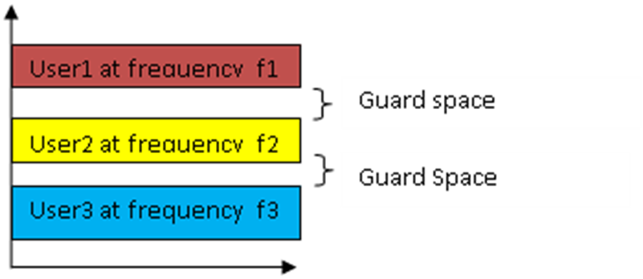
Frequencyy
Time

Figure 4: Pure FDMA
The allocation of frequencies in a FDMA system can be fixed or dynamic.
Fixed FDMA
In this scheme, the frequencies allocated to the channels are fixed and remain unchanged. E.g. radio stations. The limitation of this scheme is bandwidth wastage when the user is not using the frequencies allocated to it.
Demand Driven FDMA
The channels are allocated according to the load and demand. The frequencies assigned to the channels can be same for the whole time (Pure FDMA) or it can vary at different interval of times (FDMA + TDMA). FDMA + TDMA allows transmission to be on one of the frequency channels for some time and then jump to other frequency channel after some time (Fig. 5). This scheme is called frequency hopping and is used in Bluetooth, IEEE 802.11, GPS and other many other technologies. The pattern of channel usage is known as hopping sequence which both sender and receiver has to agree upon.

Frequency

Time
Figure 5: Frequency Hopping
If B= Total Bandwidth; G=width of Guard bands and ch is bandwidhth of single radio channel
Then Number of channels in FDMA system is given by
N=B-2G/ch
FDMA in GSM-900
GSM uses FDMA with an additional Frequency division duplexing scheme. Duplexing is required because GSM being a phone network, requires the transmission in both the directions simultaneously. The two directions are from mobile station to base station and base station to mobile station. To facilitate full duplexing the available bandwidth is divided in such a way that are two separate channels for transmission in both directions. The frequencies allocated for transmission from mobile station to base station are known as UPLINK and from base station to mobile stations are known as DOWNLINK. The UPLINK frequencies range from 890.2 MHz to 915 MHz and DOWNLINK frequencies range from 935.2 MHz to 960 MHz . The uplink and downlink bands are separated by a guard band
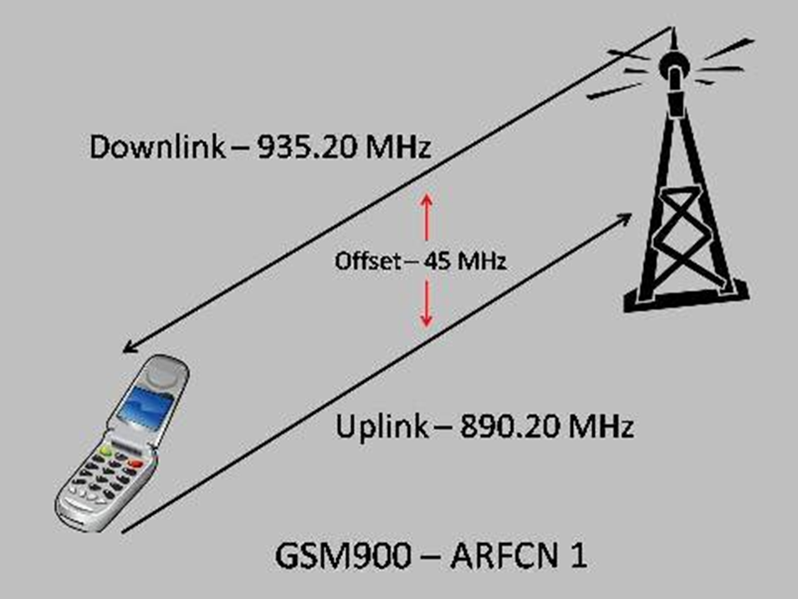
of 20 MHz.
Figure 6: Full duplexing
F_{u}= 890 MHz + 0.2 * n MHz; where n is the number of uplink channel.
Both uplink and downlink bandwidth is divided into 124 channels of 200 kHz each with guard bands of 100 kHz(Fig. 7). The uplink and downlink frequencies are calculated as :
F_{d =} 935 MHz + 0.2 * n MHz; where n is the number of downlink channel
F_{d =} F_{u +} 45 MHz
In practice GSM uses combination of FDMA and TDMA.

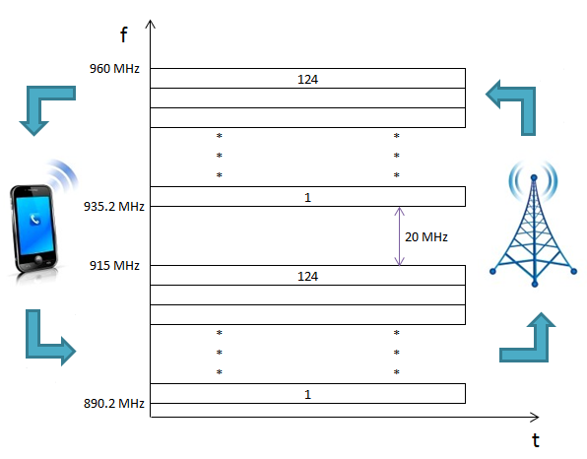
Figure 7: FDMA with FDD in GSM

Features of FDMA
- It can be used both for digital as well as analog
- Receiver should tune in to same frequency as the sender
- In digital transmission, the channel is not needed for the whole time. During that time the frequency remains unused
- FDMA demands highly efficient filters in the radio hardware, contrary to CDMA and TDMAFDMA is devoid of timing issues that exist in TDMA
- As a result of the frequency filtering, FDMA is not prone to the near-far problem that exists in CDMA.
- All users transmit and receive at different frequencies because every user receives an individual frequency slot.

Time Division Multiple Access
In this scheme, multiple users can transmit using same frequency but at different time. Each user transmit using common frequency band but at different non-overlapping time slots. The entire bandwidth is available to the user but only for a finite time.

Frequency

Time
In the figure above user 1 gets the complete frequency for time t1, user 2 at time t2 and so on. Data transmission in TDMA is not continuous but occurs in bursts. This results in low battery consumption since the subscriber transmitter can be turned OFF when not in use. Bandwidth can be supplied on demand to different users by concatenating or reassigning time slot based on priority. TDMA is used in GSM, IS-136, SS7,satellite systems etc. The two variants of TDMA are:
Fixed TDMA
The slot sizes are fixed. If T is the time in seconds and N is the number of users, then slot size=T/N. In this scheme if a user does not transmit during the allocated time slot, the corresponding bandwidth is wasted.
Dynamic TDMA
A scheduling algorithm dynamically allocates time slots according to the traffic demand of each.
Code Division Multiple Access
In this scheme, all the users use the complete bandwidth for whole time. Separation is achieved by assigning each channel its own code. The situation can be compared when people at a common place speak at same time with same frequency. Each pair speaks its own language and for others who might overhear the conversation, it may appear as noise. Thus CDMA also comes with built-in security. The languages should be clearly separated. For eg. Hindi and Gujarati won’t work but Hindi and French will serve the purpose. In code division multiple access the code separates the users as well as spreads the signal converting a narrow band signal to a broad band signal (Fig. 9).

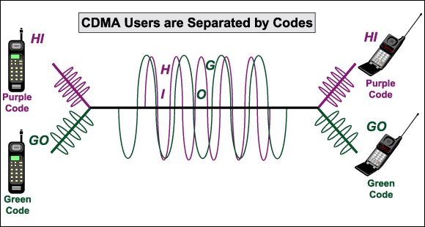
Figure 9: Example of CDMA

A good code should have these two properties:
A code for a user should have a good autocorrelation ie the absolute value of inner product of the code with itself should be a big value.
For eg. The Barker code (+1,-1,+1, +1, -1, +1, +1, +1, -1, -1, -1) has a good autocorrelation=11. This code is used in IEEE 802.11
The code should be orthogonal with other codes ie the absolute value of inner product of the code with other code should be zero.
Eg. (2,5,0) and (0,0,7) are orthogonal because (2,5,0) .(0,0,7)=0+0+0=0.

Advantage of CDMA
- Built in Security because only the receiver who knows the code can interpret it for others it is noise. That is why the code is also called pseudo random noise
- Protection against interference and tapping
Disadvantage of CDMA
- Huge Code Space is required
- Complexity at receiver side because the receiver has to know the code and separate it with user data
- Receiver should be precisely synchronized with the sender
- The strength of all the signals should be same otherwise the nearby signals will drain the far signals. Hence regular power regulations are required.
Summary
- Efficient MAC algorithms are a necessity for wireless communications
- Multiple access in wireless can be regulated in four domains
- SDMA separates users spatially like in cellular systems. Simple to implement but not efficient utilization of bandwidth
- FDMA provides different channels to different users statically or dynamically
- TDMA provides different time slots to different users. It can be static allocation or demand driven
- CDMA utilizes whole bandwidth whole time where separation is achieved using different codes

