Department Of Computer Science
Rollwala Computer Centre
Gujarat University

MCA –
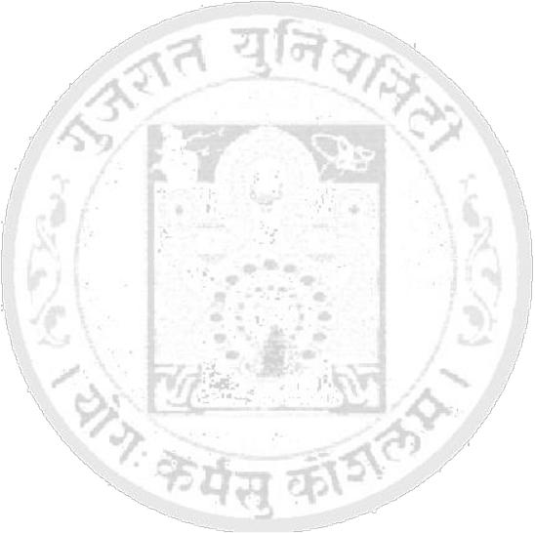

Subject: - ________Web Technology__________

Name: - _____Antra koul____________________________

Roll No.: - _13____ |  | Exam Seat No.: -______
Sr. | Contents | Pg. No | Date | Signature
No.
1. | Assignment1 | 1-17 | 25-Sept-2020
2 | Assignment 2 | 18-28 | 20-Oct-2020
3 | Assignment3 | 30-39 | 26-Oct-2020
4 | Assignment4 | 40-42 | 20-Nov-2020
5 | Assignment5 | 43-52 | 30-Nov-2020

