ECE 5332 – Machine Learning

Dr. Hamed Sari-Sarraf

**Project 6**

Digits Recognition using Convolutional Neural Network

By

An Tran

Bo Pei

Texas Tech University

May 14th, 2018

1. Network architecture and complexity (in terms of number of learnable parameters)

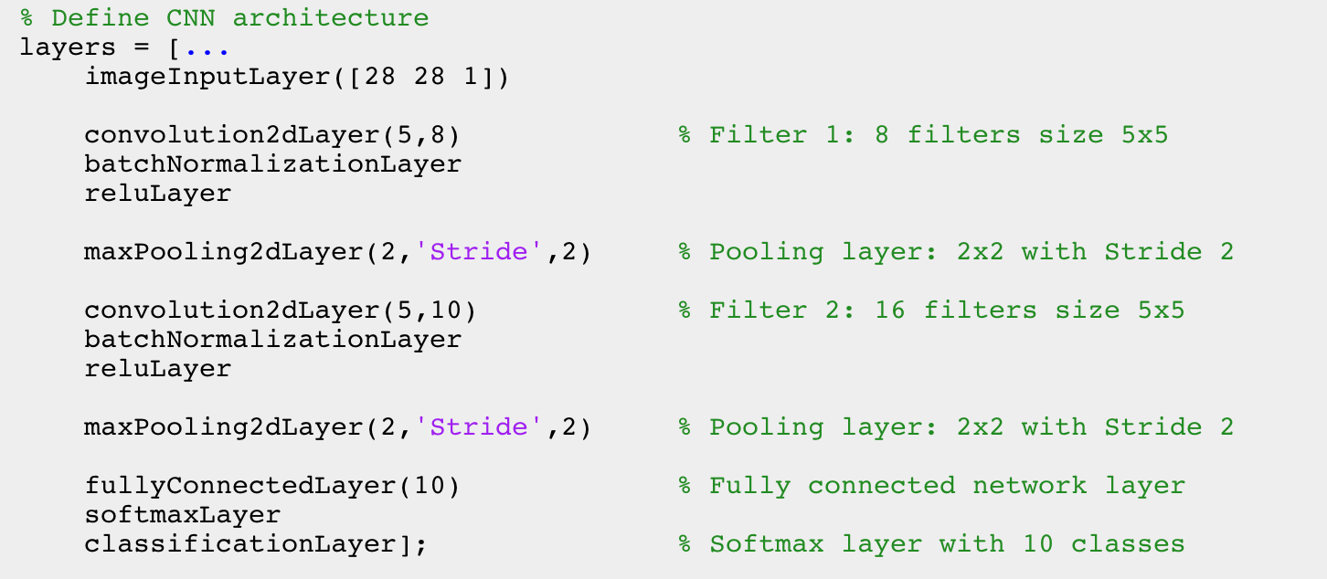

Figure 1. Network architecture and layers

|  |  |  |  |
| --- | --- | --- | --- |
| # | Name | Size | Learnable parameters |
| 1 | Input | 28x28x1 | **0** |
| 2 | Conv2d1 (Filter 1) | $\frac{28-5 }{1 }+1=24$ → **24x24x8** | (5x5)x8 + 8 = **208** |
| 3 | Maxpool1 | $\frac{24-2}{2 }+1=12$ → **12x12x8** | **0** |
| 4 | Conv2d2 (Filter 2) | $\frac{12-5}{1}+1=8$ → **8x8x10** | (5x5x8)x10 + 10 = **2010** |
| 5 | Maxpool2 | $\frac{8-2}{2}+1=4$ → **4x4x10** | **0** |
| 6 | Fully Connected | 4x4x10 = **160** | (160x10)+10 = **1610** |

* Total learnable parameters: 208 + 2010 + 1610 = **3828** parameters

1. Training time

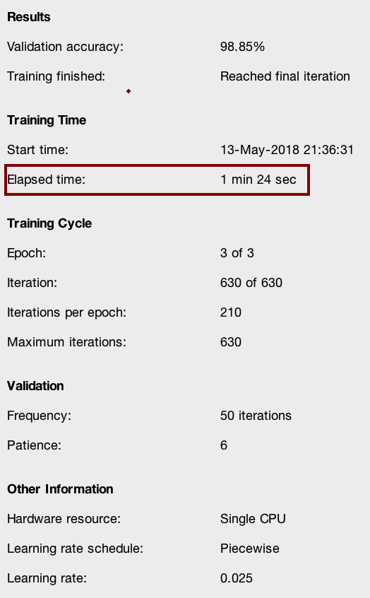

Figure 2. Training times and Validation accuracy

1. Training and testing accuracies

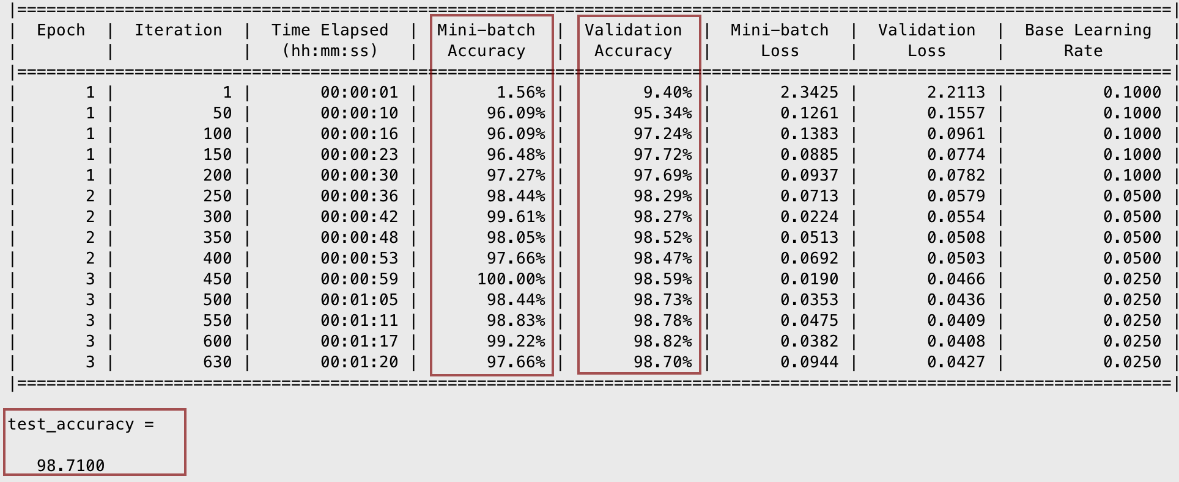

Figure 3. Testing and training accuracies

1. Brief description of live demo

* Image of each digits are taken using camera and saved as ‘jpg’ file and put in the same folder as the m files. Read the image into console, and using classify() function that was trained on the network to classify the actual hand written digits.
* There is a function named ‘process.m’ associated with the program. It is capable of reading in an image and process it so that the original image has the same format as the MNIST dataset which the model was trained on.
* First, the original image is converted to gray scale, and then the number is cropped from the redundant background using ‘largest connected component’, box that region surrounding the image and then resize it to 28x28 just like the MNIST dataset.
* From here, the model can classify the digits.

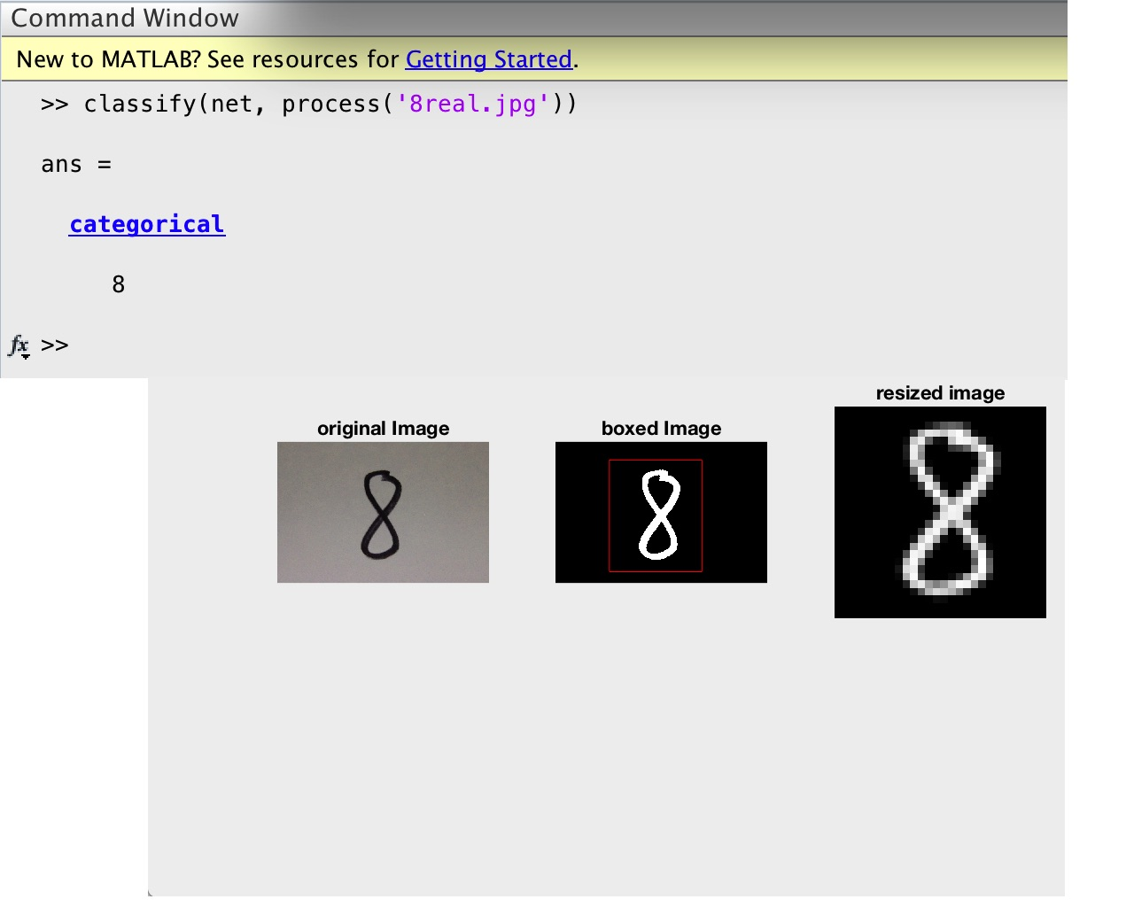

Figure 4. Demo