WIRELESS ECG MONITOR USING MOBILE DEVICE

By

DUY LE & AN TRAN

Professor Jo Woon Chong

Texas Tech University

Dec 7th, 2017

**Abstract:**

The objective of this project is to design a simple wireless electrocardiogram (ECG) monitoring system right on the user’s mobile device for convenience and mobility. This wireless ECG monitor potentially improves the quality of life of the user in general or cardiac patients in particular. The project has been completed using Radio Frequency transmission and receiver, Bluetooth technology, an ECG circuit and a mobile device for the monitoring of the signals.

1. **Introduction**

As technology has become more relevant in our daily life activities, the use of wireless communications and monitoring is indisputable in bio-medical and clinical applications, specifically in Electrocardiogram (ECG) aspect. Typically, wireless communications are practiced on two approaches: real time (synchronous) and store-forward (asynchronous). In clinical scenario, synchronous communication deals with the live transmission of medical data for monitoring and diagnosis to prevent diseases or undesired incidents. This is also called remote monitoring. On the other hand, “store-forward” method retains the medical data on a server or a computer in order to be transmitted at a later time to another location for analyzing by technicians or doctors. The feedbacks can take up several hours to be sent back to the patient [1].   
As a matter of fact, in ECG, the patient requires immediate response from the caregivers as well as doctors in the case of serious cardiac arrhythmias or sudden strokes. This is where technologies come in handy. An ECG system that is capable of monitoring the ECG signals of the patient remotely and analyzing these signals without the human inputs would play an essential role in bio-medical field. Such systems should be able to transmit and receive ECG data wirelessly and notify if the patient has arrhythmias or strokes from a distance. A study in 2007 indicates that the conventional heart monitoring systems often fails to detect cardiac strokes in patients in a timely manner, which results in the loss of opportunity to help the patients with such situations [3].

Therefore, we came up with a design that is capable of remotely monitoring cardiac activities of the users. This system can be used to monitor up to 12-lead ECG signals of the user continuously and display these signals on their mobile device using a combination of Radio Frequency and Bluetooth technology, with a bit knowledge of mobile application for the interface of the system. The application is still in preliminary stage which can receive multiple ECG lead signals at the same time but can only display one at a time, and the user has to manually select which lead they wish to look at. This mobile application has the potential to be developed further more to display multiple signals at the same time and the ability to calculate the user’s heart rate based on the incoming signals (measured in Beats per minute) in order to determine if the user has Tachycardia (fast heart rate), Bradycardia (slow heart rate) or Arrhythmia (skipping heart rate) [5]. Before going into details of the project, we would like to thank the Undergraduate students Henry and Adnan who built ECG detection circuit for us which is capable of measuring any ECG lead signal using two electrodes.

1. **Materials and Pre-processing**

Our project mostly dealt with the wireless communication and the transmitting/receiving of the signals; therefore, we are not going to discuss much about the hardware part of the project which is the ECG circuit. Figure 1 below is an overall diagram of the project flow, beginning from bottom to top.

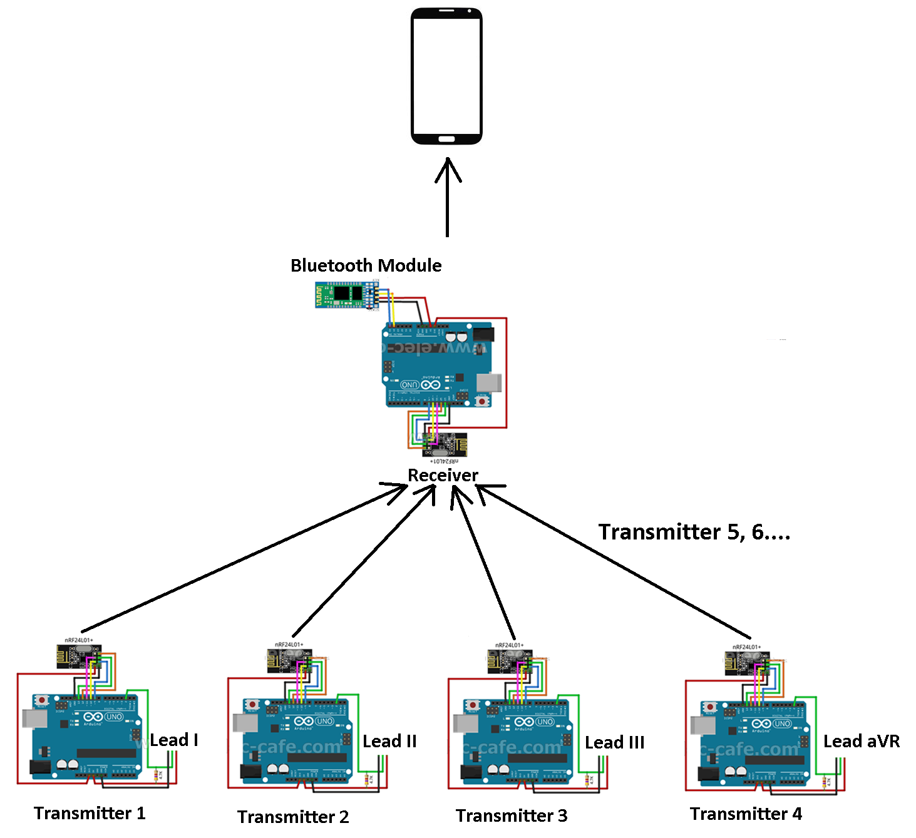

Figure 1. Flow diagram

The ECG signals such as Lead I, Lead II, Lead aVR, etc. measured by the circuits are the inputs to each of the Arduino that is connected to a specific RF module, which will be used as transmitters. These transmitted ECG signals will be sent to a separate Arduino that is also connected to the same RF module; however, this one is used as a Receiver. This whole network is called multiple transmitters with one receiver. The receiver is picking up all these signals simultaneously, and this Receiver is also connected to a Bluetooth module that is used to transmit again the received signals to the Mobile device [6]. The figure only shows 4 transmitters just to roughly demonstrate how the entire system works as a whole; in fact, each of these transmitters will be sending one lead signal, which make a total of 12 transmitters since this system is a 12-lead ECG. The following sections will explain each of the materials used and how they work from the beginning to end.

* **nRF24L01 RF Module**

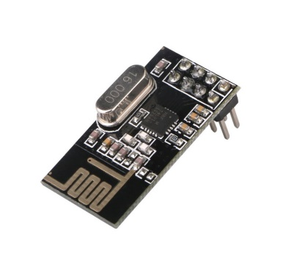

Bluetooth technology was not used for the transmitting process it only offers one on one communication. In other words, when the receiving device is talking to one transmitting device, it cannot talk to the others at the same time but they have to take turns. Therefore, transmitting multiple ECG signals for the receiver to collect them all simultaneously is impractical; fortunately, nRF24L01 is one of the few RF modules that support this feature. This particular module has a frequency of 2.4 GHz which is the same as Bluetooth technology, offers a 2 Megabytes per second of data transfer rate, consumes extremely low power which is really efficient for power saving, and more importantly, supports up to 100 meters of communication range [6]. In order for this “multiple transmitters – one receiver” network to work, the receiver will be talking to each of the transmitters simultaneously using Data Pipes. Figure 2 below is a sketch of this network:

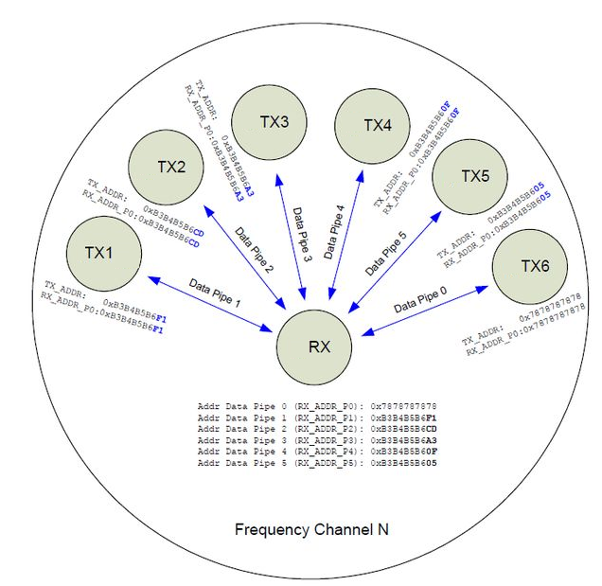

Figure 2. Multiple transmitters – One receiver network

These Data pipes are the means of communication between the receiver and its transmitters [6]. Each of the communication requires a different data pipe, and each of these data pipes is assigned a specific Address so that the receiver knows which signal is coming from which transmitters (for example Lead I is coming from transmitter 1, Lead II from transmitter 2 and so on).

1. **Methods**

* **Synchronization**

As a general problem in wireless communication, signals might be delayed due to collision during the transmitting process. As we know, signals are segmented into chunks of data when being wirelessly transmitted, and these chunks of data are carried by moving from one node to another until it reaches the final destination. Figure 3 below demonstrates this theory.

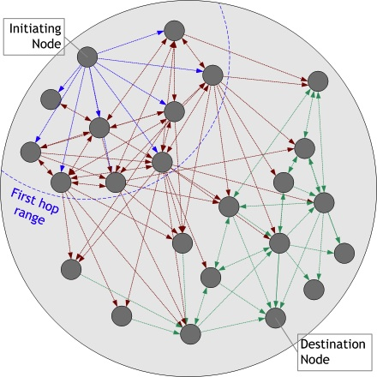

Figure 3. Wireless Transmission procedure

Since 12 signals are being transmitted, collision between each node of data is unavoidable, which potentially causes delays in some of the signals. Therefore, synchronizing these signals to make them all arrive at the same time at the receiver is necessary. In order to do that, each of the signals is assigned a specific time stamp before they are transmitted using Radio Frequency. Figure 4 below illustrates this proposal.

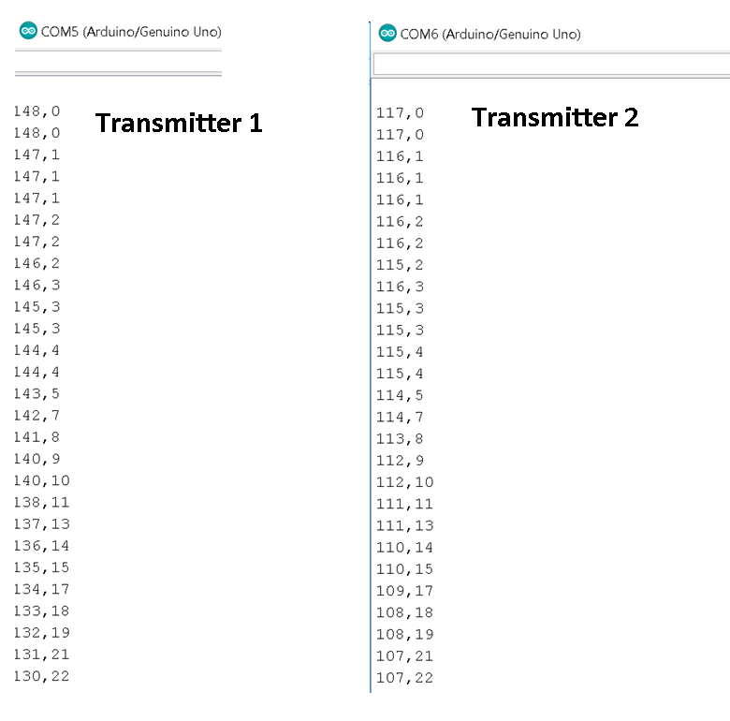

Figure 4. Time stamp for synchronization

In the figure above, let us take Transmitter 1 for example. The values on the left are the analog values of the signal; and the values on the right is the specific time measured in milliseconds assigned to that particular analog value before it is transmitted. For instance, right at 0 millisecond, a value of 148 is being sent. At 1 millisecond, a value of 147 is sent and so on. This works the same for transmitter 2. By assigning these specific time stamps to each of the analog values measured by the Arduino before they are transmitted, even if one signal is delayed compared to the others, they can always be synchronized at the receiver by aligning the values at millisecond 0 of all the transmitters, and then values at millisecond 1, etc. Figure 5 below is a small test that was carried out in order to verify that the synchronization works.

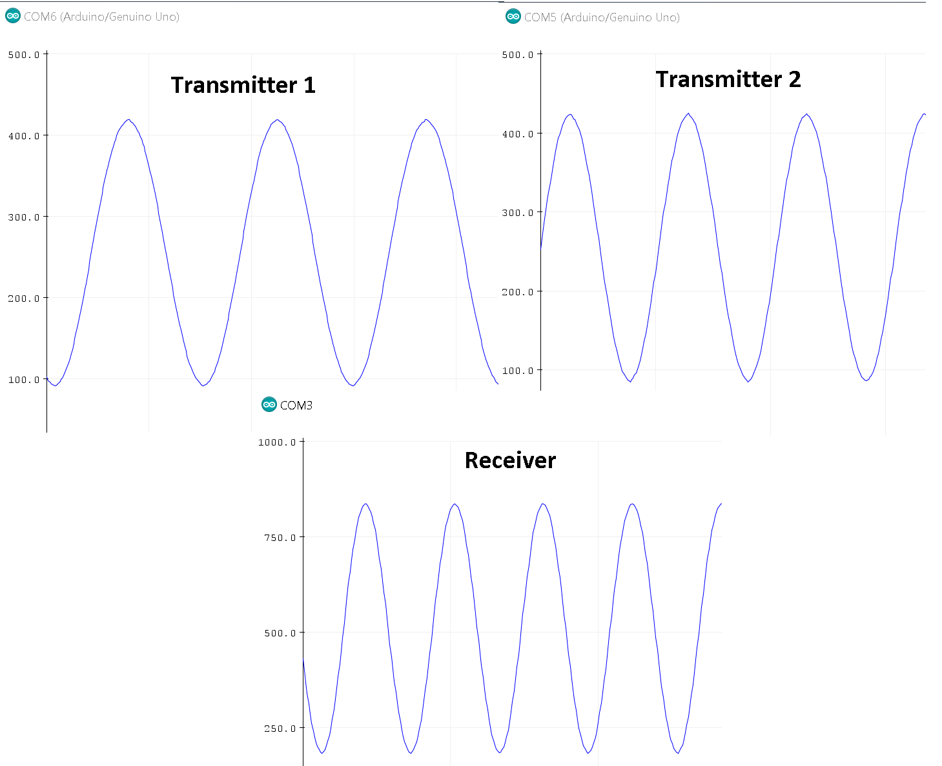

Figure 5. Synchronization verification

In this test, 2 sinusoidal signals with the same frequency are fed into transmitter 1 and transmitter 2. At the receiver, these 2 signals are added together using the time stamps assigned to each of the data bit of signals. What it means is that at the receiver, the analog value at millisecond 0 of transmitter 1 is added to analog value at millisecond 0 of transmitter 2. Therefore, the signal at the receiver would be the sum of these 2 sinusoidal waves, and if it has the same waveform but its magnitude is equal to the sum of the 2 signals from transmitter 1 and transmitter 2, then it is verified that these signals are synchronized. As seen in the figure above, the signal at the receiver has the same waveform as the 2 signals from both transmitters, and its magnitude looks approximately equal to the sum of the 2 signals; consequently, the signals are synchronized. Also note that during the testing process, there were multiple spikes present in the synchronized signals such as Figure 6 below. This is due to the ambient noises that generate these spikes randomly, and because of the use of breadboard for the testing purpose that causes a lot of noise. If the testing had been done on a fabricated green board, the signals would be a lot cleaner and less noisy.

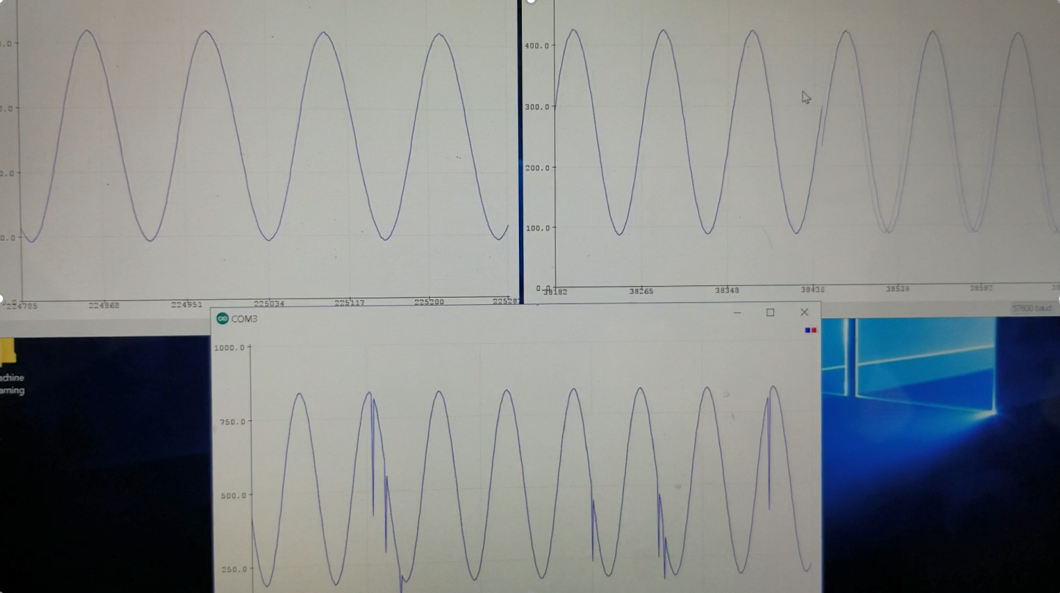

Figure 6. Spikes due to noises

1. **Results**

* **HC-05 Bluetooth Module**

Now that the signals are synchronized at the receiver, the next step in the process is to transmit these signals to the Mobile Device using Bluetooth, and the Bluetooth module that was used is the HC-05 Bluetooth module. This module is directly connected to the Arduino that is used as the receiver as seen in Figure 7.

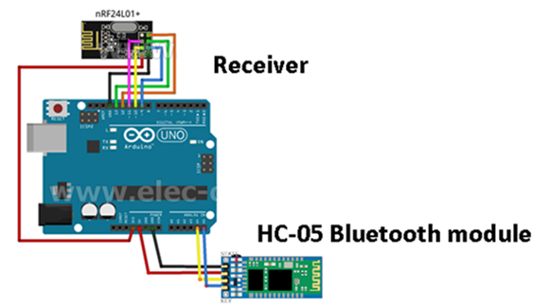

Figure 7. HC-05 Bluetooth Module

At the receiver, the synchronized signals are transmitted to the Mobile Device with the help of this Bluetooth Module. Only 4 pins of the module are used for the purpose of this application: Vcc, Ground, TX and RX. The TX pin of the module is connected to the RX pin of Arduino, and the RX pin of the module is connected to the TX pin of the Arduino. However, since the module only receives data from the Arduino and does not need to send anything back, the TX pin of the module is not necessary and only the RX pin is utilized, and the synchronized signals are sent to the Bluetooth module as Serial Data. Now that these signals have been transmitted thanks using Bluetooth, the signals are hanging around in the air waiting to be picked up. Therefore, a mobile application had to be created in order to establish a Bluetooth connection with the module to collect these signal data. A simple Android application is designed to connect with the Bluetooth module using BluetoothSPP library (Serial Port Profile) and pick up the serial data from the module. An ECG graph was also designed within the application in order to plot the collected ECG data from the receiver. The Graphical User Interface (GUI) of each stage is represented in the Figure below.

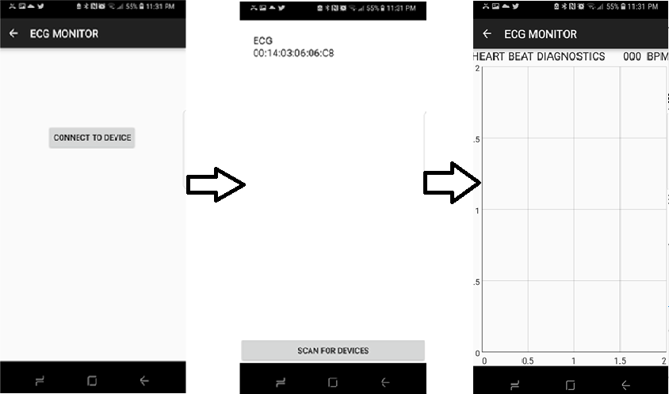

Figure 8. GUI of the Android application

Below is a demonstration of the ECG graph where it plots the incoming ECG signal from the receiver and compared to the actual signal seen by the oscilloscope:

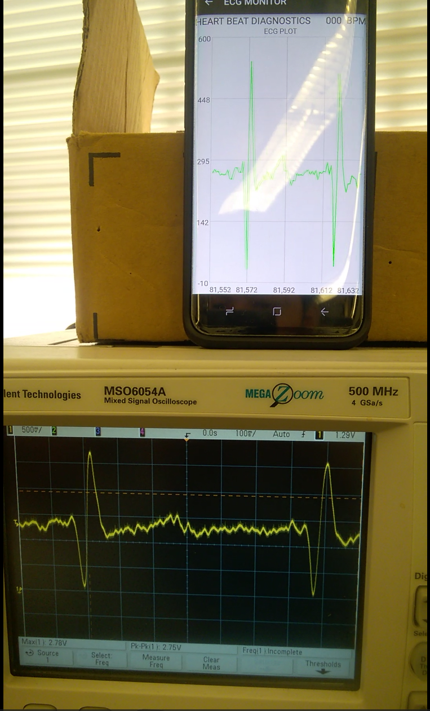

Figure 9. ECG plot by the Mobile device compared to the oscilloscope

1. **Conclusion**

This project has been accomplished for transmitting multiple ECG lead signals into one receiver, and eventually to Mobile device using Bluetooth. The signals have been successfully synchronized with wireless communication at the receiver end. The mobile application designed for this project is only able to plot and display one signal at a time for now, and the user has to choose which lead they would like to look at manually in the receiver code; however, the application has the potential to plot multiple ECG signals at a time if a little more time and effort is put into the application in order to change the approach it collects the signals from the receiver. Moreover, if an algorithm is implemented to calculate the heart rate based on the incoming ECG signals, this application would be a perfect wireless ECG monitor for the users.

References:

[1] M. A. Ahamed, M. K. Hasan, M. S. Alam, “Design and Implementation of Low Cost ECG Monitoring System for the Patient Using Smartphone,” International Conference on Electrical & Electronic Engineering, 2015.

[2] R. J. OWEIS and A. BARHOUM, “PIC microcontroller-based RF wireless ECG monitoring system” Journal of Medical Engineering & Technology, Vol. 31, No. 6, November/December 2007, 410 –418

[3] P. Vidwan, P.Panchal, S.Sharma “REAL TIME PORTABLE WIRELESS ECG MONITORING SYSTEM, 2012

Asian Journal of Computer Science and Information Technology

[4] Sudip Deb. Design and Implementation of Low Cost ECG Monitoring System for the Patient Using Smart Device - IEEE Conference Publication, 18 Feb. 2017, [www.ieeexplore.ieee.org/document/7913007/](http://www.ieeexplore.ieee.org/document/7913007/)

[5] Oweis, R J, and A Barhoum. “PIC Microcontroller-Based RF Wireless ECG Monitoring System.” Journal of Medical Engineering & Technology., U.S. National Library of Medicine, 11 Dec. 2011, [www.ncbi.nlm.nih.gov/pubmed/17994414](http://www.ncbi.nlm.nih.gov/pubmed/17994414).

[6] “Arduino Bluetooth Basic Tutorial.” Arduino Project Hub, [www.create.arduino.cc/projecthub/user206876468/arduino-bluetooth-basic-tutorial-d8b737](http://www.create.arduino.cc/projecthub/user206876468/arduino-bluetooth-basic-tutorial-d8b737)