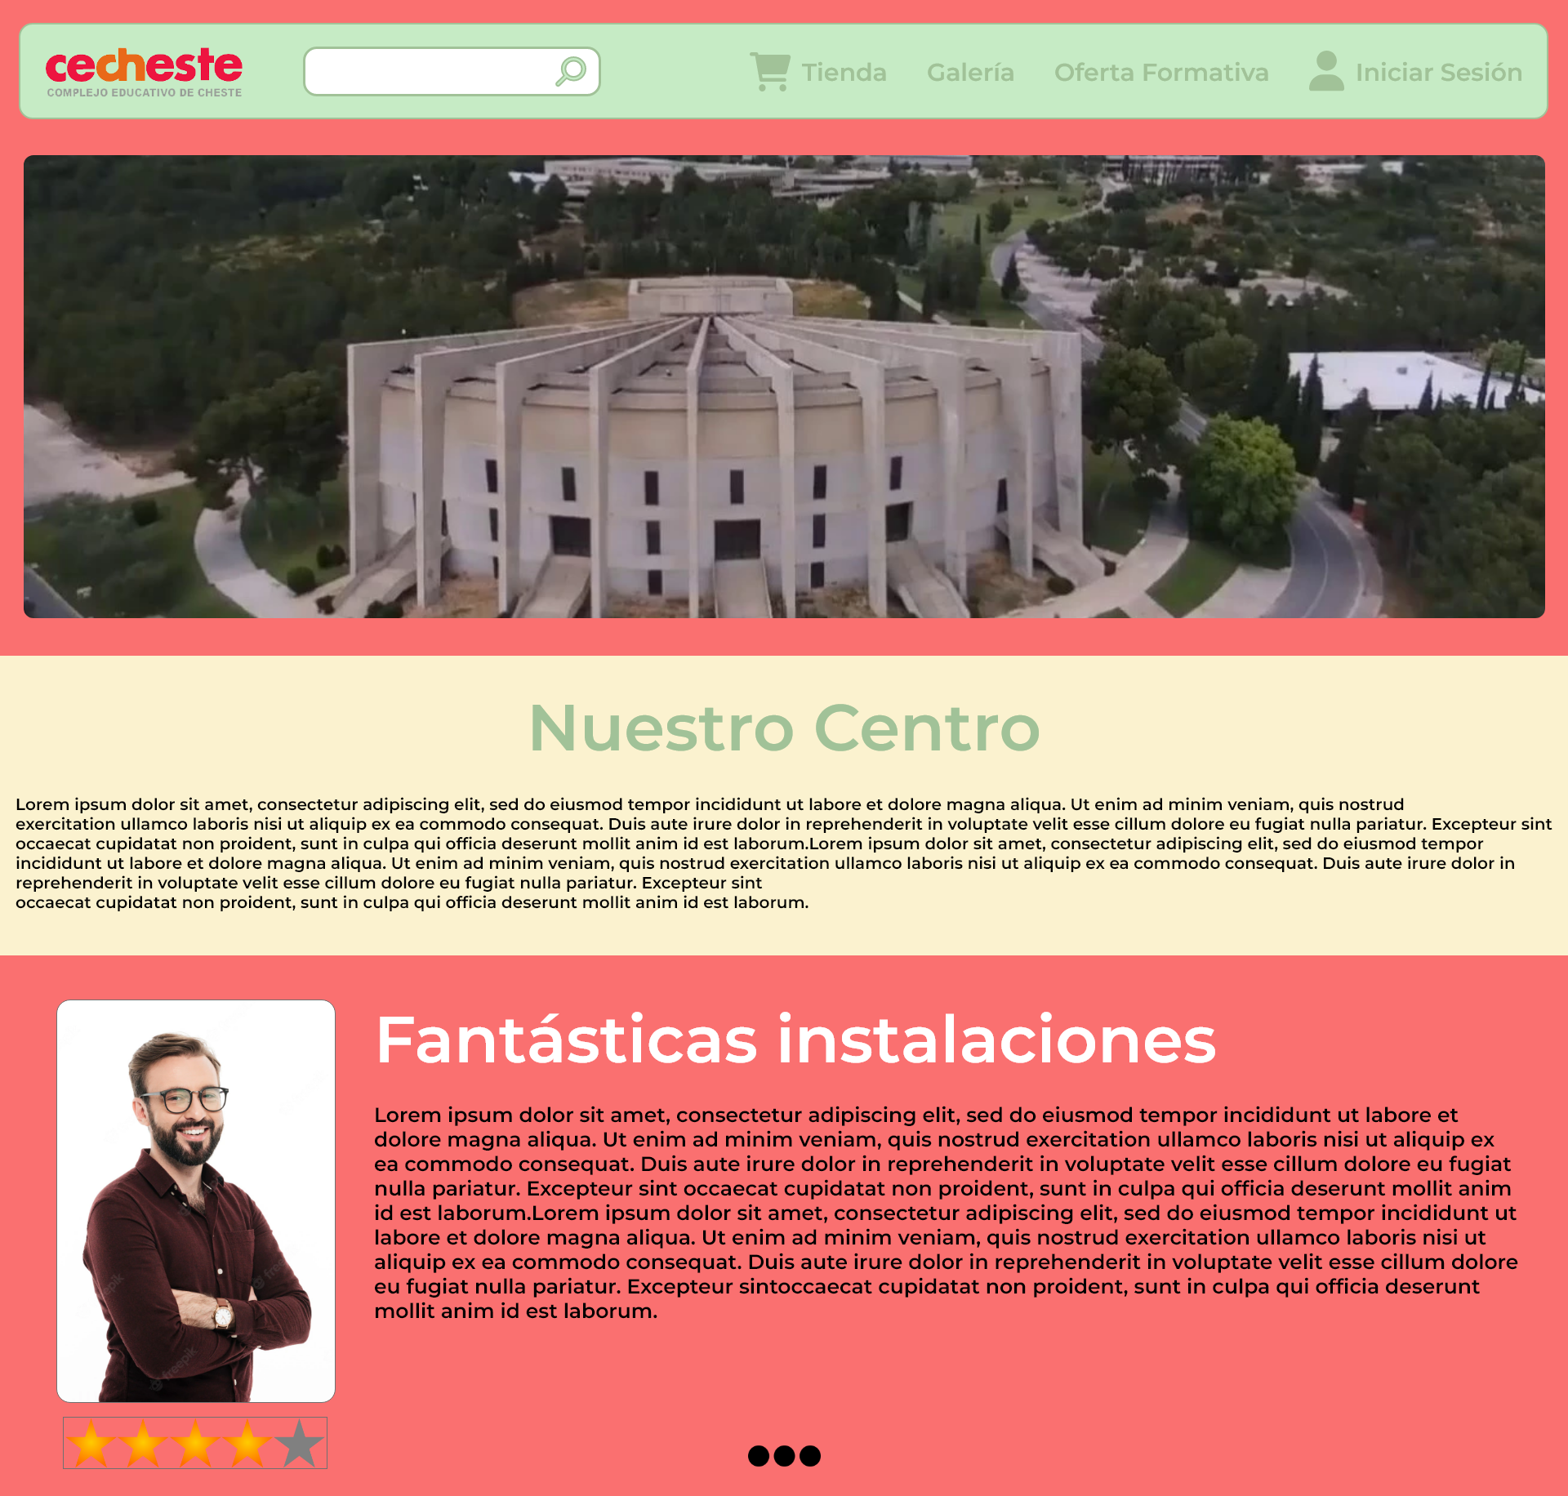

|  |  |
| --- | --- |
|  | #FA7070 |
|  | #FBF2CF |
|  | #C6EBC5 |
|  | #A1C298 |
|  | #8FAD86 |

|  |  |
| --- | --- |
| Cabeceras | Montserrat Bold |
| Textos | Montserrat Regular |
| Iconos | Font awesome (shopping cart solid, user solid, magnifying glass solid) |
| Border Radius | 17px |