**PROJECT REPORT**

**FACE RECOGNITION SYSTEM**

*Submitted by-*

**Antriksh Chaudhary[RA1711003030079]**

*Under the Guidance of*

**Mr. Rajiv Ranjan Dwivedi**

(Assistant Professor)



Delhi NCR Campus,Modi Nagar,Ghaziabad

**May 2021**

**SRM INSTITUTE OF SCIENCE & TECHNOLOGY**

(Under Section 3 of UGC Act, 1956)

**BONAFIDE CERTIFICATE**

Certified that this project report titled “**FACE RECOGNITION SYSTEM**” is the bonafide work of “ **ANTRIKSH CHAUDHARY”**[Reg No: RA1711003030079], who carried out the project work under my supervision. Certified further, that to the best of my knowledge the work reported herein does not form any other project report or dissertation on the basis of which a degree or award was conferred on an earlier occasion on this or any other candidate.

Signature Signature

**Mr. Rajiv Ranjan Dwivedi Dr. R.P. Mahapatra**

(Guide) Head of the Department

Assistant Professor Department of CSE

Signature of Internal Examiner Signature of External Examiner

**Abstract**

This project in the main focuses on building AN group action audio system that accesses the digital camera of the device and detects the person within the digital image and verifies it from the custom info designed.Then it updates the group action of the person in AN stand out sheet.This way it becomes an ideal group action System.This project finds a numerous variety of uses each in domestic furthermore as company atmosphere.This can be used as a security tools because it keeps a record of individuals. It replaces the manual need to be compelled to enter everyone’s group action. It mechanically holds the group action of everybody.

**ACKNOWLEDGEMENTS**

I would like to express our deepest gratitude to our guide, Mr. Rajiv Ranjan Dwivedi for his valuable guidance, consistent encouragement, personal caring, timely help and providing me with an excellent atmosphere for doing research. All through the work, in spite of his busy schedule, he has extended cheerful and cordial support to me for completing this research work. I also wish to thank **Dr. R.P. Mahapatra**, Professor and Head, Department of Computer Science and Engineering, **SRM Institute of Science and Technology** (Delhi-NCR Campus), for his valuable suggestions and encouragement throughout the period of the project work. We sincerely thank staff and students of the **Computer Science and Engineering Department**, SRM Institute of Science and Technology, for their help during my research.

**Antriksh Chaudhary**

**Introduction**

Face is the most easiest way to distinguish between people.Face Recognition works on these facial expressions and evaluate the differences between the two digital images then compares them both to verify of they belong to the same person or not. Face recognition comprises of two steps majorly:-

1.Face Detection

2.Face recognition

Face Detection is a process which detects and makes sure if the object present in the digital is the face of a human.

Face Recognition now takes over and checks it in the database whether the person is entered in the database.

This is a Supervised Learning model which means it works on a pre-installed database.

The database is customizable and can accept up to any number of input digital images.

**Objective**

Object is to build a system which updates attendances of people in an Excel sheet who have been entered in a custom database using Face Recognition.

**Understanding**

**The**

**Problem**

**Face Recognition is a series of several problems:**

**1.**First,look at digital image and verify how any faces are there in the digital image.

2.Second,focus on each phase and figure out whether a face is in bad lighting and checks if it the same person.

3.Third,picking up the characteristics of the face and using them to differentiate from other people-like the eye size,the face size,etc.

4.Finally,compare the unique features of that face to all the images from the dataset.

**Installations**

First we have to download a c++ compiler.We can do this by installing Visual Studios.

You can download the community version for free from their website.

Once the installation is complete we can run it and select the ‘Desktop Development with C++’.

The download and installation will take some time as it is a few GBs.





After completing and restarting the computer,now we will head on to our Jupyter project.Here we will install the required packages using Anaconda Command Prompt.

**Below is the list:**

**Cmake**

**Dlib**

**Face_recognition**

**Numpy**

**Opencv-python**

**Literature**

**Study**

**1.Large Scale Dataset for space Anti-Spoofing(2019)-** Anti-Spoofing multi-model referred to as CASIASURF. It is really the most important open database/data set. It consists of 21,000 videos and 1,000 subjects.

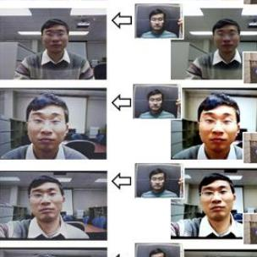

**2.FaceNet: A Unified Embedding for Face Recognition and Clustering(2015)-** This paper is termed FaceNet.The FaceNet uses a deep convolutional neural network. The network is trained on a C.P.U. for one,000 to 2,000 hours.They are trained on four databases. Accuracy which there's 95.2 on Youtube dataset.

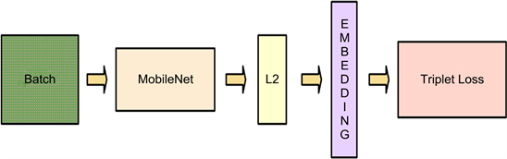

**3.Probabilistic Face Embeddings by Yichun Shi and Anil K. Jain, from Michigan State University(2019)-** The Embedding Systems used presently will perform high performance in controlled settings. They take a digital image of a face and store the face.The current ways square measure inefficient once it involves absent facial expressions. Probabilistic Face Embeddings(PFEs) square measure projected.

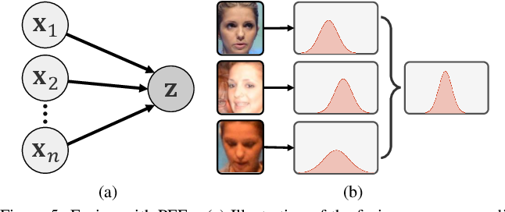

**4.The Devil of Face Recognition is in the Noise(2018)-** one in all the foremost common issue with the datasets is that the great amount of noise. It is aimed to arrange a dataset named IMDb-Face.

Goals- Discover noise effects on performance.

Results- 32% Megaface

20% MS-Celeb-1M dataset.

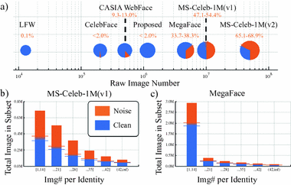

**5.VGGFace2: A dataset for recognising faces across pose and age(2018)-** his dataset contains 3.31 million images and 9131 subjects.

Oxford University researches introduced VGGFace 2 dataset.

It includes images of different age,ethnicity,illumination,and posings.

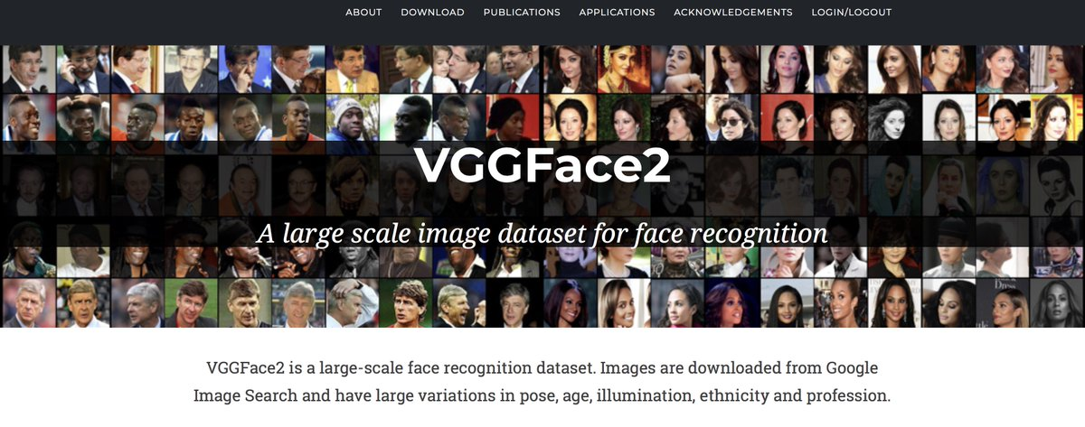

**Working**

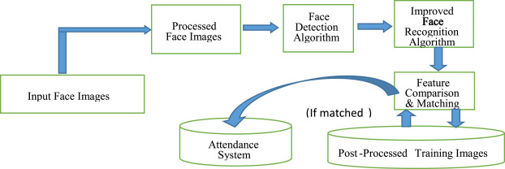

As soon as the webcam of the device detects a face,

It compares the physical features of the detected face with all the digital images present in the dataset/training set.

If the physical features of any digital image matches with the face detected by the webcam the attendance of the person is recorded else not.

**Requirements**

**1.Webcam-** It is a very commonly used device present in any basic computer system.

We can also use additional external devices in order to have a better camera but that is optional.

**2.Python Programming Language-** Python Language is a High-Level language.

It was developed by Guido Van Rossum in 1991.

It is used for:

1.Web Development

2.System Script

3.Game Development

Python works on a server to develop web applications.It can be connected to datasets to read and modify files.It handles big data and works on complex mathematics because it is reliable. Rapid-Prototyping or for production-ready software development can also be performed in python.

**3.Jupyter Notebook-** It is an open source web application used to develop or share code.

**Code implementation**

import cv2

import numpy as np

import face_recognition

import os

from datetime import datetime

path = 'ImagesBasic'

images = []

classNames = []

myList = os.listdir(path)

print(myList)

for cl in myList:

curImg = cv2.imread(f'{path}/{cl}')

images.append(curImg)

classNames.append(os.path.splitext(cl)[0])

print(classNames)

def findEncodings(images):

encodeList = []

for img in images:

img = cv2.cvtColor(img, cv2.COLOR_BGR2RGB)

encode = face_recognition.face_encodings(img)[0]

encodeList.append(encode)

return encodeList

def markAttendance(name):

with open('Attendance.csv','r+') as f:

myDataList = f.readlines()

nameList = []

for line in myDataList:

entry = line.split(',')

nameList.append(entry[0])

if name not in nameList:

now = datetime.now()

dtString = now.strftime('%H:%M:%S')

f.writelines(f'n{name},{dtString}')

encodeListKnown = findEncodings(images)

print('Encoding Complete')

cap = cv2.VideoCapture(0)

while True:

success, img = cap.read()

imgS = cv2.resize(img,(0,0),None,0.25,0.25)

imgS = cv2.cvtColor(imgS, cv2.COLOR_BGR2RGB)

facesCurFrame = face_recognition.face_locations(imgS)

encodesCurFrame = face_recognition.face_encodings(imgS,facesCurFrame)

for encodeFace,faceLoc in zip(encodesCurFrame,facesCurFrame):

matches = face_recognition.compare_faces(encodeListKnown,encodeFace)

faceDis = face_recognition.face_distance(encodeListKnown,encodeFace)

matchIndex = np.argmin(faceDis)

if matches[matchIndex]:

name = classNames[matchIndex].upper()

y1,x2,y2,x1 = faceLoc

y1, x2, y2, x1 = y1*4,x2*4,y2*4,x1*4

cv2.rectangle(img,(x1,y1),(x2,y2),(0,255,0),2)

cv2.rectangle(img,(x1,y2-35),(x2,y2),(0,255,0),cv2.FILLED)

cv2.putText(img,name,(x1+6,y2-6),cv2.FONT_HERSHEY_COMPLEX,1,(255,255,255),2)

markAttendance(name)

cv2.imshow('Webcam',img)

cv2.waitKey(1)

**Result**

