Introduction:

Learning the basics interface of Atmel Studio 7 and how to create a project. Create a delay loop and call it in the main code to blink LEDs. Create a push button function for LEDs to blink on and off.

Equipment:

* Simon Board
* Atmel Studio 7

Procedure:

* Create an Atmel project and select the ATmega324PB under devices.
* Write a simple loop for LEDs to toggle.
* Build the solution and check for errors.
* Toggle debugging mode on and select simulator as the debugger.
* Open the I/O window to view the bits changing on the ATmega.
* Plug the usb in the ATmega and the PC.
* Select the ATmega as the debugger.
* Create a delay loop by creating a function to loop for 560 bits.
* Use the CALL keyword in the main loop to use the loop function.
* Create a function for set the LEDs register in input mode to receive bits from the push.
* Integrate the delay loop with the push button to create a delayed Blink when the button is pressed.

Results:

The code created a delay loop and a push button function for the LEDs to blink on command.

Conclusion:

I learned how to create a project in Atmel Studio 7 and the basic tools used in the program. I also learned how to create a function to call in the main loop to cause a time delay. The code resulted in the LEDs being able to turn on or off by presses the button mapped in the code.

Appendices:

Figure – Main code for time delay function

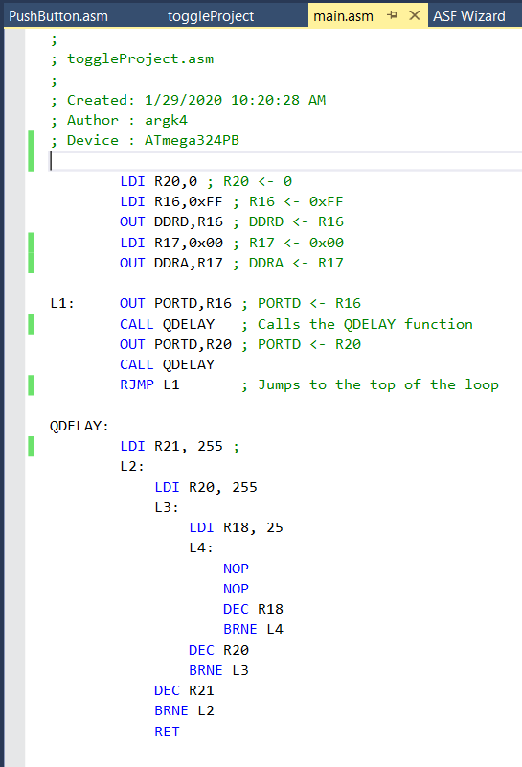

Figure – first half of push button code

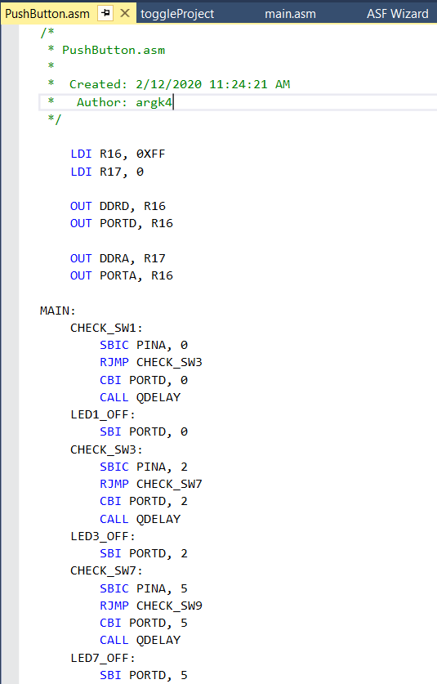

Figure – Second half of the push button code

