Analyze Problem Statement

This task provides three project and our group got one project to work with that is Mountain Path by Franke. Our task is design the diagram from this problem. First thing that we do is come and talk together try to understand this problem together because it can cause problems if someone has some misunderstand about it. During the work we talking with others all the time and try to use Git to make us work easier.

This report will include UML (have 2 versions first is full version that follow the code and second is for first year student this will have less detail and easy to understand), activity diagram, use case diagram, and sequence diagram. All of this diagram made from our knowledge and skill to help first year student work easier and have more understand in this problem.

Mr.Jirachai Chansivanon 58130500204

Mr.Suppawit Satitsongtam 58130500237

Ms.Apichaya Senathong 58130500256

Diagram

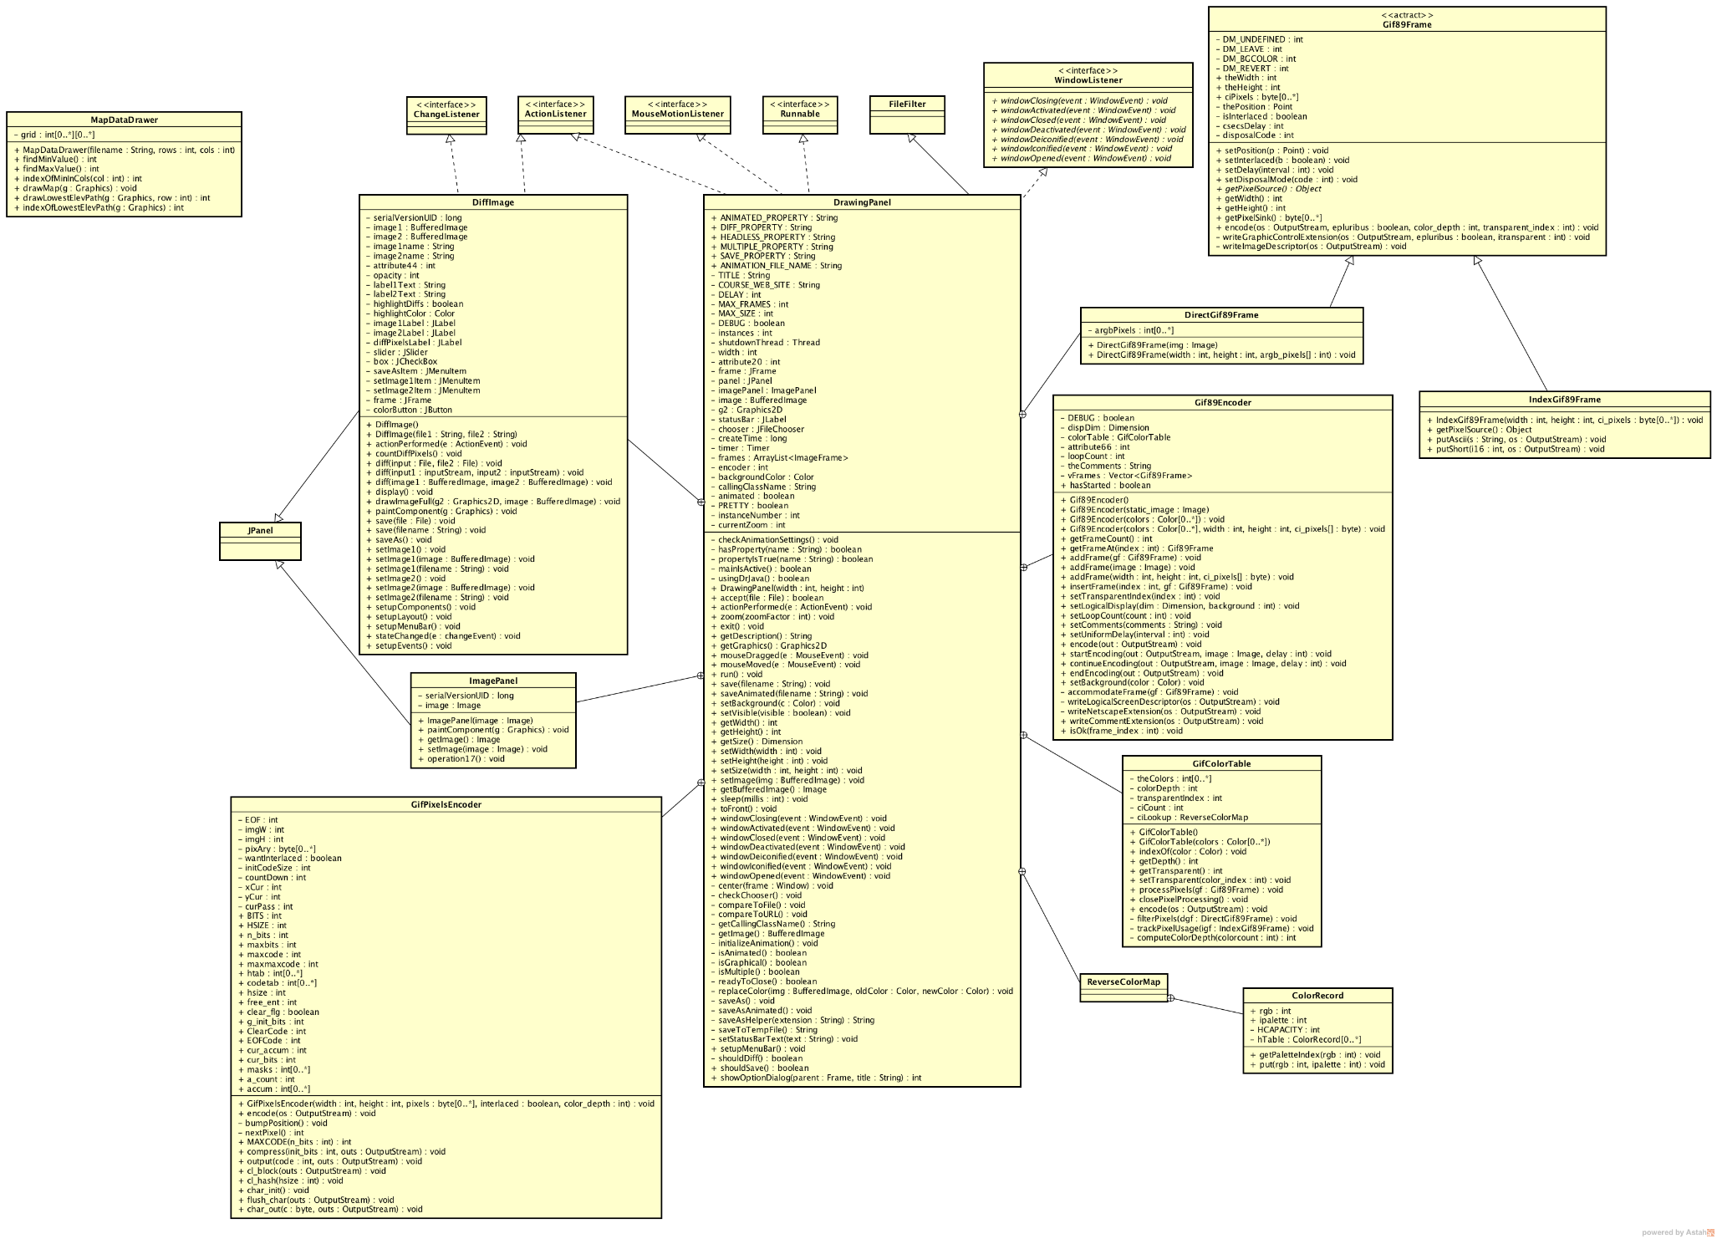UML, Class diagram Full version­

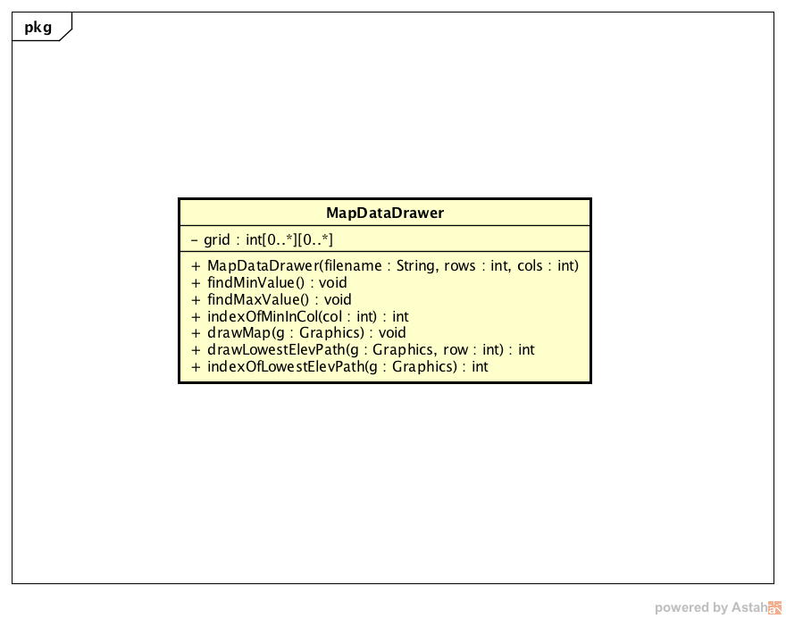UML, Class diagram Easy understanding version

Activity Diagram

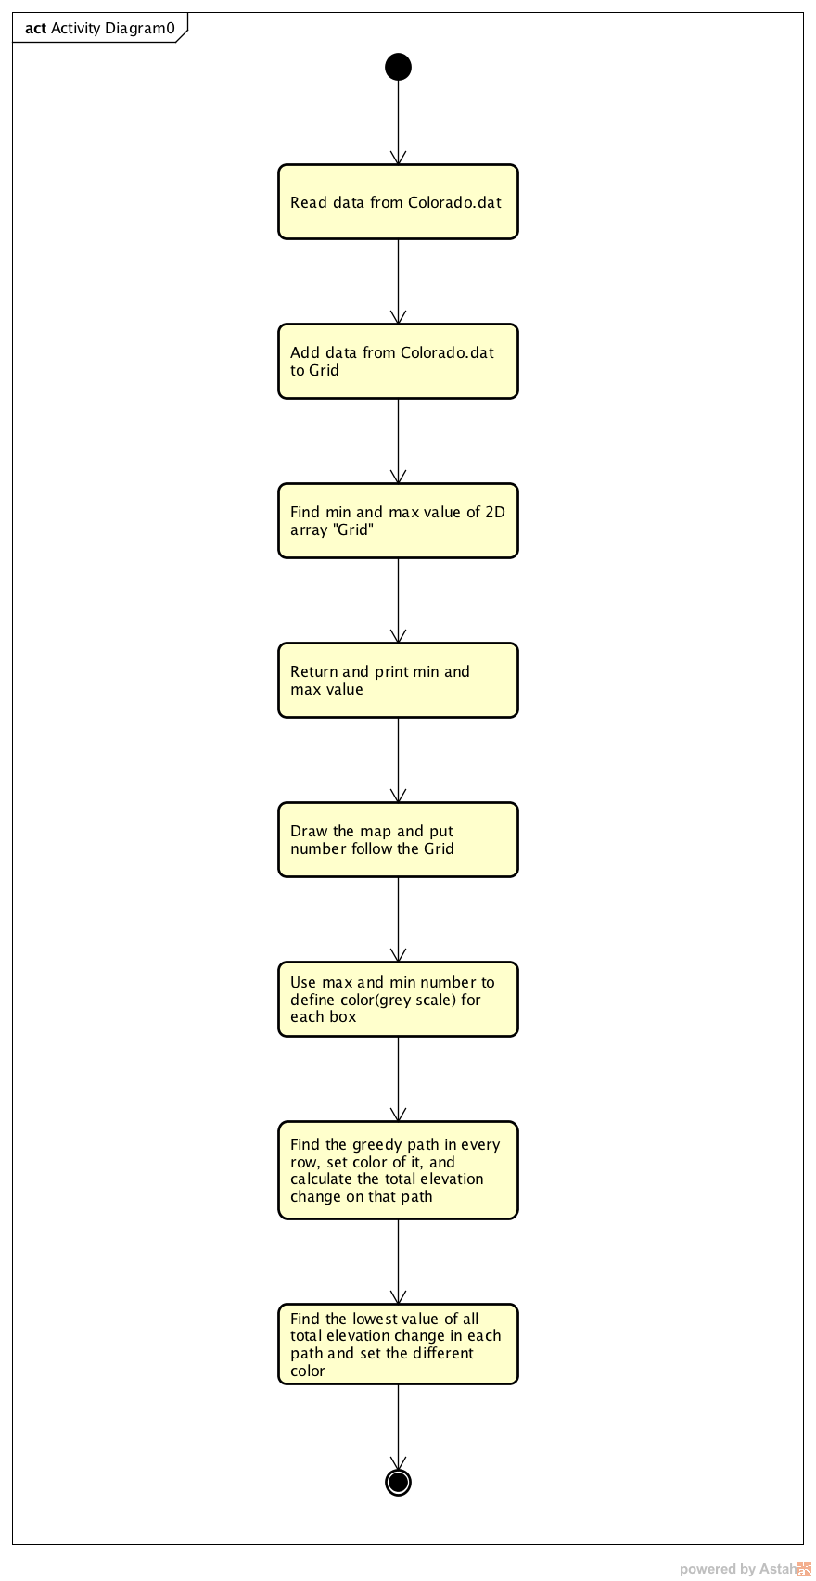

Sequence Diagram

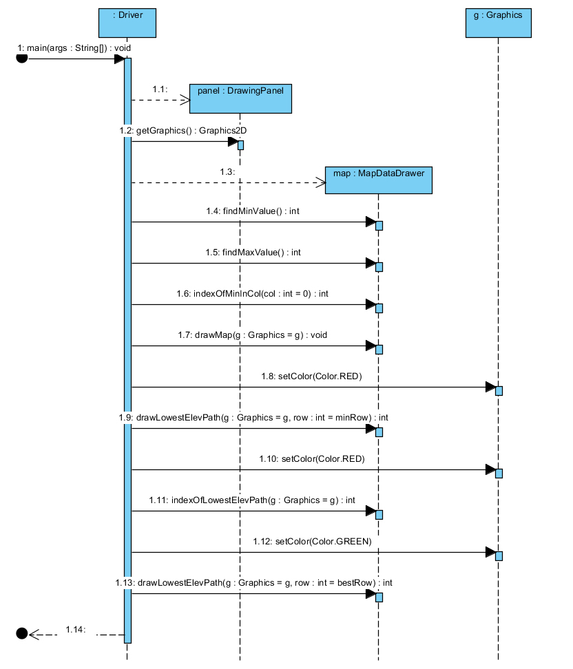

Use Case Diagram

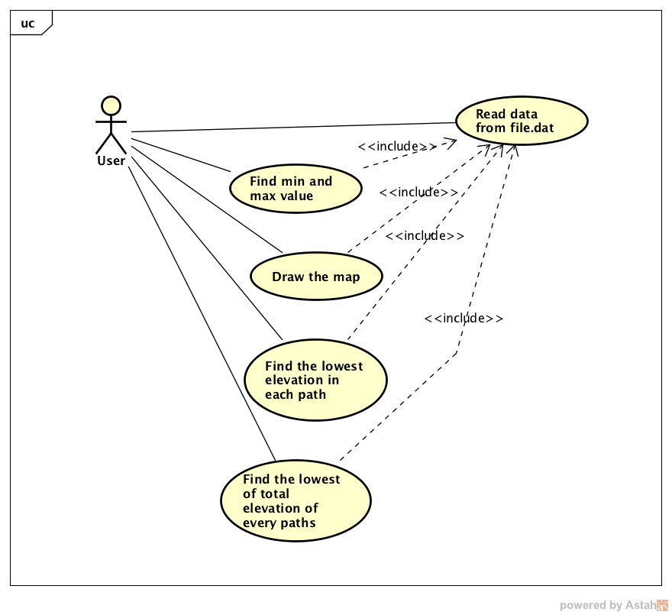

From diagram above, the first step is input data into the system then the system will read the file in to 2D array. The second step system will calculate min and max value to draw the map. The third step system will find lowest elevation from staring row and calculate to move forward to other lowest elevation. Last step is find and draw the lowest elevation form the whole map.