Seasonal pumped thermal energy storage over 90% round-trip efficiency
Antti Saarenheimo, the author of this study and its software, graduated from the Electrical Department of the then Helsinki University of Technology in the late 1980s with a major in Software Engineering. The author conducted the study in 2023–2026 on his own time, alongside his regular job as Software Designer. All ideas presented here are freely available to others. All references were checked in 2026.
Abstract
This work represents public Pumped thermal energy storage design and simulation web application at https://anttisaarenheimo.github.io/ and the related research. The web application designs and simulates an exceptionally large seasonal thermal battery of electric power built into an open pit filled with crushed stone. Axial flow turbomachines of storage implement a two-way closed Brayton cycle to charge and discharge electricity as extreme heat and cryogenic cold to and from crushed waste rock. This work also presents the other works, and their thermodynamic formulas and algorithms embedded in the software. We inspect the technical details of the concept by representing the other works on geology, mineralogy, rock engineering, fluid flow mechanics, metallurgy, thermodynamics, power engineering, turbomachinery and mean-line loss models of axial flow compressors and turbines. The web application designs energy storage, its optimized axial flow turbomachines and heat exchangers. It also calculates the efficiency predictions for the turbomachines and the closed two-way Brayton cycle with 1D loss models and finally simulates the energy storage and its profitability with historical European power market data.
The default parameters of the web application produce 939 GWh/2436 MW energy storage. Its round-trip efficiency predicted by the best mean line loss models is 90.4%. The round-trip efficiency prediction increases to 92.6% if we assume 2% average stage efficiency increase by modern multi-objective 3D CFD optimization for compressors and 1% for turbines. Exceptionally high round-trip efficiency is explained by fully optimized subsonic axial flow turbomachine designs, very low inlet temperature of cryogenic compressor and high turbine inlet temperature. The axial turbomachines are quite compact compared to the huge synchronous motor-generators but together they have tremendous inertia stabilizing the grid frequency. Energy density of storage is only about 10% of lithium-ion battery, but the capacity of a 45 Mt (million metric tons) storage is almost three times the expected 353 GWh added lithium-ion energy storage capacity for year 2026.
The webpage uses unit cost parameters based on public information to predict the cost of energy storage. The default values predict 903 million euros as total cost for energy storage, the plant, and all machinery. The capex costs of the default energy storage, 0.93 €/kWh and 371 €/kW, are extremely low compared to any other grid scale battery storage solution. Respectively the cost of additional storage capacity is 0.35 €/kWh and the cost of additional power 231 €/kW. These very competitive costs are explained by large scale of the plant, high round-trip efficiency, very low cost of crushed stone processing and simplicity of synchronous standalone axial turbomachines. Simulation of digital plant in the power market of Germany predicts 44% ROI for year 2025 when operating costs are €10m and electricity price elasticity is 3%/500 MW. Low-cost seasonal energy storage enables the replacement of existing coal, oil and natural gas power plants with more competitive solar and wind power. Power sector accounts for 40% of global energy-related carbon dioxide emissions.
Introduction
Storing energy produced by wind and solar energy is one of the biggest challenges of the green transition. Here we present a solution to that problem. Axial flow turbomachines charge and discharge electricity as extreme heat and cryogenic cold to and from a truncated cone-shaped open pit filled with screened crushed stone. The storage consists of two insulated gas-tight halves. The mass of the upper low-pressure storage pressurizes the lower high-pressure storage that contains extreme heat. Between these reservoirs, axial flow turbomachines implement a bidirectional closed Brayton cycle using nitrogen. The concept is known in scientific literature under various names, such as Pumped Thermal Energy Storage (PTES), Pumped Heat Electricity Storage (PHES) or Carnot Battery.
Axial flow turbomachines charge electricity into the energy storage as extreme heat and cryogenic cold with the reverse Brayton cycle, which works on the same principle as a heat pump. The main compressor compresses the hot gas from the upper part of the low-pressure storage to red-hot into upper part of the high-pressure storage. At the same time, the opposite cryogenic turbine keeps the storage pressures constant by cooling the cold gas with a heat pump from the bottom of the high-pressure storage to the saturation point and saving the cryogenic cold to lower part of the low-pressure storage.
The discharge of electricity takes place with the normal Brayton cycle, where the main turbine discharges red-hot gas from the high-pressure storage to the upper part of the low-pressure storage. The cryogenic compressor maintains pressure difference between the storages by compressing the cryogenic gas from the bottom of the low-pressure storage to the cold bottom of the high-pressure storage. The work done by the compressor is directly proportional to the absolute temperature of the incoming gas, so the discharge cycle has maximal efficiency because compressor inlet temperature is as close to the saturation point as possible.
The gas discharged from turbines and compressors flows very slowly through the screened crushed stone of both storages while either heating up or cooling down to the temperature of the opposite side. Thus, in this solution, the crushed and screened stone functions as both a heat storage and a heat exchanger at the same time. Since the efficiency of the system cannot be 100%, excess heat accumulates during charge and discharge, but most excess heat can be recycled back into the process using higher pressure difference during the discharge.
A high-efficiency helium heat pump removes in charge phase the excess heat accumulated on the cryogenic side. It cools the cold gas coming from high-pressure storage so that the gas coming out of the cryogenic axial turbine is at the saturation point and at the same time slightly wet so that low- and high pressure can be kept constant while gas temperature and volumetric mass change. The liquefied part of the gas is separated into separate storage. The heat produced by the heat pump compressor is cooled as waste heat, fed directly into the district heating network or stored in some other way.
The excess heat accumulated on the hot side can be converted into electricity when the pressure difference in the discharge mode is increased so that the exit temperature of the gas from the main turbine is the same as the inlet temperature of the main compressor. This solution simplifies the structure of low-pressure storage, because the excess heat does not need to be cooled. In addition, the hot compressor and turbine can share the same low-pressure pipes and gas distribution channels. However, at the same time, the cryogenic cooling must be slightly increased, because in addition to the main turbine, the pressure ratio of its counterpart, the cryogenic compressor, and the waste heat it produces also increase.
The capacity of the storage is limited by the fact that the specific heat capacity of the working fluid is almost constant at different temperatures, while the specific heat capacity of solids decreases to zero as absolute zero is approached. Thus, the cryogenic low-pressure storage is about 3 times bigger than the hot high-pressure storage. The dependence of the specific heat capacities of solids on temperature is best described by the Debye model. In the model, the specific heat capacity of a solid depends on the ratio of the measurement temperature and its Debye temperature. The lower is solid’s Debye temperature, the better it stores cryogenic cold. The Debye temperatures of rock minerals are between 500–1200 K, so they store cryogenic cold quite poorly compared to, for example, water ice, which has a Debye temperature of 300 K, when the measurement temperature is 100 K. In this study we will use the charge-discharge simulation to show that, despite the limitations imposed by the Debye model, about 50% of the theoretical maximum heat capacity of high-pressure storage can be utilized.
In this study the operating principle of the solution will be described in detail, the dimensioning of the energy storage will be optimized, problems related to its technical implementation will be analyzed and solutions proposed, the operation of the storage will be simulated programmatically, optimized designs of plant’s axial turbomachines and heat exchangers are presented, and best mean-line loss models are used to predict the efficiencies of axial compressors and turbines. The predicted design point round-trip efficiency of the energy storage is 90.4% when the heat is stored into 977 °C screened crushed stone made from blast furnace slag or exceptionally heat-resistant rock. The selected compressor and turbine mean line loss models were fine-tuned with empirical data of turbomachines available before 1976 and 1982 respectively. Google AI searches claim that advanced modern multi-objective 3D CFD optimization has increased subsonic axial flow compressor stage efficiencies up to 5-6% since 1976 and axial flow turbine stage efficiencies about 2% - 5% since 1982 but only the abstracts were available in most referred sources. If we assume 2% average stage efficiency increase by modern CFD 3D optimization for the fully 1D optimized compressor stages in this study and 1% increase for the fully 1D optimized turbine stages, the round-trip efficiency prediction of the system increases to 92.6%, which is better than in any pumped hydro storage and in the upper range of large lithium-ion batteries (85% - 95%).
The round-trip efficiency depends on maximum temperature of crushed stone and pressure ratio. Typical blast furnace slags don’t yet weather at 1000 °C, but the maximum operating temperatures of ordinary rocks are between 550 and 1000 °C. Rocks consisting mainly of heat-resistant compatible minerals are in the upper end, but the mixed rocks containing quartz cannot exceed 572 °C. The round-trip efficiency prediction drops to 89.5%, if the max operating temperature is 550 °C. The predicted power, capacity and ROI also drop from 2436 MW, 939 GWh, and 44% to 1441 MW, 567 GWh, and 37% with the default mass flow and storage size.
45 Mt energy storage design has a wide power range. The round-trip efficiency prediction decreases only 0.1% if the default 2436 MW power is doubled to 4806 MW. However, if the energy storage size is less than ten million tons crushed stone, various size-related problems and equipment costs increase rapidly. The technical upper limit for the charge and discharge power is set by the increasing flow resistance of the screened crushed stone and its heat exchange capability, which are opposite properties. The power of heat exchange is directly proportional to the surface area of the crushed stone, but on the other hand, the small average grain size and low porosity of the crushed stone increase the gas flow resistance.
Nitrogen is the best working fluid because it is inexpensive to produce on site, and its low vaporization temperature allows for a larger temperature difference between the cryogenic and hot cycles of the storage. In addition, nitrogen is an inert gas, meaning it reacts very weakly with other elements. This makes it a very problem-free working fluid compared to hydrogen, oxygen, methane or carbon dioxide. Argon is the secondary choice as the working fluid. Finally, the unit costs of the stored energy and the charging and discharging power and the return on investment are evaluated.
The search words "energy store Brayton cycle” return many new scientific articles about the thermal storage of electricity based on the Brayton cycle. A recently published study Derived energy storage systems from Brayton cycle is an overview of the current state of research in the field. In it, researchers compare Brayton cycle-based CAES (compressed air energy system) and PTES (pumped thermal energy store) solutions at a theoretical level. For example, under the leadership of Josh McTigue, the feasibility of PTES projects has been mapped . The researchers considered that a 75% round-trip efficiency could be achieved with supercritical carbon dioxide when the heat is stored in table salt . The techno-economic comparison of PTES solutions has also been studied in another study, which also ended up proposing different pressure ratios for charging and discharging. Concrete solutions to the further development needs of PTES and techno-economic challenges mentioned in those studies will be presented in this article. In this solution, the crushed stone acts as a massive low-cost heat storage and heat exchanger at the same time. The inexpensive crushed stone processing, open-pit rock mining technology and closed two-way Brayton cycle enable costs/kWh that are two orders of magnitude lower than in any other battery storage.

General operating principle and energy storage layout
The next figure shows a cross-section of 516 GWh/2436 MW energy storage generated with the design and simulation web application. Its size, 25 million tons of crushed stone, corresponds to a typical volume of a small closed open pit. When the storage is made mainly from piled waste rock, the predicted processing cost per ton is 2.5 € and the predicted total cost of storage is €771m. If the storage is mined to a new site, then the per ton processing cost could double to 5 €/ton (typical mining and processing cost for open pit mines of that size), and the total cost prediction would increase to €861m. The charge and discharge devices are opposite sides of the figure for clarity. The pressure control tank is in the permanently cryogenic crushed stone near to the bottom of low-pressure storage. Quick power market simulation of year 2025 predicts 49% ROI in Germany (3% price elasticity) and 40% in Finland (10% price elasticity).
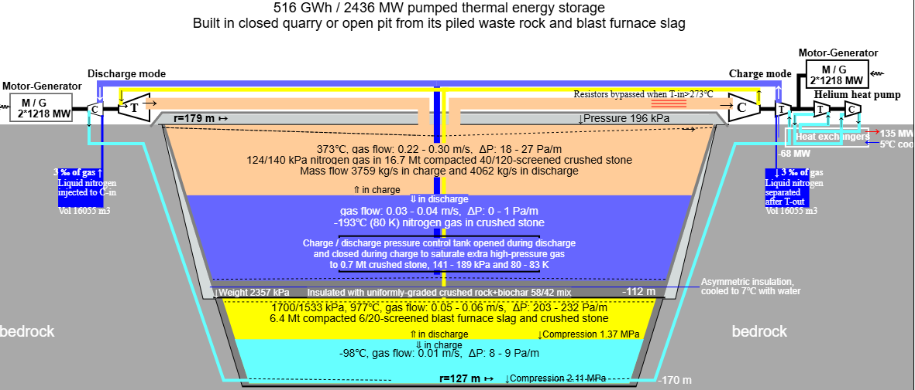
Figure 1. Cross -section and operating principle of the energy storage system
In the figure, the slope of the fully reinforced wall of the open pit (including the gray filled double ramps) is 73 degrees, the high temperature is 977 °C. The high discharge/charge pressures are 1700/1533 kPa, and the respective low pressures are 124/140 kPa. Axial flow compressor and turbine 1D mean-loss models predict with default CFD optimization 92.5 % round-trip efficiency for system, while 5.7 % heat pump cryogenic cooling work and motor-generator 1.8 % loss are included. The hot high-pressure blades of compressor and turbine have internal cooling. About 60 % of the 6 Mt high-pressure crushed stone is assumed to be made of ultramafic rock or blast furnace slag having high compressive strength and excellent heat resistance. The possible transportation cost of blast furnace slag is not included in the cost predictions.
If hot high-pressure crushed stone were made of common ingenious rock with high silicate content (such as granite), its temperature could not exceed 573 °C (846 K), because at that temperature a sudden quartz crystal transformation is accompanied by a significant change in volume change which weathers the rock. The round-trip efficiency prediction, capacities and the cost of such 45 Mt and 567 °C energy storage would be 89.7 %, 550 GWh, 1481 MW and €699m. The actual cost would probably be less and ROI better than predicted (36% in Germany), because the less expensive non-cooled steel and alloys can be used in turbomachines and pipes. Grid bottlenecks may force building energy storage from less optimal rock near to consumers or producers.
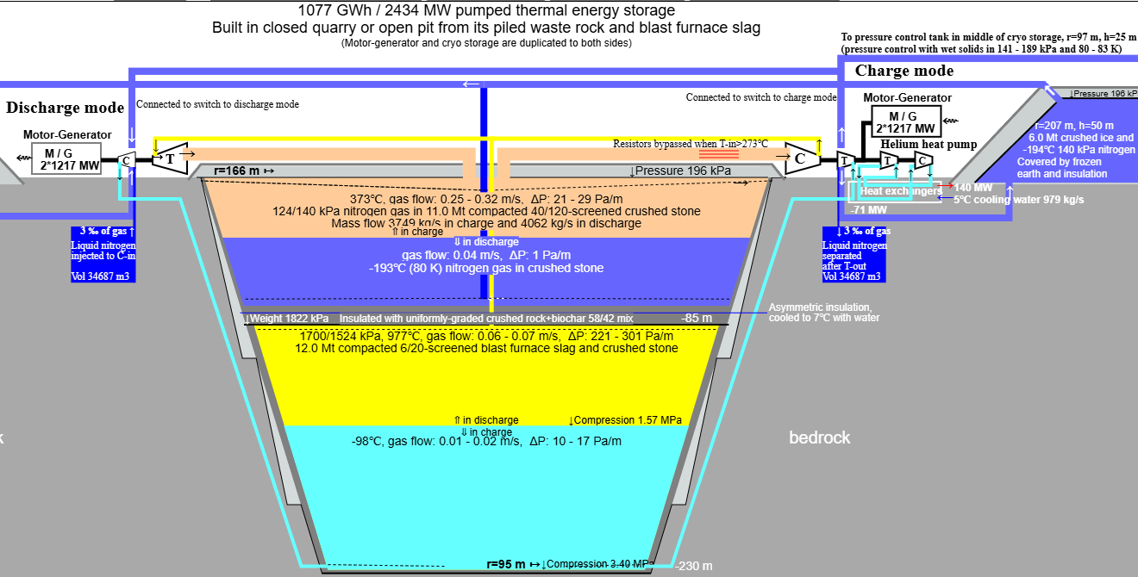
This figure shows a 25 Mt energy storage where the capacity has been doubled to 1077 GWh with 6.0 Mt external cryogenic storage made of natural ice. Natural ice has low a Debye temperature and thus 50% better volumetric heat capacity than rock minerals at the saturation temperature of nitrogen. Its predicted cost is €840m and year 2025 ROI 47% in Germany and 41% in Finland. By default, the estimated processing and transportation cost of natural ice is 4€/ton, but it depends very much on distance of transportation and other logistics. External cryogenic ice storage may be a profitable option in Finland, Sweden, Canada and northern USA and China, but elsewhere the availability of natural ice will be a problem.
For clarity, the charging and discharging and the separate ice storage are placed on different sides in the figure, even though they share the same motor-generator. In the figure, this plant would consist of two identical motor-generator units and four main turbines, so that they could be run flexibly according to the demand and supply of electricity, and so that they could be maintained one at a time. In addition, the discharging and charging power can be adjusted about 30-40% up and down by changing the operating pressure, pressure ratio or inlet temperature.
The black lines in the figure are gas-tight boundaries, which can be welded steel or aluminum plates, injected rock, or even rock frozen by geothermal piping. The steel plate above the hot high-pressure storage becomes a soft surface that stretches and shrinks with the surrounding crushed stone. The gas-tightness of the pressure storage can be ensured by a mixture of fine crushed stone above the steel plate and crushed stone that partially melts at the temperature of the high-pressure storage, which compresses into a solid elastic gas-impermeable layer under heat and pressure.
The dark grey areas inside the black lines are the thermal insulation, which contain 42% stone wool and/or high-quality biochar and 58% uniformly graded crushed stone having the compacted porosity 0.42. Heat conduction by convection can be minimized by adding thin horizontal layers of compacted clay to the vertical insulation layers. The estimated heat transfer coefficient of this insulation is 0.1 W/m²/K, which is possible only when the optimal combination of rock mineral, insulation and stone diameter is selected for different temperatures. U-value of the insulation is a function of heat transfer coefficient of used rock mineral, porosity of crushed stone, quality of insulation between stones, effective diameter of stone particles and density of gas. The crushed stone could be replaced with granulated or crushed structural expanded clay. Its k-value is about 0.12 W/m/K and compressive strength 12 MPa, but its cost might be too high (about 100 euros/m³). Expanded blast furnace slag could also replace the crushed stone in the insulation mix.
Rock minerals have a very wide range of heat transfer coefficients (see pages 34-48 in Thermal properties of rocks). Thermal conductivity of rocks having high quartz content increases exponentially below 0 °C. The best crushed stone for insulation at ambient and cryogenic temperatures are rocks with high feldspar content and very low quartz content. For example, the heat transfer coefficient of a feldspar, solid andesine, is between 1.5 and 2.0 W/m/K at 80K-1000K, but its compressive strength is too low to be used at high temperatures. Basalt is probably the best rock to be used for insulation at high temperatures and for a wide temperature range. For solid, low-porosity basalt rock, the thermal conductivity is roughly 1.7 to 2.2 W/(m·K) at cryogenic temperatures, 1.5 to 1.7 W/(m·K) at room temperature and 1.2 to 1.6 W/(m·K) at 1000 K.
The maximum porosity for compressed screened even sized crushed stone is about 0.42. The porous space has the heat transfer coefficient of the mixed insulation, biochar and/or stone wool, and the even distribution of insulation to all gaps between stones is crucial. Radiative heat transfer (function of T⁴) is major part of heat transfer at high temperatures. More heat can be transferred through a small empty space than by the contact of the stones. At cryogenic temperatures radiative heat transfer is almost zero and no insulation may be needed if heat transfer by convection can be blocked by removing almost all gas.
Conductive heat transfer of even sized crushed stones does not depend on effective diameter of stone particles because number of stone contacts/m² (1/D_{e})² is compensated by number of contacts/m and split ΔT, but smaller effective diameter decreases heat transfer by radiation and convection. Optimal effective diameter depends on number of screens below 10 mm, but it is probably <5 mm. Its maximum point load can be multiplied by 3 at least (I_{s} ~ I_{s(50)}/(D_{e}/50)^{0.45 - 0.55}) which also increases the porosity. Smallest screened diameters can be used in the hottest part of the insulation.
Heat transfer by gas convection is prevented by insulation between stones, or if the insulation is in a closed space, the gas can be sucked out until it is almost void.
Biochar is excellent for high-temperature insulation in anoxic conditions. The melting point of biochar is 3000 Kelvin, the k-value is 0.03 W/m/K, its pore density is very high, and its pore size is very small, at best only a few micrometers , so it insulates thermal radiation at least one order of magnitude better than typical commercial insulations, with cell size between 100 and 200 µm. The pyrolysis temperature should match with the temperature range of the insulation. At 900 °C biochar has transformed to a very small graphite sheets and its carbon content is over 90%.
Instead of biochar, blown stone wool could be used without binders. Stone wool does not reduce iron oxide in the crushed stone and oxygen does not anneal it. The binders of ordinary stone wool insulation begin to evaporate at 250 °C, but the temperature range of the ordinary pure stone wool is 700–850 °C and ceramic fiber wools can withstand temperatures up to 1200 °C. The use and application of blown stone wool may be technically simpler than biochar, and its price per unit volume depends on the density, which may be from 40 to 200 kg/m³ (with porosity 99 – 93%). The tax-free hardware store price of blown stone wool sold in plastic bags is about 1.6 euros/kg, but the factory price for thousands of tons of loose stone wool is very likely below 500 euros/ton, which would make the cubic cost of 57/43 mix of crushed stone and high density stone wool insulation might be 25 - 45 euros/m³. At that density, stone wool has a k-value of 0.033 W/m/K, but it is worse high-temperature insulator compared to biochar due to its larger pore size. The lowest possible radiative heat transfer of high-density stone wool could be about 0.04 W/K/m at 977 °C when the fiber diameter 3 µm and porosity 93%. The radiative heat transfer of biochar at 977 °C is only 0.01 W/K/m for 10 µm pores and 0.004 W/K/m for 4 µm pores. The view factor is assumed to be 1 and the emissivity 0.93 (typical rock emissivity).
In the figure, the thickness of the insulation layers has been calculated so that the heat leakage is approximately the same everywhere. The default heat leak parameter is 20 W/m², which means that the heat leakage of the high-pressure storage in the figure would be less than 4 MW when fully charged. The storage roof can be constructed using standard storage hall construction technology, and insulated from above with non-combustible stone wool, if this proves to be a more economical structure.
The in- and outcoming gas is distributed evenly along the branching channels running in the crushed stone so that its flow rate slows down enough so that stone dust is not carried into the equipment with the incoming gas. The gas ducts in the hot upper part of the high-pressure storage are vaulted structures can be laid big custom firebricks for vaults. The vault structures of the other three gas distribution ducts can be cast from reinforced concrete, where the steel mainly acts as concrete shrinkage reinforcement. The compressive strength of concrete increases as the temperature decreases, so it is therefore perfectly suited for vault structures in cryogenic lower parts having the highest compression. The branching distribution ducts are vaults open from the bottom, below which there is a gas distribution layer about 1–2 meters thick made of washed, sorted, coarser crushed stone, where the gas spreads and slows down to the very slow speed less than 0.2 m/s.
Between the hot and cold crushed stone layers is a heat exchange area. The downward convection from hot to cold expands the area, but upward convection shrinks it. The capacity of 45 Mt energy storage decreases very slowly, about 35%, in 10 years of simulation with real power market data, and its capacity can be restored by over-charging and over-discharging the storages one by one near to their min temperature.
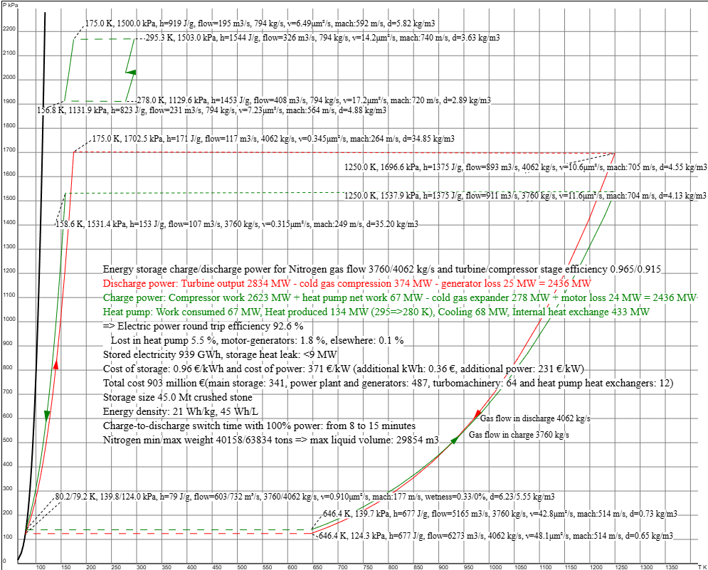
Figure 2. Energy storage operation as a TP diagram, with the horizontal axis showing temperature in Kelvins and the vertical axis showing pressure in kilo Pascals. The black line on left is the nitrogen saturation curve. The heat pump TP diagram has been moved up because otherwise it would be on the main diagram. TP diagram of helium heat pump is presented on top left.
Figure 2 shows a temperature/pressure diagram of the plant operation drawn by the design program. The storage charge cycle is drawn in green and the discharge cycle in red. The arrows indicating the gas flow direction are upwards for compressors and downwards for turbines. The dashed lines depict the gas flow through the crushed stone. They are slightly inclined to the gas flow direction due to the pressure drop caused by the crushed stone. The TP curves for turbines and compressors are curved because the pressure change has been calculated in very small parts according to the average stage efficiencies calculated by 1D loss models and CFD optimization. Charge and discharge cycles share the same motor-generator and external power, so their mass flows and equipment powers have been adjusted accordingly. In the middle of the figure are the powers and losses of the main components, the electricity round-trip efficiency and the price estimate calculated according to the unit prices given to the program. The default unit price values are based on published price estimates for the corresponding work stages, equipment and other power plant types.

Structural engineering of thermal energy storage
The design and structural engineering of the energy storage must address at least the following issues: thermal expansion and contraction of crushed stone must not rupture pressure insulations or pipes. In addition, the repeated heating and cooling cycles must not fragment and compact the rock particles too much during the planned service life. The implementation of storage walls and the management of thermal expansion are considerably simplified when the storage is inside of a closed open pit, quarry or similar depression in such a way that all crushed stone of the storage is surrounded by rock walls. The next figure shows a small 25 Mt 511 GWh storage. The portion of low-pressure storage has been increased because the cryogenic rock has lowered specific heat capacity. Its pressure control tank made of cryogenic crushed rock is near to the bottom of low-pressure storage.
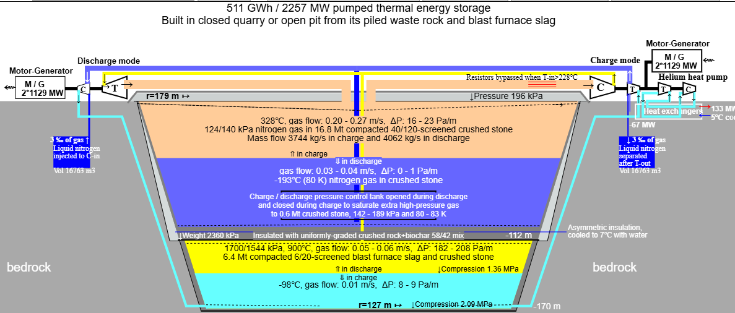
Figure 3. 25 mt, 2227 MW and 486 GWh storage with 1:13.7 discharge pressure ratio and 900 °C high temperature

The durability of the crushed stone in high-pressure storage
Crushed and screened blast furnace slag could be the best possible choice to be used for the hottest part of high-pressure storage. Its compressive strength was above 200 MPa/m² until 1300 K in study Behavior of Crack Generation of Slag in Continuous Solidification Process of Blast Furnace Slag. The high compressive strength was probably explained by the fast 120 seconds continuous solidification process presented in that work, but other solidification processes using air or water may produce more porous slag with lower density and compressive strength. The strength of blast furnace slag depends also on its minerals. The main components of blast furnace slag are CaO (30–57%), SiO₂ (7–38%), Al₂O₃ (0–24%), and MgO (1–18%). In general, increasing the CaO content of the slag results in raised slag basicity and an increase in compressive strength. The MgO and Al₂O₃ content show the same trend up to respectively 10–12% and 14%, beyond which no further improvement can be obtained. Typical steel making slags have a very low silica (SiO₂) content and a high lime (CaO) content. Worldwide production of slags is between 400 and 450 million tons annually and it is used as concrete aggregate, but it has many other uses too. The bulk cost of unprocessed air-cooled iron slag depends on region, because the transportation makes up major part of its price. The main weakness of blast furnace slag is porosity (depends also on cooling method) and low volumetric heat capacity. It is only about 60% of average volumetric heat capacity of ingenious rocks. Availability may also be a problem: 5 million tons (for upper 40% of high-pressure storage) would be 1.1% of world-wide production of slag.
Common rocks can be used instead of blast furnace slag in hot storage, but there is a wide variation in their max operating temperatures. Mixed rocks containing quartz weather above 572 °C, but some other rocks have been tested to have sufficient compressive strength at 1000 °C.
The crushed stone of the high-pressure storage must withstand at least several dozen very slow heating and cooling cycles between the upper and lower temperatures of the high-pressure storage. It must maintain sufficient compressive strength so that the crushed stone does not start to compress into a pile. In addition, the crushed stone should not evaporate a harmful amount of gas, such as sulfur, which, by liquefying and crystallizing, would impair the operation of the main turbine. The crushed stone should also have a high volumetric heat capacity. The most common mixed igneous rocks found on the surface of the earth, such as granite or gneiss, do not meet these requirements. For example, granite gradually begins to thermally crack after exceeding a temperature of 572 °C, because at this point the dominant α-crystal structure of quartz starts to change to a β-crystal structure that has approximately 4% larger volume. This causes microcracks in crushed stone, even if it is heated and cooled very slowly. This is probably because the other main mineral in granite, potassium feldspar, does not undergo a similar change in crystal structure, so internal stresses are created in crushed stone. In other words, rocks in which the proportion of quartz crystals is either sufficiently small or very large can better withstand high temperatures.
It was found in work High Temperature Versus Geomechanical Parameters of Selected Rocks— The Current State of Research that the compressive strength of the tested sandstones and claystones initially increased significantly up to 400 °C and then began to slowly decrease. The compressive strength of fine-grained and dense sandstone was above its initial value 150 MPa until 1000 °C, but for coarse-grained sandstone the initial compressive strength was lost before 800 °C. For the other tested rock types (granite, marble and limestone), the compressive strength decreased continuously with increasing temperature, and at high temperatures it was significantly worse than the compressive strength of sandstones. This study also found a collapse in the compressive strength of granite before 600 °C. The researchers concluded that the temperature behavior of the rock's strength depends on its mineral composition, crystal size and porosity.
The work Effect of heat on the mechanical properties of selected rock types in a laboratory study compared the strength properties of diabase, granite and two quartzite schists after heating and cooling. The granite lost almost completely its compressive strength at temperature of 1100 °C. In that study, ultramafic diabase retained best its original compressive strength.
The same conclusion has also been reached in Finnish sauna stove stone tests . Currently, the stove stones sold in Finland are mostly olivine gabbro. Olivine gabbro and other stove stones can withstand temperatures of at least 1100 °C without melting. Stove stones are mafic or ultramafic rocks, meaning they have solidified at the bottom of ancient volcanic vents and magma chambers. The sequence of the crystallization of common silicate minerals is described by Bowen's reaction series in the next figure with the classification of igneous rock types.
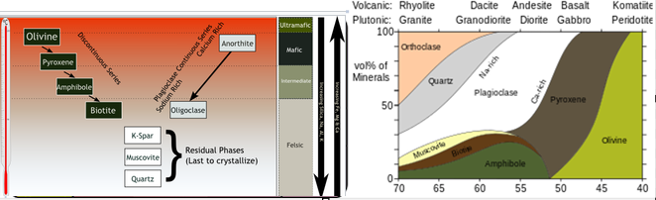
Figure 4. On the left, the Bowen’s reaction series, on the right, the classification of rock types according to the content of silica and minerals (source Wikipedia). The melting point of rock increases from left top corner to bottom right.
The properties of mafic and ultramafic rocks also vary. On the left, the Bowen’s reaction series divides igneous rock types into main classes according to the crystallization temperature of magma eruptions. On the right, they are classified according to their silica content. The upper limit for the silica (SiO2) content of mafic rocks is about 52% and that of ultramafic rocks 45%. In the figure, the proportions of the main minerals in each rock type are shown on the vertical line. The heat resistance of rocks generally increases as the proportion of silica decreases. In mafic rocks, the melting point is about 1100 °C at 52%. The melting temperature of pure magnesian olivine or chromite used as foundry sand is about 1800 °C . Mafic rock types are characterized by dark color, alkalinity, higher density than surface rock types, and thus also a higher specific heat capacity per volume.
In the more precise QFPA classification, rock types are classified based on the sliding percentages of the four main minerals, and ultramafic rocks are classified separately based on the three main minerals. Thus, the properties and melting points of so-called pure rock types also depend on the content of their main minerals and other impurities. The minerals of the rocks first soften and finally melt, each in its own temperature range. When the melting starts, the compressive strength of the rock decreases rapidly, even if it is externally intact.
Chromite and olivine, as well as mafic Plagioclase and pyroxene have high melting points. Plagioclase consists of two and pyroxene consists of five minerals, with mafic minerals with higher melting points at one end and felsic minerals with lower melting points at the other end. In summary, magnesium- and calcium-rich mineral subtypes have higher melting points, and correspondingly rocks containing potassium or sodium melt at lower temperatures. Replacing the magnesium portion with iron also lowers the melting temperature of the mineral. Minerals of heat-resistant rock have similar thermal expansion coefficients, high melting points, and there should be no phase changes below the max operating temperature. Preheating the crushed stone above 800 °C may improve its heat-resistance, compressive strength, and decrease thermal expansion because it removes all water bound to the minerals and may also reverse the possible serpentinization of olivine.
Some mafic rocks cannot withstand high temperatures. The article Damage and Changes in Mechanical Properties of a Gabbro Thermally Loaded up to 1,000°C. The summary states that the first microcracks caused by different thermal expansion coefficients of its mineral crystals appeared in the gabbro sample below 600 °C, and above that, compressive strength of the gabbro decreased dramatically mainly because of oxidation of free iron and magnesium. However, oxidation is not possible in pure nitrogen or argon atmosphere of the storage.
The largest sauna stove stone quarry in Finland is in Luvia , which belongs to the diabase vein area of southern Satakunta. Stove stones such as olivine diabase and peridotite serpentine have also been quarried from the Kemi intrusion in Keminmaa. Very dark diabase and gabbro, sold under the trade name black granite, are quarried at several natural stone quarries in Central and Eastern Finland. Mäntyharju is the only known deposit of pure olivine in Finland, from which stove stone is also quarried. The melting temperature of the olivine quarried there has been measured at the Technical University of Helsinki to be 1350 °C. The mafic calcium-containing subtype of hornblende (Amphibolite) can also withstand high temperatures and is considered a good sauna stove stone. Mafic hornblende has previously been quarried in Hyvinkää as stove stone.
The high proportion of waste rock is considered a challenge in the commercial exploitation of mafic rock deposits. For example, in Luvia, only about 25% of the rock extracted can be sold as stove stones. In the stone quarries, blocks of several cubic meters are cut from the rock, so they have even higher waste percentage. The waste rock content is high, because mafic deposits are layered and/or veined, partially or completely metamorphosed, and may be mixed with other mafic or intermediate layers such as diorite. A typical mafic so-called waste rock is peridotite, which, however, may have even better heat resistance than pure diabase or gabbro. Thus, mixed mafic aggregates may be as usable as pure aggregates of a single rock type. Based on the storage simulation, only about 13% of all extracted crushed stone heats up to the maximum temperature of the high-pressure storage, so the above-mentioned typical concentrations of rock quarries are sufficient.
The mafic rock deposits have been quite well studied and drilled, so based on the existing research data, it is possible to focus further research on the most promising areas. For example, the description of the Finland’s bedrock shows the largest mafic rock areas, but in the more detailed high-resolution description of the bedrock you can see, that smaller mafic rock areas and lines with a diameter or length of a few kilometers can be found practically everywhere at least in Finland. Mafic and ultramafic deposits are found with old volcanoes. In Europe, they can also be found outside the actual active volcanic zones, for example in England, Central Germany, and Central France.
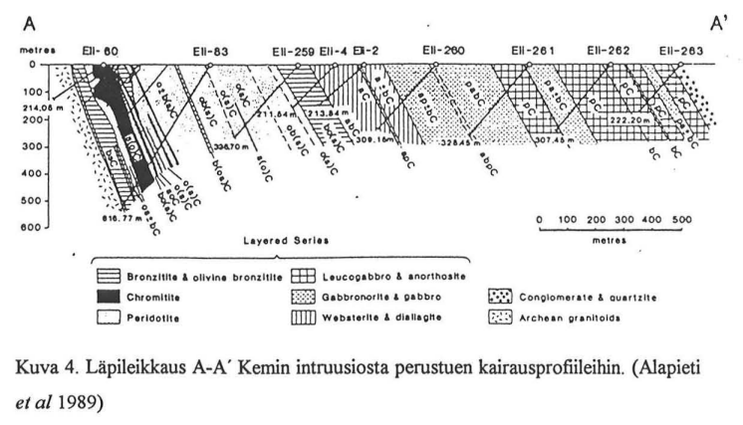
Figure 5. Cross section of mafic Kemi intrusion based on drilling profiles
The Kemi intrusion in Finland is a good example of the geology of an ultramafic deposit. There is a good description of it in Alan Forsman's Master’s thesis , from which the above image is copied. The image shows a cross-section of the intrusion viewed from the northeast. As a result of later folding, the intrusion has tilted at an angle of 70 degrees to the northwest, and the igneous rock types layered at the bottom of the magma chamber are in order from left to right. At first there is a less than kilometer-wide strip of ultramafic minerals such as peridotite, olivine, chromite and pyroxene. The proportion of pyroxene increases as you go to the right. After that comes a kilometer wide strip of mafic gabbro-like rock types, which are replaced on the top of the intrusion by leucogabbro and anorthosite. At the top and bottom of the intrusion, silicates have undergone metamorphosis and changed to serpentine, chlorite, amphibole, talc, and carbonates. Thus, the best aggregate is probably found in the partially metamorphosed ultramafic zone. The unaltered gabbro zone in the middle could also be a possible location for energy storage. Outokumpu is mining chromite in Kemi. The open pits have been closed, and the mining continues underground. The Kemi intrusion at the mouth of the Kemijoki River and Luvia are located close to the nodes of the Finnish electricity grid, so electricity could be charged and discharged from several directions.
Some transformed mafic and ultramafic rock deposits contain asbestos fibers. However, the minor asbestos content has not been found to be a significant safety problem in the utilization of those deposits.

Strength requirements of the crushed stone
The compacted crushed stone begins to compress when its maximum point load is exceeded. The maximum point load is generally considered to be about 5% of the intact rock compressive strength , but the percent is smaller (1/24) for hard igneous rocks and bigger for softer rocks having lower ultimate compressive strength. The point load I_{s(50)} has been measured for particles having effective diameter of 50 mm. According to the sources mentioned above, after repeated heating and cooling cycles, the compressive strength of mafic rocks may decrease by about half. The crushed stone is compressed by its own weight above and the compression between the side walls caused by the thermal expansion. The point load caused by weight above is about 1.5-2 MPa in the bottom of the hottest area and about 3 MPa in the permanently cryogenic bottom. If continuous point load is only 50% of ultimate point load, then 150-200 MPa would be the minimum ultimate compressive strength of crushed stone used in the hot high-pressure storage (150 – 200 MPa / (24*2*2) = 1.5 – 2 MPa). If allowed point load is exceeded, effective diameter D_{e} (mm) of crushed stone must be decreased which increases the pressure drop. The point load formula of effective diameter D_{e} is I_{s} = I_{s(50)}/(D_{e}/50)^{0.45-0.55}. The used exponent depends on properties of crushed stone, and the formula is valid at least for diameters between 10 and 100 mm. The suggested effective diameter of high-pressure storage is 13 mm (6/20) which means that the allowed point load can be multiplied by 2. The result (3 – 6 MPa) exceeds 1.7 MPa, the maximum compression in the hot part of the high-pressure storage in the default design.
At the operating temperatures of the low-pressure storage or in the bottom of high-pressure storage, the crushed stone does not lose its original compressive strength. Only the upper 40% of the high-pressure storage will be heated to the top temperature. So, the less heat resistant felsic and intermediate aggregates can be used elsewhere. A temporary exceeding of the maximum point load is not a problem for the operation of the energy storage if the compressed crushed stone reaches a new equilibrium state before its gas permeability decreases significantly.

Pressurization of thermal storage and control of thermal expansion of the crushed stone
The optional above-ground part of the energy storage could be closed inside welded stainless-steel sheet. The top of the high-pressure storage could have gas-tight roof of soft steel. However, both steel covers must withstand the thermal expansion of the crushed stone and the possible vertical compaction of several meters during the plant's usage.
The thermal expansion coefficient of basalt, gabbro and diabase is reported to be about 5.4 10 ⁻⁶ m/K . According to the simulation of the overhead storage, the average temperature difference between the empty and full storage would be approximately 570 °C, so the average volumetric change of the rock would be about 1%. Since the rock surrounding the storage is inelastic, the thermal expansion of the crushed stone can only direct upwards, so that the top of the hot storage might rise by 0.5 meter when the storage is fully charged. However, some of the thermal expansion only compacts the crushed stone. An example of this is fire bricks, which, due to their porous structure, have a thermal expansion coefficient of approximately 30% lower than that of ordinary solid bricks. The porosity of the compacted crushed stone is significantly larger than the porosity of the fire bricks, so it can be assumed that its thermal expansion coefficient of compressed crushed stone is less than 50% compared to solid rock. The difference probably depends on the porosity, as well as on the compression, the elasticity of the aggregate, the size of the particles and the settings of stone crusher, so the actual thermal expansion coefficient of the crushed stone must be measured on a case-by-case basis in the expected compression.
Cryogenic low-pressure and hot high-pressure pipes are in the middle of the low-pressure storage, and they move vertically with crushed stone.
The friction of the crushed stone in the wall insulation must be at least the same as the friction of the crushed stone in the storage. Otherwise, the thermal expansion and contraction may gradually pump up the insulation. When pressed, round-edged screened sand slides between the fingers much more easily than angular rock ash that has passed through the same screen. The friction therefore presumably depends on both the size of the fraction and the average angularity and aspect ratio of the particles.
Thermal expansion also raises and lowers the low-pressure storage, but significantly less, because the volume change of the high-pressure storage is more widely distributed there, and its thermal movement is also smaller and opposite to that of the high-pressure storage. The temperature difference of the low-pressure storage is about 520°C, and if the low-pressure storage were partially above ground, two-thirds of the expansion occurs laterally in its upper part. As a result of the opposite thermal movement of the storages, most of the thermal expansion of the low-pressure storage occurs downwards. We have disabled the above-ground storage in the default design because selected 140 kPa low pressure and horizontal thermal expansion of above ground part would cause structural problems, but it can be enabled with the option “Top fill used as Storage”. The top radius would be 140 meters, and the coefficient of thermal expansion of the granite is on average 7 10 ⁻⁶ m/K, so a temperature change of 520°C could push the sidewall outwards by up to 25 centimeters if about 50% of the rock heat capacity can be utilized. When this is repeated, for example, 50 times, the above-ground part of the storage could gradually spread by almost 12 meters and at the same time the above-ground part would lower by several meters. However, the expansion would require that the crushed stone particles would have continuous horizontal contact between heating and cooling cycles, which is quite unlikely. The above-ground part of the low-pressure storage would probably widen outwards perhaps 10–20 centimeters per year. That probably could be handled by the structural design of the storage walls and roof if the max low pressure were 96 kPa.
The gas-tight barrier above the hot upper high-pressure storage can be made of soft, very low-carbon mild steel, which becomes elastic at the operating temperature of the upper high-pressure storage and thus adapts to its vertical thermal movement. The central part of the upper high-pressure storage may rise above its edge, but the crushed stone of the storage can expand upward perhaps half meter in relation to the surrounding rock (with 50 % utilization). In the cooler insulation layer at the edge, the steel can be replaced first with an aluminum alloy as the temperature drops, then with a mixture of pure aluminum and load-bearing crushed stone, and right near the rock, when the temperature drops below 200 °C, with an airtight mixture of crushed stone and technical rubber (or bitumen) melted together. At best, the long-term maximum operating temperature of heat-resistant technical rubbers is slightly above 200 °C. At that temperature, pure aluminum is probably still sufficiently malleable, so by changing the material the gas-tight pressure barrier can be extended to the rock walls. The softness of steel and aluminum depends on their additives such as carbon or silicon and heat treatment. The toughness of soft insulation layers can be improved by mixing, for example, carbon fiber strands into them, and their compressive strength can be improved by mixing them with a uniform size of good quality crushed stone, which prevents the soft pressure insulation from moving laterally. Above and below the insulation layer, the crushed stone fraction must be sufficiently fine so that the pressure does not compress soft metal or rubber uncontrollably into the crushed stone.
The gas barrier of the steel surface above the upper high-pressure storage can be ensured by a layer of crushed stone and crushed biotite, which partially melts and becomes plastic at operating temperature. The melting of biotite minerals begins about at 800 °C . The permeability of a one-meter-thick layer may at best be even lower than that of a few millimeters of steel plate . Under compression and heat, the mixture will probably become completely gas-impermeable if at least 20% of its minerals either melt or become plastic, completely filling the empty space in compacted crushed stone.
The cracks and surfaces of the rock walls of the storage can be sprayed and injected with concrete to make them gas tight and waterproof. At the same time, it enables very steep walls and improves safety of the workers. In very broken areas, a continuous steel plate anchored to the rock can be left inside the sprayed concrete. The rock can also be strengthened and made water- and gas-tight by freezing it below the groundwater level. This may also have to be done if the storage is penetrated by an active rock movement joint that cannot be concreted with certainty to make it gas tight. Freezing is used to strengthen the rock in rock construction. The insulation thickness above is defined so that the continuous heat leakage of a full storage is 7 MW. Of this, perhaps about 4 MW leaks into the rock. When the cooling capacity of the rock piping is dimensioned sufficiently large, rock freezing could be done almost free of charge in northern winter. Continuous freezing with a heat pump would require less than 1 MW of power, because the average temperature difference would probably be less than 20 °C.

Volatile gases
Volatile gases are released from heated crushed stone. The type of gas released depends heavily on the temperature. Key volatiles released include water, carbon dioxide, sulfur compounds, and noble gases. Below 600 °C surface trapped gases, water and hydrocarbons are released. None of these are harmful to turbomachines or heat exchangers in the operation temperatures, but too much water may be a problem for storage. The water evaporated from hot rock will saturate as water, ice and snow on a quite narrow height of permanently cold crushed stone on both sides of 0 °C. The saturated water exceeding the field capacity will flow downward and freeze at -0 °C blocking the gas passages in crushed stone. This means that water must be removed from hot area of crushed stone before startup for example by heating the upper parts and keeping the temperature of the lower parts above 0 °C. Extra water may be pumped from the bottom, and the rest may freeze on cryogenic crushed stone. Water vapor does not move in cryogenic crushed stone, because vapor pressure of ice drops very fast. Water vapor mass flow is below 2 g/s at -40 °C and about 0.2 g/s at -50 °C when nitrogen gas mass flow is 4000 kg/s.
Above 600 °C sulfide minerals react to form sulfur dioxide SO₂, and calcite decomposes to lime and CO₂ between 840 and 950 °C. They also saturate or freeze on crushed stone and may cause similar problems as water if the hot crushed stone has too high sulfide, calcite or organic matter content.

External cryogenic storage made of crushed stone or ice
The energy storage capacity can be doubled when cryogenic cold is mainly stored to an external cryogenic storage made of ice. By default, its volumetric size is 55 % of crushed stone. The volumetric heat capacity of crushed ice is approximately 1.5 times that of crushed stone at the nitrogen vaporization temperature of the low-pressure storage (80 K), but their volumetric heat capacities are almost the same at 200 K. Crushed stone and ice perform almost as well in the storage simulation. However, the specific heat capacities of different rock types vary somewhat, so the ratio depends on the composition of the crushed stone in the low-pressure storage and its porosity. The density of crushed aggregates could be increased in the permanently cryogenic part because dense cryogenic gas has very small velocity and pressure drop in crushed stone and ice.
In the charge-discharge simulation, the temperature at the bottom of external cryogenic storage can be at most 4 degrees above the minimum temperature (a configuration parameter). The top of the cryogenic ice storage reaches its maximum temperature only when the energy storage is completely empty, which is a very rare situation in normal use. When the storage is simulated with the default parameters, the maximum temperature at the top of the cryogenic ice storage is 164 K, but it may increase a few degrees when plant has been operated several years. The compressive strength of compacted crushed stone is about 5% of compressive strength of the rock. However, ice is significantly more plastic compared to crushed stone, so we use yield strength of solid ice instead of its compressive strength when calculating the maximum point load for crushed ice. Based on measurements, the yield strength of ice increases almost linearly with decreasing temperature . According to the source, the yield strength of ice is 40 MPa at 80 K and 10 MPa at 200 K. The compression is approximately 0.4 MPa in the bottom of 50 m high ice storage, which is below its maximum allowed point load 2 MPa by a very large safety margin (2 MPa = 40 MPa ⋅ 5 %).
External cryogenic storage made of crushed stone is estimated 30% more expensive than storage made of natural ice, but in most cases, there is no natural ice available, or the transportation costs make it too expensive. The cost of crushing, screening, transportation and piling of crushed stone is well known compared to the processing cost of natural ice. Cryogenic storage could also be made from mix of crushed stone and ice where the crushed stone would be used for truck causeways on crushed ice.
Cryogenic ice storage should be built from natural ice collected from nearby sources. Cooling 7.5 million tons of ice from water would require over 0.6 terawatt-hours of cooling energy. In addition, the capital cost of the massive cooling equipment required would probably be in the hundreds of millions. Instead, cooling the natural ice to 80 K can be done using the storage's own equipment while the storage is initialized to initial state before the first operational charge. The enthalpy change of ice from 273 K to 78 K (275 kJ/kg) is less than the melting heat of ice, 333 kJ/kg.
Cryogenic ice storage can be built partly with the same machines as the main thermal storage made of crushed stone: large trucks, loaders and crushers used in open pit mines. In addition, long-range diggers, possibly fixed or mounted on rails, are needed to lift the ice pushed by tugboats to the shore. The ice storage can be pressure-insulated with a wet mixture of the soil in the area and the remaining fine crushed stone, which is frozen into a gas-impermeable layer after spreading. The outside of the insulation layer must be a flexible metal plate or any other elastic membrane that is impermeable to water vapor. The XPS insulation could be used in its temperature range. Biochar, stone wool or wood fiber insulation could be used elsewhere. In the bottom they could be mixed with uniform-sized crushed stone. The ice must be processed in mid-winter when natural ice is available. If the average thickness of the natural ice is 0.5 meters, then the required collection area would be at least 15 km². In inland waters, natural ice must be broken into blocks with light machinery, but at sea it can be done with an icebreaker. The current of the river, the wind or a boom pulled or pushed by tugs could push the broken ice onto the shore, within reach of the excavator, which dumps them on the shore to dry before crashing and transportation.
The filling of the circular ice storage proceeds from the walls to the center, so that the side walls rise first and freeze at the same time with the ice. The installation of the upper channel elements and roof insulation begins from side towards the center as soon as the ice reaches its final height. The crushed and screened ice is driven to the site by large mining trucks and spread on a safe slope by loaders or bulldozers. During the filling, the ice should be cooled to a load-bearing temperature by heating the outside air with a compressor, which is first cooled in heat exchanger to about 280 Kelvin and then in a turbine to a cryogenic temperature. The hot air from the heat exchanger preheats the crushed stone in the low-pressure storage to the target temperature of the empty low-pressure storage. Cold air from the cooling turbine is directed to the bottom of the circular crushed ice storage, from where it flows through the crushed ice up and into the center. The cold air flowing over the end walls of the storage freeze also the soil on the outer edge.

Energy storage design and simulation application
The energy storage design and simulation application is a research and design tool built on top of the JavaScript adaptation of the public Coolprop (http://coolprop.org/) thermodynamics library. All essential variables affecting the construction, size, power and costs of energy storage and turbomachines are editable design parameters. The software has been extended in several stages, when new ideas have had to be verified, to design the axial turbomachines of the plant, predict their efficiencies and map possible technical problems. The most important algorithms used in the storage design are briefly described here. The code contains some references to scientific articles from which the algorithms used have been adopted. The gases supported by the Coolprop library, their sources and allowed pressures and temperatures are listed in the List of Fluids section at http://www.coolprop.org/fluid_properties/PurePseudoPure.html . For example, the maximum allowed temperature for methane is 625 K, so the program sets the upper temperature of the storage to 623 Kelvin if methane is selected as the working fluid.
The program and its source code have been published at https://anttisaarenheimo.github.io/ .

Simulation of compressor and turbine operation
The ideal gas equations cannot be used with real gases when the pressure of gas is too high, it is wet, or if its temperature is close to the saturation temperature. Therefore, thermodynamic libraries are used to simulate the operation of compressors and turbines. They provide very accurate results under all conditions. In its simplest form, the simulation is performed by calculating four properties of the fluid in a loop, when the turbomachine’s average stage machine efficiency η is known: pressure P (Pa), temperature T (K), enthalpy h (J/kg), and entropy s (J/kg/K). The system can be assumed to be closed, because the mass flow and enthalpy change are very large compared to the heat losses in the turbomachinery and pipes.
The program uses the easy-to-use high-level PropsSI interface of the Coolprop library, where two gas properties are used to query a third property. When the average stage efficiency of a compressor or turbine is η, the positive or negative enthalpy change Δh, the initial state of the gas before the compressor or turbine stage (T1, P1, h1, s1) and the final state after the stage (T2, P2, h2, s2). For a compressor, efficiency is the part of the enthalpy that changes the pressure while the entropy remains constant. The rest of the enthalpy change is converted into heat, which in turn increases the temperature and entropy of the gas in the final state. Thus, here is the state change of a compressor stage with nitrogen gas:
P2 = PropsSI ('P', 'H', h1+ Δh ⋅ η, 'S', s1, 'Nitrogen')
h2 = h1 + Δh
T2 = PropsSI ('T', 'H', h2, 'P', P2, 'Nitrogen')
s2 = PropsSI ('S', 'H', h2, 'P', P2, 'Nitrogen')
In the case of a compressor stage, Δh is the enthalpy (J/kg) added into the system, which with the part determined by the efficiency increases the pressure. In the case of a turbine, Δh is the work produced by the pressure drop caused by Δh/η in turbine. The stage loop is repeated until known end pressure, temperature or enthalpy has been reached. There is also a reverse version of this calculation, where the cryogenic turbine is simulated backwards with efficiency 1/η because only its exit values are known.
There is a bug in Coolprop library, that produces invalid pressure values from entropy s and enthalpy h in some points near to the nitrogen saturation line. The code cross checks all returned pressure values by fetching entropy with enthalpy and returned pressure. If the fetched entropy is different from the parameter s, then the correct pressure is binary searched by fetching the entropy with the enthalpy and tested pressure value until the result is the same as the entropy parameter.

Calculating the dimensions of energy storage
Energy storage is assumed to be shaped like a cut cone. That shape minimizes construction costs and heat loss. At the same time, it enables pressurizing the hot high-pressure storage with the mass of the low-pressure storage. The default cost of crushed stone (2.5 €/ton) has been selected assuming that the storage is made in a closed quarry or open pit mainly from its waste rock. The cost of crushed stone should be doubled if a new open pit is mined for energy storage.
The main dimensioning parameters of the energy storage are size of main storage in tons, low inlet pressure of charge, high inlet pressure of discharge, the maximum temperature of the hot high-pressure storage, density of the rocks used for the high- and low-pressure storages, specific heat capacity, maximum steepness of open cut side, crushed stone screen sizes for high- and low-pressure storage, k-value of insulation and the heat leakage (W/ m²) of hot and cryogenic part of storage.
The algorithm calculates average volume specific heat capacities for the temperature ranges of both storages. The specific heat capacity of the rock depends on the temperature. At low temperatures, this relationship is best described by the Debye model. According to the model,the Debye temperature can be calculated from the maximum of the crystal vibration of solid elements and minerals. The ratio of this to the measurement temperature can be used to normalize the temperature dependence of the specific heat capacities of solids to the same curve (see the next figure). The most important thing from the point of view of energy storage is the reduction of the specific heat capacity to zero when the temperature is approaching absolute zero, and the fact that the ability of minerals to store very cold is inversely proportional to their Debye temperature. However, the Debye temperature is not constant but usually increases at the same time as the measurement temperature. For example, the Debye temperature of ice increases from 222 Kelvin to 300 Kelvin when the measurement temperature increases from 0 to 100 Kelvin. The Debye temperature of silicate minerals is typically between 500 and 1200 Kelvin measured at room temperature.
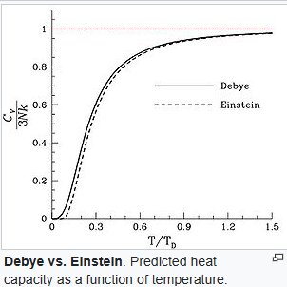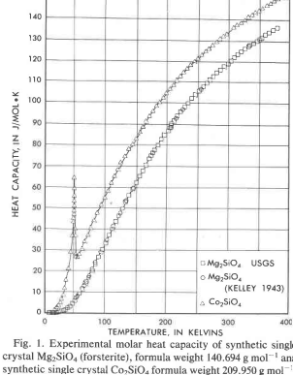
The figure on right shows the measured specific heat capacities of two ultramafic minerals, forsterite (Mg₂SiO₄, T_{D} 758 K) and cobalt olivine (Co₂SiO₄, T_{D} 548 K). A specific Debye temperature cannot be defined for ordinary rocks, because they consist of several minerals, the mutual ratios of which can vary by tens of percent. On the other hand, there is about the same absolute difference between the heat molar capacities of those minerals at 100 K and at ambient temperatures. Thus, the rock samples having the highest volumetric heat capacity at 273 K are also the best rocks to store cryogenic cold.
In the next figure on the left are the measured mass specific heat capacities of several rock samples, and on the right their normalized distribution from the study A Review and Evaluation of Specific Heat Capacities of Rocks, Minerals , and Subsurface Fluids . Part 1: Minerals and Nonporous Rocks .
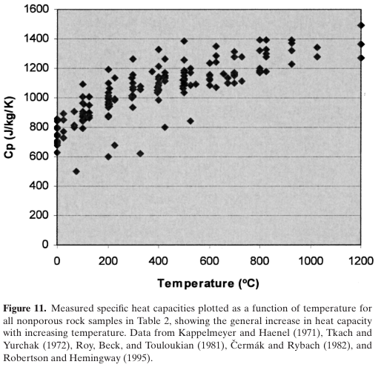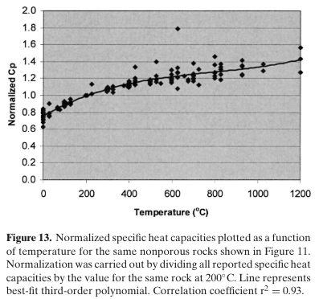
The calculation of the specific heat capacity of the energy storage has been simplified by following the Debye curve of 650 Kelvin linearly through three reference points below 20 °C (heat capacity at 77 K: 23%, at 200 K: 78%, at 293 K: 100%) and the normalized curve of the aggregates above through three reference points above (heat capacity at 473 K: 125%, at 773 K: 150%, at 1023 K: 163%). The thermal capacity of high-pressure storage is obtained by calculating the average specific heat capacity of its temperature range, multiplying it by the temperature range and mass of the storage and finally multiplying it by the heat capacity utilization parameter. The initial value of capacity utilization factor parameter (53%) is calibrated by optional charge/discharge simulation and updated. The utilization factor determines how much of the maximum capacity of the high-pressure storage can be used before defined exit temperatures are exceeded and the round-trip efficiency begins to decrease significantly.
The density of the crushed stone is calculated based on min/max screening parameters, and on the assumption that the cubic weight of the compacted 0–100 mm aggregate would be 2.1/2.65 of the rock weight, and the density of a completely uniform compacted crushed stone would be 1.5/2.65 of the stone density and porosity 0.43. Based on this, the ratio of the density of an evenly distributed screened compacted crushed stone fraction to the stone density is (1.5 + (2.1-1.5) ⋅ (1-screen min/max))/2.65, i.e. the smallest particle leaves an empty space in the crushed stone, which reduces the density. The densities of the crushed stone, of course, depend on the actual screen spacings used, the particle size, the average particle aspect ratio and distribution, the crusher settings and the splitting of the aggregate. The actual values can only be determined by measurement. Crushed stone with a rounder shape and smaller aspect ratio has been found to pack more tightly, and the gas and liquid flow is faster. Presumably, the point load carrying capacity of rounder particles is also better. Thus, with the right crusher and screen settings, the operation of the energy storage can be improved and probably also extend its service life.
Calculating the shape and dimensions of a storage is a typical multi-step heuristic algorithm, the optimal outcome of which is known in advance, but the many interacting variables make it impossible to solve as an equation. Energy storage must meet the following requirements:
- Thermal storage capacities of high- and low-pressure storage must be symmetrical, i.e. when the high-pressure storage is full of heat, the low-pressure storage is full of cold, and of course vice versa. Relative storage sizes are calculated based on their cold capacity, because it is the limiting factor for both storages. The cold capacity of both storages depends on the minimum temperature and the allowed exit temperatures.
- The optional above-ground part of the storage should preferably be completely above the upper pressure storage, i.e. it should not extend beyond the excavated rock. The current design does not have the above ground part because the thermal expansion could break its external walls and the selected low pressure is too high.
- The weight (in Newtons) per square meter of the upper low-pressure storage must be above the maximum pressure of the high-pressure storage. The program assumes that the compacted crushed stone on the storage scale behaves like a liquid: only the mass directly above the high-pressure storage matters in the calculation. The actual gravitational compression force can be measured with pressure sensors above the high-pressure storage.
- The area of the storage's external surface should be as small as possible to minimize the costs and heat leak.
- Maximum point load of crushed stone must not be exceeded
At first, initial weights of parts are calculated using an educated guess about the dimensions of the storage. The algorithm makes necessary corrections to the dimensions, and the calculation is made again. If the storage has a high pressure (such as 2000 kPa), this is repeated until the safety margin of the result is less than 5% above or below 100 kPa. If the pressure is low, then the surface area is minimized.
Along with the storage dimensions, the program calculates the proportion of gas to be liquefied during the charge, which is 0.3% of the mass flow with the default parameters for nitrogen.

Simulation of energy storage operation
The operation of the designed energy storage is simulated programmatically. PlantSimulation.js object implements digital energy storage. It has functions to charge, discharge, idle and switch the pressure ratio between charge and discharge modes. The switch functions assume VFD-controlled cryogenic turbomachines to be used in off-design mode to change storage operating pressures between charge or discharge modes. Power control tank in the middle of low-pressure storage is used to saturate excess nitrogen gas during charge. The methods simulate gas flow through crushed stone and the heat exchange inside the crushed stone and within insulation layers. The methods maintain the complete internal state of the storage including its charge level and vertical temperature distribution of crushed stone and surrounding insulation.
The energy storage object can also be operated by power market trading algorithm using wholesale hourly power prices of European countries between 2016 and 2026.
The simulation algorithm divides the crushed stone and ice into horizontal thin slices (default 10 cm), which are assumed to have the same temperature. In the simulation, each slice is heated or cooled by the forced convection of gas for a given time (default 900 seconds) so that the end temperature of the gas and the solid in the block would be the same. In reality, of course, there is a very small difference, and if desired, the actual heat exchange coefficient between the crushed stone and the gas can be enabled. However, using the heat exchange coefficient in the simulation does not significantly change the efficiency of the storage, or even its maximum capacity, because the temperature of the gas flowing out normally deviates from the temperature of the crushed stone or ice by fractions of a degree at most. Only when the storage is almost empty or full can the temperature difference of the hot gas coming out from the upper end increase to 1–2 degrees.
The internal and external heat leaks (W/m/K) are also included in the simulation, so that the heat transfer coefficients of rock and dry 5/16 crushed stone in room temperature (2.5 and 0.37 W/m/K) are split to the conductive heat transfer and heat transfer by radiation. In the simulation, the heat radiation is scaled to the actual temperature and median particle size of the crushed stone. Although heat radiation increases the heat transfer coefficient of the crushed stone in hot high-pressure storage by an order of magnitude higher than in the room temperature, it does not seem to have a significant effect on the storage capacity or even the energy storage time, because the internal heat leak is small compared to the heat capacity of the storage, and on the other hand because the internal heat leak has an effect only when it changes the temperature of the gas leaving the storage, i.e. only when the storage is almost empty or full. Based on the simulation, even months of downtime do not significantly equalize the internal temperature differences.
The simulation determines the initial capacity by discharging the fully charged energy storage until the hot turbine inlet temperature exceeds the configured minimum. The available capacity is the discharge hours multiplied net output power. The net output power depends on inlet temperatures of the hot turbine and cryogenic compressor. When the storage is almost empty or full, the high temperature of low-pressure storage may drop too low for main compressor. In that case additional resistors placed in alternative pipe route to main compressor are used to heat the incoming gas to an on-design value. If the temperature difference is less than 100 K, the extra heating can be done by increasing the pressure ratio, but that also decreases the mass flow through the hot compressor.
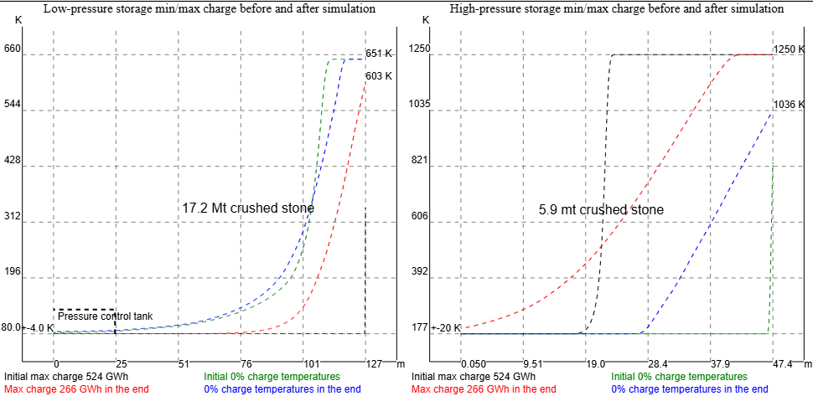
Figure 6. Simulation of small 25 Mt 2400 MW/500 GWh energy storage from 2021 to 2026 in power market of Germany.
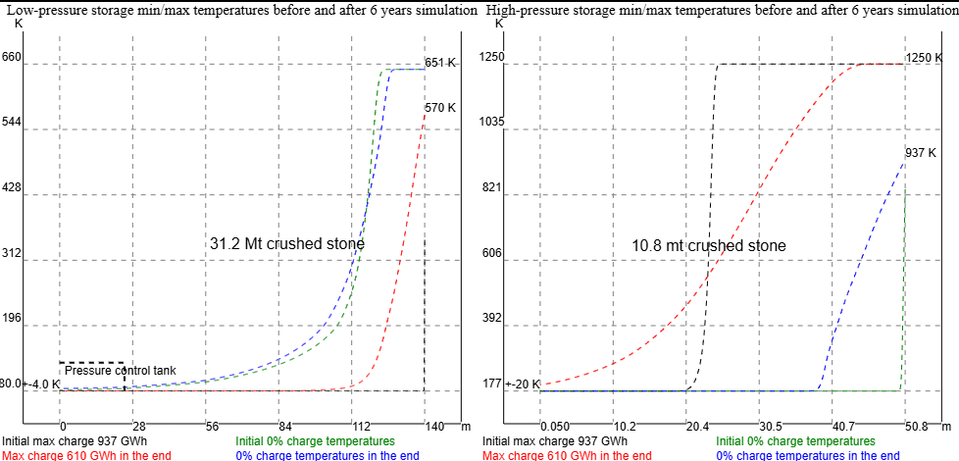
Figure 7. Simulation of medium-size 45 Mt 2400 MW/900 GWh energy storage from 2021 to 2026 in power market of Germany
The previous figures show the internal min and max temperatures (K) by height of a small and a medium-size energy storage after 21 sold TWh, 23 purchased TWh and six years continuous simulation in the power market of Germany. The small storage has lost 50% and medium size storage 35% of the initial capacity. The capacity is defined by net output (GWh) in discharge between allowed exit temperatures. The original capacity of both storages can be restored by over-discharging and then over-charging both storages near to their minimum temperatures.
Power market simulation with simple trading algorithm
The energy storage is integrated with a simple trading algorithm using average hourly power prices of European countries between 2016 and April 2026. There are two versions of the trading simulation. The quick version uses simple charge level counter with constant work for pressure ratio change and additional charge level dependent resistor load when the compressor inlet temperature is too low. The slower version of trading algorithm operates the digital energy storage model simulating internal and external heat exchange. Its time resolution is 15 minutes, and the heat exchange is simulated for each 10 cm high horizontal slice of crushed stone and wrapping insulation. The quick market simulation predicts 3 - 5 % higher cash flow than power trading simulation using digital energy storage.
The trading algorithm uses purchasing and selling price limits for each 20% step of charge. The exact price for storage charge percentage is interpolated from the nearest values. The historical hourly wholesale price is multiplied or divided by given price elasticity percent parameter powered with purchased or sold power divided by 500 MW. There are two optimized default price limit sets for Finnish and German power markets and medium size storage. The default price elasticity is 10%/500 MW in Finland and 3%/500 MW in Germany. The market trading simulation shows similar results for Finland and Germany: an exceptionally high ROI (return of investment) in 2022 (78 and 66 % respectively) and an increasing trend of ROI for normal years after 2022 because of on-going green transformation: the predicted ROI is 23, 31 and 38% in Finland and 33, 41 and 44% in Germany for years 2023, 2024 and 2025. The next table shows the results when the trading algorithm operates digital energy storage object with power market data of Germany. The cost of initial charge is not included in the capital costs of the energy storage because it would be difficult to estimate, but it could be about €30m in Germany and €6m in Finland with the recent purchase prices. The next table presents operating 2400 MW/1034 GWh digital energy storage with German power market data, 3 % price elasticity and operating expenses €10m/year:
Year | Cash flow | ROI | Sold electricity |  |  | Purchased electricity |  |  | Price change
2021 | €327m | 36 % | 3566 GWh | €532m | €149/MWh | 3330 GWh | €195m | €58.6/MWh | -3 %
2022 | €592m | 66 % | 3869 GWh | €1029m | €266/MWh | 4443 GWh | €427m | €96.2/MWh | -2 %
2023 | €294m | 33 % | 3895 GWh | €490m | €126/MWh | 4661 GWh | €187m | €40.1/MWh | -2 %
2024 | €373m | 41 % | 4514 GWh | €496m | €110/MWh | 4662 GWh | €113m | €24.3/MWh | -4 %
2025 | €395m | 44 % | 4400 GWh | €534m | €121/MWh | 4811 GWh | €129m | €26.8/MWh | -3 %
1.1.-  8.6.2026 | €199m | 51 % | 1985 GWh | €257m | €129/MWh | 2088 GWh | €53m | €25.5/MWh | -3 %
Total | €2179m | 44 % | 22229 GWh | €3338m | €150/MWh | 23994 GWh | €1104m | €46.0/MWh | -3 %

The next figure shows the distribution of cumulative cash flow, sold and purchased power on charge level percents in Finland (left) and Germany (right). Lower power prices and number of zero price periods increase the cash flow between 80 and 100 % charge in Finland, but the charge level is almost never above 95 % in Germany because preheating with resistors is profitable only when electricity price is almost zero.
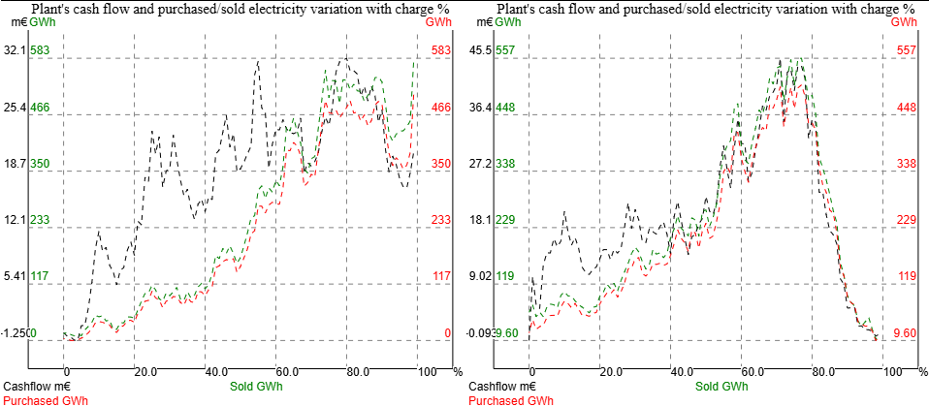
Figure 8. Variation of cumulative cash flow, sold and purchased power on charge % in Finland (left) and in Germany (right) 2021 - 2026
The power market simulations of energy storage predict an excellent 20 - 40% ROI in those countries where variable renewable energy sources have a high market share.
Dimensioning of pipelines
The allowable pressure drop in the pipes between the storages and turbo machines is a design parameter. Its default value is 1%. Based on the given allowable pressure drop, the diameters of the pipes and the gas velocity in the pipe are calculated. The actual pressure drop is calculated using the Darcy-Weisbach equation. The friction factor f used in the equation is calculated as presented by Tkachenko and Mileikovskyi in 2020. The value of epsilon (ε) is 0.025 (steel, structural or forged), which is probably an order of magnitude worse than the typical value of steel pipes. On the other hand, pipe bends, welds, dust filters and valves each increase the pressure drop, so it probably gives a good estimation of the actual value. The algorithm is again heuristic because the desired result is known, i.e. the allowed pressure-drop, but the equation is too complex to directly be solved with only variable affecting it, i.e. the diameter of the pipe.

Gas flow resistance in crushed stone
Air flow in the crushed stone has apparently not been studied very much, because with the search words used, only a seminar presentation of a research project was found. In that study, the radon ventilation of the subfloor was studied with two EU standard crushed stones 6/12 and 10/20. The conclusion of the study was that for the crushed stone, the Darcy-Forchheimer equation best corresponds to the measurement results. The superiority of the equation is quite self-evident, because the laminar and turbulent parts of the equation have their own measurement-based coefficients depending on the properties of the crushed stone.
The Darcy-Forchheimer equation is: ΔP/L = μ /k ⋅ ν + c/k ⋅ ν², where ΔP is the pressure change (Pa), L is the distance (m), μ is the fluid viscosity (Pa⋅s), k the measured permeability of the crushed stone (m²), ν velocity (m/s) and c the measured Forchheimer factor.
The study measured the permeability of two standard crushed stones, the Forchheimer factor and the pressure drop at air flow speeds of 0.015–0.5 m/s. The gas flow velocity range of energy storage (0.02–0.15 m/s) is within those speeds, but the min and max particle size of the crushed stones and the porosity differ significantly from the EU standard crushed stones in the study. The crushed stones measured in the study were apparently uncompacted because their porosity was 0.40 and 0.51. Therefore, in the calculation of the pressure drop in the storages, the values measured for the 20/40 crushed stone of the study are used as a fixed point. The laminar (200) and turbulence coefficient (1630) are scaled for the selected crushed stone type and its porosity with Erguin equation:
Δ P/L=v⋅(150 ⋅ μ / D_{p}²)⋅(1-n)² /n³ +v² ⋅(1.75⋅ ρ / D_{p})⋅(1-n)/n ³ , where v is velocity (m/s), μ is viscosity (Pa⋅s), D_{p} is the average diameter of the particles in the crushed stone, n is the porosity of the crushed stone and ρ is the gas density.
The viscosity and density of the air of study are scaled to the selected working fluid at the pressure and temperature of the storage part.
The program calculates the pressure drops separately for both storage and for their hot and cold sections. The calculation of the electricity round-trip efficiency assumes that the energy storage is 50% charged.

Strength calculation of compressor and turbine blades
The relative blade maximum thickness (t/c) is a main factor in the axial flow compressor profile loss and chord/height (c/h) ratio of end-wall loss. So, blade maximum thickness, chord length and height must be known to be able to calculate stage efficiency.
The greatest stress is placed on the rotor blades. The rotor blade stress mainly consists of centrifugal force and bending caused by the pressure difference. The tensile stress of the centrifugal force depends solely on the blade mass distribution along its length. The algorithm calculates first the torques in the median gas flow and in the hub. The maximum thickness of the blade at the median flow and rotor hub are obtained from their torques and the maximum permissible tensile stress of the selected alloy in the max operating temperature of the blade. When the given minimum thickness of the blade at the tip (default 1 mm for cantilevered compressor blades and 3 mm for shrouded turbine blades) is known, the ratio of the cross-sectional areas of the tip and hub can be obtained, from which the centrifugal force applied to the hub can be calculated. If the centrifugal force exceeds the permissible tensile stress, then the thickness of the blade is increased at the hub and median flow.
The torque acting on the blade can be calculated from the power consumed (or produced) by the stage and from the blade angles at the measurement points. The compressor loss model (described later) is used to calculate the blade angles at the hub, in the median flow and in the median of the outer half of the gas flow. The torque of the bending is calculated by dividing the blade span to 10 parts each having 10% of the flow and force F accelerating the gas. The total force F is fluid mass flow ⋅ velocity change/ (1 - reaction). The velocity change is the axial velocity⋅(tan(α2)- tan(α1)), where α1 absolute angle in blade inlet and α2 in blade exit. The force bending the blade in the hub is obtained by dividing the transverse force F by the cosine of the blade angle at the measurement point, multiplying it by the cosine of the difference between the angle of the hub and the center of the flow, and finally multiplying it by the difference between the radii of each center of the flow and the hub. The torque acting on the median of the blade is calculated in a similar way.
The section modulus of the blade is integrated by dividing NACA 63A010 airfoil to small rectangles. The section modulus of rectangle is S = b ⋅ t² /6 , where t is the thickness and b the width of the rectangle. The bending resistance therefore increases as the square power of the thickness. The maximum torque is M_{y} = S ⋅ σ_{y}, where σ_{y} is the maximum allowable tensile stress. The width is calculated as b = s ⋅ c, i.e. the solidity multiplied by the chord length of the blade. Solidity is the chord length divided by the distance between blades. The chord length is assumed to increase from the hub to the tip in the ratio 1/cosine of the stagger angle of the blade. The actual section modulus of the blade depends on its cross-sectional shape. It must be at least a few percents greater than the used bending resistance of the rectangle.
The centrifugal force acting on a rotating blade is calculated by the formula σ_{ct} = 0.5 ⋅ ρ_{b} ⋅ U_{t} ² ⋅ K ⋅ (1-b²) , where ρ_{b} is the density of the material, U_{t} is the speed of rotation in the rotor tip, b is the ratio of the radii of the rotor hub to the tip. The coefficient K is calculated by the formula K=1 – (1 – d) ⋅ (2 – b – b²) / (3 ⋅ (1-b)), where d is the above-mentioned ratio of the blade tip and hub cross-sections. If the centrifugal force exceeds the maximum permissible tensile stress, the blade thickness at the hub is increased until d is sufficiently small.
A heuristic algorithm calculates a preliminary estimate of the blade angles and relative maximum thickness at first. Then it uses stage efficiency prediction (by loss model) and blade stagger angles to get the exact results. The implementation can be found in a function getDeltaH.

Comparing the working fluids
Air and other mixed gases are not suitable as a working fluid for this system because they do not have an exact saturation temperature. Each gas in the mixture saturates at its own changing partial pressure and temperature. Carbon dioxide is not suitable because its triple point pressure is over five atm, which would be far too high for the low-pressure storage. Hot oxygen, on the other hand, would react with the crushed stones, turbomachines, pipes and with possible biochar insulation.
Argon, helium, methane, nitrogen or hydrogen are possible working fluids. Of these, nitrogen has the best electricity round-trip efficiency prediction 92.6%. The storage simulation with default parameters calculates the total weight of nitrogen gas to be 64000 tons. That is less than 0.2% of the worldwide production of industrial nitrogen gas and its on-site production cost could be about 6 million euros. The production cost depends mainly on the price of the electricity.
The calculated round-trip efficiencies for argon are about 1.5% less than for nitrogen when the power and capacity are the same. The estimated cost of its turbomachinery (based on number of blades) is about the same as with nitrogen, but its heat exchangers are much bigger and more expensive, because argon mass flow is two times that of nitrogen for the same power, but argon has better storage capacity than nitrogen. Argon has the advantage of lower high pressure due to the lower pressure ratio of the noble gas. The lowest operation temperature of cryogenic argon compressor drops below its triple point when its pressure ratio exceeds 10. The storage simulation with the default parameters calculates the total weight of needed argon to be 66000 tons. That would be almost 10% of the current worldwide production of industrial argon gas, but the availability and cost of argon may not be a problem because argon is a side product when oxygen is produced about 100 million tons in the cryogenic air distillation process. Thus, its annual worldwide production could expand up to 4 million tons if there is demand. The lowest published factory price of liquid argon is only US$ 100/ton (in China). Shipping to the site in LNG tanker would increase the cost perhaps 20-30%. So, the cost of argon gas may be about the same as on-site produced nitrogen.
The high temperature of methane is set 625 K because it is the maximum temperature of methane in Coolprop, Methane is stable up to 900 °C, but it is usually more expensive than argon or nitrogen and its autoignition temperature with air is 537 °C. It is possible to design efficient methane turbomachines, but the higher dew point and lower max temperature decrease its round-trip efficiency few percents below nitrogen or argon.
Helium is not a practical choice because of the high cooling work at its low-pressure saturation point. In addition, it is an expensive gas with a limited supply.
The physical properties of hydrogen make it very challenging to design efficient commercial compressors or turbines for it. An example of this is the recently published counter-rotating hydrogen compressor concept by Siemens Energy . It has a single-stage efficiency of 89% (i.e. polytropic efficiency), and the pressure ratio of its counter-rotating half is 1.09 (24 counter-rotating pairs create a pressure of 80 atmospheres, meaning the concept has a total of 48 stages and apparently the same number of motors). The concept is still in its design phase. In the same way it is almost impossible to design hydrogen turbomachines with this tool. The default dimensionless design parameters produce a very high number of stages with sonic velocities and centrifugal forces breaking the blades.

Motor-generators used in pumped hydro plants
First pumped hydro energy storages were built at the beginning of the 20th century. Since then, their power and efficiency have been continuously improved by technological developments. Today, the largest pumped storage power plants usually consist of a reversible pump turbine and a synchronous motor-generator. Voith Hydro is the largest supplier of pumped storage power plants, and its technical solutions and references are described in the brochure Harnessing the power of water with engineered reliability .
The most interesting from an energy storage perspective are Voith's motor-generator solutions, with outputs of up to 530 MVA (Bath County, USA, rpm 257). Most Voith references have only one speed, i.e. their motor-generator is synchronous. Thus, their speed is always a fraction of the grid frequency, and the number of pole pairs in their motor-generator varies between 5 and 14. Voith has also supplied asynchronous motor-generators, such as the largest 433 MVA unit in Europe (Frades II, Portugal, rpm 350–381). Voith supplies both induction and frequency converter based asynchronous motor-generators.
The world’s largest induction motor made by GE in 2018 has a power of 80 MW and an efficiency up to 98.1%. Either this is not completely true, or the big asynchronous motor-generators supplied by Voith are controlled with static frequency converters. The typical power range of frequency converters extends up to 10 MW, so for example the asynchronous 433 MVA unit of Frades II would be too big or them. However, in 2018, ABB delivered a 4⋅103 MW static frequency converter system to the German railways, which had 4 different frequencies .
Voith's brochure does not state the efficiency of its references, but their pump turbines have a maximum power of 90% of the motor-generator power. This may mean that pumping is carried out at almost full power with discharge power approximately equal to the turbine power, i.e., at most 90%. Voith motor-generators can be cooled with air or water. Air cooling can be used in generators in hydroelectric power plants even at high power levels, if their speed is low enough. Large thermal power generators of more than 60 MW directly connected to the grid frequency must use hydrogen cooling or a combination of hydrogen and water cooling. Therefore, motor-generators of hydroelectric pumped storage plants cannot be used as such in thermal gas pumped storage plants, but their technical solutions are directly applicable there.
The advantage of asynchronous motor-generators is their power control and self-starting. Large synchronous motors and motor-generators require either an external or integrated starting system, or most often a combination of both.
A synchronous generator can act also as a synchronous motor. Big synchronous generators of large thermal power plants have usually four poles (rpm 1500 or 1800) and smaller ones have two poles (rpm 3000 or 3600). The suggested unit size in this work, 1200 MW, would be an exceptionally big motor-generator, but there can be more than one generator unit in the same shaft. All turbomachines are connected to the generator shafts, i.e. they have the same rotational frequency. The efficiency of large synchronous generators is 99% at best. Power can be controlled by changing the pressure ratio and mass flow of the turbine. However, this adjustment usually comes at the expense of efficiency. Only small power plants use a gearbox between generator and turbine, because otherwise small turbomachines would have too low rotational speed for their size.

Turbine and compressor technology of current gas turbine power plants
According to Wikipedia, the single-stage efficiency of axial compressors would be 0.92 at best, and the typical pressure ratio of industrial compressors is 1.05–1.2. Nowadays supersonic compressors of new large gas turbines reach 24–25 atm pressure in just 13–15 stages and a mass flow of 700–1000 kg/s . A Chinese research team was able to improve the efficiency of the first compressor stage of an old gas turbine model to 95% using CFD modeling and achieve pressure ratio of 1.5. The original stage efficiency was 94%.
The compressor power of new gas turbines is at best less than 45% of the gross turbine power, and the turbine unit power is typically about twice the net power of the plant. For example, a 448 MW Mitsubishi M701JAC gas turbine could have a compressor power of about 400 MW, and its turbine unit power of about 900 MW.
Thanks to the complex cooling technology, the temperature of the gas turbines has been raised to almost 1700 °C. Nevertheless, the production of the compressed air required for cooling and extra cooling loss reduces the overall efficiency of the gas turbine. The efficiency of the turbine is also reduced by the relatively small number of stages (maximum 4), which inevitably increases the load factors of the individual stages and the torques of the blades. For these reasons, the stage efficiencies of commercial gas turbines are significantly below the maximum value of 0.97. Manufacturers only state the overall efficiency of the gas turbine power plant, which does not allow conclusions to be drawn about the efficiency of the compressor or turbine units of the plant. The tensile strength of common nickel alloys of turbine and compressor rotor blades generally begin to decrease rapidly above 650 °C, and it is completely lost in most alloys at 1000 °C. The blades of the first high-pressure stages of gas turbines are usually made of a directionally solidified nickel-tungsten alloy . Its tensile strength remains unchanged up to 800 °C. When the tensile stress at the operating temperature is exceeded, the rotor blades must be cooled. Simpler internal cooling can be used if blade temperature is cooled at most 100 °C. Above that, external cooling must be used, in which a thin layer of colder gas is directed onto the blade surface.

Performance limits of axial turbomachines
Work Performance Limits of Axial Turbomachine According to Stages predicted 95.5% as the maximum efficiency for the analyzed upstream (low-pressure) compressor stage. Correspondingly, the maximum efficiency of an uncooled optimized turbine stage would be 97.2%, according to the study. Compressor and turbine loss distributions are presented in the next figure. The work did not present in detail the used loss models, and its compressor profile loss prediction is more optimistic than predicted by compressor mean-line loss model (Koch & Smith) used in this work. In this work only the three lowest stages of cryogenic compressor have 95% machine efficiency prediction mainly because of exceptionally high Reynold's number. The best stage efficiency prediction by the loss model is 93.3% in main nitrogen compressor and 93.7% in heat pump helium compressor.
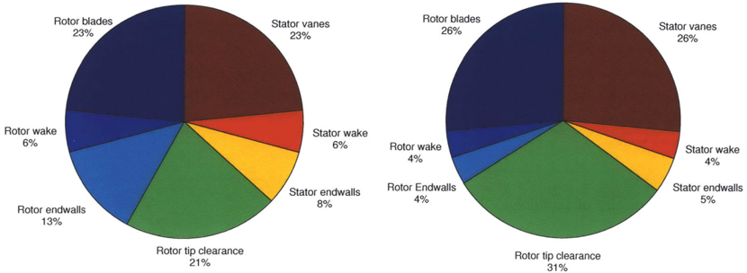
Figure 9. Losses of an optimized low-pressure compressor stage on the left and a turbine stage on the right according to the study "Performance Limits of Axial Turbomachine Stages"
Compressor’s Reynold number was 500 000 and rotor tip clearance 1% of the blade length, typical for upstream stages. According to this model, each 1% increase in the tip clearance decreased the efficiency of the stage by 1%. Other studies and measurements of physical devices have shown that the efficiency decrease is as high as 2%. Large tip gaps are typical for downstream high-pressure stages, and it is a reason why their efficiency may be several percent lower than that in upstream stages.
Rotor blades, rotor wake, stator vanes and stator wake are included in the profile loss of the stage. The profile loss increases in proportion to the relative thickness of the blade. It is also inversely proportional to the Reynold’s number when it is below 10⁵, because then the proportion of laminar flow surfaces and the losses resulting from them begin to increase rapidly. One of the goals of aerodynamic design is to keep the flow completely turbulent. The Reynold’s number for compressors and turbines indicates the relative size of the blade. Re_{c} is calculated by multiplying the chord (width) of the blade by the flow velocity in the direction of the gas axis and dividing them by the dynamic viscosity (viscosity/density).
In addition to tip gap leakage, compressor end wall losses are caused by a slower flow region on the inner and outer end walls, which narrows the free flow region from both sides. End wall losses independent of tip gap leakage increase linearly with blade width, as shown in the next figure on the right.

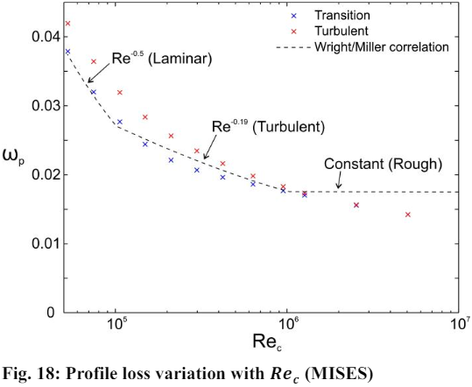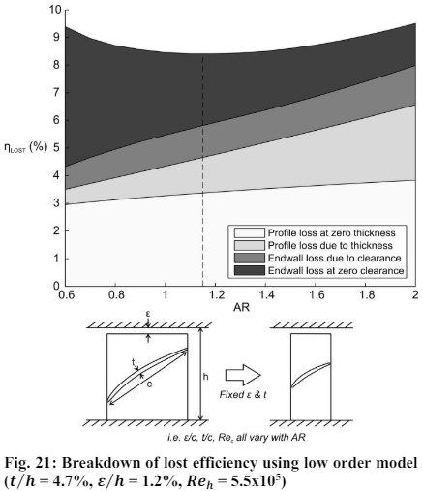
The figure above shows the relationship between profile losses and Reynold’s number according to the study THE EFFECT OF ASPECT RATIO ON COMPRESSOR PERFORMANCE . On the right is another figure copied from the same study, shows the dependence of the blade aspect ratio (blade height/chord length c) on profile and end wall losses. The figure shows the contribution of 1.2% of the tip gap and 4.7% of the blade thickness to the total losses at different aspect ratios, when Re_{h} is constant 5.5⋅10⁵. The Reynold’s number Re_{h} in the figure has been calculated according to the rotor blade height, so that in the CFD simulation it would be constant as the aspect ratio and blade width change. In the figure, the profile losses increase, and the end wall losses decrease as you go to the right. At the same time, the Reynold’s number of chord length Re_{c} decreases from 9.2⋅10⁵ to 2.25⋅10⁵. In the figure, the optimum blade aspect ratio AR 1.15 is found in the middle, where Re_{c} is 4.3⋅10⁵, meaning that the laminar flow surfaces have started to increase profile losses.
Reynolds number also affects endwall loss and blockage: In compressor cascades, Reynolds number affects characteristics of loss, deviation angle and loading distributions by changing transition and separation behaviors of boundary layer along blade surfaces. In compressor stages, Reynolds number shows more complicated influences on performances besides airfoils, involving endwall effects, inter-stage matching and three-dimensional flow details. As a result, the Reynolds number effects varied among compressors stages, and were mainly discussed in the correction models of overall performances.

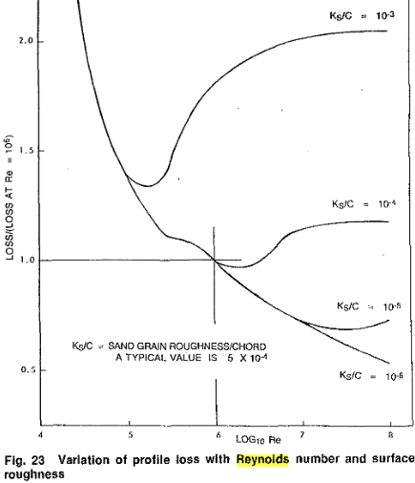
Reynold number correction factor of the profile loss depends on the relative sand grain roughness Ks/c of the blade surface, where Ks is the sand grain roughness and c is the chord length. The previous figure shows the dependence of Re correction factor from blade surface roughness Ks (source: Loss Mechanisms in Turbomachines). K_{S}/C between 10⁻⁴ - 10⁻⁵ are the expected roughness/chord length values of the high-pressure blades in this work. 40 years ago 5*10⁻⁴ was a typical value for blade roughness. The Ks value of a new smooth high-quality blade is below 2 µm, but a damaged blade may have 150 µm or more (see google search “what is sand grain roughness of compressor blade”). Thus, the high-pressure blades of cryogenic turbomachines, having chord length 30 mm and Re_{c} about 10⁷, should have Ks value 0.3 µm. The other turbomachines have longer chord lengths and lower Reynolds numbers. The formula of suggested maximum blade roughness on the webpage is Ks/C = 10^{5-Log10(Re)-3}.
The next diagram shows the Reynold’s number corrections of compressor profile and endwall loss and turbine profile loss in this work. The third correction is from Axial Flow Compressor Mean-line Design (by Niclas Falck), which was probably from the original work of Koch and Smith.
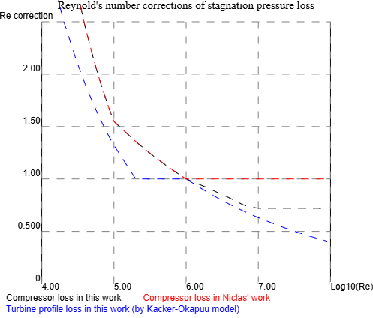
Figure 10 Reynold's number corrections of this work
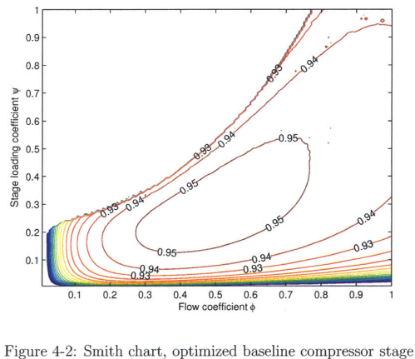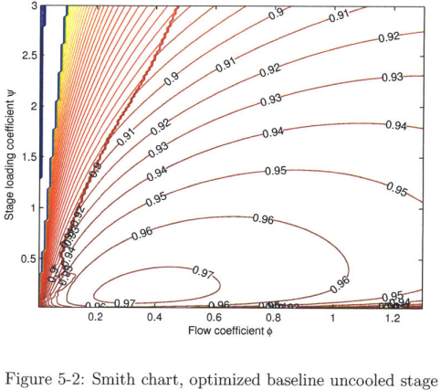
When the other loss factors in a compressor or turbine have been optimized to a minimum, the efficiency of a stage can be calculated from its stage loading and flow coefficients. Stage loading coefficient is calculated by the formula ψ= Δh/U², where Δh is the change in gas enthalpy J/kg and U is the rotation speed of the rotor tip m/s. The flow coefficient is φ=V_{x} /U, where V_{x} is the axial velocity of the gas.
In the figure above, on the left is the Smith chart of an optimized low-pressure upstream compressor stage and on the right is the chart of optimized uncooled low-pressure downstream turbine stage from the study Performance Limits of Axial Turbomachine. The Smith chart shows dependence of the stage efficiency on the flow coefficient and stage loading coefficient. The best efficiency is achieved by us a higher number of lowly loaded stages. The efficiencies in the figure have been calculated assuming that the tip gap is 1% of the blade length.

Mean-line loss model of axial compressors
The axial compressor loss models have been developed by several researchers since 1950s. It calculates the relative flow angles and velocities on the leading and tailing edge of the blade, and the maximum relative velocity of the fluid flow on the low-pressure side. From these, the diffusion factor DF and the equivalent diffusion ratio DR are calculated, which are the parameters of end wall and profile loss coefficients. The main source of the model is Axial Flow Compressor Mean-line Design (by Niclas Falck) available as an e-book and from Turbomachinery Lecture Series (RDDM) power point presentation. Seymor Lieblein developed approximation for diffusion factor DF and equivalent diffusion ratio DR. Later Koch and Smith modified the Lieblein approach and developed a more advanced correlation for the losses which includes maximum thickness to chord (t/c) and the Axial Velocity Density Ratio, i.e. AVDR.
Lieblein, Koch and Smith’s loss model has been calibrated by several compressor cascade tests, and it matches well with subsonic compressors at design point, but it gives less reliable results in the off-design conditions or for loaded intersonic compressors. The error margins of the subsonic cascade tests can probably be explained by errors in assumed Reynold’s number correction and blockage factors, that rarely match exactly with the actual values of a specific cascade.
The loss of an axial compressor is the function of load coefficient, flow coefficient, blade chord length c, blade spacing s, blade height h, max blade thickness t, tip clearance gap ε, axial velocity of the fluid Vx, the Mach number of the velocity, inlet and outlet density of the fluid (d1,d2), radius of inlet and outlet (r1, r2), Reynolds number Re_{c}, the blockage factor, the reaction of the stage and the type of the blade. The used loss algorithm ignores the possible shock loss (up to 30 %) caused when the flow velocity exceeds the speed of sound. The fluid acceleration and deceleration loss in compressor inlet and outlet is an input parameter (the default loss is 3% of static enthalpy change).
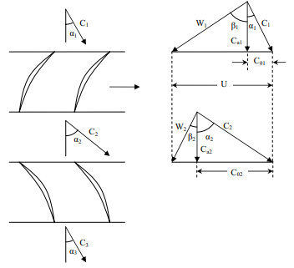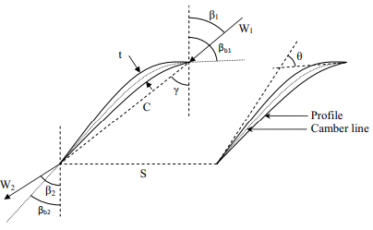
Figure 11. Symmetric velocity triangle of rotor and stator blades with reaction 0.5 on left, and incidence angle i (β₁ - β_{b1}), deviation angle δ (β₂- β_{b2}), and the camber angle Θ (β_{b1} - β_{b2}) on right. Source: Axial Flow Compressor Mean-line Design by Niclas Falck. The right-side figure is incorrect. Its relative velocity and incidence angles have very off-design values. A NACA65 reference incidence angle may be between -8° and 6° and its most typical value is about 0°.
On the left C₁, C₂, C₃ are absolute fluid velocities, W₁ and W₂ are fluid velocities relative to the rotating rotor blade, U is the rotational speed. On the right are incidence angle i (β₁ - β_{b1}), the deviation angle δ (β₂- β_{b2}), and camber angle θ (β_{b1} - β_{b2}). Relative rotor inlet and outlet velocity angles β₁, β₂, and absolute velocity angles α₁, α₂, and α₃ are calculated from the median stage loading and flow coefficients. All values are of the median flow with radius rMid = sqrt((rTip²+rHub²)/2) . The reaction is the relative pressure rise of the rotor divided by the relative pressure rise of the stage. 0.5 is usually the optimal reaction for conventional axial compressors.
β₁ = atan([reaction + loadCoefficient/2]/flowCoefficient) // inlet flow angle relative to rotor
β₂ = atan([reaction - loadCoefficient/2]/flowCoefficient) // outlet flow angle relative to rotor
α₂ = atan([ (1-reaction) + loadCoefficient/2]/flowCoefficient) // absolute/relative flow angle at stator inlet
α₃ = atan([ (1-reaction) - loadCoefficient/2]/flowCoefficient) // absolute/relative flow angle at stator outlet
If we assume, that the axial velocity V_{x} is constant (c_{a} == c_{a1} == c_{a2}) for all stages and reaction is 0.5, then α₁ == α₃, and the velocities are V_{x}/cos(angle of velocity). Parameters (α1 , α2) equal to (β₁, β₂) for rotor and (α₂, α₃) for stator. The profile and endwall lossed are calculated separately and then added: stage loss = reaction ⋅ rotorLoss + (1 – reaction) ⋅ statorLoss.
The source code of axial compressor mean-line stagnation pressure loss model by Lieblein, Koch and Smith is presented below. All angles are in degrees. Because this work uses isentropic (or machine) effciency, the resulted stagnation pressure loss coefficient is transformed into static enthalpy loss.
The next code calculates the incidence and deviation angles, diffusion factor and equivalent diffusion ratio (by Koch and Smith). The incidence angle formulas were verified with an old AMES report made for NASA. The values Ksh⋅Kit⋅i010 matched with the figures in the report, but the signs in the formula of n had to be changed to get the same incidence angles than in the report. The modified formula of n did not change compressor efficiency prediction, but it increased the stall margin. Factor n defines the reference incidence angle, and that may be the reason why there are more than one version from its formula. The reference incidence is a design choice.
// Source code from function getCamberAngle (..)
// for rotor and stator
Ksh = isNACA65?1: 0.7; //NACA65 series airfoil for subsonic or DCA half circle for intersonic (and supersonic)
thickness correction factor
Kit = -0.0214 + 19.17⋅(t/c) - 122.3⋅ (t/c)² + 312.5⋅ (t/c)³
i010 = 0.0325-0.0674⋅c/s + (-0.002364+0.0913⋅c/s) ⋅ α1 + (1.64/100000-2.38/10000⋅c/s) ⋅ α1²
// There seems to be different formulas for coefficient n, because the exact value of reference incidence angle is a design choice
// Niclas’ version of n produced too low iRef values ~ -4°
// n = -0.063+0.02274⋅c/s + (-0.0035+0.0029⋅c/s) ⋅ α1 - (3.79/100000+1.11/100000⋅c/s) ⋅ α1²
// This version was copied from an old Polytechnique Montréal material. It produces too high iRef ~ +4°
//n = 0.063-0.02274 ⋅ c/s + (-0.0035+0.0029 ⋅ c/s) ⋅ α1 + (3.79/100000 + 1.11/100000 ⋅ c/s) ⋅ α1²
// My modified version matches with the figures in the referred NASA paper and produces the expected iRef values near to 0°
// and its results match with the figures of https://ntrs.nasa.gov/api/citations/19710024786/downloads/19710024786.pdf
n = 0.063-0.02274 ⋅ c/s + (-0.0035+0.0029 ⋅ c/s) ⋅ α1 - (3.79/100000 + 1.11/100000 ⋅ c/s) ⋅ α1²
Kδ = 0.0142 + 6.172⋅(t/c) + 36.61⋅ (t/c)²
δ010 = -0.0443+0.1057⋅c/s + (0.0209-0.0186⋅c/s) ⋅ α1 + (-0.0004+0.00076⋅c/s) ⋅α1²
b = 0.9655+2.538/1000⋅α1+4.221/100000⋅α1²-1.3/1000000⋅α1³
m = 0.17 - 3.33/10000⋅(1.0-0.1⋅α1) ⋅α1 ⋅ (s/c) ^{b} // For NACA 65 series:
m = 0.249 + 7.4/10000⋅α1 - 1.32/100000⋅α1² + 3.16/10000000⋅α1³ ⋅ (s/c) ^{b} // For DCA:
iRef = δRef = 0
10 loops {
camberAngle = α1-iRef - (α2-δRef) // θ = β₁´ - β₂´
iRef = Ksh⋅Kit⋅i010 + n⋅camberAngle // incidence angle iRef = β₁ - β₁´
δRef = Ksh⋅Kδ⋅δ010 + m⋅camberAngle // deviation angle δRef = β₂ - β₂´
}
α1θ = α1 – iRef // suction side flow angle on leading edge
α2θ = α2 – δRef // suction side flow angle on tailing edge
staggerAngle = α1 - camberAngle/2 // approximation copied from Niclas’ Master thesis

// Source code from function getLossParameters(..)
Vx1 = Vx2 = Vx // axial velocity is kept constant
vssLE = Vx1/cos(α1θ) // suction side velocity on leading edge
vssTE = Vx2/cos(α2θ) // suction side velocity on tailing edge
vFlowIn = Vx1/cos(α1) // relative velocity at blade inlet
vFlowOut = Vx2/cos(α2) // relative velocity at blade exit
vSSmax ~= vFlowIn + (vssLE - vssTE)/(2⋅c/s) // approximation maximum suction side velocity
//oldDF = (vSSmax - vFlowOut)/ vFlowIn // Seymor Lieblein’s approximation of diffusion factor (not used)

C_theta_in = Vx1⋅Math.tan(α1) // angular velocity of blade inlet
C_theta_out = Vx2⋅Math.tan(α2) // angular velocity of blade outlet
gamma = (r1⋅ C_theta_in - r2⋅ C_theta_out) / (vFlowIn⋅ c/s ⋅(r1+r2)/2)
deHallerNum = vFlowOut/ vFlowIn
DF_lbl = 1 – deHallerNum + |gamma/2| // used because produces 0.04-0.09 higher DF values and higher loss

// Equivalent diffusion ratio by Koch and Smith:
Γ = (r1⋅ C_theta_in - r2⋅ C_theta_out) / (vFlowIn⋅c/s ⋅(r1+r2)/2)
AVDR = d2⋅Vx2/(d1⋅Vx1)
ApStar = (1 - 0.4458 ⋅ c/s ⋅ t/c / cos(α1+α2)/2) ⋅ (2 + 1/AVDR)/3
densityRatio = 1 (Vx1/vMach)² / (1 - Vx1/vMach)² ⋅ (1 - ApStar - 0.244 ⋅ c/s ⋅ Γ ⋅ sin(α1))

eqDR = (vFlowIn/vFlowOut⋅(1 + 0.7688 ⋅ t/c) + 0.6024 ⋅ Γ) ⋅ sqrt([sin(α1) - 0.2445 ⋅ c/s ⋅ Γ] ² + cos(α1) / [ApStar ⋅ densityRatio])
profileLossParam = func(eqDR, vFlowIn/vMach) // see the next figure Equivalent diffusion ratio
endWallLossParam = func(DF_lbl, tipGap/c) // see the next figure Diffusion factor
// Niclas forgot to multiply profileLossParam with solidity! Solidity increases wetted perimeter of the blade row and loss.
profileLoss_{x} = scaleToRe(Re) ⋅ 2 ⋅ solidity ⋅ profileLossParam ⋅ deHallerNum² / cos(α2) / blockageFactor_{n}
endWallLoss_{x}= end'WallLossParam ⋅ deHallerNum² ⋅ c / h/ blockageFactor_{n}
// The blockage factor used in this study is calculated from endWallEnthalpyLoss of the previous cascade
// ω_{ew} ⋅ AR_{eff} ⋅ k = δ / c and AR_{eff} = (h - δ) / c => relative blockage δ/h = 1 / (1 / (k⋅ ω_{ew}) + 1) =>
k = f (∆𝑝 /(𝜌₁⋅V_{x}²)) // blockage factor k is function of static pressure rise coefficient of axial velocity
blockageFactor_{n+1} = 1 - 1 / (1 / (k ⋅ endWallLoss_{n}) + 1) // blockage factor of the next blade row

Y = profileLoss_{x} + endWallLoss_{x} // stagnation pressure loss coefficient

// Transform stagnation pressure loss coefficient Y to enthalpy loss (i.e. work lost as heat)
// According to Denton, the stagnation entropy change:
// https://www.unife.it/ing/lm.meccanica/insegnamenti/fluidodinamica-delle-macchine/materiale-didattico/JT_V115_621-656.pdf
// Chapter: 2.3 Relation of Entropy Change to Machine Efficiency.
// Compressor stagnation pressure coefficient
// Y = (P01 -P02) / (P01 – P1), where P0_{x} = PropsSI(‘P’, ‘S’, S_{x} , ‘H’, H_{x} + 0.5*V_{x_rel}², fluid)
// => P02 = P01 - Y ⋅ (P01 – P1) => s02-s01 = R ⋅ ln(P02/P01) = R ⋅ ln(1 – Y ⋅ (P01 – P1)/P01)
P02 = P01 – Υ*(P01 – P1)
s2 = PropsSI(‘S’, ‘P’, P02, ‘H’, h2 + 0.5*V_{2rel}, fluid)
P2 =PropsSI(‘P’, ‘S’, s2, ‘H’, h2, fluid)
h2_100 = PropsSI( 'H', 'S', s1, 'P', P2, fluid )
η_{x} = 1 – (h2 – h2_100)/(h2 – h1)
stageEfficiency = η_{r} ⋅ R + η_{s} ⋅ (1 - R) // add rotor and stator efficiencies added balanced by reaction R

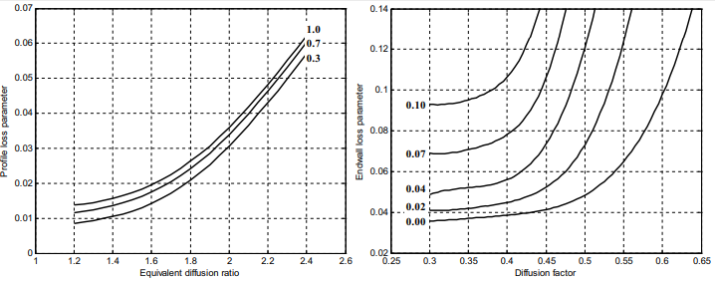
Figure 12. Profile loss parameter with variation of Mach number and Equivalent diffusion ratio eqDR, and end-wall loss parameter with variation tip gap/c and Diffusion factor DF
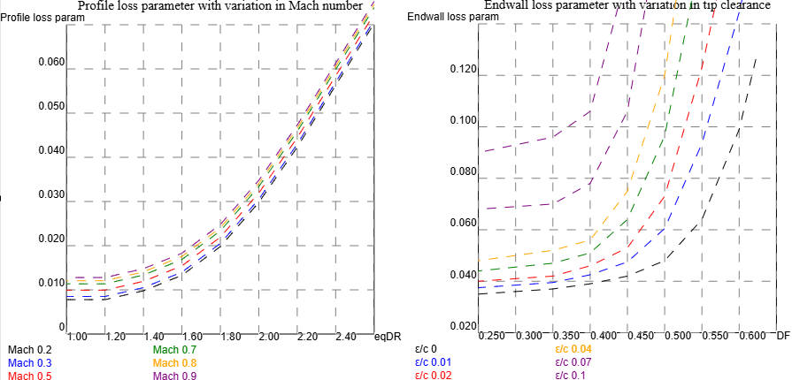
Figure 13. Linear extrapolation of profile and endwall loss parameter functions in this work. Design eqDR =~1.8 and DF=0.45
The algorithm implementing this loss model can also be found in the source code of the program's HTML page with names getLossParameters and getEfficiencyWithDF_DR. The algorithm uses the formula of NACA 65 series blades, when the relative gas velocity at the blade tip is below 0.7 Mach, and otherwise it uses the formula of DCA (Double Circular Arcs) blades. The blade solidity, stage loading coefficient, flow coefficient, blade angles and relative thickness have been calculated at the median radius of the blade, i.e. there are equal section areas both sides of the mean-line. The average losses of the stage are assumed to be the same as the losses of the mean-line. The compressor loss model did not include Reynold number correction or did not mention the reference value of the model. We chose Re_{c}=10⁶ as the reference value, because then the model matches best with the other loss model, and it is also a logical choice as the reference value of Reynold’s number, because then the flow becomes fully turbulent.
The compressor mean-line loss model returns the stagnation pressure loss coefficient Υ for a stationary blade row:
Υ = (P01 - P02) / (P01 – P1) => P02 = P01 – Υ*(P01 – P1)
P1 is the static pressure in blade row inlet and P01 and P02 are relative stagnation pressures in inlet and exit. The relative stagnation pressure is calculated with the thermodynamic library from entropy, relative velocities and static values of enthalpy and pressure: P01 = PropsSI(‘P’, ‘S’, s1, ‘H’, h1 + 0.5*V_{1rel} , fluid), where s1 is the entropy (J/kg/K), h1 is the static enthalpy (J/kg) and V_{1rel} is the relative velocity in blade inlet.
When also Υ, h2 and V_{2rel} are known, the machine efficiency and exit values of a compressor blade row are:
P02 = P01 – Υ*(P01 – P1)
s2 = PropsSI(‘S’, ‘P’, P02, ‘H’, h2 + 0.5*V_{2rel}, fluid)
P2 =PropsSI(‘P’, ‘S’, s2, ‘H’, h2, fluid)
h2_100 = PropsSI( 'H', 'S', s1, 'P', P2, fluid)
η = 1 – (h2 – h2_100)/(h2 – h1)
A stationary blade row must have the same axial velocity, stage loading coefficient and flow coefficient in row inlet and exit. If this is not the case, then the machine loss must be calculated either with the inlet or exit values. The resulting loss is used to get the actual P2, s2 and h2 values. Even a very small difference between the inlet and exit values may increase the calculated loss several hundred percents or change the loss to negative.

Denton suggested the following approximation for the compressor machine efficiency for a blade row:
Δs = -R*ln(P02/P01) = -R*ln(1 - Υ*(P01 – P1)/ P01)
η = 1 – T2*Δs/(h2 – h1)

The error of this approximation is shown in compressor data table, and it is 0 – 4 % for default designs of this work. The approximation is used to calculate quickly the compressor loss values on Smith’s chart.

Simple compressor blockage model based on endwall loss and pressure rise coefficient of axial velocity
The loss caused by compressor endwall blockage is included in our compressor mean-line loss model implementation. In literature, end wall blockage is usually defined as a work done factor parameter, the proportion of the cross-sectional area doing actual work, i.e. compressing the gas, that decreases by decreasing steps down to a constant value in the rear high-pressure stages. The cross-sectional area of each stage and its calculated stagnation pressure loss coefficient must be divided by the blockage factor of the stage. The maximum blockage factor is usually an input parameter, e.g. 0.86, but in this work, we calculate the blockage from the endwall loss ω_{ew} and the stage static pressure rise coefficient of axial velocity V_{x}.

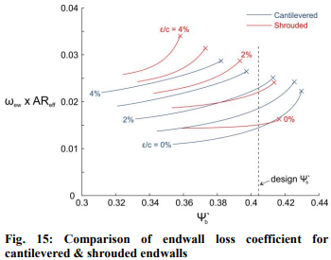
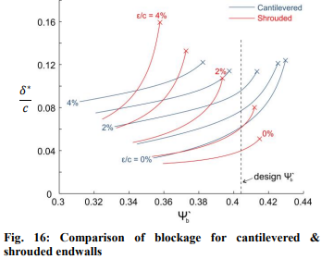
The relation of blockage δ to the endwall loss coefficient ω_{ew} and static pressure rise coefficient Ψ⋅_{bU} = 2⋅∆𝑝/𝜌U² is shown in the previous figures from work THE EFFECT OF ASPECT RATIO ON COMPRESSOR PERFORMANCE. We can define the dependency of two graphs as ω_{ew} ⋅ AR_{eff} ⋅ k = δ / c. In the figure factor k is a function of the static pressure rise coefficient Ψ⋅_{bU} only because the used flow coefficient V_{x}/U is constant 0.6.
It has been found in CFD-simulations of multistage compressor, that the blockage is insensitive to the radial blade velocity U, but it is a function of stage static pressure rise coefficient of axial velocity: Ψ⋅_{bVx}= ∆𝑝/𝜌V_{x}². It means that the blockage decreases from left to right on Smith’s chart when radial velocity U and the stage loading coefficient ∆h/U² are constant, but increased loading ∆h or decreased radial velocity U does not increase the blockage, if the axial velocity is unchanged.
J.H. Horlock’s theoretical blockage model for a fully turbulent flow agrees with that finding: ∆δ = K⋅H⋅Ψ⋅_{bU}⋅τ/(2⋅Φ²) , where H is the shape factor of boundary layer, K the coefficient of Horlock’s blockage model, τ dimensionless tip clearance, Φ stage flow coefficient V_{x}/U and V_{x} axial velocity. Radial velocity U can be screened away from the Horlock’s formula: K⋅H⋅Ψ⋅_{bU}⋅τ/(2⋅Φ²) == K⋅H⋅τ ⋅∆𝑝 /(𝜌⋅V_{x}²). In the next picture Ψ⋅_{bU} at design point is only half of its value 0.81 mentioned in the study, because it has been calculated for a blade row. The Ψ⋅_{bU} values can be divided by (Φ = 0.6) ².When the effective aspect ratio AR_{eff is} (h – δ*) /c and AR_{eff} ω_{ew} equals k ⋅ δ*/c, we get blockage to blade height δ*/h = 1 / (1 / (k ⋅ ω_{ew}) + 1), where factor k is a function of axial static pressure rise Ψ⋅_{bVx} = ∆𝑝 /(𝜌⋅V_{x}²). In the picture factor k is about 2.8, 4.3 and 5.0 for Ψ⋅_{bU} values 0.355, 0.405 and 0.43, when the stage loading and flow coefficients are constant (0.44 and 0.60). Respective Ψ⋅_{bVx} values are 0.986, 1.125 and 1.194, which are the reference points of the extrapolation of k.
The previously referred study “The effect of end wall boundary layer on matching and corresponding flow control technique for multistage axial compressor suggests” the re-cambering of the rear stators in the hub region can decrease the blockage. This means that the blockage would decrease by increased flow coefficient and reaction in the displacement area near the hub. Increased reaction near the hub also decreases profile loss and centrifugal stress.
The blockage depends also on Reynold’s number, but we do not make an extra correction because the compressor endwall loss has already been Reynold’s number corrected.
Compressor blockage increases both the cross-sectional area of the stage and the loss, and the increased endwall loss increases again the blockage until the blockage stabilizes before 10th stage. For simplicity we ignore this gradual increase, but we set the blockage of the next stage immediately to the level it would reach after repeating several identical stages. On the other hand, the blockage decreases immediately, if the endwall blockage and factor k produces a smaller blockage.
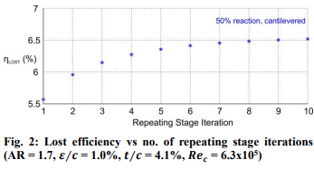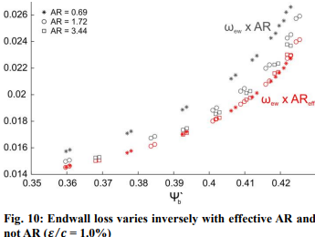
Figure 2 shows the increase of the lost efficiency caused by blockage when the endwall loss is increased only by blockage itself. The stage outlet blockage increases the loss of the next stage, and its endwall loss increases the blockage until the increase becomes too small to measure at stage 10. The loss of stage 10 is the loss of stage 1 divided by 0.85, which is about the same as work done factor 0.86. The endwall loss is about 40 % of the total loss in the previous figure.

Compressor stall/surge prediction model
A dependable stall prediction model is useful in the initial compressor design phase. The best compressor efficiency is usually near the stall/surge limit, but it also sets the maximum pressure ratio for the compressor. We selected the algorithm suggested in a recent study. The algorithm usually predicts the stall to occur in the hub of the first low pressure compressor stage, but if the compressor has the constant inner radius, the stall may occur in any upper stage. So, the stall margin is calculated for all stages in tip, mean flow and hub.
The writers claim that model predictions are within 15 % of the actual tested stall values, which means that the compressor design is safe when its stall margin does not exceed 85 %.
Below is the JavaScript implementation of their algorithm of this work. The algorithm is function getLossParameters on the webpage.
// stall/surge limit by Koch et al:
const s = c/solidity; // spacing between blades = chord/solidity
const U2 = U⋅r2/r1; // angular velocity in blade outlet
const V2 = axV2/Math.cos(α2); // absolute velocity in stator inlet
const Re1 = dynamicVisc1 ⋅ c ⋅ vRel1;
const Re2 = dynamicVisc2 ⋅ c ⋅ V2;
// actual static pressure rise coefficient
const Cp = (ΔhStage - 0.5⋅(U2⋅U2 - U⋅U)) / ((vRel1⋅vRel1 + V2⋅V2)/2);
const Vmin = (β2+α2) <= Math.PI/2 && β2 >= 0 ? V2⋅Math.sin(β2+α2) :
(β2+α2) > Math.PI/2 ? V2 : U2;
const Fef = (V2⋅V2 + 2.5⋅Vmin⋅Vmin + 0.5⋅U2⋅U2) / (4⋅V2⋅V2);
const ReStage = (Re1⋅vRel1⋅vRel1 + Re2⋅V2⋅V2) / (vRel1⋅vRel1 + V2⋅V2);
const camberAngleRad = ret.camberAngle ⋅ Math.PI / 180;
const Rc = c / 2 / Math.sin(camberAngleRad/2);
const Xc = Rc ⋅ Math.cos(ret.midβ1θ) + s / 2;
const Yc = Rc ⋅ Math.sin(ret.midβ1θ);
const k1 = -Math.tan(β1);
const k2 = -Math.tan(β2);
const Xa = (Xc + k1⋅Yc - Math.sqrt(Math.abs(Rc⋅Rc⋅(k1⋅k1+1) - Math.pow(k1⋅Xc-Yc,2))))/(k1⋅k1+1);
const funcβ2 = k2⋅(Rc⋅Math.cos(β2)-s/2)+Rc⋅Math.sin(β2);
const Xb = Xc - (k2⋅funcβ2 + Math.sqrt(Rc⋅Rc⋅(k2⋅k2+1) - Math.pow(funcβ2,2)))/(k2⋅k2+1);
const Ya = k1⋅Xa;
const Yb = k2⋅(Xb-Xc+s/2-Rc⋅Math.cos(β2))+Yc+Rc⋅Math.sin(β2);
const κA = Math.atan((Ya-Yc)/(Xc-Xa));
const κB = Math.atan((Yb-Yc)/(Xc-Xb));
const κ2 = ret.midβ2θ; // κA-κB < 0 !!! when the loading is very low
const modLg2 = solidity⋅Math.abs(κA-κB)/2/(Math.sin(camberAngleRad/2)⋅Math.cos(κ2));
const BL = Math.pow(ReStage, 1/6) / solidity;
const modCh = getStallingPressureRiseCoefficientModCh(modLg2, getBlockagePercent(BL));
const refCamberAngleRad = (0.0165 ⋅ Math.pow(ret.staggerAngle,2) - 2.029 ⋅ ret.staggerAngle + 72.97)
⋅ Math.PI / 180; // to radians
const Fcam = Math.pow(
(camberAngleRad ⋅ Math.sin(refCamberAngleRad/2)⋅Math.cos(κ2-refCamberAngleRad/2+camberAngleRad/2))
/ (refCamberAngleRad⋅Math.sin(camberAngleRad/2)⋅Math.cos(κ2)), 2);
const ΔZ = c⋅stageData.rotorStatorGap; // 0.2 is typical space between compressor blade rows
const Z = Math.round(2⋅Math.PI⋅r1/s); // number of blades on row
const g = Math.PI⋅(r1+r2)/2⋅(Math.cos(ret.midβ1θ)+Math.cos(ret.midβ2θ))/Z;
const Fεg = fTipClearanceAveragePitchlineGap( h⋅tipGap / g );
const FΔZs = fNormalizedAxialSpacing( ΔZ / s );
ret.CpMax = modCh⋅Fcam⋅Fεg⋅FΔZs⋅Fef; // return maximum allowed static pressure rise
ret.Cp = Cp; // return actual static pressure rise
ret.stallMargin = ret.Cp/ret.CpMax; // return the stall margin
return ret;

function fTipClearanceAveragePitchlineGap( εg ) {
const a = [[0,1.215],[0.01,1.14],[0.02,1.085],[0.04,1.035],[0.1,0.92],[0.12,0.89],[0.13,0.88],[0.14,0.865],[0.15,0.84]];
return getLinearInterOrExtrapolation( a, εg );
}
function fNormalizedAxialSpacing( deltaZ_s ) {
const a = [[0,1.19],[0.1,1.06+0.02⋅3/12],[0.2,1.0305],[0.3,1.01],[0.4,0.995],[0.5,0.89],[0.6,0.88],[0.7,0.865],[0.8,0.865]];
return getLinearInterOrExtrapolation( a, deltaZ_s );
}
// An improved stall prediction model for axial compressor stage based on diffuser analogy, 2022
// Figure 9: Effects of blockage indicator on static-pressure-rise coefficient
// BL >= 9 => Rec >= 531441
function getBlockagePercent(BL) {
if (BL >= 9) return 1;
else if (BL >= 8) return 1 + 1⋅(9-BL);
else if (BL >= 7) return 2 + 3⋅(8-BL);
else if (BL >= 5.5) return 5 + 4⋅(7-BL);
else return 13 + 8/3⋅(4.75-BL);
}
// An improved stall prediction model for axial compressor stage based on diffuser analogy, 2022
// Figure 8: Correlations of static-pressure-rise coefficient at different blockage
function getStallingPressureRiseCoefficientModCh(modLg2, blockagePercent)
{
const blockagePercent1 = [[0.5⋅3/12, 0.2],[0.5, 1.3/17],[1, 0.5+0.25/17],[1.5, 0.6+0.2/17]];
const blockagePercent9 = [[0.5⋅7/12, 0.2],[0.5, 0.2+1.3/17],[1, 0.4],[1.5, 0.4+1.2/17],
[2.0 ,0.5+0.45/17],[2.5, 0.5+1.2/17]];
const blockagePercent13= [[0.5,0.2], [1.0, 0.3+0.7/17], [1.5, 0.4+0.35/17],
[2.0, 0.4+1.2/17], [2.5, 0.5+0.2/17]];
if (blockagePercent <= 1) {
return getLinearInterOrExtrapolation( blockagePercent1, modLg2 );
}
else if (blockagePercent <= 9) {
const modCh1 = getLinearInterOrExtrapolation( blockagePercent1, modLg2 );
const modCh2 = getLinearInterOrExtrapolation( blockagePercent9, modLg2 );
return modCh1⋅(9 - blockagePercent)/8 + modCh2⋅(blockagePercent-1)/8;
}
else {
const modCh1 = getLinearInterOrExtrapolation( blockagePercent9, modLg2 );
const modCh2 = getLinearInterOrExtrapolation( blockagePercent13, modLg2 );
return modCh1⋅(13 - blockagePercent)/4 + modCh2⋅(blockagePercent-9)/4;
}
}
// Linear inter- and extrapolation
function getLinearInterOrExtrapolation( xyVals, xVal )
{
var i;
for (i = 0; i < xyVals.length; i++) {
if (xVal <= xyVals[i+1][0] || (i+2) == xyVals.length) {
return xyVals[i][1] + (xyVals[i+1][1] - xyVals[i][1])
⋅ (1 - (xyVals[i+1][0]-xVal)/(xyVals[i+1][0]-xyVals[i][0]));
}
}
}

Turbine mean-line loss model
This work uses the turbine mean-line loss model presented by Kacker and Okapuu in 1982. The source code was adapted from the work of Roberto Agromayor and Lars O. Nord Preliminary Design and Optimization of Axial Turbines Accounting for Diffuser Performance. It contains an excellent description of the turbine loss model with MathLab source code, and there is no reason to present it here again in detail. The Kacker-Okapuu turbine loss model matches well with the empirical tests of turbines at design point, but it is not particularly useful in the prediction of off-design conditions. The source code of the model is available in file Kacker-Okapuu_loss_model.js, that is almost direct JavaScript translation of Roberto’s original MathLab source code. Jonas Persson’s Master of Science Thesis is another excellent presentation of 1D turbine loss models at design point and at off-design conditions. The turbine mean-line loss algorithm is called from the stage design loop originally made for compressors but later extended for turbines.

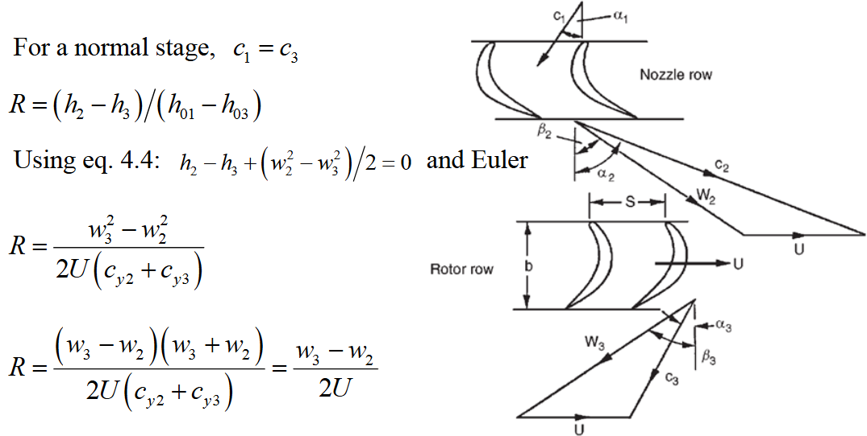
Figure 14. Turbine velocity triangle (source https://www.lth.se/fileadmin/tpe/Kurser/Chapter_4.pdf)
Turbine velocity triangle and its flow angles are different from compressor ones. These axial turbine flow angle formulas are derived from three different formulas of reaction R in Theory of turbo machinery (LTH World class) :
https://www.lth.se/fileadmin/tpe/Kurser/Chapter_4.pdf:
Stage loading coefficient: Ψ = ΔW/U²
Flow coefficient: Φ = Cx/U, R = reaction
Cy2 = Wy2 + U
Wy = Cx*tan(Ꞵ)
Cy2 = Cx*tan(α2)
R = 1 + Ψ/2 - Cy2/U
=> R = 1 + Ψ/2 - Φ*tan(α2)
=> tan(α2) = (1 - R + Ψ/2)/Φ
R = 0.5 + Φ/2*(tan(Ꞵ3) - tan(α2))
=> R = 0.5 + Φ/2*(tan(Ꞵ3) - (1 - R + Ψ/2)/Φ)
=> 2*(R - 0.5)/Φ = tan(Ꞵ3) - (1 - R + Ψ/2)/Φ
=> tan(Ꞵ3)= 2*(R - 0.5)/Φ + (1 - R + Ψ/2)/Φ = (2*R - 1 + 1 - R + Ψ/2)/Φ
=> tan(Ꞵ3) = (R + Ψ/2)/Φ
R = Φ/2*(tan(Ꞵ3) - tan(Ꞵ2))
=> R = Φ/2*((R + Ψ/2)/Φ - tan(Ꞵ2)) = (R + Ψ/2)/2 - tan(Ꞵ2)*Φ/2
=> tan(Ꞵ2) = 2*((R + Ψ/2)/2 - R)/Φ = (R + Ψ/2 - 2*R)/Φ
=> tan(Ꞵ2) = (Ψ/2 - R)/Φ
Cy3 = Wy3 - U = Cx*tan(α3) = Cx*tan(Ꞵ3) - U
=> tan(α3) = tan(Ꞵ3) - 1/Φ = (R + Ψ/2)/Φ - 1/Φ = (R - 1 + Ψ/2)/Φ = (Ψ/2 - (1 - R))/Φ
=>
α2 = atan((1 - R + Ψ/2)/Φ)
Ꞵ3 = atan((R + Ψ/2)/Φ)
Ꞵ2 = atan((Ψ/2 - R)/Φ)
α3 = α1 = atan((Ψ/2 - (1 - R))/Φ)

Kacker-Okapuu loss model returns the turbine stagnation pressure rise loss coefficient Y = (P01 – P02) / (P02 – P2) for a stationary blade row, where P01 and P02 are stagnation pressures of blade inlet and exit. The stagnation pressure can be calculated with the thermodynamic library from the static values of entropy, enthalpy and relative velocity in blade inlet and exit:
P01 = PropsSI(‘P’, ‘S’, s_{in}, ‘H’, h_{in} + 0.5*V_{relIn} , fluidName)
P02 = PropsSI(‘P’, ‘S’, s_{out}, ‘H’, h_{out} + 0.5*V_{relOut} , fluidName).
The entropy at blade exit (s_{out}) is possible to calculate only if we first guess the machine loss. This means, that there must be an iterative loop, which repeats until the error (Y - (P01 – P02) / (P02 – P2))/Y is almost zero at least by three decimal digits. Blade row must be stationary: its inlet and exit must have the same axial velocity, stage loading coefficient and flow coefficient. The resulting efficiency is used to calculate the actual P2, s2 and h2 values, if the blade row is not stationary.
Kacker-Okapuu loss model contains Reynold’s number correction, but there is no blockage correction for the axial turbine loss or stage cross-sectional area, because we found no references about turbine blockage in literature.
The loss model uses the blade thickness correlation from Ainley/Mathieson/Dunham/Came (AMDC) loss system: Y_{p} = Y_{p} * (tMax / chord / 0.2)ª where exponent a = β₁/α₂ (metal flow angle in/relative flow angle out) which equals α₁/α₂ for modern curved turbine blades with zero incidence and deviation angles. Negative exponent would reverse the meaning of equation. The source implementation solved this problem by changing negative exponent to 0: a = max(0, α₁/α₂), which means, that there would be no thickness correlation when stage loading coefficient is less than 2*R or 2*(1-R). We use another solution: a = |α₁/α₂|, because flow angles are unsigned in AMDC and Kacker-Okapuu models (see the next figure), and the loss of shifted opposite max thickness positions cannot depend on the sign of inlet flow angle.
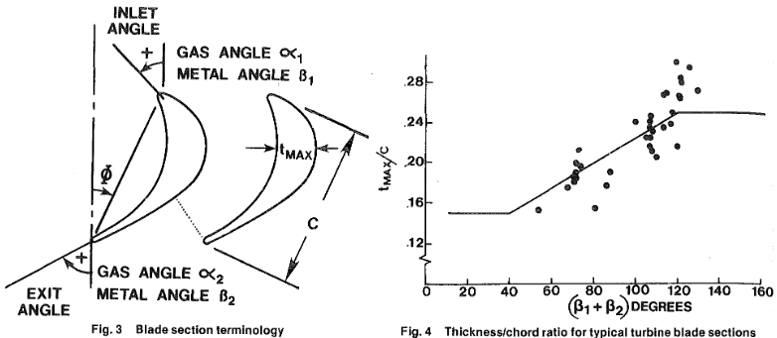
Figure 15. Blade section terminology and thickness/chord ratio for typical turbine blade sections by Kacker and Okapuu
This work presents turbine designs with efficiency predictions 2-3 % above the best reference measurements of Kacker and Okapuu model (see next figure). Nevertheless, the model predicts quite well the efficiencies between 80 % and 94 % of the turbine designs from 70s, and it very likely still works also above that range. In this work the best stage efficiency predictions are about 97% when stage loading coefficient ΔH/U² is 0.7 and flow coefficient C_{x}/U is 0.45-0.50. These values match well with the extrapolation of the Smith’s chart in the next figure. Most reference turbines had just one stage, but there is an interesting case of a turbine with 4 stages (30, 31, 32 and 33) where lower pressure ratios and high aspect ratios produce good efficiencies matching well with predictions. In the same way the increased number of stages with very high aspect ratio, high Reynolds numbers, low pressure ratios and low loading explain the excellent turbine efficiency predictions of this work. The lower stage efficiencies of the 4 stages turbine (about 91%) are mainly explained by its high stage loading and flow coefficients (2.32-2.71 and 1.25-1.50 respectively).
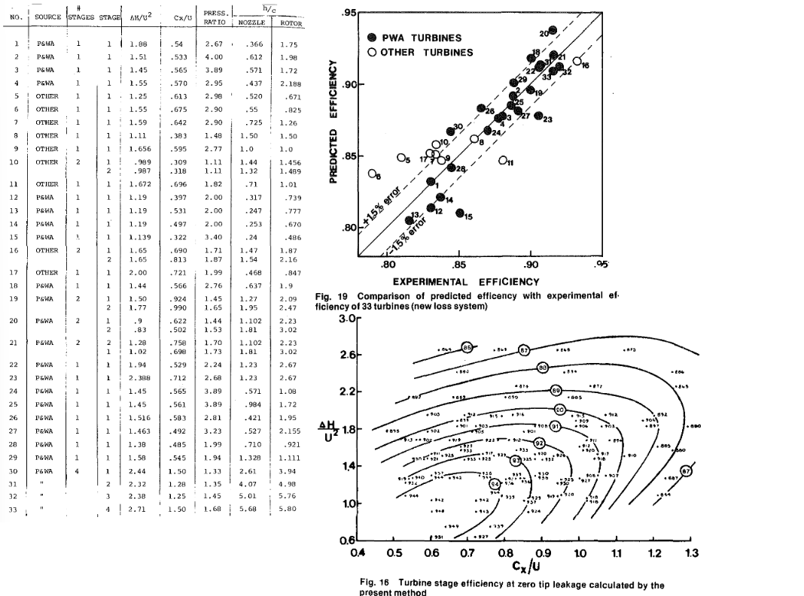
Figure 16. The experimental efficiencies compared to the efficiencies predicted by Kacker-Okapuu.loss model on table and Smith’s chart.

Subsonic velocity and lower stage loading coefficient usually mean increased number of stages. The next figure from work Turbomachinery flowpath design and performance analysis for supercritical CO2 shows the efficiency vs number of stages for a large supercritical CO2 turbine with a constant pressure ratio 2.86 and variable rotational speeds. In our work the selected mass flow, rotational frequency and min hub/tip ratio parameter set number of the stages.
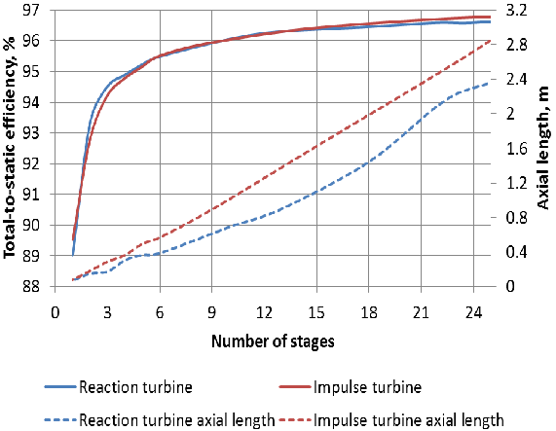

The operating range of axial turbomachines
Axial compressors have a quite narrow operating range because changed inlet temperature or pressure ratio changes axial velocity and increase gradually the incidence angle outside of the low loss range in the downstream stages. The next figure shows the variation of loss coefficient and incidence angle for NACA 65 compressor blades with constant inlet flow angle β1=55° and constant stagger angle 42°. In this work the NACA 65 compressor cascades have the best efficiency and stall margin predictions when β1 is 50° and stagger angle 36°. The reference incidence angle is usually set in the middle of the low loss range, which means that the maximum allowed difference to the reference incidence angle would be about 7°- 8° in the figure. The axial compressors set the power range for a two-way Brayton cycle because axial turbines are less sensitive off-design incidence angle.
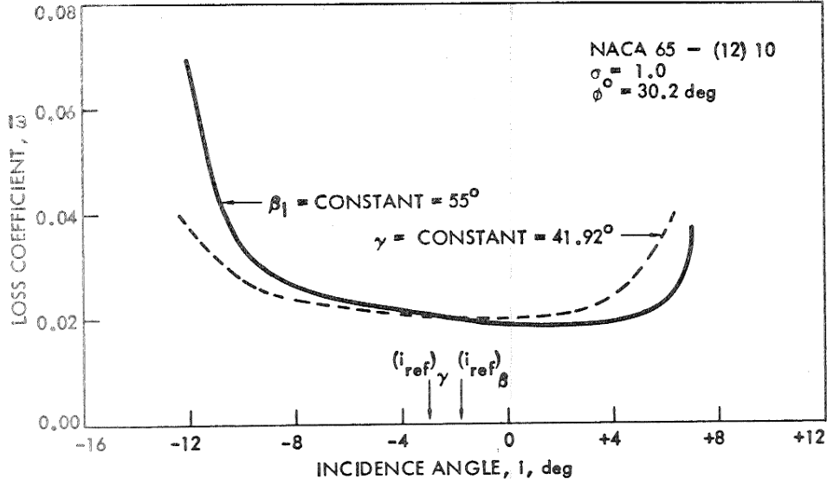
Figure 17. Variation of compressor loss coefficient with constant inlet flow angle and constant blade stagger angle.

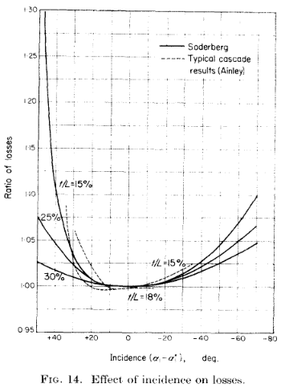
The reference incidence and deviation angles of curved turbine blades is usually 0°. They have a wider range of low loss incidence angles than compressors, but in the same way the loss starts to increase very rapidly outside that range. The maximum positive incidence angle of modern supersonic turbines may be 10°, but it is higher in old subsonic cascades on the left. The left side figure shows that low loss incidence range increases with t/L. The maximum mean blade thickness to chord length parameter t/L has been set to 18% for the turbines in this work.
This work uses an axial turbine incidence loss model by Moustapha, Kacker and Trembley to predict the incidence loss.

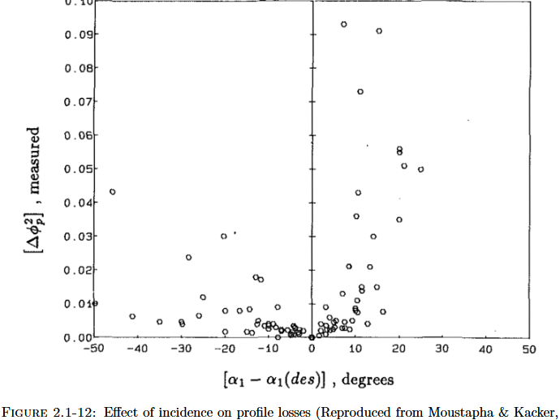
Figure 18. Measured axial turbine incidence losses
PTES design and simulation tool try to evaluate the incidence angles outside the design point with different inlet values of temperature, pressure and stage enthalpy change Δh. If only the temperature is given, the enthalpy change Δh is T_{test}/T_{ref}. If the stage power per mass flow is constant, we assume the inlet axial velocity Vx to depend on the stage enthalpy change Δh by equation Δh* Vx = Δh_{ref}* Vx_{ref} for compressors and Δh/Vx = Δh_{ref}/Vx_{ref} for turbines when the rotational frequency is constant. Outside the design point the axial velocity either decreases or increases continuously in each downstream stage because the density of the fluid either decreases too slowly or increases too fast or the compressor blockage of the stage is different from the design point. The changed axial velocity changes the flow coefficient (Φ =Vx/U) and flow angles because the rotational frequency U is constant.
The changed Δh also changes the stage loading coefficient (Ψ= Δh/U²) in main compressors and turbines because their rotational velocity U is always synchronized with the motor-generator. Stage loading and flow coefficients set the inlet flow angle β₁=atan((R+ Ψ/2)/ Φ) for compressors and β₁=atan((Ψ/2-R)/ Φ) for turbines). The incidence angle is β_{1ref} - β₁.
The cryogenic turbomachines can be disconnected from the main shaft outside their design point and operated with variable frequency drives. Their rotational frequency is changed to keep constant the stage loading coefficient of the first stage, and we also assume that the inlet flow coefficient Φ is constant, because axial velocity of the first stage is synchronized with rotational velocity U: Vx= Φ*U. Nevertheless, the incidences of the rear stages still change because the inlet values are not design-point values. Operating the default cryogenic compressor design with 144% power (MW) changes pressure ratio from 13.7 to 18.5, and the predicted incidence of last stage is 5.3°. With the same pressure ratio, the main turbine operates with 142% power, and its maximum incidence is 5.7°. Respectively, the cryogenic compressor with 87.5% power produces pressure ratio of 11.2 and incidence -5.3°. That pressure ratio operates the main turbine with 75% power and 5.5° incidence. This means that the system net power range would be at least 72% - 142% when the compressor power is subtracted from the turbine power.

Charge/discharge unit of the plant
At the center of the charge/discharge unit is a large motor-generator, which acts as a motor in the charging phase and as a generator in the discharging phase. The motor-generators of the largest pumped hydro storage power plants have an output of 500 MW. 99 % is a typical efficiency for large synchronous generators (and motors) of several hundred megawatts.
The best round-trip efficiency is obtained while all turbomachines are synchronized with the main shaft, i.e. they have the same rotational frequency as the motor-generator. The optimal size, mass flow and power of axial turbomachines depend on the rotational frequency. If the rotational frequency increases from 1500 to 3000 rpm (from 4 poles to 2 poles), the number of synchronized turbomachines and motor-generators must be multiplied by 4 and their cross-sectional area decreased to 1/4. Energy storage has the best round-trip efficiency prediction of 92.6% when the rotational frequency is 1500, but then its charge units are huge, 2*1209 MWh, and they may not be practical in small power markets. Respectively the size of discharge units is 4* 610 MWh. The round-trip efficiency prediction drops to 90.9% with 3000 rpm, but eight smaller turbomachines may be easier to operate in a small power market. On the other hand, 3000 rpm generators have shorter service life and lower efficiency.
In the default design all turbines and compressors are subsonic, i.e., they operate entirely below the speed of sound at the design point. The default plant design has two motor-generators. Two cryogenic compressors and main turbines are on the other side of a motor-generator. On the opposite side of the motor-generator are the main compressor, two cryogenic turbines and the heat pump consisting of two medium-size axial compressors and cryogenic turbines and four counter flow micro heat exchangers. If the main shaft passes through the pipe shafts of turbines and compressors, then any individual turbomachine can be disconnected from the rotating main shaft. There are variable-frequency drives in both ends of the main saft that can take over the cryogenic compressors and the cryogenic turbine when they cannot be operated any more with the generator frequency.
The axial turbomachines operate in a pressure well because the fluid first accelerates to the designed axial velocity. The acceleration converts a part of the fluid’s static enthalpy into kinetic energy by lowering its pressure and temperature. In the outlet the diffuser correspondingly slows down the fluid to the velocity of the pipe, whereby the kinetic energy of fluid converts back into enthalpy, increasing the pressure and temperature. The efficiency of the fluid acceleration and diffusion is an input parameter. Its default value is 0.97, which is a typical loss for an optimized diffuser.
The main compressor and its motor-generator do not need any external startup motor, because they can be started by the normal startup procedure of the main turbine. When the motor-generator’s rotational frequency matches with the grid frequency, its magnets are enabled, the grid frequency starts to turn the main shaft, and the turbine can be disconnected. The main compressor and motor-generator may also be cold-started with the variable-frequency drive.
The gas incoming to turbomachines must be filtered to remove the dust particles in the same way as in the gas turbine power plants. A technical challenge is the hot gas from the upper high-pressure storage entering the main turbine, which exceeds the operating temperature of most conventional filter materials. High-temperature resistant ceramic or silicate fibers or combinations of them may be a filter material. If the filter is a long sock inside the enlarged pipe, its pressure loss should be minimal, and the filter would be easy to clean or replace when fluid flow is opposite bypassing the filter.
The large hot gas pipe of the low-pressure storage can be ordinary steel, but all other pipes between the storage and the turbomachines must be austenitic steel. The tensile strength of austenitic steel may not be sufficient at the upper temperature of the high-pressure storage, in which case the pipe should have internal insulation and external cooling.
The heat pump, that pre-cools the fluid before the cryogenic turbine, is connected to main shaft and its power is adjusted by changing its internal pressure (e.g., by changing the fluid temperature in its pressure control tank). Heat pump power depends on the cooling water temperature and the cooling requirement of the main flow. A helium heat pump unit consists of two axial compressors, a cryogenic axial turbine and four heat exchangers between the turbomachines. The heat pumps power usage is about 6.5 % of the net power, and its cooling power is 4.3 %. The heat exchange power of heat pump's four counterflow plate heat exchangers is approximately 25% of the net power of the plant. The estimated cost of the counterflow micro heat exchangers designed by the program with the default parameters is 11.6 million euros for two heat exchangers of a 2436 MW 1500 rpm plant or 16.8 million euros for 8*4 heat exchangers of 2404 MW 3000 rpm energy storage. The list price for such cooling systems seems to be about the same. Helium is the default working fluid for heat pump because its heat exchangers are compact compared to nitrogen and helium heat pump produces 0.2% better round-trip efficiency.
The total weight of gas changes with the charge level because the compressed cold gas has higher density than cold low-pressure gas. The excess gas liquefies during charge to a separate storage tank, and it is injected back in discharge cycle. The liquidized part (about 3 ‰ of nitrogen flow) can be separated mechanically by directing the slightly wet gas coming out of from the cryogenic turbine at a sufficiently slow speed through a condensing fiber layer.
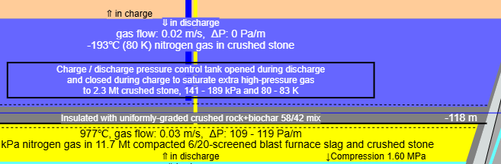
Figure 19. Charge/discharge pressure control tank located in the middle of permanently cryogenic part of low-pressure storage
The discharge and charge modes operate with different pressure ratios so that the inlet and outlet temperatures of the main turbine and compressor are the same. The pressure control uses both decreased low pressure in discharge and crushed stone (or ice) enclosed in tank where the excess gas saturates on cryogenic solids before charge mode and boils back to gas before discharge mode. The solids are cooled to the minimum temperature of storage. When pre-cooled gas from cryogenic turbine flows to the enclosed space, its pressure increases, and the incoming gas saturates on colder crushed stone (or ice). The weight of enclosed solids depends on maximum gas weight difference between charge and discharge modes and maximum pressure used in enclosed pressure control tank. The maximum pressure is 1.35 times the selected low charge pressure, and the maximum temperature is the saturation temperature of that pressure. The constant pressure ratio 1.35 is within on-design values of the cryogenic turbomachines of the system, that are used to execute switch between charge and discharge states. The pressure control tank is open during discharge, and the gas flows from its upper end to cryogenic compressors.

Optimized turbomachinery designs
The design and simulation program designs the axial compressors and turbines for the plant and estimates their efficiencies with 1D mean-line loss models. The result can be the starting point for the actual design process and CFD modeling.
The default dimensionless design parameters have been optimized for the best possible efficiency and low compressor stall probability. Because of high Reynold’s numbers, the efficiency predictions are possible only if cryogenic compressor blades have very tight manufacturing tolerances and smooth surfaces (Ra 0.3 μm, smooth machine finished). All designs have stationary cascade rows, i.e., they have constant enthalpy (and temperature) change, the same stage loading and flow coefficients and constant radius of median flow.
The exceptional high efficiencies are the result of optimal hub/tip ratio, moderate pressure ratios, aspect ratios, small tip gaps, optimized solidities, high mass flow and optimal stage loading and flow coefficients.
The design program creates Smith’s charts for its turbomachinery designs, where the approximate machine loss is calculated for the turbomachine with all combinations of stage loading coefficient Δh/U² and flow coefficient Vx/U. This also changes tip and hub radius of all stages because number of stages, power and mass flow are constant. The charts show the approximate area of the best efficiency, but the suggested optimal values have been tuned by testing to get the best possible efficiency.
Low- and high pressures, max temperature, rotational frequency, number of motor-generators and mass flow are common fixed design parameters. The optimal solidities (chord length / space between blades) have been selected by testing. Reaction 0.5, constant mean diameter and the same power in all stages give the best efficiency prediction for all turbomachine designs.
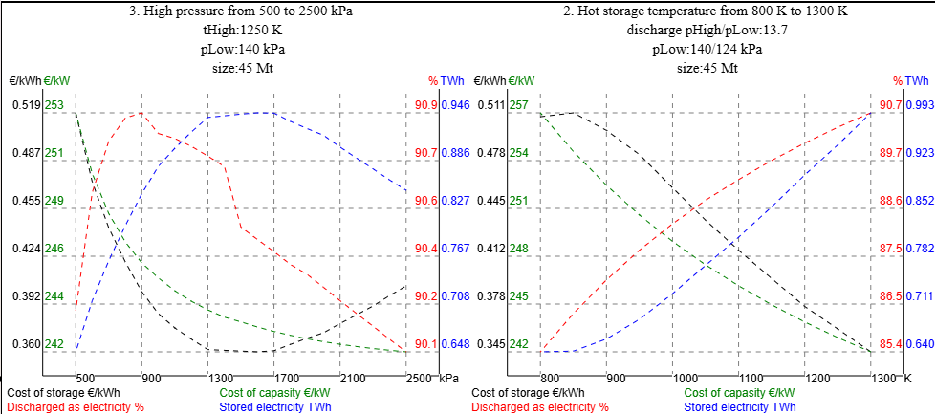
Figure 20. 1D optimized round-trip efficiency, stored electricity and the unit cost of storage and capacity on variation of discharge pressure ratio (left) and high temperature (right). Actual low discharge pressure is 124 kPa.
The previous figure shows round-trip efficiency, capacity, cost of power and cost of capacity in variation of pressure ratio and max temperature. Pressure ratio 1:7 has about 1 % better round-trip efficiency than 1:20 and the implementation of the high-pressure storage is simpler with a lower pressure, but it also has about 20 % lower storage capacity.
Crushed blast furnace slag or other rock aggregate sets the upper limit for the max temperature of high-pressure storage. Every 100 K decrease in the max temperature decreases the round-trip efficiency by 1 % and the discharge power by 100 MW for the same turbomachinery and mass flow. 1300 K is probably the max temperature of blast furnace blast.

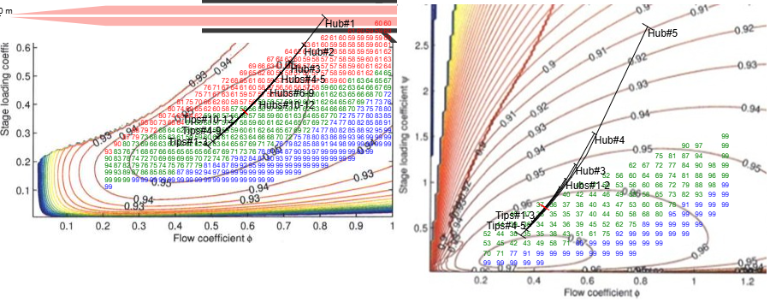
Figure 21 Smith's charts of plant’s cryogenic compressor (left) and cryogenic turbine (right). Green machine loss values are subsonic, blue ones are intersonic and the first stage would stall red ones. Red cross line marks the position of the constant mean radius and black cross lines marks the position of blades’ tips and hubs. Adiabatic efficiencies predicted by the loss models are 0.913 for the compressor and 0.975 for the turbine. The losses are calculated with the constant mass flow and rotational frequency and selected max hub/tip ratio.
The optimal stage loading and flow coefficients are about 0.36 and 0.59 for axial compressors and about 0.70 and 0.45 for axial turbines. In the case of compressors, they are in the middle the area of the expected best stage efficiency, but the optimal values of axial flow turbines match better with the extrapolated optimum suggested by Kacker and Okapuu in figure 16.
The number of axial flow turbomachine stages automatically adjusts to maximum hub/tip ratio parameter of the low-pressure stage. The optimal hub/tip ratio is about 0.6 for compressors and 0.5 for turbines. Lower compressor hub/tip ratio would increase efficiency but also stall probability. The internal heat pump pressure affects efficiency, size and cost of its turbomachines and heat exchangers.
The endwall loss coefficient is divided by the aspect ratio in both loss models. Increased blade aspect ratio increases the number of blades and shrinks the chord length, but the height and maximum thickness of the blade and the total weight and surface area of all blades in cascade do not change. On the other hand, higher number of smaller blades increases the total cost of turbomachines. Higher aspect ratio also increases the compressor profile loss because of higher relative thickness tMax/chord. An iterative loop selects the optimal blade aspect ratio for each compressor stage. Profile loss of axial turbine is less sensitive to increased relative thickness, and its predicted stage efficiency increases up to aspect ratio 12. The maximum allowed turbine aspect ratio is a design parameter. The stage aspect ratio may not increase tMax/chord ratio over the max values for mean line and hub. The default value of first parameter is 0.18 based on typical turbine tMax/chord values in figure 15. The second parameter, max enclosed cross-sectional area in rotor hub (hub solidity * tMax/chord), has an arbitrary default value 0.50. If aspect ratio is decreased to 50% of optimum, the predicted efficiency drops 0.75 % for the compressors and 0.5 % for the turbines. Aspect ratio 12 is possible only in the rear stages of the hot turbine. The cryogenic turbine stages have aspect ratios between 5.5 and 10 because otherwise the maximum enclosed cross-sectional area in rotor hub would exceed 0.5.
The tip clearance gap has a high impact on turbomachine endwall loss. Tip clearance depends on the operating temperature range, blade bending, the rotor elongation by the centrifugal stress and the type of the blade. Shrouded turbine blades usually have smaller tip clearances than the cantilevered compressor blades. Stable or controlled temperatures of blade, disk and frame, low centrifugal stress and small thermal expansion of the ambient and cryogenic blades make possible small tip clearance gaps. The tip clearance gaps of big hot turbomachines are above 0.5 mm, which matches well with the typical tip clearance gap of industrial compressors: 20–50 thousandths of an inch, or about 0.5–1.3 mm in 2000. The thermal extension of the hot high-pressure blades may be up to 1.5 %, but the blades operating in ambient and cryogenic temperatures shrink less than 0.2 % because of smaller temperature range and lower coefficient of thermal expansion. Their minimum tip clearance gap is set as 0.25 mm. The selected tip clearance is the bigger one from two design parameters: absolute minimum tip gap of the turbomachine and percent of blade span. If hot compressor tip clearance gap increases from 0.25 % to 0.5 % or 1 %, its efficiency prediction drops 0.2 % and 0.9 %, respectively. The size of the stage tip clearance gaps can be controlled by cooling or heating its disk and/or blades. The temperature control shrinks or extends rotor and stator clearance gaps at the same time.
The next figure is the default design of cryogenic compressor maintaining the discharge pressure ratio for the main turbine. Koch and Smith loss model predicts its end-to-end adiabatic efficiency 91.8 %. The geometry of the inlets and outlets is for reference only. The geometry of the inner part matches with the used loss model parameters. The compressor has an IVG (inlet vane guide). Its loss is included in 3 % loss of the inlet.
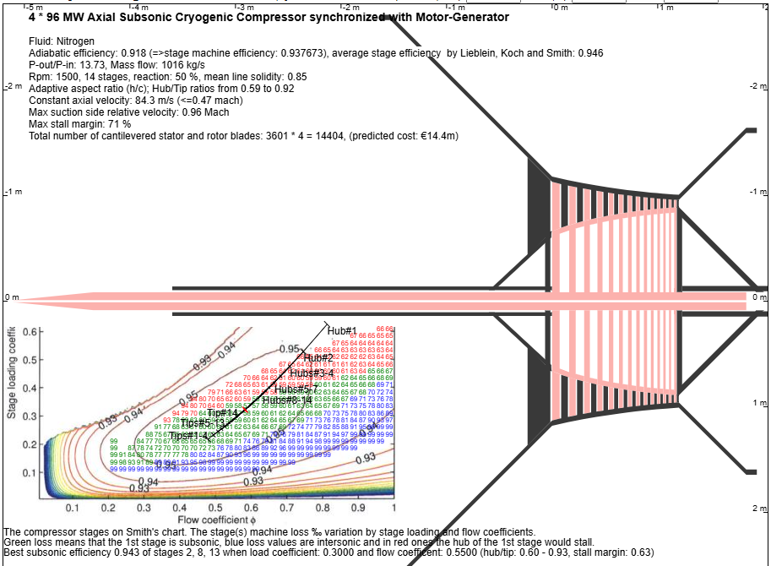
Below are the states, parameters and characteristics of cryogenic compressor stages 1-5 and 11-14 (url parameter https://anttisaarenheimo.github.io/?maxStages=12 hides the extra middle stages from html table). The bending resistance of the blade is not added to the centrifugal force, because in the bending the sum of the compression and stretching of the opposite sides is zero. Chord length, rotor tMax/c, stator tMax/c, stagger angle, stage loading coefficient and flow coefficient are the values of the median flow.
Cold compressor | Inlet | Stage 1 | Stage 2 | Stage 3 | Stage 4 | Stage 5 | Stage 11 | Stage 12 | Stage 13 | Stage 14 | Exit | Pipe out
Temperature K | 79 | 77 | 81 | 88 | 95 | 102 | 144 | 151 | 158 | 165 | 172 | 177
Pressure kPa | 124 | 99 | 133 | 174 | 223 | 281 | 867 | 1013 | 1174 | 1351 | 1547 | 1700
Axial velocity (Vx) m/s | 8.2 | 84.3 | 84.3 | 84.3 | 84.3 | 84.3 | 84.3 | 84.3 | 84.3 | 84.3 | 84.3 | 5.8
Diameter mm | 5326 | 2261 | 2188 | 2134 | 2091 | 2058 | 1950 | 1940 | 1932 | 1925 | 1919 | 2544
Gas flow m3/s | 183 | 221 | 176 | 145 | 122 | 104 | 47 | 42 | 38 | 35 | 32 | 30
P2/P1 | 0.80 | 1.34 | 1.31 | 1.28 | 1.26 | 1.24 | 1.17 | 1.16 | 1.15 | 1.14 | 1.10
Power MW |  | 6.86 | 6.86 | 6.86 | 6.86 | 6.86 | 6.86 | 6.86 | 6.86 | 6.86
Efficiency | 0.970 | 0.952 | 0.951 | 0.950 | 0.949 | 0.948 | 0.943 | 0.942 | 0.941 | 0.942 | 0.970
Entropy increase J/kg/K | 1.90 | 4.00 | 3.78 | 3.58 | 3.39 | 3.22 | 2.55 | 2.47 | 2.40 | 2.26 | 0.81
Static enthalpy kJ/kg | 79 | 74 | 81 | 87 | 94 | 101 | 141 | 148 | 155 | 162 | 169 | 173
Stagn. enthalpy kJ/kg | 79 | 79 | 85 | 92 | 99 | 106 | 146 | 153 | 160 | 167 | 173 | 173
Delta kinetic J/kg | 4740 | 0 | 0 | 0 | 0 | 0 | 0 | 0 | 0 | 0 | -4757 | 0
rTip mm |  | 1129 | 1092 | 1065 | 1044 | 1027 | 973 | 968 | 964 | 961
Mean radius mm |  | 925 | 925 | 925 | 925 | 925 | 925 | 925 | 925 | 925
Hub/Tip |  | 0.59 | 0.66 | 0.71 | 0.76 | 0.79 | 0.90 | 0.91 | 0.92 | 0.92
Rotor mean height mm |  | 439 | 353 | 291 | 244 | 207 | 95 | 86 | 78 | 71
Rotor chord (c) mm |  | 93 | 80 | 68 | 58 | 51 | 30 | 28 | 26 | 25
Tip gap mm |  | 0.88 | 0.71 | 0.58 | 0.49 | 0.41 | 0.24 | 0.24 | 0.24 | 0.24
Aspect ratio h/c |  | 4.75 | 4.42 | 4.27 | 4.18 | 4.07 | 3.17 | 3.05 | 2.95 | 2.84
Rotor blades |  | 53 | 62 | 72 | 85 | 97 | 164 | 176 | 188 | 199
Stator blades |  | 60 | 68 | 79 | 92 | 105 | 173 | 185 | 197 | 209
Blade alloy |  | c450H900 | c450H900 | c450H900 | c450H900 | c450H900 | c450H900 | c450H900 | c450H900 | c450H900
Rotor mean tMax/c % |  | 4.6 | 4.8 | 5.3 | 5.7 | 6.1 | 7.3 | 7.5 | 7.7 | 8.1
Rotor hub tMax/c % |  | 10.9 | 11.1 | 11.7 | 12.4 | 13.0 | 16.4 | 17.5 | 18.7 | 19.8
Rotor hub tMax/pitch % |  | 12.90 | 12.08 | 12.06 | 12.32 | 12.62 | 14.70 | 15.65 | 16.62 | 17.55
Stator mean tMax/c % |  | 3.7 | 3.8 | 4.1 | 4.4 | 4.7 | 5.4 | 5.5 | 5.6 | 5.7
Tip stagger angle ° |  | 42 | 45 | 44 | 39 | 39 | 38 | 37 | 37 | 37
Mid stagger angle ° |  | 40 | 40 | 36 | 36 | 36 | 36 | 36 | 36 | 36
Hub stagger angle ° |  | 25 | 28 | 30 | 32 | 33 | 35 | 35 | 35 | 35
Rotor mean flow β1/β2 ° |  | 49/30 | 49/30 | 49/30 | 49/30 | 49/30 | 49/30 | 49/30 | 49/30 | 49/30
Suction side flow β1/β2 ° |  | 51/20 | 51/20 | 50/23 | 49/23 | 49/23 | 49/23 | 49/23 | 49/23 | 49/23
Reference incidence angle iRef° |  | -1.94 | -2.00 | -0.91 | -0.79 | -0.68 | -0.38 | -0.35 | -0.31 | -0.24
Stator α2/α3° |  | -49/-30 | -49/-30 | -49/-30 | -49/-30 | -49/-30 | -49/-30 | -49/-30 | -49/-30 | -49/-30 | -30
vRel tip inlet Mach |  | 0.78 | 0.77 | 0.73 | 0.69 | 0.66 | 0.55 | 0.53 | 0.52 | 0.50
max ss vRel Mach |  | 0.90 | 0.96 | 0.91 | 0.84 | 0.80 | 0.65 | 0.63 | 0.61 | 0.59
Re(c) E06 |  | 9.57 | 10.03 | 9.55 | 9.07 | 8.87 | 8.27 | 8.22 | 8.17 | 8.15
Blade bending kN/m |  | 19.1 | 19.1 | 19.1 | 19.1 | 19.1 | 19.1 | 19.1 | 19.1 | 19.1
Bending stress MPa |  | 470 | 465 | 461 | 457 | 452 | 426 | 421 | 417 | 413
Centrifugal stress MPa |  | 45 | 38 | 32 | 28 | 24 | 12 | 11 | 10 | 9
Mean-line load coefficient |  | 0.32 | 0.32 | 0.32 | 0.32 | 0.32 | 0.32 | 0.32 | 0.32 | 0.32
Mean-line flow coefficient |  | 0.58 | 0.58 | 0.58 | 0.58 | 0.58 | 0.58 | 0.58 | 0.58 | 0.58
Diffusion factor DF |  | 0.45 | 0.45 | 0.45 | 0.45 | 0.45 | 0.45 | 0.45 | 0.45 | 0.45
Equivalent DR* |  | 1.80 | 1.79 | 1.80 | 1.80 | 1.81 | 1.82 | 1.82 | 1.82 | 1.80
deHaller Num |  | 0.77 | 0.77 | 0.77 | 0.77 | 0.77 | 0.77 | 0.77 | 0.77 | 0.77
AN2 E08 |  | 0.06 | 0.05 | 0.04 | 0.03 | 0.03 | 0.01 | 0.01 | 0.01 | 0.01
Rotor/stator loss(h) % |  | 2.4/2.4 | 2.5/2.4 | 2.5/2.5 | 2.6/2.5 | 2.6/2.6 | 2.9/2.8 | 3.0/2.8 | 3.0/2.9 | 3.1/2.7
Profile/endwall loss(h) % |  | 3.9/0.8 | 4.0/0.9 | 4.1/1.0 | 4.1/1.0 | 4.2/1.0 | 4.3/1.4 | 4.3/1.5 | 4.3/1.5 | 4.2/1.5
h loss approximation/h loss % |  | 105 | 106 | 106 | 106 | 106 | 106 | 106 | 106 | 106
Rotor/stator loss error ‰ |  | 0/0 | 0/0 | 0/0 | 0/0 | 0/0 | 0/0 | 0/0 | 0/0 | 0/0
(∆h-(U1²-U2²))/maxVrel² |  | 0.41 | 0.41 | 0.41 | 0.41 | 0.41 | 0.41 | 0.41 | 0.41 | 0.41
∆𝑝/(𝜌∙Vx²), blockage param with ew loss |  | 1.03 | 1.00 | 0.99 | 0.98 | 0.98 | 0.95 | 0.95 | 0.94 | 0.94
Blockage factor |  | 0.99 | 0.99 | 0.99 | 0.99 | 0.99 | 0.98 | 0.98 | 0.98 | 0.98
Machine loss/P0 loss coefficient |  | 2.01 | 2.04 | 2.06 | 2.08 | 2.10 | 2.19 | 2.20 | 2.20 | 2.21
Tip % of stall |  | 47 | 43 | 44 | 38 | 38 | 40 | 40 | 41 | 41
Mid % of stall |  | 51 | 51 | 44 | 44 | 44 | 43 | 43 | 44 | 44
Hub % of stall |  | 71 | 60 | 55 | 52 | 50 | 45 | 45 | 44 | 44
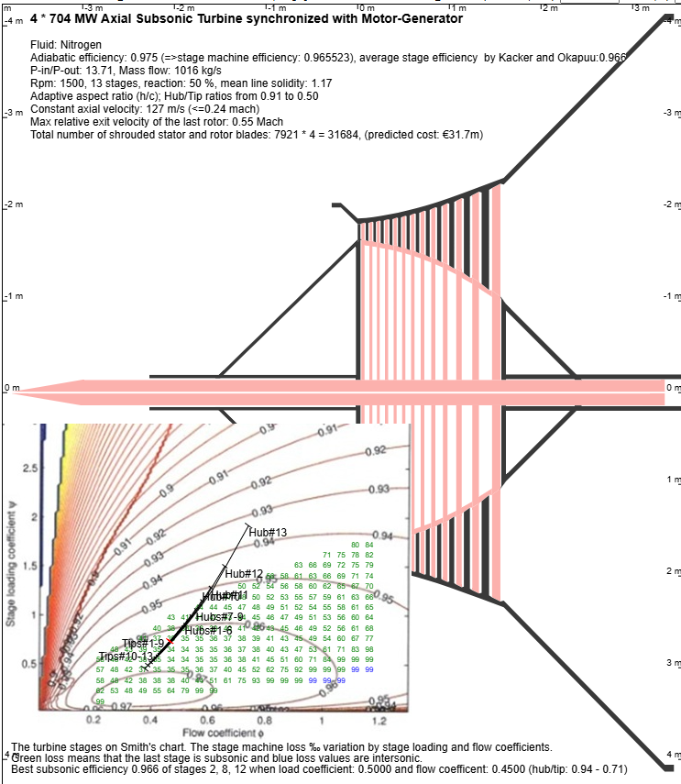
The previous figure is the default design of the main turbine producing 704 MW gross power. Kacker and Okapuu loss model predicts its adiabatic efficiency 97.5 %. The middle stages are available only on webpage.
Hot turbine | Inlet | Stage 1 | Stage 2 | Stage 3 | Stage 4 | Stage 5 | Stage 10 | Stage 11 | Stage 12 | Stage 13 | Exit | Pipe out
Temperature K | 1250 | 1243 | 1199 | 1154 | 1110 | 1065 | 835 | 788 | 740 | 691 | 642 | 650
Pressure kPa | 1695 | 1659 | 1419 | 1211 | 1027 | 865 | 325 | 258 | 203 | 157 | 119 | 124
Axial velocity (Vx) m/s | 25.6 | 127.0 | 127.0 | 127.0 | 127.0 | 127.0 | 127.0 | 127.0 | 127.0 | 127.0 | 127.0 | 39.2
Diameter mm | 3334 | 3676 | 3696 | 3718 | 3744 | 3774 | 4034 | 4122 | 4231 | 4366 | 4536 | 7173
Gas flow m3/s | 223 | 227 | 256 | 288 | 327 | 372 | 776 | 919 | 1100 | 1331 | 1633 | 1586
P1/P2 | 1.02 | 1.17 | 1.17 | 1.18 | 1.19 | 1.20 | 1.26 | 1.27 | 1.30 | 1.32 | 0.96
Power MW |  | 54.14 | 54.14 | 54.14 | 54.14 | 54.14 | 54.14 | 54.14 | 54.14 | 54.14
Efficiency | 0.970 | 0.951 | 0.960 | 0.963 | 0.962 | 0.965 | 0.970 | 0.971 | 0.971 | 0.970 | 0.970
Entropy increase J/kg/K | 0.19 | 2.30 | 1.94 | 1.86 | 1.97 | 1.91 | 2.07 | 2.16 | 2.28 | 2.54 | 0.38
Static enthalpy kJ/kg | 1374 | 1367 | 1313 | 1259 | 1206 | 1153 | 886 | 833 | 779 | 726 | 673 | 681
Stagn. enthalpy kJ/kg | 1375 | 1375 | 1322 | 1268 | 1215 | 1162 | 895 | 842 | 788 | 735 | 682 | 682
Delta kinetic J/kg | 7731 | 857 | 0 | 0 | 0 | 0 | 0 | 0 | 0 | 0 | -8145 | 0
rTip mm |  | 1846 | 1857 | 1870 | 1885 | 1903 | 2059 | 2113 | 2181 | 2266
Mean radius mm |  | 1757 | 1757 | 1757 | 1757 | 1757 | 1757 | 1757 | 1757 | 1757
Hub/Tip |  | 0.91 | 0.90 | 0.88 | 0.87 | 0.85 | 0.70 | 0.65 | 0.58 | 0.50
Rotor mean height mm |  | 177 | 200 | 226 | 258 | 295 | 640 | 770 | 941 | 1176
Rotor chord (c) mm |  | 36 | 33 | 31 | 39 | 37 | 53 | 64 | 78 | 98
Tip gap mm |  | 0.55 | 0.55 | 0.57 | 0.64 | 0.74 | 1.60 | 1.92 | 2.35 | 2.94
Aspect ratio h/c |  | 4.91 | 6.05 | 7.22 | 6.67 | 8.07 | 12.00 | 12.00 | 12.00 | 12.00
Rotor blades |  | 358 | 391 | 412 | 334 | 354 | 242 | 201 | 165 | 132
Stator blades |  | 380 | 415 | 438 | 357 | 379 | 264 | 221 | 183 | 148
Blade alloy |  | MAR-M200 | MAR-M200 | MAR-M200 | MAR-M200 | MAR-M200 | c450H900 | c450H900 | c450H900 | c450H950
Rotor mean tMax/c % |  | 18.0 | 18.0 | 18.0 | 18.0 | 18.0 | 14.9 | 13.5 | 12.0 | 10.4
Rotor hub tMax/c % |  | 36.6 | 36.7 | 36.8 | 36.9 | 37.1 | 31.8 | 29.2 | 26.5 | 23.6
Rotor hub tMax/pitch % |  | 45.11 | 45.53 | 46.02 | 46.62 | 47.34 | 45.87 | 44.34 | 43.48 | 43.61
Stator mean tMax/c % |  | 13.3 | 13.4 | 13.4 | 13.5 | 13.5 | 11.7 | 10.7 | 9.7 | 8.7
Mid stagger angle ° |  | 22 | 22 | 22 | 22 | 22 | 22 | 22 | 22 | 22
Rotor tip β2/β3 ° |  | -22/62 | -23/62 | -24/62 | -24/62 | -25/62 | -31/63 | -33/63 | -35/63 | -38/63
Rotor mean β2/β3 ° |  | -18/62 | -18/62 | -18/62 | -18/62 | -18/62 | -18/62 | -18/62 | -18/62 | -18/62
Rotor hub β2/β3 ° |  | -13/61 | -12/61 | -12/61 | -11/61 | -9/61 | 3/61 | 9/61 | 16/62 | 27/63
Stator flow α1/α2° |  | 0/-62 | 18/-62 | 18/-62 | 18/-62 | 18/-62 | 18/-62 | 18/-62 | 18/-62 | 18/-62 | 18
vRel tip outlet Mach |  | 0.39 | 0.40 | 0.41 | 0.41 | 0.42 | 0.49 | 0.51 | 0.53 | 0.55
Re(c) E06 |  | 0.82 | 0.68 | 0.58 | 0.65 | 0.55 | 0.44 | 0.46 | 0.49 | 0.52
Blade bending kN/m |  | 43.4 | 43.4 | 43.4 | 43.4 | 43.4 | 43.4 | 43.4 | 43.4 | 43.4
Bending stress MPa |  | 108 | 145 | 182 | 136 | 174 | 248 | 248 | 250 | 257
Centrifugal stress MPa |  | 36 | 41 | 46 | 51 | 58 | 106 | 123 | 144 | 169
Blade cooling K |  | 100 | 100 | 100 | 0 | 0 | 88 | 40 | 0 | 0
Mean-line load coefficient |  | 0.70 | 0.70 | 0.70 | 0.70 | 0.70 | 0.70 | 0.70 | 0.70 | 0.70
Mean-line flow coefficient |  | 0.46 | 0.46 | 0.46 | 0.46 | 0.46 | 0.46 | 0.46 | 0.46 | 0.46
AN2 E08 |  | 0.04 | 0.05 | 0.05 | 0.06 | 0.07 | 0.14 | 0.16 | 0.19 | 0.24
Rotor/Stator loss(h) % |  | 2.6/2.4 | 2.2/1.8 | 2.0/1.7 | 2.0/1.7 | 1.9/1.6 | 1.5/1.4 | 1.5/1.4 | 1.5/1.4 | 1.6/1.4
Profile/trailing loss(h) % |  | 1.5/1.1 | 1.3/1.1 | 1.3/1.1 | 1.3/1.1 | 1.3/1.1 | 1.2/1.1 | 1.1/1.1 | 1.1/1.1 | 1.2/1.1
Clearance/secondary loss(h) % |  | 0.6/1.7 | 0.4/1.2 | 0.3/1.0 | 0.3/1.1 | 0.2/0.9 | 0.1/0.6 | 0.1/0.6 | 0.1/0.6 | 0.0/0.6
Rotor/stator loss error ‰ |  | 1/1 | 0/0 | 0/0 | 0/0 | 0/0 | 0/0 | 0/0 | 0/0 | 0/0
Machine loss/P0 loss coefficient |  | 1.19 | 1.20 | 1.20 | 1.20 | 1.20 | 1.18 | 1.17 | 1.16 | 1.15
These and 5 other turbomachine designs are available on the web site https://anttisaarenheimo.github.io/.
Heat pump heat exchangers
The heat pump turbomachines are integrated with four quite massive counter flow micro heat exchangers. These counter flow heat exchangers have cross flow triangles in opposite corners where the other fluid flows in and out in 45° angle. The cross flow is defined to be 25% of the panel length. The algorithm designs the heat exchangers from following design parameters:
- Coolant fluid rotating between turbine and compressors through the four heat exchangers. The coolant fluid should have lower dewpoint than the main fluid of the storage. Helium gives 0.4% better efficiency than nitrogen when nitrogen is the main fluid, but helium and nitrogen perform as well as coolants of argon.
- The default internal heat pump pressure parameter values were selected to have optimal efficiency and cost predictions. The default is 1500 kPa for 1500 rpm and 1000 kPa for 3000 rpm.
- Relative pressure loss inside heat exchanger. The very low default value 0.001 gives 0.2% better round-trip efficiency than 0.002 with €3.5m additional cost prediction. The pressure loss outside the micro channels is assumed to be zero because of very low velocity and Reynolds numbers of external pipes (Re < 1).
- Heat exchanger panel length (gross length heat exchange area) does not change the total cross-sectional area of heat exchanger, but it increases the cross-sectional area of a micro channel. If the panel length is increased from default 0.5 m to 1 m, the total cost estimation is increased by 3.2 M€ and the number of micro channels is decreased by 50%. The channel size and panel length would be set by the degree of the fouling and the manufacturing capabilities. All other fluids except the cryogenic high-pressure fluid of the main storage can be expected to be very clean because of a closed loop and any incoming dust of cryogenic nitrogen flow can be filtered without significant pressure drop because of very low velocity.
- Heat exchanger temperature difference defines the size and efficiency of the heat exchanger. If the temperature difference of fluids is decreased from 2 K to 1 K, the system round-trip efficiency increases 0.1% and the cost of heat exchangers by 6.1 M€.
- Cooling water temperature defines the work done by heat pump compressors that is the main source of the loss. The system round-trip efficiencies with variation of cooling water temperature are: -10 C°: 92.9%, 0 C°: 92.7%, 5 C°: 92.6%, 10C°: 90.5% and 20C°: 92.3%. The utilization and storing the possible winter-time cold may be an economic way to improve the round-trip efficiency of the system. The distilled cooling water could be mixed with alcohol. Unfortunately, mixed water or other mixtures are not fully supported by the thermodynamic library, and the cooling water temperature must be at least +0° to properly calculate the heat exchanger.
- 2 configuration parameters define the structural strength of the micro channels by adjusting the aspect ratio and thickness of walls. The first parameter defines the panel height divided by sheet thickness at 100 kPa pressure difference (default 40). The second parameter is the width of high-pressure channel divided by thickness of sheet (default 20) at 100 kPa pressure difference. The algorithm decreases both values when the pressure difference between the micro channels exceeds 100 kPa. If the pressure difference exceeds 800 kPa, the strength must be increased by other means, for example by changing the straight wall between the channels to an arc or by changing the aluminum to stainless steel. The default pressure differences of the default design are 426, 266, 44 and 45 kPa. The default structural configuration parameters have not been analyzed, but the produced structure must be quite strong, because the internal pressure inside aluminum soda cans is about 250 kPa at 20 C°, its walls are thinner (~0.1 mm) and diameter about 66 mm.
- Heat exchanger panel width to length (default 4) defines the length triangular cross flow areas in the opposite corners. That length (25%) is not included in the heat exchange of the counter flow area.
- There are 3 parameters to calculate a cost estimation for the heat exchangers. The cost estimation is the sum of the material costs, the processing cost of panel blocks and the other costs scaling with the heat exchanger cross-sectional area, typically 55-66% of all costs. The material costs are the cost of cryogenic 5000-series 0.3 mm aluminum sheets per ton. The default processing cost estimation 5€/m² is based on the unit production cost of a soda can (0.06 – 0.12 $). The other costs include the margin, design, installation work, the frame and external pipes. The estimated cost of all heat exchangers is €13m that is about 20% of estimated cost of all turbomachines (€70m) based on the number of rotor and stator blades.
The used Nusselt number is 8.6 (fully developed forced laminar flow in a panel heat exchanger). The algorithm uses the same hydraulic diameter of channel rectangle for both pressure drop and heat transfer calculations. Aluminum has a remarkably high heat conductivity, and the side walls may transfer the same amount heat as the walls between different fluids. There is also a small heat leak caused by aluminum sheets. Those errors can be compensated by decreasing the desired temperature difference by 2-3%.
The next table contains the heat exchanger properties produced by the default parameter values. The algorithm uses the thermodynamic values of fluids in the middle of heat exchanger. It verifies the result by adding the actual pressure loss in ten subsections. The small error between actual and desired pressure loss (~0.3%) is more likely caused by 1% error margin of the heuristic loops. The heuristic algorithm is in method calcFlatPlateHeatExchanger on HTML page.

Counter flow plate heat exchanger | Nitrogen to Helium HE | Internal Helium to Helium HE | Helium to water HE 1 | Helium to water HE 2
Coolant | Helium | Helium | Water | Water
Cooled fluid | Nitrogen | Helium | Helium | Helium
Coolant mass flow kg/s | 187 | 187 | 232 | 232
Cooled mass flow kg/s | 866 | 187 | 187 | 187
Plate height mm | 2.072 | 2.441 | 2.793 | 2.582
Plate width m | 0.126 | 0.126 | 0.124 | 0.124
Plate length m | 0.503 | 0.505 | 0.496 | 0.498
Effective length m | 0.377 | 0.379 | 0.372 | 0.373
Sheet thickness mm | 0.221 | 0.122 | 0.140 | 0.129
Coolant passage height*width mm | 0.981*18.8 | 1.13*3.95 | 0.373*6.27 | 0.390*5.80
Cooled passage height*width mm | 0.650*1.04 | 1.06*1.51 | 2.14*6.27 | 1.93*5.80
Coolant hydraulic diameter mm | 0.933 | 0.880 | 0.352 | 0.366
Cooled hydraulic diameter mm | 0.399 | 0.624 | 1.596 | 1.450
Coolant inlet temp K | 135.61 | 155.65 | 283.00 | 283.00
Coolant exit temp K | 155.65 | 283.00 | 306.07 | 306.20
Fluids' temp difference K | 2.00 | 2.00 | 2.00 | 2.00
Coolant pressure kPa | 339 | 339 | 456 | 456
Coolant pressure drop Pa | 340 | 337 | 1928 | 1871
Cooled pressure kPa | 765 | 501 | 412 | 501
Cooled pressure drop Pa | 767 | 507 | 414 | 501
Coolant mid flow m3/s | 169.51 | 254.08 | 0.23 | 0.23
Cooled mid flow m3/s | 47.18 | 172.27 | 280.36 | 230.65
Coolant mid velocity m/s | 2.702 | 1.037 | 0.003 | 0.003
Cooled mid velocity m/s | 0.747 | 0.742 | 3.359 | 3.340
Coolant mid ht coefficient W/m2 | 848 | 1184 | 14116 | 13596
Cooled mid ht coefficient W/m2 | 296 | 1671 | 799 | 880
Coolant mid Re | 62 | 30 | 1278 | 1321
Cooled mid Re | 538 | 31 | 181 | 198
Plates' total cross-sectional area m2 | 244 | 575 | 111 | 94
Plates' total volume m3 | 123 | 291 | 55 | 47
Micro channels/m2 (cross-sectional area) | 409408 | 351613 | 111728 | 130728
Metal heat leak % | 3.24 | 4.07 | 0.66 | 0.55
Plates' total weight in tons | 91 | 115 | 18 | 15
Plates' total sheet area M2 | 118537 | 238064 | 39509 | 36360
Material costs of aluminum sheets € | 226639 | 287422 | 44545 | 37899
Processing costs of plate blocks € | 592687 | 1190320 | 197544 | 181801
Other costs € | 976876 | 2301941 | 445278 | 377122
Total costs € | 1796202 | 3779683 | 687368 | 596821

Operating the plant with variable power
Mean-line loss algorithms give reliable results only when the turbomachines are operating near their design point values. It means that the incidence angle of the blade inlet flow must be inside the flat area where the loss is minimal. The next figure is from a study made by M.J. Miller and T. Skånberg for NASA. The reference incidence angle is usually in the middle of the minimal loss area, and the incidence angle may turn up to 4 – 8 degrees before the mean-line loss algorithms became unreliable, and incidence loss increases rapidly. Incidence angle turns from the refence value whenever inlet temperature and/or pressure ratio are different from design values. Off-design inlet values can be evaluated on Design and Simulation webpage. It gives an incidence loss prediction for turbines, but its compressor loss prediction may become unreliable if the incidence angle is over 6 degrees.
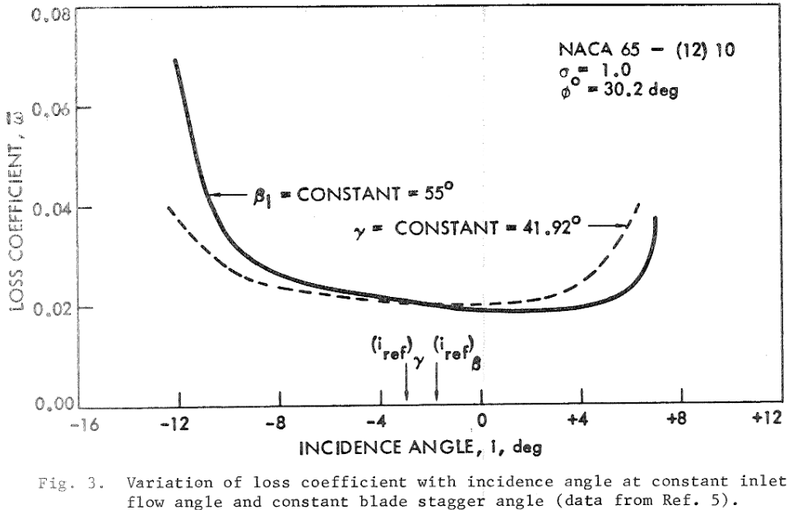
There are three ways to produce or consume variable power with this energy storage:
- Turbomachines can operate with a wide range of inlet pressure as far as the inlet temperature and pressure ratio are same. Design and Simulation tool predicts round-trip efficiency to decrease to 87.6% at 20% and to 90.1% at 140%. Only the other heat pump compressor pair can be used when power is below 60%, otherwise they would stall. The excess gas can be stored in liquid storage during charge and added back in discharge, but the liquid nitrogen storage must be enlarged. The change of pressure level is a slow operation, and it takes hours or even days because the low temperature of low-pressure storage must be increased at the same time as pressure. Power can increase much faster if pressure ratio is allowed to increase at the same time.
- The storage pressure ratio can be changed by speeding up or slowing down cryogenic turbomachine rotational frequency with VFD. Pressure ratio power range of the hot turbine is at least ±50%, but maximum power needs six cryogenic compressors for four hot turbines or more if the power must be increased to maximum in less than an hour. Main turbomachine blades are measured for 150% overload by default, and the storage design must also hold the maximum high-pressure.
- Hot turbine output power can be adjusted with pressure ratio ±40% in seconds if cold gas from VFD operated cryogenic compressor flows through a heat exchanger to the hot turbine inlet. The heat exchanger counter flow would rotate from high-pressure storage hot exit to its cold inlet by gravitation. Volatile gases from high-pressure storage hot exit might freeze inside heat exchanger, but volatile gases should not be a problem when hot crushed stone is made from blast furnace slag and immediate power control would not be used until all volatile gases have frozen permanently on cryogenic crushed stone. Heat exchanger’s cost prediction for a single 600 MW hot turbine and cryogenic compressor pair is €20m when the heat exchange temperature difference is 10 K. The heat exchanger design is presented at the end of webpage, but it is not included in the cost of the storage.

The profitability and capital costs of energy storage
Energy storage simulation with power market data predicts average €401m cash flow per year in Germany and €345m in Finland. Return of investment depends on the capital costs of the storage. Estimating costs for entirely new plants, processes, equipment, or work phases is highly uncertain. The most important thing is to conduct the work as far as possible using methods known to be cost-effective or by applying them, and to use existing technology as far as possible. The construction of energy storage consists of large-scale open-pit mining with large machines, crushing aggregate, compacting, and strengthening rock walls, and excavating gas pipelines embedded in the wall. These unit costs are predictable, and the contract prices can therefore be estimated in advance and competitively priced. New work phases that are more difficult to estimate include the installation or masonry of gas distribution channel elements that can withstand the weight of the upper crushed stone, mixing loose stone wool and biochar into crushed stone, building elastic gas-tight layers above both storages. The pipes of hot and cryogenic gas, their control valves are, at least for the most part, conventional process technology. The total length of all pipelines is about two kilometers.
The costs of storage decrease if the storage is built in an abandoned open pit, and especially if the quarry's nearby stockpiled waste rock can be reused as crushed stone for the storage. In this case, the compacted walls of the open pit can function as pressure insulators, and thermal expansion is directed only upwards. In principle, any screened crushed stone is suitable for low-pressure storage, but the crushed stone at the top of a high-pressure storage should be made of blast furnace slug, or if not possible, at least of heat-resistant mafic rock. However, the waste rock of ore mines is usually mafic or ultramafic rock.
Among the new work phases, the casting and masonry of vault structures and sloping wall structures are common construction techniques. Insulation layers can be made by alternately spreading evenly sized crushed stone and insulation in a thin mat with trucks and then harrowing them together. Stone wool can be mixed directly into the crushed stone before spreading.
In the United States, the average price of biochar in 2023 was $131/ton, so on an industrial scale, the price per ton of biochar is likely to be somewhere between 100–200 euros. The density of biochar is approximately 200 kg/m³. In this case, the price of one cubic meter of 42% biochar insulation would be less than 20 euros. It would be most economical to produce biochar in connection with a thermal power plant operating on wood or peat, where the gasified half of the biomass would produce heat and electricity. Also, when using loose stone wool at triple density, the price of insulation could be less than 30 euros/m³.
The size of the plant buildings is approximately the same as a simple cycle gas turbine plant of equivalent capacity without heat recovery. The size of the hot compressors and turbines is significantly smaller because all combustion process technology is omitted. The cryogenic compressors and turbines are also small. The turbines and compressors of the main circuits would fit into two or three trailer combinations, at least in terms of size, so their estimated cost may be too high. The heat exchanger integrated with the heat pumps and motor-generators would use more space. The predicted volume of the heat pump heat exchanger panel boxes is 1,000 cubic meters, but its pipes connections will take at least 4,000 cubic meters. Huge motor-generators would need at least the same space. The expansion storage for liquefied gas would be 30,000 m³ for nitrogen. It would fit in an underground cylindrical austenitic steel storage insulated in the same way as LNG storage.
If the electricity storage concept presented here proves to be technically and economically feasible, it would open a new market worth at least several billion for manufacturers of turbomachines. That would enable rapid product development of equipment tailored to the concept and perhaps also reasonable prices.
The cost prediction of the turbomachines is based on the total number of blades. The price range of aviation OEM compressor and turbine blades is 20 – 200 $. The default cost estimation for turbomachinery is the total number of blades multiplied by 1000 €. OEM manufacturers produce both axial turbomachine blades and disks from the specifications.
The profitability of the investment depends on the plant's construction costs, operating costs, electricity price fluctuations, and the total amount of electricity sold annually. Year 2022 was exceptionally turbulent in European power markets, but price fluctuations leveled out in 2022. However, the fluctuations have been increasing from year 2022, because electricity production dependent on the sun and wind has been constantly increasing and the continuous increase in the price of emission allowances have removed old fossil energy plants from the market. We can therefore assume that in the longer term, turbulence will continue, and thus the need for regulated electricity production will continue to grow. The predicted gross margin of energy storage market simulation has been increasing from year 2022 both in Germany and in Finland.

Verification of the feasibility of energy storage
This plan is currently based solely on public sources, so the suggestions and preliminary estimates presented above must be verified either by simulation or measurement.
The most important issues to verify are:
- The performance of the carbon-free mild steel and aluminum used in the elastic gas insulation of the high-pressure storage must be tested by simulating the expected thermal movement of the crushed stone. Extra insulation layer of partly melted crushed stone should be designed for different temperatures and its gas permeability tested.
- What are optimal combinations of screened crushed stone of low conductive heat transfer coefficient, stone wool, and biochar for different temperatures of the storage? What is k-value, compressive strength and gas permeability in convection at operating temperatures.
- What is the hydraulic conductivity, thermal expansion coefficient, internal heat transfer, and heat exchange efficiency of the screened crushed stone. The heat exchange efficiency is measured using forced convection at the designed gas flow rate.
- Simulation and measurement of the gradual compression, and long-term durability of selected blast furnace slag or mafic rock in the high-pressure storage when the crushed stone temperature is changing between the min and max temperature, and the thermal expansion is compressing the crushed stone.
- Testing the efficiencies and structural designs of turbomachine with CFD- simulation. How accurate are the efficiency predictions and the used compressor blockage model? What are the reference incidence angles and the operational range of turbomachine designs?
Most points can be measured empirically, for example, in a decommissioned steam power plant's pressure boiler, the central part of which is filled with the investigated crushed stone and the edge parts are insulated with crushed stone and stone wool or biochar mix. Argon or nitrogen gas, pressurized with a centrifugal or screw compressor and heated with possible additional resistors, is led to the upper part of the boiler. The lower part has an adjustable pressure equalizer and a return pipe to the compressor. The outer surface of the pressure boiler has a dense water-cooling pipeline inside the insulation. The U-value of the crushed stone insulation can be calculated from the cooling power. The hydraulic conductivity and the heat exchange efficiency of the crushed stone mix can be measured from the pressure and temperature change of the gas between inlet and outlet.
The high-pressure storage bottom can be manually pressed either with an expanding vessel made of carbon-free steel, which is pressurized with a second compressor to the desired pressure of 20–40 atmospheres. Economic simulation of dozens of heating and cooling cycles may require parallel thermal storage where the hot and cryogenic cold released from the measuring storage can be stored. If there is a heat exchanger in between, the second storage does not even need to be pressurized, but can be, for example, a vessel inside a welded austenitic steel plate covered with stone wool, which is heated and cooled with air.
In Finland, Olivine aggregate is sold, for example, from Luvia sauna stove stone quarries, but the purity of the aggregate and the screening of measurable crushed stone fractions may require special arrangements. Biochar can be ordered in cubic meters and in 1.6m3 big bags. When purchasing and testing biochar, it is important to determine its pore size, which is essential for insulating thermal radiation. Biochar produced at hottest temperatures has the smallest pore size. The same applies also to tested stone wool. Its fiber width should be minimal, and it should not have any volatile binders.
Summary
This study is a concrete proposal for the implementation of a low-cost and high-efficiency PTES plant. These are the main findings in this study:
- A very efficient closed two-way Brayton cycle can charge and discharge electricity to and from heat and cryogenic cold in a massive low-cost thermal pumped energy storage made of crushed stone and optionally also crushed ice.
- The thermal energy storage can be made using very affordable open-pit mining technology, or alternatively it can be built into an abandoned open-pit quarry and recycle its waste rock.
- The hot top side of the high-pressure storage can be made of heat-resistant crushed blast furnace slag or other ultramafic or mafic rock.
- The energy storage can be insulated with a 58/42 mixture of very porous crushed stone, stone wool and biochar that can withstand the high pressure and temperature of the energy storage.
- The hot high-pressure storage section can be pressure insulated with elastic carbon-free mild steel that adapts to the thermal movement of the crushed stone. Aluminum, technical rubber and bitumen can be used in the colder edge section.
- The predicted excellent 92.6 % electricity round-trip efficiency can be achieved with fully optimized subsonic axial flow turbomachinery technology.
- The amount of crushed stone can be halved by using crushed ice to store the cryogenic cold. Crushed ice has about 50% better volumetric heat capacity at 77K than crushed stone.
- The long-term simulation of the storage shows that the system can utilize 30-50% of the theoretical maximum heat capacity of the crushed stone in the hot high-pressure storage.
This work shows through software modeling that these points are technically feasible, and energy storage is very cost-effective compared to other electricity storage methods. The modeling has considered, as accurately as possible, the properties of the materials found in other studies, the physical formulas related to the modeling, known technical limitations, and the costs of corresponding equipment and work stages used.
Motor-generators of hundreds of megawatts are existing commercial technology, and ordinary generators with minor modifications can be adapted to a PTES plant. The plant's control system would in principle be a combination of gas turbine power plant and pumped storage systems, supplemented by predictive pressure ratio control and possible active rotor tip gap control.
If the electricity storage system presented here proves to be technically feasible, and its initial price estimate is even approximately correct, its global impact would be revolutionary in the energy sector. Solar cells and wind power already produce electricity at a much lower cost than with fossil fuels. If the almost free electricity produced during their production peaks can be stored for a long time with low-cost, then electricity production based on fossil energy will become unprofitable. In addition, low-cost electricity would accelerate the replacement of gas and oil heating with heat pumps. Together, these would make the global goal of carbon neutrality in 2050 entirely possible. On a global level, economic considerations and political realities have determined the use of fossil fuels and the continuous growth of their carbon emissions in electricity production. The only guaranteed way to abandon the use of fossil fuels on a rapid schedule is to make their use economically unprofitable. Fossil power generation and heating account for 50% of global energy-related CO2 emissions.

https://energyindustryreview.com/power/battery-storage-capacity-record-growth-and-trends-in-2026/
https://thundersaidenergy.com/downloads/battery-storage-costs-the-economics/
https://www.iea.org/reports/the-role-of-ccus-in-low-carbon-power-systems/the-co2-emissions-challenge
https://en.wikipedia.org/wiki/Brayton_cycle
https://en.wikipedia.org/wiki/Debye_model
Bronzon Turbine, Axial Compressor Technology: Efficiency, Reliability, and the Future of High-Volume Gas Compression https://www.bowzonturbine.com/blog-Industry-News/Axial-Compressor-Technology-Efficiency-Reliability-and-the-Future-of-High-Volume-Gas-Compression-12024045.html
P N Vasanth Sudarshan, Madhesh Devasenan, A comprehensive study of recent studies on the efficiency of axial flow turbines with an investigation on blade profile modifications in stator and rotor assemblies https://doi.org/10.1177/0309524X241275144
https://doi.org/10.1016/j.isci.2024.109460
https://core.ac.uk/download/pdf/42338379.pdf
https://www.researchgate.net/publication/356766772_Techno-economic_analysis_of_recuperated_Joule-Brayton_pumped_thermal_energy_storage
https://www.energy.gov/sites/default/files/2020/12/f81/SETO%20PTES%20Workshop%20McTigue_NREL.pdf
https://www.mdpi.com/1996-1073/15/24/9595
https://wiki.sustainabletechnologies.ca/wiki/Aggregates
https://www.laterlite.com/wp-content/uploads/2022/05/Technical-data-sheet-Laterlite-Expanded-Clay.pdf
Eugene C. Robertson, 1988 “Thermal properties of rocks” https://pubs.usgs.gov/of/1988/0441/report.pdf
Agnieszka Tomczyk, Zofia Sokołowska, Patrycja Boguta, Biochar physicochemical properties: pyrolysis temperature and feedstock kind effects https://link.springer.com/article/10.1007/s11157-020-09523-3#Tab2
Shenggao Lu, Yutong Zong, Pore structure and environmental serves of biochars derived from different feedstocks and pyrolysis conditions, DOI:10.1007/s11356-018-3018-7, https://pubmed.ncbi.nlm.nih.gov/30159845/#:~:text=The%20pore%20size%20distribution%20of,1.5%2D3%20%CE%BCm%2C%20respectively
https://en.wikipedia.org/wiki/Mineral_wool#Use
Yasutaka Ta, Takeru Hoshino, Hiroyuki Tobo, Keiji Watanabe, Behavior of Crack Generation of Slag in Continuous Solidification Process of Blast Furnace Slag, https://doi.org/10.2355/isijinternational.ISIJINT-2020-632
https://www.mineralproducts.org/Mineral-Products/Slag/Air-cooled-blast-furnace-slag.aspx
https://en.wikipedia.org/wiki/Slag
https://nationalslag.org/wp-content/uploads/2025/05/BFS-Brochure-v12.pdf
Lei Liu, Yuan Wang, Huaming An, Fractal Characteristics and Energy Dissipation of Granite After High-Temperature Treatment Based on SHPB Experiment https://doi.org/10.3389/feart.2022.861847
Anna Sygała, Mirosława Bukowska, Tomasz Janoszek, High Temperature Versus Geomechanical Parameters of Selected Rocks – The Present State of Research 10.7424/jsm130407, https://www.sciencedirect.com/science/article/pii/S2300396015300689?via%3Dihub
https://www.academia.edu/93970453/Effect_of_heat_on_the_mechanical_properties_of_selected_rock_types_a_laboratory_study
https://saunologia.fi/kiuaskivet/
https://en.wikipedia.org/wiki/Bowen%27s_reaction_series
https://en.wikipedia.org/wiki/Igneous_rock
https://tupa.gtk.fi/raportti/arkisto/m19_3132_81_80.pdf
https://en.wikipedia.org/wiki/QAPF_diagram
https://en.wikipedia.org/wiki/Ultramafic_rock
https://en.wikipedia.org/wiki/Plagioclase
https://en.wikipedia.org/wiki/Pyroxene
https://pmc.ncbi.nlm.nih.gov/articles/PMC9147395/
DOI:10.1007/s00024-010-0130-0, https://www.researchgate.net/publication/225969655_Damage_and_Changes_in_Mechanical_Properties_of_a_Gabbro_Thermally_Loaded_up_to_1000C
https://saunologia.fi/saunagranit-luvian-kiuaskivitehatalla/
https://tupa.gtk.fi/raportti/arkisto/m19_3132_81_80.pdf
https://suomenkiuaskivi.fi/oliviini-kiuaskivet/
https://en.wikipedia.org/wiki/Amphibolite
https://www.suomalainenkivi.fi/vanha/wp-content/uploads/2016/03/luonnonkiviväkteiden_suunnentilohje_osa2.pdf
https://tupa.gtk.fi/raportti/arkisto/50_2017.pdf
https://tupa.gtk.fi/kartta/erikoiskartta/ek_098_300dpi.pdf
https://saunologia.b-cdn.net/wp-content/uploads/2018/02/1997-Forsman-kiuaskivet_silikaattimineraalit-SaunologiaS.pdf
https://tupa.gtk.fi/julkaisu/tutkimusraportti/tr_127.pdf
https://www.doria.fi/bitstream/handle/10024/121669/lts_2015-68_978-952-317-181-7.pdf?sequence=1&isAllowed=y
https://www.britannica.com/science/rock-geology/Thermal-properties
https://www.researchgate.net/publication/259049396_Experimental_melting_of_biotite_plagioclase_quartz_muscovite_assemblages_and_implications_for_crustal_melting
Ranges of common intrinsic permeabilities https://en.wikipedia.org/wiki/Permeability_(materials_science)
E. Kaufmann, N. Attree, T. Bradwell, A. Hagermann, Hardness and Yield Strength of CO2 Ice Under Martian Temperature Conditions https://doi.org/10.1029/2019JE006217
https://en.wikipedia.org/wiki/Debye_model
Richard A. Robie, Debye temperatures of selected silicate minerals, https://pubs.usgs.gov/of/1988/0663/report.pdf
Douglas W. Waples, Jacob S. Waples, DOI:10.1023/B:NARR.0000032647.41046.e7: https://www.researchgate.net/publication/226113239_A_Review_and_Evaluation_of_Specific_Heat_Capacities_of_Rocks_Minerals_and_Subsurface_Fluids_Part_1_Minerals_and_Nonporous_Rocks
Jiayi Peng,Zhenzhong Shen, Jiafa Zhang, Measuring the Effect of Pack Shape on Gravel’s Pore Characteristics and Permeability Using X-ray Diffraction Computed Tomography https://doi.org/10.3390/ma15176173, https://www.ncbi.nlm.nih.gov/pmc/articles/PMC9458179/
https://trepo.tuni.fi/bitstream/handle/10024/135911/Convective_heat_transfer_in_crushed.pdf?sequence=1
https://www.researchgate.net/publication/322140487_Behaviour_study_of_airflow_through_gravels_based_on_laboratory_experimentation_and_contrast_with_FEM_models
https://en.wikipedia.org/wiki/Ergun_equation
http://airfoiltools.com/airfoil/details?airfoil=n63010a-il#polars
https://en.wikipedia.org/wiki/Section_modulus
NA: Module_04_-_Axial_Flow_Comp.pdf (polymtl.ca)
https://en.wikipedia.org/wiki/Air_separation
Advanced Hydrogen Compressor for Hydrogen Storage Integrated with a Powerplant https://www.osti.gov/servlets/purl/1874341
https://voith.com/corp-en/11_06_Broschuere-Pumped-storage_einzeln.pdf
https://en.wikipedia.org/wiki/Induction_motor
https://www.gevernova.com/power-conversion/news/ge-successfully-completed-no-load-testing-one-worlds-largest-80-megawatt-induction
https://new.abb.com/news/detail/10379/worlds-most-powerful-rail-frequency-converter
https://en.wikipedia.org/wiki/Hydrogen-cooled_turbo_generator
https://en.wikipedia.org/wiki/Synchronous_motor
https://en.wikipedia.org/wiki/Axial_compressor
Masanori Yuri, Junichiro Masada, Keizo Tsukagoshi, Eisaku Ito, Satoshi Hada, Development of 1600°C-Class High-efficiency Gas Turbine for Power Generation Applying J-Type Technology https://www.mhi.co.jp/technology/review/pdf/e503/e503001.pdf
Shuaipeng Liu, Shaojuan Geng, Xinlong Li, Yun Jin, Hongwu Zhang, Optimization Design of Aspect Ratio and Solidity of a Heavy-Duty Gas Turbine Transonic Compressor Rotor https://doi.org/10.3390/machines11010082. https://www.mdpi.com/2075-1702/11/1/82
Nickel-tungsten alloy, MAR-M 200, directionally Solidified, https://upcommons.upc.edu/bitstream/handle/2117/350237/ANEXO%203-%20Materiales.pdf?sequence=2
David Kenneth Hall (2008): Performance Limits of Axial Turbomachine Stages
Ho-On To, Robert J. Miller, THE EFFECT OF ASPECT RATIO ON COMPRESSOR PERFORMANCE, https://api.repository.cam.ac.uk/server/api/core/bitstreams/fbfb70fe-58b3-47fb-a338-859384279d7c/content
Xiaochen WANG, Chunwei GU, Correction models of Reynolds number effects for through-flow method in axial compressors, https://doi.org/10.1016/j.cja.2025.103735
Denton J.D., Loss Mechanisms in Turbomachines, https://doi.org/10.1115/93-GT-435
RDDM, Turbomachinery Lecture Series Module 00 – Masters Introduction Gas Turbine Engine Design & development https://moodle.polymtl.ca/pluginfile.php/1035680/mod_resource/content/1/MEC8250-2020-Kidikian-Part-01-02.pdf
CC Koch, LH Smith Jr - 1976 Loss sources and magnitudes in axial-flow compressors
MJ Miller · 1971, Reference incidence angle as a function of camber angle and 0 solidity https://ntrs.nasa.gov/api/citations/19710024786/downloads/19710024786.pdf
Li Zhihui, Zheng Xinqian, Ji Baohua, The effect of end wall boundary layer on matching and corresponding flow control technique for multistage axial compressor, https://doi.org/10.1177/0954410015621928
J.H. Horlock, The Determination of End-Wall Blockage in Axial Compressors: A Comparison Between Various Approaches DOI:10.1115/1.555452. https://www.researchgate.net/publication/245354852_The_Determination_of_End-Wall_Blockage_in_Axial_Compressors_A_Comparison_Between_Various_Approaches
Xiaochen WANG, Chunwei GU, Correction models of Reynolds number effects for through-flow method in axial compressors, https://doi.org/10.1016/j.cja.2025.103735
Li, J., Teng, J., Ferlauto, M., Zhu, M., Qiang, X. (2022) An improved stall prediction model for axial compressor stage based on diffuser analogy, DOI:10.1016/j.ast.2022.107692, https://iris.polito.it/retrieve/580ec40f-1a42-42d8-8f74-841adc5600cd/postprint.pdf
Kacker, S.C.; Okapuu, U. A Mean Line Prediction Method for Axial Flow Turbine Efficiency. J. Eng. Power 1982, https://doi.org/10.1115/1.3227240, https://www.sci-hub.box/10.1115/1.3227240
Roberto Agromayor, Lars O. Nord, Preliminary Design and Optimization of Axial Turbines Accounting for Diffuser Performance, https://doi.org/10.3390/ijtpp4030032, https://www.mdpi.com/2504-186X/4/3/32
Jonas Persson, 1D Turbine Design Tool Validation and Loss Model Comparison: Performance Prediction of a 1-stage Turbine at Different Pressure Ratio, https://www.diva-portal.org/smash/get/diva2:878059/FULLTEXT01.pdf
Theory of turbo machinery / Turbomaskinernas teori, Chapter 4 https://www.lth.se/fileadmin/tpe/Kurser/Chapter_4.pdf
Leonid Moroz, Boris Frolov, Maksim Burlaka, Oleg Guriev, Turbomachinery flowpath design and performance analysis for supercritical CO2 https://www.softinway.com/wp-content/uploads/2024/09/GT2014-25385.pdf
M.J. Miller, T. Skånberg (1971) Reference incidence angle as a function of camber angle and 0 solidity https://ntrs.nasa.gov/api/citations/19710024786/downloads/19710024786.pdf
J.H. Horlock (1959), Losses and efficiencies in axial-flow turbine, https://web.unica.it/unica/protected/363935/0/def/ref/MAT292228/
S.H. MOUSTAPHA, S.C. KACKER, B. TREMBLAY, An Improved Incidence Losses Prediction Method for Turbine Airfoils https://scispace.com/pdf/an-improved-incidence-losses-prediction-method-for-turbine-3o9ypjmutu.pdf
https://voith.com/corp-en/11_06_Broschuere-Pumped-storage_einzeln.pdf
https://en.wikipedia.org/wiki/Variable-frequency_drive
https://en.wikipedia.org/wiki/Bernoulli%27s_principle#Compressible_flow_in_thermodynamics
https://www.ato.com/heat-exchanger-price-list
Meherwan P. Boyce, “Axial-Flow Compressors”, https://www.netl.doe.gov/sites/default/files/gas-turbine-handbook/2-0.pdf
MJ Miller 1971 Reference incidence angle as a function of camber angle and 0 solidity https://ntrs.nasa.gov/api/citations/19710024786/downloads/19710024786.pdf
The Ultimate Business Guide to Biochar: Everything You Need to Know https://cloverly.com/ultimate-business-guide-to-biochar/#:~:text=Biochar%20price%3A%20The%20average%20biochar,their%20portfolio%20of%20carbon%20credits.
https://www.iea.org/reports/the-role-of-ccus-in-low-carbon-power-systems/the-co2-emissions-challenge

