MET CS 555 Assignment 4 – 20 points Spring, 2018
SUBMISSION REQUIREMENTS: Please submit a single document (word or PDF) for submission. Your submission should contain a summary of your results (and answers to questions asked on the homework) as well as your R code used to generate your results (please append to the end of your submission).
The data on the next two pages is from a Canadian 1970 census which collected information about specific occupations. Data collected was used to develop a regression model to predict prestige for all occupations. Use R to calculate the quantities and generate the visual summaries requested below.
- Save the data to excel or CSV file and read into R for analysis. (1 point)
Data read in with commands:
occupations <- read.csv("occupations.csv")
occupations <- rename(
occupations,
c(
"Occupational.Title"="occupation",
"Education.Level..years."="education",
"Income...."="income",
"Percent.of.Workforce.that.are.Women"="fraction.females",
"Prestige.Score"="prestige"
)
)

- To get a sense of the data, generate a scatterplot to examine the association between prestige score and years of education. Briefly describe the form, direction, and strength of the association between the variables. Calculate the correlation. (3 points)
plot(
occupations$education,
occupations$prestige,
main="Prestige vs Education",
xlab="Education (years)",
ylab="Prestige Score",
cex=0.2
)
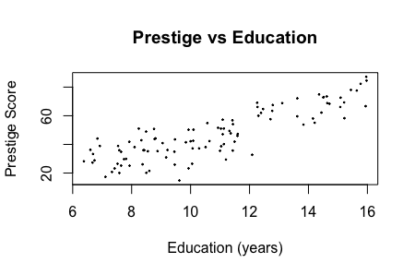
form: linear. points tend toward a straight line pattern
direction: there is a positive association between education and prestige
strength of association: points tend to follow a clear pattern, and are thus strongly associated
cor(
occupations$education,
occupations$prestige
)
0.8501769; education is very strongly correlated to prestige score

- Perform a simple linear regression. Generate a residual plot. Assess whether the model assumptions are met. Are there any outliers or influence points? If so, identify them by ID and comment on the effect of each on the regression. (4 points)
education.bar <- mean(occupations$education)
education.sd <- sd(occupations$education)
prestige.bar <- mean(occupations$prestige)
prestige.sd <- sd(occupations$prestige)
r <- cor(occupations$education, occupations$prestige)
beta1 <- r*prestige.sd/education.sd
beta1
5.360878
beta0 <- prestige.bar - beta1*education.bar
beta0
-10.73198
The SLR equation:
y = -10.73198 + 5.360878*x

m <- lm(occupations$prestige~occupations$education)
plot(
occupations$education,
occupations$prestige,
axes=TRUE,
frame.plot=TRUE,
xlab='education',
ylab='prestige'
)
abline(m, lty=3, col="blue")
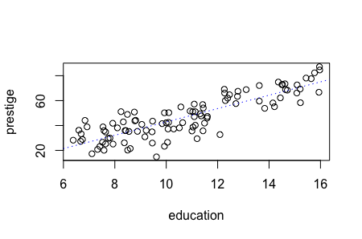

plot(
fitted(m),
resid(m),
axes=TRUE,
frame.plot=TRUE,
xlab='fitted values',
ylab='residue'
)
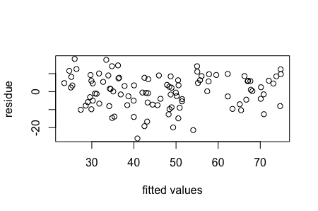
plot(
occupations$education,
resid(m),
axes=TRUE,
frame.plot=TRUE,
xlab='education',
ylab='residue'
)
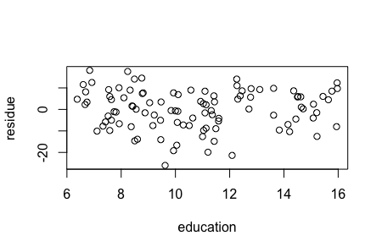
hist(resid(m))
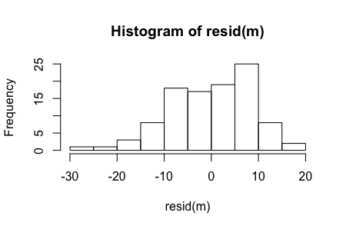
assumptions:
- relationship is linear
- observations are independent
- the variation of prestige around education is constant
- residuals are normally distributed
outliers / influence points:
- there are no outliers in the data set as there is nothing exceptionally large in the y direction.
- there are no influencing points with regard to education as there is nothing outlying in x.

- Calculate the least squares regression equation that predicts prestige from education, income and percentage of women. Formally test whether the set of these predictors are associated with prestige at the = 0.05 level. (4 points)
m <- lm(occupations$prestige~occupations$education+occupations$income+occupations$fraction.females)
lm(formula = occupations$prestige ~ occupations$education + occupations$income + occupations$fraction.females)
Intercept: -6.794334
education: 4.186637
income: 0.001314
fraction.females: -0.008905
y.hat = -6.794334 + 4.186637*education + 0.001314*income - 0.008905*fraction.females

k <- 3
n <- nrow(occupations)
reg.df <- k
res.df <- n - k - 1

total.ss <- sum((occupations$prestige - mean(occupations$prestige))^2)
reg.ss <- sum((fitted(m) - mean(occupations$prestige))^2)
resi.ss <- sum((occupations$prestige-fitted(m))^2)

qf(0.95, df1=reg.df, df2=res.df)
2.697423; reject if H0 >= 2.697423

f.statistic <- (reg.ss/reg.df)/(resi.ss/res.df)
f.statistic
129.1917

p.value <- 1-pf(f.statistic, df1=reg.df, df2=res.df)
p.value
0
129.1917 >= 2.697423. There is significant evidence at the alpha=0.05 level that
beta.education, beta.income, beta.fraction.females all do not equal 0. That is,
there is evidence of a linear association between prestige and education and/or income
and/or fraction.females (here p<0.001).

R2 <- reg.ss/total.ss
R2
0.7981775

- If the overall model was significant, summarize the information about the contribution of each variable separately at the same significance level as used for the overall model (no need to do a formal 5-step procedure for each one, just comment on the results of the tests). Provide interpretations for any estimates that were significant. Calculate 95% confidence intervals where appropriate. (4 points)

The model is significant.
summary(m)
 | Estimate | Std. Error | t value | Pr(>|t|)
(Intercept) | -6.7943342 | 3.2390886 | -2.098 | 0.0385 *
Education | 4.1866373 | 0.3887013 | 10.771 | < 2e-16 ***
Income | 0.0013136 | 0.0002778 | 4.729 | 7.58e-06 ***
Fraction females | -0.0089052 | 0.0304071 | -0.293 | 0.7702

qt(0.95, res.df)
1.660551
reject H0 if |t| >= 1.660551
reject education since 10.771 >= 1.660551
reject income since 4.729 >= 1.660551
do not reject fraction of females since 0.293 < 1.660551

- Generate a residual plot showing the fitted values from the regression against the residuals. Is the fit of the model reasonable? (2 points)

m <- lm(occupations$prestige~occupations$education+occupations$income+occupations$fraction.females)
summary(m)
resid(m)
par(mfrow=c(3,2))
plot(fitted(m), resid(m), axes=TRUE, frame.plot=TRUE, xlab='fitted values', ylab='residue')
plot(occupations$education, resid(m), axes=TRUE, frame.plot=TRUE, xlab='education', ylab='residue')
plot(occupations$income, resid(m), axes=TRUE, frame.plot=TRUE, xlab='income', ylab='residue')
plot(occupations$fraction.females, resid(m), axes=TRUE, frame.plot=TRUE, xlab='fraction.females', ylab='residue')
hist(resid(m))
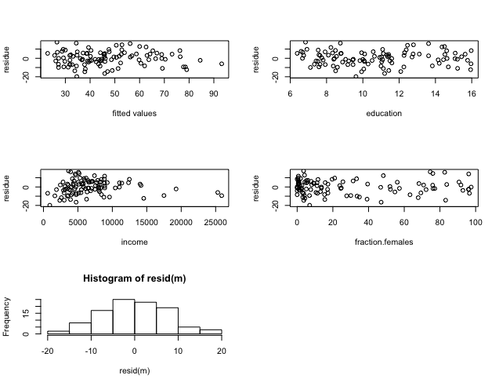from the distribution of points in each residual plot, we can conclude that the fit of the model is reasonable.

- Are there any outliers or influence points? (2 points)

par(mfrow=c(1,1))
plot(fitted(m), resid(m), axes=TRUE, frame.plot=TRUE, xlab='fitted values', ylab='residue')
boxplot.stats(occupations$prestige)$out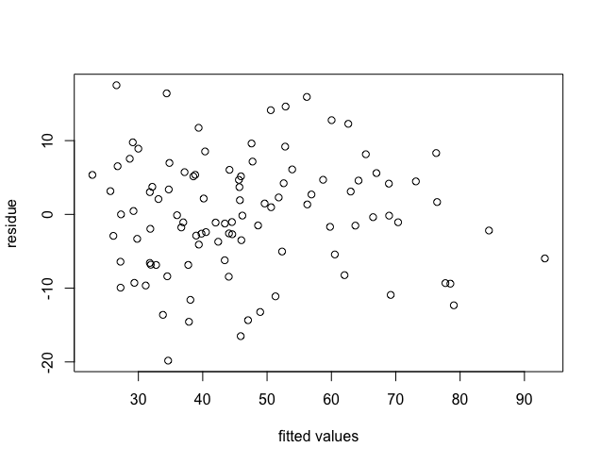
there are no outliers in the data set as there is nothing exceptionally large in the y direction.

plot(occupations$education, resid(m), axes=TRUE, frame.plot=TRUE, xlab='education', ylab='residue')
boxplot.stats(occupations$education)$out
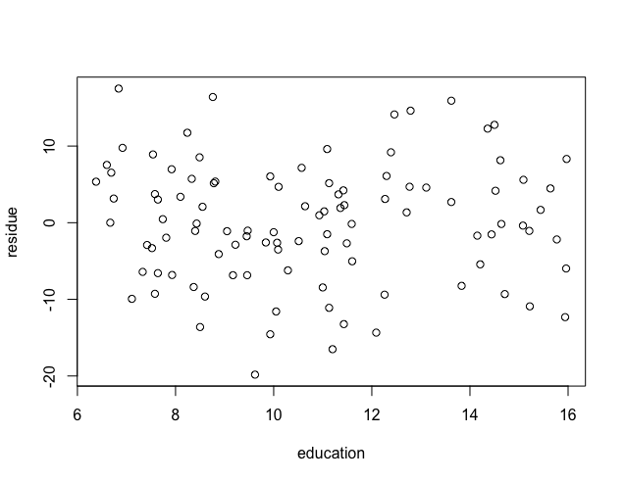
there are no influencing points with regard to education as there is nothing outlying in x.

plot(occupations$income, resid(m), axes=TRUE, frame.plot=TRUE, xlab='income', ylab='residue')
boxplot.stats(occupations$income)$out
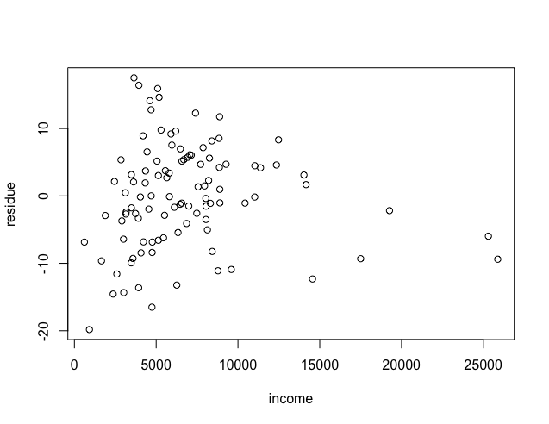
there are influencing points with regard to income 25879 19263 25308 14558 17498

plot(occupations$fraction.females, resid(m), axes=TRUE, frame.plot=TRUE, xlab='fraction.females', ylab='residue')
boxplot.stats(occupations$fraction.females)$out
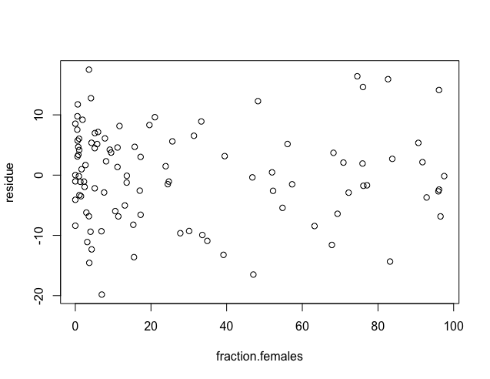
there are no influencing points with regard to fraction of females as there is nothing outlying in x.

Occupational Title | Education Level (years) | Income ($) | Percent of Workforce that are Women | Prestige Score
GOV_ADMINISTRATORS | 13.11 | 12351 | 11.16 | 68.8
GENERAL_MANAGERS | 12.26 | 25879 | 4.02 | 69.1
ACCOUNTANTS | 12.77 | 9271 | 15.7 | 63.4
PURCHASING_OFFICERS | 11.42 | 8865 | 9.11 | 56.8
CHEMISTS | 14.62 | 8403 | 11.68 | 73.5
PHYSICISTS | 15.64 | 11030 | 5.13 | 77.6
BIOLOGISTS | 15.09 | 8258 | 25.65 | 72.6
ARCHITECTS | 15.44 | 14163 | 2.69 | 78.1
CIVIL_ENGINEERS | 14.52 | 11377 | 1.03 | 73.1
MINING_ENGINEERS | 14.64 | 11023 | 0.94 | 68.8
SURVEYORS | 12.39 | 5902 | 1.91 | 62
DRAUGHTSMEN | 12.3 | 7059 | 7.83 | 60
COMPUTER_PROGRAMERS | 13.83 | 8425 | 15.33 | 53.8
ECONOMISTS | 14.44 | 8049 | 57.31 | 62.2
PSYCHOLOGISTS | 14.36 | 7405 | 48.28 | 74.9
SOCIAL_WORKERS | 14.21 | 6336 | 54.77 | 55.1
LAWYERS | 15.77 | 19263 | 5.13 | 82.3
LIBRARIANS | 14.15 | 6112 | 77.1 | 58.1
VOCATIONAL_COUNSELLORS | 15.22 | 9593 | 34.89 | 58.3
MINISTERS | 14.5 | 4686 | 4.14 | 72.8
UNIVERSITY_TEACHERS | 15.97 | 12480 | 19.59 | 84.6
PRIMARY_SCHOOL_TEACHERS | 13.62 | 5648 | 83.78 | 59.6
SECONDARY_SCHOOL_TEACHERS | 15.08 | 8034 | 46.8 | 66.1
PHYSICIANS | 15.96 | 25308 | 10.56 | 87.2
VETERINARIANS | 15.94 | 14558 | 4.32 | 66.7
OSTEOPATHS_CHIROPRACTORS | 14.71 | 17498 | 6.91 | 68.4
NURSES | 12.46 | 4614 | 96.12 | 64.7
NURSING_AIDES | 9.45 | 3485 | 76.14 | 34.9
PHYSIO_THERAPSTS | 13.62 | 5092 | 82.66 | 72.1
PHARMACISTS | 15.21 | 10432 | 24.71 | 69.3
MEDICAL_TECHNICIANS | 12.79 | 5180 | 76.04 | 67.5
COMMERCIAL_ARTISTS | 11.09 | 6197 | 21.03 | 57.2
RADIO_TV_ANNOUNCERS | 12.71 | 7562 | 11.15 | 57.6
ATHLETES | 11.44 | 8206 | 8.13 | 54.1
SECRETARIES | 11.59 | 4036 | 97.51 | 46
TYPISTS | 11.49 | 3148 | 95.97 | 41.9
BOOKKEEPERS | 11.32 | 4348 | 68.24 | 49.4
TELLERS_CASHIERS | 10.64 | 2448 | 91.76 | 42.3
COMPUTER_OPERATORS | 11.36 | 4330 | 75.92 | 47.7
SHIPPING_CLERKS | 9.17 | 4761 | 11.37 | 30.9
FILE_CLERKS | 12.09 | 3016 | 83.19 | 32.7
RECEPTIONSTS | 11.04 | 2901 | 92.86 | 38.7
MAIL_CARRIERS | 9.22 | 5511 | 7.62 | 36.1
POSTAL_CLERKS | 10.07 | 3739 | 52.27 | 37.2
TELEPHONE_OPERATORS | 10.51 | 3161 | 96.14 | 38.1
COLLECTORS | 11.2 | 4741 | 47.06 | 29.4
CLAIM_ADJUSTORS | 11.13 | 5052 | 56.1 | 51.1
TRAVEL_CLERKS | 11.43 | 6259 | 39.17 | 35.7
OFFICE_CLERKS | 11 | 4075 | 63.23 | 35.6
SALES_SUPERVISORS | 9.84 | 7482 | 17.04 | 41.5
COMMERCIAL_TRAVELLERS | 11.13 | 8780 | 3.16 | 40.2
SALES_CLERKS | 10.05 | 2594 | 67.82 | 26.5
NEWSBOYS | 9.62 | 918 | 7 | 14.8
SERVICE_STATION_ATTENDANT | 9.93 | 2370 | 3.69 | 23.3
INSURANCE__AGENTS | 11.6 | 8131 | 13.09 | 47.3
REAL_ESTATE_SALESMEN | 11.09 | 6992 | 24.44 | 47.1
BUYERS | 11.03 | 7956 | 23.88 | 51.1
FIREFIGHTERS | 9.47 | 8895 | 0 | 43.5
POLICEMEN | 10.93 | 8891 | 1.65 | 51.6
COOKS | 7.74 | 3116 | 52 | 29.7
BARTENDERS | 8.5 | 3930 | 15.51 | 20.2
FUNERAL_DIRECTORS | 10.57 | 7869 | 6.01 | 54.9
BABYSITTERS | 9.46 | 611 | 96.53 | 25.9
LAUNDERERS | 7.33 | 3000 | 69.31 | 20.8
JANITORS | 7.11 | 3472 | 33.57 | 17.3
ELEVATOR_OPERATORS | 7.58 | 3582 | 30.08 | 20.1
FARMERS | 6.84 | 3643 | 3.6 | 44.1
FARM_WORKERS | 8.6 | 1656 | 27.75 | 21.5
ROTARY_WELL_DRILLERS | 8.88 | 6860 | 0 | 35.3
BAKERS | 7.54 | 4199 | 33.3 | 38.9
SLAUGHTERERS_1 | 7.64 | 5134 | 17.26 | 25.2
SLAUGHTERERS_2 | 7.64 | 5134 | 17.26 | 34.8
CANNERS | 7.42 | 1890 | 72.24 | 23.2
TEXTILE_WEAVERS | 6.69 | 4443 | 31.36 | 33.3
TEXTILE_LABOURERS | 6.74 | 3485 | 39.48 | 28.8
TOOL_DIE_MAKERS | 10.09 | 8043 | 1.5 | 42.5
MACHINISTS | 8.81 | 6686 | 4.28 | 44.2
SHEET_METAL_WORKERS | 8.4 | 6565 | 2.3 | 35.9
WELDERS | 7.92 | 6477 | 5.17 | 41.8
AUTO_WORKERS | 8.43 | 5811 | 13.62 | 35.9
AIRCRAFT_WORKERS | 8.78 | 6573 | 5.78 | 43.7
ELECTRONIC_WORKERS | 8.76 | 3942 | 74.54 | 50.8
RADIO_TV_REPAIRMEN | 10.29 | 5449 | 2.92 | 37.2
SEWING_MACH_OPERATORS | 6.38 | 2847 | 90.67 | 28.2
AUTO_REPAIRMEN | 8.1 | 5795 | 0.81 | 38.1
AIRCRAFT_REPAIRMEN | 10.1 | 7716 | 0.78 | 50.3
RAILWAY_SECTIONMEN | 6.67 | 4696 | 0 | 27.3
ELECTRICAL_LINEMEN | 9.05 | 8316 | 1.34 | 40.9
ELECTRICIANS | 9.93 | 7147 | 0.99 | 50.2
CONSTRUCTION_FOREMEN | 8.24 | 8880 | 0.65 | 51.1
CARPENTERS | 6.92 | 5299 | 0.56 | 38.9
MASONS | 6.6 | 5959 | 0.52 | 36.2
HOUSE_PAINTERS | 7.81 | 4549 | 2.46 | 29.9
PLUMBERS | 8.33 | 6928 | 0.61 | 42.9
CONSTRUCTION_LABOURERS | 7.52 | 3910 | 1.09 | 26.5
PILOTS | 12.27 | 14032 | 0.58 | 66.1
TRAIN_ENGINEERS | 8.49 | 8845 | 0 | 48.9
BUS_DRIVERS | 7.58 | 5562 | 9.47 | 35.9
TAXI_DRIVERS | 7.93 | 4224 | 3.59 | 25.1
LONGSHOREMEN | 8.37 | 4753 | 0 | 26.1
TYPESETTERS | 10 | 6462 | 13.58 | 42.2
BOOKBINDERS | 8.55 | 3617 | 70.87 | 35.2

