MET CS 555 Assignment 6 – 20 points Spring, 2018
SUBMISSION REQUIREMENTS: Please submit a single document (word or PDF) for submission. Your submission should contain a summary of your results (and answers to questions asked on the homework) as well as your R code used to generate your results (please append to the end of your submission).
The data in this document consists of body temperature measurements and heart rate measurements for 65 men and 65 women. Save the data to excel and read the data into R. Use this data to address the following questions.
(1) We are interested in whether the proportion of men and women with body temperatures greater than or equal to 98.6 degrees Fahrenheit are equal. Therefore, we need to dichotomize the body temperature variable. Create a new variable, called “temp_level” in which temp_level = 1 if body temperature >= 98.6 and temp_level=0 if body temperature < 98.6. (1 point)
library(plyr)
setwd("/Users/anthony.valencia/met/cs555/assignments/06/")
data <- read.csv("data.csv")
data$temp_level <- ifelse(data$temp>=98.6, 1, 0)

(2) Summarize the data relating to body temperature level by sex. (2 points)
dat1 <- data.frame(
sex = factor(c("female", "female", "male", "male")),
temp_level = factor(c(0, 1, 0, 1), levels=c(0, 1)),
percentage = c(
nrow(data[data$sex==2 & data$temp_level==0,])*100/65,
nrow(data[data$sex==2 & data$temp_level==1,])*100/65,
nrow(data[data$sex==1 & data$temp_level==0,])*100/65,
nrow(data[data$sex==1 & data$temp_level==1,])*100/65
)
)
library(ggplot2)
ggplot(data=dat1, aes(x=sex, y=percentage, fill=temp_level)) + geom_bar(stat="identity")
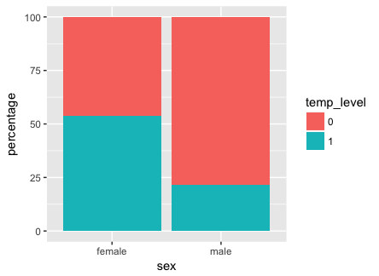
Females run slightly hotter with a little over 50% of females with a temp level above 98.6F.
Males run mostly colder with around 22% running below 98.6F.

(3) Calculate the risk difference. Formally test (at the α=.05 level) whether the proportion of people with higher body temperatures (greater than or equal to 98.6) is the same across men and women, based on this effect measure. Do females have higher body temperatures than males? (4.5 points)
female_0 <- nrow(data[data$sex==2 & data$temp_level==0,])
female_1 <- nrow(data[data$sex==2 & data$temp_level==1,])
male_0 <- nrow(data[data$sex==1 & data$temp_level==0,])
male_1 <- nrow(data[data$sex==1 & data$temp_level==1,])
p_hat_1 <- female_0/(female_0+female_1)
p_hat_2 <- male_0/(male_0+male_1)
p_hat_1-p_hat_2
-0.3230769. Meaning about 32% more males have a colder temp level. Here 0 (<98.6) was taken as the success event.

1) Set up the hypotheses and select the alpha level
h0: p1 = p2
h1: p1 != p2
alpha=0.05

2) Select the appropriate test statistic
z = (p_hat_1 - p_hat_2)/(sqrt(p_hat*(1-p_hat)*((1/n1)+(1/n2))))

3) State the decision rule
Critical value from the standard normal distribution for a right hand tail probability of alpha/2 = 0.05/2 = 0.025
Decision Rule: Reject h0 if |z| >= 1.960
Otherwise, do not reject h0

4) Compute the test statistic and the associated p-value
n1 <- nrow(data[data$sex==2,])
n2 <- nrow(data[data$sex==1,])
p_hat <- (female_0+male_0)/(n1+n2)
z <- (p_hat_1 - p_hat_2)/(sqrt(p_hat * (1-p_hat) * (1/(n1)+(1/n2)) ))
abs(z)
3.800585

5) reject h0 since 3.800585>=1.960.
females do have higher body temperatures than men as shown from p_hat_1-p_hat_2 value.

(4) Perform a logistic regression with sex as the only explanatory variable. Formally test (at the α=.05 level) if the odds of having a temperature greater than or equal to 98.6 is the same between males and females. Include the odds ratio for sex and the associated 95% confidence interval based on the model in your summary and interpret this value. What is the c-statistic for this model? (5.5 points)
m <- glm(data$temp_level ~ data$sex, family=binomial)
summary(m)
beta_1 <- 1.4469
se_beta_1 <- 0.3911
1) Set up the hypothesis and select the alpha level
h0: beta_1=0 or =1 (there is no association between sex and temp level)
h1: beta_1!=0 or !=1 (there is an association between sex and temp level)
alpha=0.05

2) select the appropriate test statistic
z = beta_1/se_beta_1

3) state the decision rule
determine the appropriate value from the standard normal distribution associated with the right hand tail
probability of alpha/2=0.025
using the table, this is 1.960
decision rule: reject h0 if |z|>=1.960 or reject h0 if p<=a. otherwise, do not reject h0.

4) compute the test statistic
z <- beta_1/se_beta_1
z=3.699565

5) conclusion
reject h0 since 3.699565>=1.960. or since <=alpha. we have significant evidence at the alpha=0.05 level
that beta_1!=0. That is, there is evidence of an association between sex and temp level.

c-statistic:
library(pROC)
data$prob <- predict(m, type=c("response"))
g <- roc(data$temp_level ~ data$prob)
Area under the curve (c-statistic): 0.672
plot(g)
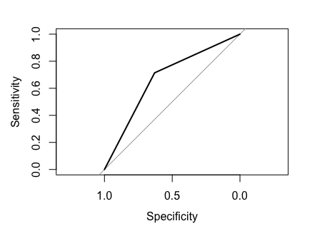
(5) Perform a multiple logistic regression predicting body temperature level from sex and heart rate. Summarize briefly the output from this model. Give the odds ratio for sex and heart rate (for a 10 beat increase). What is the c-statistic of this model? (5 points)
m <- glm(data$temp_level ~ data$sex + data$Heart.rate, family=binomial)
summary(m)
sex:
beta_1 <- 1.38919
se_beta_1 <- 0.39868
heart rate:
beta_2 <- 0.06337
se_beta_2 <- 0.02850
odds ratio
per 10 unit increase:
exp(m$coefficients[2]*10)
sex: 1079345
exp(m$coefficients[3]*10)
heart rate: 1.884521

c-statistic:
data$prob <-predict(m, type=c("response"))
g <- roc(data$temp_level ~ data$prob)
Area under the curve (c-statistic): 0.7289
plot(g)
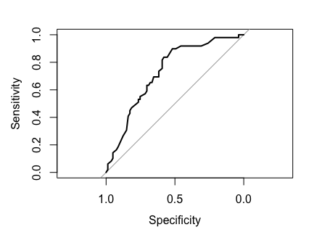

(6) Which model fit the data better? Support your response with evidence from your output. Present the ROC curve for the model you choose. (2 points)
The model considering both sex and heart rate better fits the data. From the ROC curves, we can see that the c-statistic is greater when both are considered. Furthermore, while beta_1 (sex) does have a greater influence, beta_2 (heart rate) does still carry much significance. The second ROC curve (from problem 5 above) is the model I choose.

Data (1=males, 2 =females)
temp | sex | Heart rate
96.3 | 1 | 70
96.7 | 1 | 71
96.9 | 1 | 74
97 | 1 | 80
97.1 | 1 | 73
97.1 | 1 | 75
97.1 | 1 | 82
97.2 | 1 | 64
97.3 | 1 | 69
97.4 | 1 | 70
97.4 | 1 | 68
97.4 | 1 | 72
97.4 | 1 | 78
97.5 | 1 | 70
97.5 | 1 | 75
97.6 | 1 | 74
97.6 | 1 | 69
97.6 | 1 | 73
97.7 | 1 | 77
97.8 | 1 | 58
97.8 | 1 | 73
97.8 | 1 | 65
97.8 | 1 | 74
97.9 | 1 | 76
97.9 | 1 | 72
98 | 1 | 78
98 | 1 | 71
98 | 1 | 74
98 | 1 | 67
98 | 1 | 64
98 | 1 | 78
98.1 | 1 | 73
98.1 | 1 | 67
98.2 | 1 | 66
98.2 | 1 | 64
98.2 | 1 | 71
98.2 | 1 | 72
98.3 | 1 | 86
98.3 | 1 | 72
98.4 | 1 | 68
98.4 | 1 | 70
98.4 | 1 | 82
98.4 | 1 | 84
98.5 | 1 | 68
98.5 | 1 | 71
98.6 | 2 | 77
98.6 | 1 | 78
98.6 | 1 | 83
98.6 | 2 | 66
98.6 | 1 | 70
98.6 | 1 | 82
98.7 | 2 | 73
98.7 | 1 | 78
98.8 | 1 | 78
98.8 | 1 | 81
98.8 | 2 | 78
98.9 | 1 | 80
99 | 2 | 75
99 | 2 | 79
99 | 1 | 81
99.1 | 1 | 71
99.2 | 1 | 83
99.3 | 1 | 63
99.4 | 1 | 70
99.5 | 1 | 75
96.4 | 2 | 69
96.7 | 2 | 62
96.8 | 1 | 75
97.2 | 1 | 66
97.2 | 2 | 68
97.4 | 2 | 57
97.6 | 1 | 61
97.7 | 2 | 84
97.7 | 1 | 61
97.8 | 2 | 77
97.8 | 2 | 62
97.8 | 2 | 71
97.9 | 1 | 68
97.9 | 2 | 69
97.9 | 2 | 79
98 | 2 | 76
98 | 1 | 87
98 | 2 | 78
98 | 2 | 73
98 | 2 | 89
98.1 | 2 | 81
98.2 | 2 | 73
98.2 | 2 | 64
98.2 | 2 | 65
98.2 | 2 | 73
98.2 | 2 | 69
98.2 | 2 | 57
98.3 | 2 | 79
98.3 | 2 | 78
98.3 | 2 | 80
98.4 | 2 | 79
98.4 | 2 | 81
98.4 | 2 | 73
98.4 | 2 | 74
98.4 | 2 | 84
98.5 | 2 | 83
98.6 | 2 | 82
98.6 | 2 | 85
98.6 | 2 | 86
98.6 | 2 | 77
98.7 | 2 | 72
98.7 | 2 | 79
98.7 | 2 | 59
98.7 | 2 | 64
98.7 | 2 | 65
98.7 | 2 | 82
98.8 | 2 | 64
98.8 | 2 | 70
98.8 | 2 | 83
98.8 | 2 | 89
98.8 | 2 | 69
98.8 | 2 | 73
98.8 | 2 | 84
98.9 | 2 | 76
99 | 2 | 79
99 | 2 | 81
99.1 | 2 | 80
99.1 | 2 | 74
99.2 | 2 | 77
99.2 | 2 | 66
99.3 | 2 | 68
99.4 | 2 | 77
99.9 | 2 | 79
100 | 2 | 78
100.8 | 2 | 77

