Anthony Valencia
CS699 – HW01

- Install Weka (10 points)
Complete WEKA installation using the installation instruction in Appendix A of this assignment (The link to the installation instruction file is also included in Section 19 of Module 1). Run the WEKA Explorer, open the iris.arff dataset (located in WEKA installations data folder). Provide a snapshot of the resulting screen in your submission. (10 points)
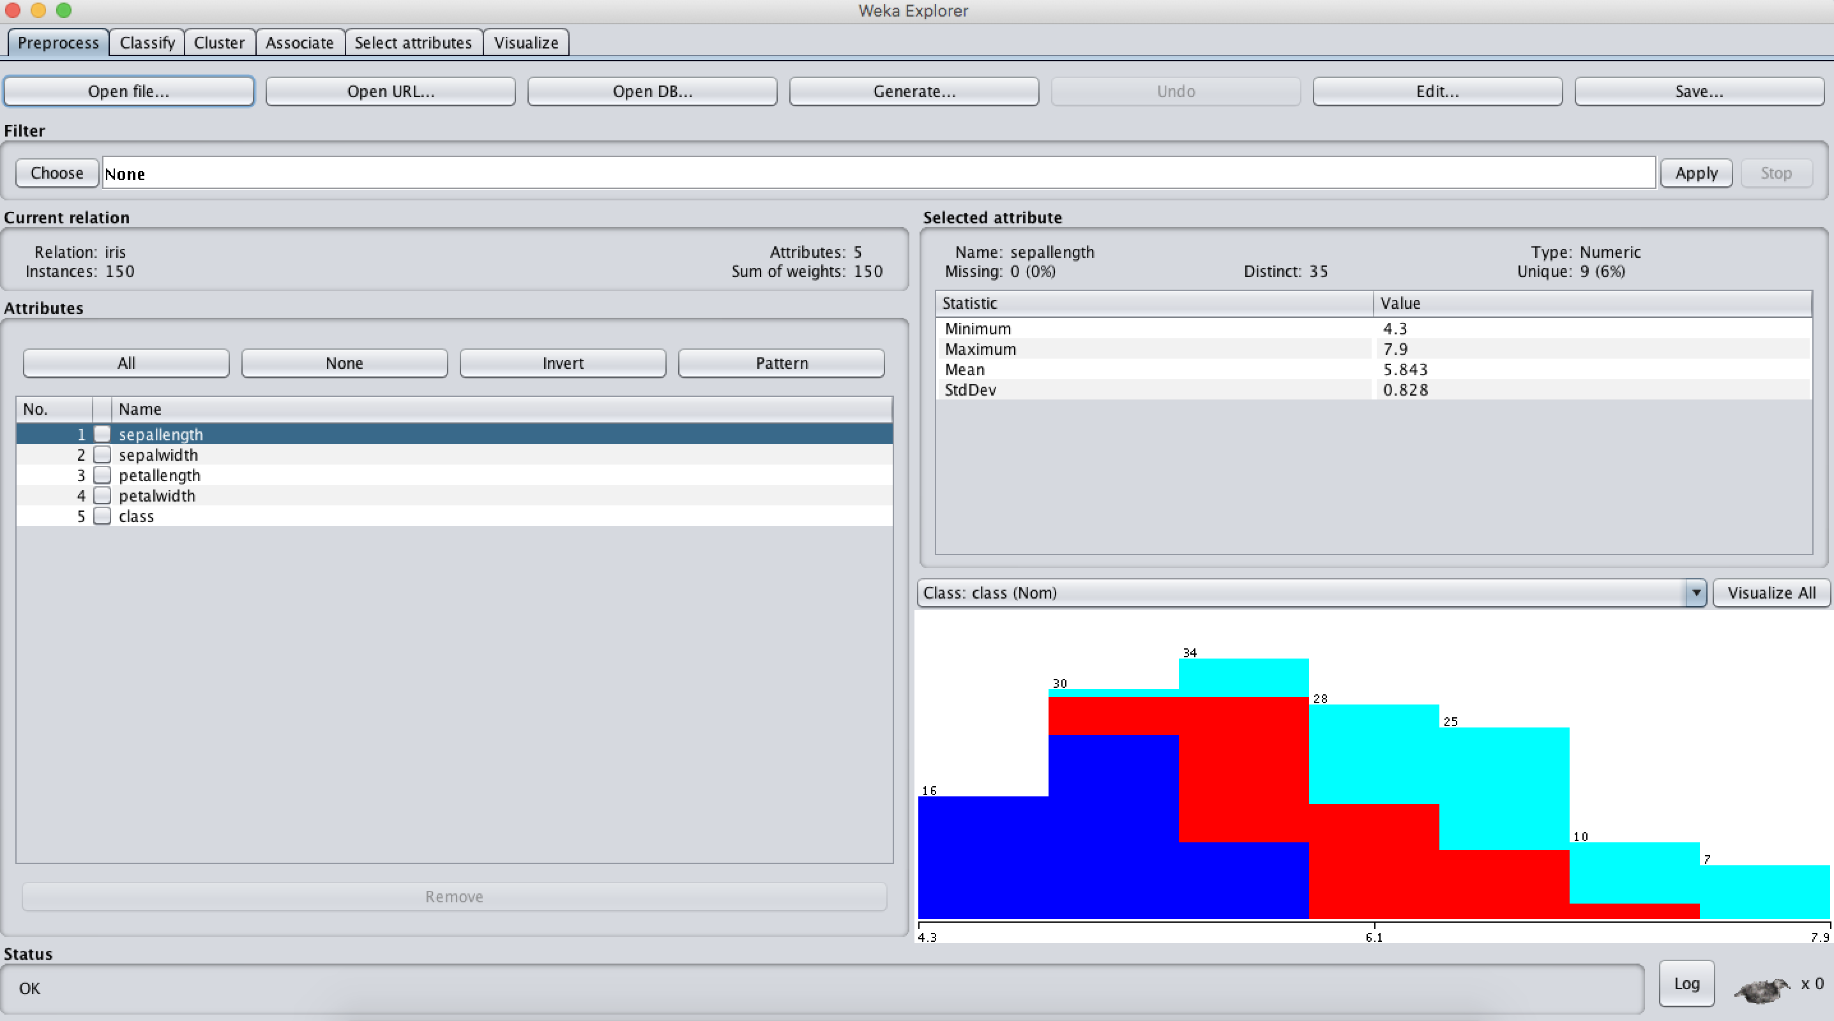
- Install Oracle (10 points)
You will not directly install Oracle on your computer. Instead, you will install Oracle
Virtual machine. Follow the instruction below:
(a). Complete Oracle 11gR2 virtual machine installation using the installation instruction in Appendix B of this assignment (The link to the installation instruction file is also included in Section 21 of Module 1).
(b). Start the oracle virtual machine.
(c). Login with username oracle (this is a linux user) and password oracle. (d). Once the linux boots up, you will see SQL Developer shortcut icon on the
desktop. Start SQL Developer by double clicking it.
(e). Capture the SQL Developer Start Page screen and include it in your submission.
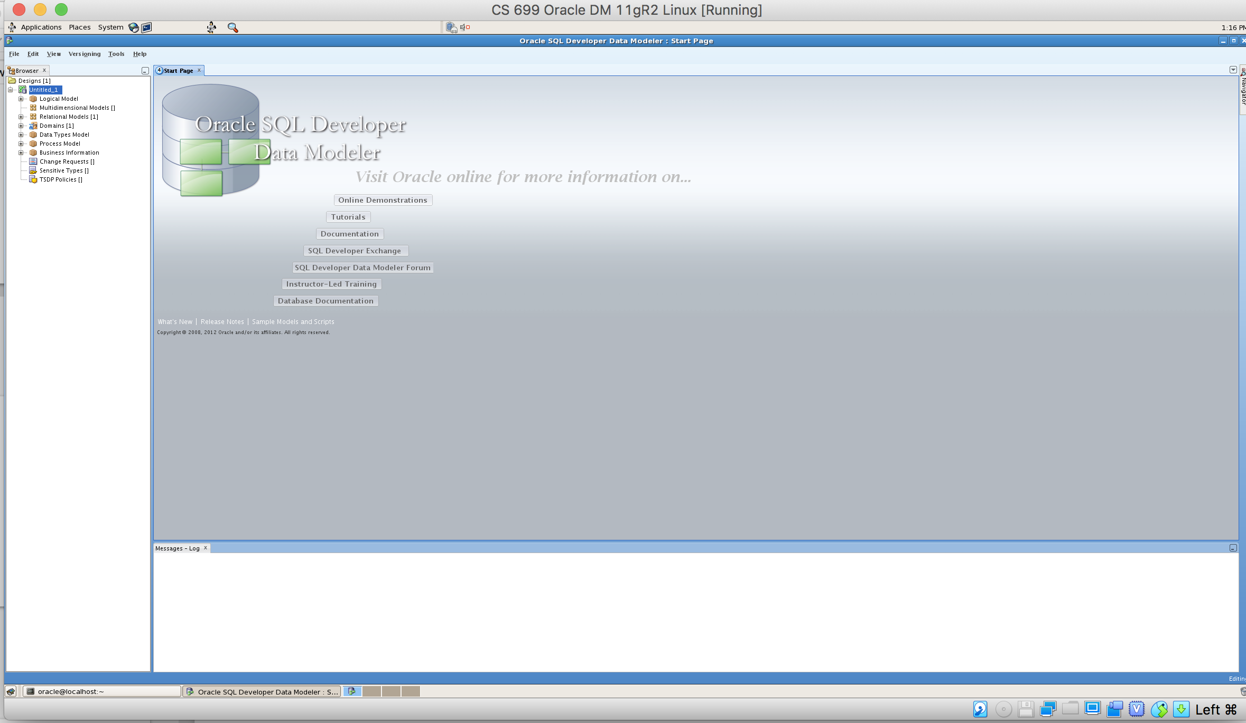
- Install JMP Pro (10 points)
Complete JMP installation using the installation instruction in Appendix C of this assignment. Follow the instruction and capture the last screen in the appendix and paste it to your submission document.
