**Due**: 3/20  
**Note: Show all your work.**

**Assignment 6**

**Problem 1 (10 points)** Suppose you built two classifier models *M*1 and *M*2 from the same training dataset and tested them on the same test dataset using 10-fold cross- validation. The error rates obtained over 10 iterations (in each iteration the same training and test partitions were used for both *M*1 and *M*2) are given in the table below. Determine whether there is a significant difference between the two models using the statistical method discussed in Section 6 of the online lecture Module 4 (also in Section 8.5.5, pp 372-373 of the textbook). Use a significance level of 1%. If there is a significant difference, which one is better?

|  |  |  |
| --- | --- | --- |
| Iteration | M1 | M2 |
| 1 | 0.21 | 0.13 |
| 2 | 0.12 | 0.1 |
| 3 | 0.09 | 0.20 |
| 4 | 0.15 | 0.2 |
| 5 | 0.03 | 0.15 |
| 6 | 0.07 | 0.05 |
| 7 | 0.13 | 0.14 |
| 8 | 0.14 | 0.21 |
| 9 | 0.05 | 0.23 |
| 10 | 0.14 | page1image4998544  0.17 |

**Note: When you calculate *var(M1 – M2)*, calculate a sample variance (not a population variance).**

***Null hypothesis: M1 and M2 are the same.***

***From attached file Valencia_Anthony_HW6.xls – worksheet P1***

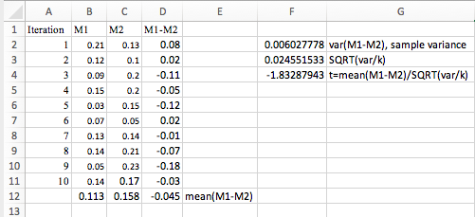

***For a significance level ($α$) of 1%, and degrees of freedom = k-1 = 9, tα/2, df = t0.005, 9 = 3.250, according to the t-distribution critical values table. Sinceit is not true that t < -t0.005, 9, (-1.8329 >= -3.250) we cannot reject the null hypothesis and cannot conclude that the difference between M1 and M2 is statistically significant. If it were, the model with the lower error rate would have been M1.***

**Problem 2 (10 points).** The following table shows a test result of a classifier on a dataset.

|  |  |  |
| --- | --- | --- |
| Tuple_id | Actual Class | Probability |
| 1 | P | 0.82 |
| 2 | N | 0.75 |
| 3 | N | 0.94 |
| 4 | P | 0.85 |
| 5 | P | 0.81 |
| 6 | P | 0.90 |
| 7 | N | 0.74 |
| 8 | P | 0.73 |
| 9 | N | 0.91 |
| 10 | P | 0.76 |

**Problem 2-1.** For each row, compute *TP*, *FP*, *TN*, *FN*, *TPR*, and *FPR*.

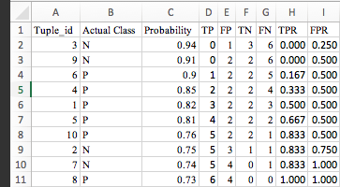

***From attached file Valencia_Anthony_HW6.xls – worksheet P2***

**Problem 2-2.** Plot the ROC curve for the dataset.

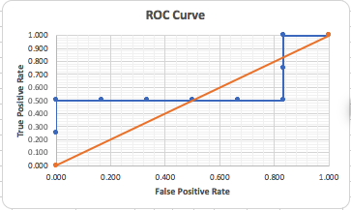

***From attached file Valencia_Anthony_HW6.xls – worksheet P2***

**Problem 3 (10 points).** For this problem, you will run bagging and boosting algorithms that are implemented on Weka on the *german-bank.arff* dataset

**Problem 3-1 (5 points).** Run Bagging twice first with Naïve Bayes as a base classifier and next with J48 as a base classifier. For each result, capture the screenshot of a part of Classifier Output window that shows “Correctly Classified Instances” and “Confusion Matrix” and include them in your submission. Compare and discuss the performance of the two models with the result from homework 5.

***Bagging: Naïve Bayes***

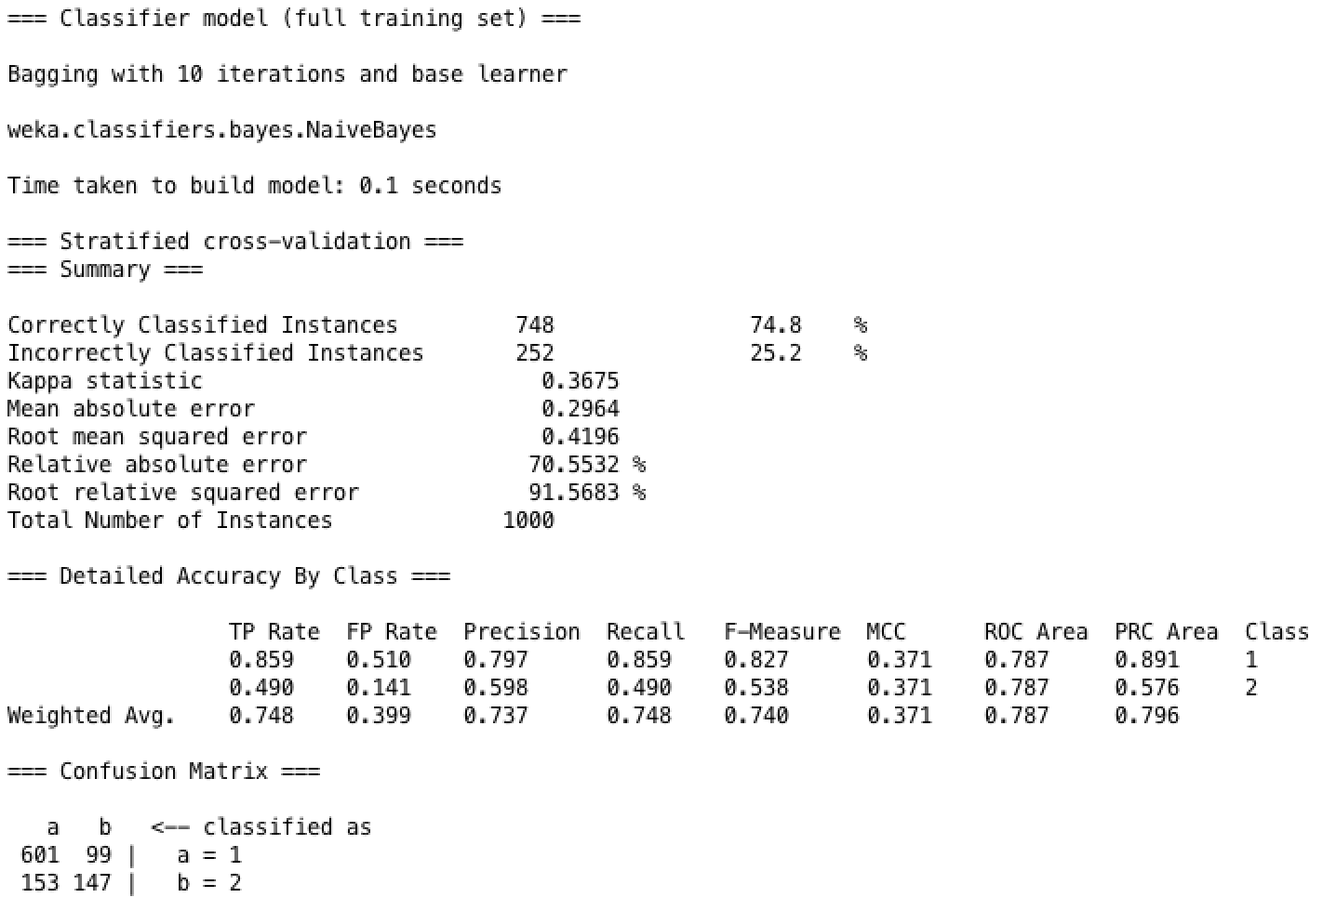

***Bagging: J48***

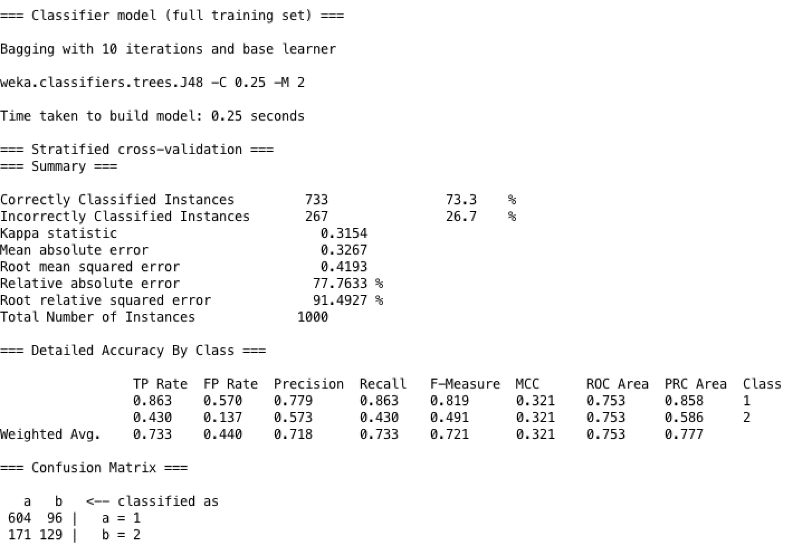

***Bagging: Naïve Bayes has the most correctly classified instances. The description of the german dataset specifically notes “It is worse to class a customer as good when they are bad (5), than it is to class a customer as bad when they are good (1).” Therefore, the algorithm that produces the lowest rate of false positives on class 1 is 0.399 for the Bagging: Naïve Bayes. Both of these algorithms have lower rates of false positives (bagging-NB: 0.399 and bagging-J48: 0.440) than the best algorithm for HW5, MultilayerPerceptron (0.477), so they both perform better.***

**Problem 3-2 (5 points)** Run AdaBoostM1 twice first with Naïve Bayes as a base classifier and next with J48 as a base classifier. For each result, capture the screenshot of a part of Classifier Output window that shows “Correctly Classified Instances” and “Confusion Matrix” and include them in your submission. Compare and discuss the performance of the two models with the result from homework 5. Also compare the result with that of Problem 3-1 (Bagging result).

***Boosting: Naïve Bayes***

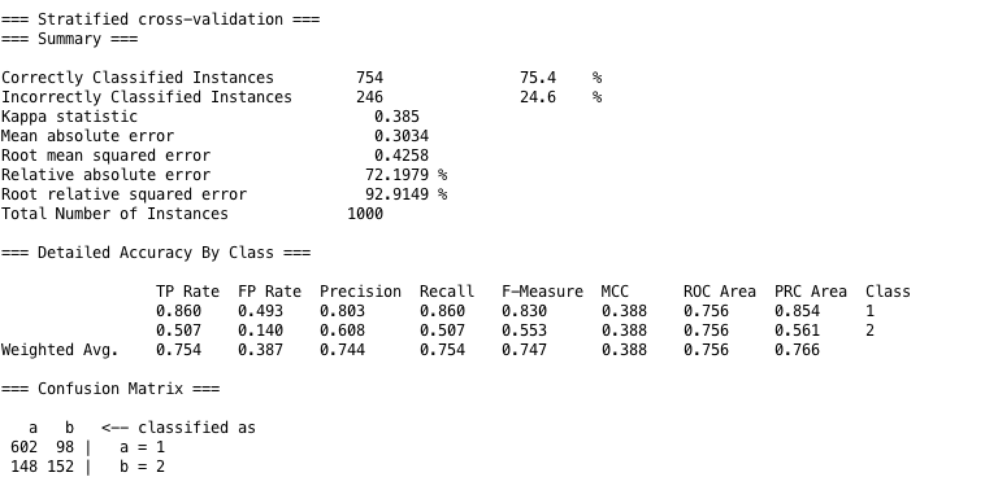

***Boosting: J48***

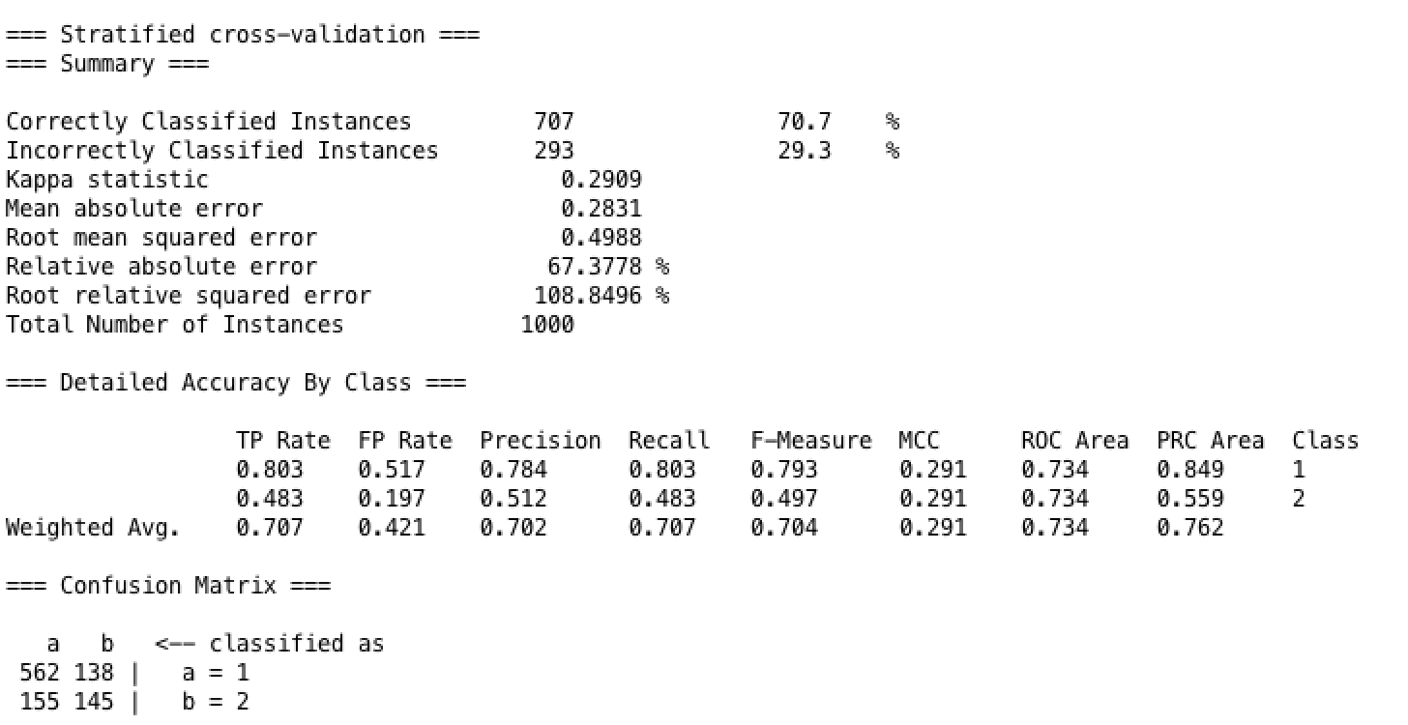

***Boosting: Naïve Bayes has the most correctly classified instances. The description of the german dataset specifically notes “It is worse to class a customer as good when they are bad (5), than it is to class a customer as bad when they are good (1).” Therefore, the algorithm that produces the lowest rate of false positives on class 1 is 0.387 for the Boosting: Naïve Bayes. Both of these algorithms have lower rates of false positives (boosting-NB: 0.387 and boosting -J48: 0.421) than the best algorithm for HW5, MultilayerPerceptron (0.477), so they both perform better.***

**Problem 4 (10 points).** This is a practice of comparing performance of classifier models using ROC curves. You can plot ROC curves using Weka Knowledge Flow. On the Blackboard course web site, I posted a Weka Manual under Course Documents. How to use Knowledge Flow is described in Section 7. Following the instruction in the manual (especially Section 7.4.2), build and test SimpleLogistic and RandomForest classifiers on *german-bank.arff* dataset, and capture the screenshot which shows two ROC curves. Include this screenshot in your submission. Compare and discuss the performance of the two models using the ROC curves.

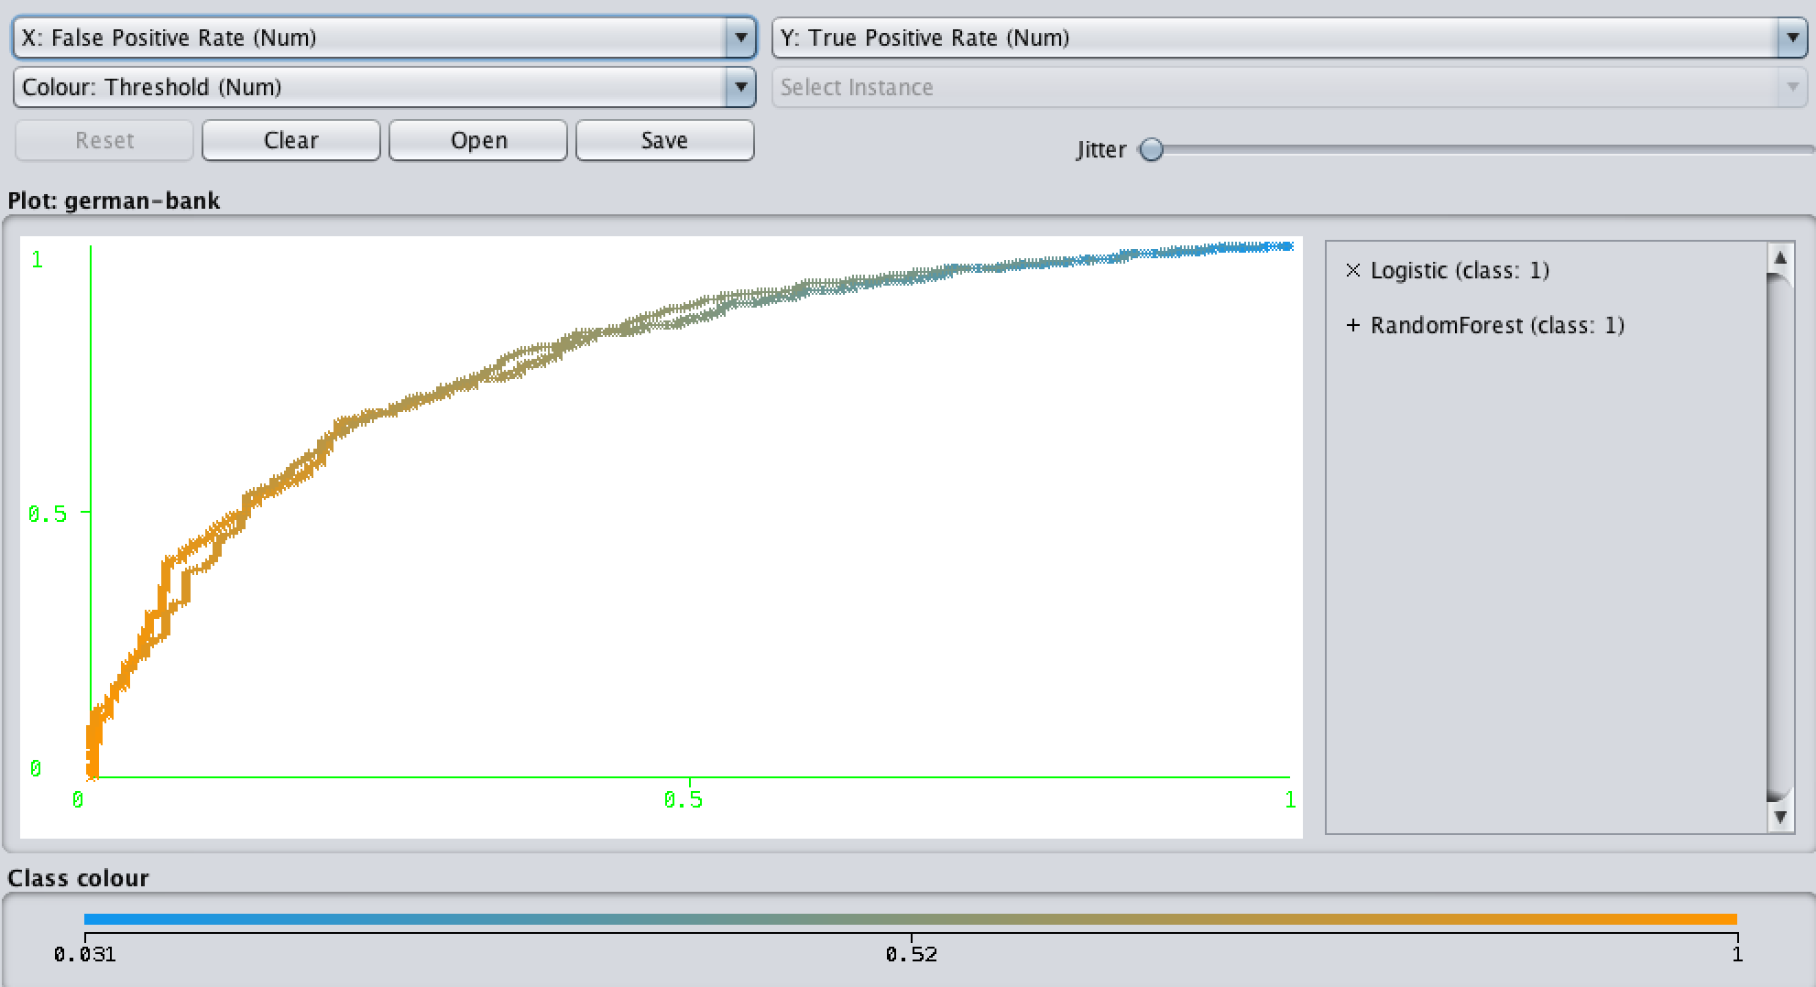

***Both the SimpleLogistic and the RandomForest classifiers appear to be almost indistinguishable from each other as far as the ROC is concerned. There is some difference near the FPR and TPR of 0,0. There is a decent amount of area under the curve for both classifiers suggesting that both models perform well and are thus fairly accurate.***