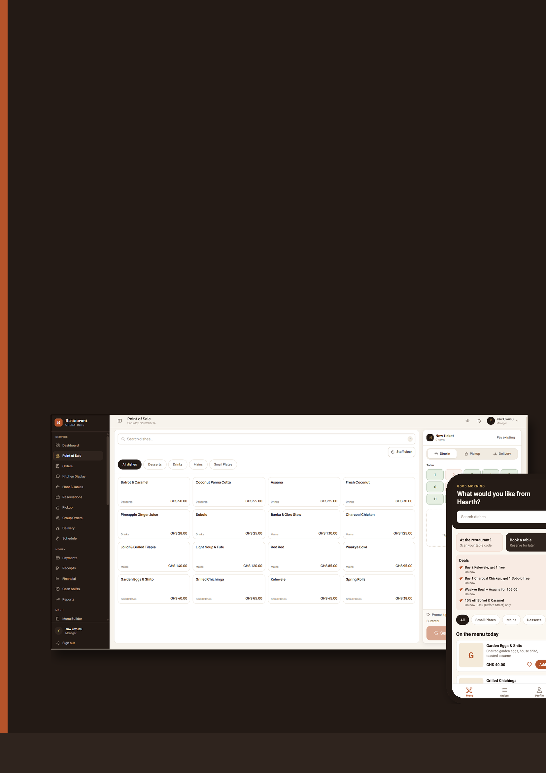
BUSINESS PROPOSAL · RESTAURANT TECHNOLOGY
Restaurant
Management System
Run Smarter. Serve Better.
Grow Your Restaurant.
One intelligent platform to manage restaurant operations, streamline customer experiences, control transactions, and empower your team.
INSIDE THIS PROPOSAL
Contents

01 The Modern Restaurant Challenge  02 Introducing the Platform  03 A Better Customer Experience  04 Intelligent Table & Dining Management  05 Smarter POS & Sales Management  06 Payments, Accountability & Control  07 Better Coordination Between Teams  08 Attendance & Workforce Management | 09 Payroll Management  10 Multi-Branch Management  11 Reports, Insights & Business Control  12 Business Benefits for Owners  13 Who Can Benefit  14 Why Choose This Platform  15 Getting Started

ABOUT THIS DOCUMENT
Built around how restaurants really work
This proposal walks through the platform the way a restaurant experiences it: from the moment a guest sits down and scans the table QR code, through the kitchen, the cashier's drawer and the close of day, to the people who make it all happen and the payroll that rewards them.
Every screen shown in this document is taken from the working application.

01 · THE CHALLENGE

The Modern Restaurant Challenge

Running a restaurant means managing dozens of moving parts at once: guests, tables, the kitchen, cash, card and mobile money, suppliers, and a team working in shifts. When those parts live in notebooks, separate apps and people's memories, small gaps quickly turn into lost revenue and unhappy guests.
Orders that get lost or delayed  Handwritten tickets and verbal hand-offs between floor and kitchen lead to forgotten dishes, wrong items and long waits. |  | Tables nobody can see at a glance  Without a live view of which tables are free, occupied or waiting for the bill, guests wait longer and tables turn more slowly.
Sales that are hard to trace  When sales are spread across receipt books, mobile money messages and spreadsheets, owners struggle to see what really came in. |  | Payment accountability gaps  Unrecorded discounts, voids, refunds and cash differences are hard to explain without a clear record of who did what.
Attendance on paper  Sign-in sheets are easy to fill in after the fact. Late arrivals, missed shifts and overtime are difficult to verify. |  | Payroll by calculator  Turning hours, leave, overtime, tips and statutory deductions into accurate payslips every month takes days and invites errors.
Limited visibility for owners  Owners often find out how the restaurant is doing days later, and only by asking someone or counting cash. |  | Teams that don't share one picture  Cashiers, kitchen staff, riders and managers each work with partial information, so coordination depends on shouting across the room.

Why integrated software matters
Most of these problems share a root cause: information that is created in one place is needed somewhere else. A single platform that connects the guest's order, the kitchen, the payment, the cash drawer and the staff rota removes those hand-offs entirely, and turns every action into a record the owner can trust.

02 · THE SOLUTION

Introducing the Restaurant Management System

An all-in-one platform that connects guests, front-of-house staff, the kitchen, cashiers, riders, HR and owners. Everyone works from the same live information, so the restaurant runs as one team.
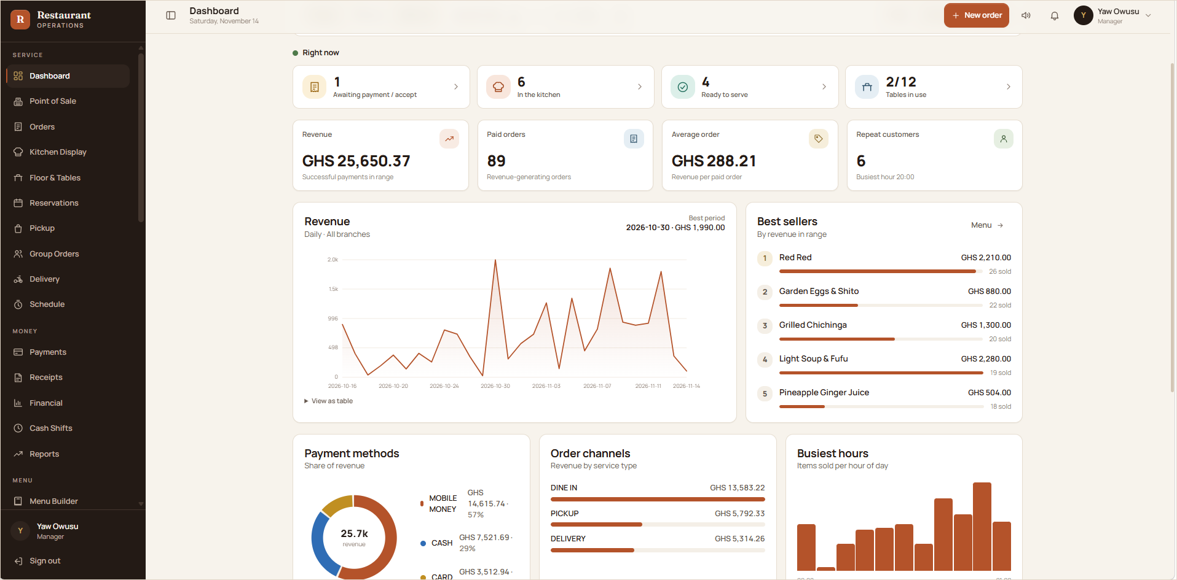
FIGURE 1 The owner's dashboard: live service status, revenue, paid orders, average order value, best sellers, payment methods, order channels and busiest hours, all in one view.

Access is role based. The platform has dedicated roles for administrators, managers, cashiers, riders, HR officers and customers, so each person sees exactly what they need and nothing they shouldn't. Cashiers go straight to the point of sale, riders only see their deliveries, and HR officers only reach the HR module.

Three connected experiences, one system
A  For guests  Order from the table by scanning a QR code, with no app or account. Or use the customer app to order for pickup or delivery, book a table, collect loyalty points and reorder favourites. |  | B  For the team  A point of sale, a kitchen display, a live floor plan, delivery dispatch, cash shifts and staff clock-in, each tailored to the person's role. |  | C  For owners and managers  Live dashboards, financial controls with manager approval, daily reconciliation, exportable reports, multi-branch oversight and full HR and payroll.

03 · GUEST EXPERIENCE

A Better Customer Experience

Every table carries its own permanent QR code. Guests scan it with their phone camera and the restaurant's ordering page opens instantly: no app to download, no account to create. They browse, order, follow their food and settle the bill at their own pace.

The guest journey at the table
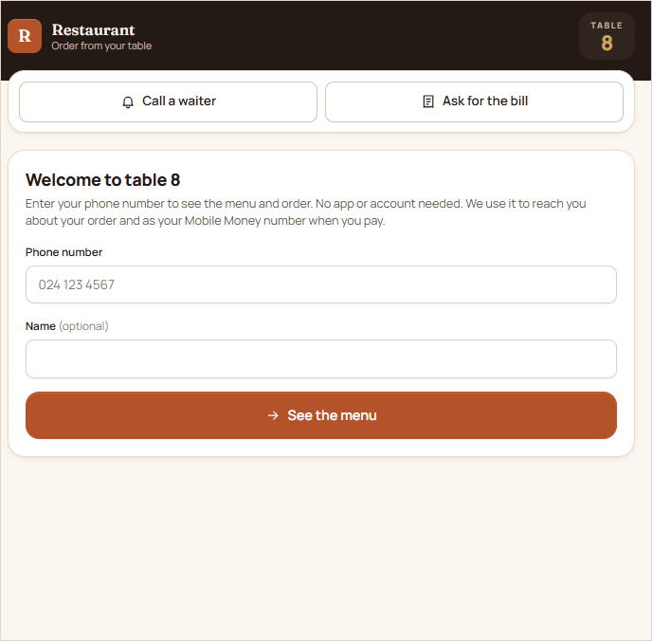  FIGURE 2 1. Scan and enter a phone number. No app or account needed. | 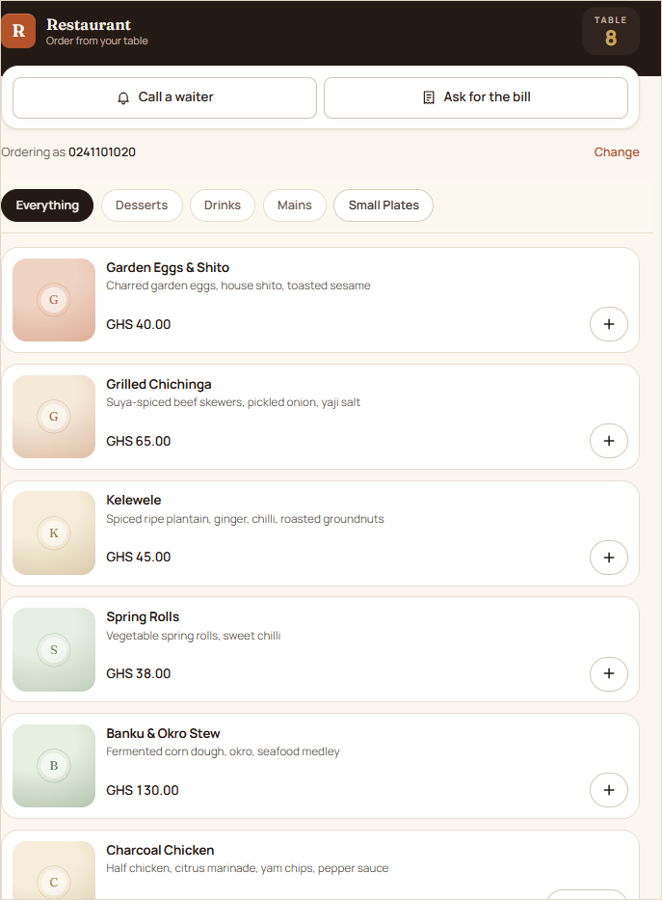  FIGURE 3 2. Browse the live menu by category. | 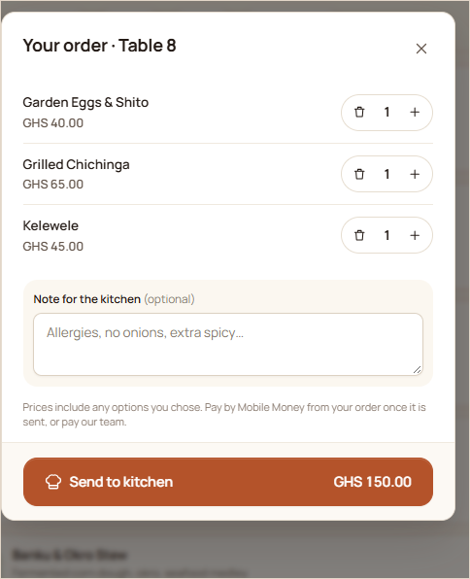  FIGURE 4 3. Review the order, add kitchen notes and send it. | 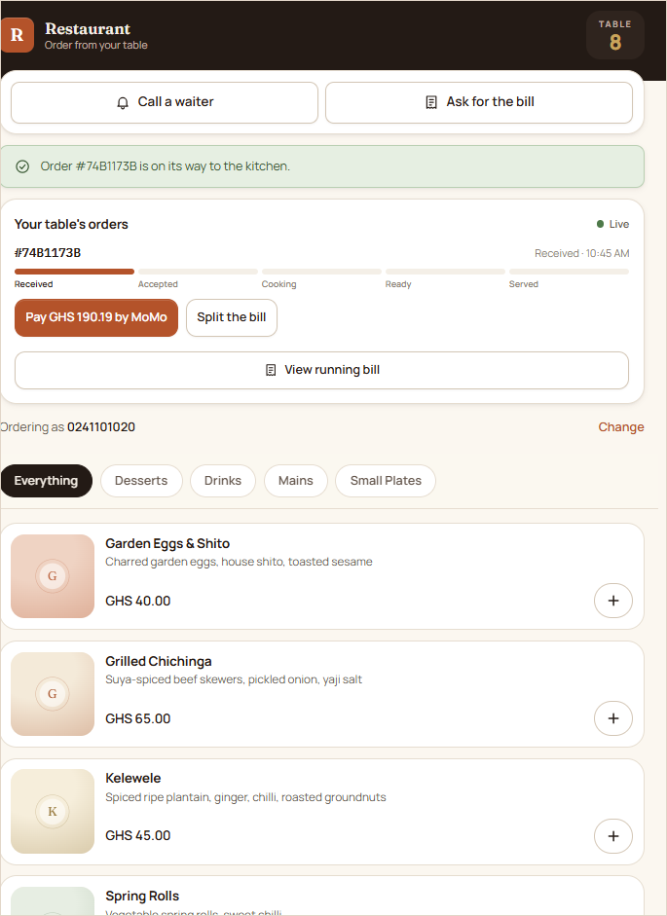  FIGURE 5 4. Follow the order live, from received to served.

Call a waiter or ask for the bill  Two buttons at the top of every table page send a request straight to the team's screens, so guests never have to wave for attention. |  | A live order tracker  Each order moves through Received, Accepted, Cooking, Ready and Served, updated in real time as the kitchen works.
Pay from the table  Guests can pay the whole bill by Mobile Money from their phone, or pay the team in cash or by card in the usual way. |  | Split the bill fairly  A table can split the bill equally, and each person pays their own share by Mobile Money.

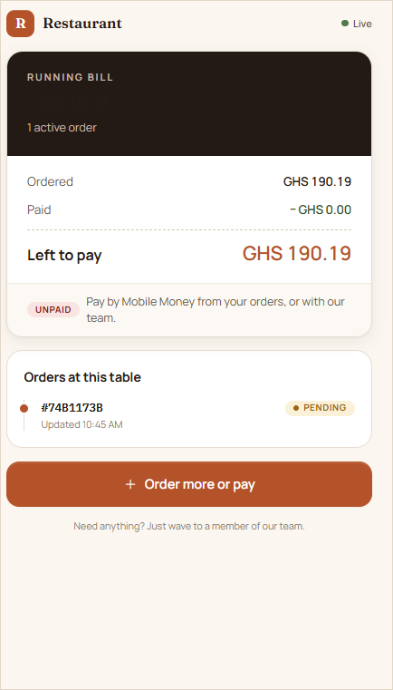  FIGURE 6 The running bill shows what has been ordered, what is paid and what is left. | 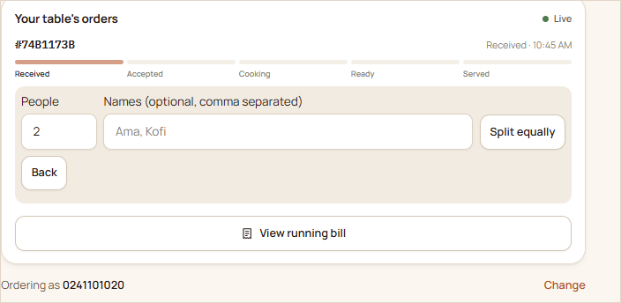  FIGURE 7 Guests can split the bill equally between the people at the table.

The customer app: pickup, delivery and loyalty
Beyond the table, customers can use the mobile app to order ahead for pickup or delivery, book a table, take advantage of current deals and earn loyalty points with every paid order.
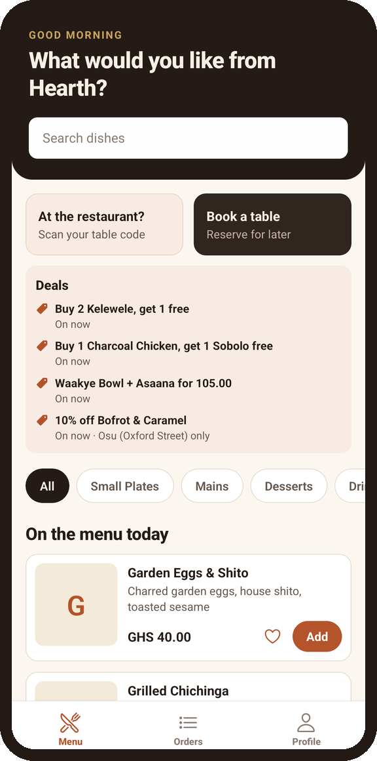  FIGURE 8 Home screen with live deals, table scanning and booking. | 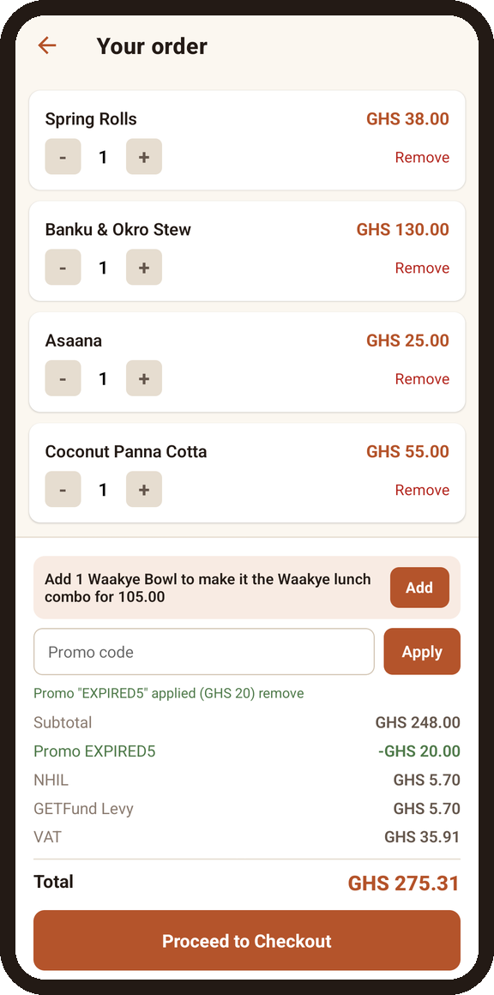  FIGURE 9 Cart with promo codes and combo suggestions. | 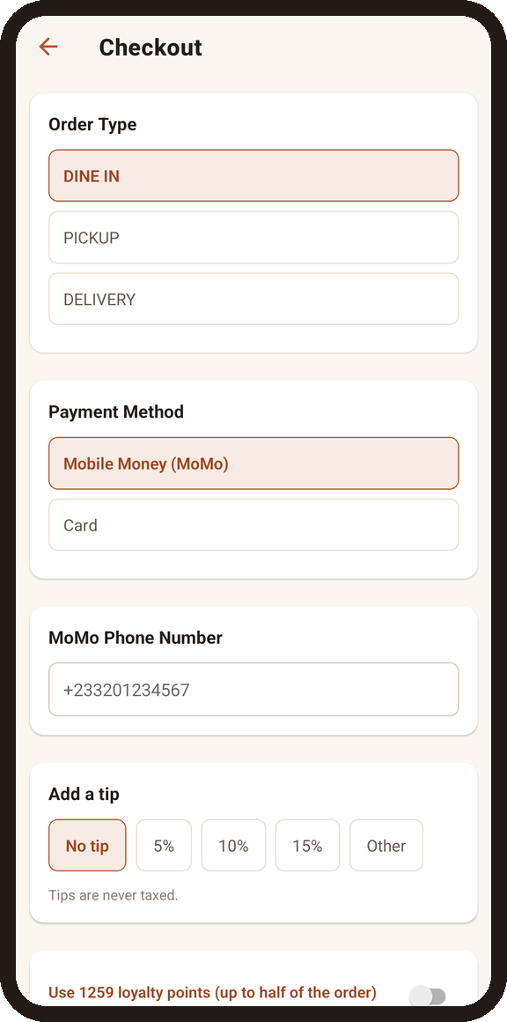  FIGURE 10 Checkout: dine-in, pickup or delivery, and tips. | 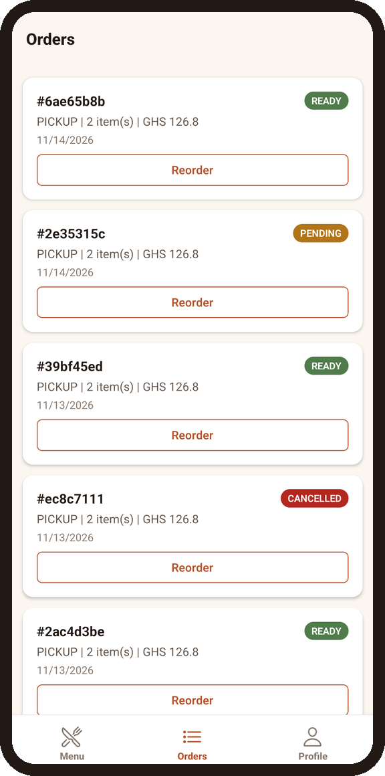  FIGURE 11 Order history with live status and one-tap reorder.

Deals that sell themselves  Running offers such as buy-two-get-one, combos and happy hours appear on the menu, and the cart tells customers when one more dish would complete a deal. |  | Loyalty that brings guests back  Customers earn points on paid orders and can spend them at checkout. The balance and history sit in their profile.
Clear, honest pricing  Every order shows its service charge, each tax line and any discount before the customer pays. |  | Feedback after every meal  Customers are invited to rate their order. Low ratings alert the branch's managers in real time, and replies reach the customer by WhatsApp and in the app.

GUEST TRUST
Privacy by design
Each party only sees its own sitting. When guests leave and the bill is settled, the next party at that table starts with a clean page. Phone numbers are kept on the order for staff and never shown on public screens.

04 · FRONT OF HOUSE

Intelligent Table & Dining Management

See your whole dining room at a glance. The floor plan shows which tables are free, occupied, reserved or closed, how many seats each has, and what every occupied table has ordered so far.
A live floor plan  Tables are grouped by zone (bar, main room, private room, terrace) with clear status counts. From any table, staff can take an order or open its bill.  Tables that manage themselves  Placing a dine-in order marks the table as occupied. When the bill is settled, the table is released automatically, ready for the next guests. A table that already has an open order isn't offered for a new one by mistake.  A watch on unpaid tables  Managers can see what each table owes, when it was served and whether the bill was requested, so nothing slips through at the end of a busy service. | 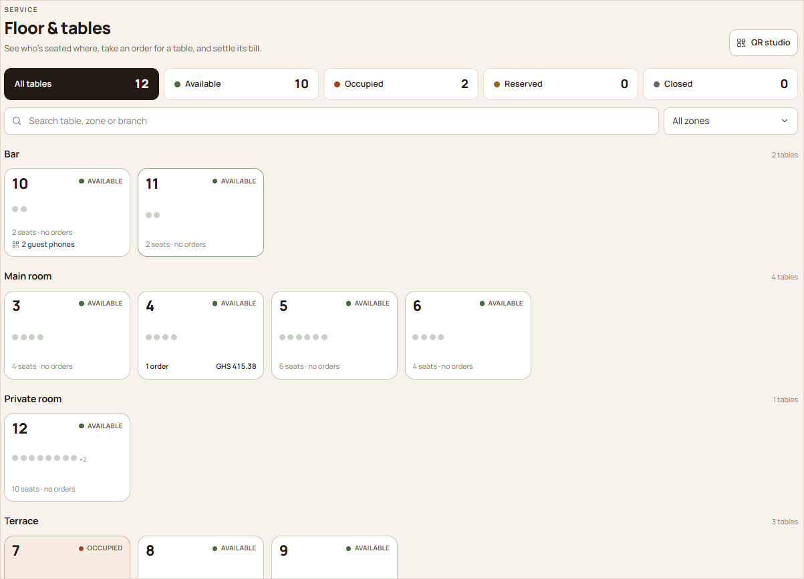  FIGURE 12 Floor & tables: status counts, seats and running totals per table.

Dining sessions from first order to final payment
One running bill per table  Several rounds of orders build up on one table bill. Guests and staff see the same total, paid amount and balance. |  | Walk-in guests, served as usual  Guests who don't scan a QR code are served through the POS in exactly the same way: the order is linked to the table, sent to the kitchen and settled at the counter.
Shared tables and split bills  A table's bill can be split equally into shares, and each share is paid separately in cash, by card or by Mobile Money. |  | Walkouts on record  If guests leave without paying, a manager records the walkout with the amount, reason, who took the order and the guests' phone number. Losses are reported, not hidden.

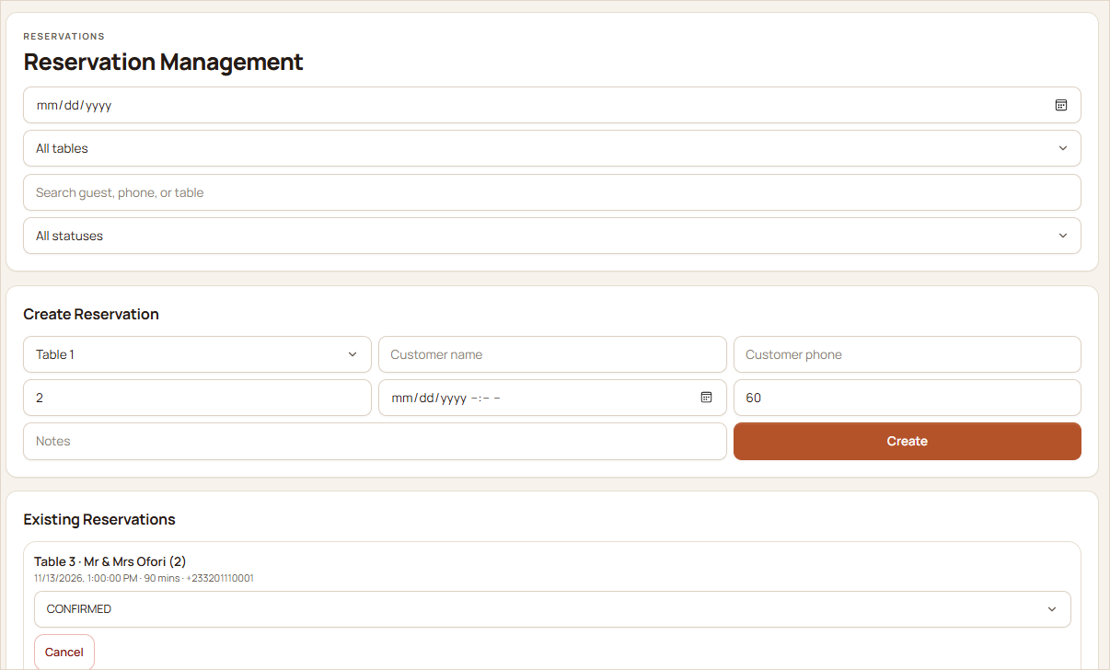  FIGURE 13 Reservation management for staff. | Reservations without double bookings  Bookings are checked for clashes on the same table. One hour before a reservation the table is held for the party, and it is released again if the booking is cancelled or the guests haven't arrived 30 minutes after the booked time.  Customers can book from the website or the mobile app, and staff can create and manage reservations from the web.

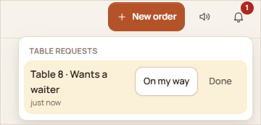
FIGURE 14 A guest's “call a waiter” request arrives instantly on staff screens, with “On my way” and “Done” actions.

05 · POINT OF SALE

Smarter POS & Sales Management

A fast, touch-friendly point of sale built for busy service. The menu and the ticket sit side by side, prices are calculated automatically, and orders go straight to the kitchen.
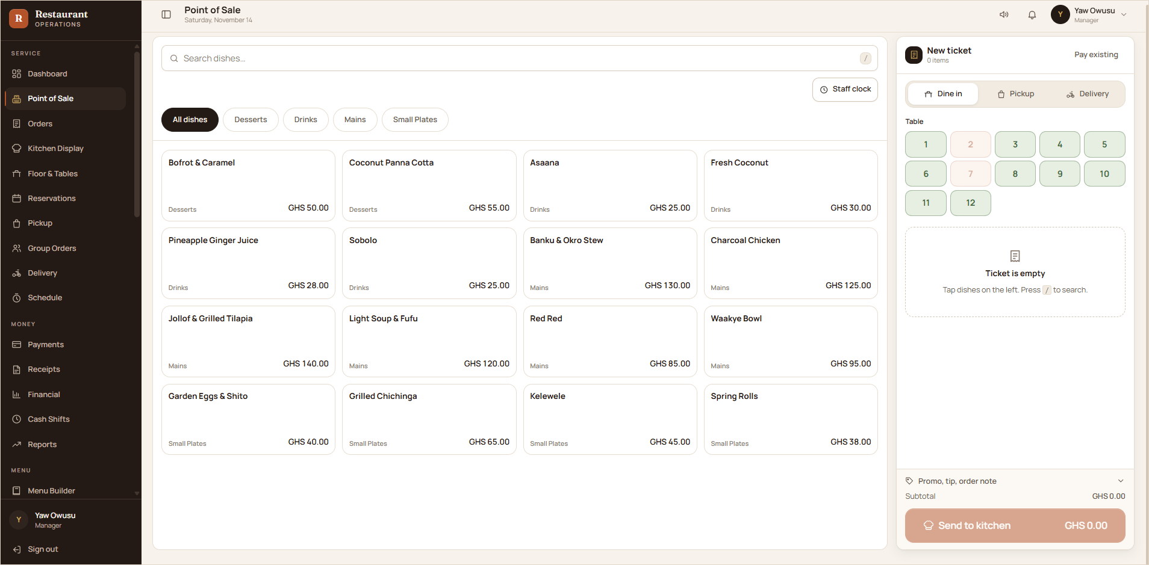
FIGURE 15 The point of sale: dishes by category on the left, the ticket with dine-in, pickup or delivery and the table picker on the right.

Dine-in, pickup and delivery  One screen handles every channel. For dine-in, a table grid shows which tables are free. For delivery, the zone and fee are added automatically. |  | Accurate orders, every time  Required choices such as size or spice level can't be skipped, and kitchen notes travel with each dish.
Pricing done for you  Offers, promo codes, service charge and each tax line are worked out automatically, so cashiers never calculate by hand. |  | Built for speed  Keyboard search adds dishes in seconds, and payment is a separate, clear step once the order is in.

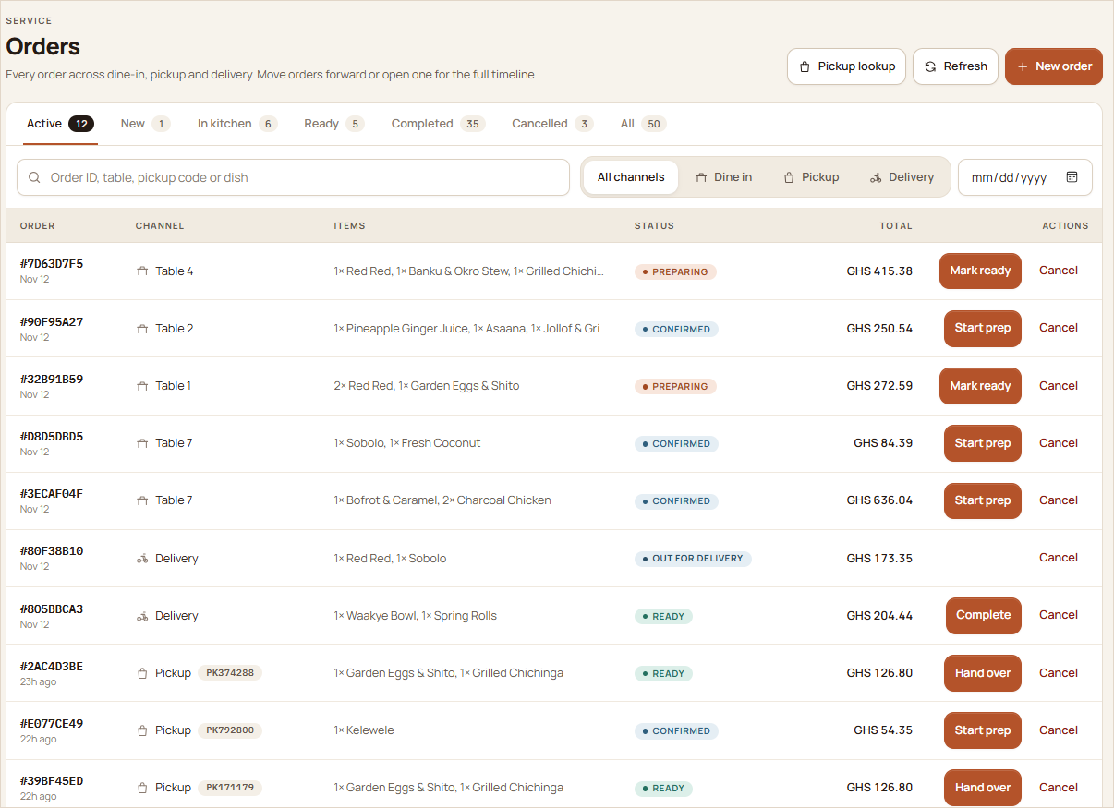
FIGURE 16 All orders across dine-in, pickup and delivery, with status tabs, channel filters and one-click next steps.

Menu, offers and stock in one place
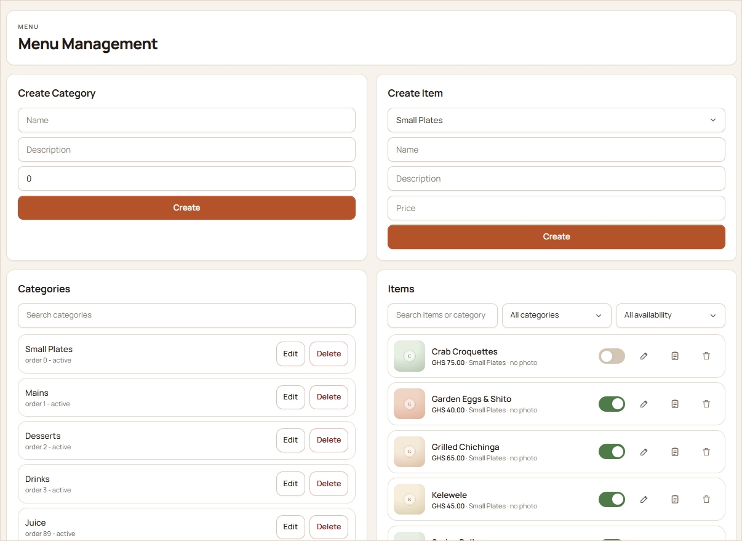  FIGURE 17 Menu builder: categories, dishes, photos and an availability switch. | 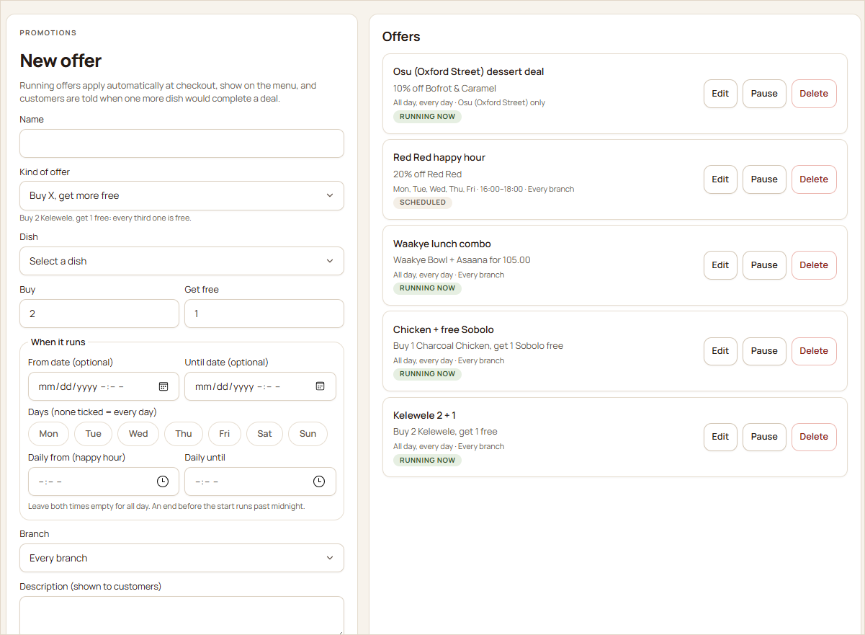  FIGURE 18 Offers: buy-X-get-Y, combos, happy hours and branch-only deals.

Inventory that follows every sale
Each dish can have a recipe. When an order is placed, its ingredients are deducted from that branch's stock, and cancelled orders put them back.
When an ingredient runs out, the dish is marked sold out at that branch and comes back once restocked. Managers get live low-stock alerts.
A food cost report compares ingredients used against net sales and shows each dish's recipe cost and margin.
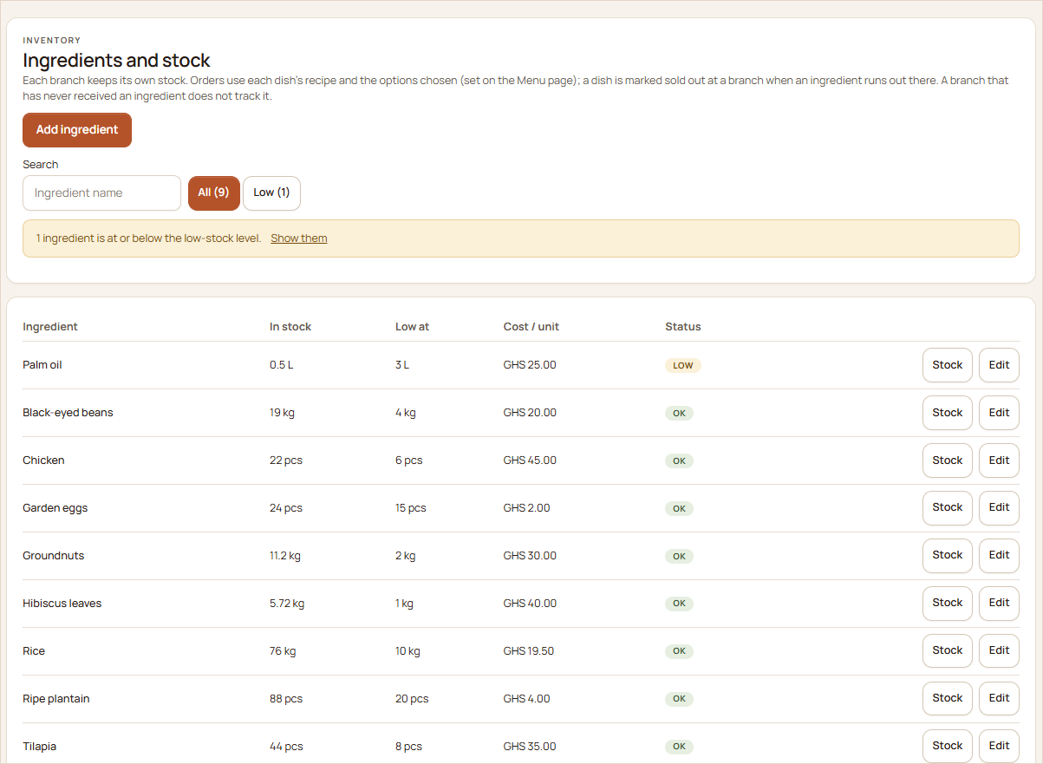
FIGURE 19 Ingredients and stock per branch, with low-stock status, restock and stock-count actions.

06 · MONEY & CONTROL

Payments, Accountability & Control

Every payment, discount, void and refund is recorded, approved where it matters and traceable to a person. Owners get the confidence that what was sold is what was collected.
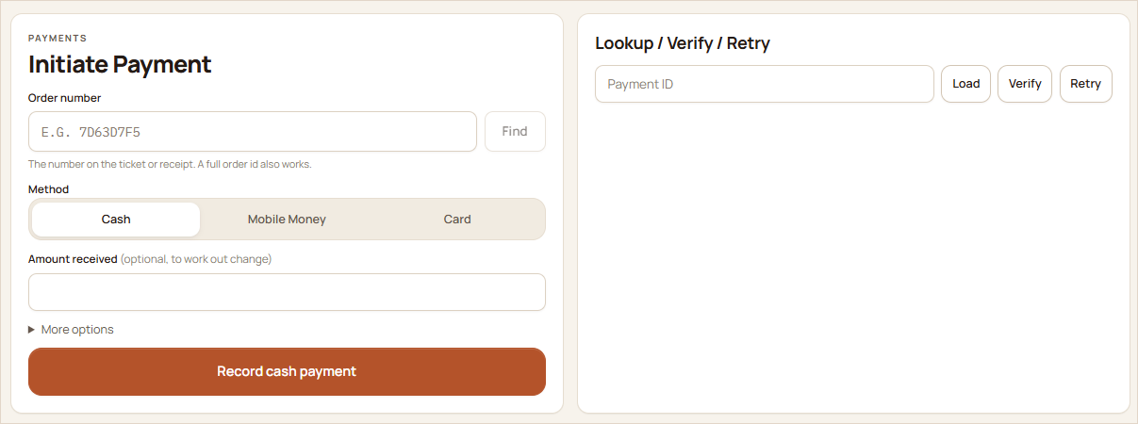  FIGURE 20 Record payments by cash, Mobile Money or card, with change worked out. | 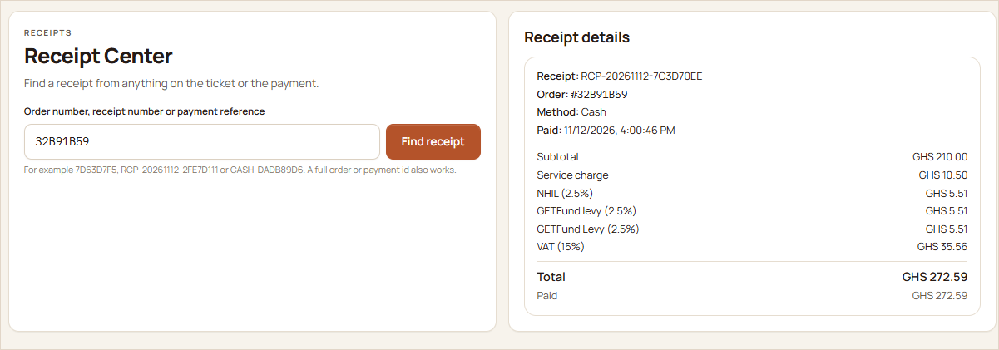  FIGURE 21 Find any receipt from the order number, receipt number or payment reference.

Electronic payments  Mobile Money and card payments are processed through Paystack. A successful payment confirms the order automatically and updates the table. |  | Cash confirmed by the cashier  Cash is recorded at the counter with the amount received and the change due, and is tied to the cashier's open drawer.
Paid once, never twice  An order that is already paid can't be charged again, and pending attempts are checked before a new one starts. |  | Pickups need a code  Pickup orders are paid before cooking starts, and handing one over requires the customer's pickup code.

Controls that protect the business
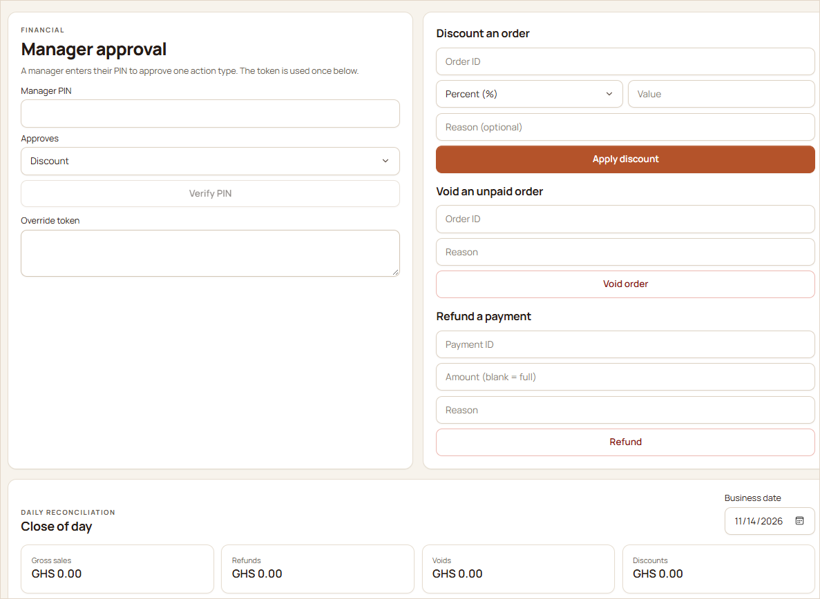  FIGURE 22 Discounts, voids and refunds need a manager's PIN, followed by the close-of-day reconciliation. | 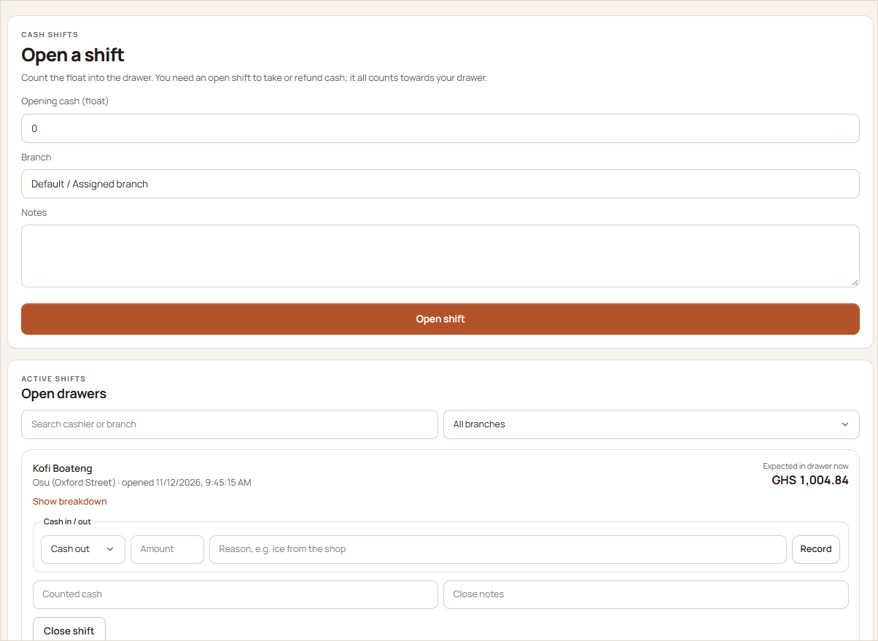  FIGURE 23 Cash shifts: opening float, cash in and out with reasons, and the expected cash in the drawer.

CONTROL | WHAT IT GIVES YOU
Manager PIN approval | Discounts, voids and refunds need a manager's PIN for that specific action. Each approval is single-use and expires within minutes.
Cash drawer shifts | Cash can only be taken with an open shift. Closing records the counted cash and any shortage or overage.
Daily reconciliation | Gross and net sales, refunds, voids, discounts, totals per payment method and expected cash, signed off once per day and branch.
Audit trail | Logins, PIN events, role changes and every financial action are logged with who, when and what.
Tax and service charge | Service charge, NHIL, GETFund levy and VAT (charged on top of the levies) are applied consistently and printed on every bill. Tips are never taxed.

ROADMAP
Exit verification at the security post
A planned addition to the accountability workflow is a temporary payment QR code that guests show at the restaurant's security post on the way out. A quick scan would confirm with the system that the bill is settled, and every verification scan would be recorded for audit. The process is designed to be quick and discreet, so paying guests leave without fuss. Walk-in guests who never scanned a table QR code would be covered too, because their bills are created by staff on the POS.
This feature is on the roadmap and not yet part of the current release. Today, staff can already confirm any bill's payment status in seconds from the receipt or order number, and unpaid tables are visible on the payment watch.

07 · TEAMWORK

Better Coordination Between Teams

Orders, requests and status changes flow to the right screen the moment they happen. The floor, the kitchen, the cashier and the rider all work from the same live picture, so far less needs to be shouted across the room.
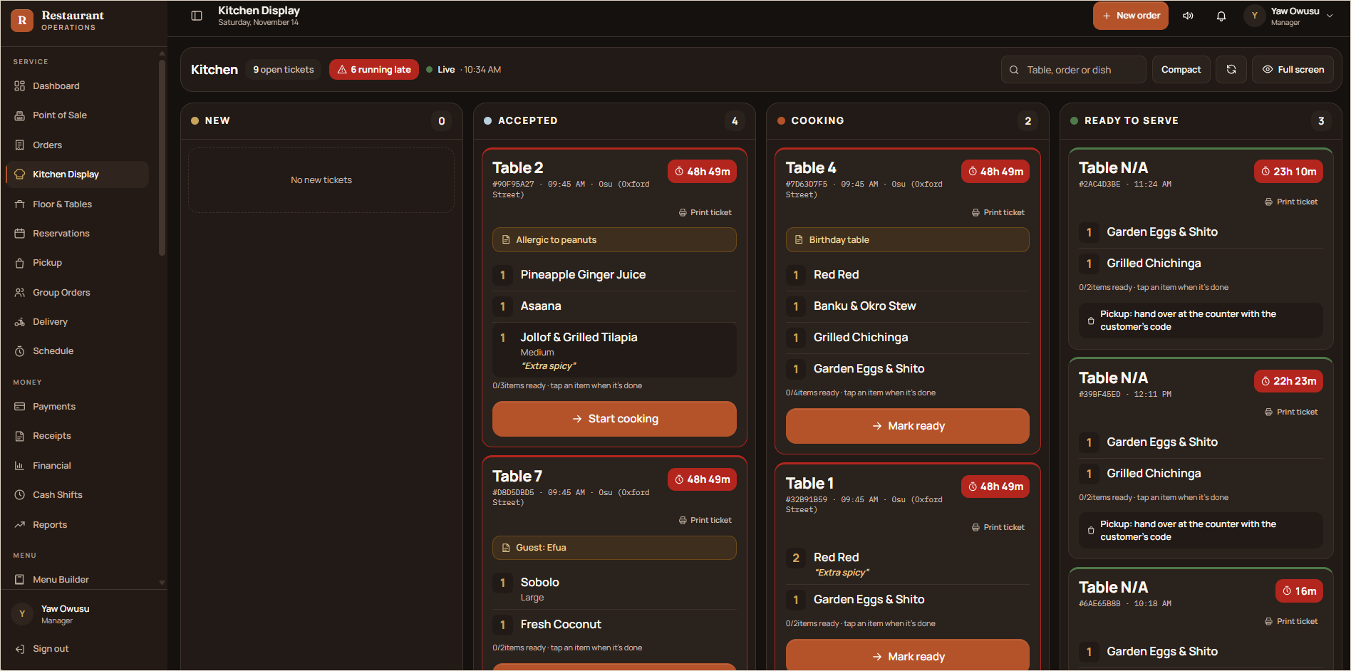
FIGURE 24 The kitchen display: tickets in New, Accepted, Cooking and Ready columns, with waiting timers, late tickets highlighted, and allergy and guest notes in plain sight.

ROLE | HOW THE PLATFORM SUPPORTS THEM
Front-of-house staff | Take orders on the POS, see the live floor plan, and receive “call a waiter” and “ask for the bill” requests the moment guests tap them.
Kitchen | Every new order lands on the kitchen display with item options and notes. Cooks advance tickets and mark single items ready, and tickets can be printed.
Cashiers | Take payment in cash, by card or by Mobile Money, split bills, hand over pickups with the customer's code, and run their own cash drawer.
Riders | Assigned deliveries appear in the rider view with the address, order total and navigation, and the customer can follow the delivery.
Managers | Approve discounts, voids and refunds, dispatch riders, manage stock, reply to feedback and watch the dashboard.
Administrators & HR | Set up branches, billing and taxes, menus and staff roles. HR officers manage people, attendance, leave and payroll.

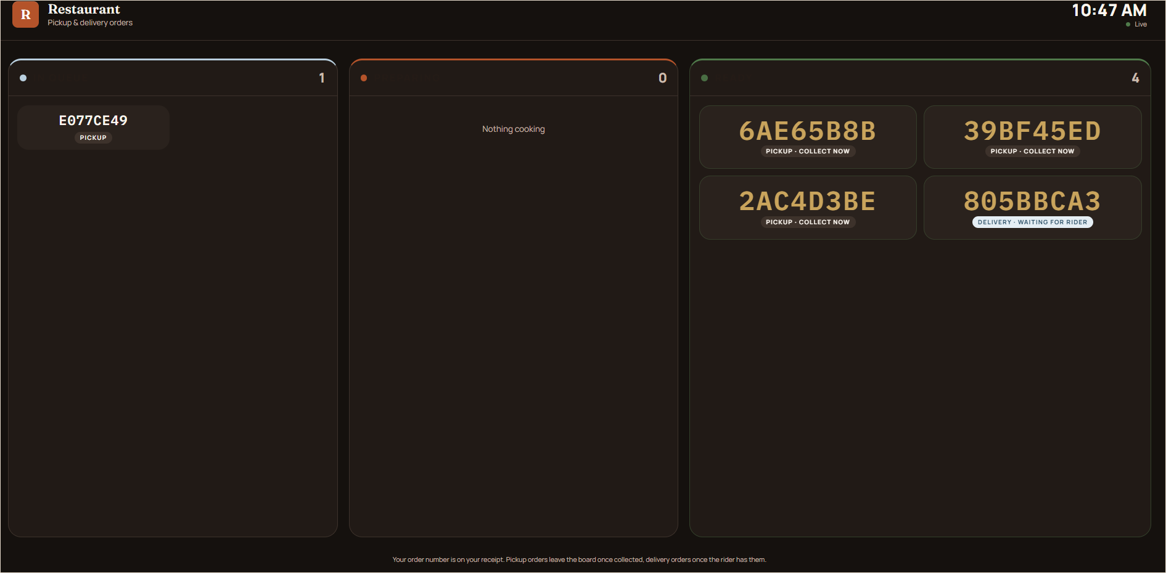  FIGURE 25 Public pickup board for a screen in the restaurant: order numbers move from queue to ready. | 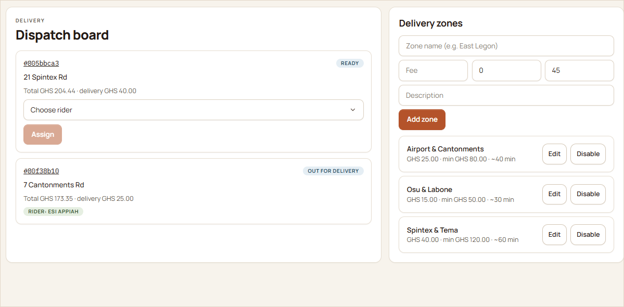  FIGURE 26 Delivery dispatch: assign riders and manage delivery zones with fees and minimums.

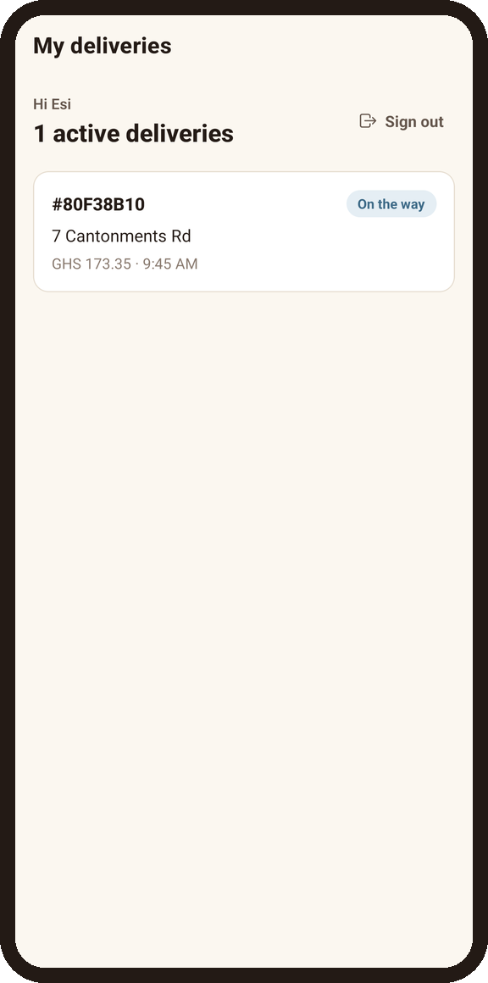  FIGURE 27 Rider view: active deliveries. | 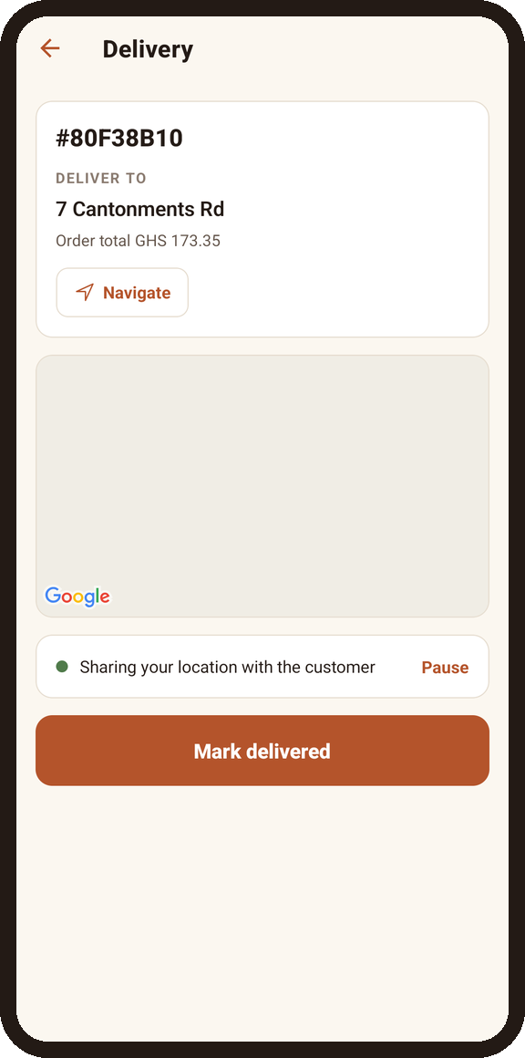  FIGURE 28 Navigate, share location and mark delivered.

08 · WORKFORCE

Attendance & Workforce Management

Know who is in, who is late and who is missing, today and every day. Clock-ins come from the POS or from biometric terminals, and every record feeds straight into timesheets and payroll.
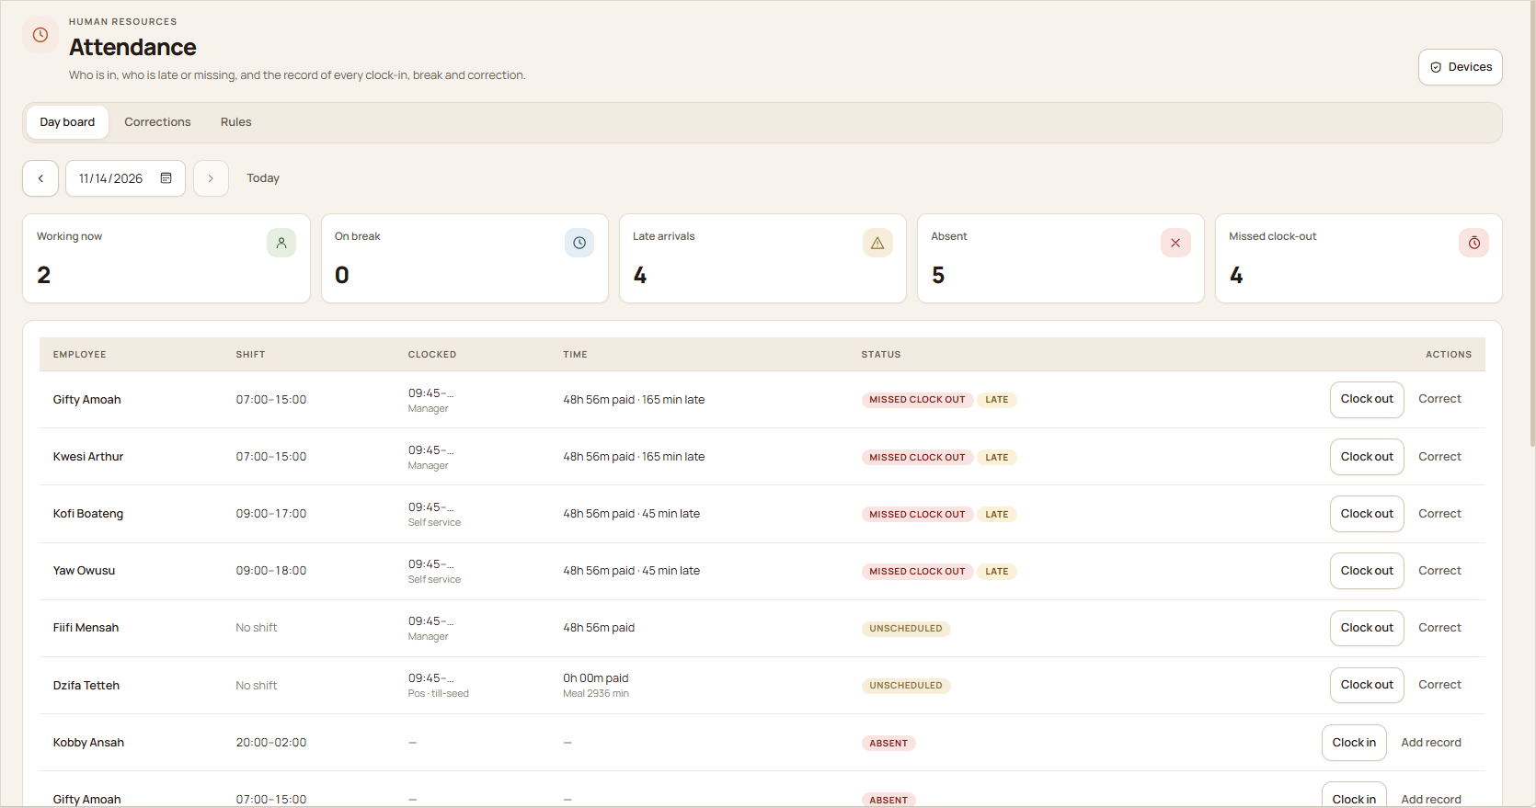
FIGURE 29 The attendance day board: working now, on break, late arrivals, absences and missed clock-outs, with clock-in, clock-out and correction actions.

Clock in, break, clock out  Staff clock in and out (with breaks) from the POS staff clock or the schedule page. Arriving more than 5 minutes after a scheduled start counts as late. |  | Corrections with a reason  Managers can correct a missed or wrong entry, always with a reason. Original records are kept, so the history stays honest.
Working rules you set  Attendance policies, break rules and overtime settings are configurable, so the system follows your restaurant's way of working. |  | Live exceptions  Late arrivals, absences and missed clock-outs are flagged on the day board as they happen, not discovered at month end.

Hikvision biometric terminals  The platform reads Hikvision face, fingerprint and card terminals through a small attendance gateway that runs on the restaurant's own network.  - Scans are queued locally, so none are lost if the internet drops.  - Device passwords never leave the restaurant.  - The terminal's own check-in, break and check-out status is used. Unclear scans wait for a person to review them instead of being guessed.  - A health overview warns when a device goes offline, the gateway goes quiet or a clock drifts. | 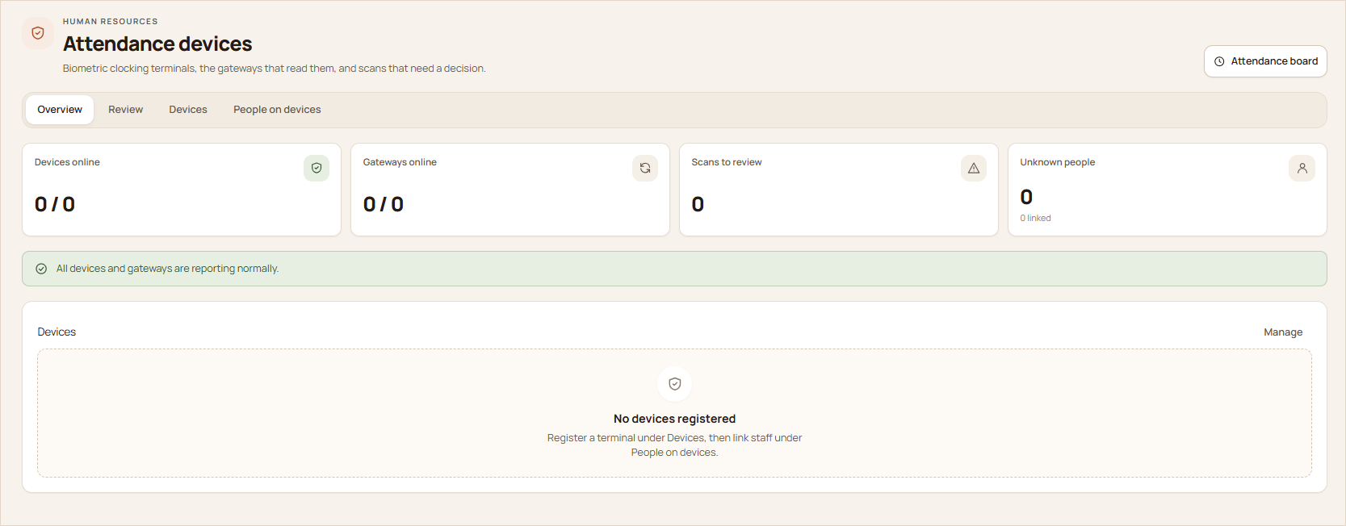  FIGURE 30 Attendance devices: devices and gateways online, scans to review and unknown people.

Schedules, rotas and timesheets
Managers plan shifts on a weekly board that checks each draft against leave, rest time, shift length, weekly hours and availability before it is published, and staff are notified. Open shifts can be picked up by eligible staff, colleagues can swap shifts with a manager's approval, and the board estimates the labour cost of the rota before it goes live.
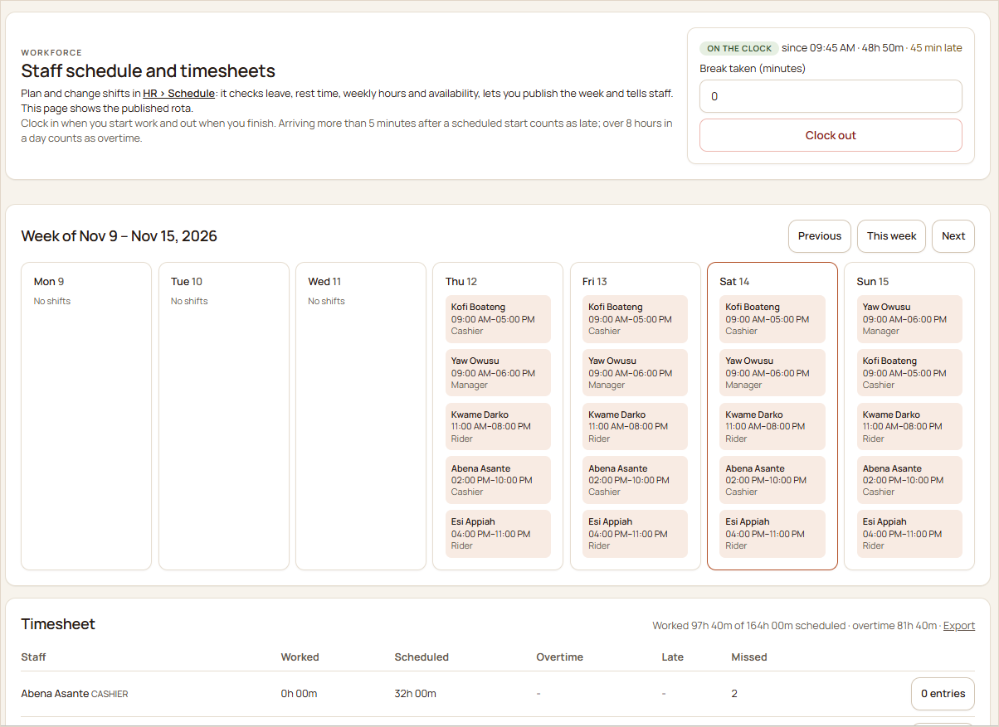
FIGURE 31 The weekly rota and timesheet: published shifts per day, with worked hours, scheduled hours, overtime, late arrivals and missed shifts per person.

09 · PAYROLL

Payroll Management

Pay is calculated from each person's contract, their approved and locked timesheets, unpaid leave and your deduction rules. Hours worked flow straight into payslips without anyone retyping them.
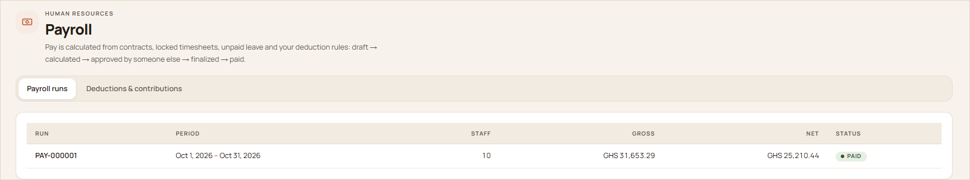
FIGURE 32 Payroll runs move from draft to calculated, approved by a second person, finalised and paid.

Every way of paying people  Contracts can be monthly, weekly, daily or hourly. Hourly staff are paid from their approved hours, and approved overtime is paid at its own rate. |  | Leave that's already accounted for  Leave types, entitlements, balances and approval chains are built in. Approved leave clears the rota and is reflected in timesheets and pay. |  | Four-eyes approval  The person who calculates a payroll run can't approve it. Finalised payslips never change afterwards.
Statutory deductions, configured  Income tax bands, social security (employee and employer) and other deductions are set as dated rules. A Ghana preset with SSNIT and PAYE is available, along with the returns. |  | Payslips and payment files  Staff see their own payslips as PDFs. Bank and Mobile Money payment files can be downloaded for the payout. |  | Loans, final pay and year-to-date  Recurring deductions such as loan instalments, final pay for leavers and year-to-date totals are handled in the run.

Why connecting attendance and payroll matters
When clock-ins, approved timesheets, leave and payroll live in the same system, hours are counted once and paid correctly. Disputes become a matter of opening the record instead of arguing over memories, and month-end payroll takes hours instead of days.

Deductions, contributions and tips
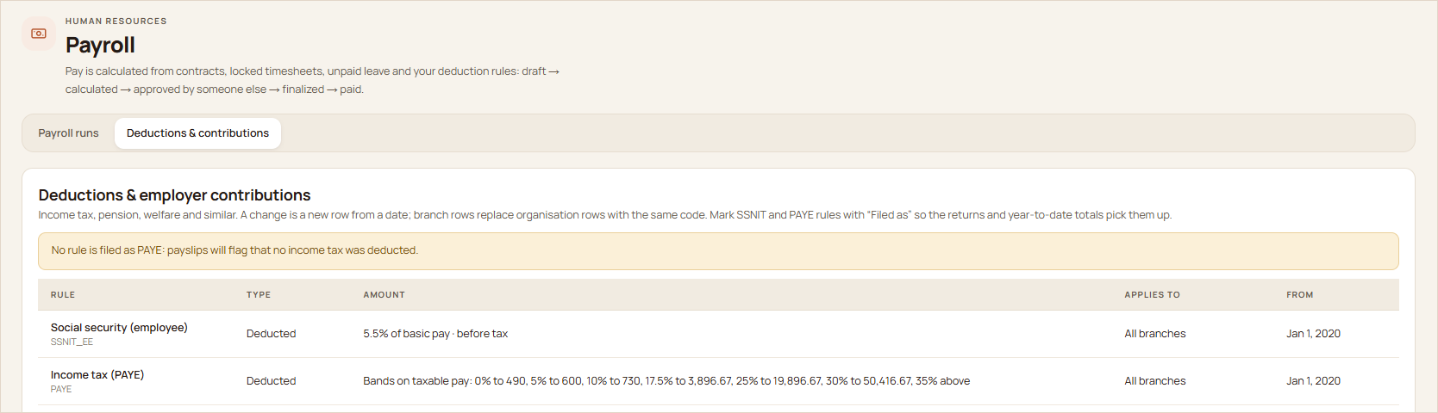
FIGURE 33 Deduction and employer contribution rules, such as SSNIT and PAYE bands, set as dated rules.

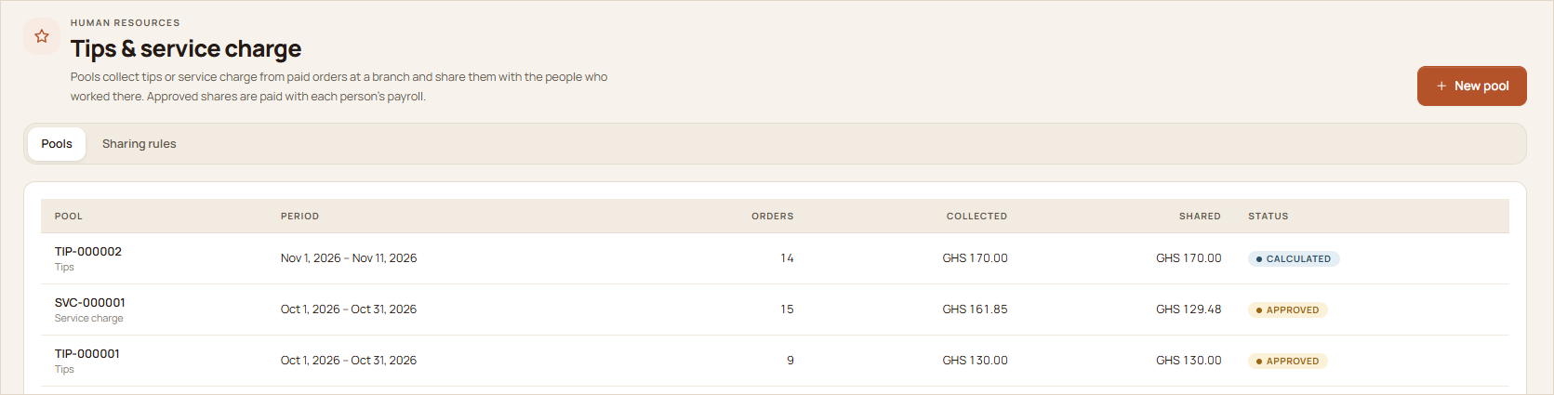
FIGURE 34 Tip and service charge pools: collected from paid orders, shared out and paid through payroll.

Tips and service charge collected at a branch are pooled for a period and shared among the people who worked there using sharing rules you define. Once approved, each person's share is paid with their payroll.
10 · GROWTH

Multi-Branch Management

Run one restaurant or a group of them from the same platform. Each branch keeps its own tables, stock, staff and cash, while owners see everything together or one branch at a time.
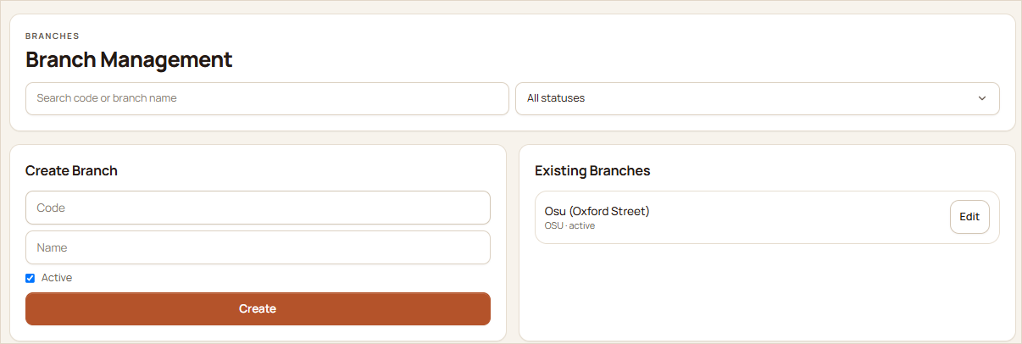  FIGURE 35 Branch management: create and edit branches. | 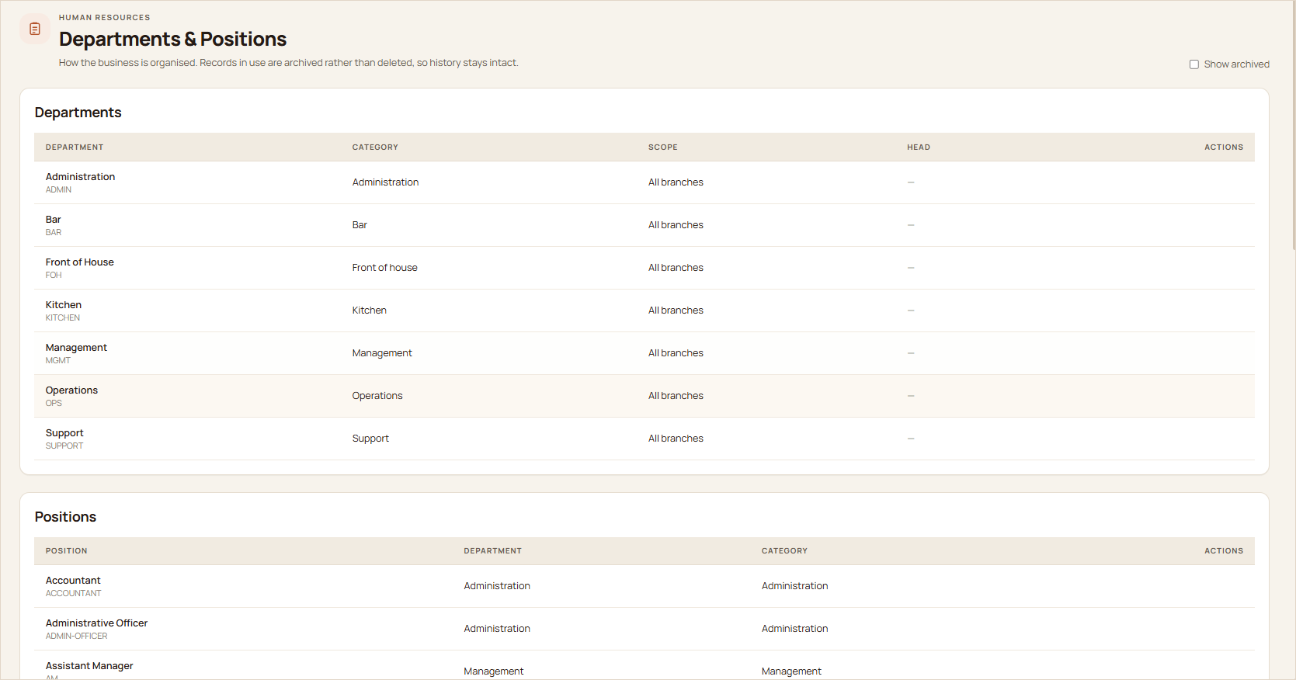  FIGURE 36 Departments and positions shared across branches.

AREA | HOW BRANCHES ARE HANDLED
Operations | Tables, orders, the kitchen display and pickups are scoped to the branch, so each team sees its own service.
Stock | Each branch receives, counts and uses its own stock. A dish sold out at one branch stays available where another branch can still make it.
Money | Financial actions, cash shifts and the daily reconciliation sign-off are kept per branch and per date.
Offers & feedback | Offers can run at every branch or one only. Ratings belong to the order's branch, and each branch's managers are alerted about their own.
People | Staff are assigned to branches. Rotas, attendance and labour cost are tracked per branch, and branch managers only see their own people.
Owner view | The dashboard adds a branch comparison table when there is more than one branch, and every report can be filtered by branch.

11 · INSIGHT

Reports, Insights & Business Control

Decisions are only as good as the information behind them. The platform turns every order, payment, shift and rating into dashboards and reports that owners and managers can act on.
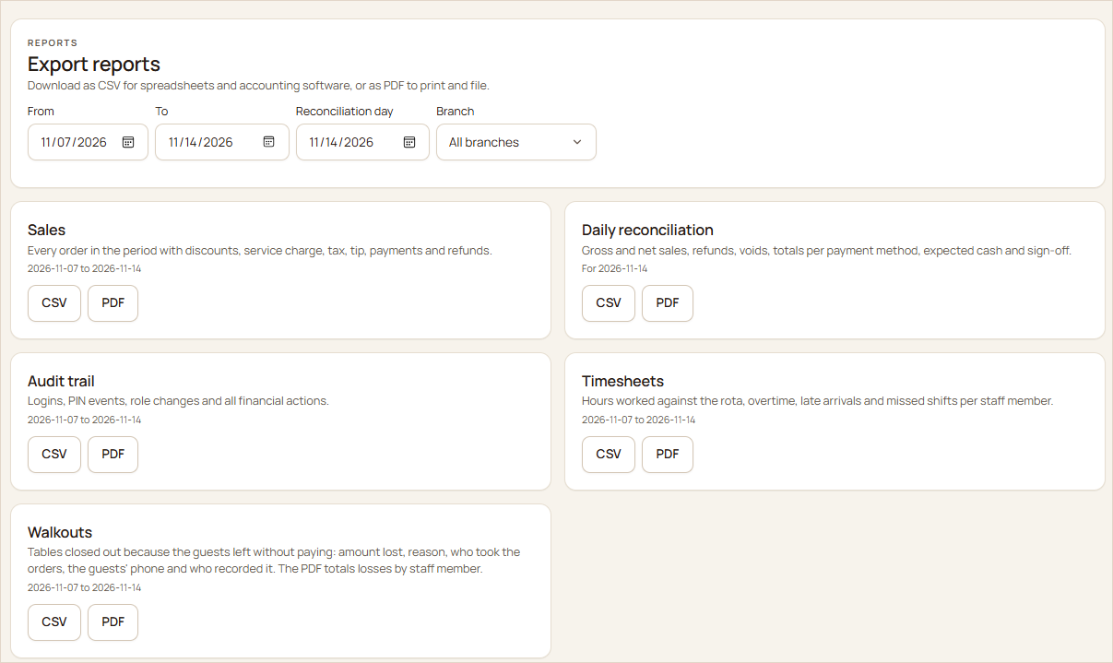  FIGURE 37 Export reports as CSV or PDF: sales, daily reconciliation, audit trail, timesheets and walkouts. | 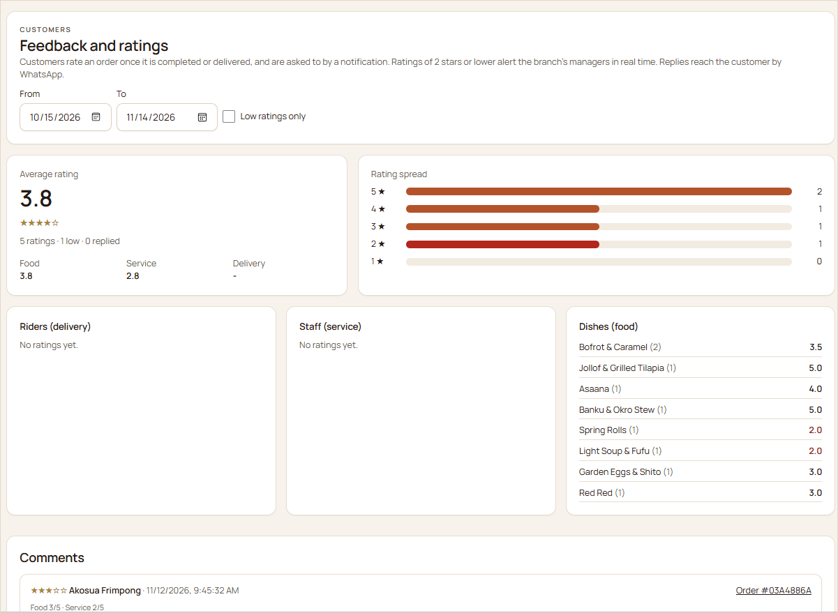  FIGURE 38 Feedback and ratings, with breakdowns by dish, staff member and rider.

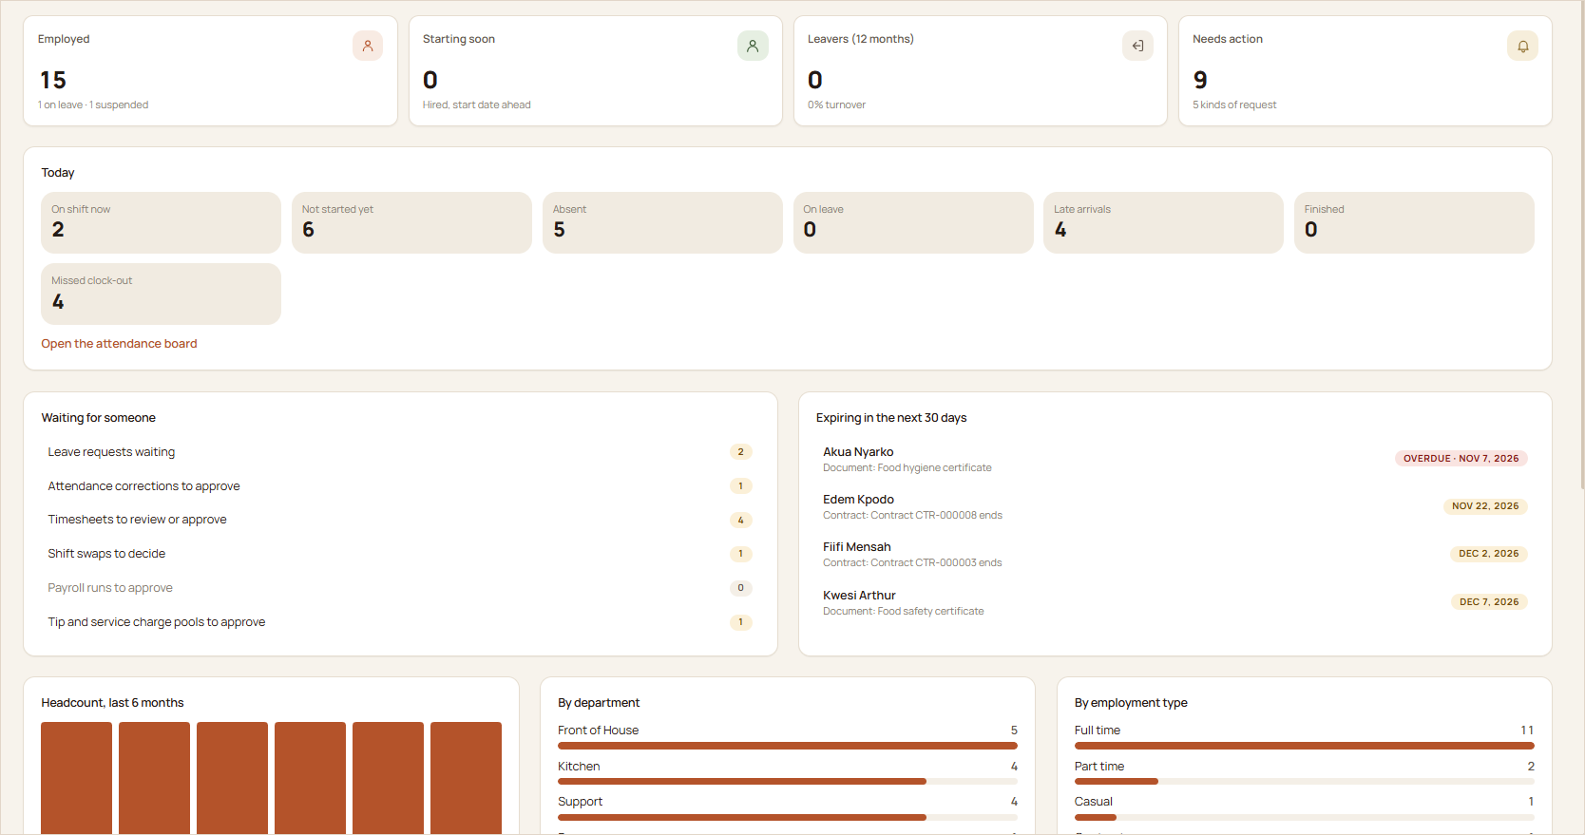
FIGURE 39 The HR dashboard: headcount, today's attendance, work waiting for approval, expiring documents and headcount trends.

QUESTION | WHERE THE ANSWER LIVES
How are sales doing today, this week, this month? | Dashboard revenue trend, paid orders, average order value and repeat customers
What sells, and when are we busiest? | Best sellers, order channels, payment methods and busiest hours
Does the cash match? | Daily reconciliation, cash shift variances and the sign-off record
Who changed what? | The audit trail of logins, PIN approvals, role changes and financial actions
Are we making money on each dish? | The food cost report with recipe cost and margin per dish
Are guests happy? | Ratings by dish, staff member and rider, with low-rating alerts
Is the team on time, and what does it cost? | Timesheets, the attendance day board, HR reports and labour cost against sales

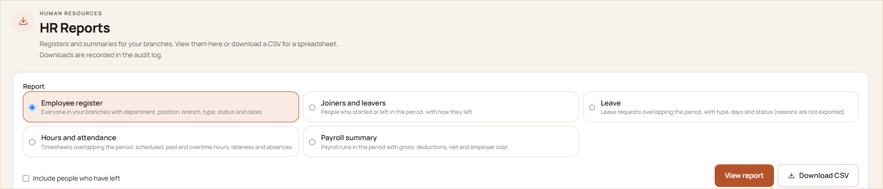
FIGURE 40 HR reports: employee register, joiners and leavers, leave, hours and attendance, and payroll summary, viewable or downloadable as CSV.

12 · THE VALUE

Business Benefits for Restaurant Owners

The value of the platform shows up in daily operations: fewer mistakes, faster service, tighter control of money and a team that's easier to manage.
Better operational control  Every order, table, payment and shift is visible in one place, live. |  | Improved customer experience  Guests order, follow their food and pay without waiting for attention.
More organised operations  The kitchen, the floor and the counter work from the same tickets and statuses. |  | Better payment accountability  Manager approvals, cash drawers, reconciliation and an audit trail close the gaps.
Improved staff coordination  Requests and orders reach the right person instantly, on the right screen. |  | More accurate attendance  Biometric and POS clock-ins replace sign-in sheets, with exceptions flagged.
Better payroll administration  Pay is built from approved hours, leave and configured rules, with a second approver. |  | Visibility into performance  Dashboards and reports show sales, best sellers, busy hours, margins and ratings.
Less manual admin  Taxes, offers, stock deductions, timesheets and payslips are calculated for you. |  | Ready for growth  Add branches, staff and channels such as pickup and delivery on the same platform.

13 · FIT

Who Can Benefit?

The platform adapts to the way different food businesses serve their guests, from a single café to a group of restaurants.
BUSINESS | WHERE THE PLATFORM HELPS MOST
Independent restaurants | One system for orders, payments, the kitchen and staff, replacing paper and separate apps.
Fine-dining restaurants | Table service with reservations, kitchen notes and allergies on every ticket, discreet bill requests and itemised bills with every tax line.
Fast-food restaurants | Fast POS ordering, paid-before-cooking pickups with codes, a public pickup board and a kitchen display that keeps tickets moving.
Cafés | Quick counter service, table QR ordering for seated guests, loyalty points and simple cash drawer control.
Hotels with restaurants | Table ordering without an app for guests, reservations, card and Mobile Money payments, and full HR and payroll for the team.
Restaurant chains | Branch-level stock, cash, staff and feedback, with group-wide dashboards and reports for the owners.
Table-service food businesses | Live floor plans, running bills, split payments and waiter requests built around the dining table.

14 · WHY US

Why Choose This Platform?

Many restaurants run a POS from one vendor, take bookings in another app, track attendance on paper and calculate payroll in a spreadsheet. This platform brings all of it together, and that's where its value comes from.
WITH SEPARATE TOOLS | WITH ONE INTEGRATED PLATFORM
The guest's QR order has to be re-entered for the kitchen | The QR order goes straight to the kitchen display and onto the table's bill
Payments are matched to orders by hand | Each payment confirms its order and frees the table automatically
Stock is counted separately from sales | Every sale deducts its recipe from that branch's stock
Attendance sheets are retyped into payroll | Approved timesheets flow straight into payroll runs
Each branch reports in its own way | Every branch reports the same way, and owners see them side by side
Accountability depends on trust | Approvals, cash drawers and an audit trail make every action traceable

01  Designed for local operations  Mobile Money first, Ghana's NHIL, GETFund and VAT built in, SSNIT and PAYE payroll presets, and phone numbers in local format. |  | 02  Real-time by default  Orders, tables, payments, waiter calls and deliveries update live on every screen that needs them.
03  Accountability built in  Manager approvals, cash drawers, reconciliation sign-off and a complete audit trail. |  | 04  A complete workforce suite  Scheduling, biometric attendance, leave, payroll, tips, recruitment and HR reporting.

15 · NEXT STEPS

Getting Started

The best way to judge the platform is to see it working on your own menu and your own floor plan. We'd welcome the chance to show you.
1  Request a product demonstration  A guided walk-through of the guest QR journey, the POS, the kitchen display, payments and the owner's dashboard. |  | 2  Explore the platform  Try the customer, staff and manager views with realistic sample data, and see how each role works.
3  Discuss your restaurant's needs  Tell us how you serve guests, take payments, schedule staff and run payroll, and we'll map it to the platform. |  | 4  Arrange an onboarding discussion  Plan the setup: your menu, tables and QR cards, branches, staff roles, billing rules and attendance devices.

Run Smarter. Serve Better. Grow Your Restaurant.
Bring your guests, your team and your numbers onto one platform, and give every service the control and clarity it deserves.
Contact us today to arrange your demonstration.

