PES UNIVERSITY, BANGALORE
Department of Computer Science and Engineering
UE24CS341A — Software Engineering
Software Requirements Specification
for
Student Attendance Management System
Version 1.1 (Pending Approval)
Updated to reflect the work done in Sprints 1 and 2
Prepared by Team 3
Anmol Vyas (PES2UG24CS072)
Anupam Rajesh Tiwari (PES2UG24CS073)
Anupriya (PES2UG24CS074)
Anusha G (PES2UG24CS075)
PES University, Bengaluru
30-10-2026

Revision History
Version | Date | Author | Change Summary | Approval
1.0 | 03-09-2026 | Team 3 | Initial SRS document  with system  requirements, use-case diagrams, and RTM | Pending
1.1 | 30-10-2026 | Team 3 | Updated to reflect the work done in Sprints 1 and 2: time-slot wording (SAM-F-012, SAM-F-013, UC-01), RTM status, Section 10 | Pending
Approvals
Role | Name | Signature / Email | Date
Course Coordinator

Table of Contents
1. Introduction 4
1.1 Purpose 4
1.2 Scope 4
1.3 Intended Audience 4
1.4 Definitions and Acronyms 4
1.5 References 5
2. Overall Description 6
2.1 Product Perspective 6
2.2 Product Functions 6
2.3 User Classes and Characteristics 6
2.4 Operating Environment 7
2.5 Design and Implementation Constraints 7
2.6 Assumptions and Dependencies 7
3. External Interface Requirements 8
3.1 User Interfaces 8
3.2 Hardware Interfaces 8
3.3 Software Interfaces 8
3.4 Communications Interfaces 8
4. System Features (Detailed) 9
4.1 User Authentication 9
4.2 Student Management 9
4.3 Faculty and Subject Management 10
4.4 Attendance Recording 10
4.5 Attendance Monitoring and Modification 11
4.6 Attendance Reports 13
5. Non-Functional Requirements (Detailed) 14
5.1 Security 14
5.1.1 Security Objectives 14
5.1.2 Security Requirements 15
6. Quality Attributes & Acceptance Tests 16
6.1 Quality Attributes 16
6.2 Acceptance Criteria 16
6.3 Acceptance Test Cases 16
7. System Models and Diagrams 17
7.1 Actors 17
7.2 Use Cases 17
7.3 Use-Case Diagram 18
7.4 Use-Case Descriptions 19
8. Requirements Traceability Matrix (RTM) 21
9. Conclusion 22
10. Changes in Version 1.1 23
1. Introduction
1.1 Purpose
This document is the Software Requirements Specification (SRS) for the Student Attendance Management System (SAMS), developed by Team 3 as part of the UE24CS341A Software Engineering mini-project. It defines the functional and non-functional requirements, system interfaces, features, quality attributes, and verification criteria of the system. The document serves as the reference baseline for developers, faculty members, administrators, students, and project evaluators through the requirements, design, implementation, and testing phases of the project.
1.2 Scope
The Student Attendance Management System automates the recording, management, monitoring, and reporting of student attendance, replacing manual attendance registers with a centralized digital platform. Faculty members mark attendance for their assigned classes, students view their own attendance records, and administrators manage students, faculty, subjects, and system-wide attendance data.
Core capabilities include user authentication with role-based access, attendance recording and correction, automatic attendance-percentage calculation, attendance history and reporting, and low-attendance alerts.
Out of scope: payroll management, examination evaluation, fee management, and any other non-academic administrative activity not directly related to attendance tracking.
1.3 Intended Audience
• Developers, who need to understand and implement the system requirements.
• Faculty members, who will record and monitor student attendance.
• Students, who will view their attendance status and history.
• Administrators, who manage users, subjects, classes, and system data.
• QA/test engineers, who verify and validate system functionality against this SRS.
• Project guides and evaluators, who assess requirement coverage and implementation quality.
The remainder of this document is organized following the standard SRS structure: overall system description, external interfaces, detailed functional and non-functional requirements, quality attributes, use-case diagrams, and the requirements traceability matrix.
1.4 Definitions and Acronyms
Term / Acronym | Definition
SRS | Software Requirements Specification
SAM | Student Attendance Management
UI | User Interface
API | Application Programming Interface
DB | Database
Admin | System Administrator
Faculty | Teacher responsible for marking attendance
Student | User whose attendance is recorded

Term / Acronym | Definition
Attendance | Record indicating whether a student was present or absent
CRUD | Create, Read, Update, Delete
ID | Identification Number
Authentication | Process of verifying the identity of a user
Authorization | Process of determining what a user is permitted to access
1.5 References
• IEEE/software engineering SRS guidelines, as adapted in the Mini-Project SRS template (PES University, Dept. of
CSE).
• UML modelling standards for use-case diagrams.
• Django Software Foundation, "Django Documentation", https://docs.djangoproject.com/
• Oracle Corporation, "MySQL 8.0 Reference Manual", https://dev.mysql.com/doc/
• Institutional attendance rules and academic requirements (as communicated by the course coordinator).

2. Overall Description
2.1 Product Perspective
The Student Attendance Management System (SAMS) is a new, self-contained web-based application; it is not a follow-on to an existing institutional system. It replaces manual, register-based attendance tracking with a centralized system comprising a browser-based user interface, an application server, and a relational database.
The system uses Python with the Django web framework for the application layer and MySQL for relational persistence. Django was selected for its built-in authentication module, role-based authorization support, and ORM capabilities, which streamline entity mapping for students, faculty, courses, and attendance records. MySQL provides standard relational integrity, acid-compliant transactions, and native foreign-key constraints to prevent data duplication.
Faculty members record attendance for their assigned subjects, students view their own attendance status, and administrators manage students, faculty, subjects, classes, and attendance records. A high-level view of the major components and their interconnections is provided as a structural note: the browser-based client communicates over HTTPS with the Django application server, which in turn performs all reads and writes against the MySQL database; no other external system integration is required for the current scope.
2.2 Product Functions
The major functions of the system, summarized at a high level (details are in Section 4), are:
• User Authentication: secure login with role-based access for Admin, Faculty, and Student.
• Student Management: add, update, search, and view student records.
• Faculty and Subject Management: maintain faculty profiles, create subjects, and assign subjects to faculty.
• Attendance Recording: mark students Present/Absent per class and subject, with duplicate-entry prevention.
• Attendance Modification: authorized correction of previously recorded attendance.
• Attendance Monitoring: automatic percentage calculation and history viewing.
• Attendance Reports: student-wise, subject-wise, and class-wise reports, downloadable/printable.
• Low-Attendance Alerts: automatic warnings when a student's attendance falls below the configured threshold.
• Dashboards: role-specific dashboards for Admin, Faculty, and Student.
2.3 User Classes and Characteristics
Student
• Logs in using valid credentials issued by the institution.
• Views personal attendance records, subject-wise percentage, and history.
• Receives low-attendance warnings.
• Requires only basic computer or smartphone familiarity; this is the most frequent but least privileged user class.
Faculty
• Logs in securely and views assigned classes and subjects.
• Marks and corrects attendance, and generates attendance reports for their subjects.
• Requires basic familiarity with the institution's attendance process; moderate frequency of use, moderate privilege.

Administrator
• Has full administrative access: manages student and faculty accounts, departments, classes, and subjects.
• Assigns subjects to faculty and views consolidated, institution-wide attendance reports.
• Least frequent user class but highest privilege level; most important for data integrity and system configuration.
2.4 Operating Environment
• Client: desktop, laptop, tablet, or smartphone with a modern web browser (Chrome, Edge, Firefox).
• Frontend: HTML, CSS, JavaScript, with Bootstrap for responsive layout.
• Backend: Python 3 with the Django web framework.
• Database: MySQL (relational).
• Server operating system: Linux (Ubuntu), compatible with Windows/macOS for local development.
• Network: institutional LAN or the internet, secured with HTTPS.
2.5 Design and Implementation Constraints
• The backend framework and database are fixed as Django and MySQL for this project (Section 2.1); no alternate
stack will be introduced mid-project.
• Only authenticated users may access protected system functions, and access must match the user's assigned
role.
• Only authorized faculty or administrators may modify attendance records once submitted.
• Passwords must be stored using a one-way hashing algorithm (Django's default PBKDF2/Argon2 password
hasher); plaintext storage is prohibited.
• Regular database backups must be scheduled to prevent loss of attendance records.
• The system must follow the attendance rules and policies defined by the institution (e.g., minimum attendance
percentage thresholds).
2.6 Assumptions and Dependencies
• It is assumed that all students and faculty are issued institutional credentials prior to system rollout; the system
does not perform its own identity verification against external ID documents.
• The system depends on continuous availability of the MySQL database and the underlying network for normal
operation; extended outages will degrade functionality.
• It is assumed that class timetables and subject-to-semester mappings are supplied by the administrator and are
accurate at the time attendance is recorded.
• The project depends on Django's built-in authentication and ORM libraries, which are assumed to remain stable
for the duration of development.

3. External Interface Requirements
3.1 User Interfaces
The system provides a simple, role-aware web interface:
• A single login page shared by students, faculty, and administrators, differentiated by role after authentication.
• A role-specific dashboard shown immediately after login (Section 2.2).
• Forms for entering and updating student, faculty, subject, and attendance details, with inline validation.
• An attendance-marking interface presenting each enrolled student with a Present/Absent toggle.
• Attendance-percentage and report views with clear tabular layouts.
• Consistent navigation menus, clear primary-action buttons, and legible error messages.
• A responsive layout usable on desktop, tablet, and smartphone screens.
3.2 Hardware Interfaces
The system requires no specialized hardware and runs on standard computing devices.
• Keyboard and mouse, or touchscreen, for data entry and navigation.
• A standard display for viewing the application.
• A printer, optionally, for physical copies of attendance reports.
• Standard server hardware (or a cloud virtual machine) to host the Django application and MySQL database.
3.3 Software Interfaces
• Database: MySQL, accessed through the Django ORM, for storing student, faculty, subject, and attendance data.
• Backend framework: Django (Python 3), handling request routing, business logic, and template rendering.
• Web browser: Google Chrome, Microsoft Edge, or Mozilla Firefox (current stable releases).
• Authentication module: Django's built-in authentication system, extended with role-based permission checks for
Admin, Faculty, and Student.
• Reporting module: a Django-based reporting component that queries attendance data and renders it as on-
screen tables and downloadable/printable documents.
3.4 Communications Interfaces
• All communication between the browser, application server, and database occurs over the institutional network
or the internet.
• HTTPS (TLS) is used to protect all data transmitted between the client and the server.
• The system displays clear, user-facing error messages when the network or server is unavailable, rather than
failing silently.
• Database connections are restricted to the application server and secured to prevent unauthorized direct
access.

4. System Features (Detailed)
Each functional requirement below includes an acceptance criterion and a reference test case. Requirement IDs follow the pattern SAM-F-###. A total of 20 functional requirements are specified across six functional domains.
4.1 User Authentication
Description: The system shall authenticate students, faculty members, and administrators before granting access, and shall enforce role-based access thereafter.
Req ID | Requirement | Type | Priority | Source /  Stakeholder | Acceptance  Criteria / Test Case Ref | Comments / Dependencies
SAM-F-001 | The system shall allow users to  log in using a  valid username and password. | Functional | High | All Users | Valid credentials shall provide  access. Test: TC-Auth-01 | Requires user database
SAM-F-002 | The system shall display an  appropriate  error message  when invalid  login credentials are entered. | Functional | High | Security | Invalid  credentials shall be rejected.  Test: TC-  Auth-02 | Depends on  authentication module
SAM-F-003 | The system shall provide role-  based access for Admin, Faculty, and Student  users. | Functional | High | Administrator | Users shall  access only  features  permitted for  their role. Test: TC-Auth-03 | Requires role management
4.2 Student Management
Description: The system shall allow administrators to maintain student information.
Req ID | Requirement | Type | Priority | Source /  Stakeholder | Acceptance  Criteria / Test Case Ref | Comments / Dependencies
SAM-F-004 | The system shall allow the  administrator to add new  student details. | Functional | High | Administrator | New student  shall be  successfully  stored. Test: TC-Student-01 | Requires database
SAM-F-005 | The system shall allow the  administrator to update student information. | Functional | High | Administrator | Modified details shall be saved  correctly. Test: TC-Student-02 | Admin  authorization required
SAM-F-006 | The system shall allow the  administrator to search and view | Functional | Medium | Administrator/ Faculty | Correct student information  shall be  displayed. Test: | Search by student  ID/name

Req ID | Requirement | Type | Priority | Source /  Stakeholder | Acceptance  Criteria / Test Case Ref | Comments / Dependencies
 | student details. |  |  |  | TC-Student-03
4.3 Faculty and Subject Management
Description: The system shall allow the administrator to manage faculty members, subjects, and class assignments.
Req ID | Requirement | Type | Priority | Source /  Stakeholder | Acceptance  Criteria / Test Case Ref | Comments / Dependencies
SAM-F-007 | The system shall allow the  administrator to add and  manage faculty details. | Functional | High | Administrator | Faculty  information  shall be stored and displayed correctly. Test: TC-Faculty-01 | Requires database
SAM-F-008 | The system shall allow the  administrator to create and  manage  subjects. | Functional | High | Administrator | Subject details shall be  successfully  added or  updated. Test: TC-Subject-01 | Requires subject database
SAM-F-009 | The system shall allow the  administrator to assign subjects to faculty  members. | Functional | High | Administrator | Assigned  subject shall  appear on the faculty  dashboard.  Test: TC-  Subject-02 | Faculty account required
4.4 Attendance Recording
Description: Faculty members shall be able to record attendance for students belonging to their assigned classes.
Req ID | Requirement | Type | Priority | Source /  Stakeholder | Acceptance  Criteria / Test Case Ref | Comments / Dependencies
SAM-F-010 | The system shall allow faculty  members to  select a class  and subject  before marking attendance. | Functional | High | Faculty | Correct class  and subject  shall be  displayed. Test: TC-Att-01 | Requires  class/subject data
SAM-F-011 | The system shall allow faculty  members to  mark each  student as  Present or  Absent. | Functional | High | Faculty | Attendance  status shall be  stored correctly.  Test: TC-Att-02 | Requires  student list

Req ID | Requirement | Type | Priority | Source /  Stakeholder | Acceptance  Criteria / Test Case Ref | Comments / Dependencies
SAM-F-012 | The system shall store attendance with student ID, subject, date, time slot, and attendance status. | Functional | High | Faculty/  Administrator | Database record shall contain all required fields. Test: TC-Att-03 | Requires database
SAM-F-013 | The system shall prevent duplicate attendance records for the same student, subject, date, and time slot. | Functional | Medium | System | Duplicate  record shall be rejected. Test: TC-Att-04 | Requires  database constraint
4.5 Attendance Monitoring and Modification
Req ID | Requirement | Type | Priority | Source /  Stakeholder | Acceptance  Criteria / Test Case Ref | Comments / Dependencies
SAM-F-014 | The system shall allow  authorized  faculty  members to  modify an  attendance  record. | Functional | High | Faculty | Authorized  changes shall be saved  successfully.  Test: TC-Att-05 | Authorization required
SAM-F-015 | The system shall calculate the  attendance  percentage for each student  and subject. | Functional | Medium | Student/Faculty | Percentage shall be calculated  correctly. Test: TC-Calc-01 | Based on  attendance records
SAM-F-016 | The system shall allow students  to view their  attendance  history. | Functional | High | Student | Student shall see only their own  attendance.  Test: TC-  View-01 | Authentication required
SAM-F-017 | The system shall display a  warning when a student's  attendance falls below the  required  percentage. | Functional | Medium | Student/Faculty | Low-attendance student shall  receive a  warning. Test:  TC-Alert-01 | Attendance threshold  configurable

4.6 Attendance Reports
Req ID | Requirement | Type | Priority | Source /  Stakeholder | Acceptance  Criteria / Test Case Ref | Comments / Dependencies
SAM-F-018 | The system shall generate  student-wise  attendance  reports. | Functional | High | Faculty/Admin | Report shall  display correct attendance  details. Test: TC-Report-01 | Requires  attendance data
SAM-F-019 | The system shall generate  subject-wise  and class-wise  attendance  reports. | Functional | High | Faculty/Admin | Selected  subject/class  report shall be  generated. Test: TC-Report-02 | Requires reporting module
SAM-F-020 | The system shall allow  authorized  users to  download or  print  attendance  reports. | Functional | Medium | Faculty/Admin | Report shall be available in  printable/downl oadable format.  Test: TC-  Report-03 | Requires report generation
Total Functional Requirements: 20

5. Non-Functional Requirements (Detailed)
IDs follow the pattern SAM-NF-###. The following non-functional requirements define the performance, reliability, usability, and maintainability criteria for the system.
Req ID | Requirement | Category | Priority | Acceptance Criteria / Measurement
SAM-NF-001 | The system shall display normal user requests  within 3 seconds under normal load. | Performance | High | 90% of requests  complete within 3 seconds. Test: TC-Perf-01
SAM-NF-002 | The system shall  provide at least 99% availability during  academic working  hours. | Reliability | High | Monthly availability report shall meet the target. Test: TC-  Reliability-01
SAM-NF-003 | The system shall  provide a simple and user-friendly interface for students, faculty, and administrators. | Usability | High | Representative users  shall complete common tasks without  assistance. Test: TC-  UX-01
SAM-NF-004 | The system shall  protect stored  attendance and user information from  unauthorized access. | Security | High | Unauthorized access attempts shall be  denied. Test: TC-Sec-01
SAM-NF-005 | The system shall  support regular  database backup and recovery of attendance records. | Reliability | High | Backup and restoration shall successfully  recover test data. Test: TC-Recovery-01
SAM-NF-006 | The system shall be maintainable so that new features can be added without major changes to existing modules. | Maintainability | Medium | New module  integration shall not break existing  functions. Test: TC-Maint-01
SAM-NF-007 | The system shall  support multiple users accessing the system  simultaneously without significant performance degradation. | Scalability | Medium | Load testing shall meet defined response-time limits. Test: TC-Load-01
Total Non-Functional Requirements: 7
5.1 Security
5.1.1 Security Objectives
The Student Attendance Management System shall satisfy the following security objectives:
SO-01: Confidentiality. The system shall ensure that student personal information, login credentials, and attendance records are accessible only to authorized users.

SO-02: Integrity. The system shall ensure that attendance records cannot be modified, deleted, or manipulated by unauthorized users, and that stored attendance information remains accurate.
5.1.2 Security Requirements
Req ID | Security Requirement | Priority | Acceptance Criteria / Test
SAM-SEC-001 | The system shall require  authentication before  allowing access to protected features. | High | Unauthenticated users shall be redirected to the login page. Test: TC-SEC-01
SAM-SEC-002 | The system shall implement role-based access control for Admin, Faculty, and Student users. | High | Users cannot access functions outside their assigned role.  Test: TC-SEC-02
SAM-SEC-003 | Passwords shall be stored  securely using a one-way  password hashing mechanism and shall never be stored as plain text. | High | Database inspection shall confirm passwords are  hashed. Test: TC-SEC-03
SAM-SEC-004 | The system shall prevent  students from viewing or  modifying another student's attendance records. | High | Attempted unauthorized  access shall be rejected. Test: TC-SEC-04
SAM-SEC-005 | The system shall record  important attendance  modifications and  administrative actions in an audit log. | Medium | Changes shall include user, action, and timestamp. Test: TC-SEC-05
Total Security Requirements: 5

6. Quality Attributes & Acceptance Tests
6.1 Quality Attributes
The Student Attendance Management System shall exhibit the following quality attributes:
• Usability: the system shall be simple and easy to use for students, faculty, and administrators.
• Performance: the system shall respond quickly to user requests (Section 5, SAM-NF-001).
• Reliability: attendance records shall be stored accurately without data loss.
• Security: only authorized users shall be able to access or modify attendance information.
• Maintainability: the system shall be easy to update and extend as new features are required.
• Scalability: the system shall support an increasing number of students and attendance records without
significant degradation.
6.2 Acceptance Criteria
A build is considered acceptance-ready when: all High-priority functional requirements (Section 4) are implemented
and pass their reference test cases; no critical non-functional requirement (Section 5) fails; all five security
requirements (Section 5.1.2) pass; and the Requirements Traceability Matrix (Section 8) shows every requirement
mapped to a design module and test case with no unresolved gaps.
6.3 Acceptance Test Cases
The following test suites shall be used to verify the system prior to final submission:
Test Suite | Purpose
Authentication Test | Verify login, logout, and role-based access.
Student Management Test | Verify adding, updating, searching, and viewing students.
Attendance Test | Verify marking, updating, and storing attendance.
Attendance Calculation Test | Verify correct attendance percentage calculation.
Report Test | Verify generation and downloading of attendance reports.
Performance Test | Verify that the system responds within the specified time.
Security Test | Verify authentication, authorization, password protection, and data access controls.

7. System Models and Diagrams
7.1 Actors
The Student Attendance Management System defines the following actors:
• Student: a user who views their own attendance records, percentage, and history.
• Faculty: a user who records and modifies attendance for their assigned classes and subjects, and generates reports.
• Administrator: a user who manages student, faculty, and subject data, assigns subjects to faculty, configures the attendance threshold, and views consolidated reports.
• Audit Module: a system-internal actor that receives and stores the log of sensitive administrative actions (Section 5.1.2, SAM-SEC-005).
7.2 Use Cases
The primary use cases, grouped by actor, are summarized below and shown in the two use-case diagrams that follow
(Section 7.3). Several use cases include a shared sub-use-case, shown as a separate oval connected by an «include»
relationship: for example, Log In / Authenticate includes both Authenticate Credentials and Validate User Role, and
Mark Attendance includes Select Class and Subject and Save Attendance Record.
• Student: Log In / Authenticate, View Attendance History, View Attendance Percentage, Receive Low-Attendance Alert.
• Faculty: Log In / Authenticate, View Assigned Subjects, Select Class and Subject, Mark Attendance, Modify Attendance Record, Generate Reports.
• Administrator: Manage Student Records, Manage Faculty Records, Manage Subjects and Classes, Assign Subjects to Faculty, Manage User Access, View Consolidated Attendance Reports, Configure Attendance Threshold, Manage Database Backup.

7.3 Use-Case Diagram
7.3.1 Student and Faculty Use Cases
The diagram below shows the Student and Faculty actors and their associated use cases. Login is shared by both actors and includes two sub-use-cases (Authenticate Credentials and Validate User Role); marking attendance includes selecting a class and subject beforehand and saving the resulting record; viewing attendance percentage includes the underlying percentage calculation; and generating reports includes selecting the report type and date range.
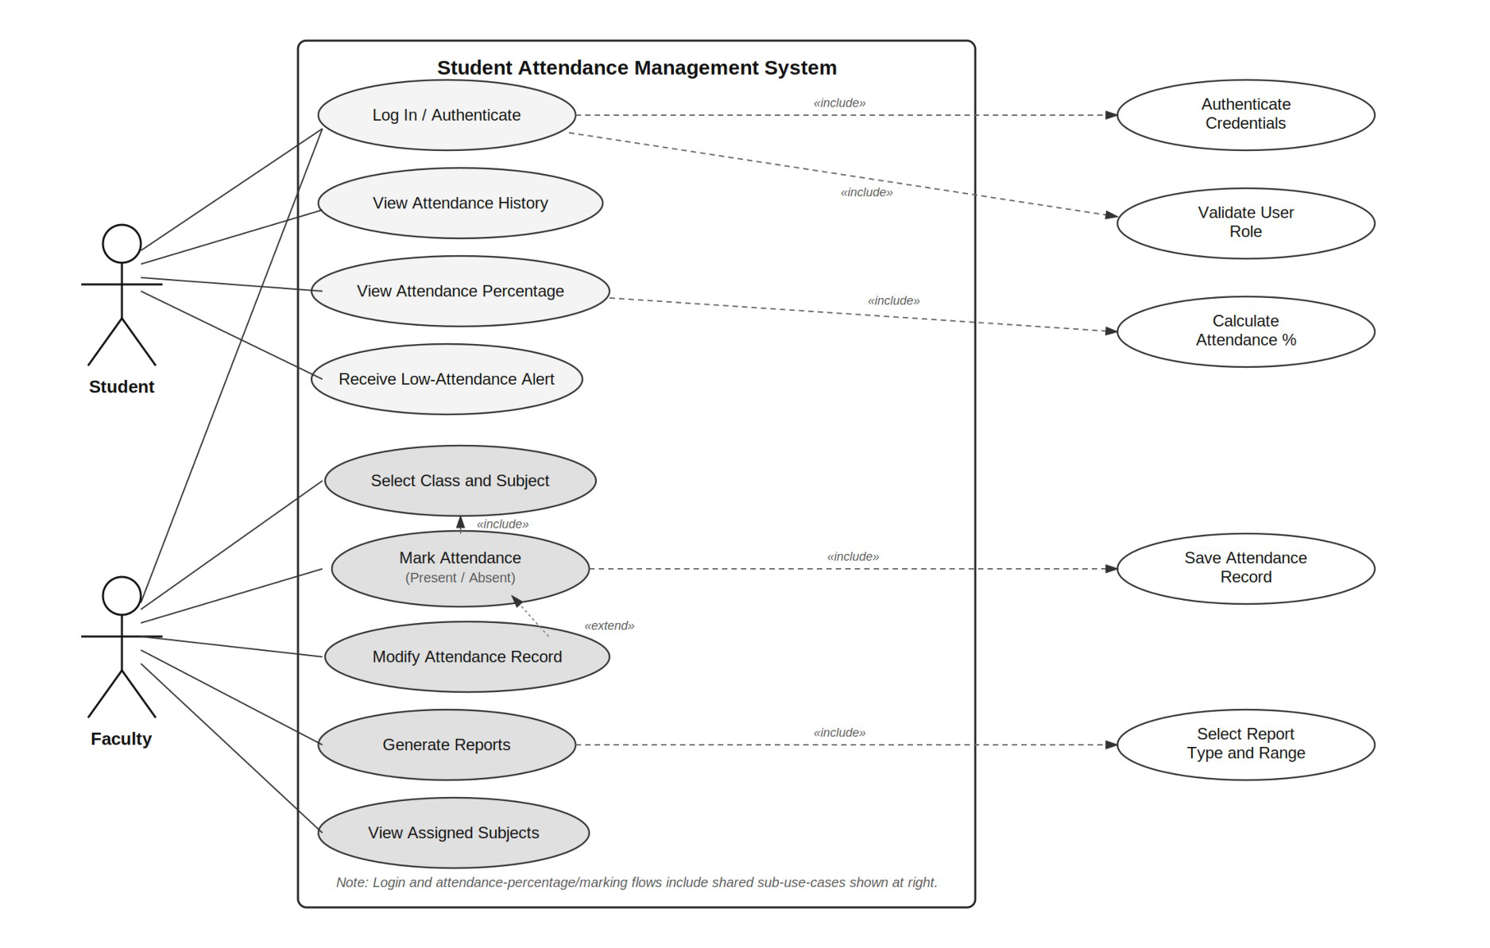

7.3.2 Administrator Use Cases
The diagram below shows the Administrator actor and the administrative use cases. Record-modifying and access-control actions (Manage Student Records, Assign Subjects to Faculty, Manage User Access, and Configure Attendance Threshold) each include Log Administrative Action, which writes to the Audit Module, in line with SAM-SEC-005; the same relationship applies to Manage Database Backup.
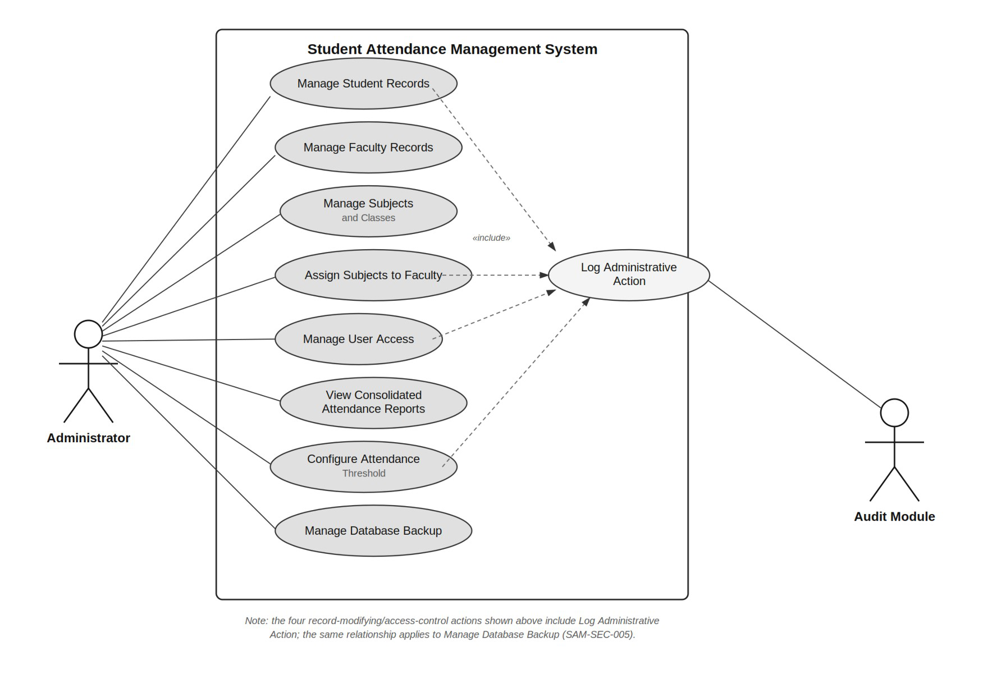
7.4 Use-Case Descriptions
UC-01: Mark Attendance
Actor: Faculty. Precondition: Faculty is authenticated and has at least one assigned class/subject. Main flow: (1) Faculty selects class and subject (includes UC-02); (2) system displays the enrolled (active) student list; (3) Faculty picks the date and one or more one-hour time slots (two for a two-hour lab) and marks each student Present or Absent; (4) system stores one record per student per time slot with student ID, subject, date, time slot, and status in a single transaction, and saves nothing if any chosen slot is already marked for that date (SAM-F-012, SAM-F-013). Alternative flow: the faculty member later corrects a saved session, giving a reason that is kept in the audit log (SAM-F-014). Postcondition: attendance for the session is recorded and available for percentage calculation.
UC-02: Select Class and Subject
Actor: Faculty. Included by UC-01. Main flow: Faculty selects one of their assigned classes and subjects from a list scoped to their account; the system validates the selection before proceeding.
UC-03: View Attendance Percentage
Actor: Student. Precondition: Student is authenticated. Main flow: Student requests their attendance summary; the system calculates the percentage per subject from stored records (SAM-F-015) and displays it, along with a low-attendance warning if the percentage is below the configured threshold (SAM-F-017).

UC-04: Manage User Access
Actor: Administrator. Main flow: Administrator creates, updates, or deactivates a student or faculty account and assigns its role. This action includes UC-05 (Log Administrative Action) so that the change is auditable.
UC-05: Log Administrative Action
Actor: Audit Module (system). Triggered by: UC-04 and other record-modifying or access-control administrator actions (Manage Student Records, Assign Subjects to Faculty, Configure Attendance Threshold, Manage Database Backup). Main flow: the system records the acting user, the action taken, and a timestamp to the audit log (SAM-SEC-005).
UC-06: Generate Reports
Actor: Faculty or Administrator. Precondition: user is authenticated and has report-viewing permission for the requested scope. Main flow: user selects the report type (student-wise, subject-wise, or class-wise) and a date range (includes Select Report Type and Range); the system compiles the report from stored attendance records (SAM-F-018 to SAM-F-020) and returns it in an on-screen, printable, or downloadable format.
UC-07: View Attendance History
Actor: Student or Faculty. Precondition: user is authenticated. Main flow: user requests attendance history for a subject or class; the system retrieves matching records and displays them chronologically. Students see only their own records (SAM-SEC-004); faculty see records for classes they are assigned to.

8. Requirements Traceability Matrix (RTM)
The following RTM maps every requirement of the Student Attendance Management System to its SRS section, design module, and corresponding test case. Status: N = Not Tested, P = Pass, A = Approved. In version 1.1 every requirement has been verified by its test cases, which run automatically on every pull request in the GitHub Actions pipeline (STP v1.1, Appendix A); all are marked P, and move to A after the final review.
Req ID | Requirement (Short) | Section Ref / Design Spec | Module | Test Case(s) | Status | Comments
SAM-F-001 | User login | 4.1 / DS-Auth-01 | Authentication Module | TC-Auth-01 | P | —
SAM-F-002 | Invalid login handling | 4.1 / DS-Auth-02 | Authentication Module | TC-Auth-02 | P | —
SAM-F-003 | Role-based access | 4.1 / DS-Auth-03 | Authentication Module | TC-Auth-03 | P | —
SAM-F-004 | Add student | 4.2 / DS-  Student-01 | Student Module | TC-Student-01 | P | —
SAM-F-005 | Update student | 4.2 / DS-  Student-02 | Student Module | TC-Student-02 | P | —
SAM-F-006 | Search student | 4.2 / DS-  Student-03 | Student Module | TC-Student-03 | P | —
SAM-F-007 | Manage faculty | 4.3 / DS-  Faculty-01 | Faculty Module | TC-Faculty-01 | P | —
SAM-F-008 | Manage subjects | 4.3 / DS-  Subject-01 | Subject Module | TC-Subject-01 | P | —
SAM-F-009 | Assign subject to faculty | 4.3 / DS-  Subject-02 | Subject Module | TC-Subject-02 | P | —
SAM-F-010 | Select class and subject | 4.4 / DS-  Attendance-01 | Attendance Module | TC-Att-01 | P | —
SAM-F-011 | Mark attendance | 4.4 / DS-  Attendance-02 | Attendance Module | TC-Att-02 | P | —
SAM-F-012 | Store attendance record | 4.4 / DS-  Attendance-03 | Attendance Module | TC-Att-03 | P | —
SAM-F-013 | Prevent duplicate attendance | 4.4 / DS-  Attendance-04 | Attendance Module | TC-Att-04 | P | Database  constraint
SAM-F-014 | Modify  attendance | 4.5 / DS-  Attendance-05 | Attendance Module | TC-Att-05 | P | Authorized users only
SAM-F-015 | Calculate  attendance percentage | 4.5 / DS-Calc-01 | Calculation Module | TC-Calc-01 | P | —
SAM-F-016 | View attendance history | 4.5 / DS-View-01 | Student Module | TC-View-01 | P | —
SAM-F-017 | Low-attendance warning | 4.5 / DS-Alert-01 | Notification Module | TC-Alert-01 | P | Threshold  configurable
SAM-F-018 | Student-wise report | 4.6 / DS-  Report-01 | Report Module | TC-Report-01 | P | —
SAM-F-019 | Subject/class report | 4.6 / DS-  Report-02 | Report Module | TC-Report-02 | P | —
SAM-F-020 | Download/print report | 4.6 / DS-  Report-03 | Report Module | TC-Report-03 | P | —

Req ID | Requirement (Short) | Section Ref / Design Spec | Module | Test Case(s) | Status | Comments
SAM-NF-001 | Response time ≤ 3 seconds | 5 / DS-Perf-01 | Web/Application Module | TC-Perf-01 | P | Performance  testing required
SAM-NF-002 | 99% availability | 5 / DS-  Reliability-01 | System Module | TC-Reliability-01 | P | —
SAM-NF-003 | User-friendly interface | 5 / DS-UI-01 | User Interface | TC-UX-01 | P | —
SAM-NF-004 | Data protection | 5 / DS-Security-01 | Security Module | TC-Sec-01 | P | —
SAM-NF-005 | Database backup and recovery | 5 / DS-  Recovery-01 | Database Module | TC-Recovery-01 | P | —
SAM-NF-006 | Maintainability | 5 / DS-Maint-01 | Application Module | TC-Maint-01 | P | —
SAM-NF-007 | Multiple-user support | 5 / DS-Scale-01 | Application Module | TC-Load-01 | P | Load testing required
SAM-SEC-001 | Authentication required | 5.1.2 / DS-  Security-01 | Security Module | TC-SEC-01 | P | —
SAM-SEC-002 | Role-based  authorization | 5.1.2 / DS-  Security-02 | Security Module | TC-SEC-02 | P | —
SAM-SEC-003 | Secure password storage | 5.1.2 / DS-  Security-03 | Authentication Module | TC-SEC-03 | P | Passwords must be hashed
SAM-SEC-004 | Protect student attendance data | 5.1.2 / DS-  Security-04 | Access Control Module | TC-SEC-04 | P | —
SAM-SEC-005 | Audit important actions | 5.1.2 / DS-  Security-05 | Audit Module | TC-SEC-05 | P | Timestamp required
9. Conclusion
This document has specified the functional requirements (20, Section 4), non-functional requirements (7, Section 5), security objectives and requirements (2 and 5 respectively, Section 5.1), quality attributes and acceptance criteria (Section 6), use-case models (Section 7), and full requirements traceability (Section 8) for the Student Attendance Management System.
The team has committed to a Python/Django backend with a MySQL database (Section 2.1). The requirement set establishes a three-role access architecture (Student, Faculty, and Administrator) with attendance recording, calculation, and reporting as core functionalities. This SRS forms the baseline against which the subsequent project plan, test plan, and implementation deliverables will be developed and verified.
Team 3: Anmol Vyas, Anupam Rajesh Tiwari, Anupriya, Anusha G.

10. Changes in Version 1.1
This version is updated to reflect the work done in Sprints 1 and 2 (19 to 30 October 2026). No requirement was added or removed. The changes refine wording that the SAD (v1.0, ADR-004) had already flagged, and record the test status.
• SAM-F-012 and SAM-F-013 (Section 4.4): attendance is stored per student, subject, date, and one-hour time slot, and duplicates are refused per time slot. A two-hour lab is two records, so it counts as two classes; lab and theory of one subject still count together in one percentage.
• UC-01 (Section 7.4): marking picks a date and one or more time slots and saves in one transaction; a saved session can be corrected with a reason (SAM-F-014).
• RTM (Section 8): all 32 requirements (20 functional, 7 non-functional, 5 security) have passing test cases; status changed from N to P.
Decisions made during implementation that fill in details the requirements left open (the requirements themselves are unchanged):
• SAM-F-014: only the faculty member assigned to the class and subject can modify its attendance, and a reason is required for every change.
• SAM-F-017: the threshold is set by the administrator and defaults to 75%; warnings appear on the student's dashboard and attendance page, and faculty see a list of their students below it.
• SAM-F-018 to SAM-F-020: reports take an optional date range; downloads are CSV and PDF, and the page prints without the menus.
• SAM-SEC-003: an account is locked for 15 minutes after 5 failed logins. SAM-NF-004: idle sessions expire after 30 minutes, and cookies are HTTPS-only in production.
• SAM-NF-005: backups are made and restored with two commands (backup_db, restore_db), each recorded in the audit log.
Where the implementation differs from the SAD or the STP, the difference and the reason are listed in docs/DEVIATIONS.md in the project repository.

