**HOW TO BUILD A WEBSITE IN 1 HOUR USING HTML , CSS AND 960 GRID SYSTEM ?**

**What is HTML?**

HTML is the standard markup language for creating Web pages.

* HTML stands for Hyper Text Markup Language.
* HTML describes the structure of Web pages using markup.
* Primarily designed for desired look and feel.
* HTML elements are the building blocks of HTML pages.
* It is the “mother tongue” of the browsers
* HTML elements are represented by tags.
* Browsers do not display the HTML tags, but use them to render the content of the page.

**BASIC TAGS**

<!DOCTYPE html> declaration defines this document to be HTML5.

 <html> element is the root element of an HTML page.

<head> element contains meta information about the document.

 <body> element contains the visible page content.

**Child tags of <head> tag**

<title>----------Specifies title for the webpage.

<meta>--------Specifies the content type.

<link>----------Used to call an external css.

<style>---------Specifies that css is written inside this tag

<script>--------Specifies that javascript is written inside this tag.

**Sample Code**

<!DOCTYPE html>

<html>

<head>

<meta charset=”UTF-8”>

<title>Home page</title>

</head>

<body>

<h1>Hello World<h1>

</body>

</html>

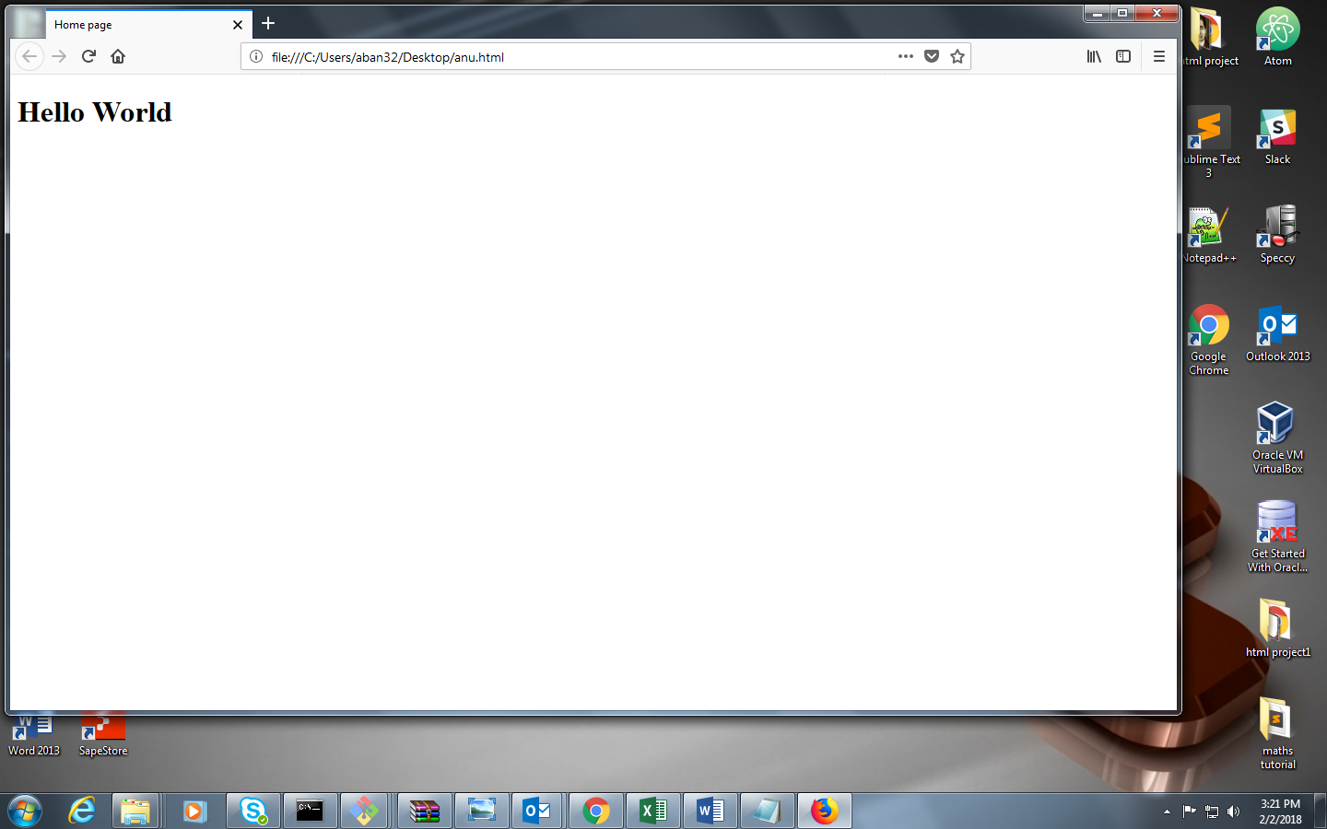

**Child tags of <body> tag**

<p>---------------------------------This is used for paragraph.

<pre>-------------------------------This is also used for paragraph and also maintains the content written as such(formatted text).

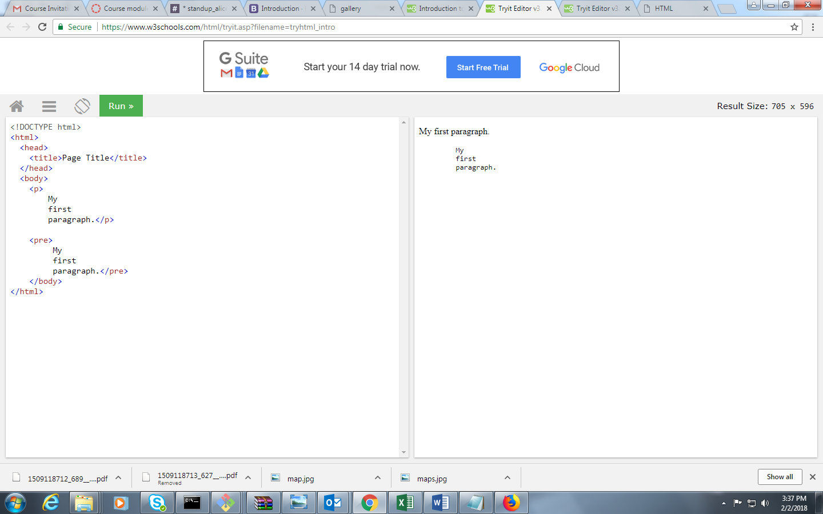

**Heading tags**

# <h1>Heading 1</h1> **Heading 1**

## <h2>Heading 2</h2> Heading2

### <h3>Heading 3</h3> **Heading 3**

#### <h4> Heading 4</h4> **Heading 4**

##### <h5> Heading 5</h5> **Heading 5**

###### <h6> Heading 6</h6> **Heading 6**

**Continue…**

* Comments-----------------<!—Write your comments here-->
  + - * Shortcut to write comments -> Shift+Ctrl+/.
* <br> tag------------------Use to give a break and move onto next line.
* <hr> tag------------------Use to draw horizontal line.
* <em> tag-----------------Emphasis on the text.
* <img src=”write relative path of image here” alt=”write alternative content here which will be shown when there is no image on defined path or path not found”/>

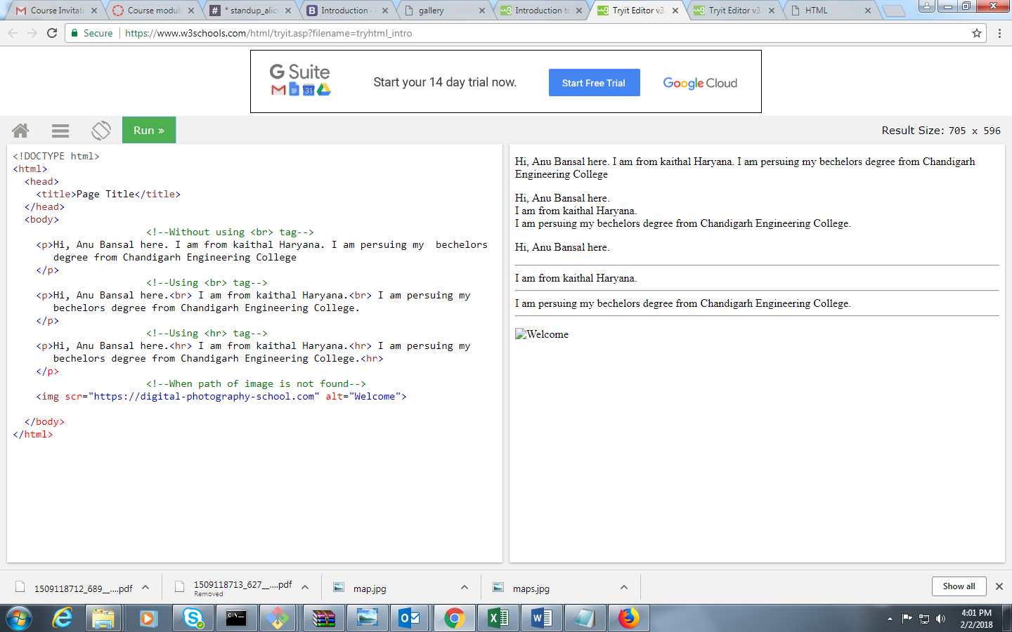

**Adding Links**

**Anchor tag----------------------------------<a>**

* <a href=”[http://www.google.co.in](http://www.google.co.in/)”>Google</a>
  + - * <!--navigation to defined link and in same tab-->
* <a href=”course.html”>Get Courses</a>
  + - * <!--navigation to page within same folder-->
* <a href=”[http://www.google.co.in](http://www.google.co.in/)” target=”_blank”>Google</a>
  + - * <!--navigation to defined link and in different tab->
* <a name=”top”> </a>

<a href=”#end” >Bottom</a>

<!—navigation on same page where ‘end’ is defined in anchor tag-->

* <a name=”end” ></a>

<a href=”#top” >Top</a>

<!—navigation on same page where ‘top’ is defined in anchor tag-->

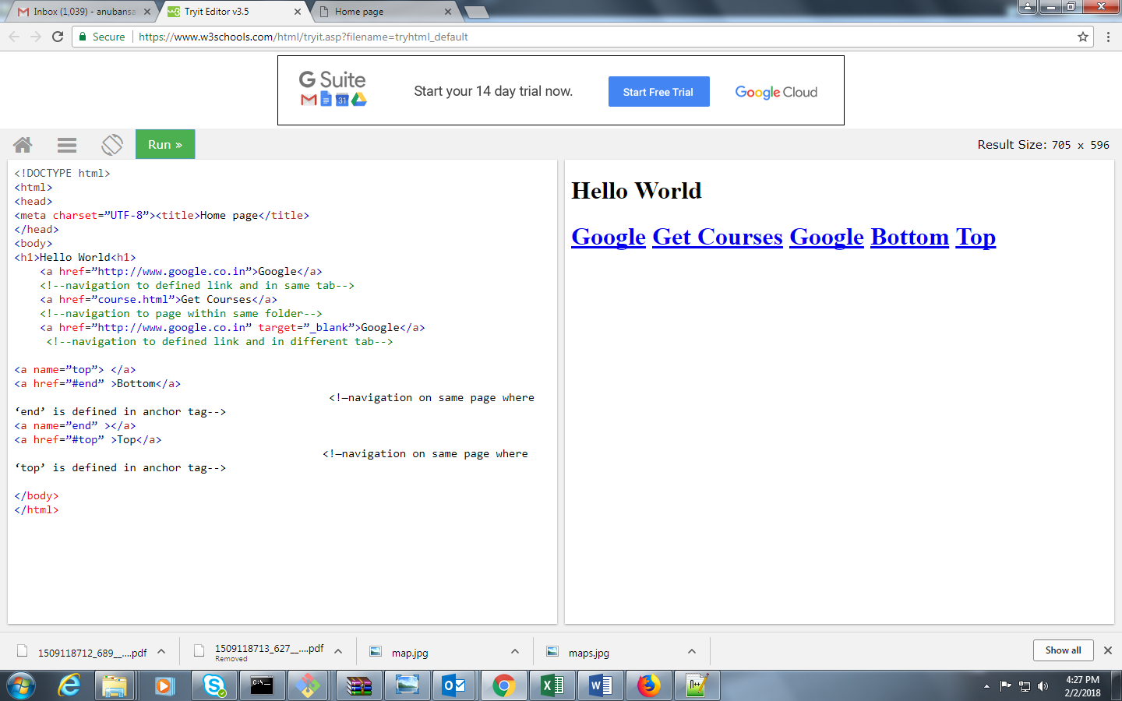

**Creating lists**

**Types of Lists:-----------**

Ordered List

Unordered List

Description List

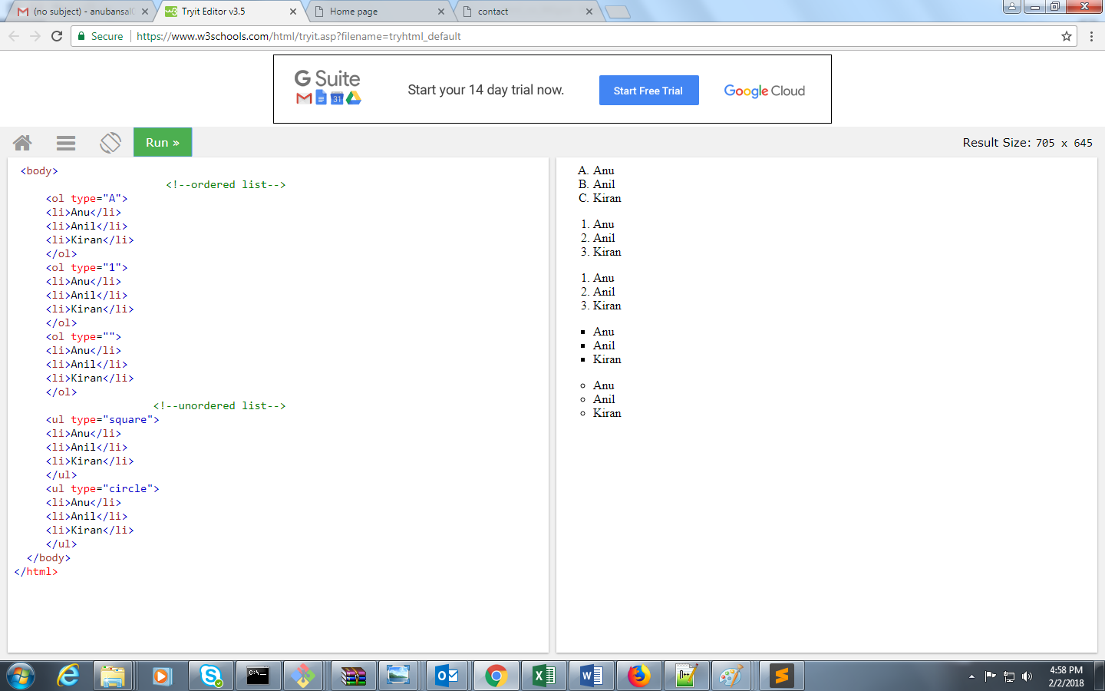

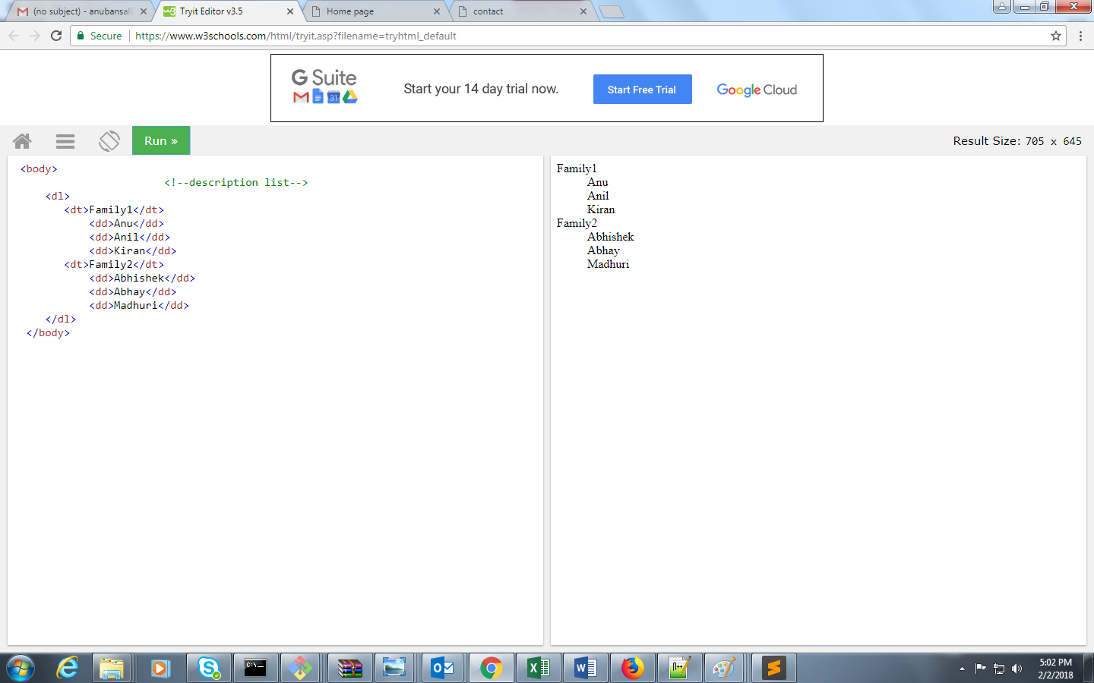

**Creating Tables**

<fieldset>------------------------------Gives boundary to the table

<legend>-------------------------------Gives heading(title) of the table

<table>---------------------------------Tag uses to create table(cells ,row and columns)

<tr>--------------------------------------Defines row of the table

<th>-------------------------------------Defines subtitles of table(like name, roll no.,etc)

<td>-------------------------------------Defines the data entered in table

Rowspan-------------------------------Combines cells of a column (no. of cells already defined there)

Colspan---------------------------------Combines cells of a row (no. of cells already defined there)

Cellspacing----------------------------Defines spaces between 2 adjacent cells

Cellpadding---------------------------Defines space between cell border and text written

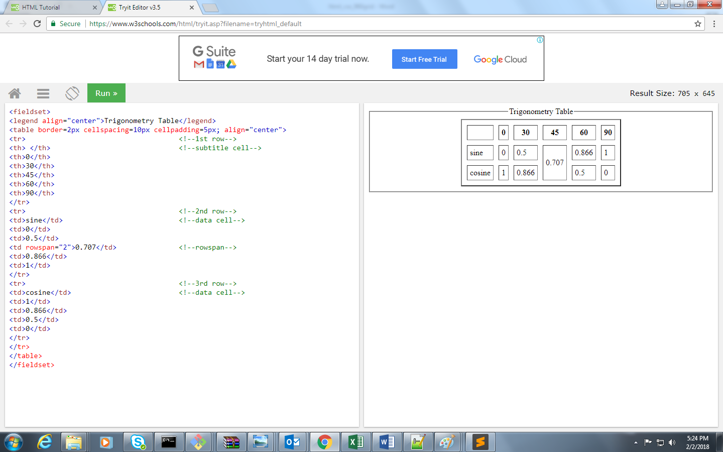

**Adding media elements**

<!DOCTYPE html>

<html>

<head>

<title>Videos</title>

</head>

<body>

**<audio src="audio.mp3" autoplay="true" controls></audio>**

**<video src="maths.mp4" height="300px" width="300px" controls></video>**

</body>

</html>

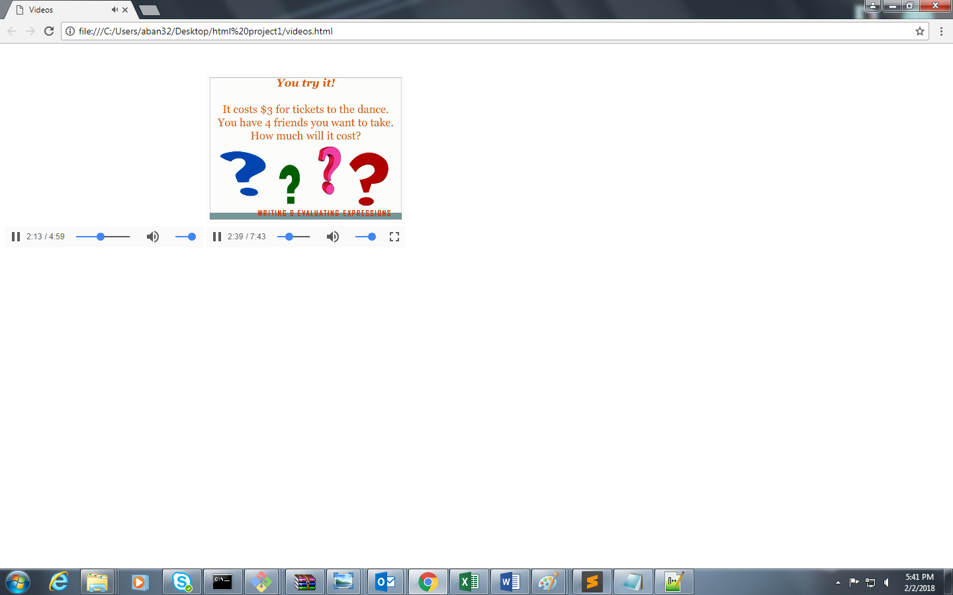

**<iframe>--------------------------------------------To add youtube videos in the website**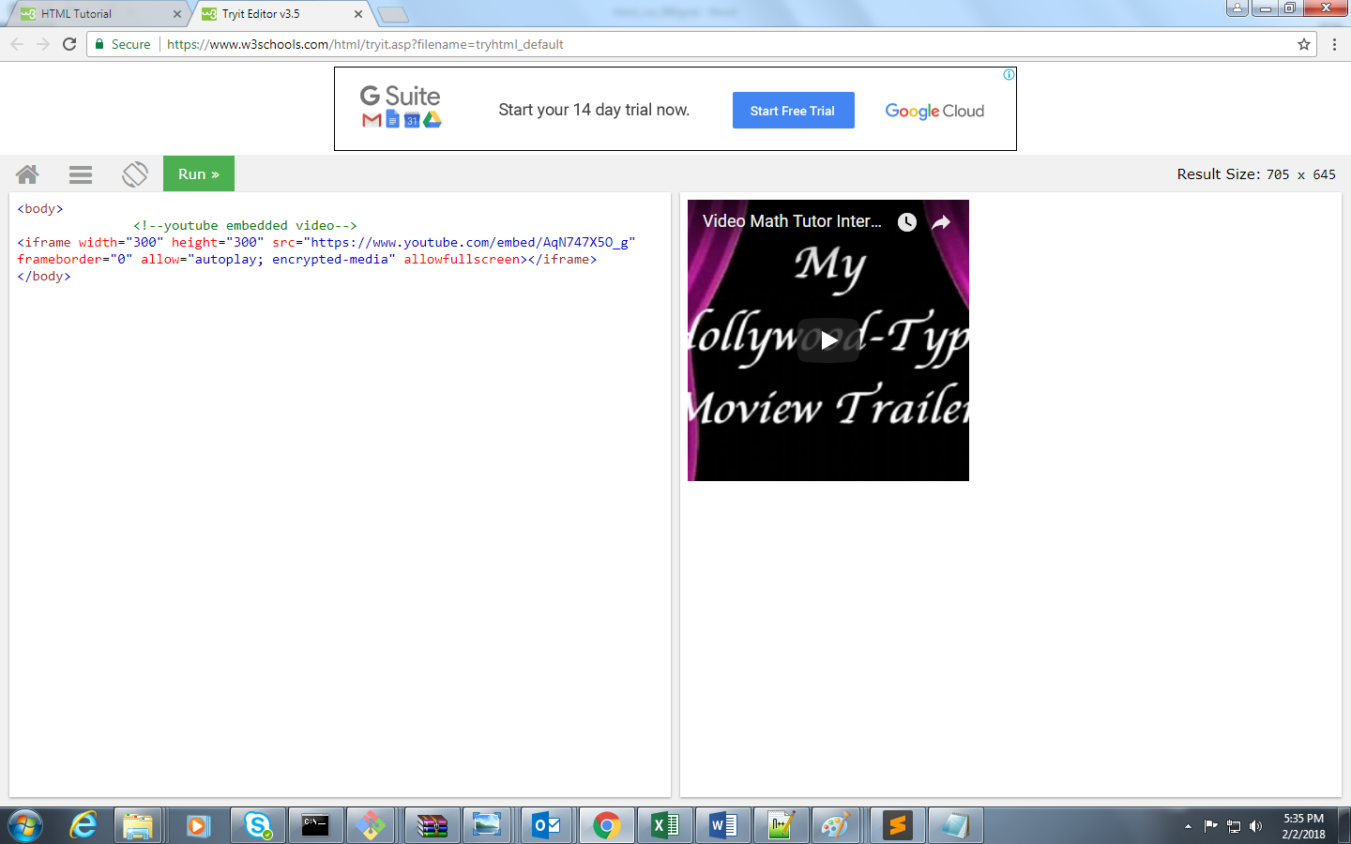

**Creating Form**

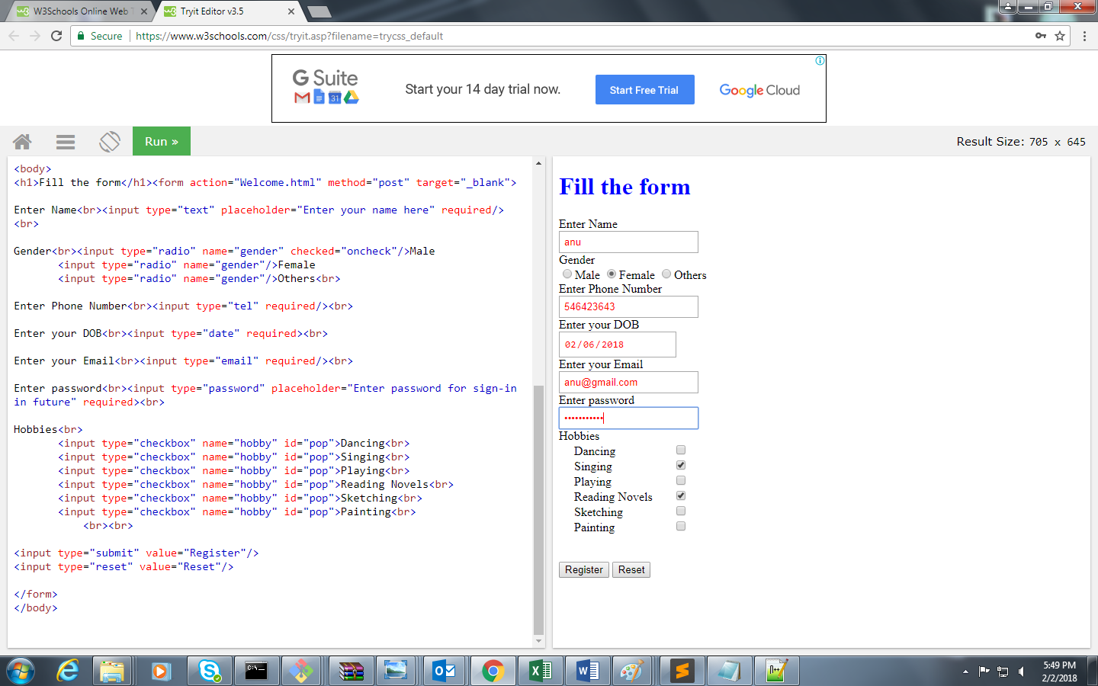

**Structural elements:-------**

**<header> tag :**

Represents a header for its nearest ancestor content.

Example-

<header>

<p> text</p>

</headerer>

**<nav> tag:**

Represents a section of a page that links to other pages or to parts within the page

Example-

<nav>

<ul>

<li> list </li>

<li> list1 </li>

<li> list2 </li>

</ul>

</nav>

**<section>tag:**

Represents left side part of the page inside header and footer

Example-

<section>

<h1>Introduction</h1>

<p>text</p>

</section>

**<footer> tag :**

Represents a footer for its nearest ancestor sectioning content.

Example-

<footer>

<p> text</p>

</footer>

**What is CSS?**

* CSS stands for **C**ascading **S**tyle **S**heets
* CSS describes how HTML elements are to be displayed on screen, paper, or in other media
* CSS is used to define styles for your web pages, including the design, layout and variations in display for different devices and screen sizes.

**Advantages of CSS**

* Content and Style Separation– Separates HTML content from the style and layout of that document
* Saves time– write CSS once and reuse the same code to group of HTML elements or across multiple HTML pages.
* Easy maintenance– By making changes in the css file, the elements in all the web pages get updated automatically. Also helps to maintain consistency across multiple documents
* Superior style to html– has more presentation capabilities than HTML. e.g., Adding opacity, gradients,rounded corners, animation
* Multi device Compatibility– Allow the HTML document to be optimized and rendered in more than one type of device or media such as desktops, laptops, mobiles etc.

**Style and structure**

CSS has style rules that are interpreted by the browser.

**Selector :** a HTML element for which style will be applied. e.g., <h1>,

<p>, etc.

**Property :** a type of attribute of HTML tag like color, font etc.

**Value :** the value assigned to a property

**Syntax :**

Selector{

property 1:value;

property 2:value;

……………

……………

Property n:value;

}

**Example :**

h1{

color:green;

font-style:italic;

font-size:30px;}

**Types of CSS**

* 1. Internal CSS
  2. External CSS
  3. Inline CSS

**Internal Stylesheet**

Internal Stylesheet is used in the same html page.

It is defined in head section and inside the <style> tags.

<head>

<style>

body{ background: skyblue url ("bg.jpg") repeat-y; }

</style>

</head>

**External Stylesheet**

External stylesheet is written in a separate file and saved with

anyname.css.

It is ideal when same style has to be applied to many pages.

External Stylesheet can change the look of an entire web site by changing a single css file.

**To embed this external stylesheet to the html web page:**

<link rel=”stylesheet” href=”style.css”>

body{

background-color: pink;

background-image: url("bg.jpg");

background-position: top center;

background-repeat: no-repeat;}

**Inline Stylesheet**

Inline Stylesheet is used inside any tag using style attribute in that tag.

Style attribute can contain any CSS property.

<body>

<h1 style=” font-family: serif font-style: oblique;”>Inline Stylesheet Example</h1>

</body>

**CSS - Background**

**background-color:** to set the background color of an element.

**background-image:** to set the background image of an element.

**background-position:** to control the position of an image in the background.

**background-attachment:** property is used to control the scrolling of an image.

**background-repeat:** is used to control the repetition of an image.

**background:** is shorthand to specify a number of other background property.

|  |  |
| --- | --- |
| <head>  <style>  body{**background: skyblue url ("bg.jpg") repeat-y;** }  </style>  </head>  <body>  <h1>Sample background</h1>  <p>This is an example to show effect of css code in background </p>  </body> |  |

**Sample Example:**

<head>

<title>anu</title>

<style>

body{

**background-color: pink;**

**background-image: url("bg.jpg");**

**background-position: top center;**

**background-repeat: no-repeat;**

}

</style>

</head>

<body>

<h1>Sample background</h1>

<p>This is an example to show effect of css code in background</p>

</body>

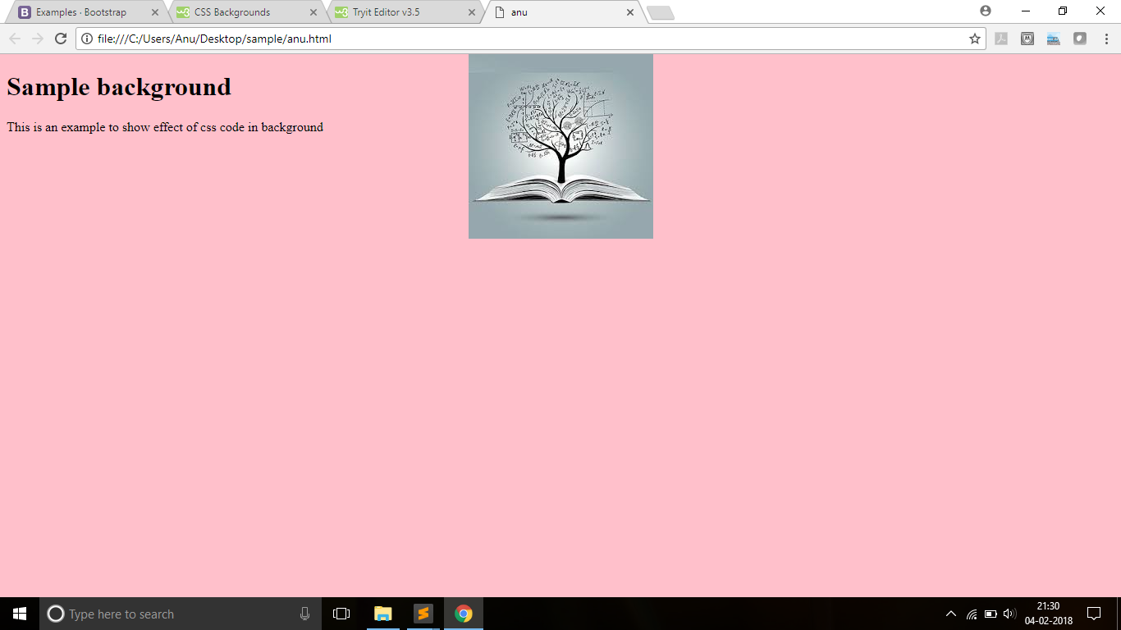

**CSS - Fonts**

**font-family** is used to change the face of a font.

**font-style** used to make a font italic or oblique.

**font-weight** used to increase or decrease the boldness for a font .

**font-size** used to increase or decrease the size of a font.

**font** is a shorthand to specify a number of other font properties.

<head>

<style>

p{ font-family: serif; font-style: oblique;

font-variant: small-caps; font-weight: normal;

font-size: 30px;}

span{font: italic bold 50px fantasy;}

</style>

</head>

<body>

<p>This is an example to show effect of css code in background</p>

<span>This is to show shorhand property of font.</span>

</body>

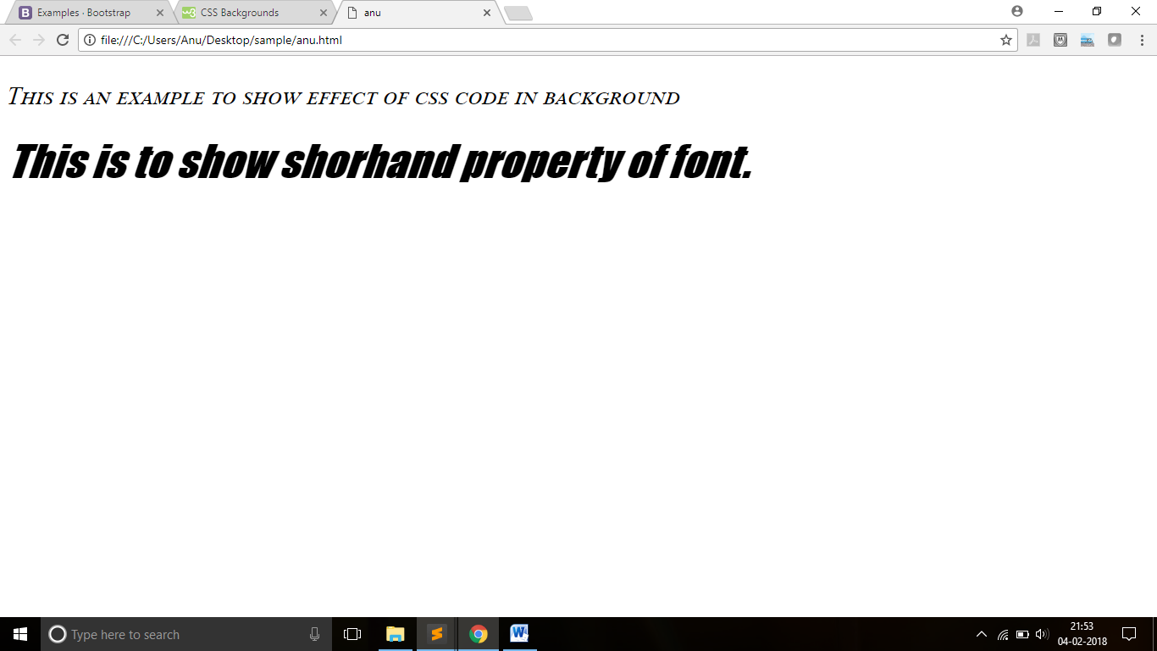

**CSS - Text**

**color** is used to set the color of a text.

**direction** is used to set the text direction.

**letter-spacing** is used to add or subtract space between the letters in a word.

**word-spacing** is used to add/subtract space between the words of a sentence.

**text-indent** is used to indent the text of a paragraph.

**text-align** is used to align the text of a document.

**text-decoration** is used to underline, overline, or strikethrough text.

**text-transform** is used to capitalize text or convert text to uppercase or

lowercase letters.

**white-space** is used to control the flow and formatting of text.

**text-shadow** is used to set the text shadow around a text.

**Sample Example:**

<head>

<style>

h1{text-shadow: 10px 10px red;

text-align: center;}

span{word-spacing: 5px;

text-transform: uppercase;

text-align: justify;

text-decoration: line-through;}

p{color: red;

direction: rtl;

letter-spacing: 5px;

text-indent:5cm;

white-space: pre-wrap;}

</style>

</head>

<body>

<h1>CSS text</h1>

<span>This is an example to show effect of css code in text(content) written</span>

<p>This is an example to show effect of css code in text(content) written. </p>

</body>

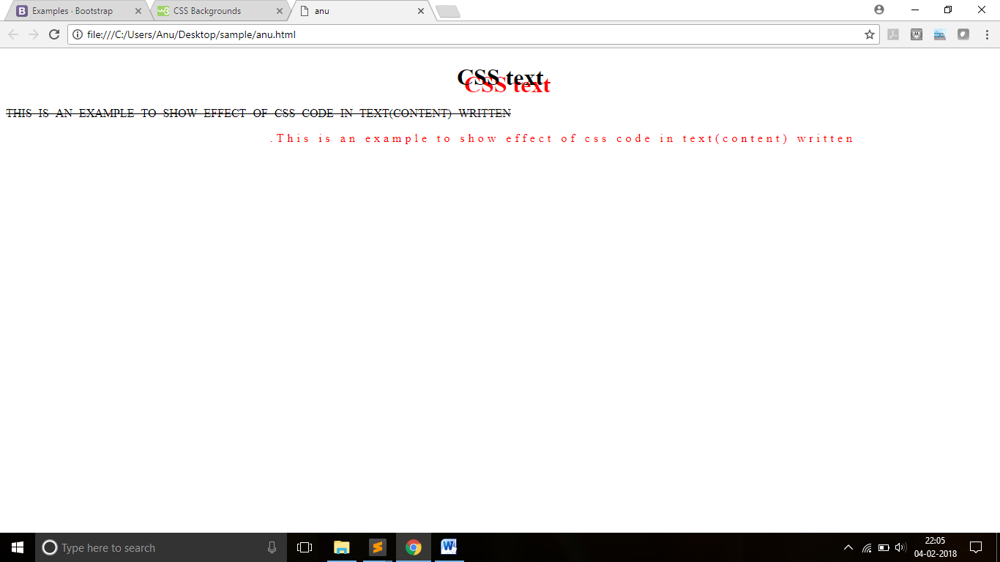

**CSS - Links**

**:link**

for unvisited hyperlinks.

**:visited**

for visited hyperlinks.

**:active**

Is when the user is currently clicking the link.

**:hover**

happens when the user's mouse pointer hover over the element.

**Sample Example:**

<!DOCTYPE html>

<html>

<head>

<style>

.start:visited{color: red;}

.sub:hover{word-spacing: 20px;}

.reset:active{letter-spacing: 30px;}

.go:link{color:blue;}

a{font-size: 30px;}

</style>

</head>

<body>

<a class="start" href="course.html">Get Started</a><br>

<a class="sub" href="home.html">Submit the form</a><br>

<a class="reset" href="index.html">reset data</a><br>

<a class="go" href="next.html" target="_blank">lets go</a>

</body>

</html>

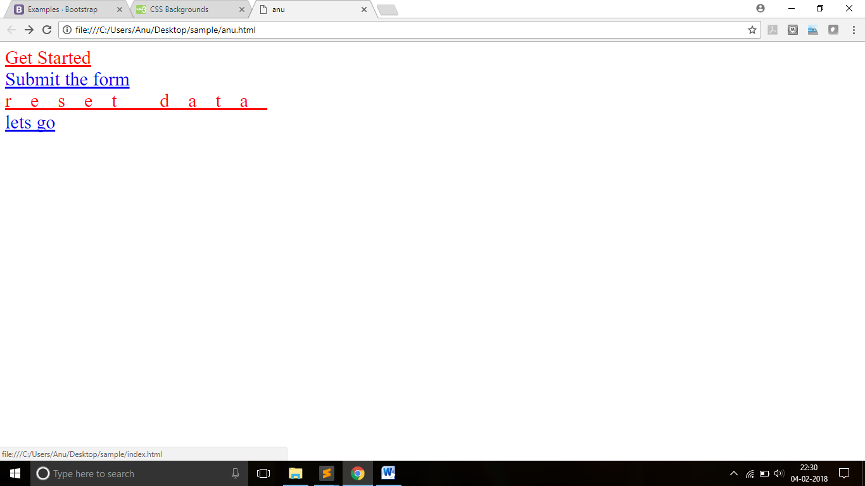

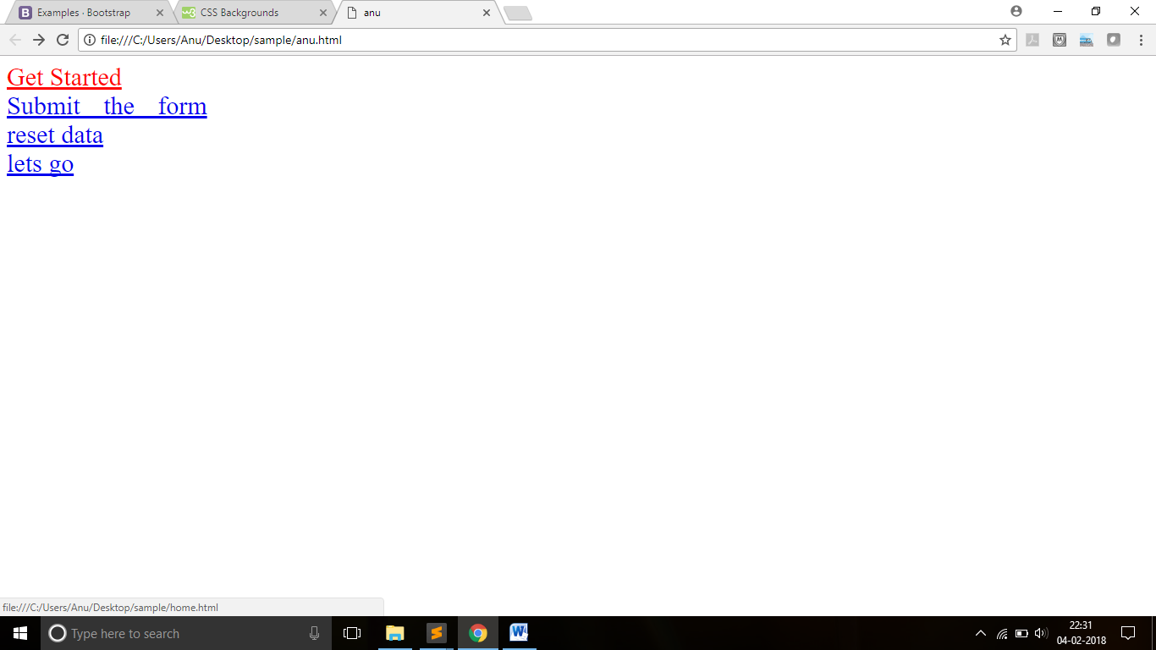

**CSS - List**

**list-style-type :** control the shape or appearance of the marker.

**list-style-image :** an image for the marker rather than a bullet point or number.

**list-style-position :** controls the position of marker.

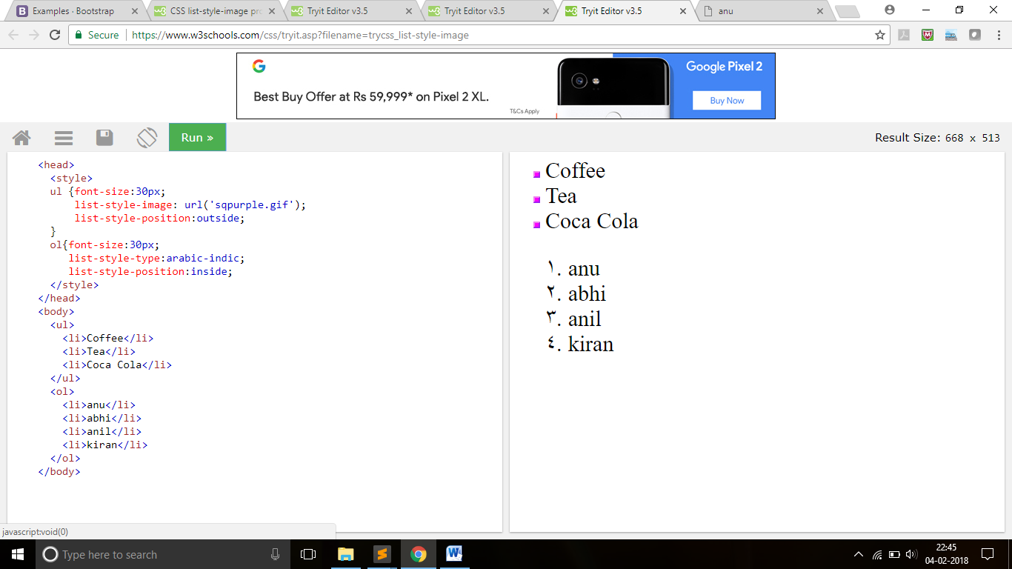

**CSS - Positioning**

• This specifies how an element is positioned in a document.

• The elements are then positioned using top, bottom, left and right

properties.

• The position values are

– static-----------------Position properties don’t effected.

– fixed-----------------Fixed with respect to ancestor,other part can scroll.

– relative--------------Positioned with respect to default position.

– absolute--------------Positioned with respect to page layout.

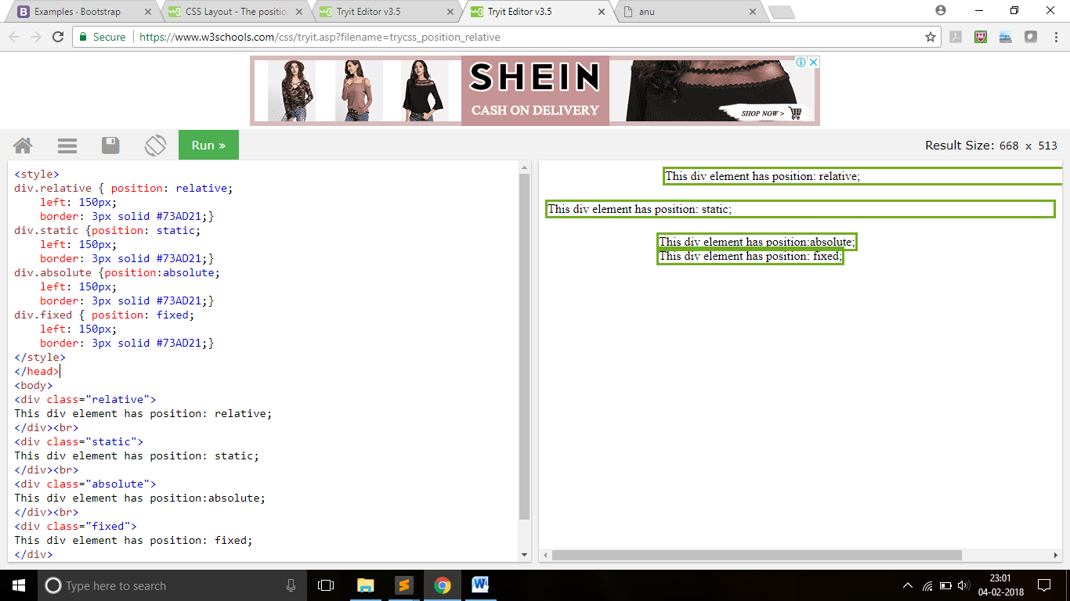

**CSS Box Model**

• CSS box model is a box that wraps around every HTML element.

• It has margins, borders, padding, and the actual content.

**Content -** The content of the box, where text and images appear.

**Padding -** Clears an area around the content. It is transparent.

**Border -** A border that goes around the padding and content.

**Margin -** Clears an area outside the border and is transparent.

**Total element width =** width + left padding + right padding + left

border + right border + left margin + right margin.

**Total element height =** height + top padding + bottom padding +

top border + bottom border + top margin + bottom margin.

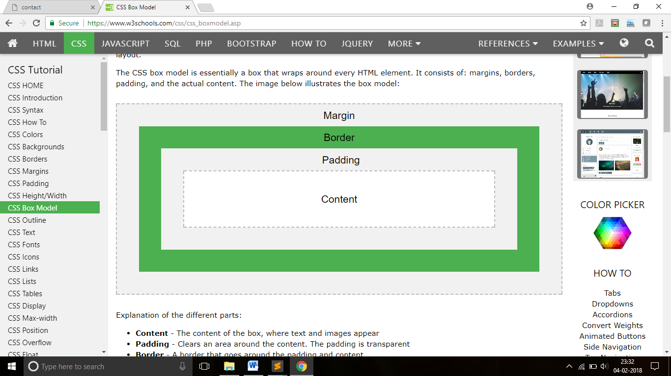

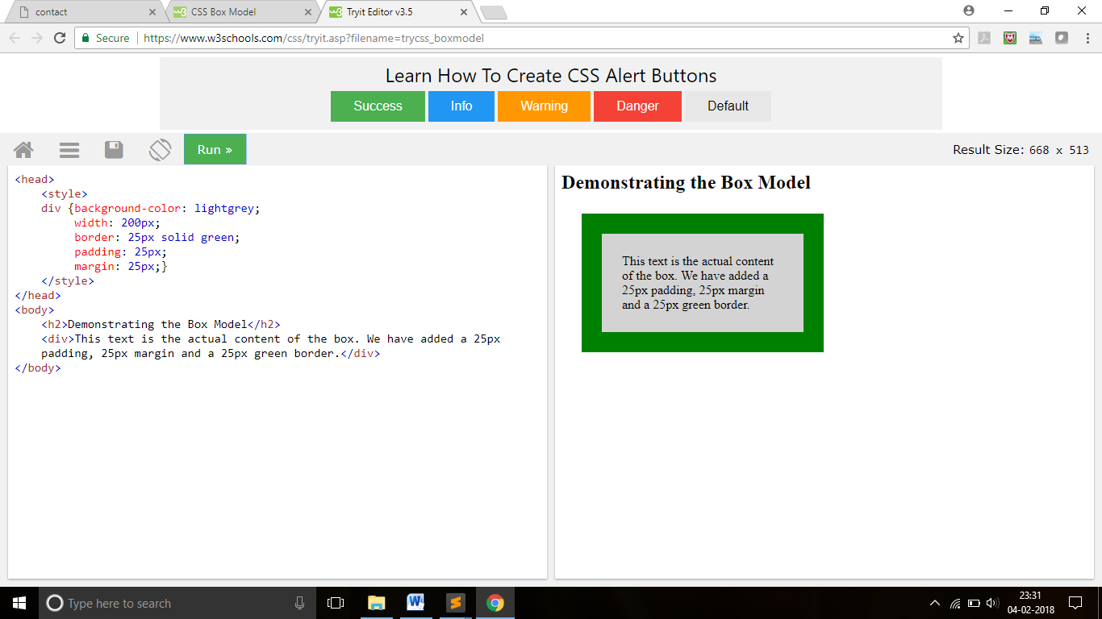

**CSS Transitions**

Transitions allows you to change property values smoothly (from one value to another), over a given duration.

The transition effect will start when the specified CSS property changes its value

To create a transition effect, specify

– the CSS property to add an effect to

– the duration of the effect

**Transition-timing-function values**

**ease :** initially slow,then fast,then again slow and so on.

**linear :** speed remains same at all the time.

**ease in :** slow in start, fast in end.

**ease out :** fast in start, slow in end.

**Css Id and Css Class**

**The id selector uses the id attribute of an HTML element to select a specific element.**

The id of an element should be unique within a page, so the id selector is used to select one unique element!

To select an element with a specific id, write a hash (#) character, followed by the id of the element.

The style rule below will be applied to the HTML element with id="pop"

Example –

**#pop** {  
    font-size:30px;  
    color: green;  
 }

**The class Selector**

The class selector selects elements with a specific class attribute.

To select elements with a specific class, write a period (.) character, followed by the name of the class.

In the example below, all HTML elements with class="push" will be red and center-aligned

Example –

**.push**{  
    font-size:40px;  
    color: green;  
}

**What is 960 grid system ?**

The 960 Grid System is an effort to streamline web development workflow by providing commonly used dimensions, based on a width of 960 pixels. There are three variants: 12, 16 and 24 columns, which can be used separately or in tandem.

**Sample 12 columns 960 grid:**

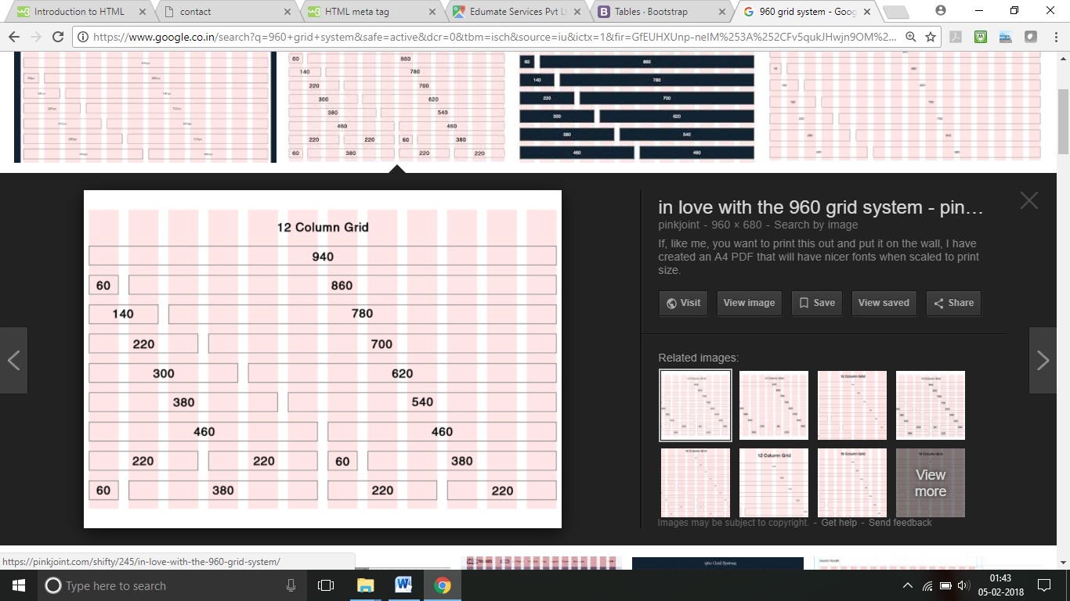

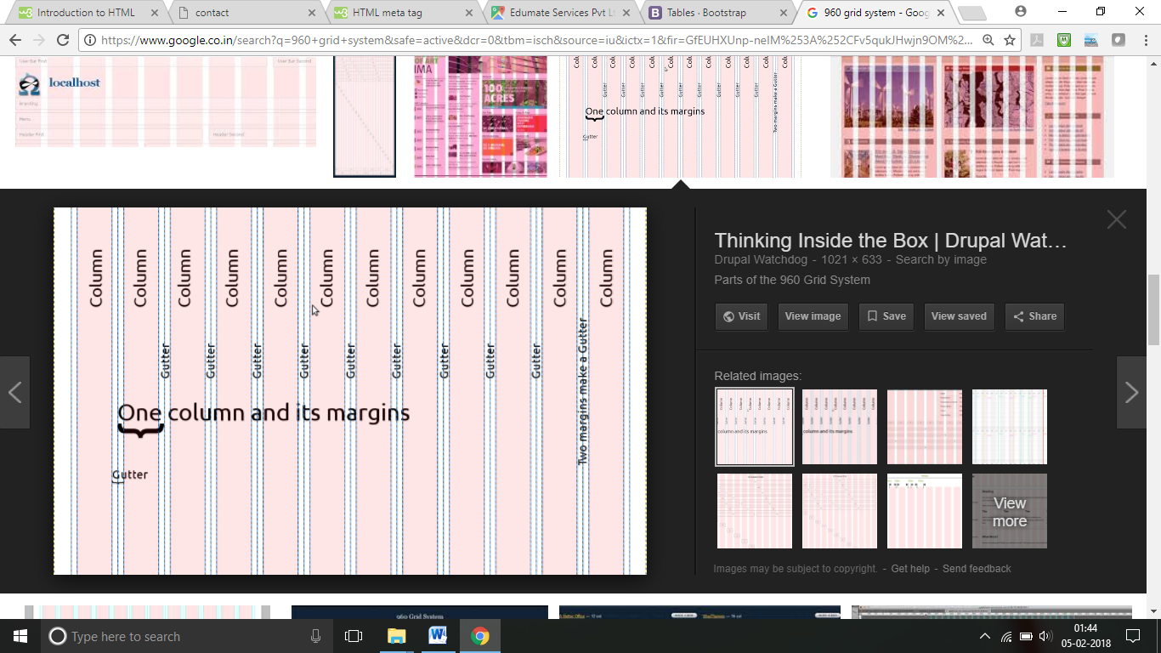

**Sample Example:**

<div class=”container_12”>

<div class=”grid_4 prefix_2”>

<h1>960 grid example</h1>

</div>

<div class=”grid_6”>

<h2>Second column of container</h2>

</div>

</div>

**For more details, refer:**

**Example of 960GS:**

