Supplementary Materials for

Deep learning prediction of material properties

Charles Le Losq, Andrew Valentine, Bjorn O. Mysen, Daniel R. Neuville

Correspondence to: lelosq@ipgp.fr

**This PDF file includes:**

Materials and Methods

Supplementary Text

Figs. S1 to S7

Tables S1 to S3

**Other Supplementary Materials for this manuscript include the following:**

Software repository at github.com/charlesll/neuravi

Supplementary Text

*Viscosity equations and the trans-theoretical nature of the deep learning framework*

No consensus exists regarding a best model to explain and reproduce the variations of liquid viscosity with parameters like temperature, pressure and composition. Despite this, some models may be preferred. For instance, the Adam-Gibbs model (*30*) has been particularly successful in reproducing viscosity data of silicate melts (*19*). It assumes that liquid movements occur through cooperative molecular re-arrangements, and represents viscosity (*)* as a function of temperature (*T)* and composition (*x*) via

, (*S1*)

with *Ae* representing a high-temperature limit, *Be* a term proportional to the energy barriers opposed to molecular re-arrangements, and *Sconf* and *Cpconf* the melt configurational entropy and heat capacity, respectively. *Tg* is the ‘glass transition temperature’, at which melt is frozen-in into glass upon quench (for convenience, we adopt hereafter the empirical definition of *Tg* as equal to the temperature for which *η* = 1012 Pa·s).

Alternatively, one might adopt the Free Volume model (*31*), which states that melts present liquid-like and solid-like molecular cells, their mobility being ensured by atomic diffusivity within/between liquid-like cells. This takes the form

**,** (*S2*)

with again representing the high-temperature limit, and , and latent variables related to free volumes’ properties like percolation, size and numbers.

Beyond the Free Volume and Adam-Gibbs models, many other theories have been proposed to describe the viscous flow of liquids. Among those, some are empirical like the Tamman-Vogel-Fulcher (TVF) equation, or semi-empirical like the Avramov and Milchev (AM) (*32*) model. We can also cite the MYEGA model (*33*) that directly derives from eq. S1. The TVF equation is

, (*S3*)

with ATVF, BTVF and T1 adjustable parameters. The AM model proposes the equation

, (S4)

with AAM a pre-exponential terms proportional to , *Tg(x)* and *m(x)* the melt glass transition temperature and fragility. The MYEGA equation can be written in a quite similar form:

**,** (S5)

with *Ae*  a pre-exponential term proportional to that was taken as equal to that in the Adam-Gibbs theory (eq. S1) because the MYEGA equation is a daughter product of the Adam-Gibbs theory. Equations S3 to S5 remain empirical or semi-empirical as unlike the Adam-Gibbs or Free Volume equations, they are not expressed in terms of measurable physical quantities, such as heat capacity. However, they still represent the viscosity dependence upon temperature well (Fig. S3). The MYEGA and AM equations also allow leveraging knowledge of melt Tg and fragility as predicted by the deep learning framework.

***The structure of aluminosilicate melts***

Aluminosilicate melts are a disorganized network of SiO2 and AlO2 tetrahedral units, with bonds formed between them; some of these bonds get disrupted by network modifier elements like alkali and alkaline-earth elements. The later also compensate for the deficit of charge around AlO2 tetrahedral units. In such melts, viscous flow involves cooperative movements of the tetrahedral units, facilitated by the presence of network modifiers cations like alkali and alkaline-earth elements. Rapid cooling of such melts allows crossing the glass transition, where the melt structure is frozen-in. Melt structure close to the glass transition can thus be observed in their glasses via, e.g., 29Si Nuclear Magnetic Resonance or Raman spectroscopy.

It is important to consider melt structure and the role of elements because this directly determines melt properties. For instance, in the present case, variations in *Sconf(Tg)* and *m* can be understood once we consider that aluminum and non-network former metal cations have important and complex roles in the melt (see review of *10*). In Al-free silicate glasses, network modifier alkali cations break Si-O-Si bonds, forming alkali channels percolating in the disrupted SiO2 tetrahedral network as described by the Modified Random Network (MRN) (*36*–*40*). Adding aluminum, entering as network forming AlO4- tetrahedral units in glasses, changes this picture: alkali metals switch their role from network modifiers to charge compensators of AlO4- tetrahedra to ensure charge balance (*23*). Alkali distribution still is non-random, but localized in compensator channels as described by the Compensated Continuous Random Network (CCRN) model (*4*, *41*). In term of properties, changing the role of alkali metals from network modifiers to charge compensators of Al results in an average decrease in *Sconf(Tg)*, particularly marked in the case of potassium compositions (Fig. 3a,b). MRNs thus may generally present higher *Sconf(Tg)* than CCRNs, at least for alkali aluminosilicates. Furthermore, mixing alkalis results in different MAE effects as the alkalis reside in MRN (for Al-free or poor melts, Fig. 3c) or CCRN (in Al rich melts, Fig. 3f). In the former case, mixing Na and K induces an excess entropy of mixing caused by the hindering of the diffusions of alkali cations in modifier percolation channels (*41*). In the latter case, variations in *Sconf(Tg)* with the Na/K ratio are close to a linear mechanical mixing of two sub-networks (Na-Al-Si-O and K-Al-Si-O subnetworks) because K and Na occupy different environments and do not really interact upon mixing (*4*, *24*).

***The difficulty of modeling aluminosilicate melts properties***

The AG theory assumes that melt viscous flow occurs through cooperative re-arrangement of molecular subunits, and such events have been identified via high-temperature 29Si NMR spectroscopy (*42*) and even direct observations (*43*, *44*) in silicate melts. The structure of simple Al-free silicate melts has been related to *Sconf(Tg)* (*7*) and *Cpconf* (*45*), and this was leveraged to calculate melt viscosity in the ternary Na2O-K2O-SiO2 system with an unrivaled precision of 0.2 log Pa·s (*7*). However, it is very difficult to extend to more complex composition like aluminosilicates because of the many new degrees of complexity generated by the addition of one critical elements like Al.

Indeed, it is actually difficult to experimentally validate models of melt structure for aluminosilicate compositions, representative of most natural and industrial glasses. In such compositions, 29Si NMR spectroscopy, which usually brings the necessary information to quantify the connectivity of SiO2 tetrahedral units, becomes blind due to Si-Al interactions causing significant signal broadening; signal interpretation relies on various hypothesis and back-end models of melt structure (*46*). Raman spectroscopy, another method to explore glass structure, does not solve this problem as it cannot be calibrated against reliable NMR data to distinguish the molecular subunits in the glasses. Furthermore, the aluminum content of the melt also affects interactions between, and the environment of the metal cations, as well as Al-Si ordering, Al coordinance and the potential presence of three-fold coordinated oxygen (see *10* for a review). Such problems severely affect our ability to construct models in the presence of aluminum, and strongly question the theoretical viability of proposed models based on untested structural calculations (e.g. *8*). This complexity pushed existing models to simply link chemical composition of aluminosilicate melts to their viscosity using a set of polynomial equations (*5*, *47*, *48*). A more complex model was proposed by Starodub et al. (*8*) for the system Na2O-K2O-Al2O3-SiO2. They proposed an associate-solution model for calculating the structure of melts in this system. Their model is interesting but one should keep in mind that the structural calculations was not validated by experimental data for aluminosilicate melts, and therefore there may be biases due to our inability to determine the structure of aluminosilicate compositions. Other biases also come from the absence of viscosity data selection in their model calibration. This can severely damage the model results since melt viscosity can be difficult to measure with precision, particularly at undercooled conditions close to the glass transition temperature.

***Internal consistency of the deep learning framework***

The ability to predict the melt fragility *m* allows further testing of the internal consistency of our deep learning framework predictions. Indeed, experimental data indicate that a direct correlation between *m* and the ratio between the configurational heat capacity at *Tg* and *Sconf*(*Tg), Cpconf(Tg)/Sconf(Tg)* shall be observed (*49*, *50*). The deep learning framework predicts this linear correlation (Figure S5), albeit some scattering that most probably arises from the way melt and glass *Cpconf* values are determined in the model. Indeed, the deep learning framework calculates *Cpconf(Tg)* as *Cpliquid(Tg) – Cpglass(Tg),* with *Cpliquid(Tg)* predicted from the model of *(51*)and *Cpglass(Tg)* calculated from the Dulong-Petit limit of 3R, with R the perfect gas constant*.* Models of *Cpliquid(Tg)* and the theoretical calculation of *Cpglass(Tg)* do not yield exact values, and this most probably explains the moderately good correlation between predicted *m* and *Cpconf(Tg)/Sconf(Tg)* values in the present work in comparison of other studies that used experimental values of *Cp*. In turn, this result indicates a critical need for better heat capacity models of aluminosilicate melts*.*

***Deep learning for small dataset?***

Using the viscosity dataset, we tested the effects of dataset size and network architecture on the deep learning framework predictive abilities. Experimental data are often scarce because they are difficult to obtain, with each experiment requiring significant work, time, and potentially funds. The common idea is that this usually prohibits the use of “data-thirsty” machine learning methods. The present datasets are small, even extremely small (e.g. that of Raman spectra), raising the question: are we not simply overfitting or even encoding our data? We tested this by training the neural networks on different training data subsets with variable size and monitoring the RMSE loss on the same unseen test data subset (Fig. S2A). As expected, the deep learning framework predictive ability directly depends on the dataset size. Results become interesting only after reaching a threshold of around ~80 different compositions within the training data subset. This yields testing RMSE lower than 0.6 log Pa·s on the *testing* *Dviscosity* subset (Fig. S2A), a reasonable achievement as existing parametric models have RMSE values higher than 0.6 log Pa·s on the full 100-1015 Pa·s range (*5*, *47*, *48*). Lower numbers of compositions in the *training* subset result in the deep learning framework constantly over-fitting the data. With more data, the lowest achievable RMSE probably lies around 0.36 Pa·s as shown by the evolution of the training RMSE (Fig. S2A) and reflects errors affecting the dataset (see below).

Aside from the number of training data, the network architecture has a direct effect on the deep learning framework predictive ability. For small datasets, common but outdated advice to avoid overfitting is to use networks with a limited number of activation units and layers. In our case, this is not true. More than a thousand hidden activation units are necessary to achieve good validation and testing RMSE on the viscosity dataset (Fig. S2). More precisely, network with more than 3 hidden layers provide better predictive abilities (Figure S2), confirming that deep networks perform better than shallow ones even on small datasets.

***Can we detect a lowest achievable limit for the deep learning framework predictive error?***

Interestingly, the training RMSE on viscosity is always of ~0.36 log Pa·s (Fig. S2A), regardless of the training data subset size. Artificial neural networks are extremely flexible and very prone to overfit the training data subset. Therefore, the fact that neural networks trained on a small number of compositions clearly overfit the training data subset but do not provide viscosity predictions better than ~0.36 log Pa·s brings an important information: this places a lowest achievable RMSE at ~0.36 log Pa·s on the present dataset. We infer that this limit reflects contributions from experimental errors affecting viscosity measurements and chemical composition values, those errors varying between different laboratories, as well as from the accuracy of the glass and melt heat capacity determination (see above).

***Configurational entropy at the glass transition: chemical and topological contributions***

Deep learning framework results show large, non-linear variations of *Sconf(Tg)* with glass composition. Such variations are better understood when considering that *Sconf(Tg)* should be considered as originating from various sources, of topological and chemical nature. As a result, it varies in a complex way with melt chemistry, and those variations are difficult to rationalize without making severe simplifications and/or assumptions. Even for the simple SiO2 glass, not all the configurational entropy can be assigned to a topological origin with certainty. Indeed, the Raman signal of the A1 vibrational doublet at high frequency arising from symmetric stretching of the SiO2 tetrahedral units is split in two components, which fractions represent 0.68 and 0.32 of the A1 signal (*20*); assuming an ideal mixing of the two vibrators, one finds a Raman-derived *Sconf(Tg)* = 5.2 ± 0.4 J mol-1 K-1. This value is surprisingly realistic, very close to the 5.1 ± 2 J mol-1 K-1 value returned from calorimetric measurements (*52*) and not very different from the 8.3 ± 2.8 J mol-1 K-1 value calculated from the SiO2 viscosity data (*7*). The same treatment for the nepheline glass yields a value of 4.6 ± 0.7 J mol-1 K-1, close to the calorimetric value of 4.85 J mol-1 K-1, this being explained by the high ordering of the Si-Al distribution in nepheline (*53*) and hence a limited chemical mixing of various units. However, as soon as chemical mixing becomes important, such calculations fail. This is shown by comparing the value of such calculation for albite, which yields a Raman-derived *Sconf(Tg)* = 3.8 ± 1.1 J mol-1 K-1, a value much lower than the calorimetric one equal to 9.2 ± 2 J mol-1 K-1 (*52*). Assuming that Na repartition in CCRN is not accompanied by any mixing effect (this seems reasonable as Na is the only cation that can occupy such environment), this difference can be assigned to Al-Si mixing. Assuming ideal mixing, one can calculate it and add it to the 3.8 ± 1.1 J mol-1 K-1 value to finally obtain a value of 8.46 ± 1.1 J mol-1 K-1, a value in much better agreement with the measured one. Such analysis may not be easily extrapolated to other compositions, but rather is an interesting exposition of the source of entropy affecting the melt configurational entropy at the glass transition, and, hence, the variations of its viscosity. In turn, the complexity of *Sconf(Tg)* indicates that values for different glasses do not necessary embed interesting information about their relative ordering. Indeed, while two glasses may present similar *Sconf(Tg)*, their decomposition may yield very different topological and mixing contributions, making any attempt in discussing glass structure using *Sconf(Tg)* pointless*.*

***Links between the Adam-Gibbs and the Free Volume theories?***

The trans-theoretical character of the present deep learning framework allows adopting a new vision about problems such as melt viscous flow and glass transition. For aluminosilicate melts, it allows observing the link between two theories: Adam-Gibbs (AG) and Free Volume (FV). In the FV theory, solid-like and liquid-like molecular cells are distinguished and separated by a critical volume *v\**, and viscous flow occurs via cooperative molecular movements between liquid-like cells. In the AG theory, viscous flow occurs via cooperative motions of molecular segments of a size *z*(T),* characterized by an intrisic entropy *Sc\**. The two theories thus share some common philosophical background: viscous flow is assumed to occur via some sort of cooperative movements of molecular entities in the melt. This background can be retrieved when diving into the details of the parameters of eqs. S1 and S2. Indeed, *BCG* embeds some structural information because it depends on *v\**:

*BFV = v* zo, (S8)*

where *zo* is an adjustable parameter. Similarly, the ratio *Be/Sconf(Tg)* embeds molecular subunit lengthscale information as

*Be/Sconf(Tg) = [ Δµ z*(Tg) ] / R, (S9)*

with *Δµ* the energy barriers opposed to the rearrangement of molecular subunits of size *z*(Tg)*, and R the perfect gas constant. We can therefore consider *v\** and *z\** as structural parameters embedding information about the volume or lengthscale of cooperative molecular regions. In this case, they should directly depend on melt or glass structure. This is confirmed by the fact that both *BFV* and *Be/Sconf(Tg)* correlate very well with *RRaman* (*rs* = 0.987 and 0.985 respectively), which provides information about the network connectivity; the higher *RRaman* is, the higher the interconnection between polyhedral units, thus the higher the 3D network topology*(54*)*.* In detail, this implies that it actually should be possible to develop a free-volume version of the AG theory, as it has been proposed (*55*, *56*). More generally, the links between *BFV,* *Be/Sconf(Tg)* and *RRaman* support the general hypothesis that melt viscous flow occurs when a critical molecular lengthscale is reached. This lengthscale can be determined from Raman spectra (Fig. 2C,D) and strongly influences the glass transition temperature *Tg* (Fig. 2A). In detail, entropic effects (like the excess of entropy resulting from the MAE) also affect *Tg* (*7* and references cited therein)but their influence remains limited compared to that of the polyhedral network topology (Fig. 2A). On the other hand, entropic effects strongly control the rate at which supercooled melt viscosity changes as a function of T, or in other terms, the melt fragility *m* because (Fig. S5)*.* Actually, we may consider that such mixing phenomena are allowed by the non-ergotic nature of melts, their inhomogeneities being frozen into glasses below *Tg*. Following from this idea, it is possible to relate *m* to ongoing density fluctuations inherited from dynamic heterogeneities formed at supercooled T, i.e. Tliquidus < T < Tg (*57*). The nature of such heterogeneities is expected to change largely with melt composition, as we can recognize different cases for network organization as described by the Random Network for simple AX2 glasses like SiO2 (*58*), the Modified Random Network for silicate liquids (*37*) and the Continuous Compensated Random Network (*4*, *41*) for aluminum-rich aluminosilicates, each one presenting distinct and different extent of heterogeneities at medium and long range order with various associated cationic mixing within such heterogeneities that drive large and complex changes in glass configurational entropy and hence viscosity.

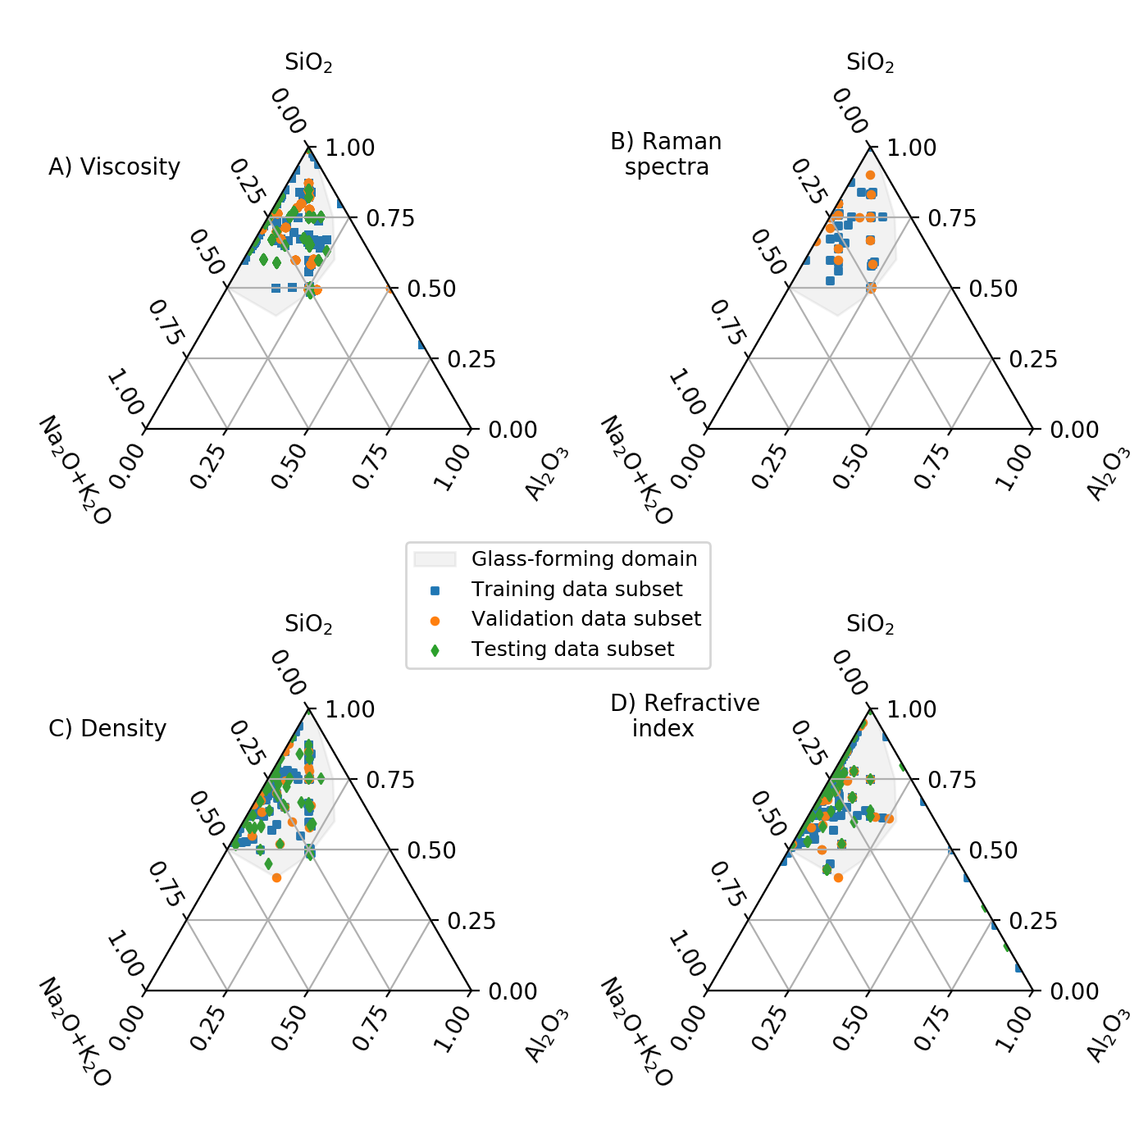Fig. S1. Viscosity (A), Raman (B), density (C) and refractive index (D) datasets used in this publication. Each symbol corresponds to a composition. The glass-forming domain at usual laboratory cooling rates is indicated in grey.

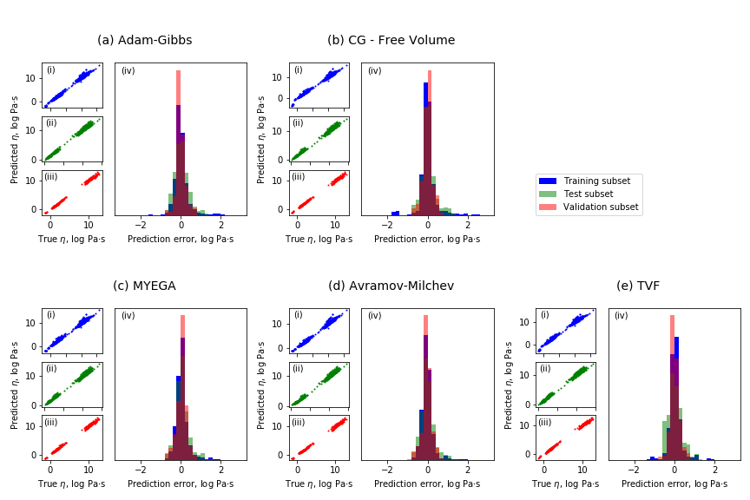Fig. S2. Comparison between predicted and measured viscosity in the Na2O-K2O-Al2O3-SiO2 system. Predictions can be made using theories like Adam-Gibbs (a) and free volume (b), or empirical equations like MYEGA (c), Avramov-Milchev (d), and Tamman-Vogel-Fulcher (e). See table S3 for RMSE and text for the equations.

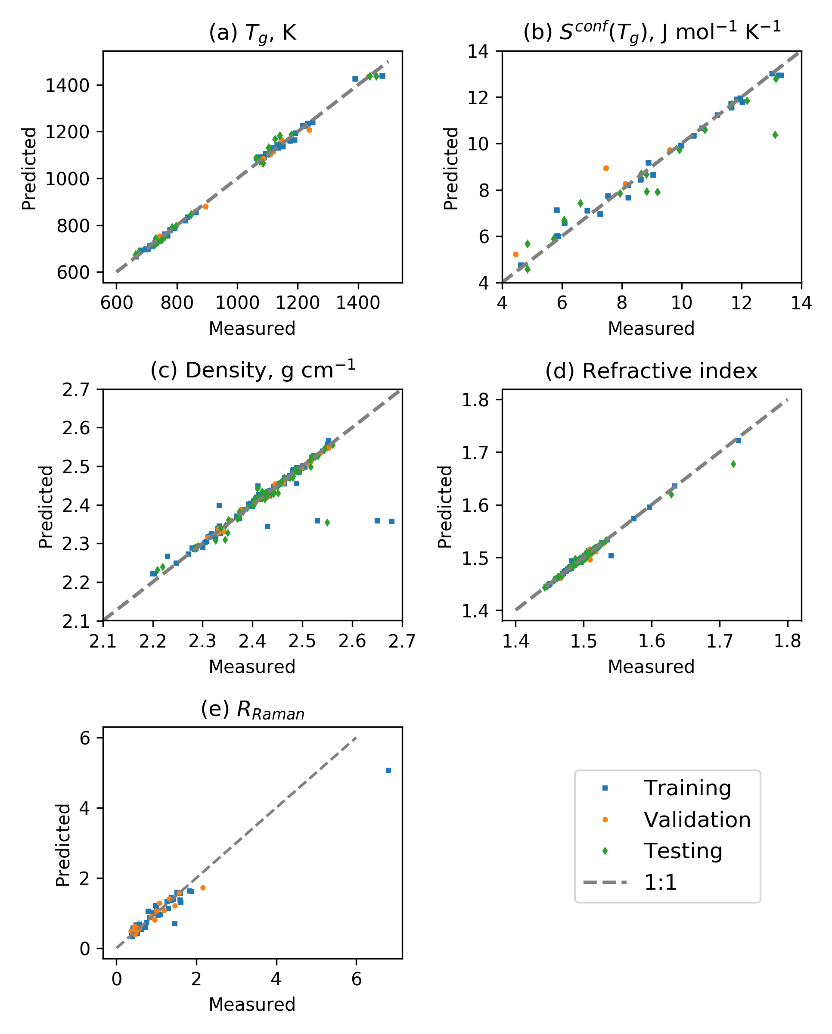Fig. S3. Comparison between predictions and observed viscous glass transition temperature (a), *Sconf(Tg)* (values from 4, 7, 19, 20, 23, 24) (b), density (c), refractive index (d), and R*Raman* (e). See table S3 for RMSE.

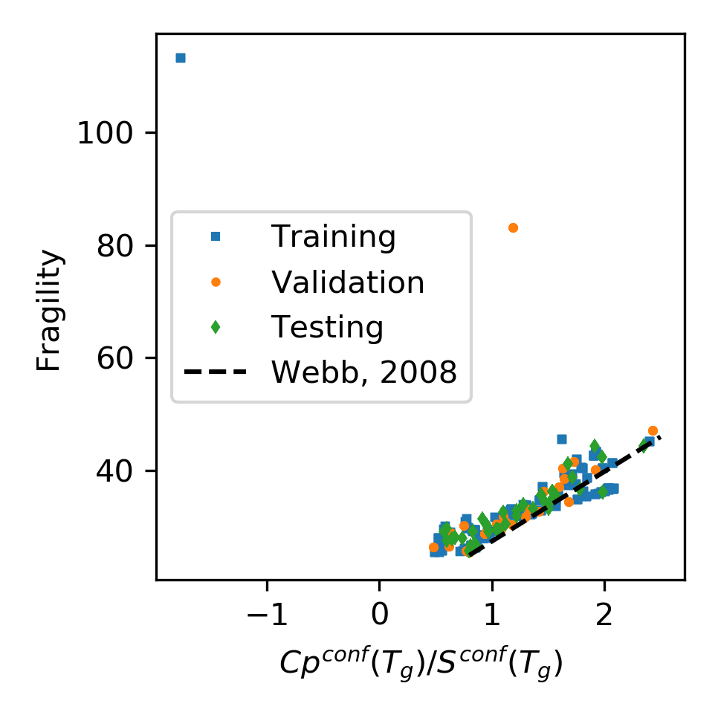**Fig. S4 Glass fragility versus melt *Cpconf(Tg)/Sconf(Tg)* ratio.** Symbols are predictions of the deep learning framework on the different subsets of the *Dviscosity* dataset. The back dotted line is the relationship observed by (*49*) using experimental heat capacity data. Except two extreme outliers that corresponds to Al2O3-SiO2 melts with more than 30 mol% Al2O3, a general good agreement is observed. This validates the internal consistency of the deep learning framework. The scatter indicates that a better agreement could be obtained with using a better heat capacity model for aluminosilicate melts. Such *Cp* calculation could be integrated in the present deep learning framework in the future albeit the acquisition of additional *Cp* data for ternary and quaternary aluminosilicate melts.

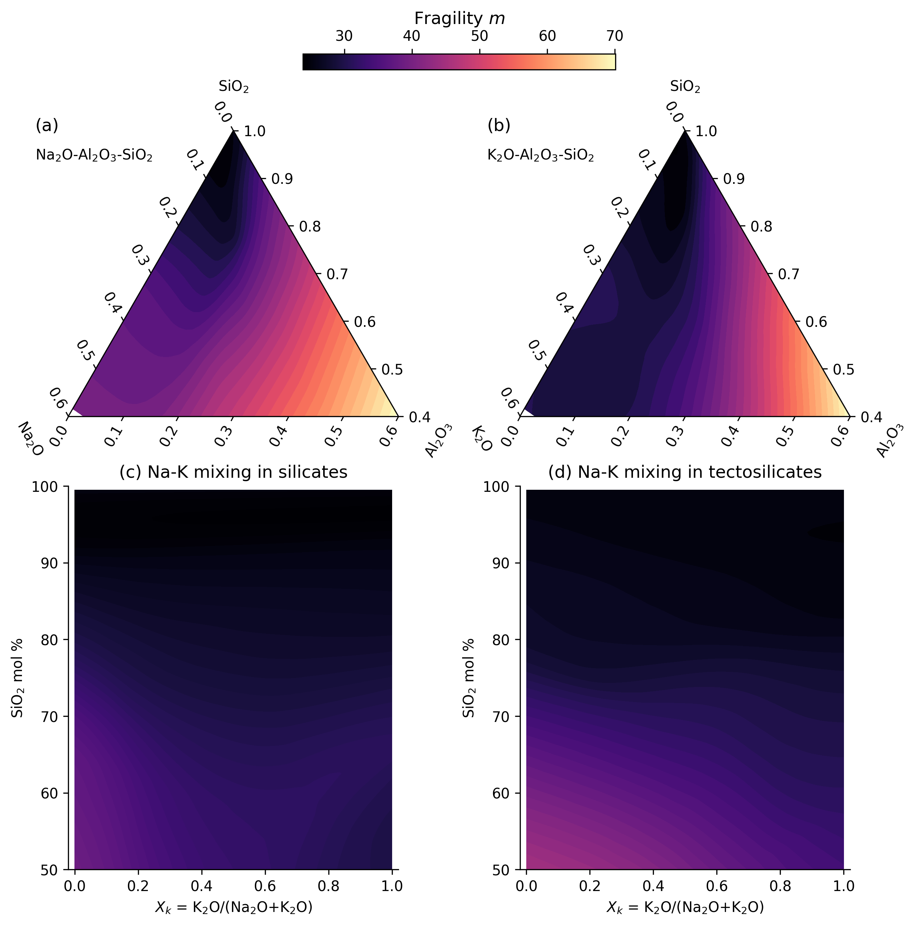

Figure S5: Melt fragility variations with composition. Fragility is represented in the glass forming domains of the ternary sodium (a) and potassium (b) aluminosilicate systems, as well as as a function of the silica fraction and the potassium to total alkali ratio of silicate (c) and tectosilicate (d) melts. No MAE is observed on melt fragility, which depends largely on melt silica content.

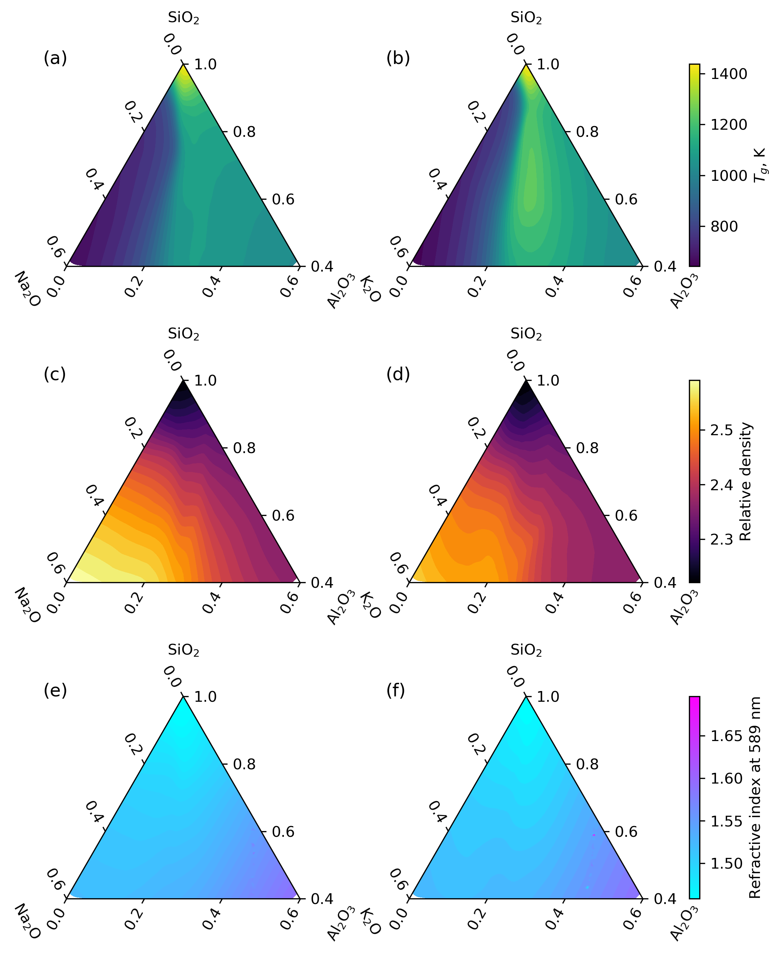Fig. S6 Deep learning framework predicted variations in glass transition temperature, relative density and refractive index in the ternary Na and K aluminosilicate diagrams.

|  |  |  |  |  |  |  |
| --- | --- | --- | --- | --- | --- | --- |
| **Glass name** |  | **%SiO2** | **%Al2O3** | **%K2O** | **%Na2O** | **Density, g cm-1** |
| KA80.05 | nom. mol% | 80.00 | 5.00 | 15.00 | 0.00 |  |
|  | nom. wt% | 71.40 | 7.60 | 21.00 | 0.00 |  |
|  | an. wt% | 74.85(44) | 7.56(14) | 15.12(22) | 0.00(4) | 2.320(1) |
| KA72.07 | nom. mol% | 72.00 | 7.00 | 21.00 | 0.00 |  |
|  | nom. wt% | 61.60 | 10.20 | 28.20 | 0.00 |  |
|  | an. wt% | 61.41(28) | 10.17(24) | 27.42(33) | 0.00(2) | 2.408(1) |
| KA65.09 | nom. mol% | 65.00 | 8.75 | 26.25 | 0.00 |  |
|  | nom. wt% | 53.70 | 12.30 | 34.00 | 0.00 |  |
|  | an. wt% | 53.32(55) | 12.49(43) | 31.68(28) | 0.00(3) | 2.451(10) |
| NA65.09 | nom. mol% | 65.00 | 8.75 | 0.00 | 26.25 |  |
|  | nom. wt% | 60.79 | 13.89 | 0.00 | 25.32 |  |
|  | an. wt% | 61.75(45) | 13.67(24) | 0.03(2) | 24.56(73) | 2.472(4) |
| NA58.10 | nom. mol% | 58.00 | 10.50 | 0.00 | 31.50 |  |
|  | nom. wt% | 53.55 | 16.45 | 0.00 | 30.00 |  |
|  | an. wt% | 54.61(28) | 16.42(18) | 0.05(2) | 28.92(37) | 2.502(5) |

**Table S1. Composition of the synthesized glasses.** Nominal (nom.) and analyzed (an.) compositions are reported. Standard deviations on measured values on 10 different spots (for EPMA measurements) or glass chips (for density measurements) are given in parenthesis (1 sigma confidence interval).

|  |  |  |  |  |  |  |  |  |  |
| --- | --- | --- | --- | --- | --- | --- | --- | --- | --- |
| **T, K** | **KA80.05** | **T, K** | **KA72.07** | **T, K** | **KA65.09** | **T, K** | **NA65.09** | **T, K** | **NA58.10** |
| 1013.1 | 9.10 | 921.5 | 9.37 | 941.3 | 9.55 | 834.0 | 9.01 | 827.3 | 10.10 |
| 1001.8 | 9.32 | 891.0 | 10.17 | 935.1 | 9.71 | 829.0 | 9.18 | 836.9 | 9.73 |
| 989.6 | 9.51 | 872.0 | 10.75 | 919.4 | 10.13 | 813.8 | 9.61 | 817.6 | 10.51 |
| 981.6 | 9.78 | 852.0 | 11.40 | 913.6 | 10.32 | 803.2 | 9.94 | 796.2 | 11.42 |
| 967.6 | 10.05 |  |  | 898.7 | 10.78 | 798.6 | 10.09 | 805.7 | 10.97 |
| 949.7 | 10.50 |  |  | 892.0 | 10.96 | 787.5 | 10.50 | 847.1 | 9.36 |
| 940.3 | 10.83 |  |  | 882.1 | 11.28 | 779.9 | 10.81 | 855.9 | 9.09 |
| 928.2 | 11.05 |  |  | 867.3 | 11.86 | 773.7 | 11.07 | 828.3 | 10.01 |
| 918.4 | 11.32 |  |  | 855.4 | 12.29 | 772.9 | 11.07 | 834.4 | 9.81 |
| 905.1 | 11.63 |  |  |  |  | 762.6 | 11.52 | 787.4 | 11.80 |
| 896.6 | 11.92 |  |  |  |  | 756.3 | 11.74 | 777.4 | 12.36 |
|  |  |  |  |  |  | 752.1 | 11.95 |  |  |

**Table S2. Viscosity measurements made on the synthesized glasses.** Viscosity is in log10 Pas and was measured using a creep apparatus following the protocol described in (*4*). Errors on temperature are lower than 0.3 K, and errors on viscosity lower, or equal to 0.03 log10 Pas.

|  |  |  |  |
| --- | --- | --- | --- |
| **Data subset:** | **Training** | **Validation** | **Testing** |
| **Adam-Gibbs (eq. S3, log Pas)** | 0.33 | 0.22 | 0.35 |
| **Free Volume (eq. S4****, log Pas)** | 0.36 | 0.23 | 0.36 |
| **TVF (eq. S5, log Pas)** | 0.36 | 0.25 | 0.35 |
| **MYEGA (eq. S7, log Pas)** | 0.36 | 0.25 | 0.34 |
| **Avramov-Milchev (eq. S6, log Pas)** | 0.34 | 0.24 | 0.34 |
| **Density (g cm-1)** | 0.07 | 0.08 | 0.08 |
| **Raman spectra (%, LAD)** | 18 | 22 | - |
| **Refractive index** | 0.003 | 0.003 | 0.005 |

**Table S3: Root-mean-square errors of the deep learning framework.** RMSE calculated between measured and predicted melt viscosity, density, refractive index, except for Raman spectra where a different metric is used (median least absolute deviation LAD).