

Supplementary Materials for

Deep learning prediction of material properties

Charles Le Losq, Andrew Valentine, Bjorn O. Mysen, Daniel R. Neuville

Correspondence to: lelosq@ipgp.fr

**This PDF file includes:**

Materials and Methods

Supplementary Text

Figs. S1 to S7

Tables S1 to S3

**Other Supplementary Materials for this manuscript include the following:**

Software repository at github.com/charlesll/neuravi

Materials and Methods

***Experimental Design***

Developing the model required the collection and compilation of viscosity, density, refractive index data, and Raman spectra for glasses and melts in the K2O-Na2O-Al2O3-SiO2 quaternary diagram (Fig. S1). The viscosity of supercooled melts for peralkaline compositions in this diagram remains poorly-understood, and we conducted additional experiments to complement the existing dataset. We further compiled existing data as specified below, prior to developing the deep learning framework in the Python programming language using the PyTorch machine learning library. The codes can be run using Jupyter Notebooks. All codes and data necessary to reproduce this study can be found on the software repository Github at the web address <https://github.com/charlesll/neuravi> .

***Data compilation***

Existing Raman spectra and observations of optical refractive index, density and viscosity of alkali aluminosilicate glasses were selected by hand via a review of the existing literature. Cross-verification of the accuracy of viscosity data from different studies is critical and was checked on compositions including sodium trisilicate, albite and jadeite. Publications presenting deviations higher than 0.1 log Pa · s compared to the general trend on such compositions were entirely discarded. Density and refractive index come from various publications reviewed in (*27*). Raman spectra are published data from the IPGP and Carnegie Institution for Science laboratories (see below for details). All data references are provided in the database available at the address <https://github.com/charlesll/neuravi/data/Database_IPGP.xlsx>

***Sample synthesis and new measurements***

To extend the scarce viscosity dataset for peralkaline aluminosilicate melts, new compositions were synthesized at IPGP in Paris from reagent-grade K2CO3, Na2CO3, Al2O3 and SiO2 dried oxide powders, following the protocol described in (*24*). Viscosity and density measurements follow the protocol described in (*23*, *24*), and the reader should consult those publications for further information. Chemical compositions have been measured using a Cameca SX50 electron microprobe (Table S1), with a 30 nA current, U = 30 kV, and 5 seconds of counting. Beam-induced alkali loss was minimized by working with a defocused beam that was moved continuously during the analysis. The values reported in Table S1 are the statistical mean of 10-20 individual measurements. The corresponding viscosity measurements are provided in Table S2.

***Raman spectroscopy***

Raman spectra of silicate and aluminosilicate glasses acquired at IPGP in Paris were recorded using a T64000 Jobin-Yvon® Raman spectrometer equipped with a confocal system, a 1024 charge-couple detector (CCD) cooled by liquid nitrogen and an Olympus® microscope. The optimal spatial resolution allowed by the confocal system is 1-2 μm2 with a x100 Olympus® objective, and the spectral resolution is 0.7 cm-1. A Coherent® laser 70-C5 Ar+, having a wavelength of 488.1 or 514.532 nm, has been used as the excitation line. Unpolarized Raman spectra were acquired between 20 and 1500 cm-1 on pieces of glass from the starting materials that were excited with a laser power of 100-150 mW on the sample.

Further Raman spectra acquired at the Geophysical Laboratory on glasses along the K2Si4O9-K2(KAl)4O9 and K2Si4O9-K2(KAl)4O9 joins were added to the database. Those spectra were acquired with a Dilor XY confocal microRaman spectrometer equipped with a cryogenic Thompson Model 4ooO CCD. The 488 nm line of a SpectraPhysics model 2025 Ar+ laser operating at several hundred mW at the sample was used for sample excitation.

Preprocessing of the spectra was kept to minimum: (i) a linear baseline was fitted to the minima in the 700-800 and 1200-1300 cm-1 portions of the spectra and then subtracted to obtained baseline-corrected spectra, (ii) the spectra were then corrected from temperature and excitation line effects (*23*), and (iii) the spectra were normalised to their maximum intensity such that the intensity in each spectrum varies between 0 and 1 (known as “min-max scaling” in the data science literature). Only signals in the 400-1250 cm-1 range were retained as different spectra had different starting and ending Raman shift values. After pre-processing, spectra were saved in a HDF5 file for their future use.

***Machine learning modelling***

*Datasets*

Data from the above sources were compiled into a single Excel spreadsheet (see supplementary archive as well as github.com/charlesll/neuravi) that serves as a database for machine learning. Four different streams of data are present:

- *Dviscosity*, the database of viscosity measurements, composed of *Xviscosity* chemical composition entries (mole fractions) as well as their associated temperatures (Kelvin) and *yviscosity* observations (Pa·s);

- *Ddensity*, the database of density measurements, composed of *Xdensity* chemical composition entries (mole fractions) and *ydensity* observations (g cm-3);

- *DRaman*, the database of Raman spectra, composed of *XRaman* chemical composition entries (mole fractions) and *yRaman* spectra observations (min-max scaled Raman intensities);

- *Doptical*, the database of optical refractive index, composed of *Xoptical* chemical composition entries (mole fractions) as well as their associated wavelength (µm) and *yrefractive index* observations.

The goal of using four different set of observations was to leverage the fact that neural networks learning multiple related tasks tend to show better prediction capacities compared to those trained to perform only one task (*3*). *Dviscosity*, *Ddensity* and *Doptical* cover an important part of the glass-forming domain of alkali aluminosilicates (Fig. S1); they were thus used to train the artificial neural network with a performance oriented mindset. *DRaman* covers a more limited set of compositions (Fig. S1). It was used as a way of improving multitask learning as well as a way of introducing structural information in the deep learning framework.

*Data train-test splitting and standardisation*

Machine learning algorithms are powerful interpolators, and it is important to avoid overfitting during training. This manifests itself as excellent performance on the dataset used for training, but poor-quality predictions when the algorithm is exposed to new, unseen data. This indicates that the algorithm has learned to encode the input-output relationships within the training data without capturing the underlying mathematical relationships. For artificial neural networks, overfitting is usually monitored by splitting the available dataset in three different, randomly chosen *training*, *validation* and *testing* data subsets (Fig. S1). The *training* subset is used for training the neural network while the *validation* subset is used for monitoring overfit during the training process. This enables tuning of hyperparameters to avoid this overfit (i.e. parameters of the algorithm that control the architecture of the network, the learning rate, etc.), and the selection of potential candidates for a final training step. The final predictive capacity of the trained neural networks are then evaluated using the unseen *testing* data subset. In the present study, the data were randomly separated by composition (*28*) to avoid the pitfall of having the same composition in the different *training*, *validation* and *testing* subsets (a phenomenon known as ‘data leakage’). *Dviscosity, Doptical* and *Ddensity* were each separated in three splits following this rule (Fig. S1). *DRaman* was divided in only two *train* and *validation* subsets due to its small size. This is not problematic, as we do not aim at precise predictions of Raman spectra but rather use this dataset as a way to improve the predictive capacity of the trained neural network and to introduce structural knowledge.

After train-validation-test splitting, an important step in any machine learning data preprocessing is standardization of the data. In practice, appropriate data scaling is often essential to obtaining good convergence within algorithms (*14*). The goal of re-scaling is to promote feature variations close to unity and ensure that all features have comparable numerical ranges: failure to do so tends to lead to instabilities in the gradient back-propagation process that is central to training neural networks. In the present study, we have implemented a custom approach. All chemical compositions inputs are in mole fractions, which corresponds to a modification of min-max (0-1) scaling. Raman spectra were normalised to be comprised between 0 and 1. Viscosity, density and refractive index were not scaled, as scaling the outputs was not found to affect network convergence. However, as we will see, when outputs are unscaled it is essential to properly initialise the bias of the output layer of the neural network to match the expected range of the predictions to be made, as done for instance for Mixture Density Network (*29*). After pre-processing, the different subsets were saved in HDF5 files for their future use.

*Viscosity equations and the trans-theoretical nature of the deep learning framework*

No consensus exists regarding a best model to explain and reproduce the variations of liquid viscosity with parameters like temperature, pressure and composition. Despite this, some models may be preferred. For instance, the Adam-Gibbs model (*30*) has been particularly successful in reproducing viscosity data of silicate melts (*19*). It assumes that liquid movements occur through cooperative molecular re-arrangements, and represents viscosity (*)* as a function of temperature (*T)* and composition (*x*) via

, (*S1*)

with *Ae* representing a high-temperature limit, *Be* a term proportional to the energy barriers opposed to molecular re-arrangements, and *Sconf* and *Cpconf* the melt configurational entropy and heat capacity, respectively. *Tg* is the ‘glass transition temperature’, at which melt is frozen-in into glass upon quench (for convenience, we adopt hereafter the empirical definition of *Tg* as equal to the temperature for which *η* = 1012 Pa·s).

Alternatively, one might adopt the Free Volume model (*31*), which states that melts present liquid-like and solid-like molecular cells, their mobility being ensured by atomic diffusivity within/between liquid-like cells. This takes the form

**,** (*S2*)

with again representing the high-temperature limit, and , and latent variables related to free volumes’ properties like percolation, size and numbers.

Beyond the Free Volume and Adam-Gibbs models, many other theories have been proposed to describe the viscous flow of liquids. Among those, some are empirical like the Tamman-Vogel-Fulcher (TVF) equation, or semi-empirical like the Avramov and Milchev (AM) (*32*) model. We can also cite the MYEGA model (*33*) that directly derives from eq. S1. The TVF equation is

, (*S3*)

with ATVF, BTVF and T1 adjustable parameters. The AM model proposes the equation

, (S4)

with AAM a pre-exponential terms proportional to , *Tg(x)* and *m(x)* the melt glass transition temperature and fragility. The MYEGA equation can be written in a quite similar form:

**,** (S5)

with *Ae*  a pre-exponential term proportional to that was taken as equal to that in the Adam-Gibbs theory (eq. S1) because the MYEGA equation is a daughter product of the Adam-Gibbs theory. Equations S3 to S5 remain empirical or semi-empirical as unlike the Adam-Gibbs or Free Volume equations, they are not expressed in terms of measurable physical quantities, such as heat capacity. However, they still represent the viscosity dependence upon temperature well (Fig. S3). The MYEGA and AM equations also allow leveraging knowledge of melt Tg and fragility as predicted by the deep learning framework.

*Deep learning framework implementation*

The deep learning *framework* presented in Fig. 1A was implemented in Python using the PyTorch library. It takes four inputs: the mole fractions of SiO2, Al2O3, Na2O and K2O. These are fed into to a neural network composed of *n* hidden layers, each one having *k* activation units (a.k.a neurons). Having explored various alternatives, we adopted the now-popular rectifier function (*34*), so that a neuron receiving input *x* returns output *y = max(0,x)*. The outputs of this core network were fed to two final linear layers. The first output layer returns vectors that we regard as Raman spectra, calculated from the linear sum of the last neural network hidden layer. The second output linear layer returns 16 different values, which we interpret as:

- the parameters *Ae*, *AAM*, *ACG* and *ATVF* (eqs. S1 to S5), as well as the coefficients *B1* to *B3* and *C1* to *C3* of the Sellmeir equation (see eq. S6) for the calculation of the glass refractive index *n* are directly given by the linear outputs; and

- the natural logarithms of *Sconf(Tg)*, *CCG*, *Tg*, *To*, *T1*, the melt fragility *m*, and the glass density *d*.

The use of the logarithm in the latter case was inspired by a strategy proposed by (*29*), and ensures that quantities are assigned positive values in accordance with their physical meaning. We also find it aids rapid convergence during training. One trick for this method to work is to properly set the initial values of the biases of the last output layer to realistic values when creating the network.

Neural network predictions can be used in the physical theories embodied by equations S1 to S5 to obtain predictions of melt viscosity, and provide directly different values like glass density, glass transition temperature or Raman spectra. Furthermore, the coefficients *B1* to *B3* and *C1* to *C3* are used to predict the refractive index at given wavelength, $n\left(λ\right)$, via the Sellmeier equation:

*. (S6)*

Our neural network therefore allows us to input compositions and obtain predictions for:

* melt viscosity, within five distinct theoretical frameworks,
* glass transition temperature,
* latent variables like configurational entropy and fragility,
* glass density,
* glass refractive index as a function of wavelength, and
* glass Raman spectra.

These predictions depend on a large number of tuneable parameters embedded within the neural network. During network training, we use our database of observed glass properties to optimize these parameters, seeking good average predictive performance.

The architecture of the hidden layers was optimized via a random search (*35*). This allowed us to observe how the number of layers and hidden units affect the generalization ability of the deep learning framework (Fig. S2). After training 2000 artificial neural networks under the same conditions on the same datasets, we observed than moderately deep networks with 3 to 5 layers and 200-300 units per layer perform best (Fig. S2); accordingly, best performance is in general reached with more than 1000 neurons. The dropout method, which consists in turning off *p* percent of neurons per layer at each training iteration in order to prevent overfitting (*13*), slightly helps preventing overfitting but is not a critical feature (Fig. S2). From this random search, we selected the 10 best neural networks with the lowest error on the validation data subset. All reported predictions are made using those 10 best neural networks, again their combination allowing better estimations to be made, following the well-known bagging principle (*15*).

*Training*

During training, we monitored the least-square deviations between measurements and predictions for the viscosity from eqs. S1 to S5 (see below) as well as density, optical and Raman spectra. We further added loss functions for known viscous *Tg* and *Sconf(Tg)* values in the dataset *Dviscosity*. This enables better-constrained estimates of *Sconf(Tg)*. This parameter is usually hard to calculate as eq. S1 does not have a well-defined, unique solution, due to strong correlations between *Be* and *Sconf(Tg)* originating from the intervention of the intrinsic entropy *Sc\** in both *Be* and *Sconf(Tg)*(*7*). The present approach was introduced to make the network less sensitive to this correlation. For the same reason, the network does not predict directly *Be* ; this term is instead calculated as

*. (S7)*

A similar strategy was adopted to calculate BFV and BTVF from the other parameters.

Batch training was performed monitoring the global loss on the *training* and *validation* data subsets. Early stopping (*14*) was used to avoid overfitting: when the global loss function on the *validation* data subset stopped decreasing for more than 50 epochs, training was stopped and the network presenting the best validation loss was saved. This, combined with the other strategies (dropout, bagging and multitask learning), avoided overfitting as much as possible despite a limited and sparse dataset.

***Statistical Analysis***

Following the bagging method, we make predictions based on the mean of the ten best neural networks obtained from the random exploration of the network architecture (see above). This improves generalization, and also allows a statistical analysis of the influence of the network size on the predictive ability of the deep learning framework (see previous section as well as Fig. S2). The influence of the dataset size was explored through training ten neural networks with the same architecture with different *training* subset of *Dviscosity*. Results of this experiment thus represent the mean of those 10 different neural networks. Finally, the correlation between the different predicted parameters was explored using the Spearman correlation coefficient that allows observing non-linear correlations between different variables (see Supplementary Notebook).

Supplementary Text

***The structure of aluminosilicate melts***

Aluminosilicate melts are a disorganized network of SiO2 and AlO2 tetrahedral units, with bonds formed between them; some of these bonds get disrupted by network modifier elements like alkali and alkaline-earth elements. The later also compensate for the deficit of charge around AlO2 tetrahedral units. In such melts, viscous flow involves cooperative movements of the tetrahedral units, facilitated by the presence of network modifiers cations like alkali and alkaline-earth elements. Rapid cooling of such melts allows crossing the glass transition, where the melt structure is frozen-in. Melt structure close to the glass transition can thus be observed in their glasses via, e.g., 29Si Nuclear Magnetic Resonance or Raman spectroscopy.

It is important to consider melt structure and the role of elements because this directly determines melt properties. For instance, in the present case, variations in *Sconf(Tg)* and *m* can be understood once we consider that aluminum and non-network former metal cations have important and complex roles in the melt (see review of *10*). In Al-free silicate glasses, network modifier alkali cations break Si-O-Si bonds, forming alkali channels percolating in the disrupted SiO2 tetrahedral network as described by the Modified Random Network (MRN) (*36*–*40*). Adding aluminum, entering as network forming AlO4- tetrahedral units in glasses, changes this picture: alkali metals switch their role from network modifiers to charge compensators of AlO4- tetrahedra to ensure charge balance (*23*). Alkali distribution still is non-random, but localized in compensator channels as described by the Compensated Continuous Random Network (CCRN) model (*4*, *41*). In term of properties, changing the role of alkali metals from network modifiers to charge compensators of Al results in an average decrease in *Sconf(Tg)*, particularly marked in the case of potassium compositions (Fig. 3a,b). MRNs thus may generally present higher *Sconf(Tg)* than CCRNs, at least for alkali aluminosilicates. Furthermore, mixing alkalis results in different MAE effects as the alkalis reside in MRN (for Al-free or poor melts, Fig. 3c) or CCRN (in Al rich melts, Fig. 3f). In the former case, mixing Na and K induces an excess entropy of mixing caused by the hindering of the diffusions of alkali cations in modifier percolation channels (*41*). In the latter case, variations in *Sconf(Tg)* with the Na/K ratio are close to a linear mechanical mixing of two sub-networks (Na-Al-Si-O and K-Al-Si-O subnetworks) because K and Na occupy different environments and do not really interact upon mixing (*4*, *24*).

***The difficulty of modeling aluminosilicate melts properties***

The AG theory assumes that melt viscous flow occurs through cooperative re-arrangement of molecular subunits, and such events have been identified via high-temperature 29Si NMR spectroscopy (*42*) and even direct observations (*43*, *44*) in silicate melts. The structure of simple Al-free silicate melts has been related to *Sconf(Tg)* (*7*) and *Cpconf* (*45*), and this was leveraged to calculate melt viscosity in the ternary Na2O-K2O-SiO2 system with an unrivaled precision of 0.2 log Pa·s (*7*). However, it is very difficult to extend to more complex composition like aluminosilicates because of the many new degrees of complexity generated by the addition of one critical elements like Al.

Indeed, it is actually difficult to experimentally validate models of melt structure for aluminosilicate compositions, representative of most natural and industrial glasses. In such compositions, 29Si NMR spectroscopy, which usually brings the necessary information to quantify the connectivity of SiO2 tetrahedral units, becomes blind due to Si-Al interactions causing significant signal broadening; signal interpretation relies on various hypothesis and back-end models of melt structure (*46*). Raman spectroscopy, another method to explore glass structure, does not solve this problem as it cannot be calibrated against reliable NMR data to distinguish the molecular subunits in the glasses. Furthermore, the aluminum content of the melt also affects interactions between, and the environment of the metal cations, as well as Al-Si ordering, Al coordinance and the potential presence of three-fold coordinated oxygen (see *10* for a review). Such problems severely affect our ability to construct models in the presence of aluminum, and strongly question the theoretical viability of proposed models based on untested structural calculations (e.g. *8*). This complexity pushed existing models to simply link chemical composition of aluminosilicate melts to their viscosity using a set of polynomial equations (*5*, *47*, *48*). A more complex model was proposed by Starodub et al. (*8*) for the system Na2O-K2O-Al2O3-SiO2. They proposed an associate-solution model for calculating the structure of melts in this system. Their model is interesting but one should keep in mind that the structural calculations was not validated by experimental data for aluminosilicate melts, and therefore there may be biases due to our inability to determine the structure of aluminosilicate compositions. Other biases also come from the absence of viscosity data selection in their model calibration. This can severely damage the model results since melt viscosity can be difficult to measure with precision, particularly at undercooled conditions close to the glass transition temperature.

***Internal consistency of the deep learning framework***

The ability to predict the melt fragility *m* allows further testing of the internal consistency of our deep learning framework predictions. Indeed, experimental data indicate that a direct correlation between *m* and the ratio between the configurational heat capacity at *Tg* and *Sconf*(*Tg), Cpconf(Tg)/Sconf(Tg)* shall be observed (*49*, *50*). The deep learning framework predicts this linear correlation (Figure S5), albeit some scattering that most probably arises from the way melt and glass *Cpconf* values are determined in the model. Indeed, the deep learning framework calculates *Cpconf(Tg)* as *Cpliquid(Tg) – Cpglass(Tg),* with *Cpliquid(Tg)* predicted from the model of *(51*)and *Cpglass(Tg)* calculated from the Dulong-Petit limit of 3R, with R the perfect gas constant*.* Models of *Cpliquid(Tg)* and the theoretical calculation of *Cpglass(Tg)* do not yield exact values, and this most probably explains the moderately good correlation between predicted *m* and *Cpconf(Tg)/Sconf(Tg)* values in the present work in comparison of other studies that used experimental values of *Cp*. In turn, this result indicates a critical need for better heat capacity models of aluminosilicate melts*.*

***Deep learning for small dataset?***

Using the viscosity dataset, we tested the effects of dataset size and network architecture on the deep learning framework predictive abilities. Experimental data are often scarce because they are difficult to obtain, with each experiment requiring significant work, time, and potentially funds. The common idea is that this usually prohibits the use of “data-thirsty” machine learning methods. The present datasets are small, even extremely small (e.g. that of Raman spectra), raising the question: are we not simply overfitting or even encoding our data? We tested this by training the neural networks on different training data subsets with variable size and monitoring the RMSE loss on the same unseen test data subset (Fig. S2A). As expected, the deep learning framework predictive ability directly depends on the dataset size. Results become interesting only after reaching a threshold of around ~80 different compositions within the training data subset. This yields testing RMSE lower than 0.6 log Pa·s on the *testing* *Dviscosity* subset (Fig. S2A), a reasonable achievement as existing parametric models have RMSE values higher than 0.6 log Pa·s on the full 100-1015 Pa·s range (*5*, *47*, *48*). Lower numbers of compositions in the *training* subset result in the deep learning framework constantly over-fitting the data. With more data, the lowest achievable RMSE probably lies around 0.36 Pa·s as shown by the evolution of the training RMSE (Fig. S2A) and reflects errors affecting the dataset (see below).

Aside from the number of training data, the network architecture has a direct effect on the deep learning framework predictive ability. For small datasets, common but outdated advice to avoid overfitting is to use networks with a limited number of activation units and layers. In our case, this is not true. More than a thousand hidden activation units are necessary to achieve good validation and testing RMSE on the viscosity dataset (Fig. S2). More precisely, network with more than 3 hidden layers provide better predictive abilities (Figure S2), confirming that deep networks perform better than shallow ones even on small datasets.

***Can we detect a lowest achievable limit for the deep learning framework predictive error?***

Interestingly, the training RMSE on viscosity is always of ~0.36 log Pa·s (Fig. S2A), regardless of the training data subset size. Artificial neural networks are extremely flexible and very prone to overfit the training data subset. Therefore, the fact that neural networks trained on a small number of compositions clearly overfit the training data subset but do not provide viscosity predictions better than ~0.36 log Pa·s brings an important information: this places a lowest achievable RMSE at ~0.36 log Pa·s on the present dataset. We infer that this limit reflects contributions from experimental errors affecting viscosity measurements and chemical composition values, those errors varying between different laboratories, as well as from the accuracy of the glass and melt heat capacity determination (see above).

***Configurational entropy at the glass transition: chemical and topological contributions***

Deep learning framework results show large, non-linear variations of *Sconf(Tg)* with glass composition. Such variations are better understood when considering that *Sconf(Tg)* should be considered as originating from various sources, of topological and chemical nature. As a result, it varies in a complex way with melt chemistry, and those variations are difficult to rationalize without making severe simplifications and/or assumptions. Even for the simple SiO2 glass, not all the configurational entropy can be assigned to a topological origin with certainty. Indeed, the Raman signal of the A1 vibrational doublet at high frequency arising from symmetric stretching of the SiO2 tetrahedral units is split in two components, which fractions represent 0.68 and 0.32 of the A1 signal (*20*); assuming an ideal mixing of the two vibrators, one finds a Raman-derived *Sconf(Tg)* = 5.2 ± 0.4 J mol-1 K-1. This value is surprisingly realistic, very close to the 5.1 ± 2 J mol-1 K-1 value returned from calorimetric measurements (*52*) and not very different from the 8.3 ± 2.8 J mol-1 K-1 value calculated from the SiO2 viscosity data (*7*). The same treatment for the nepheline glass yields a value of 4.6 ± 0.7 J mol-1 K-1, close to the calorimetric value of 4.85 J mol-1 K-1, this being explained by the high ordering of the Si-Al distribution in nepheline (*53*) and hence a limited chemical mixing of various units. However, as soon as chemical mixing becomes important, such calculations fail. This is shown by comparing the value of such calculation for albite, which yields a Raman-derived *Sconf(Tg)* = 3.8 ± 1.1 J mol-1 K-1, a value much lower than the calorimetric one equal to 9.2 ± 2 J mol-1 K-1 (*52*). Assuming that Na repartition in CCRN is not accompanied by any mixing effect (this seems reasonable as Na is the only cation that can occupy such environment), this difference can be assigned to Al-Si mixing. Assuming ideal mixing, one can calculate it and add it to the 3.8 ± 1.1 J mol-1 K-1 value to finally obtain a value of 8.46 ± 1.1 J mol-1 K-1, a value in much better agreement with the measured one. Such analysis may not be easily extrapolated to other compositions, but rather is an interesting exposition of the source of entropy affecting the melt configurational entropy at the glass transition, and, hence, the variations of its viscosity. In turn, the complexity of *Sconf(Tg)* indicates that values for different glasses do not necessary embed interesting information about their relative ordering. Indeed, while two glasses may present similar *Sconf(Tg)*, their decomposition may yield very different topological and mixing contributions, making any attempt in discussing glass structure using *Sconf(Tg)* pointless*.*

***Links between the Adam-Gibbs and the Free Volume theories?***

The trans-theoretical character of the present deep learning framework allows adopting a new vision about problems such as melt viscous flow and glass transition. For aluminosilicate melts, it allows observing the link between two theories: Adam-Gibbs (AG) and Free Volume (FV). In the FV theory, solid-like and liquid-like molecular cells are distinguished and separated by a critical volume *v\**, and viscous flow occurs via cooperative molecular movements between liquid-like cells. In the AG theory, viscous flow occurs via cooperative motions of molecular segments of a size *z*(T),* characterized by an intrisic entropy *Sc\**. The two theories thus share some common philosophical background: viscous flow is assumed to occur via some sort of cooperative movements of molecular entities in the melt. This background can be retrieved when diving into the details of the parameters of eqs. S1 and S2. Indeed, *BCG* embeds some structural information because it depends on *v\**:

*BFV = v* zo, (S8)*

where *zo* is an adjustable parameter. Similarly, the ratio *Be/Sconf(Tg)* embeds molecular subunit lengthscale information as

*Be/Sconf(Tg) = [ Δµ z*(Tg) ] / R, (S9)*

with *Δµ* the energy barriers opposed to the rearrangement of molecular subunits of size *z*(Tg)*, and R the perfect gas constant. We can therefore consider *v\** and *z\** as structural parameters embedding information about the volume or lengthscale of cooperative molecular regions. In this case, they should directly depend on melt or glass structure. This is confirmed by the fact that both *BFV* and *Be/Sconf(Tg)* correlate very well with *RRaman* (*rs* = 0.987 and 0.985 respectively), which provides information about the network connectivity; the higher *RRaman* is, the higher the interconnection between polyhedral units, thus the higher the 3D network topology*(54*)*.* In detail, this implies that it actually should be possible to develop a free-volume version of the AG theory, as it has been proposed (*55*, *56*). More generally, the links between *BFV,* *Be/Sconf(Tg)* and *RRaman* support the general hypothesis that melt viscous flow occurs when a critical molecular lengthscale is reached. This lengthscale can be determined from Raman spectra (Fig. 2C,D) and strongly influences the glass transition temperature *Tg* (Fig. 2A). In detail, entropic effects (like the excess of entropy resulting from the MAE) also affect *Tg* (*7* and references cited therein)but their influence remains limited compared to that of the polyhedral network topology (Fig. 2A). On the other hand, entropic effects strongly control the rate at which supercooled melt viscosity changes as a function of T, or in other terms, the melt fragility *m* because $m∝{C_{p}^{conf}}/{S^{conf}}\left(T_{g}\right)$ (Fig. S5)*.* Actually, we may consider that such mixing phenomena are allowed by the non-ergotic nature of melts, their inhomogeneities being frozen into glasses below *Tg*. Following from this idea, it is possible to relate *m* to ongoing density fluctuations inherited from dynamic heterogeneities formed at supercooled T, i.e. Tliquidus < T < Tg (*57*). The nature of such heterogeneities is expected to change largely with melt composition, as we can recognize different cases for network organization as described by the Random Network for simple AX2 glasses like SiO2 (*58*), the Modified Random Network for silicate liquids (*37*) and the Continuous Compensated Random Network (*4*, *41*) for aluminum-rich aluminosilicates, each one presenting distinct and different extent of heterogeneities at medium and long range order with various associated cationic mixing within such heterogeneities that drive large and complex changes in glass configurational entropy and hence viscosity.

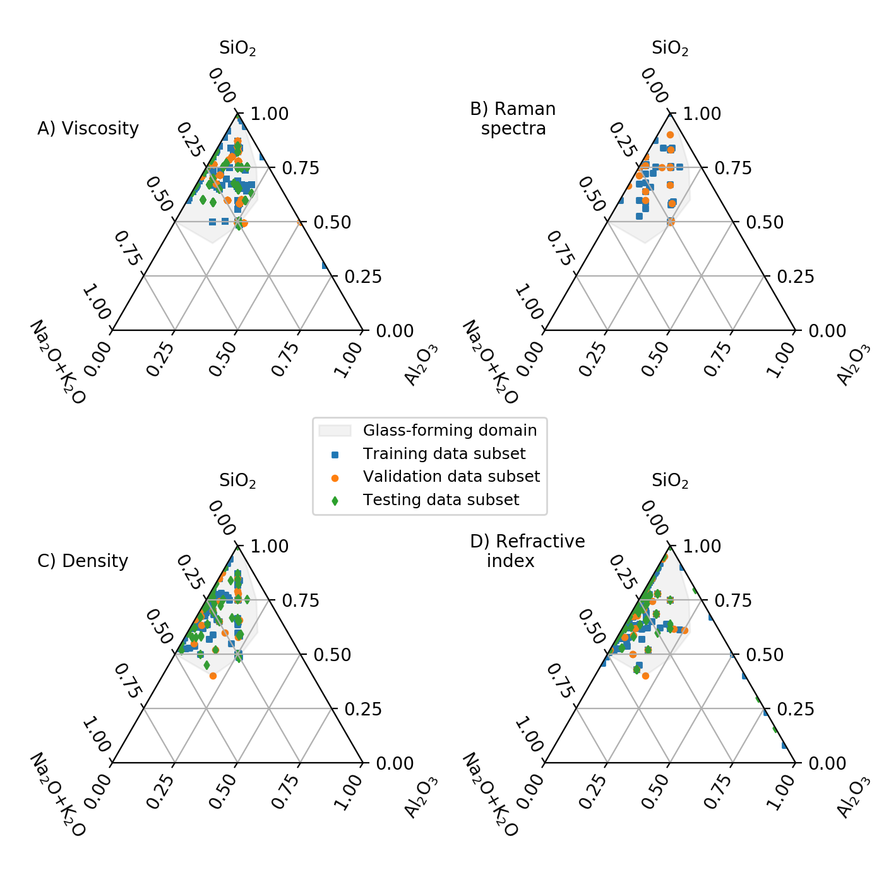Fig. S1. Viscosity (A), Raman (B), density (C) and refractive index (D) datasets used in this publication. Each symbol corresponds to a composition. The glass-forming domain at usual laboratory cooling rates is indicated in grey.

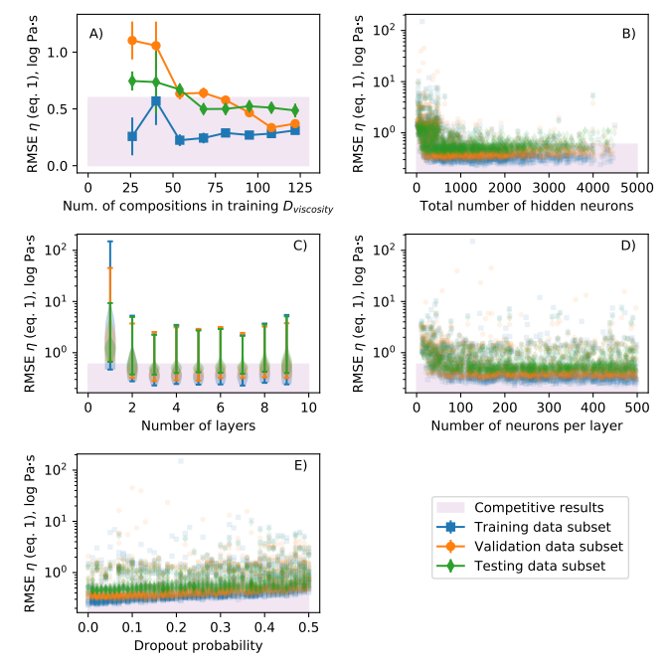Fig. S2. Network architecture and dropout influence on deep learning framework performance. RMSE between viscosity predictions made using the Adam-Gibbs model (eq. 1) and measurements in training, validation and testing data subsets as a function of the number of compositions in the training data subset (a), of the total number of hidden activation units (a.k.a. neurons, b), of the number of hidden layers (c), of the number of neurons per layer (d) and of the dropout probability (e). 2,000 neural networks were randomly selected and trained to obtain those results. Subplot (c) is a violin plot with extreme values showed. Subplots (b), (d) and (e) are scatter plots in which each slightly transparent symbol corresponds to a given neural network; less transparence is directly indicative of a higher number of models for a given X-Y value. Deep network still generalizes better than shallow one on this small problem. Overfitting is very limited limited but still present, as shown by systematically slightly lower errors on the training data subset.

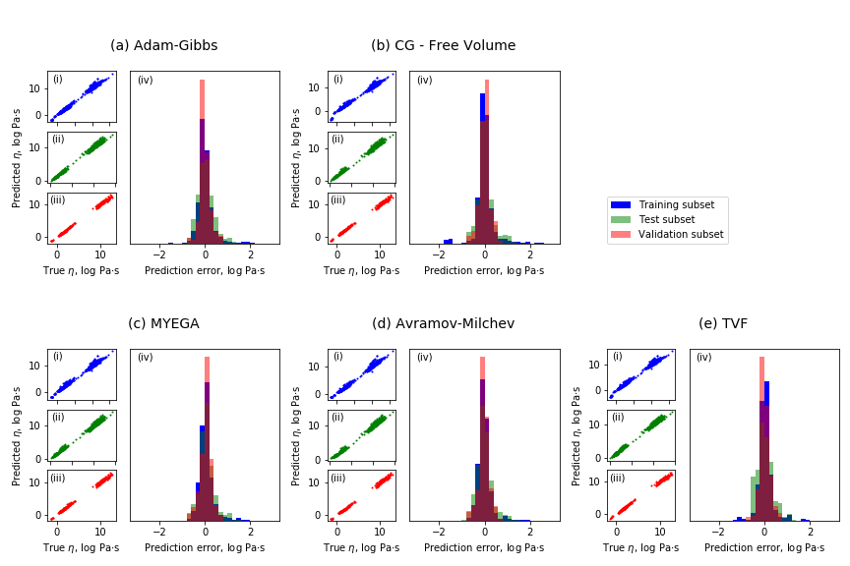Fig. S3. Comparison between predicted and measured viscosity in the Na2O-K2O-Al2O3-SiO2 system. Predictions can be made using theories like Adam-Gibbs (a) and free volume (b), or empirical equations like MYEGA (c), Avramov-Milchev (d), and Tamman-Vogel-Fulcher (e). See table S3 for RMSE and text for the equations.

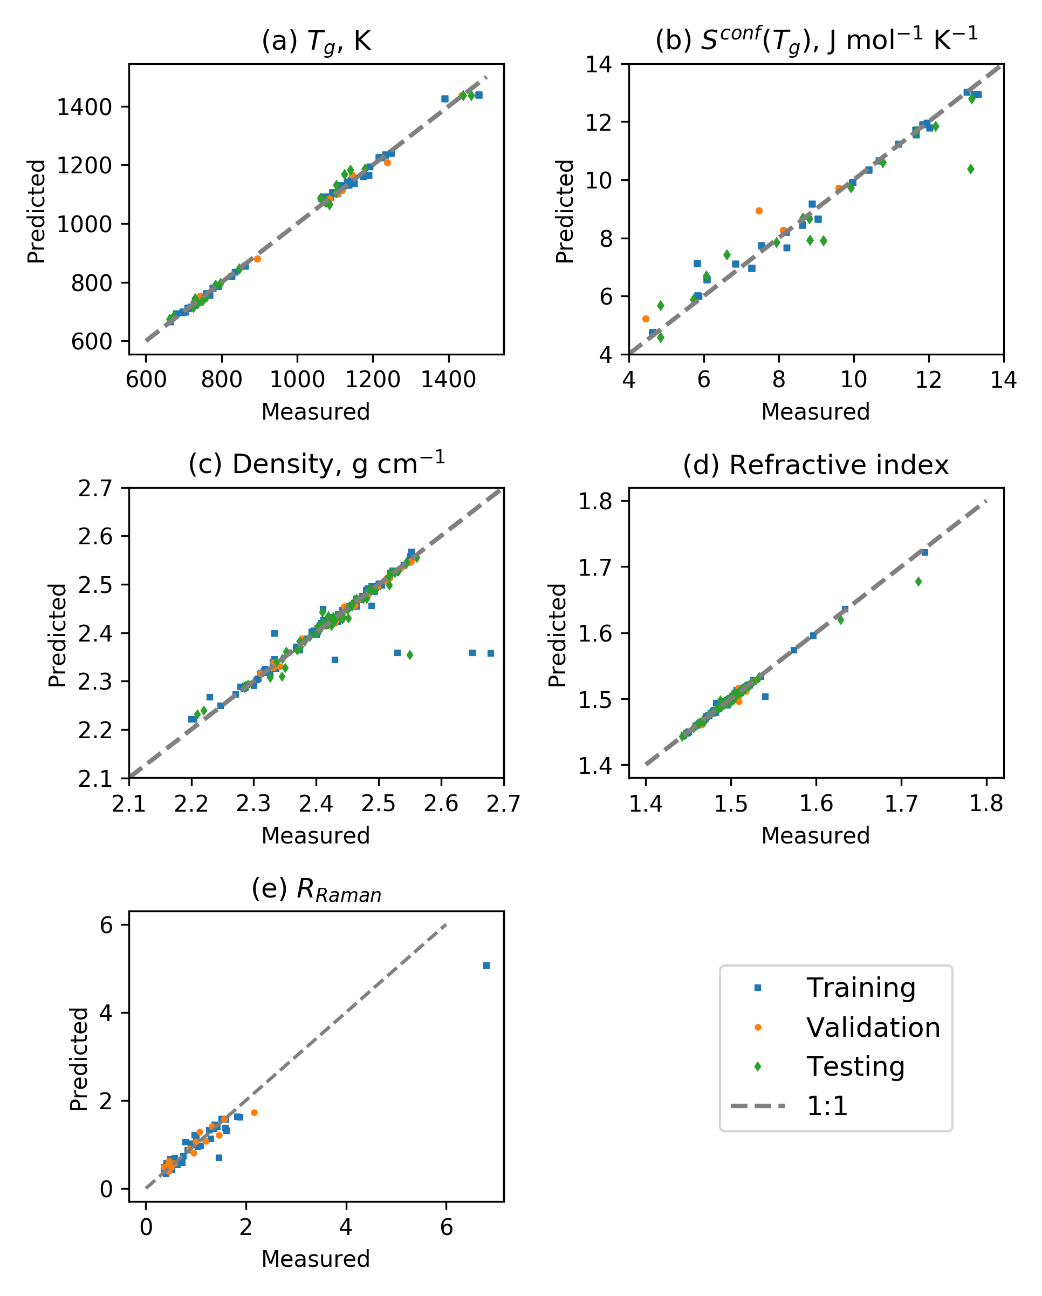Fig. S4. Comparison between predictions and observed viscous glass transition temperature (a), *Sconf(Tg)* (values from 4, 7, 19, 20, 23, 24) (b), density (c), refractive index (d), and R*Raman* (e). See table S3 for RMSE.

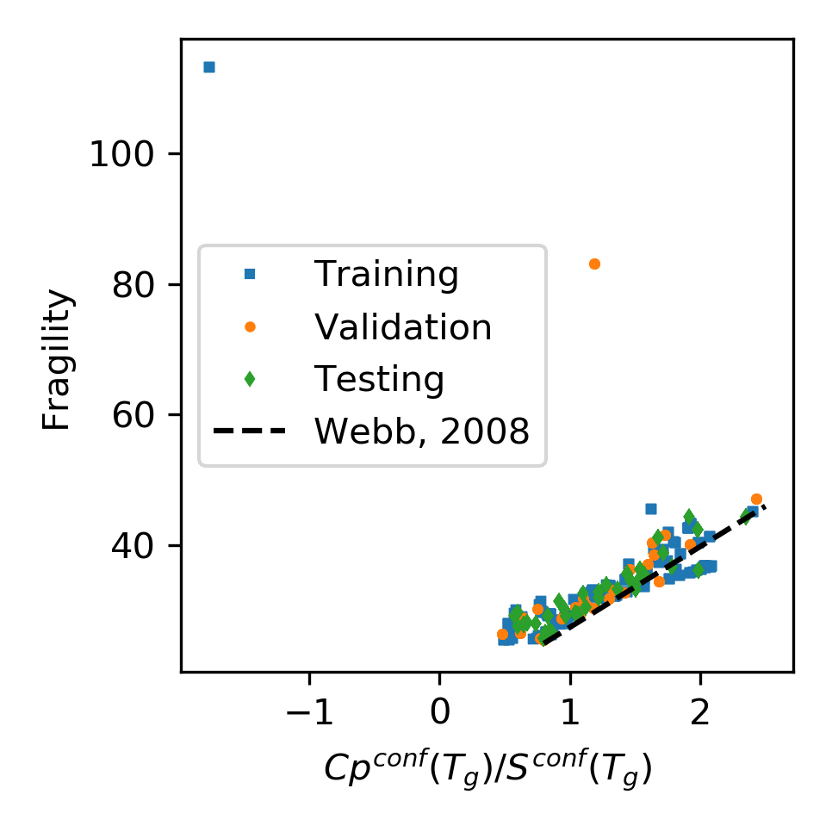**Fig. S5 Glass fragility versus melt *Cpconf(Tg)/Sconf(Tg)* ratio.** Symbols are predictions of the deep learning framework on the different subsets of the *Dviscosity* dataset. The back dotted line is the relationship observed by (*49*) using experimental heat capacity data. Except two extreme outliers that corresponds to Al2O3-SiO2 melts with more than 30 mol% Al2O3, a general good agreement is observed. This validates the internal consistency of the deep learning framework. The scatter indicates that a better agreement could be obtained with using a better heat capacity model for aluminosilicate melts. Such *Cp* calculation could be integrated in the present deep learning framework in the future albeit the acquisition of additional *Cp* data for ternary and quaternary aluminosilicate melts.

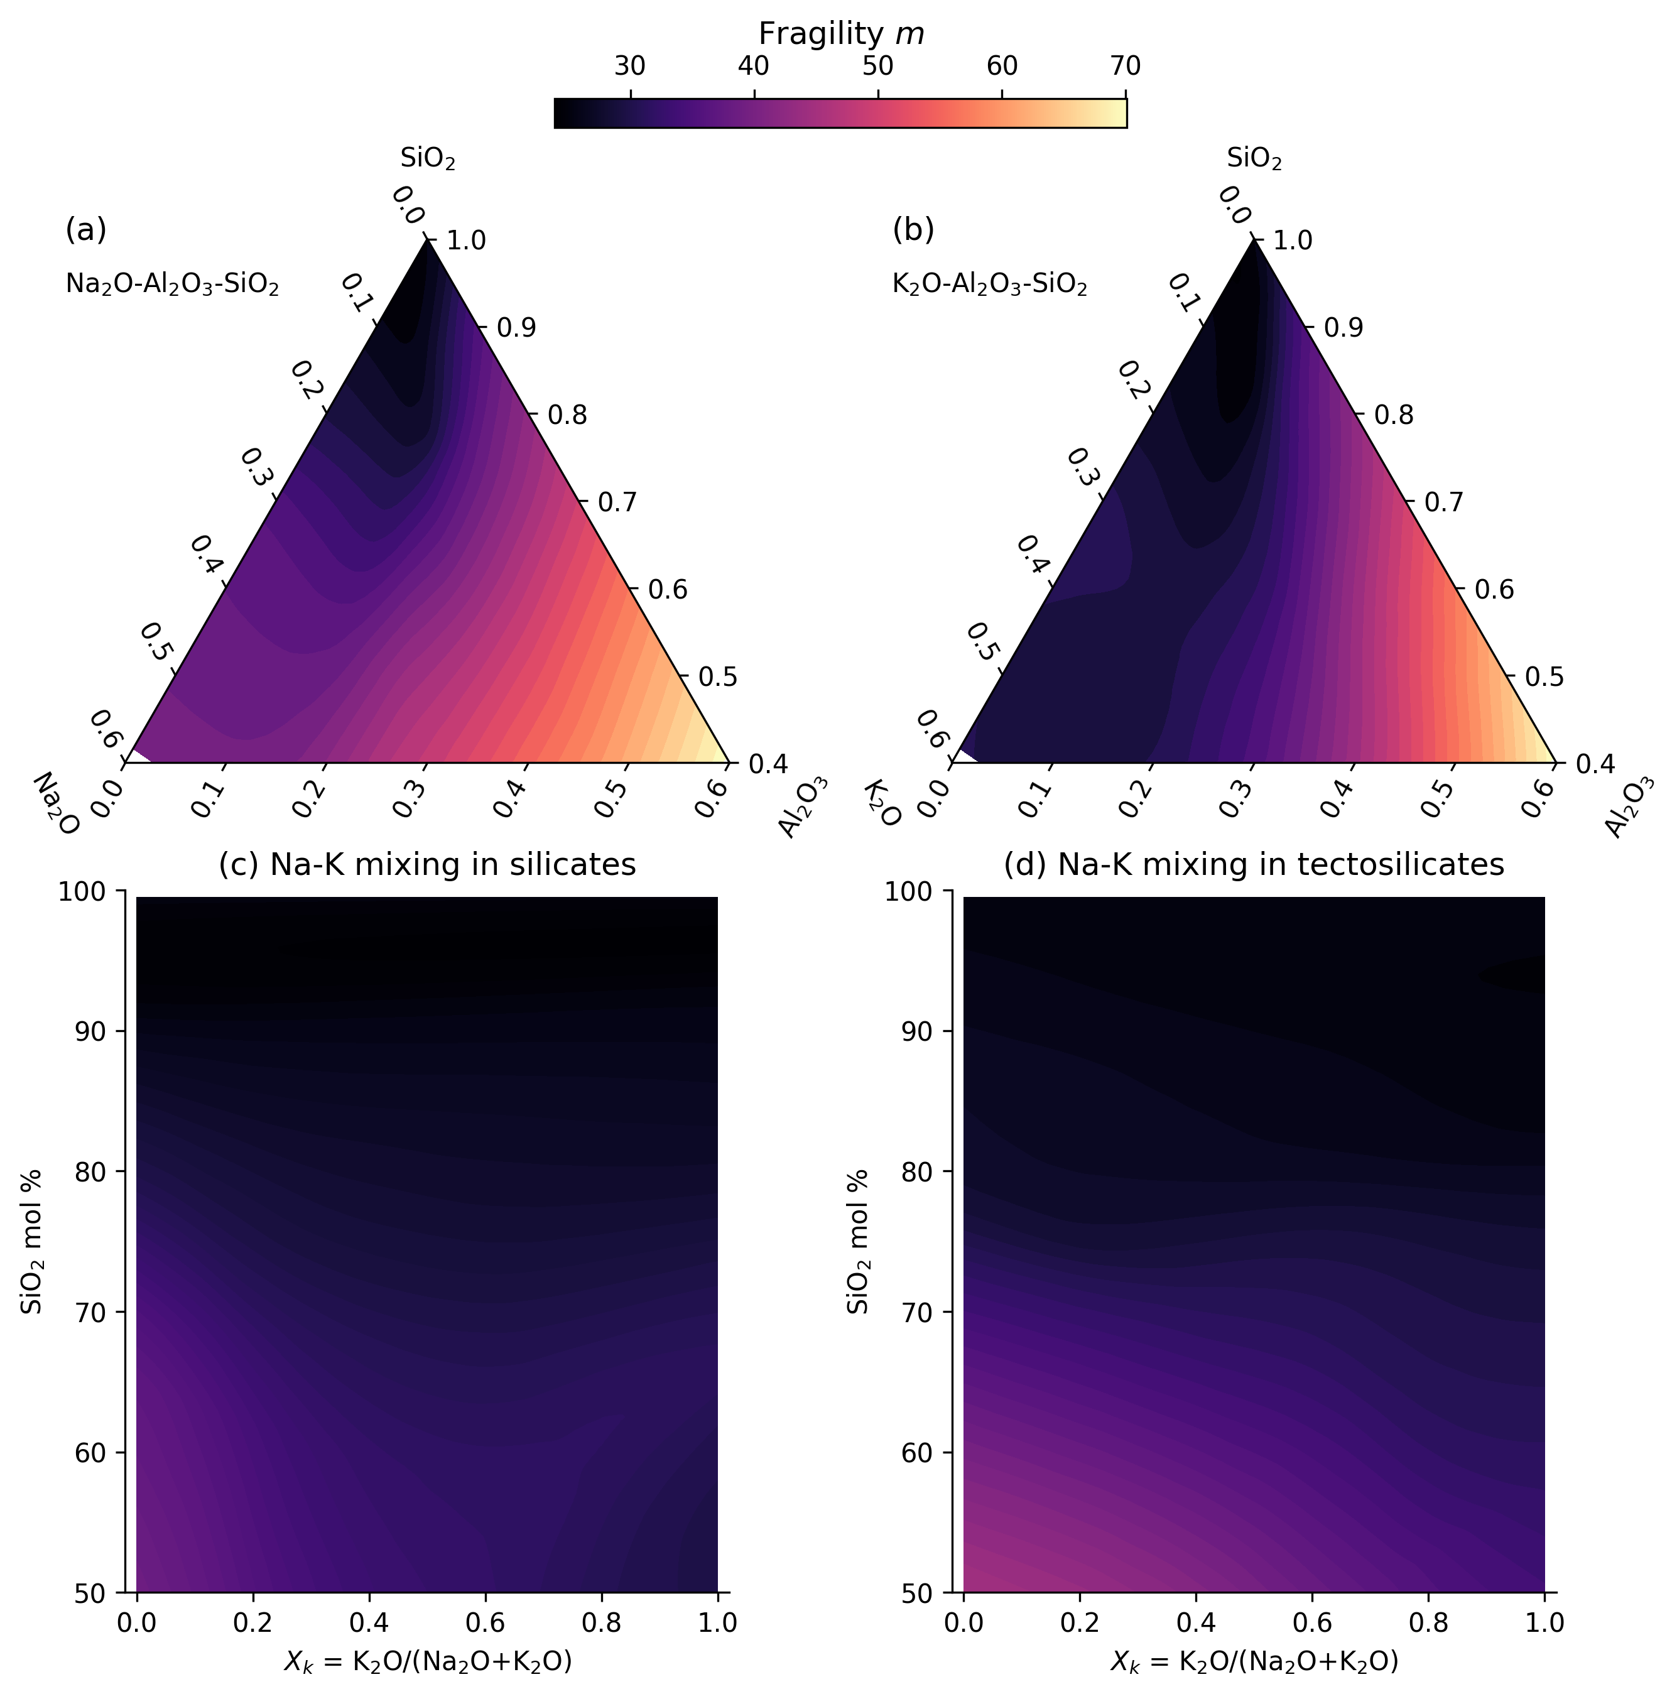

Figure S6: Melt fragility variations with composition. Fragility is represented in the glass forming domains of the ternary sodium (a) and potassium (b) aluminosilicate systems, as well as as a function of the silica fraction and the potassium to total alkali ratio of silicate (c) and tectosilicate (d) melts. No MAE is observed on melt fragility, which depends largely on melt silica content.

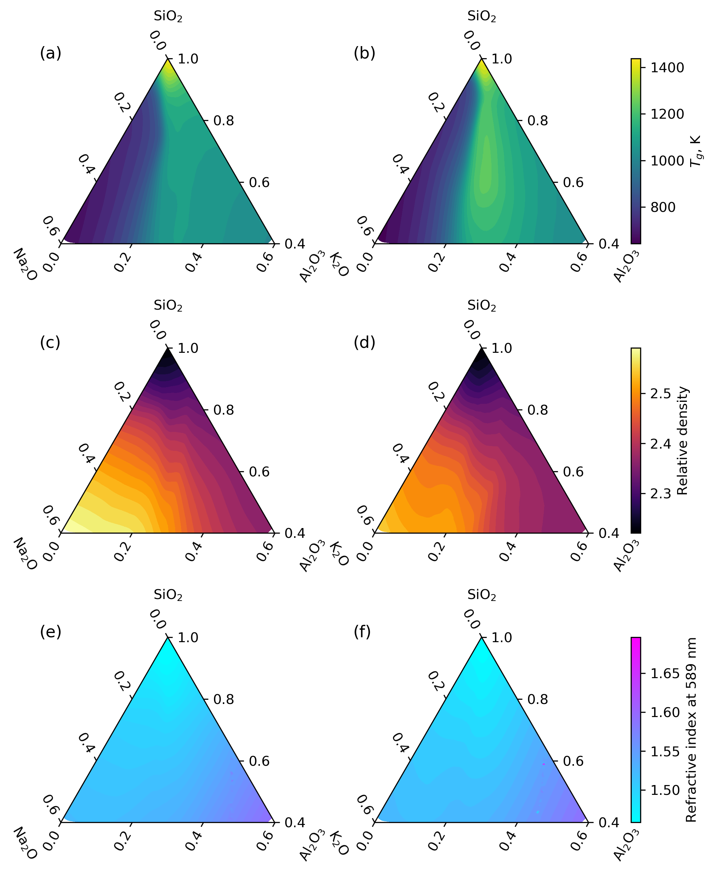Fig. S7 Deep learning framework predicted variations in glass transition temperature, relative density and refractive index in the ternary Na and K aluminosilicate diagrams.

|  |  |  |  |  |  |  |
| --- | --- | --- | --- | --- | --- | --- |
| **Glass name** |  | **%SiO2** | **%Al2O3** | **%K2O** | **%Na2O** | **Density, g cm-1** |
| KA80.05 | nom. mol% | 80.00 | 5.00 | 15.00 | 0.00 |  |
|  | nom. wt% | 71.40 | 7.60 | 21.00 | 0.00 |  |
|  | an. wt% | 74.85(44) | 7.56(14) | 15.12(22) | 0.00(4) | 2.320(1) |
| KA72.07 | nom. mol% | 72.00 | 7.00 | 21.00 | 0.00 |  |
|  | nom. wt% | 61.60 | 10.20 | 28.20 | 0.00 |  |
|  | an. wt% | 61.41(28) | 10.17(24) | 27.42(33) | 0.00(2) | 2.408(1) |
| KA65.09 | nom. mol% | 65.00 | 8.75 | 26.25 | 0.00 |  |
|  | nom. wt% | 53.70 | 12.30 | 34.00 | 0.00 |  |
|  | an. wt% | 53.32(55) | 12.49(43) | 31.68(28) | 0.00(3) | 2.451(10) |
| NA65.09 | nom. mol% | 65.00 | 8.75 | 0.00 | 26.25 |  |
|  | nom. wt% | 60.79 | 13.89 | 0.00 | 25.32 |  |
|  | an. wt% | 61.75(45) | 13.67(24) | 0.03(2) | 24.56(73) | 2.472(4) |
| NA58.10 | nom. mol% | 58.00 | 10.50 | 0.00 | 31.50 |  |
|  | nom. wt% | 53.55 | 16.45 | 0.00 | 30.00 |  |
|  | an. wt% | 54.61(28) | 16.42(18) | 0.05(2) | 28.92(37) | 2.502(5) |

**Table S1. Composition of the synthesized glasses.** Nominal (nom.) and analyzed (an.) compositions are reported. Standard deviations on measured values on 10 different spots (for EPMA measurements) or glass chips (for density measurements) are given in parenthesis (1 sigma confidence interval).

|  |  |  |  |  |  |  |  |  |  |
| --- | --- | --- | --- | --- | --- | --- | --- | --- | --- |
| **T, K** | **KA80.05** | **T, K** | **KA72.07** | **T, K** | **KA65.09** | **T, K** | **NA65.09** | **T, K** | **NA58.10** |
| 1013.1 | 9.10 | 921.5 | 9.37 | 941.3 | 9.55 | 834.0 | 9.01 | 827.3 | 10.10 |
| 1001.8 | 9.32 | 891.0 | 10.17 | 935.1 | 9.71 | 829.0 | 9.18 | 836.9 | 9.73 |
| 989.6 | 9.51 | 872.0 | 10.75 | 919.4 | 10.13 | 813.8 | 9.61 | 817.6 | 10.51 |
| 981.6 | 9.78 | 852.0 | 11.40 | 913.6 | 10.32 | 803.2 | 9.94 | 796.2 | 11.42 |
| 967.6 | 10.05 |  |  | 898.7 | 10.78 | 798.6 | 10.09 | 805.7 | 10.97 |
| 949.7 | 10.50 |  |  | 892.0 | 10.96 | 787.5 | 10.50 | 847.1 | 9.36 |
| 940.3 | 10.83 |  |  | 882.1 | 11.28 | 779.9 | 10.81 | 855.9 | 9.09 |
| 928.2 | 11.05 |  |  | 867.3 | 11.86 | 773.7 | 11.07 | 828.3 | 10.01 |
| 918.4 | 11.32 |  |  | 855.4 | 12.29 | 772.9 | 11.07 | 834.4 | 9.81 |
| 905.1 | 11.63 |  |  |  |  | 762.6 | 11.52 | 787.4 | 11.80 |
| 896.6 | 11.92 |  |  |  |  | 756.3 | 11.74 | 777.4 | 12.36 |
|  |  |  |  |  |  | 752.1 | 11.95 |  |  |

**Table S2. Viscosity measurements made on the synthesized glasses.** Viscosity is in log10 Pas and was measured using a creep apparatus following the protocol described in (*4*). Errors on temperature are lower than 0.3 K, and errors on viscosity lower, or equal to 0.03 log10 Pas.

|  |  |  |  |
| --- | --- | --- | --- |
| **Data subset:** | **Training** | **Validation** | **Testing** |
| **Adam-Gibbs (eq. S3, log Pas)** | 0.33 | 0.22 | 0.35 |
| **Free Volume (eq. S4****, log Pas)** | 0.36 | 0.23 | 0.36 |
| **TVF (eq. S5, log Pas)** | 0.36 | 0.25 | 0.35 |
| **MYEGA (eq. S7, log Pas)** | 0.36 | 0.25 | 0.34 |
| **Avramov-Milchev (eq. S6, log Pas)** | 0.34 | 0.24 | 0.34 |
| **Density (g cm-1)** | 0.07 | 0.08 | 0.08 |
| **Raman spectra (%, LAD)** | 18 | 22 | - |
| **Refractive index** | 0.003 | 0.003 | 0.005 |

**Table S3: Root-mean-square errors of the deep learning framework.** RMSE calculated between measured and predicted melt viscosity, density, refractive index, except for Raman spectra where a different metric is used (median least absolute deviation LAD).