Deep learning **predicts the properties of volcanic lavas and** glasses

Charles Le Losq1,2,3,*, Andrew Valentine2 , Bjorn O. Mysen3, Daniel R. Neuville1

*1Université de Paris, Institut de physique du globe de Paris, CNRS-UMR 7154, Paris 75005, France*

*2 Research School of Earth Sciences, Australian National University, Canberra 2601, Australia*

*3 Earth Planets Laboratory, Carnegie Institution for Science, Washington D.C. 20001, U.S.A.*

*\*Correspondence to:* [*lelosq@ipgp.fr*](mailto:lelosq@ipgp.fr)

**Abstract:** (139/150 w)

The way aluminosilicate lavas flow and degas drives the dynamics of volcanic eruptions. In parallel, in industrial furnaces, similar aluminosilicate melts are used to produce glass, and their properties drive glass-forming processes and end-product characteristics. Despite such importance, no general model allows predicting the molecular structural, thermodynamic and viscous properties of aluminosilicate melts. Here, a deep learning framework that combines a deep artificial neural network with thermodynamic equations is used for understanding and predicting melts and glasses properties, including viscosity, optical refractive index, density, and Raman signals. Trained on alkali aluminosilicate compositions, it reveals the link between nano-scale changes in lava composition/structure and the dynamic of mega-scale eruptions of silicic supervolcanoes like Yellowstone (U.S.A.). This is a glimpse into the possibilities offered by this approach, which provides a new way to build models of material properties for various applications.

**Introduction**

How do molten silicates move? How do they exchange heat with other media? How do they crystallize? These fundamental questions underpin many practical problems, including the dynamics of volcanic eruptions 1 , the formation of rocks 2, and the manufacturing of novel glass, glass-ceramic and ceramic materials. Addressing them requires knowledge of physical properties such as viscosity, heat capacity and entropy, which are ultimately governed by the liquid’s composition and associated atomic/ionic structure. At present, this information is inferred from specific experimental observations and/or thermodynamic or molecular dynamics (MD) simulations e.g. 3,4; these are usually restricted to a small range of liquid chemical compositions. Thermodynamic or empirical models may provide an intermediate way of predicting macroscopic properties, but these are usually highly simplified, and limited to predicting a handful of properties in a restricted compositional range (e.g., see for viscosity 5–9). Here, we show that these shortcomings can be resolved by combining theoretical equations and deep learning to construct a general predictive framework. This allows prediction of liquid properties under a wide range of realistic circumstances, and enables investigation of the fundamental links between material composition, structure and properties.

As a concrete example, we consider aluminosilicate melts and glasses, materials central to the Earth and material sciences 10,11. We particularly focus on compositions in the K2O-Na2O-Al2O3-SiO2 system, central to understanding the activity of silicic supervolcanoes like Yellowstone (U.S.A.) or Toba (Indonesia) 12, and for which a fairly complete dataset is available (Fig. S1). Viscosity is key to this problem 12, but the underlying structural and thermodynamic controls have yet to be properly characterized. A better understanding of – and ability to predict – the properties of alkali aluminosilicate glasses is also valuable beyond volcanology. For example, it can aid the development of technological glass materials such as smartphone screens 13. To address any such problems, we require a framework that links melt composition (*x*) and structure to physical properties and intensive variables such as temperature (*T*).

In this study, we show that it is possible to build such a framework using deep artificial neural networks. The i-MELT model (Fig. 1) we propose is built from a combination of a deep artificial neural network with various dynamic and thermodynamic equations. The artificial neural network either predicts directly-observable glass properties including density, refractive index and Raman spectra, or outputs the latent variables (such as configurational entropy, *Sconf(Tg)*, a property that reflects the melt structure) required to predict properties like melt viscosity (*η).* In the present case, this offers the ability to predict *η* within five theoretical and empirical models commonly used for reproducing experimentally-observed variations of viscosity with temperature for silicate melts: Adam-Gibbs, MYEGA, Avramov-Milchev, Tamman-Vogel-Fulcher and Free Volume Theory (Supplementary Material). While those models are popular for silicate melts, no strong consensus towards any one model appropriate for all liquids exists. Some of those models rely on very different theoretical backgrounds. For instance, the Adam-Gibbs theory 14 assumes that viscous flow originates from cooperative rearrangements of melt nanostructure, whereas the Free Volume theory 15 assumes that mobility at the molecular level is ensured by molecular jumps between free volumes. Our approach circumvent the problem of choosing one particular theory by proposing a “trans-theoretical” approach: the neural network simultaneously enables predictions across multiple theories, and is trained to provide best average performance across the selected theories. The neural network also provides optimal common values for parameters that appear in multiple theories, such as the glass transition temperature *Tg* (the temperature at which melt quench to glass upon rapid cooling).

**Results**

***Optimization of the artificial neural network architecture***

The i-MELT framework uses a feed-forward deep neural network (Fig. 1). Such network feeds its inputs to several fully connected hidden layers composed of a given number of activation units, a.k.a. neurons or perceptrons. Before presenting any results regarding the performance of the model, we first document the optimal architecture and the way we searched for it.

The architecture of the hidden layers was optimized via a random search 16. This allowed us to observe how the number of samples, the number of layers and that of hidden units affect the generalization ability of the artificial neural network (Fig. 2). After training 2000 artificial neural networks under the same conditions on the same datasets, we first observed that more than ~90 sample compositions are necessary to train efficiently the model (Fig. 2a), i.e. to avoid overfitting (the model performs good predictions on its training set but poor ones on new samples) as much as possible. Moderately deep networks with 3 to 5 layers and 200-300 units per layer perform best; accordingly, best performance is in general reached with more than 1000 neurons (Fig. 2b,c,d). Those results confirm that moderately deep neural network still generalizes better than shallow ones on this problem with small datasets. The dropout method, which consists in turning off *p* percent of neurons per layer at each training iteration in order to prevent overfitting 17, slightly helps preventing overfitting but is not a critical feature in the present case (Fig. 2e).

From this random search, we selected the 10 best neural networks with the lowest error on the validation data subset. Overfitting by each network is very limited limited but still present, as shown by systematically slightly lower errors on the training data subset (Fig. 2). To help limiting this issue, all reported predictions by i-MELT are calculated from the average of those from the 10 best neural networks. This method is called bagging 18 and promotes generalization (good predictions on new samples) of machine learning algorithms. For i-MELT, generalization was further promoted by the adopted training protocol (Methods) and by the multi-task learning strategy. Indeed, artificial neural networks learning to predict multiple related features/observables tend to show better prediction abilities compared to those trained to predict only a given task/parameter/feature 19. The overall adopted training strategy allowed i-MELT to perform good predictions on new samples despite our small experimental datasets, as documented below.

***Melt and glass property predictions***

The i-MELT model allows accurate predictions of liquid and glass properties. Trans-theoretical predictions of *η* (Fig. 3, Figure S2) are possible with good precision (σ* *< 0.4 log Pa·s on unseen data, Table S3; for comparison, σ* * 0.6 log Pa·s* *for the best empirical magma viscosity models e.g. 6). Known viscous *Tg* and *Sconf(Tg)* are predicted within 16 K and 0.8 J mol-1 K-1, respectively, and glass density and refractive index are predicted within 0.009 g cm-3 and 0.005, respectively (Fig. S3).

***Structural information through Raman spectra predictions***

In addition to physical and thermodynamic properties, i-MELT has the ability to predict structure-dependent features such as glass Raman spectra. Considering the very small experimental Raman dataset (Fig. S1), global variations of Raman signals have been captured well (Fig. 2b, S4) and can be predicted within ~20 % (average mean absolute deviation between observed and predicted spectra). i-MELT thus embeds structural information, and allows estimation of structural parameters from Raman spectra including the ratio of intra- and inter-tetrahedral aluminosilicate vibrations, *RRaman* (Fig. 2b). This ratio serves as a proxy for the glass network topology, i.e. the 3D connectivity of the polyhedral SiO2-AlO2 network. The higher *Rraman* is, the higher the aluminosilicate network connectivity. Because of such link, *RRaman* is linked to variations in melt properties 20. *Rraman* can be predicted within 15%.

**Discussion**

i-MELT allows a systematic exploration of the links between melt composition, molecular structure and physical/thermodynamic properties. For example, we can explore why viscosity varies substantially according to the concentration of Al and K in Na2O-K2O-Al2O3-SiO2 melts, a phenomenon that affects the dynamic of volcanic eruptions as introduced previously. We first observe how melt composition, structure and thermodynamic/dynamic properties are linked. In particular, i-MELT allows a systematic documentation of the known division between topological and chemical effects on different properties 21. Glass network topology correlates with the glass transition temperature (Fig. 4a), and with quantities proportional to energy barriers opposed to ionic mobility in melts like the *BCG* term of the Free Volume viscosity equation (Fig. 4b, Supplementary Materials). It also correlates well with the glass refractive index (Supplementary Materials). The glass transition temperature *Tg* exhibits detailed compositional dependence. This agrees with with the well-known mixed alkali effect (MAE) 22,23 that can affect *Tg*, and that result from metal cation interactions in the melt. While it only slightly influences properties that directly are linked to the aluminosilicate network connectivity 8, such chemical mixing effect strongly affects properties influenced by cationic interactions and steric hindrance effects, such as the configurational entropy *Sconf(Tg)* 8,21,24,25 or the term *CFV* that encompass local cationic influences on melt free volumes in the Free Volume theory (Fig. 4c,d, Supplementary Text). Results actually suggest a link between *CFV* and *Sconf(Tg).* This agrees with the possibility of building a free volume version of the Adam-Gibbs viscosity equation (Supplementary Text).

The above observations highlight the important role of cationic mixing effects on variables such as *Sconf(Tg)*. Cationic mixing can be random 21,25 or not 26,27, and is usually difficult to predict. i-MELT solves this problem by enabling systematic quantification and visualization of such phenomena (Fig. 5). For the system analyzed here, increasing [Al] leads to decreasing *Sconf(Tg)* (Fig. 5a,b). Furthermore, Al-to-alkali ratio largely affects the MAE: without Al, the MAE results in an entropy excess (Fig. 5c) and, hence, in large decreases in melt viscosity as . Increasing [Al]/[Na+K] leads to changing the role of alkali metals in the network 28. Na and K segregate in different molecular nano-environments 8,29, inducing less and less excess entropy of mixing as [Al]/[Na+K] increases. As a result, *Sconf(Tg)* varies more and more linearly upon mixing Na and K (Fig. 5d,e,f). Finally, i-MELT predicts small *Sconf(Tg)* values for K-rich and Al-rich melts (Fig. 5b,f), a finding explained the fact that Al and K respectively promote network polymerisation and nano-structuration in aluminosilicates 4,28.

The later finding puts us in a position to understand why eruptions of silicic volcanoes may be more explosive if the magma is rich in K and Al, as suggested by 12. Indeed, among the usual critical parameters driving the dynamic of volcanic eruptions such as pre-eruptive volatile content, degassing path and nano-cristallization 12,30,31, explosive or effusive eruptions of silicic volcanoes respectively appear to involve lavas more or less rich in Al and K (Figure 6). Most of the lavas emitted at silicic volcanic systems, like Yellowstone or Long Valley (U.S.A.), present dry chemical compositions made of more than 95 % of Na2O, K2O, Al2O3 and SiO2. Melts in the Na2O-K2O-Al2O3-SiO2 system can thus be considered as simplified analogues of the lavas involved in silicic volcanic eruptions, such that i-MELT can be used to glimpse the links between eruptive dynamics and magma composition, structure, and properties. From the deep learning framework predictions, the transition between effusive and explosive silicic eruptions originates from a decrease in *Sconf(Tg)* driven by ongoing network connectivity and nano-structuration as [Al] and [K] increase (Fig. 6). The chemical separation between effusive and explosive eruptions at silicic volcanic centers is associated, according to the present work, with limits in *RRaman* and *Sconf(Tg)* of ~1.5 and ~9.0 J mol-1 K-1, respectively. Those values are derived from the analysis of simplified alkali aluminosilicates and thus may vary slightly in the case of natural rhyolite, particularly when considering the role of iron and water that cannot be discussed here. In any case, those results demonstrate that a more complete version of i-MELT, embedding the effects of Ca, Mg, Fe and water, would provide the ability to explore and quantify even further the links between magma composition, structure, properties, and volcanic eruptive styles.

In conclusion, the results presented here highlight how a deep learning framework like i-MELT can be used for practical property predictions in the Earth sciences. Here, it reveals the fine structural and thermodynamic controls on magma viscosity, which, in turn, govern the dynamics of volcanic eruptions. The presented model further has the ability to predict glass properties, and can be used for the design of new glass materials. i-MELT can readily be extended to include quantities of interest across a range of domains and applications, like glass toughness and hardness. More generally, the present results demonstrate that the approach we adopted, based on the combination of machine learning with physical/thermodynamic models, can offer new perspectives on long-standing problems in many disciplines.

**Methods**

***Experimental Design***

Developing the model required the collection and compilation of viscosity, density, refractive index data, and Raman spectra for glasses and melts in the K2O-Na2O-Al2O3-SiO2 quaternary diagram (Fig. S1). The viscosity of supercooled melts for peralkaline compositions in this diagram remains poorly-understood, and we conducted additional experiments to complement the existing dataset. We further compiled existing data as specified below, prior to developing the i-MELT framework in the Python programming language using the PyTorch library. The codes can be run using Jupyter Notebooks. All codes and data necessary to reproduce this study can be found on the software repository Github at the web address <https://github.com/charlesll/neuravi>.

***Datasets***

Existing Raman spectra and observations of optical refractive index, density and viscosity of alkali aluminosilicate glasses were selected by hand via a review of the existing literature. Cross-validation of the accuracy of viscosity data from different studies is critical and was checked on compositions including sodium trisilicate, albite and jadeite. Publications presenting deviations larger than 0.1 log Pa·s compared to the general literature trend on such compositions were discarded. Density and refractive index come from various publications reviewed in 32. Raman spectra are published data from the IPGP and Carnegie Institution for Science laboratories (see below for details). Four different streams of data are thus present:

- *Dviscosity*, the dataset of viscosity measurements, composed of *Xviscosity* chemical composition entries (mole fractions) as well as their associated temperatures (Kelvin) and *yviscosity* observations (Pa·s);

- *Ddensity*, the dataset of density measurements, composed of *Xdensity* chemical composition entries (mole fractions) and *ydensity* observations (g cm-3);

- *DRaman*, the dataset of Raman spectra, composed of *XRaman* chemical composition entries (mole fractions) and *yRaman* spectra observations (min-max scaled Raman intensities);

- *Doptical*, the dataset of optical refractive index, composed of *Xoptical* chemical composition entries (mole fractions) as well as their associated wavelength (µm) and *yrefractive index* observations.

*Dviscosity*, *Ddensity* and *Doptical* cover an important part of the glass-forming domain of alkali aluminosilicates (Fig. S1); they were thus used to train the artificial neural network with a performance oriented mindset. *DRaman* covers a more limited set of compositions (Fig. S1). It was used as a way of improving multitask learning as well as a way of introducing structural information in the deep learning framework.

***Sample synthesis and viscosity-density measurements***

To extend the viscosity dataset for peralkaline aluminosilicate melts, new compositions were synthesized at IPGP in Paris from reagent-grade K2CO3, Na2CO3, Al2O3 and SiO2 dried oxide powders, following the protocol described in 29. Viscosity and density measurements follow the protocol described in 28,29. Chemical compositions (Table S1) have been measured using a Cameca SX50 electron microprobe, with a 30 nA current, U = 30 kV, and 5 seconds of counting. Beam-induced alkali loss was minimized by working with a defocused beam that was moved continuously during the analysis. The mean and standard deviation values reported in Table S1 are calculated from 10-20 individual measurements on each sample. The corresponding viscosity measurements are provided in Table S2, and are affected by an error lower or equal to 0.04 log Pa·s.

***Raman spectroscopy***

Raman spectra of silicate and aluminosilicate glasses acquired at IPGP in Paris were recorded using a T64000 Jobin-Yvon® Raman spectrometer equipped with a confocal system, a 1024 charge-couple detector (CCD) cooled by liquid nitrogen and an Olympus® microscope. The optimal spatial resolution allowed by the confocal system is 1-2 μm2 with a ×100 Olympus® objective, and the spectral resolution is 0.7 cm-1. A Coherent® laser 70-C5 Ar+, having a wavelength of 488.1 or 514.532 nm, has been used as the excitation line. Unpolarized Raman spectra were acquired between 20 and 1500 cm-1 on pieces of glass from the starting materials that were excited with a laser power of 100-150 mW on the sample.

Additional Raman spectra acquired at the Geophysical Laboratory on glasses along the K2Si4O9-K2(KAl)4O9 and K2Si4O9-K2(KAl)4O9 joins were added to the database. Those spectra were acquired with a Dilor XY confocal microRaman spectrometer equipped with a cryogenic Thompson Model 4ooO CCD. The 488 nm line of a SpectraPhysics model 2025 Ar+ laser operating at several hundred mW at the sample was used for sample excitation.

Preprocessing of the spectra was kept to minimum: (i) a linear baseline was adjusted to the minima in the 700-800 and 1200-1300 cm-1 portions of the spectra and then subtracted to obtained baseline-corrected spectra, (ii) the spectra were then corrected from temperature and excitation line effects 28,29, and (iii) the spectra were normalised to their maximum intensity such that the intensity in each spectrum varies between 0 and 1. Only signals in the 400-1250 cm-1 range were retained as different spectra had different starting and ending Raman shift values. After pre-processing, spectra were saved in a HDF5 file for their future use.

***Deep learning model***

*Overview*

The i-MELT model is implemented in Pytorch. It performs predictions by averaging the predictions of the best 10 trained neural networks 18 selected after training 2000 neural networks containing various randomly selected numbers of layers and activation units per layers. Training was done with the ADAM optimizer with a learning rate of 0.001. Generalization was promoted by the use of dropout, early stopping and the multi-task learning strategy 19,17,33.

*Train-Validation-Testing split and standardisation*

To monitor overfitting, the available datasets were split in three different, randomly chosen *training*, *validation* and *testing* subsets (Fig. S1). During the training process, the *training* subset was used for training the model while the *validation* subset was used for monitoring overfit and trigger early stopping. The final predictive abilities of the trained neural networks were then evaluated using the unseen *testing* data subset. In the present study, the data were randomly separated by composition 34 to avoid the pitfall of having the same composition in the different *training*, *validation* and *testing* subsets (a phenomenon known as ‘data leakage’). While *Dviscosity, Doptical* and *Ddensity* were each separated in three splits following the above protocol (Fig. S1), *DRaman* was divided in only two *train* and *validation* subsets due to its small size. This is not problematic, as we do not aim at precise predictions of Raman spectra but rather use this dataset as a way to improve the predictive capacity of the trained neural network and to introduce structural knowledge.

After train-validation-test splitting, an important step in any machine learning data preprocessing is standardization of the data. In practice, appropriate data scaling is often essential to obtaining good convergence within algorithms 33. The goal of re-scaling is to promote feature variations close to unity and ensure that all features have comparable numerical ranges: failure to do so tends to lead to instabilities in the gradient back-propagation process that is central to training neural networks. In the present study, we have implemented a custom approach. All chemical compositions inputs are in mole fractions, which corresponds to a modification of min-max (0-1) scaling. Raman spectra were normalised to be comprised between 0 and 1. Viscosity, density and refractive index were not scaled, as scaling the outputs was not found to affect network convergence. However, as we will see, when outputs are unscaled it is essential to properly initialise the bias of the output layer of the neural network to match the expected range of the predictions to be made, as done for instance for Mixture Density Network 35.

After pre-processing, the different scaled *training*, *validation* and *testing* data subsets were saved in HDF5 files for their future use.

*i-MELT model implementation*

i-MELT takes four inputs: the mole fractions of SiO2, Al2O3, Na2O and K2O. These are fed into to a neural network composed of *n* hidden layers, each one having *k* activation units (a.k.a neurons). Changing *k* between different hidden layers in a single network did not improve training convergence or final predictive abilities, such that we chose to keep *k* constant between the different hidden layers for simplicity. Having explored various alternatives, we adopted the now-popular rectifier function 36, so that a neuron receiving input *x* returns output *y = max(0,x)*. The outputs of this core network were fed to two final linear layers. The first output layer returns vectors that we regard as Raman spectra, calculated from the linear sum of the last neural network hidden layer. The second output linear layer returns 16 different values:

- the parameters *Ae*, *AAM*, *ACG* and *ATVF* (eqs. S1 to S5), as well as the coefficients *B1* to *B3* and *C1* to *C3* of the Sellmeir equation (see eq. 1) for the calculation of the glass refractive index *n* are directly given by the linear outputs; and

- the natural logarithms of *Sconf(Tg)*, *CCG*, *Tg*, *To*, *T1*, the melt fragility *m*, and the glass density *d*.

The use of the logarithm in the latter case was inspired by a strategy proposed by 35, and ensures that quantities are assigned positive values in accordance with their physical meaning. We also find it aids rapid convergence during training. One trick for this method to work is to properly set the initial values of the biases of the last output layer to realistic values when creating the network.

Neural network predictions can be used in the physical theories embodied by equations S1 to S5 to obtain predictions of melt viscosity, and provide directly different values like glass density, glass transition temperature or Raman spectra. Furthermore, the coefficients *B1* to *B3* and *C1* to *C3* are used to predict the refractive index at given wavelength, , via the Sellmeier equation:

*. (1)*

Our neural network therefore allows us to input compositions and obtain predictions for:

* melt viscosity, within five distinct theoretical frameworks,
* glass transition temperature,
* latent variables like configurational entropy and fragility,
* glass density,
* glass refractive index as a function of wavelength, and
* glass Raman spectra.

These predictions depend on a large number of tuneable parameters embedded within the neural network. During network training, we use our database of observed glass properties to optimize these parameters, seeking good average predictive performance.

*Training*

During training, we monitored the least-square deviations between measurements and predictions for the viscosity from eqs. S1 to S5 (Supplementary Materials) as well as density, optical and Raman spectra. We further added loss functions for known viscous *Tg* and *Sconf(Tg)* values in the dataset *Dviscosity*. This enables better-constrained estimates of *Sconf(Tg)* because this parameter is hard to evaluate as the Adam and Gibbs equation S1 does not have a well-defined, unique solution but multiple optimal solutions due to strong correlations between *Be* and *Sconf(Tg)* originating from the intervention of the intrinsic entropy *Sc\** in both *Be* and *Sconf(Tg)*(*7*). The present approach was introduced to make the network less sensitive to this correlation. For the same reason, the network does not predict directly *Be*; this term is instead calculated as *.* A similar strategy was adopted to calculate BFV and BTVF from the other parameters.

Batch training was performed using the Adam optimizer with a learning rate of 0.001, and monitoring the global loss on the *training* and *validation* data subsets. Early stopping 33 was used to avoid overfitting: when the global loss function on the *validation* data subset stopped decreasing for more than 50 epochs, training was stopped and the network presenting the best validation loss was saved. This, combined with the other strategies (dropout, bagging and multitask learning), avoided overfitting as much as possible despite a limited and sparse dataset.

***Statistical Analysis***

Following the bagging method, we make predictions based on the mean of the ten best neural networks obtained from the random exploration of the network architecture (see above). This improves generalization, and also allows a statistical analysis of the influence of the network size on the predictive ability of the deep learning framework (see previous section as well as Fig. S2). The influence of the dataset size was explored through training ten neural networks with the same architecture with different *training* subset of *Dviscosity*. Results of this experiment, presented in Fig. 2a, thus represent the mean of those 10 different neural networks. Finally, the correlation between the different predicted parameters was explored using the Spearman correlation coefficient that allows observing non-linear correlations between different variables (see Supplementary Notebook).

References and Notes. (70 citations max main text)

La mise à jour automatique des citations est désactivée. Pour voir la bibliographie, cliquez sur Actualiser dans la barre d'outils Zotero.

**Acknowledgments:** CLL thanks Malcolm Sambridge (Seismology & Mathematical Geophysics, RSES, Australian National University), Lexing Xie and Cheng Soon Ong (CECS, Australian National University), and Sung Keun Lee (Seoul National University) for various discussions regarding optimization, machine learning, and melt and glass properties.

**Funding:** CLL acknowledges funding from a Chaire d’Excellence IDEX19C627X/FD070/D110 from the IdEX Université de Paris ANR-18-IDEX-0001, from the Australian Research Council Laureate Fellowship FL1600000 to Prof. Hugh O’Neill (ANU-RSES) as well as from the Postdoctoral Fellowship of the Carnegie Institution for Science during the realization of this project. APV acknowledges support from the ARC via grants DE180100040 and DP200100053.

**Author contributions:** CLL designed the study, collected the data, performed Raman and viscosity experiments, and developed the deep learning framework and the associated computer code. AV and BOM helped in the design of the neural network. CLL, BOM and DN performed Raman measurements. CLL and AV drafted the manuscript. All authors contributed to the final version of the manuscript.

**Competing interests:** Authors declare no competing interests.

**Materials & Correspondence:** All the data are available in the main text or the supplementary materials. The computer code to reproduce the results of this study is available as a Python library at the web address <https://github.com/charlesll/neuravi> (open access will be provided upon acceptance). Correspondence can be addressed to the corresponding author.

**Supplementary Materials:**

Supplementary Text

Figures S1-S6

Tables S1-S3

**Fig. 1.** **Schematic of i-MELT.** An artificial neural network takes input melt composition, and outputs various melt and glass properties. Once trained, relationships between chemistry, structure and properties of melts and glasses can be systematically explored.

**Fig. 2. Neural network architecture and dropout influence on predictive performance.** Predictive performance was documented using theRMSE between viscosity predictions (from eq. S1) and measurements in training, validation and testing data subsets. 2,000 neural networks with randomly selected architectures were selected and trained to obtain those results. The effects of the numbers of (a) compositions in the training data subset, (b) hidden activation units, (c) hidden layers, (d) neurons per layer, and of the dropout probability (e) were explored. Subplot (c) is a violin plot with extreme values showed. Subplots (b), (d) and (e) are scatter plots in which each slightly transparent symbol corresponds to a given neural network; less transparence is directly indicative of a higher number of models for a given X-Y value.

**Fig. 3. Prediction examples.** **(a)** Melt viscosity can be predicted using various theories with a great accuracy, as shown by examples highlighting the good match between measurements (symbols) and model (curves) predictions from the Adam-Gibbs and Free Volume theories (Supplementary Materials). **(b)** Structural investigation are made through Raman spectra predictions, which compare well with experimental data for albite and sodium trisilicate glasses for instance. R*Raman*, the ratio of intertetrahedral (below 670 cm-1) to intratetrahedral (above 870 cm-1) network vibrations, can be calculated and used for structural investigations.

**Figure 4: Melt and glass properties vary in a complex way with glass network topology**. **(a)** i-MELT reveals that parameters such as the viscous glass transition temperature *Tg* **(a)** and *BCG,*an activation energy term in the Free Volume theory (Supplementary Materials) **(b),** strongly vary depending on R*Raman*. Other terms also show more complex variations, influenced by cationic mixing interactions and steric hindrance effects, such as the glass configurational entropy *Sconf(Tg)* **(c)**or the free volume parameter *CCG* **(d).** Each symbol represents the calculation for a randomly generated composition in the glass-forming domain of studied system.

**Figure 5: Configurational entropy at *Tg* of K2O-Na2O-Al2O3-SiO2 melts.** *Sconf(Tg)* vary non-linearly with oxide contents in the ternary diagrams **(a)** Na2O-Al2O3-SiO2 and **(b)** K2O-Al2O3-SiO2. In silicate melts **(c)**, a mixed alkali effect (MAE) is observed upon Na-K mixing. It disappears as [Al]/[Na+K] increases **(d, e, f)**. Al enrichment generally lead to decreasing *Sconf(Tg)*, and minimizing the MAE. Al- and K-rich melts thus present low *Sconf(Tg)*.

**Figure 6: Chemical, structural and entropic mapping of rhyolite effusive and explosive eruptions.** The rheological agpaitic index is calculated as (Na2O + K2O + CaO + MgO + FeO)/(Al2O3 + Fe2O3). From 12, Al-rich and K-rich rhyolite magmas, like those of Yellowstone (U.S.A.) are generally associated with explosive eruptions. The rheological tipping point proposed by 12 find roots in how increasing Al and K contents promote 3D network connectivity (a) and, thus reduces melt entropy (b) down to a particular threshold here identified to be ~ 9 J mol-1 K-1. Data from 1.

**Figure 1**

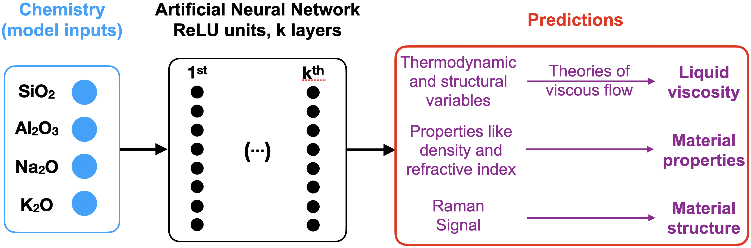

**Figure 2**

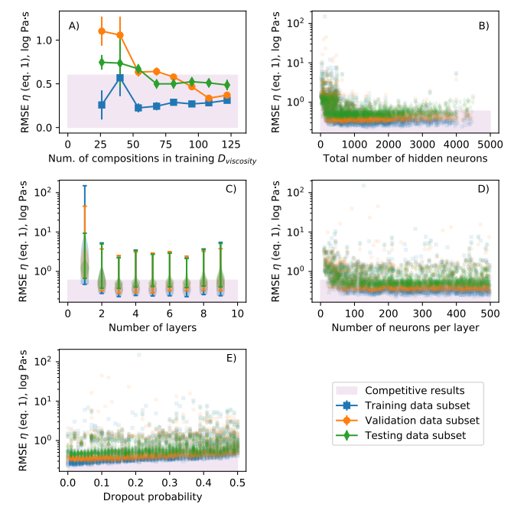

**Figure 3**

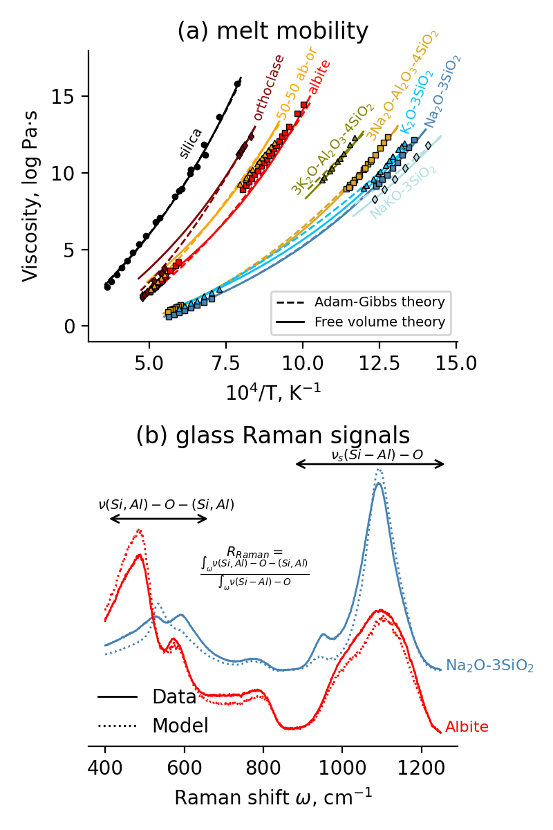

**Figure 4**

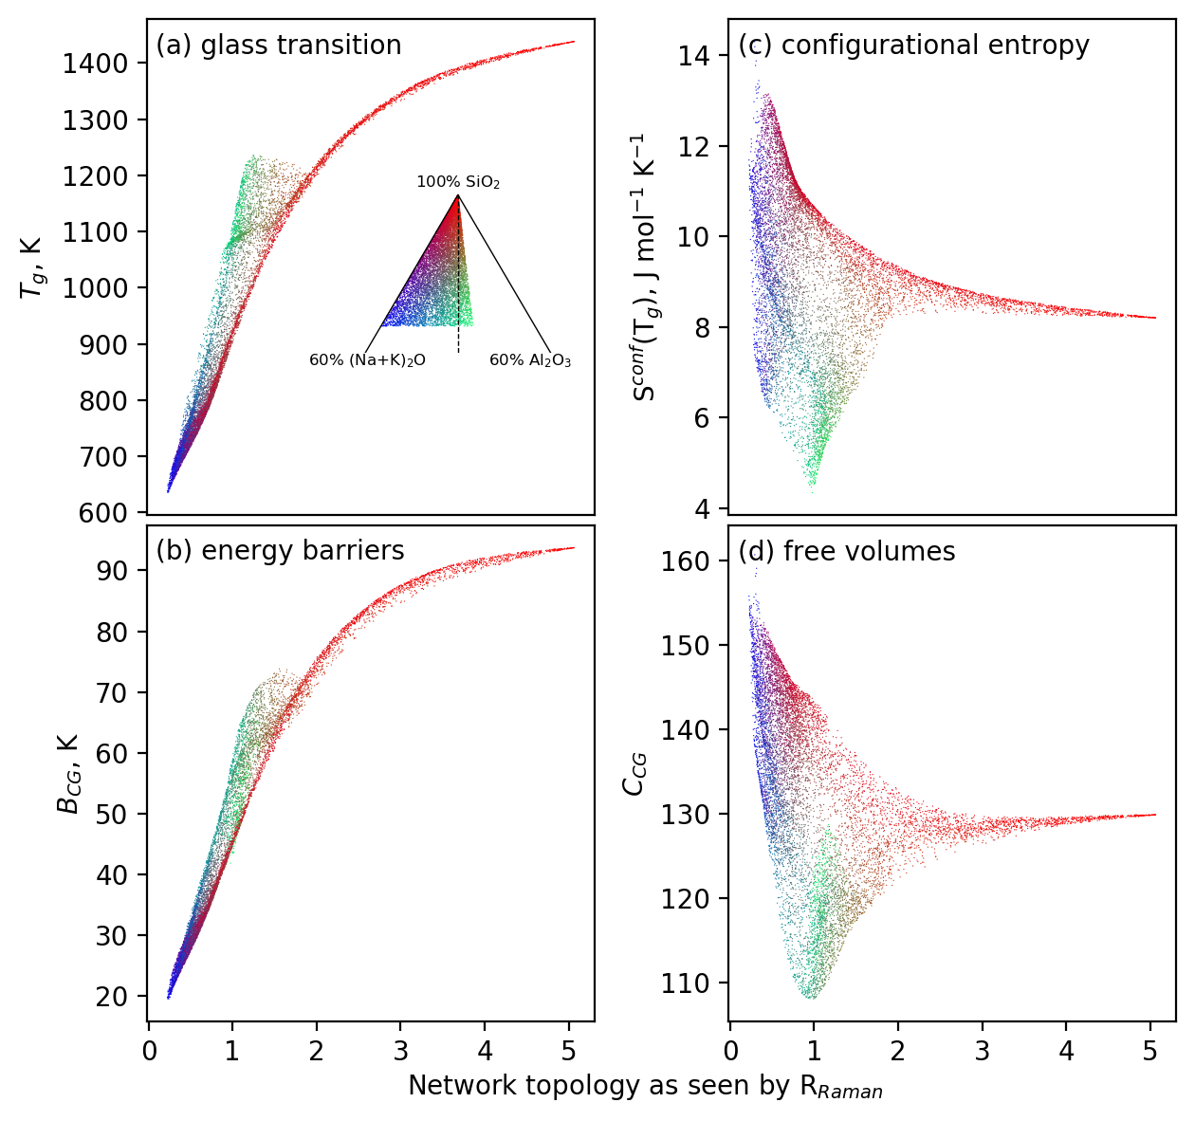

**Figure 5**

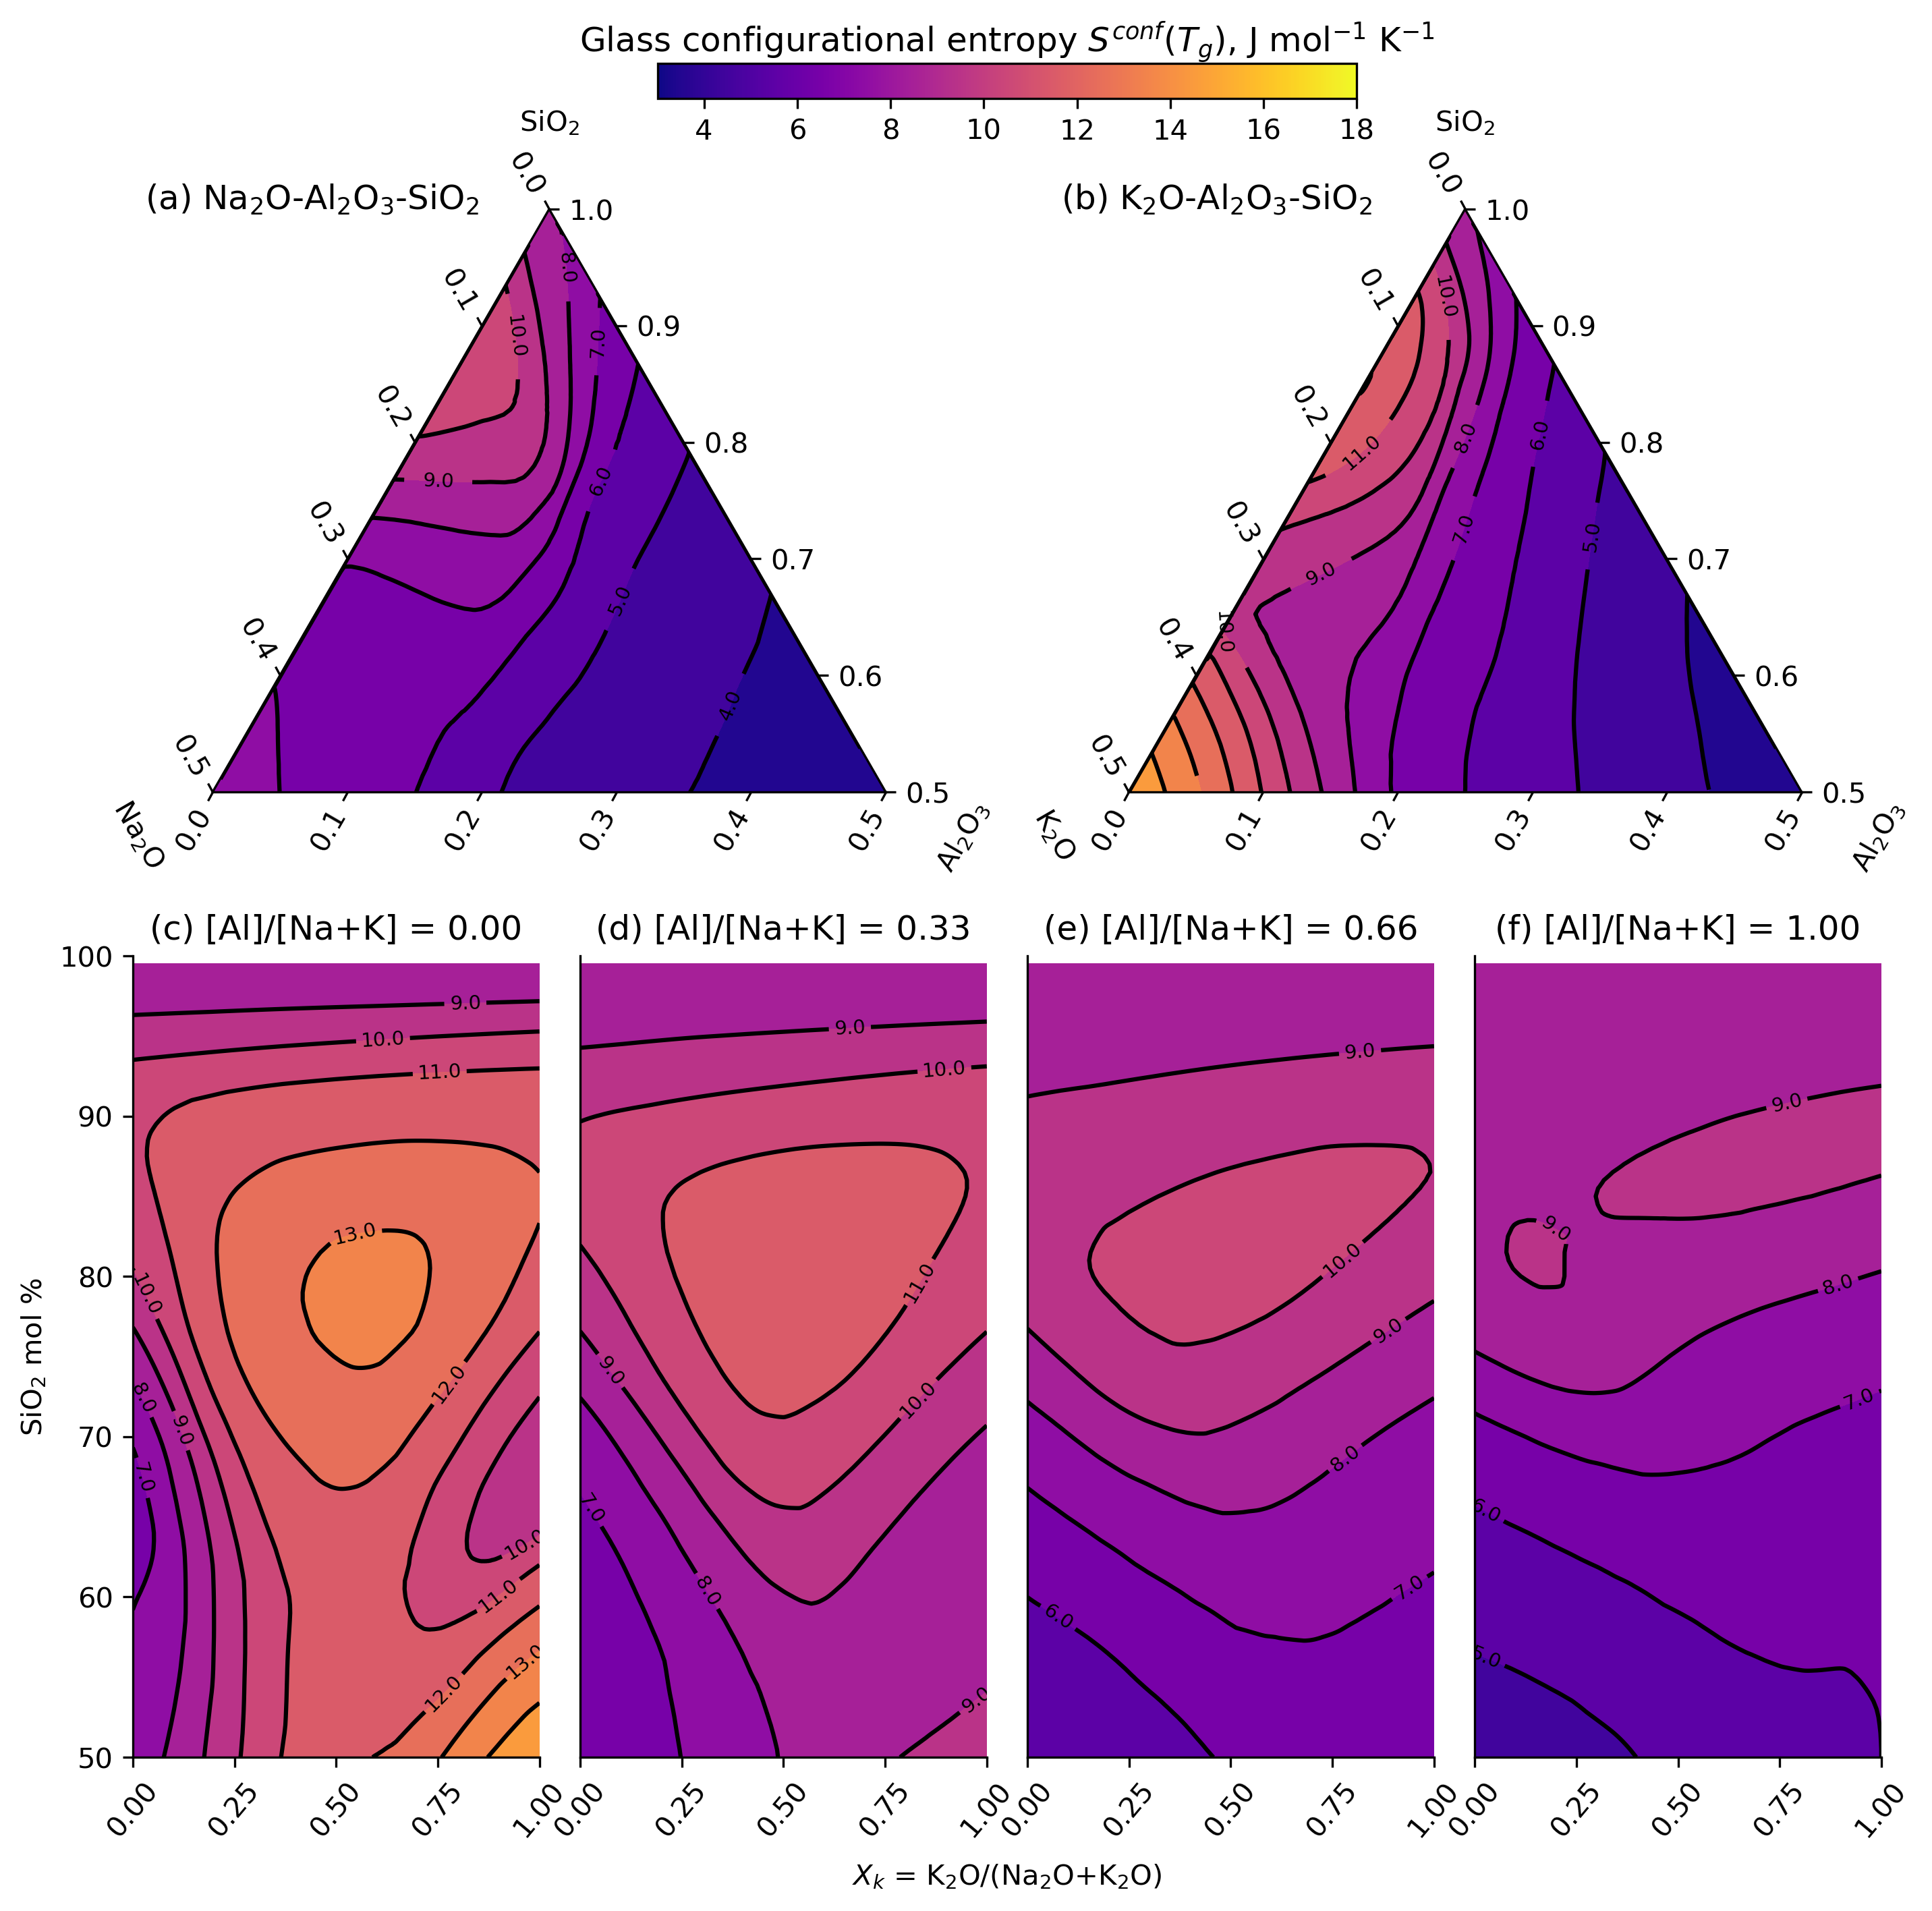

**Figure 6**

