Title: Deep learning prediction of material properties

**Authors :** **Charles Le Losq1,****2,3,*, Andrew Valentine2 , Bjorn O. Mysen3, Daniel R. Neuville1**

**Affiliations :**

1Institut de physique du globe de Paris, Université de Paris, Paris 75005, France

2 Research School of Earth Sciences, Australian National University, Canberra 2601, Australia

3 Geophysical Laboratory, Carnegie Institution for Science, Washington D.C. 20001, U.S.A.

*Correspondence to: [lelosq@ipgp.fr](mailto:lelosq@ipgp.fr)

**Abstract:** (121/125 w)

Knowledge of the tryptic relationship between chemical composition, molecular structure and macroscopic properties of materials like minerals or glasses is fundamental in many disciplines, including metallurgy, Earth and material sciences. Several avenues allow prediction of this relationship, but usually this task remains very challenging. Deep learning represents a new tool to perform such task, allowing one to link experimental results, models, and even different theories. Focusing on alkali aluminosilicate melts, of prime importance for volcanology and glass sciences, we show how a deep neural network leverages experimental data and theoretical knowledge for prediction of melt and glass properties, including viscosity, fragility, density, or even glass Raman signals. Such approach provides a new, exciting way to build models for various applications.

**One sentence summary** (112/125 characters): Deep learning bridges the gap between data and models for practical material property prediction and exploration

**Main Text:**

The intrinsic properties of materials are governed by their chemical composition, and the associated atomic/ionic structure. Understanding this connection is fundamental to material engineering and manufacturing, and also to addressing many key questions across physics, chemistry and the geosciences. Information may be drawn from several sources, particularly experimental observations and thermodynamic or molecular dynamics (MD) simulations, or a combination of these (e.g. *1*, *2*). Techniques such as CALPHAD calculations (*3*) and MD simulation (*4*) have proved successful for some simple materials (such as binary alloys), or under specific conditions (e.g. very high temperatures in MD). However, they are not yet able to effectively predict the properties of complex materials, like oxide glasses, at conditions relevant to industry or the Earth sciences. In these cases, thermodynamic models often offer an intermediate way of predicting macroscopic properties, but the experimentalist still has to link thermodynamic variables to data, and this often turns out to be challenging. In this publication, we show that machine learning can serve as the “middle man”, allowing scientists to make sense of their data and to put them in the context of different models and theories.

As a concrete example, we consider aluminosilicate melts and glasses, materials central to the Earth and material sciences (*5*, *6*). They form the liquid part of magmas, with melt viscosity directly determining whether volcanic eruptions have effusive or explosive character (*7*). As glasses, they are so important to nowadays societies that we may be living in The Glass Age (*8*). Different theories attempt to connect the structure of such materials to their properties. These often involve variables that are either difficult or impossible to measure directly, such as the glass configurational entropy *Sconf*. In this publication, we employ a deep neural network to represent such latent variables within the physical theories, and use this to infer their relationship to composition. For simplicity, we focus on compositions in the K2O-Na2O-Al2O3-SiO2 system, as a fairly complete (albeit sparse) dataset is available (Fig. S1).

In the vast landscape of theories describing the viscous flow of liquids (e.g. *9*), viscosity (**) is modeled as dependent on temperature *T* plus a certain subset of latent variables. For example, the Adam-Gibbs model (8), which assumes that liquid movements occurs through cooperative molecular re-arrangements, represents ** as a function of *T* and composition (*x*) as:

, (1)

with *Ae* a high-temperature limit, *Be* a term proportional to the energy barriers opposed to molecular re-arrangements, and *Sconf* and *Cpconf* the melt configurational entropy and heat capacity, respectively. *Tg* is the temperature at which melt is frozen-in into glass upon quench, a.k.a the glass transition temperature (for convenience, we adopt hereafter the empirical definition of *Tg* as equal to *T* at which *η* = 1012 Pa·s). Alternatively, one might adopt the Free Volume model, which states that melts present liquid-like and solid-like molecular cells, their mobility being ensured by atomic diffusivity within/between liquid-like cells. In equation, we have

**,** (2)

with a high-temperature limit, and , and latent variables related to free volumes’ properties like percolation, size and numbers. Many other models may also be found in the literature, and a few are given in the Supplementary Material.

Each of these equations is built upon its own set of theoretical assumptions, and for some applications it may be evident that one choice is more appropriate than others. Often, however, there is no clear rationale for adopting one equation instead of another; one simply requires good predictive performance (i.e., accurate forecasting of ** given *x* and *T*). Besides, while models linking melt chemistry, structure and properties exist (*10*, *11*), they remain quite specific, only predicting a limited subset of properties on a small compositional range, and further are built making strong simplications and using a given theory.

To tackle such problem, we use a trans-theoretical approach combining machine learning with physical/thermodynamic equations to predict various structural and physical properties. Given melt composition, a deep neural network predicts observable physical and structural glass properties like density and Raman spectra (Fig. 1, Supplementary Materials), as well as latent variables required to predict melt viscosity within five theoretical and empirical frameworks: the Adam-Gibbs, MYEGA, Avramov-Milchev, Tamman-Vogel-Fulcher and Free Volume theories (see Supplementary Material). We trained the deep learning model using a suite of selected data, seeking best average performance across all theories (Supplementary Materials). In particular, it should be noted that where quantities (like ) appear in multiple theoretical frameworks, our approach provides one value that is optimal across all theories.

After training, the deep learning model allows systematic trans-theoretical predictions of melt viscosity (Fig. 2A, see also Supplementary Text and Figure S3), with good precision in all cases (all predictive errors lower than 0.50 log Pa·s for all equations, Table S3). The different viscosity equations yield similar precisions and it may seem difficult to discriminate a better one. However, the Adam-Gibbs theory relates thermodynamic variables (*Sconf*, *Cpconf*...) to melt viscosity (*12*) and performs as well as, or better than others equations. This supports the use of this theory to describe the viscous flow of aluminosilicate melts. Aside this and more generally, the deep learning model successfully allows practical trans-theoretical modeling, a feature extremely interesting in many areas. Furthermore, the deep learning model predicts numerous melt and glass properties with good precision: known viscous *Tg and* *Sconf(Tg)* are predicted within 16 K and 0.8 J mol-1 K-1, respectively, and glass density and refractive index are predicted within 0.009 g cm-3 and 0.005, respectively (Fig. S4). Turning to Raman spectra, due to a limited dataset (Fig. S1), we did not aim at having excellent predictions but simply wanted the deep learning model to capture Raman signal variations, and, hence, to embed structural information. This goal seems achieved. Raman spectra are predicted with an error of ~20% (Fig. 2b, S7, Supplementary Text), but large variations in intra- and inter-tetrahedral aluminosilicate vibrations have been captured and can be predicted with a lower error (Fig. S4). The model thus allows estimations of glass Raman structural parameters like *RRaman* (Fig. 2b), the ratio of intra- and inter-tetrahedral aluminosilicate vibrations that is a proxy for glass network topology (3D connectivity of the covalent polyhedral SiO2/AlO2 units) linked to variations in melt properties (*13*).

Using the deep learning model, we can systematically explore how different variables correlate with each other in the glass-forming region of the quaternary Na2O-K2O-Al2O3-SiO2 diagram. We detected high but non-linear correlations between *Rraman* and properties like *Tg*, *Be/Sconf(Tg),* *BCG*, or the 589 nm refractive index (Fig. 3). Such results agree well, for instance, with the well-known link between Tg and the glass polyhedral connectivity (REF?). However, beyond the general trends, we detect a non-negligible chemical mapping between *Tg* and *Rraman* (Fig. 3a). This is explained by various effects that can affect glass *Tg*, like the mixed alkali effect in Al-poor silicate glasses (*14*). Such subtleties are also visible in transport properties. *Be/Sconf(Tg)* and *BCG* , two terms from the Adam-Gibbs and Free Volume theories linked to “energy barriers” opposed to molecular movements, scale generally well with glass network topology (Fig. 3b). However, in detail, they both show some non-negligible chemical mapping. This agrees with previous thermodynamic modeling of *Be* for instance : in Na2O-K2O-SiO2 melts, while additive contributions from SiO2 tetrahedral units with different numbers of bridging oxygens explain most of *Be* variability, small cationic mixing contributions are necessary to properly model *Be* (*10*). 3D network connectivity development is thus a critical parameter affecting the mobility of atoms in melts, largely affecting through this the temperature at which melts quench to glass, and even ultimately the glass properties like their optical refractive index as visible in Fig. 3c.

However, while 3D glass network topology explains most of the variability of some properties, others show a much more complex behavior. For instance, glass configurational entropy *Sconf(Tg)* (equal to that of the melt at *Tg*), a marker of atomic disorder, varies in a complex way with glass network topology (Fig. 4a). This is because *Sconf(Tg)* embeds both topological and chemical contributions (*12*, *15*–*17*). The first contribution is determined by the 3D network topology (*10*). The chemical contribution arises from cationic and molecular mixing effects that can be random (*15*) or not (*18*, *19*), and are thus difficult to predict but possible to observed with the present deep learning model (Supplementary Text and Fig. SENTRO). In agreement with this, other properties link to *Sconf(Tg),* like fragility (*20*), also show a complex topological and chemical mapping (Fig. 4b). Changing our point of view, the *CCG* parameter, linked to the compositional and pressure effects on free volumes, also varies in a complex way with glass structure and chemical composition (Fig. 4c). This indicates that all those latent variables not only depend on the general topology of the polyhedral glass skeleton, but also on the type of cations present in, and their interactions within this skeleton. Such complexity challenges the recent attempts of modeling magma viscosity from only glass Raman spectra (e.g. *13*), and stresses the need for understanding the behavior and interactions of non-network forming elements in glasses and melts, like alkali and alkaline-earth cations (*21*), because such knowledge appears critical for modeling material properties. Fortunately, the present work shows that machine learning combined with physical models allows us to study such problems, and ultimately allows practical property predictions and a more fundamental exploration of the links between material composition, structure and properties. As such, combined with data and theories, the use of machine learning is an important step toward solving long-standing problems in many disciplines, probably including the theory of the nature of glass and of the glass transition that remains currently elusive as shown by the recent work of Bapst et al. (*22*).

References and Notes. (30 citations max main text)

1. Y. Wang, T. Sakamaki, L. B. Skinner, Z. Jing, T. Yu, Y. Kono, C. Park, G. Shen, M. L. Rivers, S. R. Sutton, Atomistic insight into viscosity and density of silicate melts under pressure. *Nat. Commun.* **5** (2014), doi:10.1038/ncomms4241.

2. C. Le Losq, D. R. Neuville, W. Chen, P. Florian, D. Massiot, Z. Zhou, G. N. Greaves, Percolation channels: a universal idea to describe the atomic structure and dynamics of glasses and melts. *Sci. Rep.* **7**, 16490 (2017).

3. N. Saunders, A. Miodownik, *CALPHAD (calculation of phase diagrams): a comprehensive guide* (Elsevier., 1998).

4. D. C. Rapaport, *The art of molecular dynamics simulation* (Cambridge University Press, Cambridge, U.K., ed. 2nd, 2004).

5. B. O. Mysen, P. Richet, *Silicate Glasses and Melts* (Elsevier, ed. 2nd, 2019).

6. C. Le Losq, M. R. Cicconi, G. N. Greaves, D. R. Neuville, in *Handbook of Glass* (Springer, 2019; https://www.springer.com/us/book/9783319937267).

7. D. B. Dingwell, Volcanic Dilemma - Flow or Blow? *Science*. **273**, 1054–1055 (1996).

8. D. L. Morse, J. W. Evenson, Welcome to the Glass Age. *Int. J. Appl. Glass Sci.* **7**, 409–412 (2016).

9. Y. Bottinga, P. Richet, A. Sipp, Viscosity regimes of homogeneous silicate melts. *Am. Mineral.* **80**, 305–318 (1995).

10. C. Le Losq, D. R. Neuville, Molecular structure, configurational entropy and viscosity of silicate melts: Link through the Adam and Gibbs theory of viscous flow. *J. Non-Cryst. Solids*. **463**, 175–188 (2017).

11. K. Starodub, G. Wu, E. Yazhenskikh, M. Müller, A. Khvan, A. Kondratiev, An Avramov-based viscosity model for the SiO2-Al2O3-Na2O-K2O system in a wide temperature range. *Ceram. Int.* **45**, 12169–12181 (2019).

12. P. Richet, Viscosity and configurational entropy of silicate melts. *Geochim. Cosmochim. Acta*. **48**, 471–483 (1984).

13. D. Giordano, J. K. Russell, Towards a structural model for the viscosity of geological melts. *Earth Planet. Sci. Lett.* **501**, 202–212 (2018).

14. J. P. Poole, Improved Apparatus for Measuring Viscosity of Glasses in Annealing Range of Temperature. *J. Am. Ceram. Soc.* **32**, 215–220 (1949).

15. D. R. Neuville, P. Richet, Viscosity and mixing in molten (Ca, Mg) pyroxenes and garnets. *Geochim. Cosmochim. Acta*. **55**, 1011–1019 (1991).

16. D. R. Neuville, B. O. Mysen, Role of aluminium in the silicate network: In situ, high-temperature study of glasses and melts on the join SiO2-NaAlO2. *Geochim. Cosmochim. Acta*. **60**, 1727–1737 (1996).

17. C. Le Losq, D. R. Neuville, P. Florian, G. S. Henderson, D. Massiot, The role of Al3+ on rheology and structural changes of sodium silicate and aluminosilicate glasses and melts. *Geochim. Cosmochim. Acta*. **126**, 495–517 (2014).

18. D. R. Neuville, Viscosity, structure and mixing in (Ca, Na) silicate melts. *Chem. Geol.* **229**, 28–41 (2006).

19. S. K. Lee, Structure and the extent of disorder in quaternary (Ca-Mg and Ca-Na) aluminosilicate glasses and melts. *Am. Mineral.* **90**, 1393–1401 (2005).

20. C. A. Angell, Relaxation in liquids, polymers and plastic crystals—strong/fragile patterns and problems. *J. Non-Cryst. Solids*. **131**, 13–31 (1991).

21. B. Hehlen, D. R. Neuville, Raman Response of Network Modifier Cations in Alumino-Silicate Glasses. *J. Phys. Chem. B*. **119**, 4093–4098 (2015).

22. V. Bapst, T. Keck, A. Grabska-Barwińska, C. Donner, E. D. Cubuk, S. S. Schoenholz, A. Obika, A. W. R. Nelson, T. Back, D. Hassabis, P. Kohli, Unveiling the predictive power of static structure in glassy systems. *Nat. Phys.* **16**, 448–454 (2020).

**Acknowledgments:** CLL thanks Malcolm Sambridge (Seismology & Mathematical Geophysics, RSES, Australian National University), Lexing Xie and Cheng Soon Ong (CECS, Australian National University), and Sung Keun Lee (Seoul National University) for various discussions regarding optimization, machine learning, the implementation of the present model, and melt and glass properties.

**Funding:** CLL acknowledges funding from a “Chaire d’Excellence” from the Université de Paris, from the Australian Research Council Laureate Fellowship FL1600000 to Prof. Hugh O’Neill (ANU-RSES) as well as from the Postdoctoral Fellowship of the Carnegie Institution for Science during the realisation of this project.

**Author contributions:** CLL designed the study, collected the data, performed Raman and viscosity experiments, developed the computer code. AV and BOM helped in the design of the neural network. CLL and AV drafted the manuscript. CLL, BOM and DN performed Raman measurements. All authors contributed to the final version of the manuscript.

**Competing interests:** Authors declare no competing interests.

**Data and materials availability:** All the data are available in the main text or the supplementary materials. The computer code to reproduce the results of this study is available as a Python library at the web address <https://github.com/charlesll/neuravi> (open access will be provided upon acceptance).

**Supplementary Materials:**

Materials and Methods

Supplementary Text

Figures S1-S7

Tables S1-S3

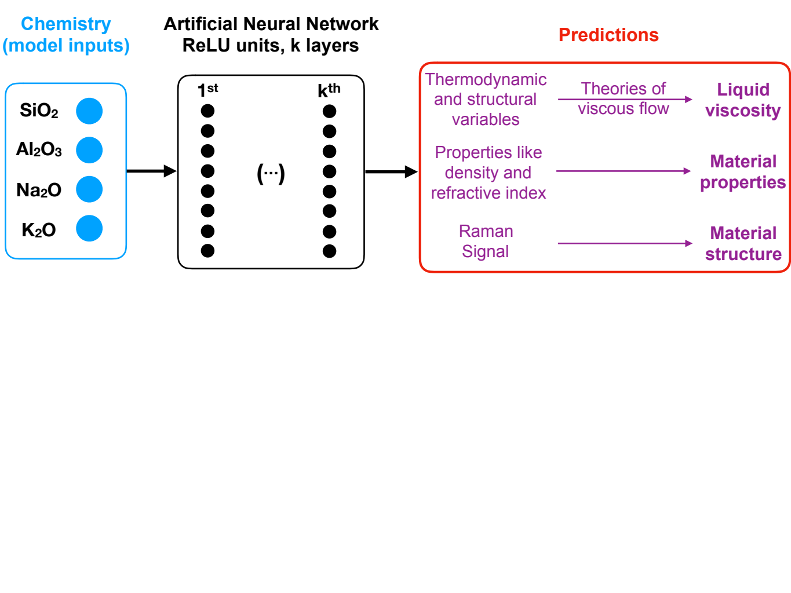**Fig. 1.** **Presentation of the model.** The melt composition is given in input to a deep neural network that predicts various melt and glass properties as well as their Raman vibrational properties (see text for details). Viscosity can then be calculated via different theories, and the relationships between chemistry, structure and properties of the melt and glasses systematically explored using this framework.

**Figure 2: Example of viscosity and Raman predictions. (a)** Measurements (symbols) and model (curves) predictions from the Adam-Gibbs and Free Volume theories are compared for melts covering a broad range of composition and structure. **(b)** Predictions of Raman spectra compared to data for albite and sodium trisilicate glasses. R*Raman* is defined as the ratio of intertetrahedral (below 670 cm-1) to intratetrahedral (above 870 cm-1) network vibrations ; it increases as the connectivity and organisation of the polyhedral SiO2-Al2O3 network develops in the glass.

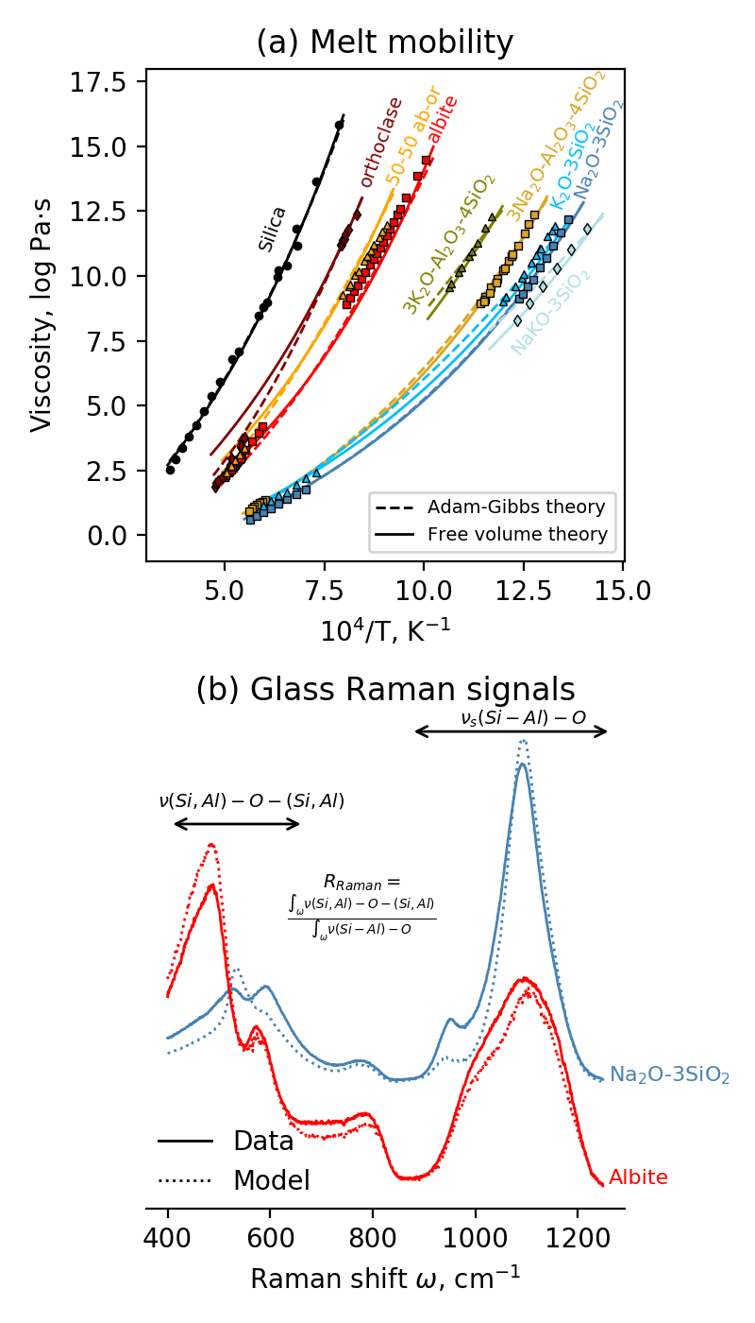**Figure 3: Glass network topology defines specific melt/glass properties.** The viscous glass transition temperature (a), terms proportional to energy barriers opposed to viscous flow like *Be/Sconf(Tg)* and *BCG* (eqs. 1 and 2) (b) or the glass refractive index at 589 nm (c) all strongly correlates with R*Raman* (see Fig. 2b). Each symbol represents the calculation for a randomly generated composition in the glass-forming domain of studied system.

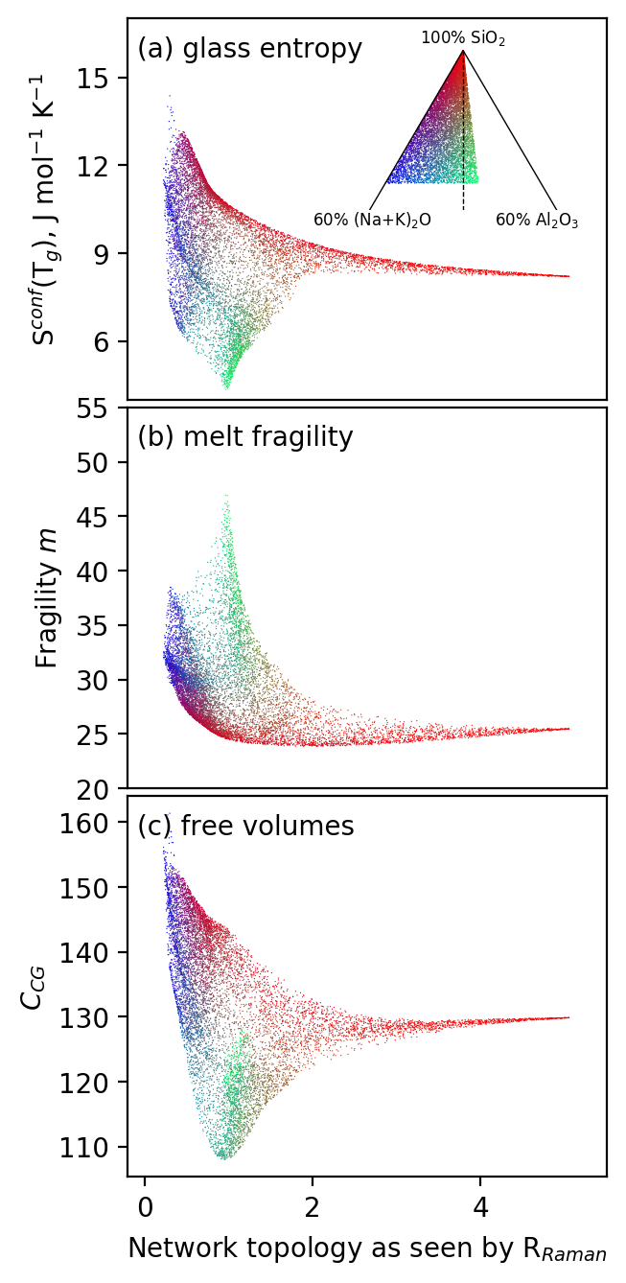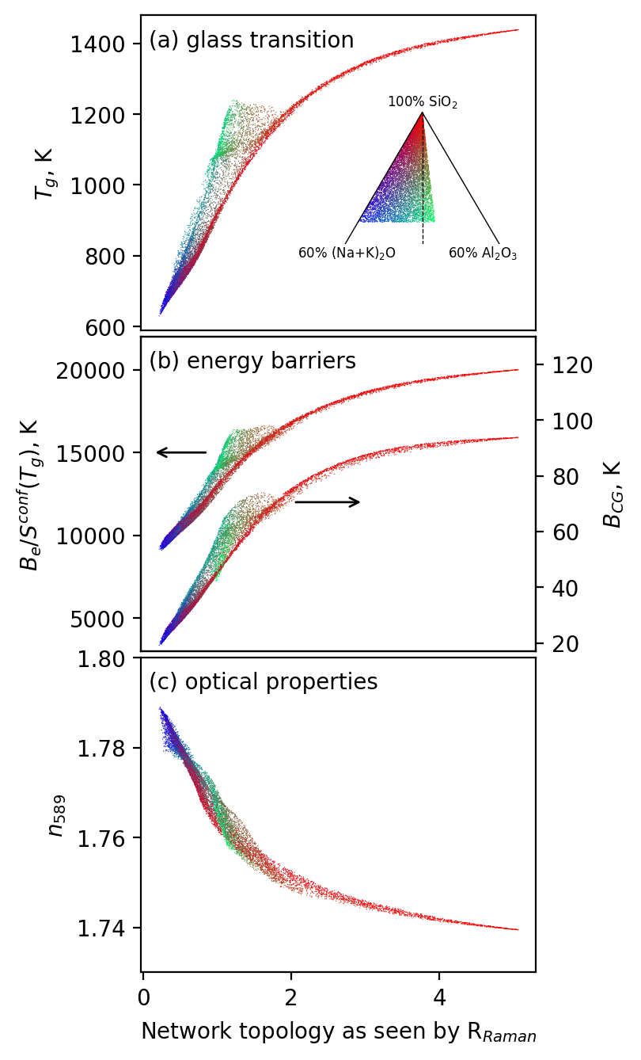**Figure 4: Entropic and volumetric properties vary in a complex way with network topology and chemistry.** (a) The glass configurational entropy *Sconf(Tg),* largely affected by chemical mixing effects (Supplementary Text) varies in a complex way with glass composition and R*Raman* (Fig. 2b). Other properties show shuch complex mapping, like (b) the melt fragility, a parameter indicating how fast melt viscosity changes near *Tg* with T,

or (c) the free volume parameter *CCG.* All those latent variables depend on intrinsic molecular properties like local entropy or free volume that critically depend on cationic electro-chemical properties and steric hindrance effects. Each symbol represents the calculation for a randomly generated composition in the glass-forming domain of studied system.