Title: Deep learning prediction of glass and melt properties

**Authors :** **Charles Le Losq1,****2,3,*, Andrew Valentine2 , Bjorn O. Mysen3, Daniel R. Neuville1**

**Affiliations :**

1Université de Paris, Institut de physique du globe de Paris, CNRS-UMR 7154, Paris 75005, France

2 Research School of Earth Sciences, Australian National University, Canberra 2601, Australia

3 Geophysical Laboratory, Carnegie Institution for Science, Washington D.C. 20001, U.S.A.

*Correspondence to: [lelosq@ipgp.fr](mailto:lelosq@ipgp.fr)

**Abstract:** (125/125 w)

Knowledge of the link between chemistry, structure and properties of molten rocks and glasses is essential for Earth sciences and the glass industry. No general model allows predicting and studying this link. Such a model is needed for practical application of experimentally-derived properties, often measured in chemically simple systems, to geological and industrial processes. Here, a deep learning framework embedding thermodynamic equations predicts melts and glasses properties, including viscosity, density, and Raman signals. Trained on alkali aluminosilicate compositions, it quantifies the link between nano-scale changes in lava composition/structure and the dynamic of mega-scale eruptions of silicic volcanoes, like Yellowstone (U.S.A.). This is a glimpse into the possibilities offered by this approach, which provides a new way to build models of material properties for various applications.

**One sentence summary** (112/125 characters): Deep learning bridges the gap between data and models for practical material property prediction and exploration

**Main Text:**

How do molten silicates move? How do they exchange heat with other media? How do they crystallize? These fundamental questions underpin many practical problems, including the dynamics of volcanic eruptions (*1*) , the formation of rocks (*2*), and the manufacturing of novel glass, glass-ceramic and ceramic materials. Addressing them requires knowledge of physical properties such as viscosity, heat capacity and entropy, which are ultimately governed by the liquid’s composition and associated atomic/ionic structure. At present, this information is inferred from specific experimental observations and/or thermodynamic or molecular dynamics (MD) simulations (e.g. *3*, *4*); these are usually restricted to a small range of liquid chemical compositions. Thermodynamic or empirical models may provide an intermediate way of predicting macroscopic properties, but these are usually highly simplified, and limited to predicting a handful of properties in a restricted compositional range (e.g., see for viscosity *5*–*8*). Here, we show that these shortcomings can be resolved by combining theoretical equations and deep learning to construct a general predictive framework. This allows prediction of liquid properties under a wide range of realistic circumstances, and enables investigation of the fundamental links between material composition, structure and properties.

As a concrete example, we consider aluminosilicate melts and glasses, materials central to the Earth and material sciences (*9*, *10*). We particularly focus on compositions in the K2O-Na2O-Al2O3-SiO2 system, central to understanding the activity of silicic supervolcanoes like Yellowstone (U.S.A.) or Toba (Indonesia) (*11*), and for which a fairly complete dataset is available (Fig. S1). Viscosity is key to this problem (*11*), but the underlying structural and thermodynamic controls have yet to be properly characterized. A better understanding of – and ability to predict – the properties of alkali aluminosilicate glasses is also valuable beyond volcanology. For example, it can aid the development of technological glass materials such as smartphone screens.

To address any such problems, we require a model that links melt composition (*x*) and structure to physical properties and intensive variables such as temperature (*T*). To build such a model, we construct a deep neural network in Pytorch, containing multiple hidden layers of rectifier activation units, that takes an input composition, and predicts directly-observable glass properties including density, refractive index and Raman spectra (Fig. 1a). It also outputs the latent variables (such as configurational entropy, *Sconf(Tg)*, a property that reflects the melt structure) required to predict melt viscosity (*η)* within five theoretical and empirical models commonly used for reproducing experimentally-observed variations of viscosity with temperature for silicate melts: Adam-Gibbs, MYEGA, Avramov-Milchev, Tamman-Vogel-Fulcher and Free Volume Theory (Supplementary Material). While those models are popular for silicate melts, no strong consensus towards any one model appropriate for all liquids exists. To circumvent such problem, we propose a “trans-theoretical” approach, whereby the neural network simultaneously enables predictions across multiple theories, and is trained to provide best average performance across the selected theories. The neural network also provides optimal common values for parameters that appear in multiple theories, such as the glass transition temperature *Tg.* To generate the deep learning framework used for predictions, first, 2000 neural networks containing various randomly selected numbers of layers and activation units per layers were trained with the ADAM optimizer. Generalization was promoted by the use of dropout, early stopping and the multi-task learning strategy (*12*–*14*). Final predictions are made via averaging the predictions of the best 10 trained neural networks (*15*). Details are provided in Supplementary Materials.

After training, the deep learning framework allows accurate predictions of liquid and glass properties, including structure-dependent properties such as Raman spectra. Trans-theoretical predictions of *η* (Fig. 1b, Figure S3) are possible with good precision (σ* *< 0.4 log Pa·s on unseen data, Table S3; for comparison, σ* * 0.6 log Pa·s* *for the best empirical magma viscosity models (e.g. *5*). Known viscous *Tg* and *Sconf(Tg)* are predicted within 16 K and 0.8 J mol-1 K-1, respectively, and glass density and refractive index are predicted within 0.009 g cm-3 and 0.005, respectively (Fig. S4). Despite a limited dataset (Fig. S1), global variations of Raman signals have been captured well (Fig. 1c, S4) and can be predicted with a reasonable error (Supplementary Text). The deep learning framework thus embeds structural information, and allows estimation of structural parameters from Raman spectra including the ratio of intra- and inter-tetrahedral aluminosilicate vibrations, *RRaman* (Fig. 1c). This serves as a proxy for glass network topology (the 3D connectivity of the polyhedral SiO2-AlO2 network), and is linked to variations in melt properties (*16*).

With the deep learning framework, we can explore why viscosity varies substantially according to the concentration of Al and K in Na2O-K2O-Al2O3-SiO2 melts. We observe the known division between topological and chemical effects (*17*) on different properties. Glass network topology, broadly speaking, correlates with the glass transition temperature (Fig. 2a), and with quantities proportional to energy barriers opposed to ionic mobility (Fig. 2b), or the glass refractive index (Supplementary Materials). The glass transition temperature exhibits detailed compositional dependence, in agreement with the well-known mixed alkali effect (MAE, *18*) resulting from metal cation interactions within the SiO44- polyhedral network (e.g. *7*). This chemical effect strongly affects properties influenced by cationic interactions and steric hindrance effects, such as the configurational entropy*(7*, *17*, *19*, *20*)*,* or the term *CFV* that encompass local cationic influences on melt free volume in the Free Volume theory (Fig. 2c,d, Supplementary Text). The deep learning framework allows such effects to be seen, and the ability to switch between theories further allows observing relationships between latent variables from different theories(Supplementary Text).

The above observations highlight the known role of cationic mixing on macroscopic variables such as *Sconf(Tg)*. Cationic mixing can be random (*17*, *20*) or not (*21*, *22*), and is usually difficult to predict. The deep learning framework solves this problem by enabling systematic quantification and visualization of such phenomena (Fig. 3). For the system analyzed here, increasing [Al] leads to decreasing *Sconf(Tg)* (Fig. 3a,b). Furthermore, Al-to-alkali ratio largely affects the MAE: without Al, the MAE results in an entropy excess (Fig. 3c) and, hence, in large decreases in melt viscosity (η ∝ 1/*Sconf(Tg)*, *19*). Increasing [Al]/[Na+K] leads to changing the role of alkali metals in the network (*23*). Na and K segregate in different molecular nano-environments (*7*, *24*), inducing less and less excess entropy of mixing as [Al]/[Na+K] increases (Fig. 3d,e,f). In addition, K-rich and Al-rich melts show higher local order (*4*) resulting in small *Sconf(Tg)* values (Fig. 3b,f).

Most of the lavas emitted at silicic volcanic systems, like Yellowstone or Long Valley (U.S.A.), present dry chemical compositions made of more than 95 % of Na2O, K2O, Al2O3 and SiO2. Melts in the Na2O-K2O-Al2O3-SiO2 system can thus be considered as analogues of the lavas involved in silicic volcanic eruptions. With this in mind, we are now in a position to understand why eruptions of silicic volcanoes may be more explosive if the magma is rich in K and Al, as suggested by (*11*). Indeed, among the usual critical parameters driving the dynamic of volcanic eruptions such as pre-eruptive volatile content, degassing path and nano-cristallization (*11*, *25*, *26*), explosive or effusive eruptions of silicic volcanoes respectively appear to involve lavas more or less rich in Al and K (Figure 4). From the deep learning framework predictions, this originates from a decrease in *Sconf(Tg)* driven by ongoing network connectivity and nano-structuration as [Al] and [K] increase (Figs. 3, 4), as those elements respectively promote network polymerisation and nano-structuration in aluminosilicates (*4*, *23*). The chemical separation between effusive and explosive eruptions at silicic volcanic centers is associated, according to the present work, with limits in *RRaman* and *Sconf(Tg)* of ~1.5 and ~9.0 J mol-1 K-1, respectively (Fig. 4). Those values are derived from the analysis of simplified alkali aluminosilicates and thus may vary slightly in the case of natural rhyolite. In any case, those results demonstrate that a more complete version of the present framework, embedding the effects of Ca, Mg, Fe and water, would provide the ability to explore and quantify even further the links between magma composition, structure, properties, and volcanic eruptive styles.

To conclude, the results presented here highlight how the deep learning framework can be used for practical property predictions in the Earth sciences. Here, it reveals the fine structural and thermodynamic controls on magma viscosity, which, in turn, govern the dynamics of volcanic eruptions. The deep learning framework can readily be extended to include quantities of interest across a range of domains and applications, with the present results demonstrating that a combination of neural networks and physical/thermodynamic models can offer new perspectives on long-standing problems in many disciplines.

References and Notes. (30 citations max main text)

1. D. B. Dingwell, Volcanic Dilemma - Flow or Blow? *Science*. **273**, 1054–1055 (1996).

2. N. L. Bowen, *The evolution of igneous rocks* (Dover Publications, 1956).

3. Y. Wang, T. Sakamaki, L. B. Skinner, Z. Jing, T. Yu, Y. Kono, C. Park, G. Shen, M. L. Rivers, S. R. Sutton, Atomistic insight into viscosity and density of silicate melts under pressure. *Nat. Commun.* **5** (2014), doi:10.1038/ncomms4241.

4. C. Le Losq, D. R. Neuville, W. Chen, P. Florian, D. Massiot, Z. Zhou, G. N. Greaves, Percolation channels: a universal idea to describe the atomic structure and dynamics of glasses and melts. *Sci. Rep.* **7**, 16490 (2017).

5. D. Giordano, J. K. Russell, D. B. Dingwell, Viscosity of magmatic liquids: A model. *Earth Planet. Sci. Lett.* **271**, 123–134 (2008).

6. J. C. Mauro, A. J. Ellison, D. C. Allan, M. M. Smedskjaer, Topological Model for the Viscosity of Multicomponent Glass-Forming Liquids. *Int. J. Appl. Glass Sci.* **4**, 408–413 (2013).

7. C. Le Losq, D. R. Neuville, Molecular structure, configurational entropy and viscosity of silicate melts: Link through the Adam and Gibbs theory of viscous flow. *J. Non-Cryst. Solids*. **463**, 175–188 (2017).

8. K. Starodub, G. Wu, E. Yazhenskikh, M. Müller, A. Khvan, A. Kondratiev, An Avramov-based viscosity model for the SiO2-Al2O3-Na2O-K2O system in a wide temperature range. *Ceram. Int.* **45**, 12169–12181 (2019).

9.B. O. Mysen, P. Richet, *Silicate Glasses and Melts* (Elsevier, ed. 2nd, 2019).

10. C. Le Losq, M. R. Cicconi, G. N. Greaves, D. R. Neuville, in *Handbook of Glass* (Springer, 2019; https://www.springer.com/us/book/9783319937267).

11. D. Di Genova, S. Kolzenburg, S. Wiesmaier, E. Dallanave, D. R. Neuville, K. U. Hess, D. B. Dingwell, A compositional tipping point governing the mobilization and eruption style of rhyolitic magma. *Nature*. **552**, 235 (2017).

12. R. Caruana, Multitask Learning. *Mach. Learn.* **28**, 41–75 (1997).

13. N. Srivastava, G. Hinton, A. Krizhevsky, I. Sutskever, R. Salakhutdinov, Dropout: A Simple Way to Prevent Neural Networks from Overfitting. *J. Mach. Learn. Res.* **15**, 1929–1958 (2014).

14. I. Goodfellow, Y. Bengio, A. Courville, *Deep Learning* (MIT Press, 2016; http://www.deeplearningbook.org).

15. L. Breiman, L. Breiman, in *Machine Learning* (1996), pp. 123–140.

16. D. Giordano, J. K. Russell, Towards a structural model for the viscosity of geological melts. *Earth Planet. Sci. Lett.* **501**, 202–212 (2018).

17. D. R. Neuville, P. Richet, Viscosity and mixing in molten (Ca, Mg) pyroxenes and garnets. *Geochim. Cosmochim. Acta*. **55**, 1011–1019 (1991).

18. J. O. Isard, The mixed alkali effect in glass. *J. Non-Cryst. Solids*. **1**, 235–261 (1969).

19. P. Richet, Viscosity and configurational entropy of silicate melts. *Geochim. Cosmochim. Acta*. **48**, 471–483 (1984).

20. D. R. Neuville, B. O. Mysen, Role of aluminium in the silicate network: In situ, high-temperature study of glasses and melts on the join SiO2-NaAlO2. *Geochim. Cosmochim. Acta*. **60**, 1727–1737 (1996).

21. D. R. Neuville, Viscosity, structure and mixing in (Ca, Na) silicate melts. *Chem. Geol.* **229**, 28–41 (2006).

22. S. K. Lee, Structure and the extent of disorder in quaternary (Ca-Mg and Ca-Na) aluminosilicate glasses and melts. *Am. Mineral.* **90**, 1393–1401 (2005).

23. C. Le Losq, D. R. Neuville, P. Florian, G. S. Henderson, D. Massiot, The role of Al3+ on rheology and structural changes of sodium silicate and aluminosilicate glasses and melts. *Geochim. Cosmochim. Acta*. **126**, 495–517 (2014).

24. C. Le Losq, D. R. Neuville, Effect of the Na/K mixing on the structure and the rheology of tectosilicate silica-rich melts. *Chem. Geol.* **346**, 57–71 (2013).

25. J. Andújar, B. Scaillet, Relationships between pre-eruptive conditions and eruptive styles of phonolite–trachyte magmas. *Lithos*. **152**, 122–131 (2012).

26. F. Cáceres, F. B. Wadsworth, B. Scheu, M. Colombier, C. Madonna, C. Cimarelli, K.-U. Hess, M. Kaliwoda, B. Ruthensteiner, D. B. Dingwell, Can nanolites enhance eruption explosivity? *Geology* (2020), doi:10.1130/G47317.1.

*Supplementary Material References*

27. O. V. Mazurin, M. V. Streltsina, Shvaiko-Shvaikovskaya, *Handbook of glass data* (Elsevier, 1987), vol. C and B.

28. C. Le Losq, A. J. Berry, M. A. Kendrick, D. R. Neuville, H. St. C. O’Neill, Determination of the oxidation state of iron in Mid-Ocean Ridge basalt glasses by Raman spectroscopy. *Am. Mineral.* **104**, 1032–1042 (2019).

29. C. M. Bishop, *Pattern recognition and machine learning* (Springer, New York, 2006), *Information science and statistics*.

30. G. Adam, J. H. Gibbs, On the temperature dependence of cooperative relaxation properties in glass-forming liquids. *J. Chem. Phys.* **43**, 139–146 (1965).

31. M. H. Cohen, G. S. Grest, Liquid-glass transition, a free-volume approach. *Phys. Rev. B*. **20**, 1077 (1979).

32. I. Avramov, A. Milchev, Effect of disorder on diffusion and viscosity in condensed systems. *J. Non-Cryst. Solids*. **104**, 253–260 (1988).

33. J. C. Mauro, Y. Yue, A. J. Ellison, P. K. Gupta, D. C. Allan, Viscosity of glass-forming liquids. *Proc. Natl. Acad. Sci.* **106**, 19780–19784 (2009).

34. X. Glorot, A. Bordes, Y. Bengio, in *International Conference on Artificial Intelligence and Statistics* (2011), pp. 315–323.

35. J. Bergstra, Y. Bengio, Random search for hyper-parameter optimization. *J. Mach. Learn. Res.* **13**, 281–305 (2012).

36. G. N. Greaves, A. Fontaine, P. Lagarde, D. Raoux, S. J. Gurman, Local structure of silicate glasses. *Nature*. **293**, 611–616 (1981).

37. G. N. Greaves, Exafs and the structure of glass. *J. Non-Cryst. Solids*. **71**, 203–217 (1985).

38. G. N. Greaves, EXAFS, glass structure and diffusion. *Philos. Mag. Part B*. **60**, 793–800 (1989).

39. A. Meyer, J. Horbach, W. Kob, F. Kargl, H. Schober, Channel formation and intermediate range order in sodium silicate melts and glasses. *Phys. Rev. Lett.* **93**, 1–4 (2004).

40. F. Kargl, A. Meyer, M. M. Koza, H. Schober, Formation of channels for fast-ion diffusion in alkali silicate melts: A quasielastic neutron scattering study. *Phys. Rev. B*. **74**, 014304 (2006).

41. G. N. Greaves, K. L. Ngai, Reconciling ionic-transport properties with atomic structure in oxide glasses. *Phys. Rev. B*. **52**, 6358–6380 (1995).

42. J. Stebbins, NMR evidence for five-coordinated silicon in a silicate glass at atmospheric pressure. *Nature*. **351**, 638–639 (1991).

43. P. Y. Huang, S. Kurasch, A. Srivastava, V. Skakalova, J. Kotakoski, A. V. Krasheninnikov, R. Hovden, Q. Mao, J. C. Meyer, J. Smet, D. A. Muller, U. Kaiser, Direct Imaging of a Two-Dimensional Silica Glass on Graphene. *Nano Lett.* **12**, 1081–1086 (2012).

44. P. Y. Huang, S. Kurasch, J. S. Alden, A. Shekhawat, A. A. Alemi, P. L. McEuen, J. P. Sethna, U. Kaiser, D. A. Muller, Imaging Atomic Rearrangements in Two-Dimensional Silica Glass: Watching Silica’s Dance. *Science*. **342**, 224–227 (2013).

45. B. O. Mysen, Experimental, in situ, high-temperature studies of properties and structure of silicate melts relevant to magmatic processes. *Eur. J. Mineral.* **7**, 745–766 (1995).

46. B. O. Mysen, A. Lucier, G. D. Cody, The structural behavior of Al3+ in peralkaline melts and glasses in the system Na₂O-Al₂O₃-SiO₂. *Am. Mineral.* **88**, 1668–1678 (2003).

47. H. Hui, Y. Zhang, Toward a general viscosity equation for natural anhydrous and hydrous silicate melts. *Geochim. Cosmochim. Acta*. **71**, 403–416 (2007).

48. X. Duan, A model for calculating the viscosity of natural iron-bearing silicate melts over a wide range of temperatures, pressures, oxygen fugacites, and compositions. *Am. Mineral.* **99**, 2378–2388 (2014).

49. S. L. L. Webb, Configurational heat capacity of Na₂O–CaO–Al₂O₃–SiO₂ melts. *Chem. Geol.* **256**, 92–101 (2008).

50. J. K. Russell, D. Giordano, Modelling configurational entropy of silicate melts. *Chem. Geol.* **461**, 140–151 (2017).

51. P. Richet, Y. Bottinga, Heat capacity of aluminum-free liquid silicates. *Geochim. Cosmochim. Acta*. **49**, 471–486 (1985).

52. P. Richet, Y. Bottinga, Glass transitions and thermodynamic properties of amorphous SiO2, NaAlSinO2n+2 and KAlSi3O8. *Geochim. Cosmochim. Acta*. **48**, 453–470 (1984).

53. P. Richet, R. A. Robie, J. Rogez, B. S. Hemingway, P. Courtial, C. Téqui, Thermodynamics of open networks: ordering and entropy in NaAlSiO₄ glass, liquid and polymorphs. *Phys. Chem. Miner.* **17**, 385–394 (1990).

54. G. N. Greaves, A. L. Greer, R. S. Lakes, T. Rouxel, Poisson’s ratio and modern materials. *Nat. Mater.* **10**, 823–837 (2011).

55. I. M. Hodge, Enthalpy relaxation and recovery in amorphous materials. *J. Non-Cryst. Solids*. **169**, 211–266 (1994).

*56. G. Liu, D. Zhao, Y. Zuo, Modified Adam–Gibbs models based on free volume concept and their application in the enthalpy relaxation of glassy polystyrene. J. Non-Cryst. Solids.* ***417–418****, 52–59 (2015).*

**Acknowledgments:** CLL thanks Malcolm Sambridge (Seismology & Mathematical Geophysics, RSES, Australian National University), Lexing Xie and Cheng Soon Ong (CECS, Australian National University), and Sung Keun Lee (Seoul National University) for various discussions regarding optimization, machine learning, and melt and glass properties.

**Funding:** CLL acknowledges funding from a Chaire d’Excellence IDEX19C627X/FD070/D110 from the IdEX Université de Paris ANR-18-IDEX-0001, from the Australian Research Council Laureate Fellowship FL1600000 to Prof. Hugh O’Neill (ANU-RSES) as well as from the Postdoctoral Fellowship of the Carnegie Institution for Science during the realization of this project. APV acknowledges support from the ARC via grants DE180100040 and DP200100053.

**Author contributions:** CLL designed the study, collected the data, performed Raman and viscosity experiments, and developed the deep learning framework and the associated computer code. AV and BOM helped in the design of the neural network. CLL, BOM and DN performed Raman measurements. CLL and AV drafted the manuscript. All authors contributed to the final version of the manuscript.

**Competing interests:** Authors declare no competing interests.

**Data and materials availability:** All the data are available in the main text or the supplementary materials. The computer code to reproduce the results of this study is available as a Python library at the web address <https://github.com/charlesll/neuravi> (open access will be provided upon acceptance).

**Supplementary Materials:**

Materials and Methods

Supplementary Text

Figures S1-S7

Tables S1-S3

**Fig. 1.** **Schematic of the deep learning framework, and prediction examples.** **(a)** A neural network takes input melt composition, and outputs various melt and glass properties. Once trained, relationships between chemistry, structure and properties of melts and glasses can be systematically explored. **(b)** Melt viscosity can be derived from these outputs using various theories with a great accuracy, as shown by examples highlighting the good match between measurements (symbols) and model (curves) predictions from the Adam-Gibbs and Free Volume theories. **(c)** Structural investigation are made through Raman spectra predictions, which compare well with experimental data for albite and sodium trisilicate glasses for instance. R*Raman*, the ratio of intertetrahedral (below 670 cm-1) to intratetrahedral (above 870 cm-1) network vibrations, can be calculated and used for structural investigations. It increases as the connectivity and organization of the polyhedral SiO2-Al2O3 network develops in the glass. It is thus very sensitive to 3D glass network connectivity and rigidity.

**Figure 2: Melt and glass properties vary in a complex way with glass network topology**. **(a)** The model allows observing that parameters such as the viscous glass transition temperature *Tg* **(a)** and *BCG,*a activation energy term in the Free Volume theory (Supplementary Materials) **(b),** strongly vary depending on R*Raman*. Other terms also show more complex variations, influenced by cationic mixing interactions and steric hindrance effects, such as the glass configurational entropy *Sconf(Tg)* **(c)**or the free volume parameter *CCG* **(d).** Each symbol represents the calculation for a randomly generated composition in the glass-forming domain of studied system.

**Figure 3: Variations of the configurational entropy at *Tg* in K2O-Na2O-Al2O3-SiO2 melts.** *Sconf(Tg)* vary non-linearly with oxide contents in the ternary diagrams Na2O-Al2O3-SiO2 and K2O-Al2O3-SiO2 in **(a)** and **(b)**. In silicate melts **(c)**, a mixed alkali effect (MAE) is observed upon Na-K mixing. It disappears as [Al]/[Na+K] increases **(d, e, f)**. Al enrichment generally lead to decreasing *Sconf(Tg)*, and minimizing the MAE. Al- and K-rich melts thus present low *Sconf(Tg)*.

**Figure 4: Chemical, structural and entropic mapping of rhyolite eruptions.** The rheological agpaitic index is calculated as (Na2O + K2O + CaO + MgO + FeO)/(Al2O3 + Fe2O3). From (*11*), Al-rich and K-rich rhyolite magmas, like those of Yellowstone (U.S.A.) are generally associated with explosive eruptions. The rheological tipping point proposed by (*11*) find roots in how increasing Al and K contents promote 3D network connectivity (a) and, thus reduces melt entropy (b) down to a particular threshold here identified to be ~ 9 J mol-1 K-1.

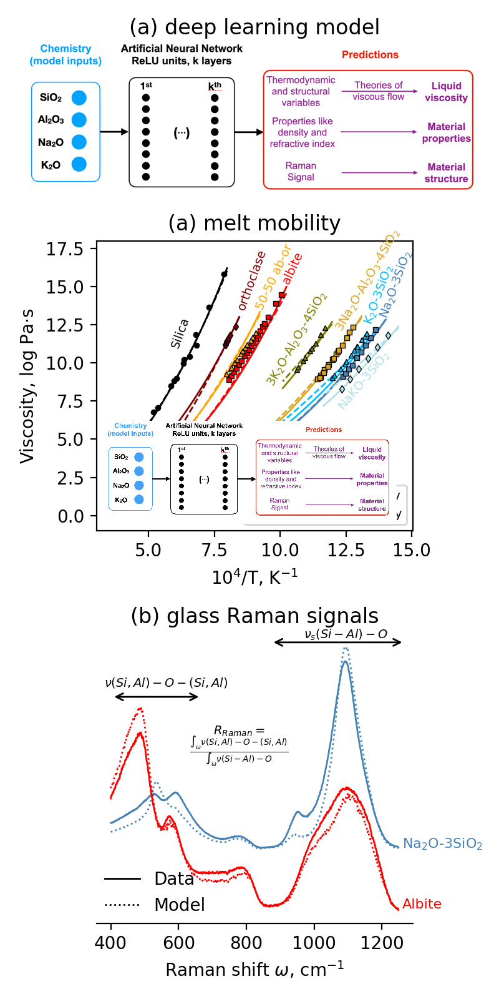**Figure 1**

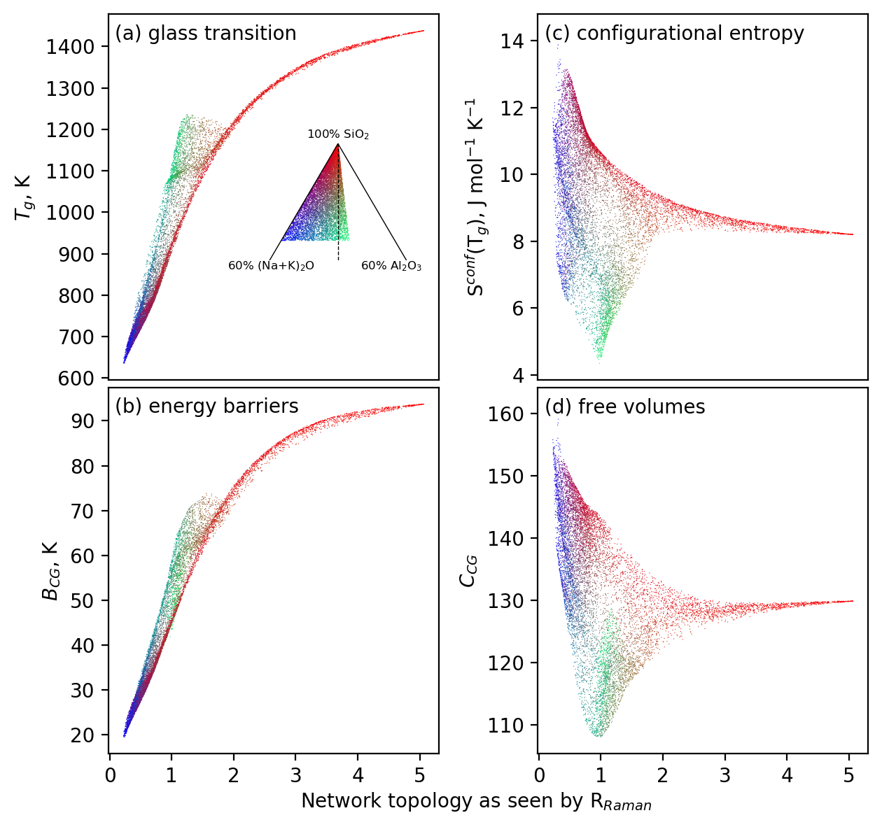**Figure 2**

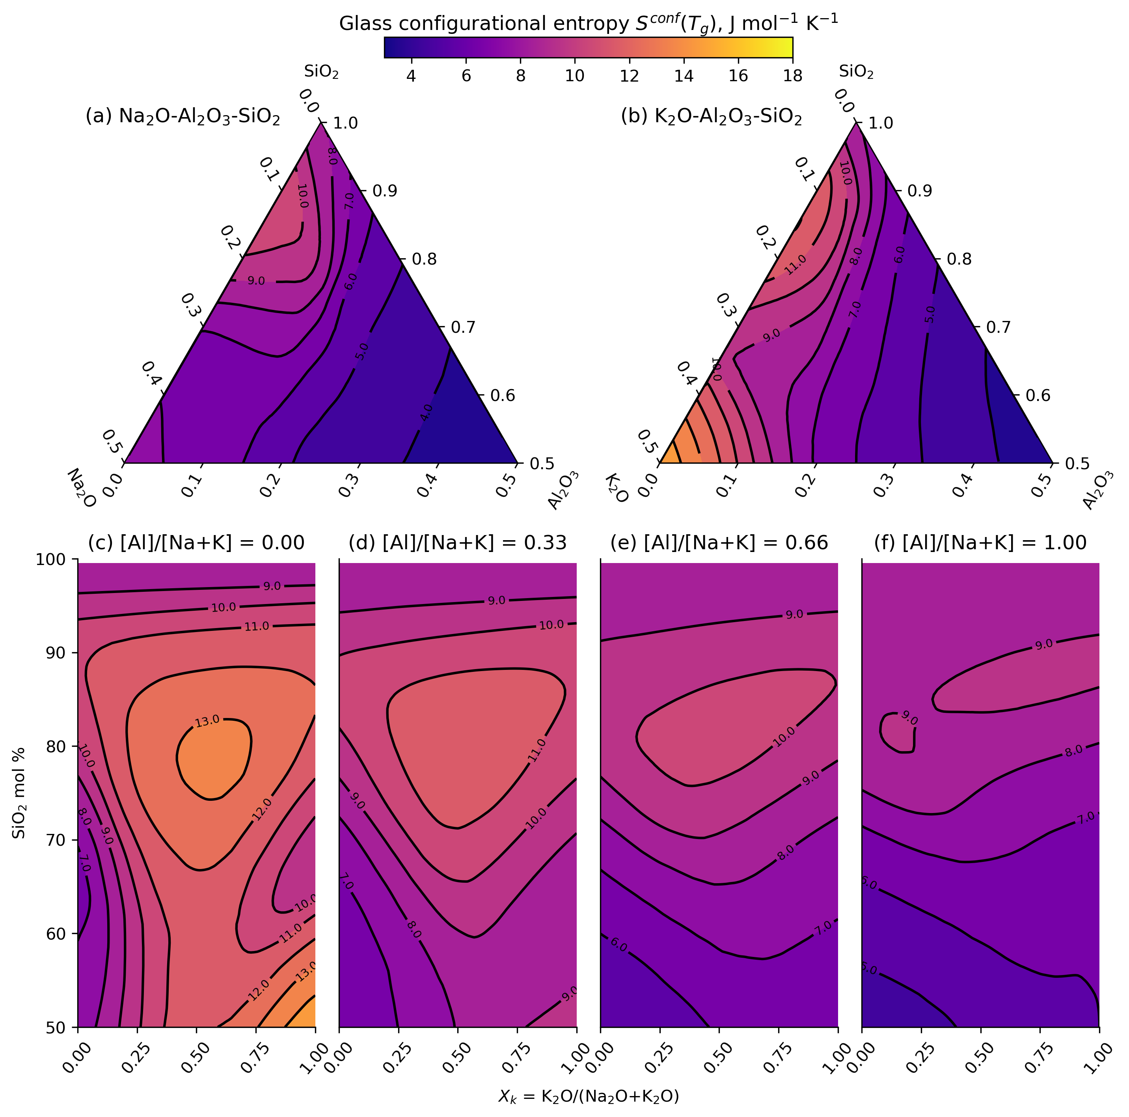**Figure 3**

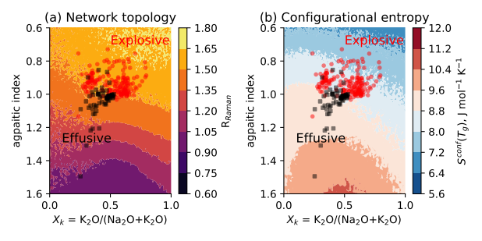**Figure 4**