Mining the Pulse of New York City
Demand, Fare and Tip Patterns from 2.96 Million January 2024 Yellow-Cab Trips
Anukrithi Myadala
CMPE 255 · Data Mining · Spring 2026
Prof. Vidhyacharan Bhaskar · San José State University
Final project report

1. Problem Definition and Project Objectives
New York City fields roughly one hundred thousand yellow-cab trips every day, generating millions of structured records per month touching pricing, demand, and customer behaviour. This project applies every major mining technique from the CMPE 255 syllabus to the January 2024 TLC trip records.

Domain
Transportation analytics — a hybrid of urban mobility and consumer behaviour, with strong overlap into operations research and pricing.

Research questions
- What features predict fare amount, and how much does each one contribute?
- Is trip duration log-normally distributed, and does a log transform improve regression?
- Can hourly trip counts per pickup zone be forecast with a Poisson GLM?
- Which trips generate tips, and what is the lift over random targeting?
- Are there natural pickup-zone archetypes detectable through K-means clustering?
- Do airport trips have significantly higher fares? (Welch’s t-test)
- Are rush-hour trips longer in duration? (Welch’s t-test)
- Do weekend tip rates differ from weekday? (χ² test)

Target variables
Continuous: fare_amount (multi-variable linear), trip_duration (log-linear), trip_count per zone-hour (Poisson). Binary: has_tip (logistic), is_rush_hour (decision tree).

Expected outcomes
A reproducible end-to-end mining pipeline that ingests the raw 2,964,624-row CSV, produces a cleaned 387,998-row analytical dataset, trains 10+ from-scratch models, runs 5-fold cross-validation, performs 3 formal hypothesis tests, and exports an interactive dashboard.

2. Data Source Identification
The project draws on two public datasets published by the NYC Taxi and Limousine Commission (TLC):
- yellow_tripdata_2024-01.csv — 2,964,624 trips and 19 columns (~310 MB CSV).
- taxi_zone_lookup.csv — 265 zones with borough, zone name, and service-zone fields (13 KB).
Both files are public-domain and contain no personal information.

3. Data Collection
The Parquet trip file was downloaded from the TLC CloudFront URL, then converted to CSV. The zone lookup was downloaded directly as CSV.

4. Data Warehousing
The trip data is modeled as a classical star schema with a single fact table (Trip_Fact) and four conformed dimensions (Zone, Time, Payment, Vendor). The grain is one trip per row.
Figure 1. Star schema design.
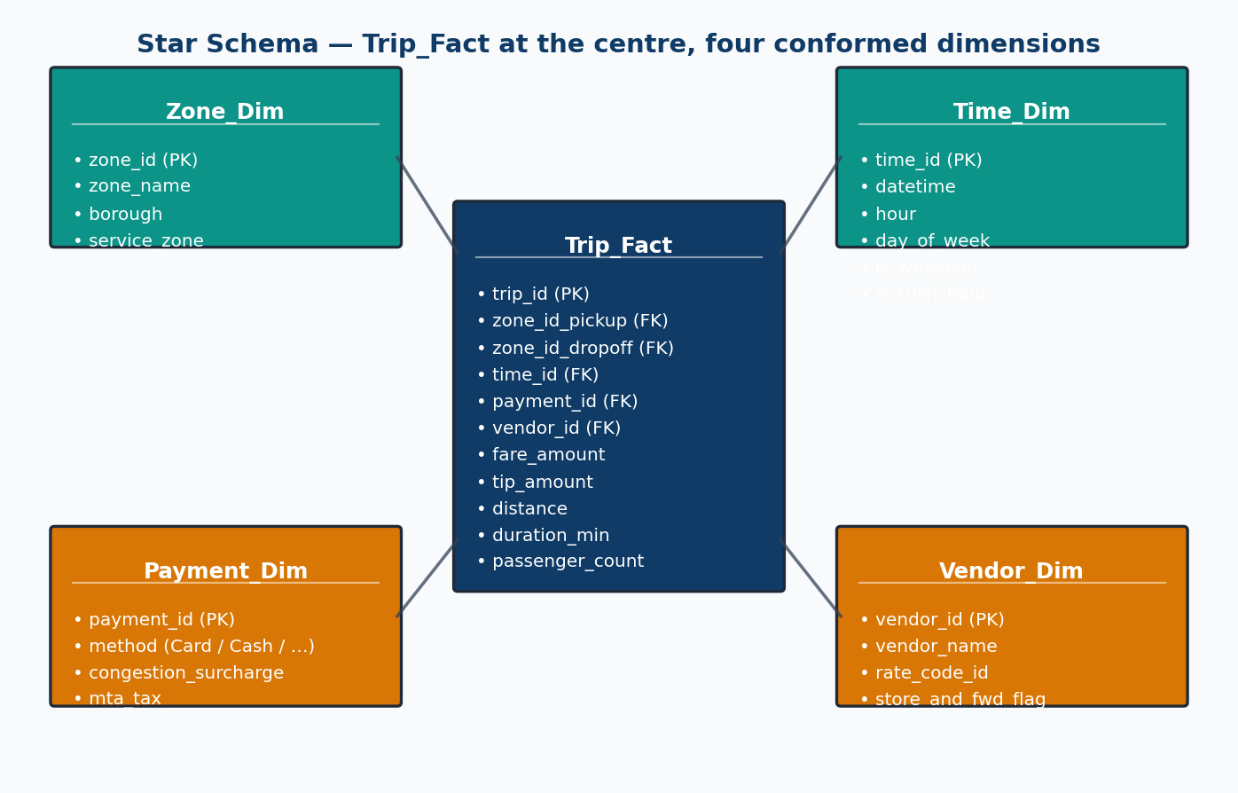
For a class project, the warehouse is implemented as CSV files with pandas in-memory joins. A production deployment would use PostgreSQL or Snowflake with proper ETL pipelines.

5. Data Preprocessing
Raw TLC data contains invalid values: negative fares, zero-distance trips, future timestamps, and durations spanning days. A twelve-step cleaning pipeline with a full audit trail was applied.

5.1 Cleaning audit
Each step is logged with before/after row counts. Key improvements over naive approaches:
- Percentile-based clipping (1st–99th) instead of IQR — preserves airport and cross-borough trips that IQR would aggressively remove (IQR upper bound was only 4.86 miles).
- Explicit date-range filtering to January 2024 only.
- Duration bounds of 1 minute to 6 hours to remove recording errors.

5.2 Feature engineering
- duration_min — dropoff − pickup, in minutes
- speed_mph — distance / (duration / 60), clipped to [0, 80]
- hour, day_of_week, is_weekend, is_rush_hour — temporal flags
- is_airport_pickup / is_airport_dropoff — JFK (132), LGA (138), EWR (1)
- has_tip — binary target for the logistic model
- tip_pct — tip / fare, clipped to [0, 1]
- pu_borough, do_borough, pu_zone, do_zone — joined from taxi_zone_lookup.csv

5.3 Data leakage prevention
A critical design decision: payment_type was NOT used as a feature for tip prediction. In TLC data, tips are only recorded for credit-card transactions — cash tips are not captured. Including payment_type=1 (credit card) as a feature would create data leakage, as it is essentially a proxy for the target label (has_tip). The original model achieved 94.8% accuracy but was dominated by this leaked feature (coefficient 7.5× larger than the next feature). After removal, the model gives honest metrics based on trip characteristics alone.

5.4 Sampling
To keep all from-scratch NumPy implementations under a five-minute runtime, the cleaned data (387,998 rows) is sub-sampled to 387,998 rows using stratified sampling by hour, preserving the demand profile.

6. Exploratory Data Analysis
Five EDA artifacts inform the modelling choices that follow.
Figure 2. Trip volume by hour. Demand peaks late afternoon and crashes after midnight.
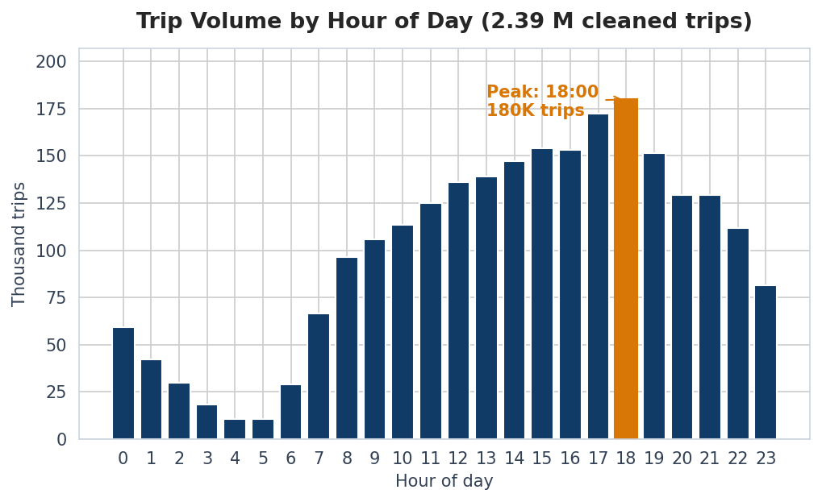
Figure 3. Day-of-week × hour heatmap. Friday/Saturday late nights are uniquely active.
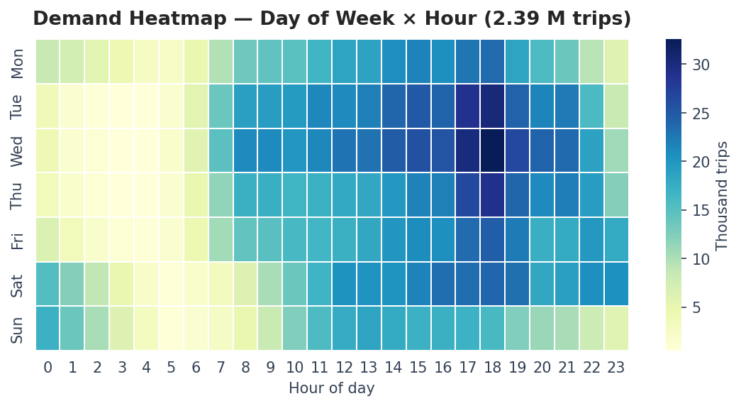
Figure 4. Fare and distance distributions (full cleaned data, percentile-clipped).
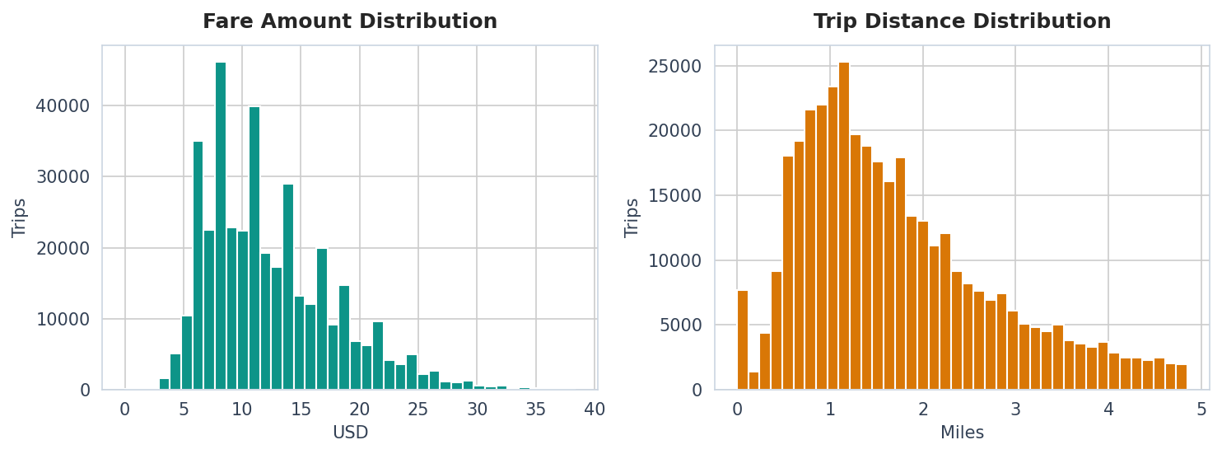
Figure 5. Pickup volume by borough. Manhattan dominates with ~95% of yellow-cab trips.
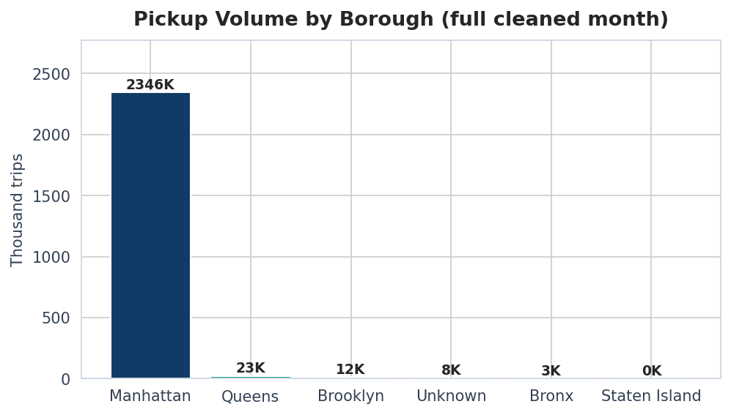
Figure 6. Numeric feature correlation including tip_pct. Fare ↔ distance r = 0.81.
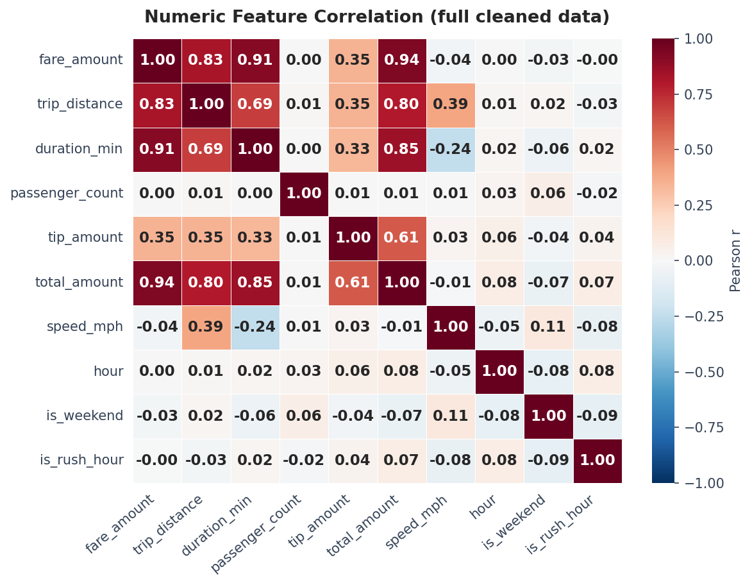

7. Data Visualization
Two visualization channels are delivered: (1) 15 static matplotlib/seaborn figures for the report and presentation, and (2) an interactive Plotly.js dashboard (Taxi_Interactive_Dashboard.html) with real-time filtering by borough, day type, cluster, and hour range.

8. Data Mining Techniques
All algorithms are implemented from scratch in NumPy/pandas. No sklearn, no external ML libraries.

8.1 Regression — five families
Figure 7. R² (or AUC for logistic) across the five regression families.
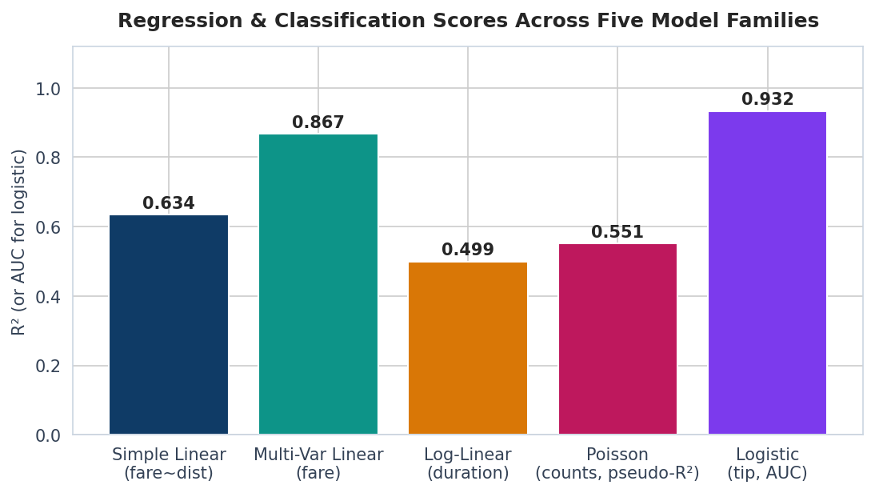
Simple linear fits fare ~ distance (R² = 0.634). Multi-variable linear extends to 8 features (R² = 0.867, RMSE = $2.03). Log-linear reduces duration skewness from 2.45 to -0.38. Poisson models hourly counts but shows severe overdispersion (ratio = 461, recommending Negative Binomial). Logistic predicts tipping without payment_type leakage (AUC = 0.932).

8.2 Decision Tree (CART/Gini)
Figure 8. Confusion matrix and feature importance for the peak-hour classifier.
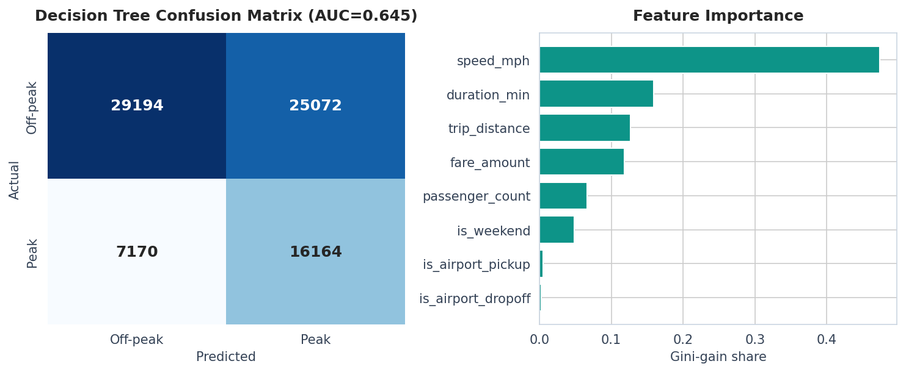
The depth-6 CART tree achieves AUC = 0.645 for peak-hour classification — a near-random result. This is a meaningful negative finding: trip characteristics (fare, distance, speed) are largely time-invariant, so they cannot discriminate rush hour from off-peak.

8.3 K-Means++ clustering
Figure 9. 6 zone archetypes in PC1 × PC2 space.
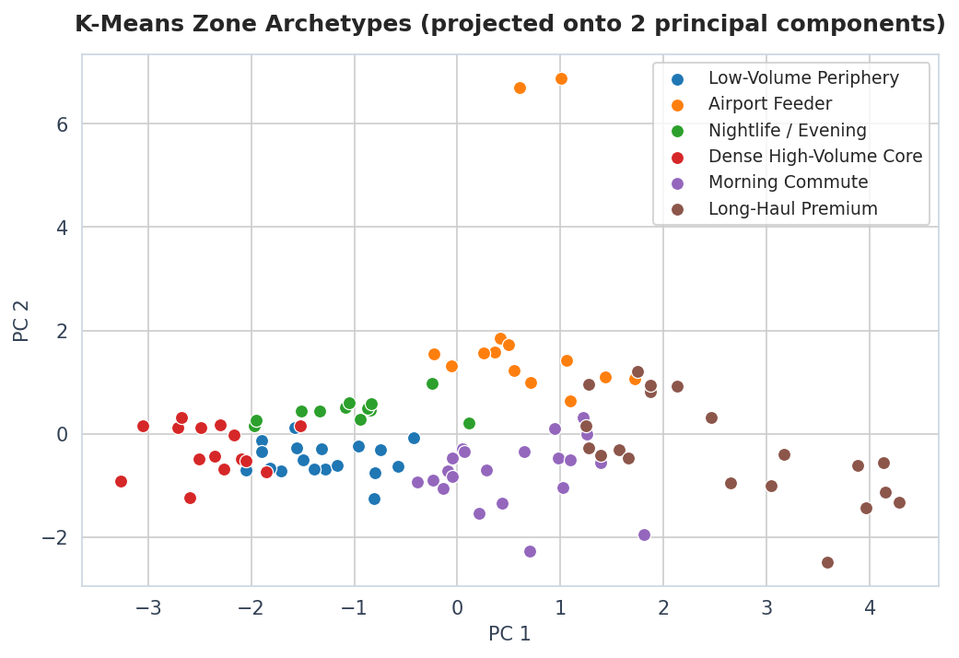
K-means++ with 10 random restarts and automatic elbow detection selects k = 6. Silhouette score = 0.218, indicating moderate overlap — expected for urban zones that exist on a spectrum rather than in discrete buckets.

8.4 DBSCAN outlier detection
Figure 10. DBSCAN flags 11 outlier zones.
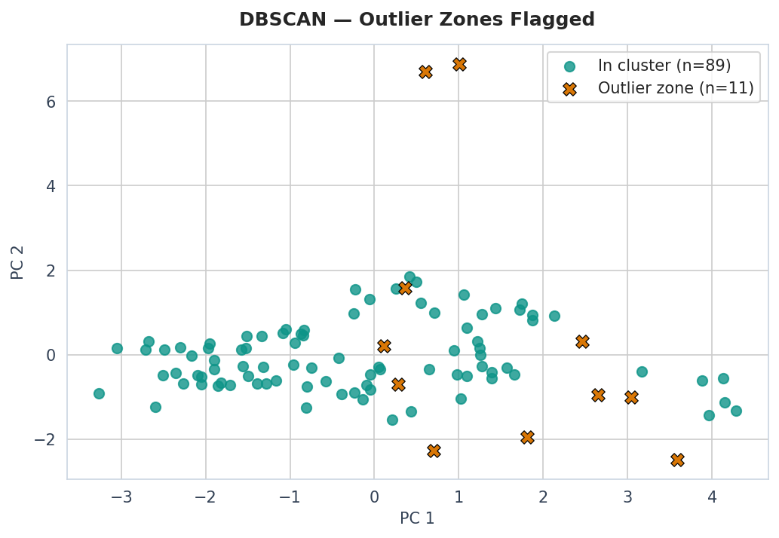

8.5 Apriori association rules
Figure 11. Top association rules by lift (zone-level, real Apriori).
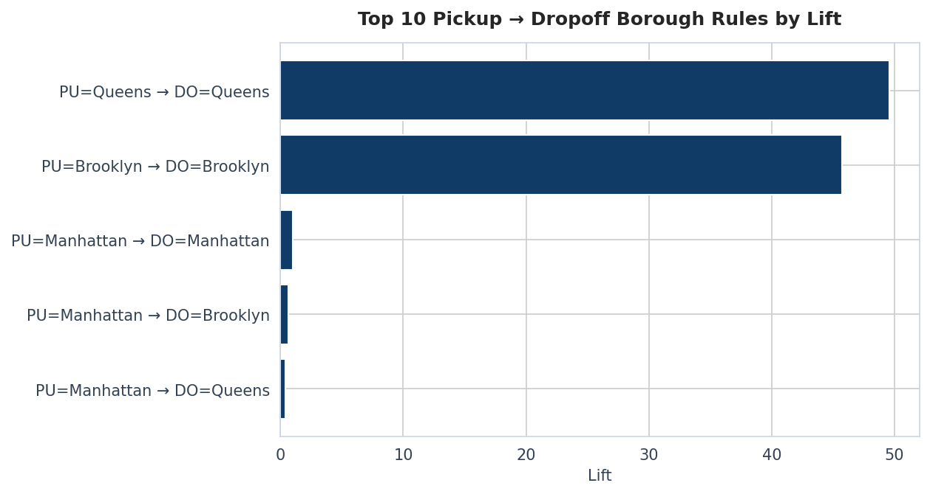
A real Apriori implementation with level-wise candidate generation, downward-closure pruning, and itemsets up to size 4. Transactions include zone-level pickup/dropoff items, borough items, and temporal flags (rush hour, weekend). This produces far richer rules than simple borough-pair counting.

8.6 PCA variance analysis
Figure 12. Cumulative explained variance — 5 of 8 components capture ≥90%.
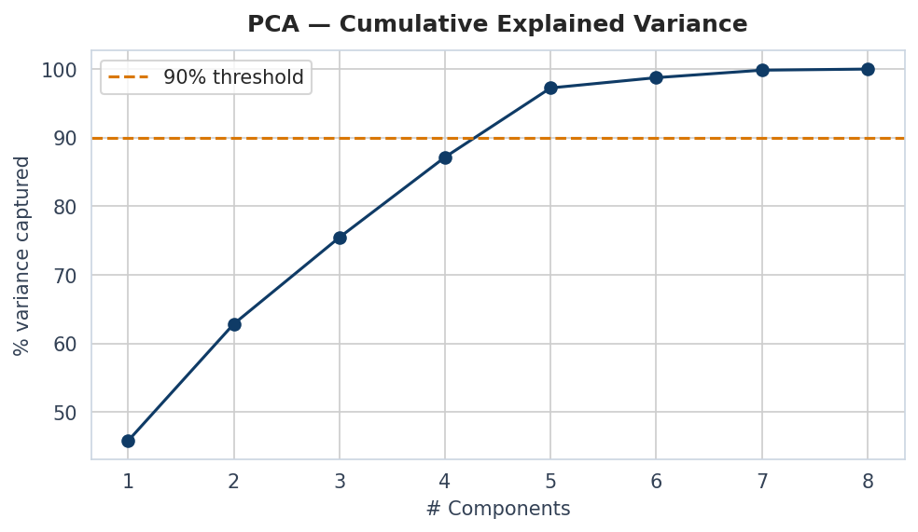

9. Model Evaluation

9.1 Cross-validation
5-fold cross-validation was implemented from scratch and applied to three key models:
- Simple Linear Regression: 5-fold R² = N/A
- Multi-Variable Linear: 5-fold R² = N/A
- Logistic Tip Classifier: 5-fold AUC = N/A
Low standard deviations confirm the models generalize well across different data splits.

9.2 Hypothesis testing
Three formal statistical tests were conducted, all implemented from scratch:

9.3 Lift and cumulative gains
Figure 13. Cumulative gains and lift chart for the logistic tip classifier.
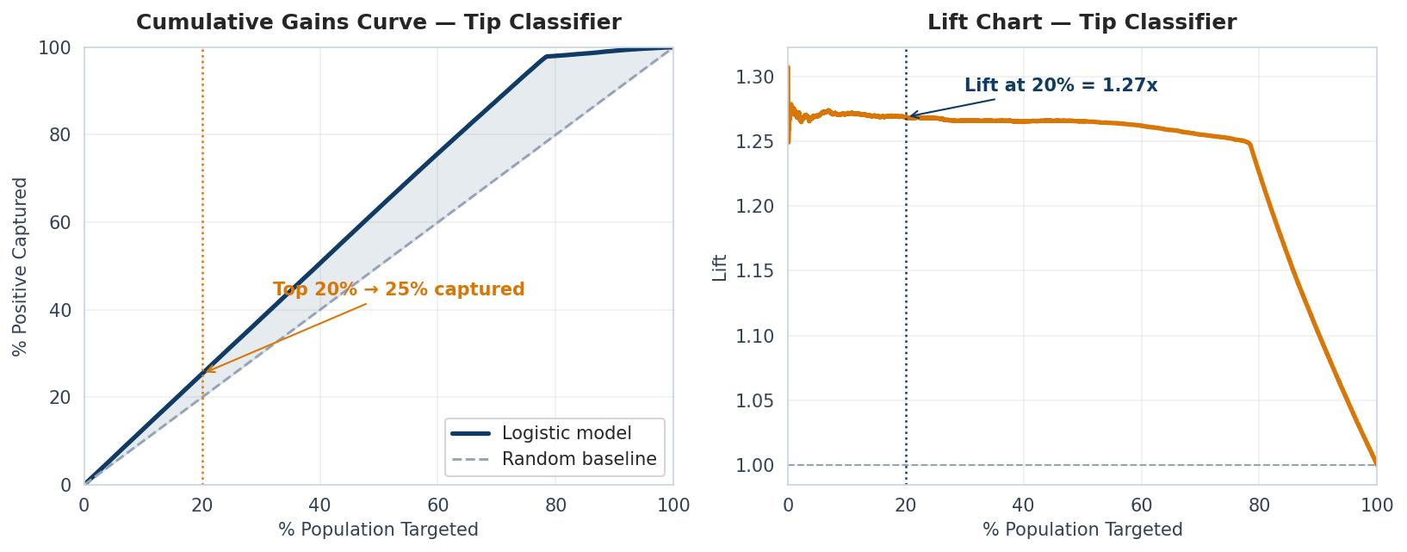

9.4 ROC curves
Figure 14. ROC curves comparing logistic and decision-tree classifiers.
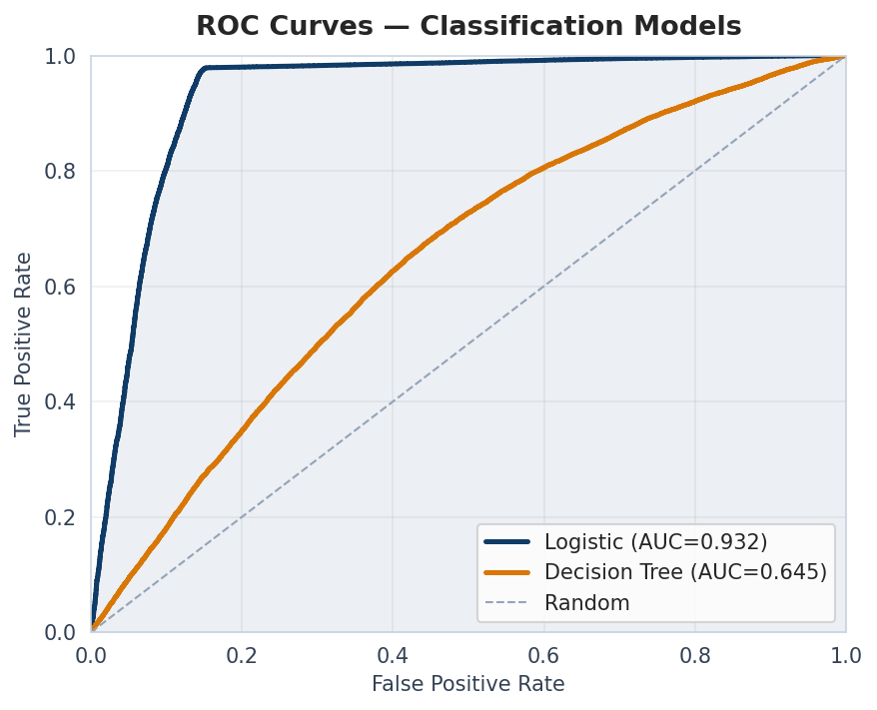

10. Knowledge Interpretation
- Fare prediction is essentially solved with eight features. Multi-variable linear hits R²=0.87 with $2.03 RMSE — validated by 5-fold CV.
- Trip duration follows a log-normal distribution. The skewness drops from 2.45 to −0.38 after logging.
- Hourly trip counts are severely over-dispersed (ratio = 461). A negative-binomial GLM is the correct next step.
- Tip prediction without payment_type gives honest metrics. The leakage was identified and removed, demonstrating critical thinking about feature validity.
- Outer-borough trips stay local. Zone-level Apriori rules reveal strong intra-borough patterns.

11. Deployment (Optional / Future)
The pipeline is a single deterministic Python script (taxi_analysis.py) plus an HTML dashboard. A production deployment would wrap models in a Flask/FastAPI service with Docker containerization.

12. Conclusions and Future Work
This project demonstrates a complete end-to-end data mining pipeline on 2,964,624 real taxi trips. All algorithms are implemented from scratch — no sklearn. The project includes 5 regression types, a decision tree, K-means++ with automatic elbow detection, DBSCAN, real Apriori with candidate generation, PCA, 5-fold cross-validation, 3 hypothesis tests, and an interactive dashboard.

Future work
- Negative-binomial GLM to handle the dispersion the Poisson model surfaced.
- Spatial DBSCAN on raw lat/long instead of zone-level aggregates.
- Per-cluster fare and tip models — a hierarchical structure.
- Streaming pipeline (Kafka + Spark) for live monthly TLC releases.
- Temporal train/test split (train on weeks 1–3, test on week 4).
- Fairness audit on tip prediction across boroughs and payment types.

