**ANU Nanopore Sequencing Workshop Schedule**

**Day 1 – Wednesday, June 14th**

|  |  |
| --- | --- |
| **9:00 AM – 9:15 AM** | **Meet at the ‘Little Pickle’ café on the ANU campus:** https://goo.gl/maps/RZZ77urmsKL2 |

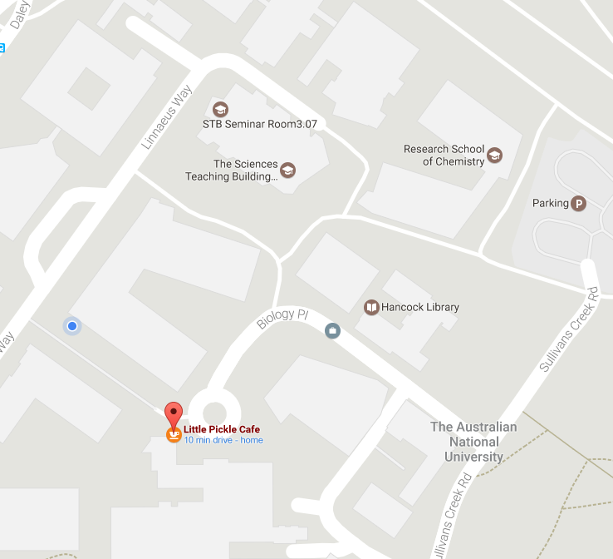**Workshop contacts**

Benjamin Schwesinger: [benjamin.schwessinger@anu.edu.au](mailto:benjamin.schwessinger@anu.edu.au)

Megan McDonald: [megan.mcdonald@anu.edu.au](mailto:megan.mcdonald@anu.edu.au)

Steve Eichten: [steven.eichten@anu.edu.au](mailto:steven.eichten@anu.edu.au)

Mobile: 0405919737

*Organisers will be here to provide nametags and record your arrival. We will then lead all attendees to our lab space in the Ecogenomics and Bioinformatics Lab (EBL) where we will start the workshop. Please arrive on time as the lab is through security doors which organisers have access to. Please note the construction occurring in the areas surrounding the café, however the café will be open.*

|  |  |
| --- | --- |
| **9:30 – 10:15 AM**  **EBL** | **Presentation: ‘Nanopore sequencing in a nutshell’**  *Workshop leaders will provide details on the overall goals of the workshop and a brief introduction to the sequencing technology used in the Oxford Nanopore MinION. This will include details regarding sequencing kits available at the time of this workshop.* |
| **10:15 – 11:00 AM**  **EBL** | **Presentation: ‘DNA extractions and Library prep methods’ – Benjamin Schwessinger**  *Nanopore sequencing quality, read length, and yield can be drastically affected by your input DNA sample. Ben will provide a brief guide regarding the input DNA requirements for our MinION library preps. This will include going through the results of DNA quality for those attendees who submitted DNA to be sequenced. This will also include information regarding library prep methods, flowcell loading, and technical videos from the Nanopore community.* |
| **11:00 – 11:30 AM**  **EBL** | **Early Lunch** |
| **11:30 – 2:00 PM**  **EBL** | **Wet Lab – Library Preparation**  *Attendees will be organised into small groups to work at a lab bench. Groups will contain people performing different library prep methods so each attendee can see multiple different options for library creation. Group leaders will walk through the protocol, answering any questions you may have. Once libraries have been created, each group will have practice loading flowcells to gain confidence in this key step of the procedure.* |
| **2:00 – 2:15 PM**  **EBL** | **Coffee and Tea Break just outside lab area** |
| **2:15 – 4:00 PM**  **EBL** | **Wet Lab – Library Preparation part II**  *A continuation of the library preparation will occur until all attendees have started sequencing****. Sequencing will occur on the laptops brought by attendees and will be left to sequence until Friday in the secured EBL lab space****. Attendees will record the use of their flowcell in a metadata-tracking sheet and we will spend time observing the initial steps of sequencing on the MinKNOW software platform. The initial reads will be moved via FTP to a server for basecalling overnight. This data will be available tomorrow for the computational analysis portion of the workshop.* |

**Day 2 – Thursday, June 15th**

|  |  |
| --- | --- |
| **9:00 – 9:15 AM**  **Little Pickle > EBL** | **Meet once again at the ‘Little Pickle’ café prior to check on MinION sequencing runs**  *Please meet at the café by 9:15 AM and we will as a group return to the EBL to examine our overnight sequencing progress. This will be chance to check on initial yield, sequencing progress, and any technical difficulties that have occurred overnight. Workshop leaders will be present to help explain any current status and answer questions.*  *We will then move to the Gould seminar room for the data analysis portion of the workshop* |
| **9:40 – 10:45 AM**  **GSR** | **Analysis I – Tutorial on data formats and basecalling**  *We will discuss the concepts and types of data that are initially created from the MinION. This will specifically include discussion of the Nanopore ‘fast5’ file format. This will be followed by a presentation on the Albacore basecalling method commonly used to create sequencing reads for downstream analysis.* |
| **10:45 – 11:00 AM**  **GSR** | **Coffee and Tea Break** |
| **11:00 – 12:30 PM**  **GSR** | **Analysis II – Read QC, run QC, and initial examination of basecalled data**  *We will examine how the ‘fast5’ files change after basecalling and use a hands-on tutorial of poretools to examine MinION sequencing reads. This will be an interactive session using trial data on provided laptops. We will go through some of the visualization methods available to examine the output data as well as create read data to be used for downstream analysis.* |
| **12:30 – 1:30 PM**  **EEG Tearoom** | **Lunch**  *Lunch will be provided in the nearby Ecology and Evolution Tearoom* |
| **1:30 – 2:30 PM**  **GSR** | **Guest Speaker I – Louise Judd – Bio21 Molecular Science and Biotechnology Institute – U. Melbourne "Bacterial genome assemblies with Oxford Nanopore MinION”**  *Louise Judd will be discussing tools developed for nanopore sequencing analysis including Porechop and Unicycler. Porechop is a read trimming and barcoding de-mulitplexing software for nanopore reads. Unicylcer is a circular genome assembler that combines the power of long and short read sequencing technologies.*  *Lab website is https://holtlab.net* |
| **2:30 – 3:30 PM**  **GSR** | **Analysis III – What can you do with long reads?**  *We will discuss examples of what can be done with the long reads sequenced on the MinION platform including read alignment, genome assembly, and sample identification. Megan McDonald will present examples of genome assembly using long reads as well as highlight other specific use cases where long reads can be using with common short-read analysis workflows.* |
| **3:30 – 4:30 PM**  **GSR** | **Guest Speaker II – Ken McGrath – AGRF Brisbane “Metagenomics on the MinION”**  *Ken McGrath is the National Sanger Sequencing Manager at the Australian Genome Research Facility, based in Brisbane, Australia. He obtained his PhD studying Molecular Pathology in 2005 from the University of Queensland, and has a research background in microbial community genomics, including human and environmental microbiomes and metagenomics analysis. Ken is currently involved with several research projects, including the US-based eXtreme Microbiome Project (XMP), as well as evaluating emerging technologies that can be used to profile the diversity of microbial communities.* |
| **5:00 – 5:20 PM**  **EBL** | **Check on sequencing runs**  *A quick check on MinION sequencing runs back in the EBL* |
| **5:20 – 7:30 PM**  **Drop In Centre**  **Linnaeus Bldg.** | **Workshop Dinner and Chat with Oxford Nanopore**  *Dinner and drinks will be provided to relax and ask questions to Oxford Nanopore representatives who will be joining us from the UK for a video call to answer any other questions you have regarding the MinION technology.* |

**Day 3 – Friday, June 16th**

|  |  |
| --- | --- |
| **9:00 – 9:15 AM**  **Little Pickle > EBL** | **Meet at the ‘Little Pickle’ café and check on sequencing runs** |
| **9:15 – 11:00 AM**  **EBL** | **Wet Lab – Completing MinION sequencing runs**  *Attendees will end their sequencing runs. We will walk through the process of washing flowcells and assist in transferring raw data to the FTP site for subsequent basecalling of your sequencing run. We will also take time to answer questions, discuss how runs progressed and compare and contrast raw yields between all attendees.* |
| **11:00 – 11:20 AM**  **EBL** | **Coffee and Tea Break** |
| **11:20 – 1:30 PM**  **EBL** | **Workshop Conclusion – Additional resources**  *Upon washing flowcells, we will briefly discuss additional software, analysis techniques, and future progress of the MinION sequencing platform. This will be an opportunity to see the ever-increasing software stack for this fast-moving technology. We will also discuss how Australia’s National Computational Infrastructure (NCI) can provide a powerful platform for basecalling and analysing future sequencing data.* |

**Workshop End**