VITYARTHI PROJECT
COURSE NAME- COMPUTER VISION

PlantVision
Classical Computer Vision Based Plant Image Analysis

Submitted by: Anushka Ranjan
24BAI10252
B.Tech CSE (AI-ML), VIT Bhopal University

Abstract
PlantVision is a computer vision application made for analysing a plant image through a sequence of preprocessing, edge detection, feature extraction, structural analysis and image segmentation operations.This is a resusable commandline program that can be further used to identify different plant varieties from each other. The implemented pipeline includes Canny, Laplacian of Gaussian (LoG), Difference of Gaussian (DoG), probabilistic Hough line detection, Harris corner detection, SIFT, HOG, Gabor filters, Otsu thresholding, GrabCut and region growing. The results are also separately mentioned in the results table.

Introduction
Computer vision often relies on the core concept of feature extraction for object recognition and classification... Edges can indicate boundaries, corners can indicate local structure, and descriptors can represent shape, texture and local appearance. Segmentation, on the other hand, attempts to separate regions of interest from their surroundings.
A single succulent image is used as the input example. The project is intended as a practical demonstration of how different classical computer vision methods respond to the same image.

Problem Statement
A raw plant photograph contains colour variation, texture, boundaries, small structures and background information. Analysing all of these properties directly from pixel values is difficult. The problem addressed in this project is to construct a practical image-analysis pipeline that extracts several visual features from the same plant image and produces reproducible outputs from the command line.

Objectives
- Load and preprocess a plant image in a consistent format and size.
- Detect important image structures using Canny, LoG and DoG edge operators.
- Detect line and corner structures using the Hough Transform and Harris detector.
- Extract local and global visual features using SIFT and HOG.
- Analyse texture and orientation using Gabor filters.
- Represent image information using a one-level Haar wavelet decomposition.
- Segment the image using Otsu thresholding, GrabCut and region growing.
- Generate saved visual outputs and a numerical summary automatically.
- Provide a command-line project structure that can be reproduced on another machine.

System Workflow
The implemented workflow is organised as: input image → preprocessing → edge and structural analysis → feature extraction → segmentation → numerical summary. Each stage saves its output inside the results directory so that the processing can be inspected independently.
Stage | Main operations | Purpose
Input / preprocessing | Load, resize, grayscale | Standardise the image
Edge analysis | Canny, LoG, DoG | Highlight intensity boundaries
Structure | Hough, Harris | Find lines and corner-like points
Feature extraction | SIFT, HOG | Describe local and shape information
Texture | Gabor filters | Analyse oriented texture response
Wavelets | Haar DWT | Separate approximation and detail information
Segmentation | Otsu, GrabCut, region growing | Separate or group image regions
Analysis | Summary statistics | Record numerical observations

Implementation and Methodology

Preprocessing
The input image is loaded with OpenCV and resized to 512 x 512 pixels for consistent processing. A grayscale version is then produced for algorithms that operate on intensity rather than colour. Gaussian smoothing is used where required to reduce small-scale noise before derivative-based operations.
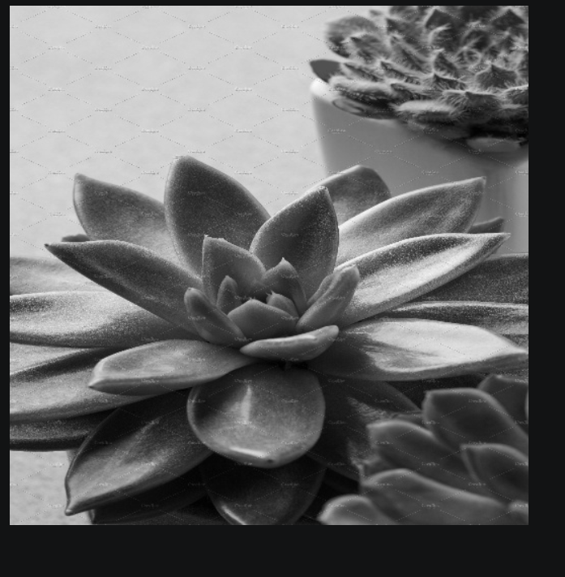

Canny Edge Detection
Canny detection is used to locate strong intensity transitions. The implementation applies lower and upper hysteresis thresholds of 80 and 160.

Laplacian of Gaussian and Difference of Gaussian
For LoG, the image is first smoothed with a Gaussian filter and then processed with the Laplacian operator.
The absolute response is normalised for display. DoG is calculated as the absolute difference between two Gaussian-blurred versions using sigma values of 1.0 and 2.0.

Hough Line Detection
Probabilistic Hough Line Transform is applied to the Canny edge map. The implementation uses a rho resolution of 1 pixel, an angular resolution of one degree, a threshold of 50, a minimum line length of 30 pixels and a maximum line gap of 10 pixels. Detected segments are drawn on a copy of the original image.

Harris Corner Detection
The Harris detector is applied to the grayscale image. Its response is dilated for visibility, and locations exceeding 1% of the maximum response are marked as corner candidates. The result provides a simple visualisation of local image structures where intensity changes in multiple directions.

SIFT
Scale-Invariant Feature Transform is used to identify local keypoints and compute descriptors. The implementation uses OpenCV's SIFT implementation. The recorded run produced 856 detected keypoints.
The keypoints are visualised on the input image.

HOG
Histogram of Oriented Gradients represents local shape information through distributions of gradient orientations. The project uses nine orientation bins, 8 x 8 pixel cells and 2 x 2 cell blocks with L2-Hys normalisation. The resulting descriptor contains 142,884 values for the 512 x 512 input.

Gabor Filters
Gabor filters are applied at four orientations: 0, 45, 90 and 135 degrees. The filter bank is used to examine oriented texture responses. The run records four orientations and a mean absolute response of 4.558 across the filter responses.

Haar Wavelet Decomposition
A one-level Haar-style decomposition is used to separate the image into an approximation component and detail components. The saved outputs provide a compact way to inspect coarse image structure and directional changes.

Otsu Thresholding
Otsu thresholding automatically selects a grayscale threshold by separating the image into two intensity groups. The binary result is saved for visual comparison with the other segmentation methods.

GrabCut
GrabCut is initialised using a rectangular region with a margin around the image boundary. The algorithm estimates foreground and background labels iteratively. In the recorded run, the estimated foreground occupied 36.96% of the 512 x 512 image. This value describes the particular input and initialisation; it should not be interpreted as a general accuracy measure.

Region Growing
Region growing starts from a central seed pixel and adds neighbouring pixels whose intensity is within a specified tolerance of the seed intensity. The implementation uses a tolerance of 15. The method is useful for demonstrating region-based segmentation, although the selected seed can strongly influence the result.

Software and Project Structure
The application is implemented in Python using OpenCV, NumPy, scikit-image, Matplotlib and PyWavelets. The project is organised so that preprocessing, edge operations, feature extraction, segmentation and visualisation are separated into source modules.
Path | Role
main.py | Command-line entry point and pipeline orchestration
src/preprocessing.py | Image loading, resizing, grayscale and blur
src/edges.py | Canny, LoG, DoG, Hough and Harris operations
src/features.py | SIFT, HOG, Gabor and Haar DWT
src/segmentation.py | Otsu, GrabCut and region growing
Path | Role
src/visualization.py | Output image saving and visualisation
data/sample.jpg | Example input image
results/ | Generated images and summary.txt
notebooks/ | Original course practical notebook

Experimental Results
The command-line application was executed successfully on the sample succulent image. The following table is copied from the generated numerical summary and reflects actual recorded run
Metric | Observed value
Image height | 512 pixels
Image width | 512 pixels
Edge pixels | 11,309
Edge percentage | 4.31%
SIFT keypoints | 856
HOG feature length | 142,884
Gabor orientations | 4
Gabor mean response | 4.558
GrabCut foreground percentage | 36.96%

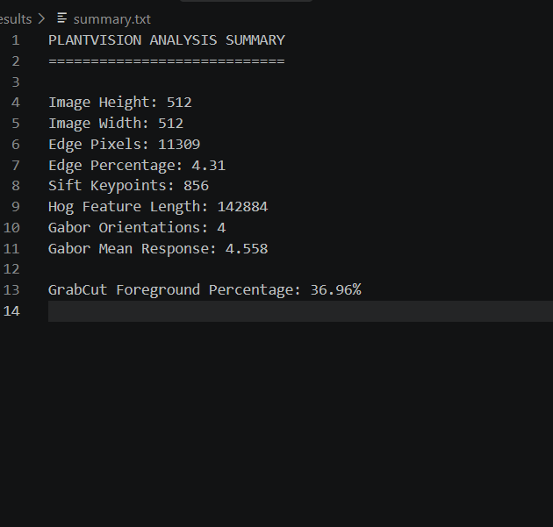
Original Image
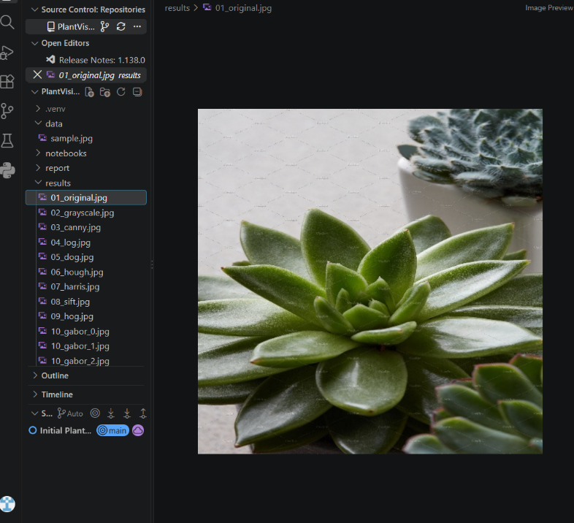
Edge Detection Results
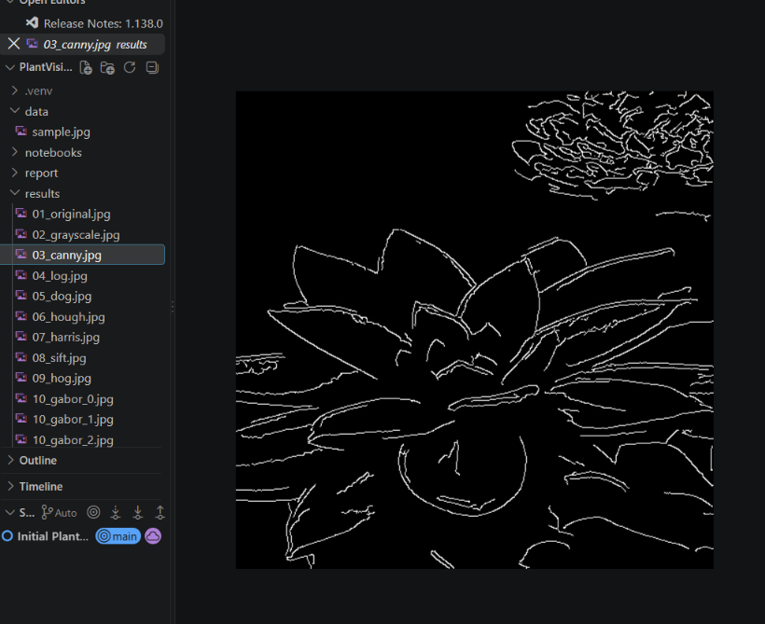
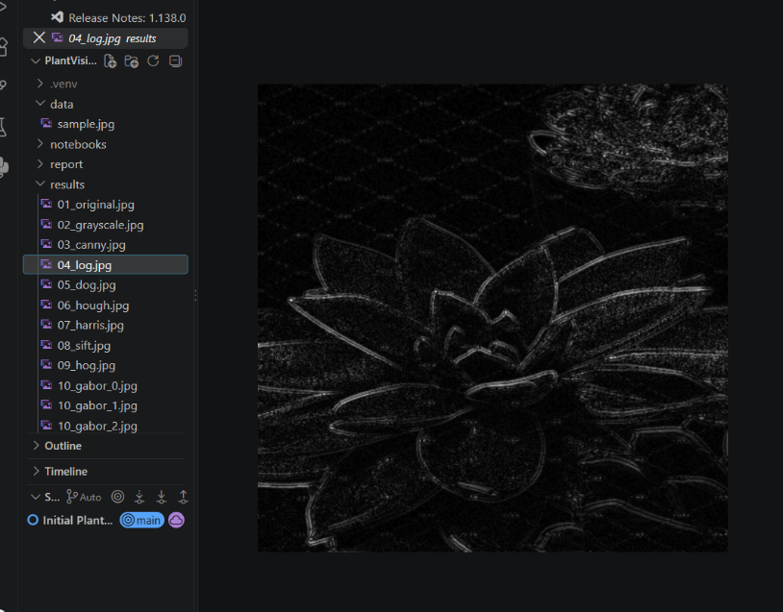
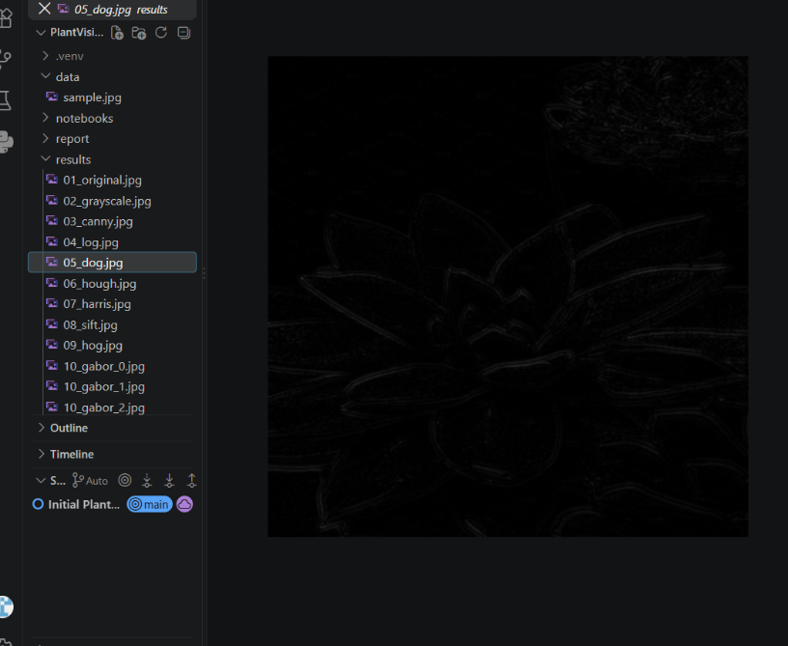

Structural Feature Detection-Hough line detection and Harris corner detection
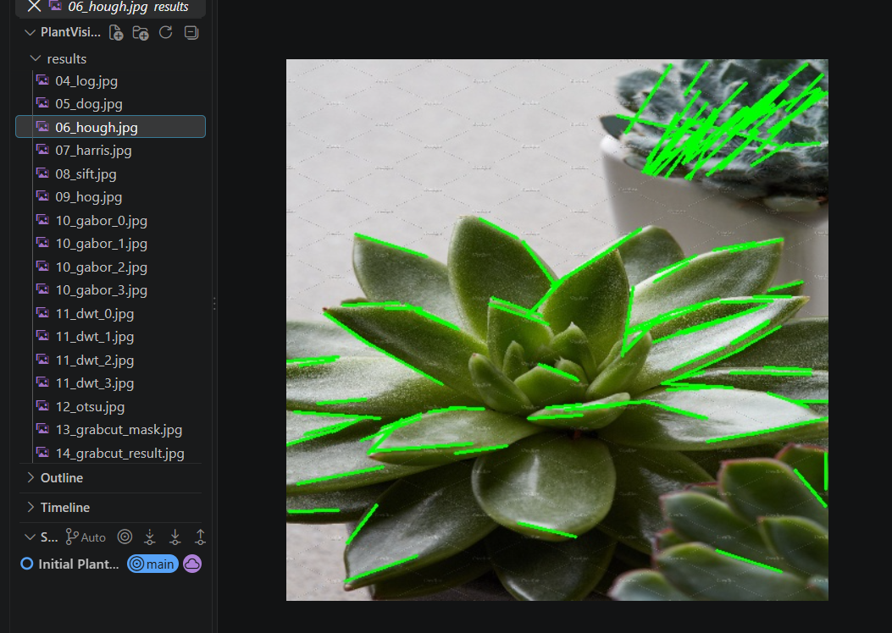
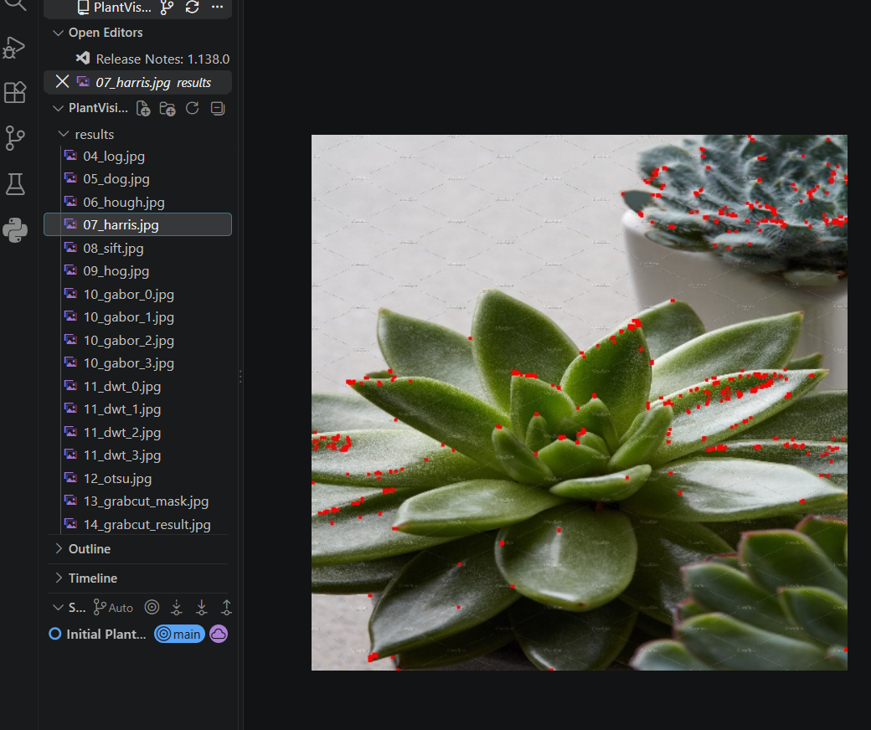

SIFT keypoints and HOG representation.
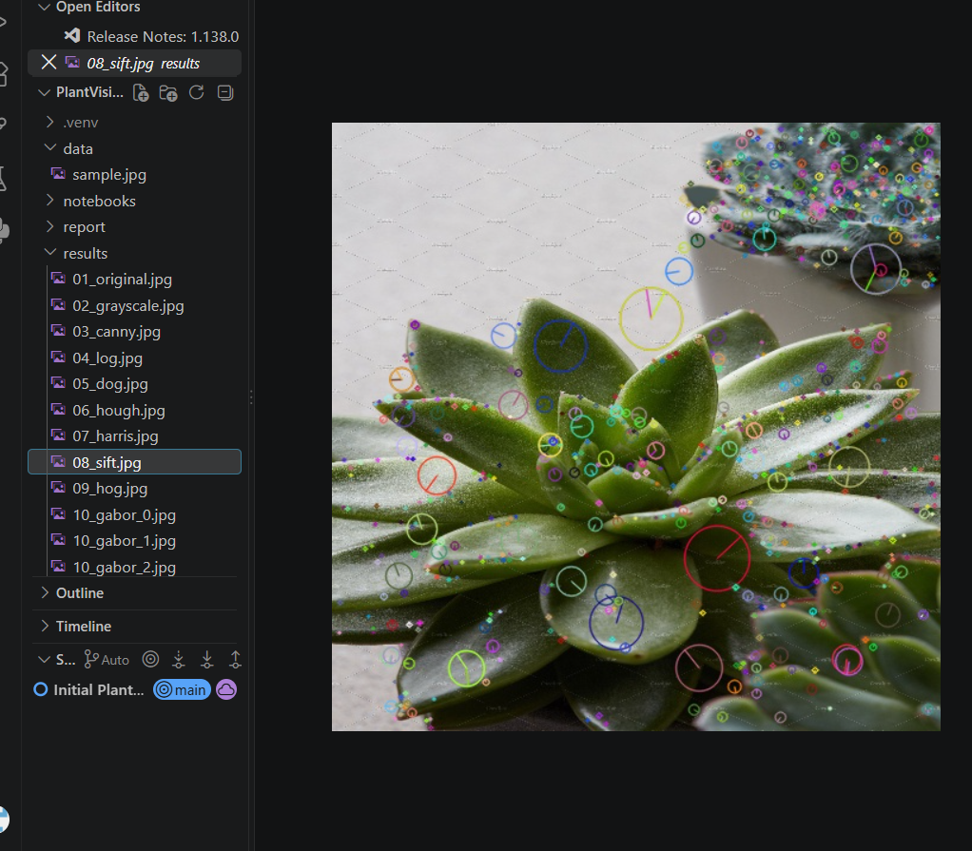

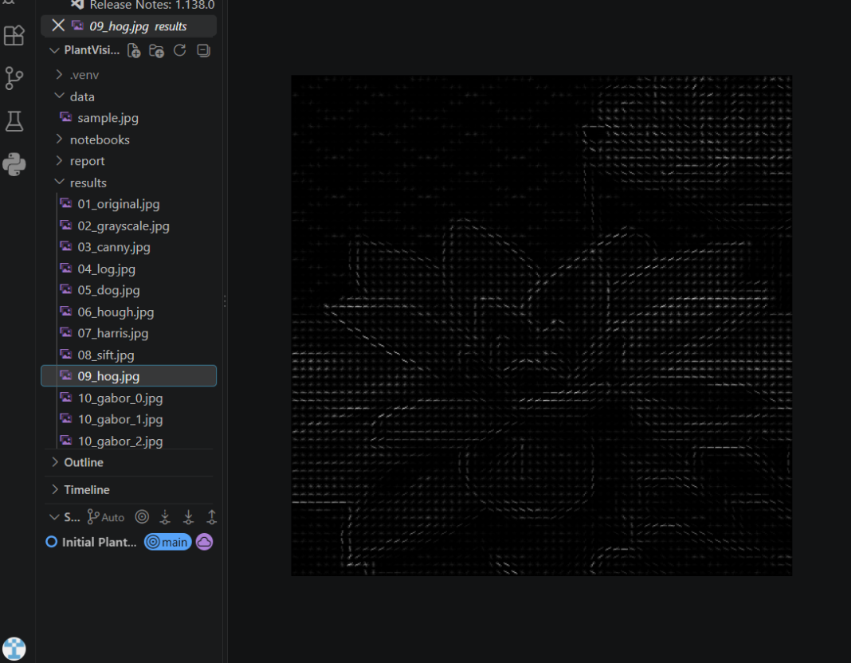
Gabor filter responses and Haar DWT components.

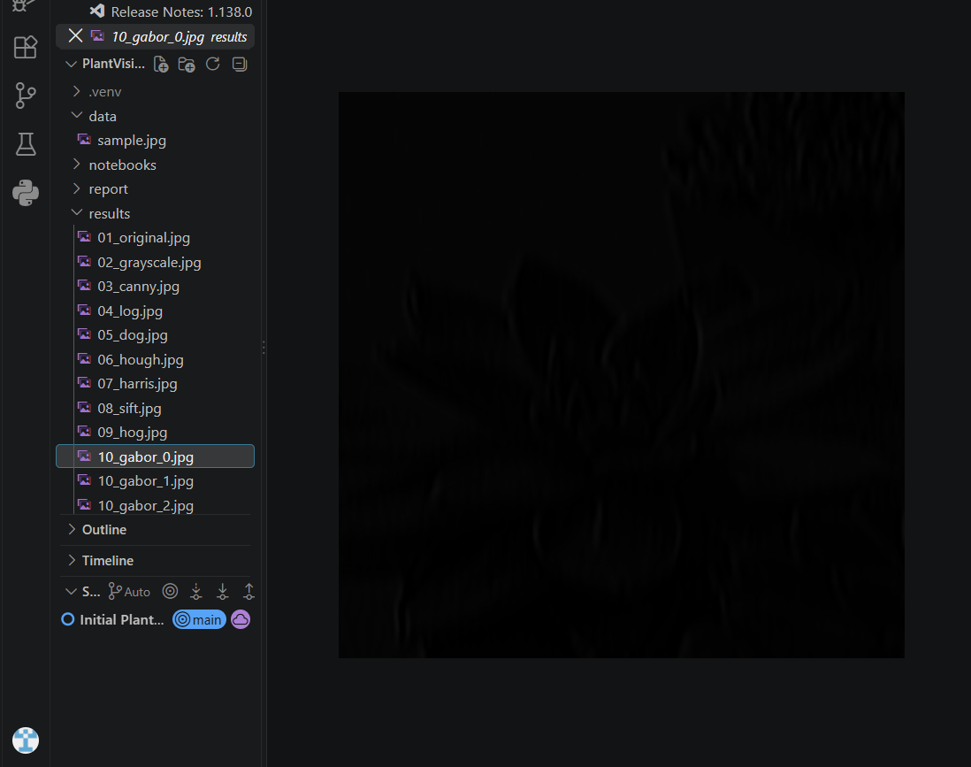
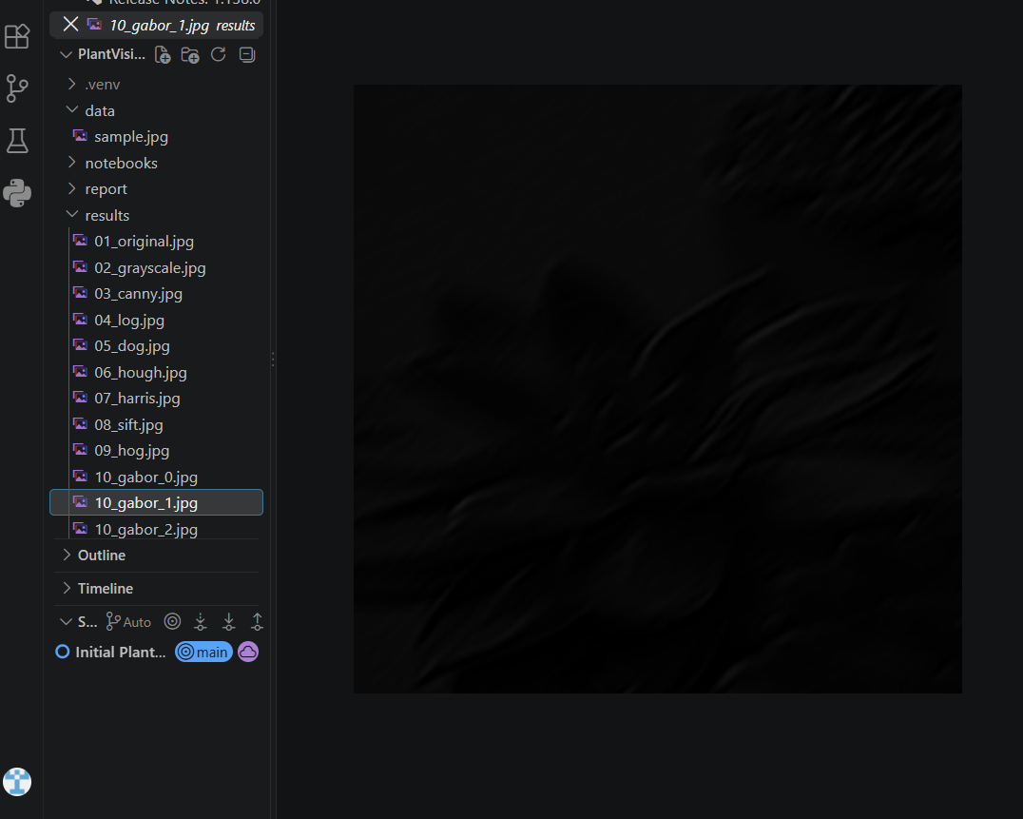
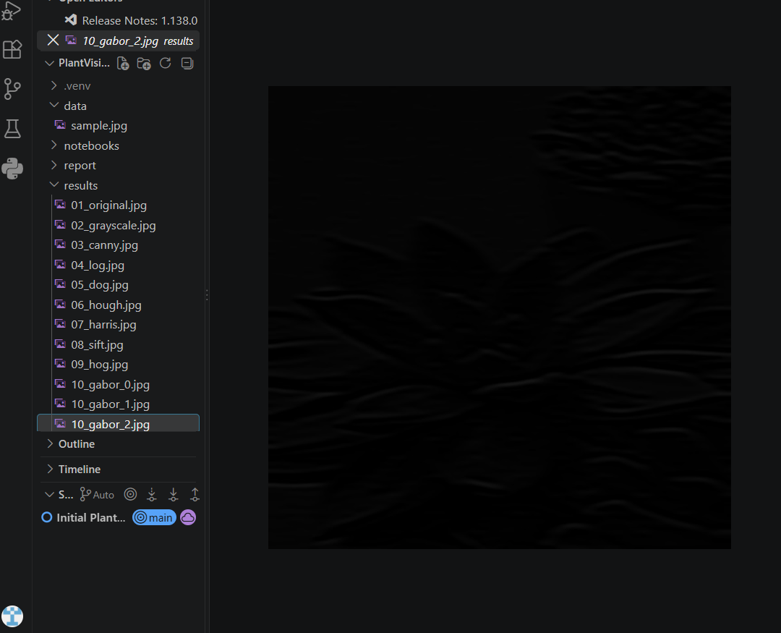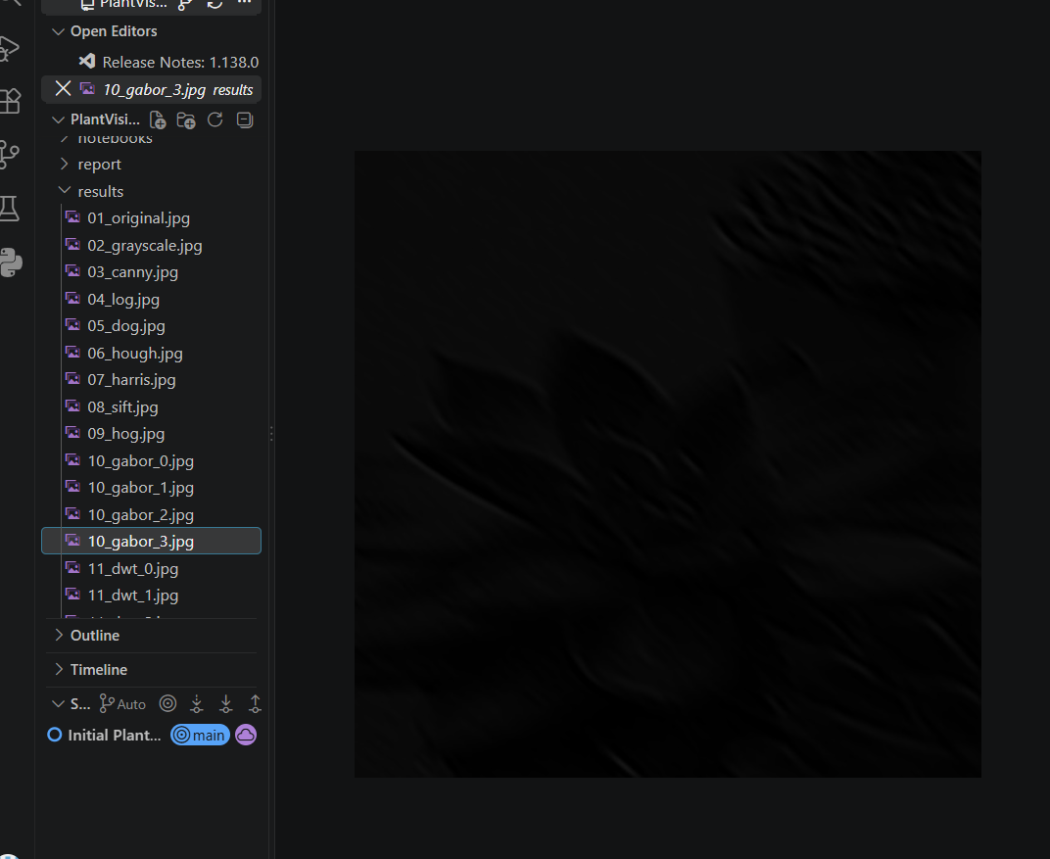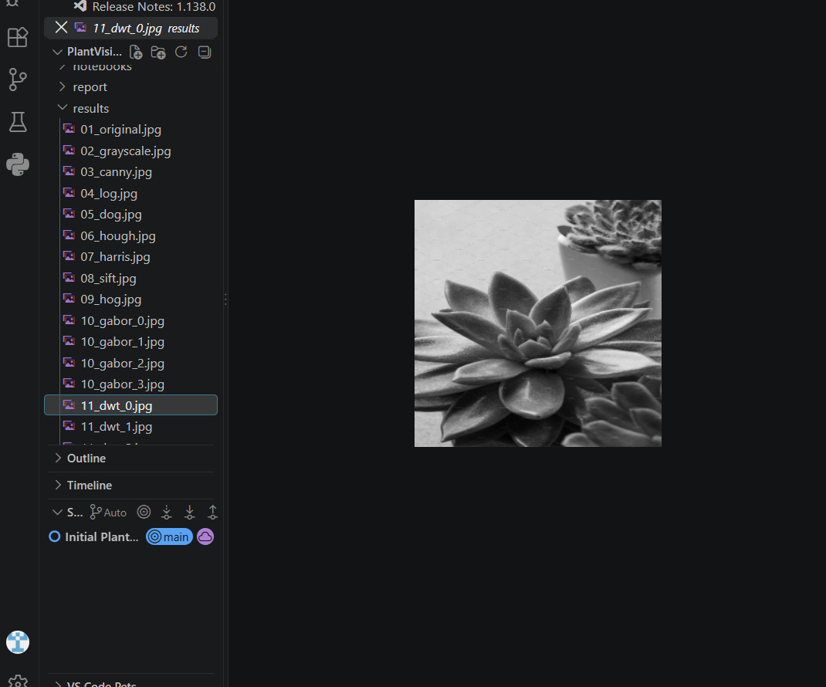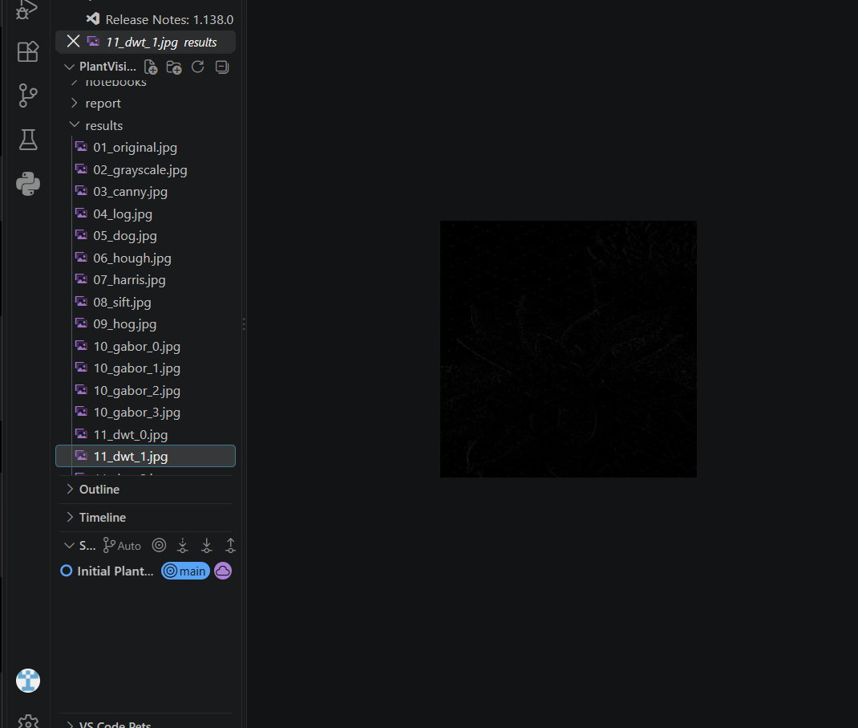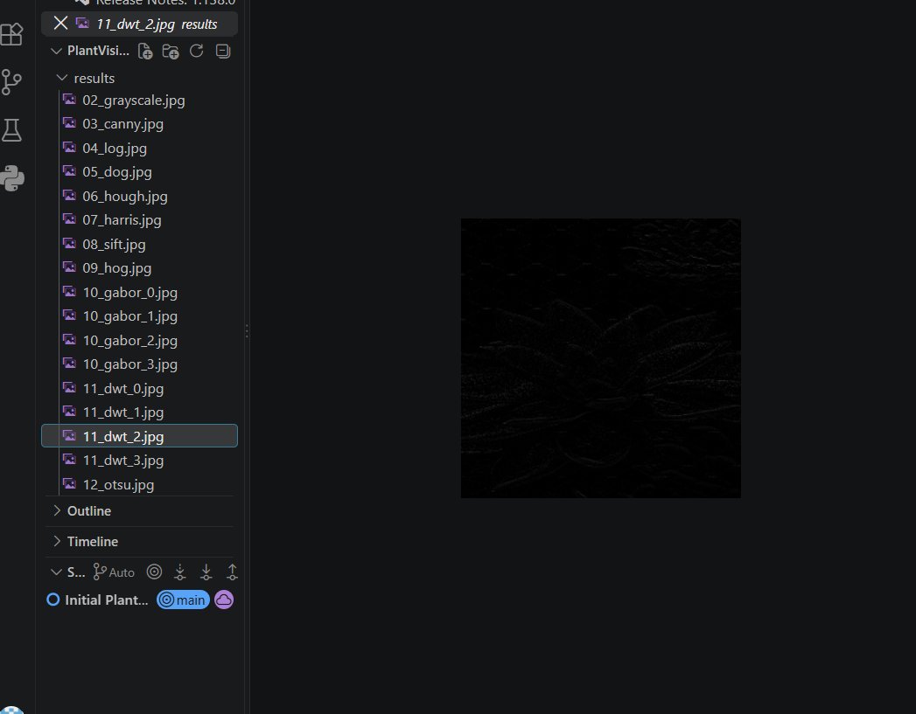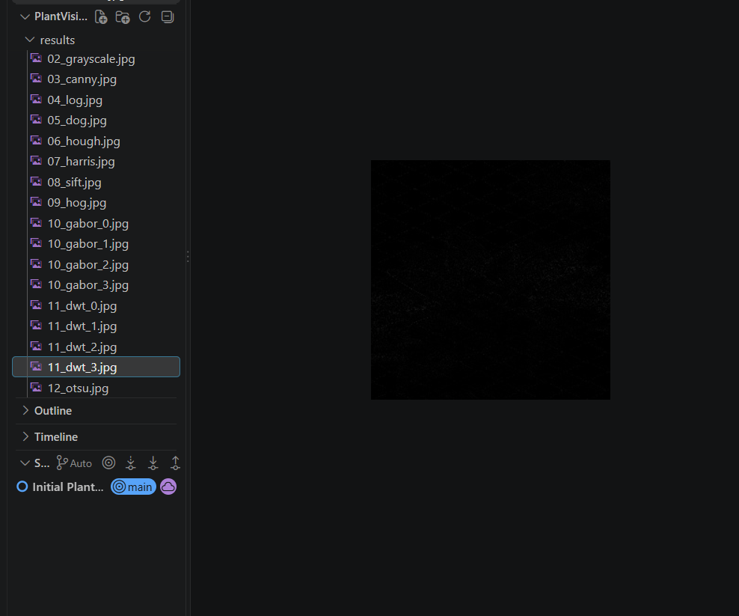
Results obtained using Otsu thresholding, GrabCut and region growing.
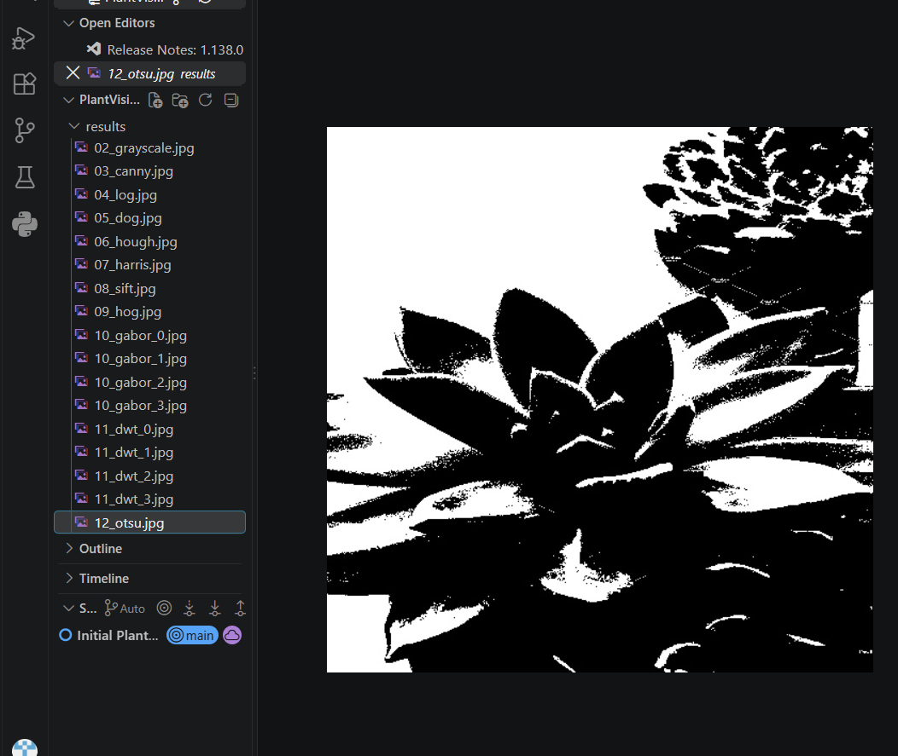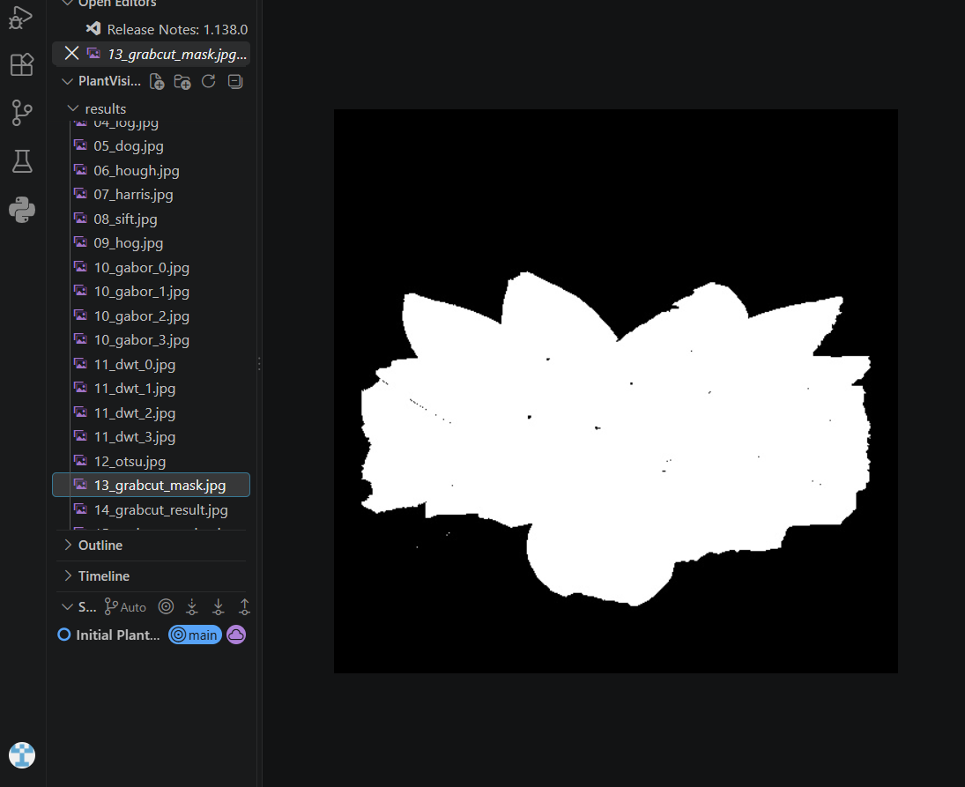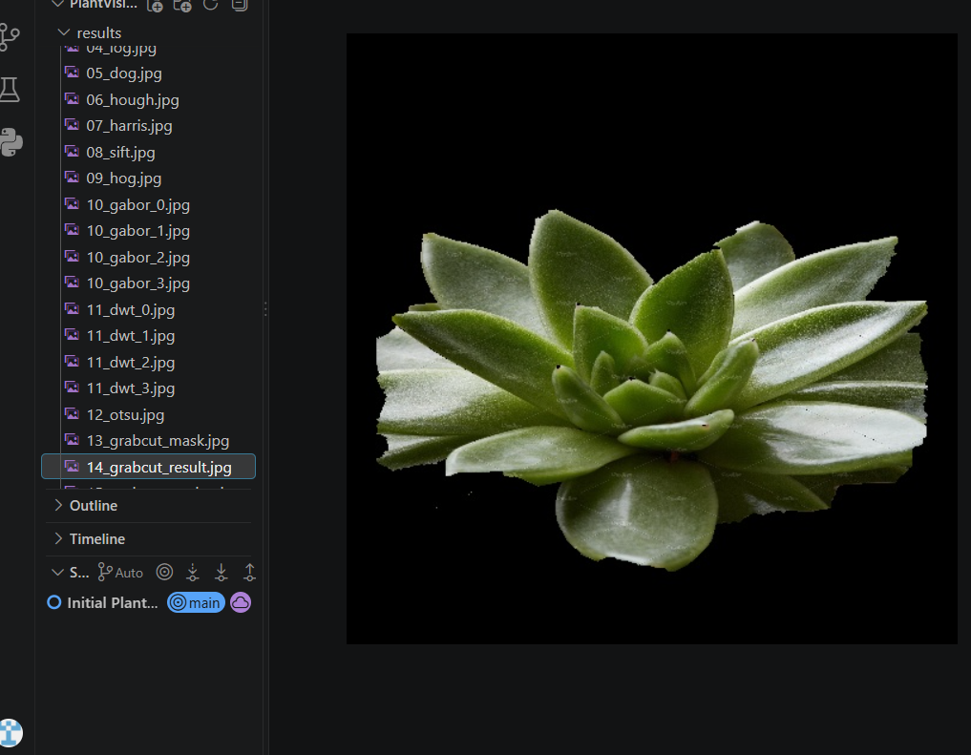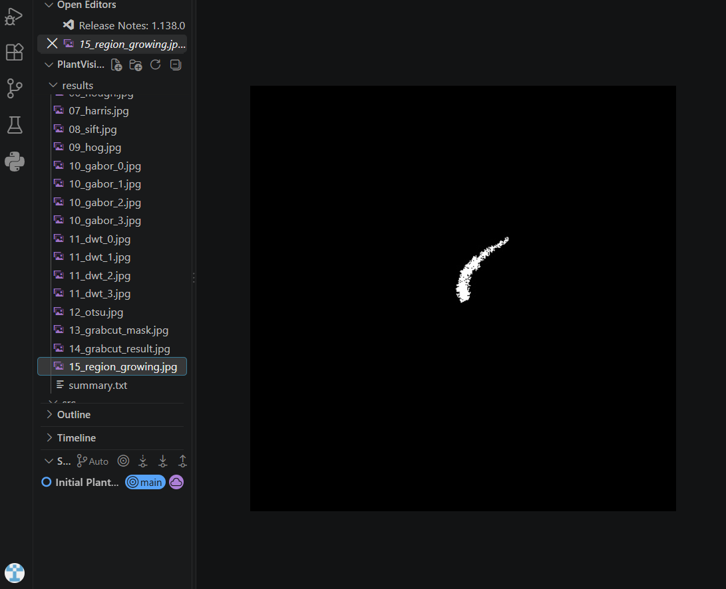

Interpretation
The edge percentage of 4.31% indicates that a relatively small fraction of the image pixels were marked as Canny edges under the selected thresholds. The SIFT stage detected 856 local keypoints, showing that the image contains many locally distinctive structures. HOG produced a comparatively large descriptor because it represents gradient orientations over many cells and blocks. The four Gabor outputs provide directional texture measurements, while the GrabCut result indicates that approximately 36.96% of the pixels were labelled as foreground under the chosen initial rectangle.

Output Files
We have successfully executed our code and the outputs are stored in files. These files are stored under the results directory and can be inspected independently.

Conclusion
PlantVision demonstrates a classical computer vision workflow for plant-image analysis. The application brings together edge detection, structural feature detection, local and gradient descriptors, texture filtering, wavelet analysis and segmentation in one reproducible command-line project. The main value of the project is the practical comparison of several computer vision representations on the same image and the separation of each method into understandable processing stages.

References
- J. Canny, “A Computational Approach to Edge Detection,” IEEE Transactions on Pattern Analysis and Machine Intelligence,1986.
- D. G. Lowe, “Distinctive Image Features from Scale-Invariant Keypoints,” International Journal of Computer Vision, 2004.
- N. Dalal and B. Triggs, “Histograms of Oriented Gradients for Human Detection,” Proceedings of CVPR, 2005.
- C. Harris and M. Stephens, “A Combined Corner and Edge Detector,” Proceedings of the Alvey Vision Conference, 1988.
- R. O. Duda and P. E. Hart, Use of the Hough Transformation to Detect Lines and Curves in Pictures, Communications of theACM, 1972.
- N. Otsu, “A Threshold Selection Method from Gray-Level Histograms,” IEEE Transactions on Systems, Man, and Cybernetics,1979.
- C. Rother, V. Kolmogorov, and A. Blake, “GrabCut: Interactive Foreground Extraction Using Iterated Graph Cuts,” ACMTransactions on Graphics, 2004.
- J. M. Gabor, “Theory of Communication,” Journal of the Institution of Electrical Engineers, 1946.
- A. K. Jain, Fundamentals of Digital Image Processing, Prentice Hall, 1989.
- OpenCV Documentation, computer vision and image processing functions used in the implementation.

