Amazon Locker Recommendation Engine – User Interface

Note
- 0 stands for No, 1 stands for Yes.
- Decision Tree Model is used for prediction as it was giving best results(~98.87% accuracy) out of all developed models.

User interface to take input features of a new order
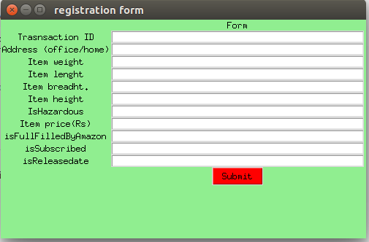

Sample input 1
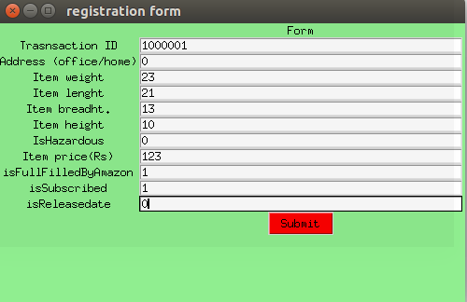

Ouput for input 1
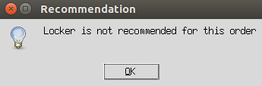

Sample input 2
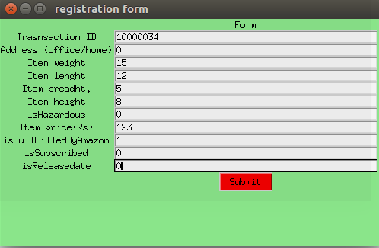

Output for input 2
