Assignment 1

Aim: develop an e-commerce application using monolithic and microservice architecture, and publish both in a public GitHub repository with screenshots.
Shared features in both versions:
- Product catalog with search, category filters and sorting
- Product detail page with stock and care information
- Register and login, using JWT tokens and hashed passwords
- Server-side shopping cart, kept per visitor through a cookie
- Checkout that requires login, with simulated card payment (4242 4242 4242 4242 succeeds, 4000 0000 0000 0002 is declined)
- My Orders page, showing only the logged-in user’s orders
- Admin-only Add Product page, with the product image uploaded from the admin’s computer
- Prices in rupees, with ₹99 flat shipping and 18% GST
- Page-level error isolation, so one broken page does not take down the rest of the site

Stack: React, Vite and Tailwind CSS on the frontend; Node.js and Express on the backend; MongoDB through Mongoose for data. The frontend code is identical in both versions.

1. Monolithic architecture
In the monolith one Express server handles products, accounts, cart, checkout and orders, and all of them read and write one shared MongoDB database. 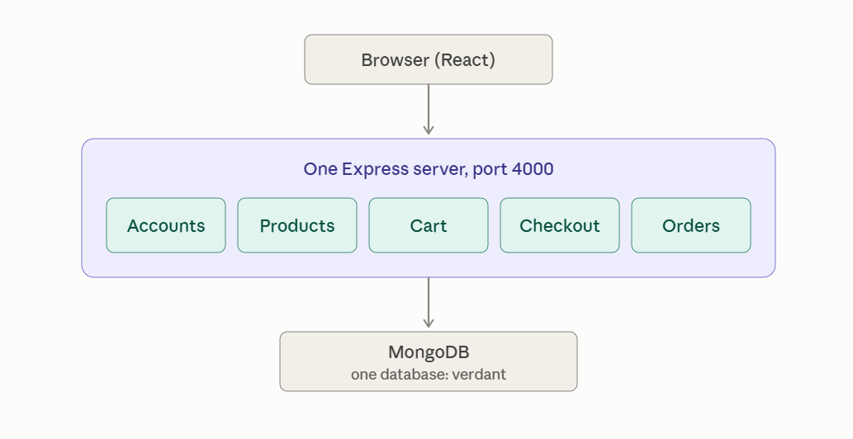
monolith · 1 server, 5 features, 1 database
Every route runs inside the same process and reaches the same database, so nothing crosses a network between features.
How a request flows: The browser calls the Express server on port 4000. A route file (auth, products, cart, checkout or orders) runs the logic and talks to the database directly through Mongoose models. Protected routes, such as checkout and Add Product, first pass through an auth middleware that checks the user’s login token. Checkout, for example, imports the Cart model straight from models/Cart.js, so there is no network hop between features.
Project structure:
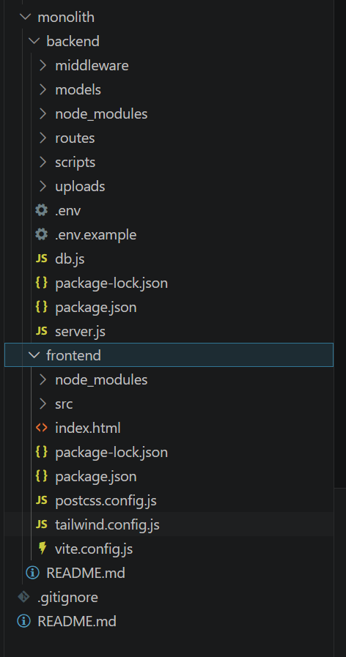
Where it is simple: one codebase, one deploy, one database connection, and every feature can call another directly.
Where it is limited: a bug or heavy load in one feature runs in the same process as the others, and the whole backend scales and deploys as a single unit.


Shop page: product catalog with images and prices in rupees.


Shop page, continued: the rest of the catalog.

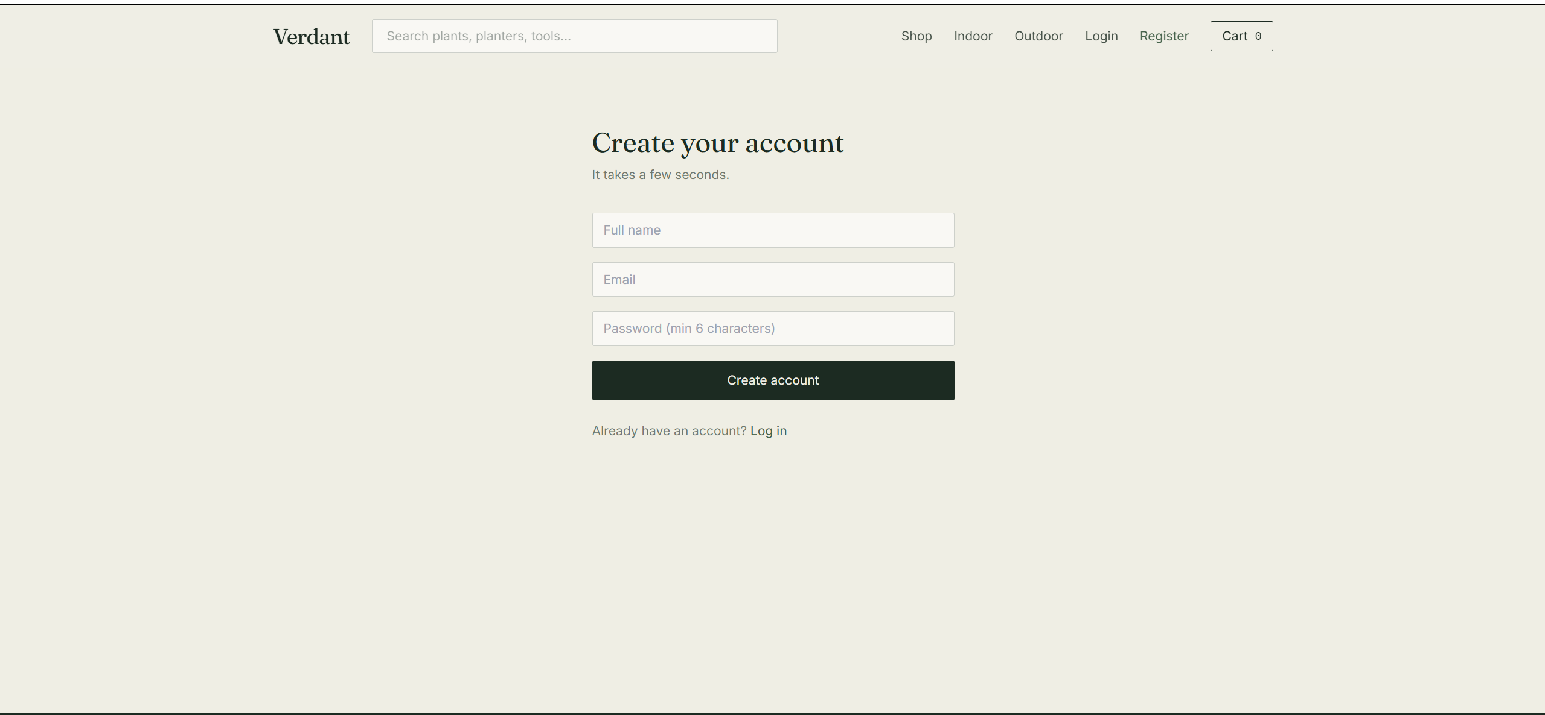
Register page.

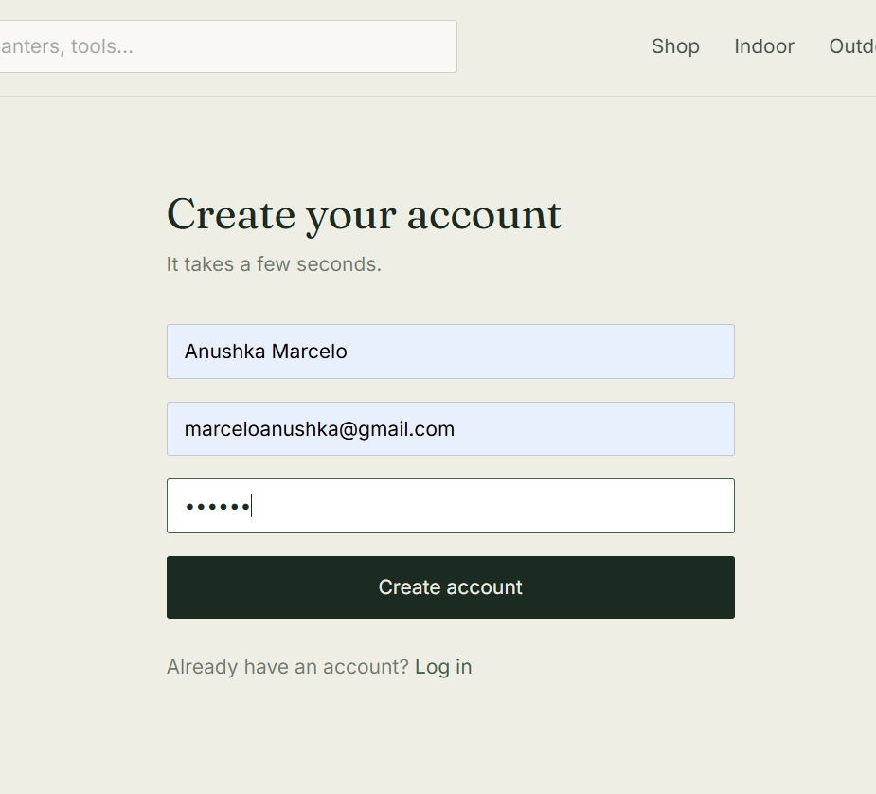
Register page with details filled in.

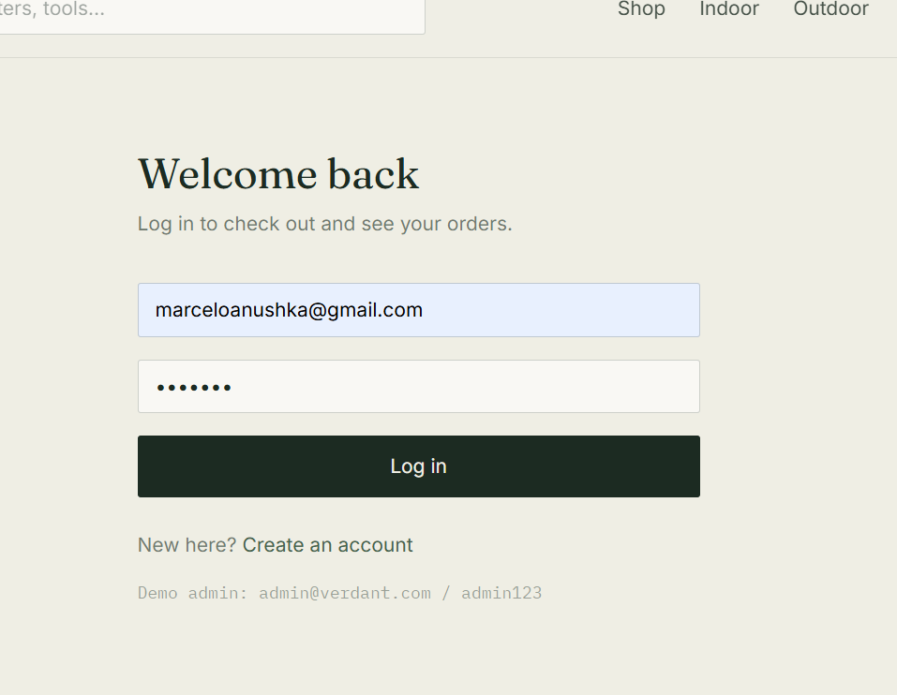
Login page.


Home page after login; the navbar shows the user's name and My orders.


Product detail page with price, stock and care information.


Product added to the cart.

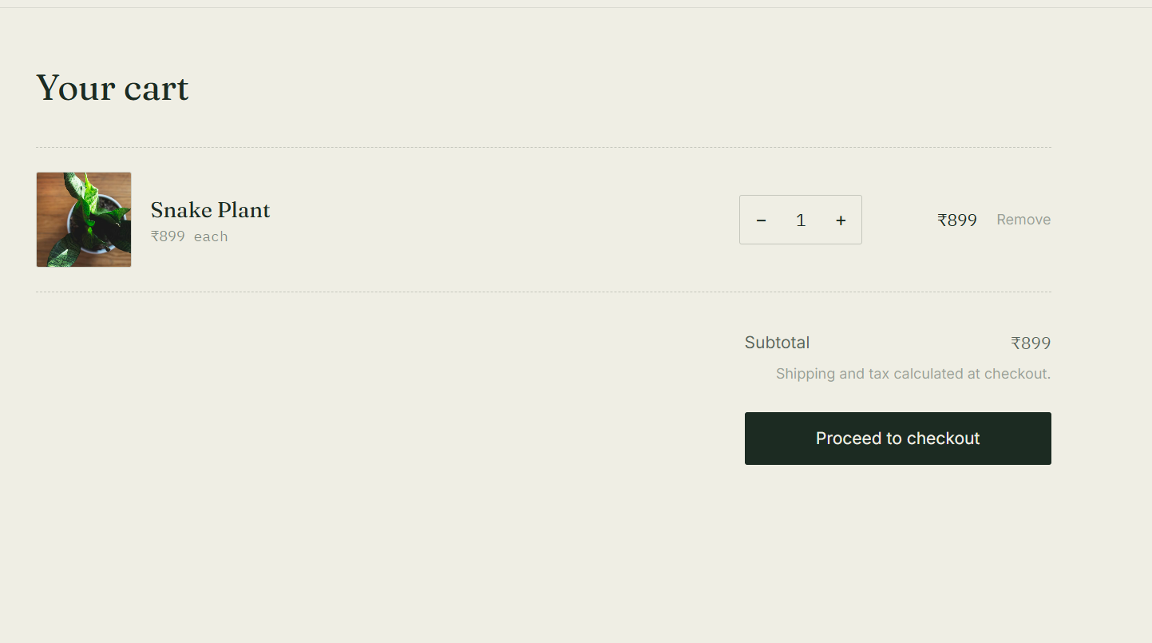
Shopping cart with subtotal and checkout button.

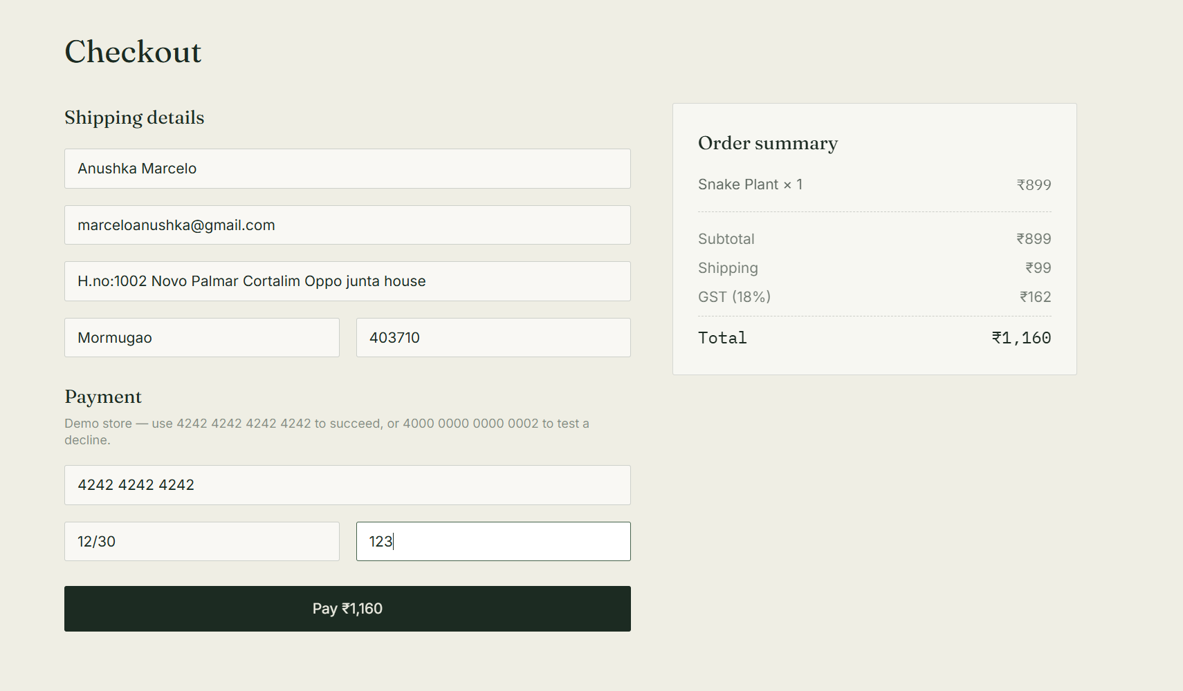
Checkout page with shipping details and simulated card payment.
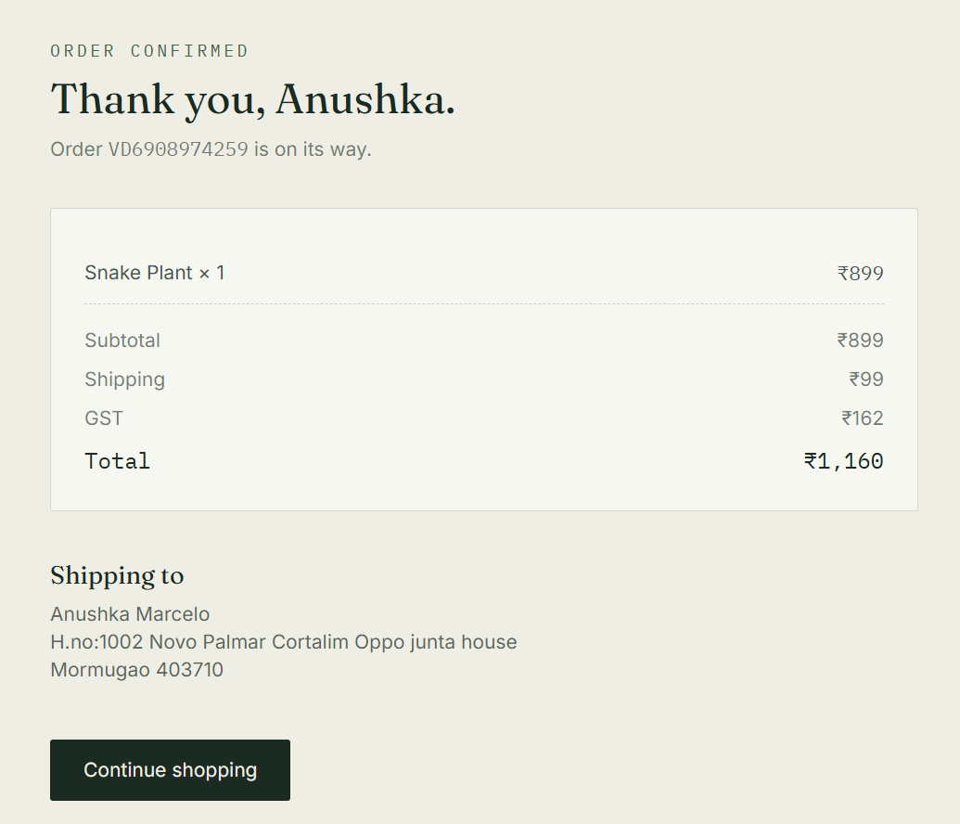
Order confirmation after a successful payment.

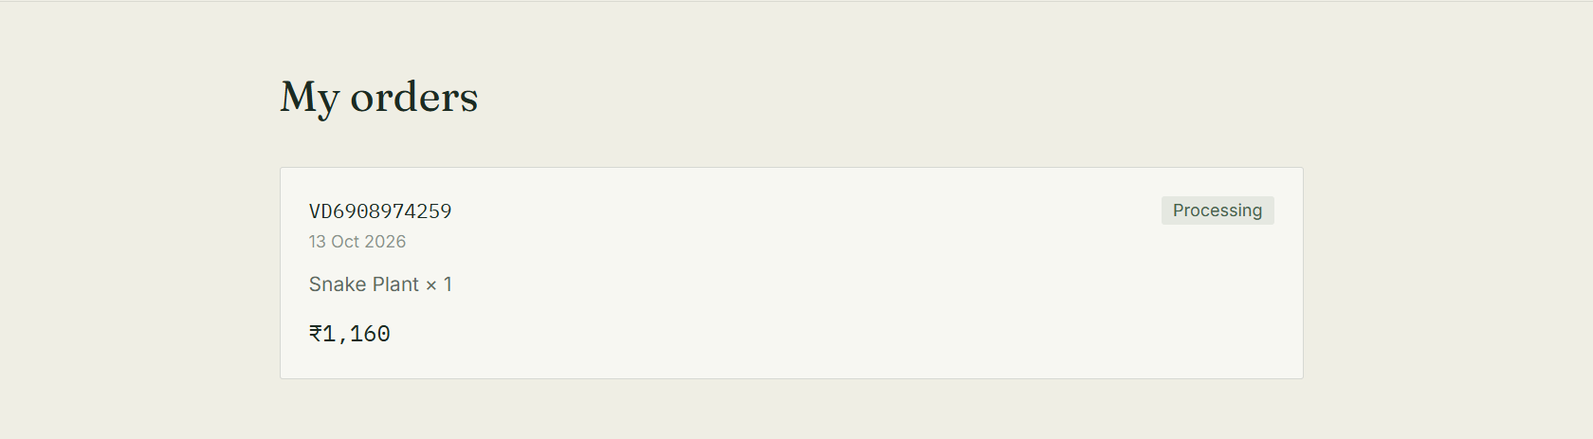
My Orders page, listing the logged-in user's order.

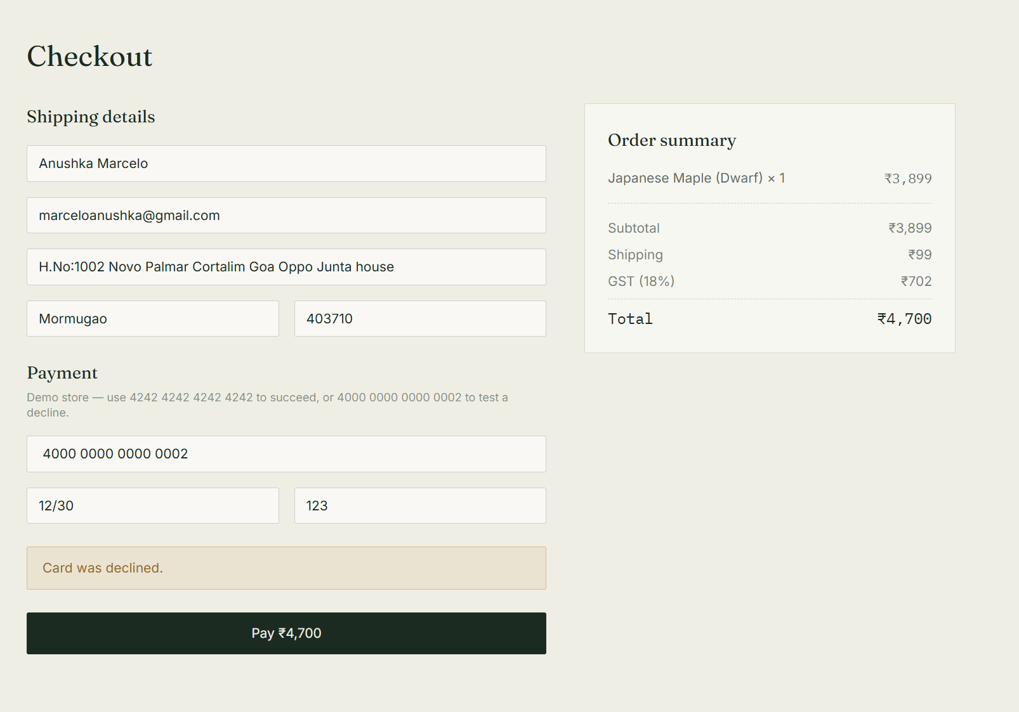
Payment declined with test card 4000 0000 0000 0002.

Admin Side
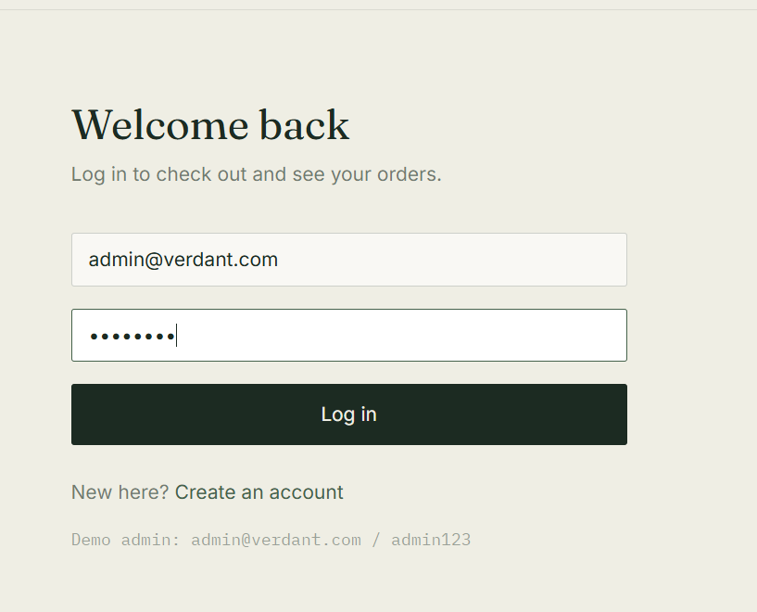
Admin login.

Home page when logged in as admin; the navbar shows Add product.
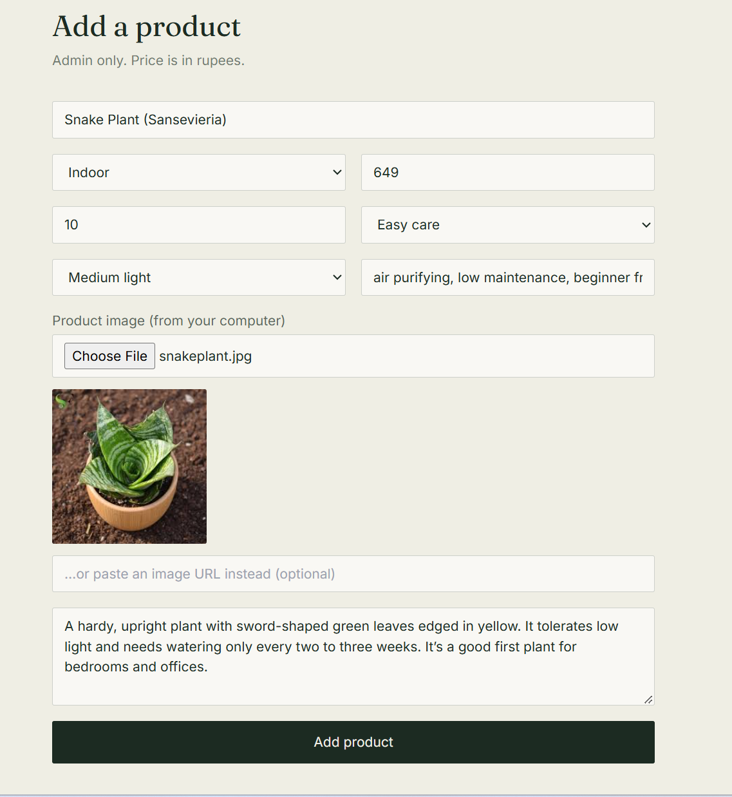
Admin-only Add Product page, with an image chosen from the computer.


The new product on the shop page.


Detail page of the new product.

2. Microservices architecture
The microservices version splits the same backend into four independent services behind an API gateway, and each service owns its own database. 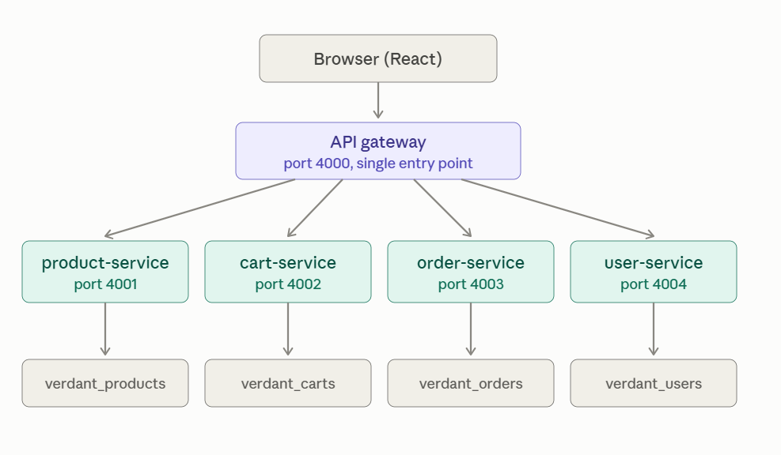
microservices · gateway, 4 services, 4 databases
The gateway is the only entry point; each service reads and writes only its own database and reaches the others over HTTP.
Service | Port | Owns | Calls
api-gateway | 4000 | Nothing; routes requests and resolves the cart cookie | product, cart, order and user services
product-service | 4001 | Product catalog and product images (verdant_products) | Nobody
cart-service | 4002 | Shopping carts (verdant_carts) | product-service, to fetch product details
order-service | 4003 | Orders and payment (verdant_orders) | cart-service, to read and then clear the cart
user-service | 4004 | Accounts, login and JWT tokens (verdant_users) | Nobody
Before the first run, the product catalog is loaded once with npm run seed inside the product-service folder, which adds 15 sample products.
The frontend only ever talks to the gateway on port 4000, exactly as it talked to the single backend before. The gateway forwards /api/products, /api/cart, /api/checkout, /api/orders and /api/auth to the service that owns that data. It also passes the visitor’s cart id as an x-cart-id header, so only the gateway deals with cookies.
The user-service signs a JWT token when someone logs in. The product-service and order-service check that token themselves, using a shared secret. They never call the user-service or read its database, and orders store only the user’s id.
Services talk over HTTP, never through each other’s databases. The cart service stores only product ids and quantities, then asks the product service for names, images and prices. The order service asks the cart service for the cart, takes the simulated payment, saves the order, and tells the cart service to empty the cart.
Project structure:
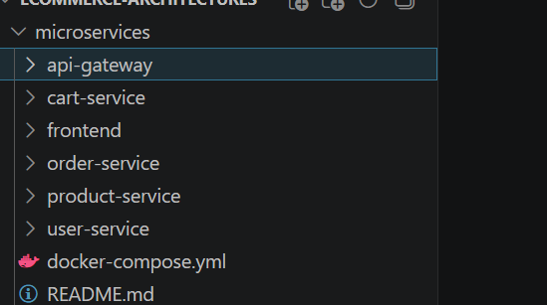

Where it is stronger: Each service can be deployed and scaled on its own, and one failing service only degrades its own feature. For example, if the user-service stops, nobody can log in, but the shop and cart keep working.
What it costs: more processes to run, network calls between services, and no shared database to join across.
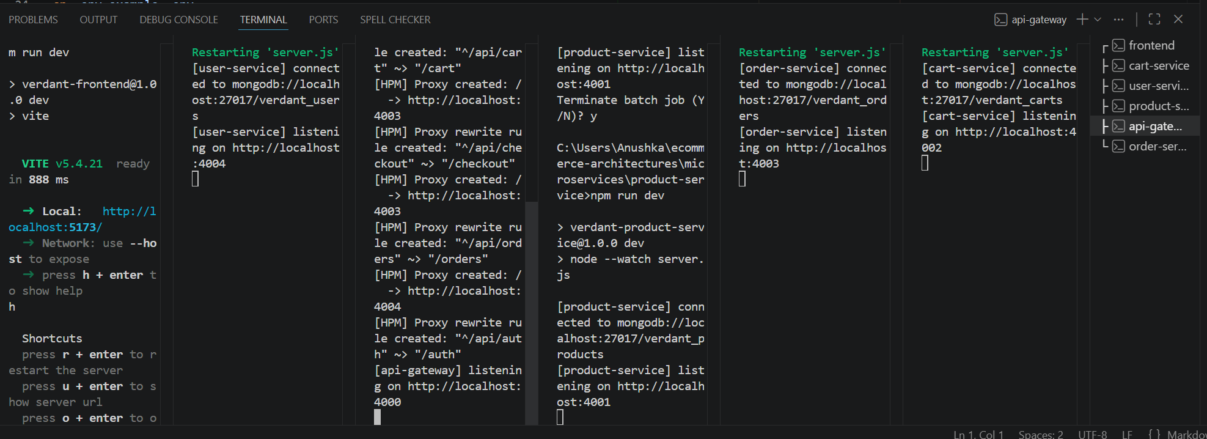
All six terminals running together: frontend, cart-service, user-service, product-service, api-gateway and order-service.
Shop page served through the API gateway.

Product catalog loaded from the product-service.

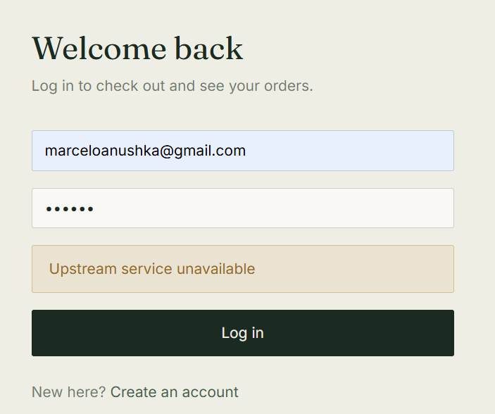
Login failing with "Upstream service unavailable" while the user-service is stopped.

Product page still loads while the user-service is stopped.
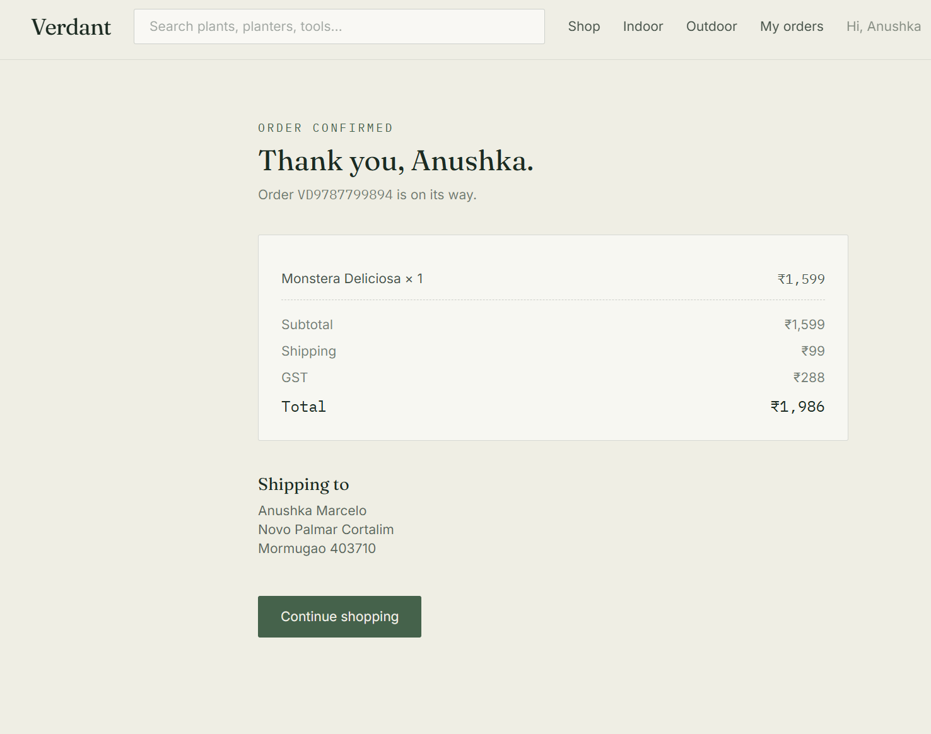
Order confirmation after a successful payment.

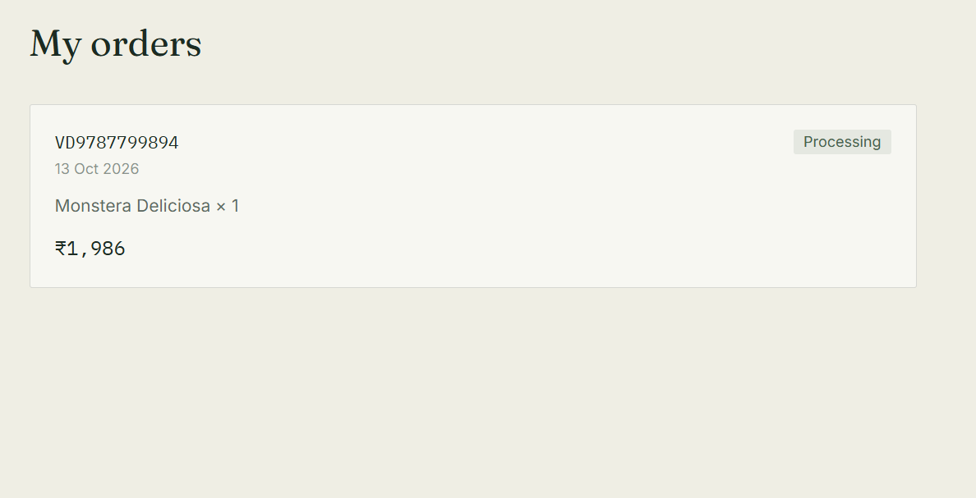
My Orders page, listing the order placed by the logged-in user.

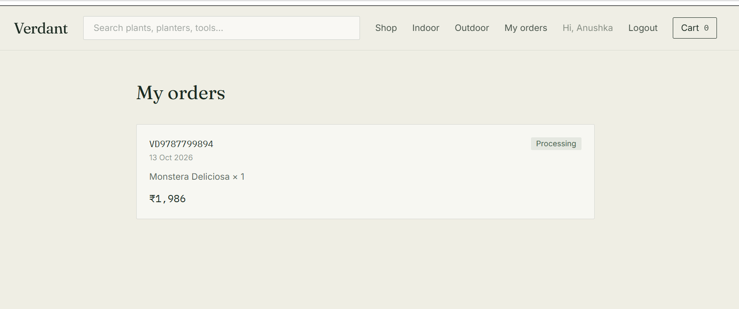
My Orders page still working while the product-service is stopped.
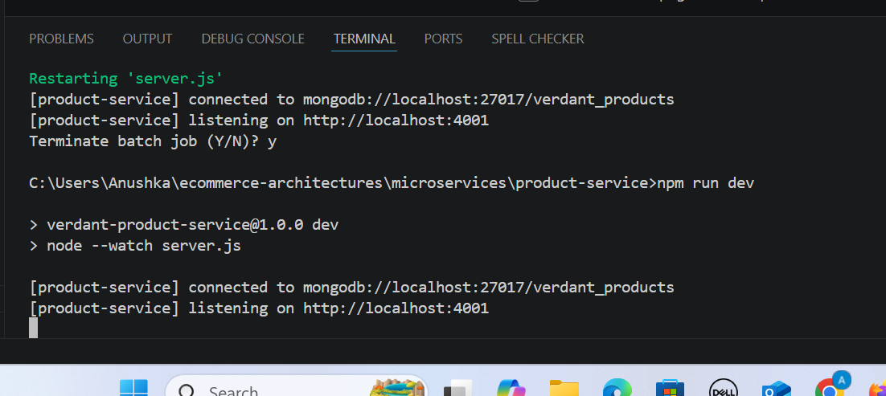
The product-service terminal after it was stopped with Ctrl + C and started again.

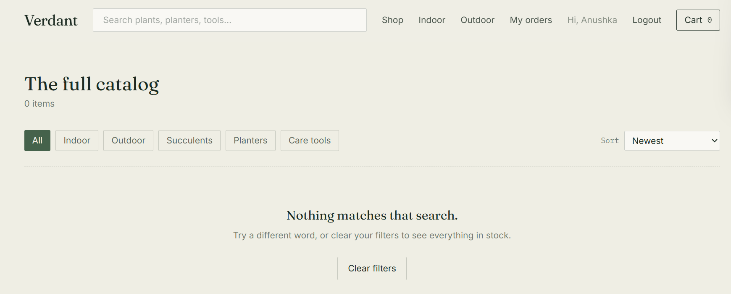
Shop page while the product-service is stopped: no products load, but the rest of the site (navbar, login, My orders) keeps working.

3. Side-by-side comparison
The monolith is simpler to build and run, while the microservices version isolates failures and lets each part scale separately at the price of more moving parts.
Comparison table
 | Monolith | Microservices
Backend processes | 1 | 5 (gateway, product, cart, order, user)
Databases | 1 (verdant) | 4 (verdant_products, verdant_carts, verdant_orders, verdant_users)
Communication between features | Direct function and model calls | HTTP calls (cart to product, order to cart)
Login | One auth route in the same server | Separate user-service; other services verify the token with a shared secret
Entry point for the frontend | Express server, port 4000 | API gateway, port 4000
Deployment | One backend and one frontend | Five backend services plus the frontend, each deployable alone
Scaling | The whole backend scales together | Each service scales on its own
If one feature fails | Can affect the whole API | Only that feature degrades
Local setup | 2 terminals | 6 terminals, or Docker Compose for the backend
Complexity | Low | Higher (service URLs, network failures, no cross-database joins)

