BUSINESS SALES PERFORMANCE ANALYTICS
Sales & Profitability Analysis Report
FY2024–2025 · Furniture, Office Supplies & Technology Retail Dataset

Prepared for: Business Owner / Leadership Team
Prepared by: Data Analytics Internship — Task 1
Reporting Period: 2024-01-01 to 2025-12-31
Records Analyzed: 4,200 cleaned order line items

Table of Contents

1. Executive Summary
Across the two-year period (2024-01-01 to 2025-12-31), the business generated total revenue of $3,944,458 from 4,200 orders and 16,669 units sold, at an average order value of $939.16. Overall profit reached $221,707, an overall margin of 5.62%.
Revenue shows a clear upward trajectory with strong seasonal peaks in November and December of both years, driven primarily by the Technology category. However, the analysis surfaces one urgent issue: Furniture, the second-largest category by revenue, is operating at a net loss across every sub-category. This report breaks down where the money is being made, where it is being lost, and what actions would have the highest impact on profitability.

Top-Line Numbers
Metric | Value
Total Revenue | $3,944,458
Total Profit | $221,707
Overall Profit Margin | 5.62%
Total Orders | 4,200
Total Units Sold | 16,669
Average Order Value | $939.16

2. Data Preparation & Cleaning
Before analysis, the raw transactional dataset was reviewed and cleaned to ensure accurate, trustworthy results. Common real-world data quality issues were identified and resolved:
- Removed 5 duplicate order records that had been entered more than once.
- Corrected 5 negative sales values caused by data-entry errors (converted to absolute values).
- Filled 15 missing discount values using the median discount for the relevant product category.
- Standardized text fields (region names, categories, product names) to consistent capitalization — e.g. fixed inconsistent casing such as “north” vs “North”.
- Parsed order dates into a proper date format and derived Order Month and Profit Margin % fields for trend and profitability analysis.
The dataset started with 4,205 rows and 13 columns. After cleaning, the analysis-ready dataset contains 4,200 rows and 16 columns, covering the period 2024-01-01 to 2025-12-31.

3. Revenue Trends Over Time
Monthly revenue rose from $133,684 in 2024-01 to $219,889 in 2025-12. The strongest month was 2025-11 at $275,182, while the weakest was 2024-02 at $76,911.
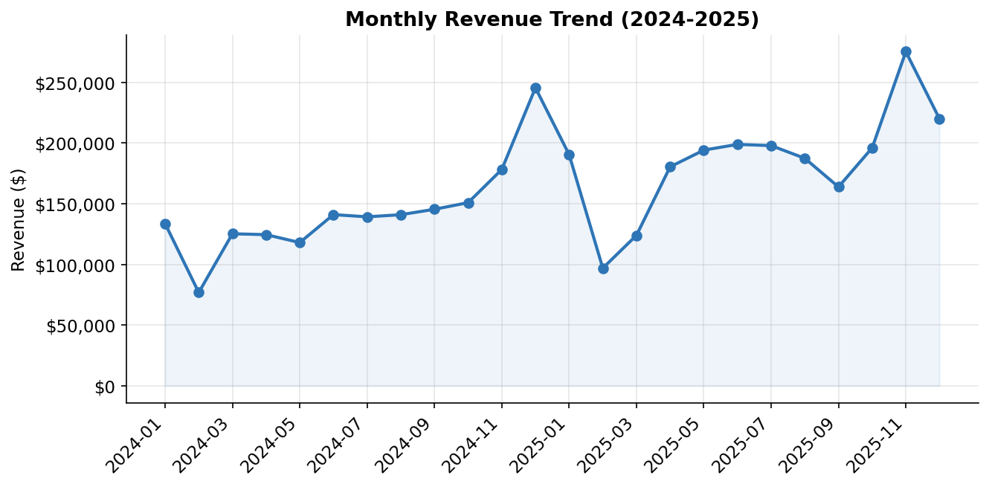
Figure 1: Monthly revenue trend, Jan 2024 – Dec 2025
A consistent seasonal pattern is visible in both years: revenue dips in January–February, builds steadily through the middle of the year, and peaks sharply in November–December — the typical holiday buying season for office and technology equipment.
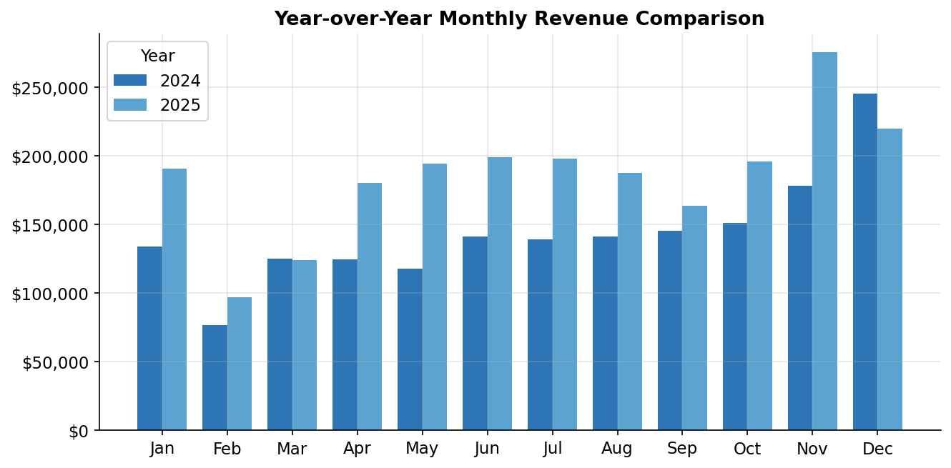
Figure 2: Year-over-year monthly revenue comparison
Comparing 2024 to 2025 month-by-month, most months in 2025 outperform their 2024 equivalent, particularly from September onward — indicating the business is on a growth trajectory heading into the next holiday season.

4. Top-Selling Products
The top 10 products by revenue account for a substantial share of total sales. Notably, two of the top five products by revenue — the 2-Seater Sofa and Reception Sofa — are loss-making, generating combined revenue of $681,427 but a combined loss of -$28,300.
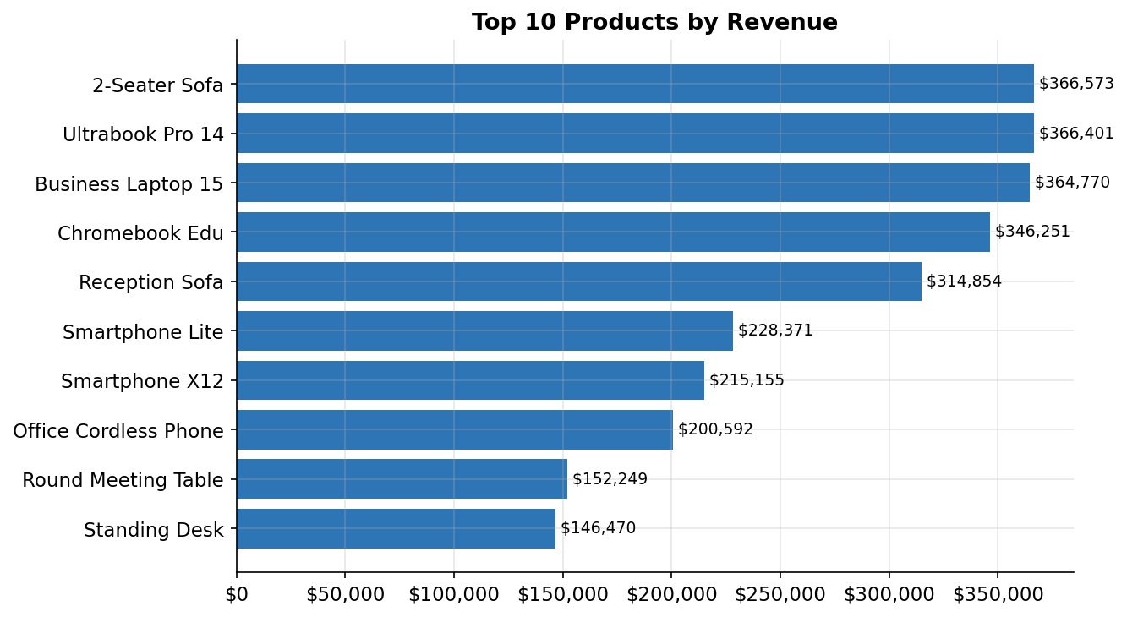
Figure 3: Top 10 products ranked by total revenue
Rank | Product | Revenue | Profit | Units Sold
1 | 2-Seater Sofa | $366,573 | -$11,792 | 536
2 | Ultrabook Pro 14 | $366,401 | $46,826 | 362
3 | Business Laptop 15 | $364,770 | $40,888 | 384
4 | Chromebook Edu | $346,251 | $34,081 | 366
5 | Reception Sofa | $314,854 | -$16,508 | 470
6 | Smartphone Lite | $228,371 | $24,323 | 494
7 | Smartphone X12 | $215,155 | $26,607 | 491
8 | Office Cordless Phone | $200,592 | $22,025 | 512
9 | Round Meeting Table | $152,249 | -$4,093 | 302
10 | Standing Desk | $146,470 | -$6,571 | 292
Table 1: Top 10 products — revenue, profit, and units sold (red = loss-making)

5. Category & Sub-Category Profitability
Technology dominates both revenue and profit, contributing 56% of total revenue and over 100% of total profit (offsetting losses elsewhere). Office Supplies is the smallest category by revenue but has the healthiest profit margin. Furniture, despite being the second-largest category by revenue, is the only category losing money overall.
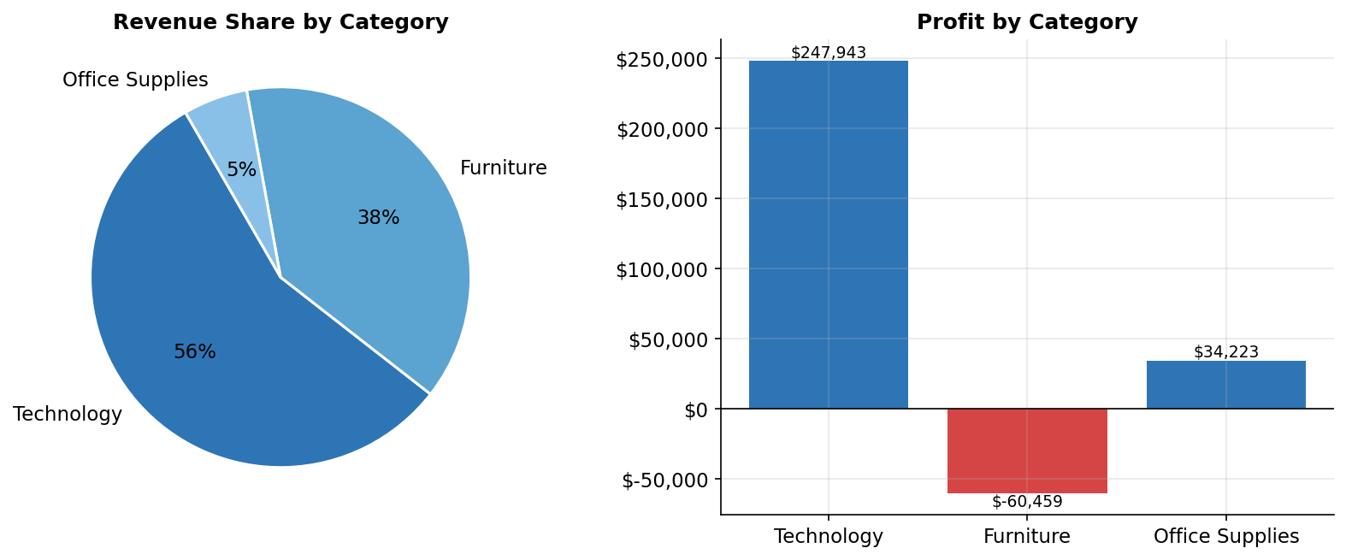
Figure 4: Revenue share and profit by category
Category | Revenue | Profit | Margin %
Technology | $2,213,865 | $247,943 | 11.20%
Furniture | $1,514,596 | -$60,459 | -3.99%
Office Supplies | $215,997 | $34,223 | 15.84%
Table 2: Category-level revenue, profit, and margin

Sub-Category Margin Breakdown
Drilling into sub-categories reveals the source of the Furniture loss: all four Furniture sub-categories — Chairs (-5.28%), Sofas (-4.15%), Bookcases (-3.60%), and Tables (-3.27%) — operate at negative margins. By contrast, every Technology and Office Supplies sub-category is profitable, with Storage (16.70%) the strongest performer.
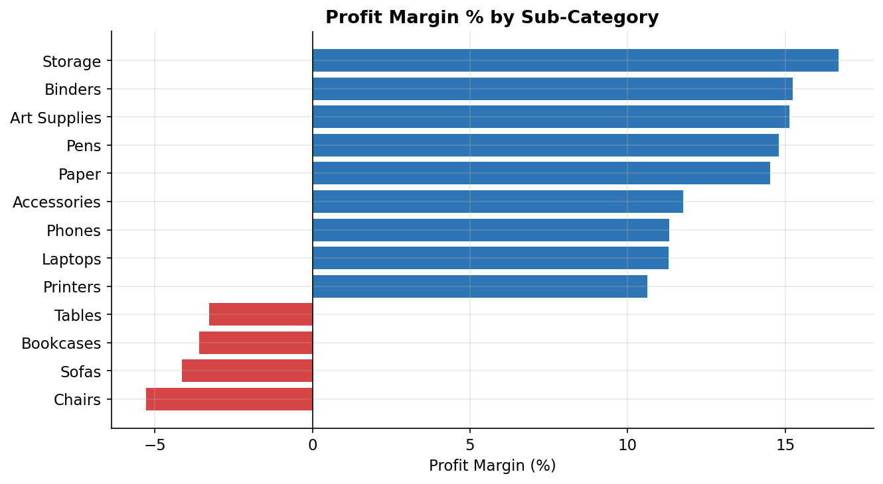
Figure 5: Profit margin % by sub-category (red = loss-making)

6. Regional Performance
West is the highest-revenue region at $915,907, closely followed by East and South. East has the best profit margin at 6.64%, while Central trails both in revenue ($507,901) and margin (4.01%).
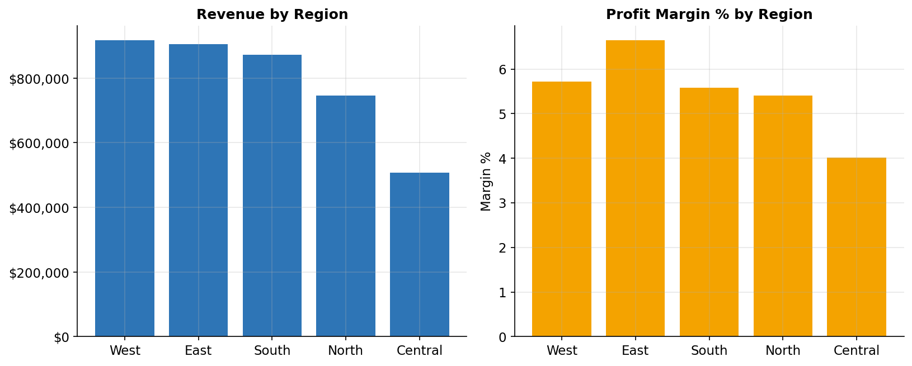
Figure 6: Revenue and profit margin by region
Region | Revenue | Profit | Margin %
West | $915,907 | $52,349 | 5.72%
East | $903,907 | $59,997 | 6.64%
South | $871,317 | $48,618 | 5.58%
North | $745,425 | $40,356 | 5.41%
Central | $507,901 | $20,388 | 4.01%
Table 3: Regional revenue, profit, and margin

7. Customer Segment Analysis
The Consumer segment is the largest, generating $1,956,684 in revenue and $117,768 in profit from 2,065 orders (AOV $947.55). Corporate and Home Office follow with broadly similar margin profiles, suggesting an opportunity for targeted bundles (e.g., Technology accessories) to lift order value in these segments.
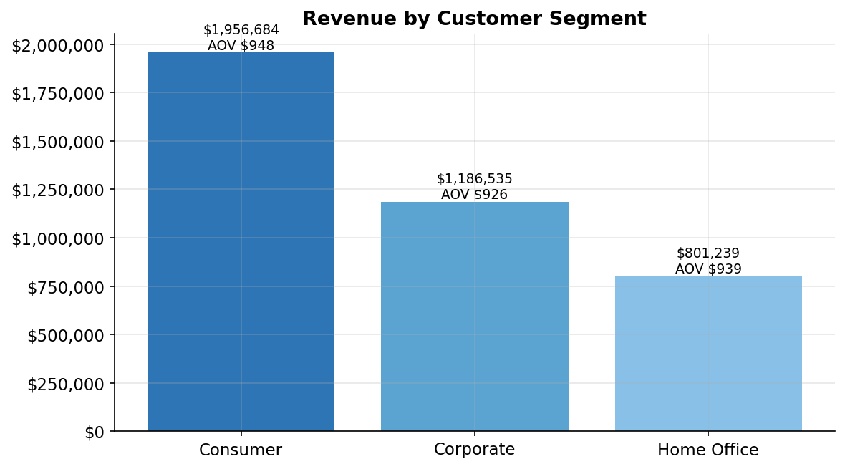
Figure 7: Revenue by customer segment (with average order value)

8. Discounting Strategy & Margin Impact
Discounting has a direct and measurable effect on profitability. Orders with no discount or modest discounts (up to 20%) remain profitable on average, but margins turn negative once discounts exceed 20% — meaning every sale at that discount level currently costs the business money after accounting for cost of goods.
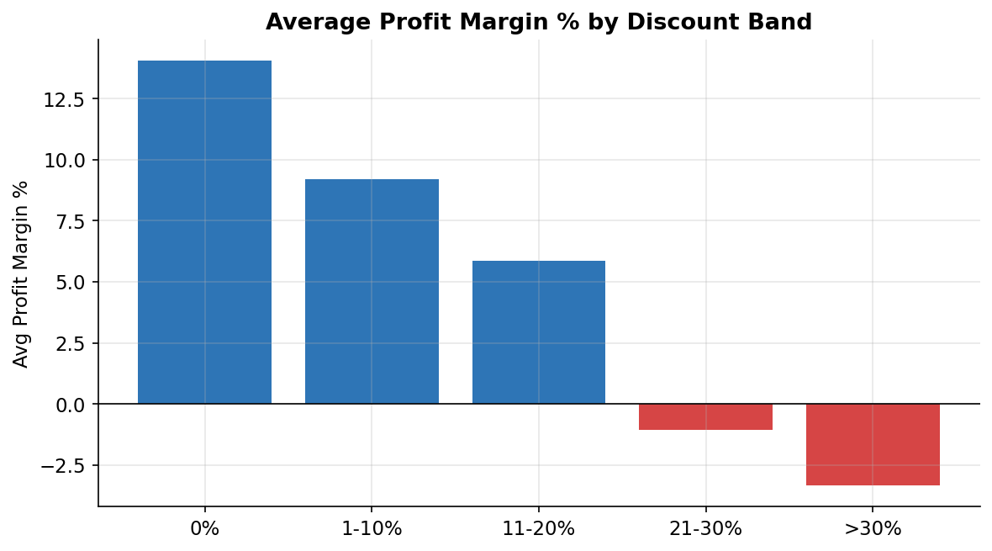
Figure 8: Average profit margin % by discount band
Specifically: 0% discount orders average 14.05% margin, while orders discounted above 30% average -3.35% margin. This establishes a practical ceiling of roughly 20% for promotional discounting without eroding profitability.

9. Key Insights & Recommendations

Insight 1 — Furniture is a structural loss-maker
Every Furniture sub-category (Chairs, Sofas, Bookcases, Tables) operates at a negative margin, costing the business roughly $60,500 over two years despite contributing 38% of revenue.
- Recommendation: Review supplier costs and pricing for Furniture. Even a modest price increase (3-5%) or renegotiated supplier costs could move this category to breakeven or profitability.
- Recommendation: Audit Furniture discounting policy — combined with Insight 3 below, Furniture items may be over-discounted relative to their margin structure.

Insight 2 — Technology is the business's profit engine
Technology contributes 56% of revenue and effectively all of the company's net profit (Furniture losses are offset by Technology and Office Supplies gains). Laptops alone generated over $121,000 in profit.
- Recommendation: Increase marketing spend and inventory investment in Technology, particularly Laptops and Phones, which show both high revenue and strong margins.
- Recommendation: Bundle Technology accessories with Laptop/Phone purchases to lift average order value across all customer segments.

Insight 3 — Discounts above 20% are unprofitable
Average profit margin turns negative once discounts exceed 20%, and worsens further beyond 30%.
- Recommendation: Cap standard promotional discounts at 20%, and require manager approval for any discount above this threshold.
- Recommendation: Replace deep discounts with value-adds (e.g., free shipping, bundled accessories) that drive sales without directly eroding the price.

Insight 4 — Revenue is growing but seasonal
Revenue grew year-over-year for most months, with sharp peaks in November-December and consistent dips in January-February.
- Recommendation: Plan inventory and staffing around the Nov-Dec peak to avoid stockouts during the highest-revenue period.
- Recommendation: Run targeted Q1 promotions (within the 20% discount cap) to smooth the January-February revenue dip.

Insight 5 — Central region underperforms
Central has both the lowest revenue ($507,900) and the lowest profit margin (4.0%) of all five regions, while East achieves the best margin (6.6%) without leading on revenue.
- Recommendation: Investigate Central region operations — review pricing, shipping costs, and sales coverage to understand the margin gap versus East.
- Recommendation: Apply East region's pricing/discount discipline as a benchmark for other regions.

10. Methodology & Notes

Data Source
This analysis uses a simulated retail sales dataset (2024-2025) modeled on the structure of common public sales datasets (e.g., Superstore-style: Order Date, Region, Category, Sub-Category, Product, Sales, Profit, Discount, Customer Segment). The dataset was generated to reflect realistic seasonal patterns, category mixes, and profitability dynamics for demonstration purposes. The same cleaning and analysis workflow applies directly to real business data — simply replace the source file with actual sales records.

Tools Used
- Python (pandas) for data cleaning, aggregation, and KPI calculation
- Matplotlib for static chart generation
- HTML/JavaScript (Chart.js) for the interactive dashboard
- docx for this report

Key Definitions
- Revenue / Sales: Total sale amount after discount, before cost of goods
- Profit: Revenue minus cost of goods (can be negative)
- Profit Margin %: Profit ÷ Revenue × 100
- AOV (Average Order Value): Total revenue ÷ number of unique orders

