MARKETING FUNNEL
Performance Analysis
Conversion drop-offs, channel performance, and recommendations to improve lead-to-customer conversion
Reporting period: January – June 2026
Prepared: July 2026
Demo dataset — built to illustrate methodology; substitute real CRM/analytics exports to reproduce this report on live data.

1. Executive Summary
- Overall lead-to-customer conversion is 4.11% — 972 customers from 23,655 leads over six months.
- The single biggest leak is at the very top of the funnel: only 4.7% of visitors become leads. Every other stage converts at 33–55%, so fixing top-of-funnel capture has the largest absolute impact.
- Channel performance varies by 26x on lead-to-customer rate: Referral converts at 12.99% vs. Paid Social at just 0.50%.
- Paid Social is running at a loss (-65% ROI, $7,310 CAC) despite driving the most traffic (128K visitors, 25% of total). It is the top candidate for budget reallocation.
- Referral and Email are the two most efficient channels — high conversion, low CAC, high ROI — and are currently the smallest budget lines. Scaling them is the fastest lever to improve blended conversion without redesigning the funnel.

2. Overall Funnel and Where Prospects Drop Off
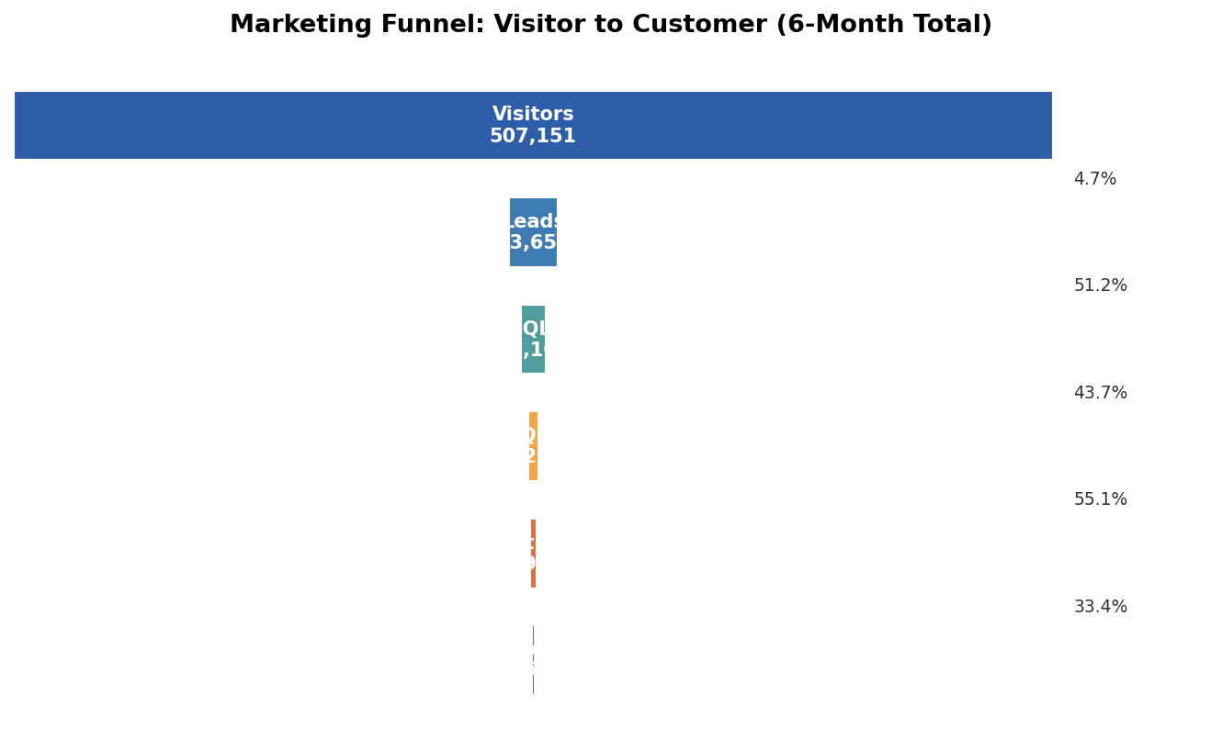
Figure 1. Visitor-to-customer funnel, six-month total
Stage | Count | % of Visitors | Stage-to-Stage Conversion
Visitors | 507,151 | 100.0% | —
Leads | 23,655 | 4.7% | 4.7%
MQLs | 12,101 | 2.4% | 51.2%
SQLs | 5,283 | 1.0% | 43.7%
Opportunities | 2,911 | 0.6% | 55.1%
Customers | 972 | 0.19% | 33.4%

Key insight: the Visitor→Lead step is the outlier. Every downstream stage (Lead→MQL, MQL→SQL, SQL→Opp, Opp→Customer) converts between 33% and 55%, a normal, healthy range. But capturing a lead from a visitor happens only 1 in 21 times. Because this is the first and highest-volume stage, even a small percentage-point improvement here compounds through the entire funnel and produces the largest absolute lift in customers.
Secondary insight: Opportunity→Customer (33.4%) is the second-weakest stage — nearly 2 in 3 opportunities are lost at final negotiation or close. This is a sales-side, not marketing-side, conversion issue worth flagging to sales operations.

3. Channel Performance
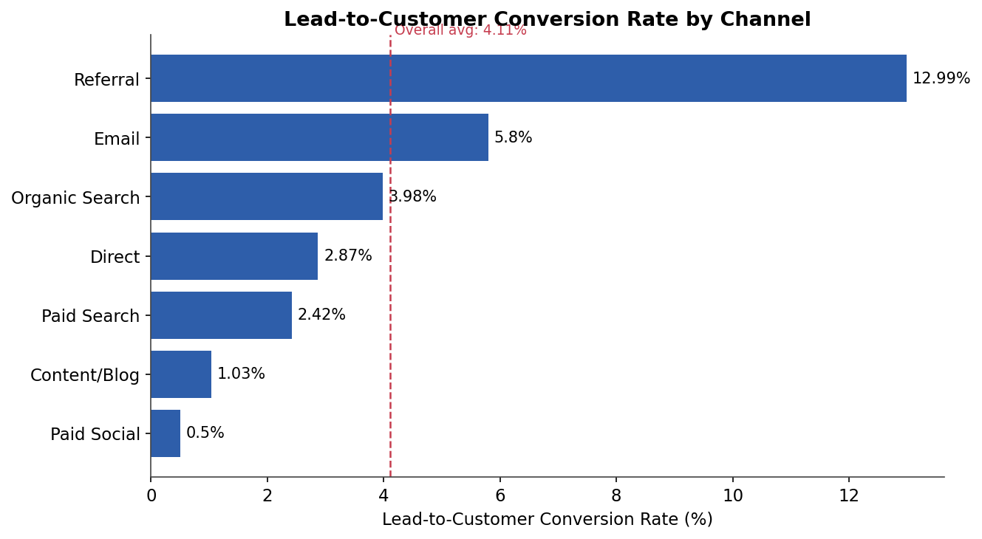
Figure 2. Lead-to-customer conversion rate by channel
Channel | Visitors | Leads | Customers | Lead→Customer | CAC | ROI
Referral | 19,064 | 2,264 | 294 | 12.99% | $10 | +52,804%
Email | 59,283 | 5,000 | 290 | 5.80% | $42 | +7,504%
Organic Search | 111,638 | 4,243 | 169 | 3.98% | $129 | +3,160%
Direct | 44,161 | 1,984 | 57 | 2.87% | $0* | n/a
Paid Search | 80,473 | 5,238 | 127 | 2.42% | $1,042 | +273%
Content/Blog | 64,141 | 1,949 | 20 | 1.03% | $1,194 | +205%
Paid Social | 128,391 | 2,977 | 15 | 0.50% | $7,310 | -65%
*Direct has no attributable ad spend, so CAC/ROI are not meaningful for it.
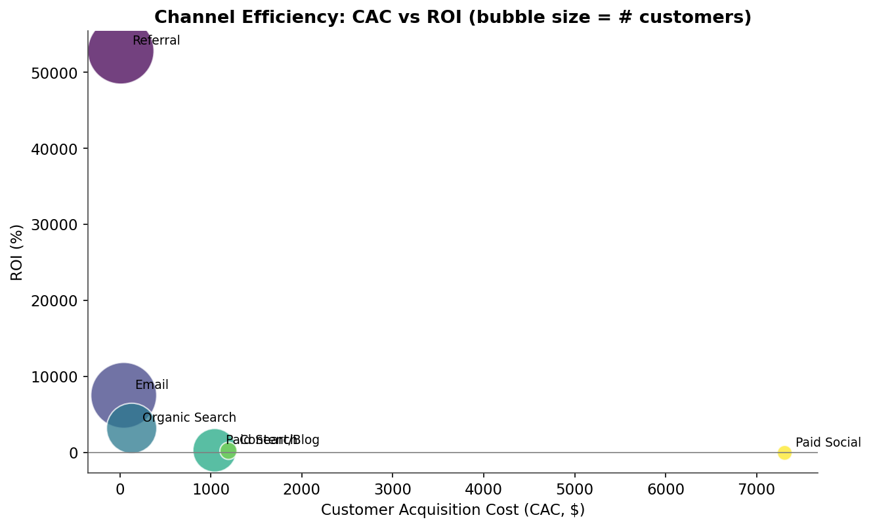
Figure 3. Channel efficiency — CAC vs. ROI (bubble size = number of customers)
Reading the bubble chart: the ideal channel sits bottom-left (low CAC) and top (high ROI) with a large bubble (high volume). Referral and Email cluster there. Paid Social sits far right and below the zero line — high cost, negative return, and low volume of actual customers despite being the largest traffic source.

4. Where Each Channel Loses People (Stage-Level Diagnosis)
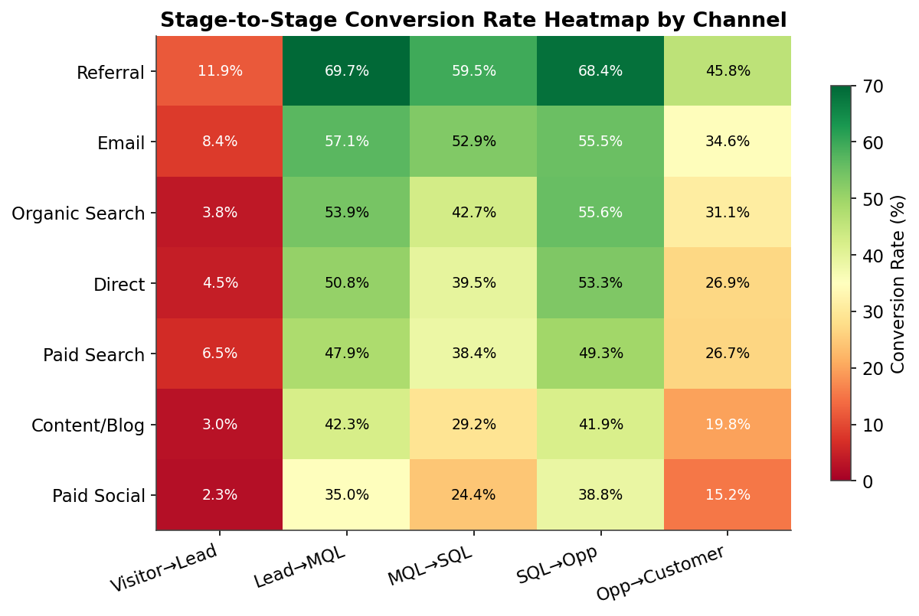
Figure 4. Stage-to-stage conversion rate heatmap by channel
Channel | Visitor→Lead | Lead→MQL | MQL→SQL | SQL→Opp | Opp→Customer
Referral | 11.9% | 69.7% | 59.5% | 68.4% | 45.8%
Email | 8.4% | 57.1% | 52.9% | 55.5% | 34.6%
Organic Search | 3.8% | 53.9% | 42.7% | 55.6% | 31.1%
Direct | 4.5% | 50.8% | 39.5% | 53.3% | 26.9%
Paid Search | 6.5% | 47.9% | 38.4% | 49.3% | 26.7%
Content/Blog | 3.0% | 42.3% | 29.2% | 41.9% | 19.8%
Paid Social | 2.3% | 35.0% | 24.4% | 38.8% | 15.2%

Pattern: Referral and Email don't just convert more at the top — they stay stronger at every single stage all the way to close. This points to lead quality, not just lead quantity, as the root driver: people who arrive via referral or email are pre-qualified by trust (a colleague's recommendation, an existing relationship) and behave better through the whole journey.
Paid Social and Content/Blog are weak at every stage, which suggests the traffic itself is lower-intent (broad targeting, top-of-funnel awareness content) rather than one broken step in the process.

5. Monthly Trend
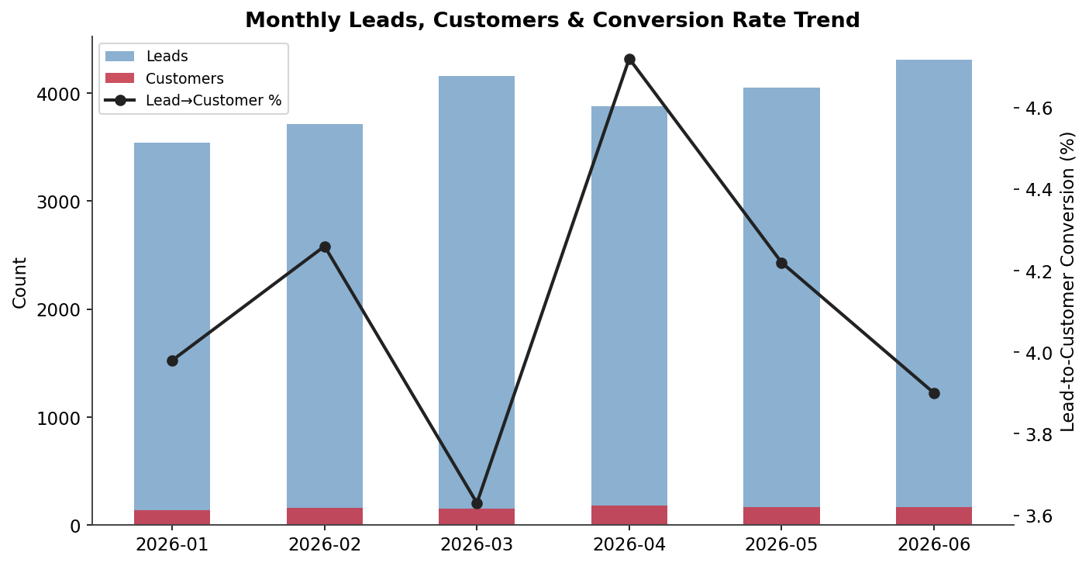
Figure 5. Monthly leads, customers, and lead-to-customer conversion rate
Month | Leads | Customers | Lead→Customer | ROAS
2026-01 | 3,539 | 141 | 3.98% | 12.14x
2026-02 | 3,712 | 158 | 4.26% | 13.37x
2026-03 | 4,162 | 151 | 3.63% | 12.32x
2026-04 | 3,880 | 183 | 4.72% | 15.58x
2026-05 | 4,053 | 171 | 4.22% | 13.31x
2026-06 | 4,309 | 168 | 3.90% | 13.90x

Lead volume is growing steadily (+22% Jan→Jun), but the lead-to-customer rate is flat and volatile (3.6%–4.7%) rather than trending up — meaning growth is currently coming from more volume, not better conversion. There is no compounding quality improvement yet; that is the opportunity this report targets.

6. Actionable Recommendations

A. Fix the top of the funnel (Visitor → Lead, currently 4.7%)
- Audit landing pages by channel — the 2.3% Paid Social and 3.0% Content/Blog visitor-to-lead rates suggest a page/offer mismatch, not just a traffic quality issue. A/B test the CTA, form length, and above-the-fold value proposition on the highest-traffic pages first (Paid Social and Organic Search combined are ~47% of all visitors).
- Add mid-funnel capture (gated content, exit-intent offers, chat) for channels with high visits but low lead rates — this stage has the most volume to work with, so even a 1-point lift here yields hundreds of extra leads.

B. Reallocate budget away from Paid Social
- Paid Social spend ($109.7K) is producing negative ROI and the lowest conversion at every funnel stage. Recommend pausing or cutting spend by 40–50% and reallocating to Email and Referral programs, which are proven, high-margin, and currently under-invested (combined spend of just $15.2K vs. $109.7K on Paid Social alone).
- If Paid Social must continue for brand-awareness reasons, tighten targeting to lookalike audiences based on existing customers rather than broad reach, and track it as an awareness (not conversion) channel with different KPIs.

C. Scale what's already working
- Build a formal referral program (incentives, easy sharing tools, partner co-marketing) — Referral already has the best conversion (12.99%) and ROI (+52,804%) on the smallest budget ($2.9K). Doubling this channel's volume alone could add roughly 290 customers at a fraction of Paid Social's cost.
- Increase Email frequency and segmentation — second-best channel by every metric, and still has the largest untapped audience relative to spend.

D. Address the Opportunity → Customer drop (33.4%)
- This is likely a sales-process issue rather than a marketing one. Recommend a joint marketing/sales review of the 66% of opportunities that don't close — common causes are slow follow-up, pricing objections, or poor sales/marketing lead handoff (SLAs, lead scoring alignment).

E. Instrument for ongoing tracking
- Stand up a monthly refresh of this dashboard (an interactive version is included alongside this report) so channel reallocation decisions can be validated against real conversion data instead of gut feel, and to catch when the flat lead-to-customer trend starts moving.

7. Deliverables in This Package
File | Contents
Marketing_Funnel_Analysis_Report.docx | This report
funnel_dashboard.html | Interactive dashboard — filter by month range and channel
funnel_data.csv | Raw dataset (month x channel x funnel stage)
generate_data.py | Script that generated the demo dataset
analyze_funnel.py | Analysis and chart generation script (reusable on real data)
channel_performance_summary.csv | Channel-level rollup table
dropoff_by_channel.csv | Stage-to-stage conversion by channel
monthly_trend.csv | Monthly trend table
README.md | Guide to using and extending this package

To run on real data: replace funnel_data.csv with an export containing columns month, channel, visitors, leads, mqls, sqls, opportunities, customers, spend, revenue (rename stages as needed) and re-run analyze_funnel.py.

