ASSIGNMENT-12
PROBLEM STATEMENT: Deploy and run the project in AWS without using the port
- Go to the EC2 Dashboard.
- Click on Launch instance.
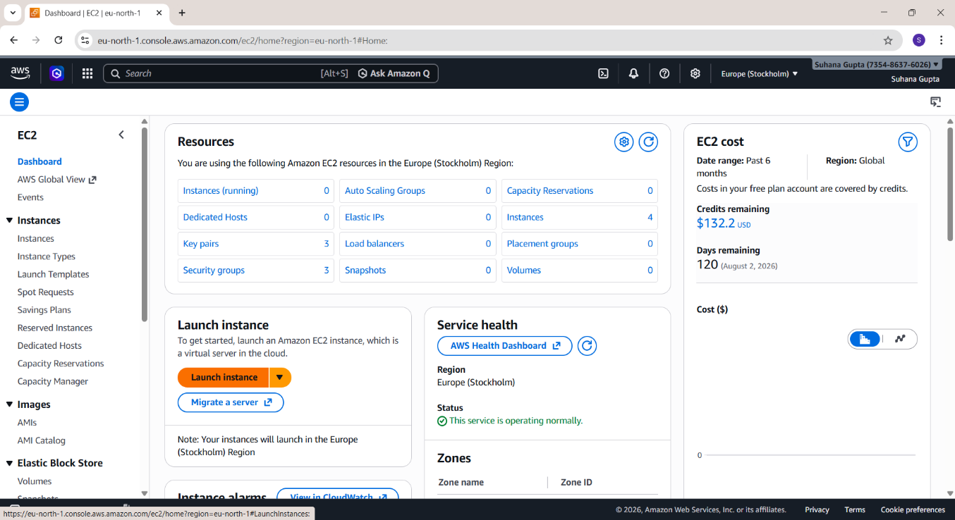

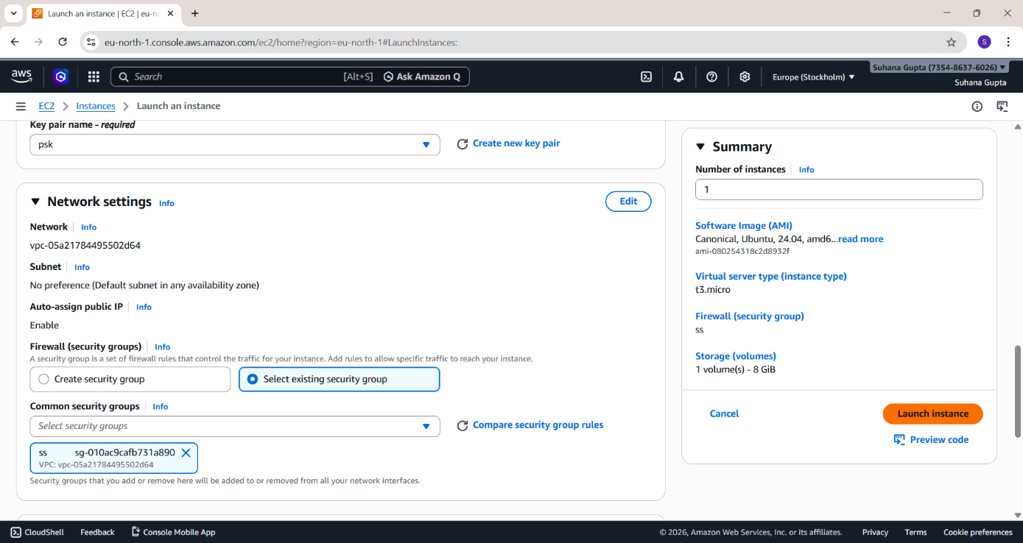
- Instance is created successfully.
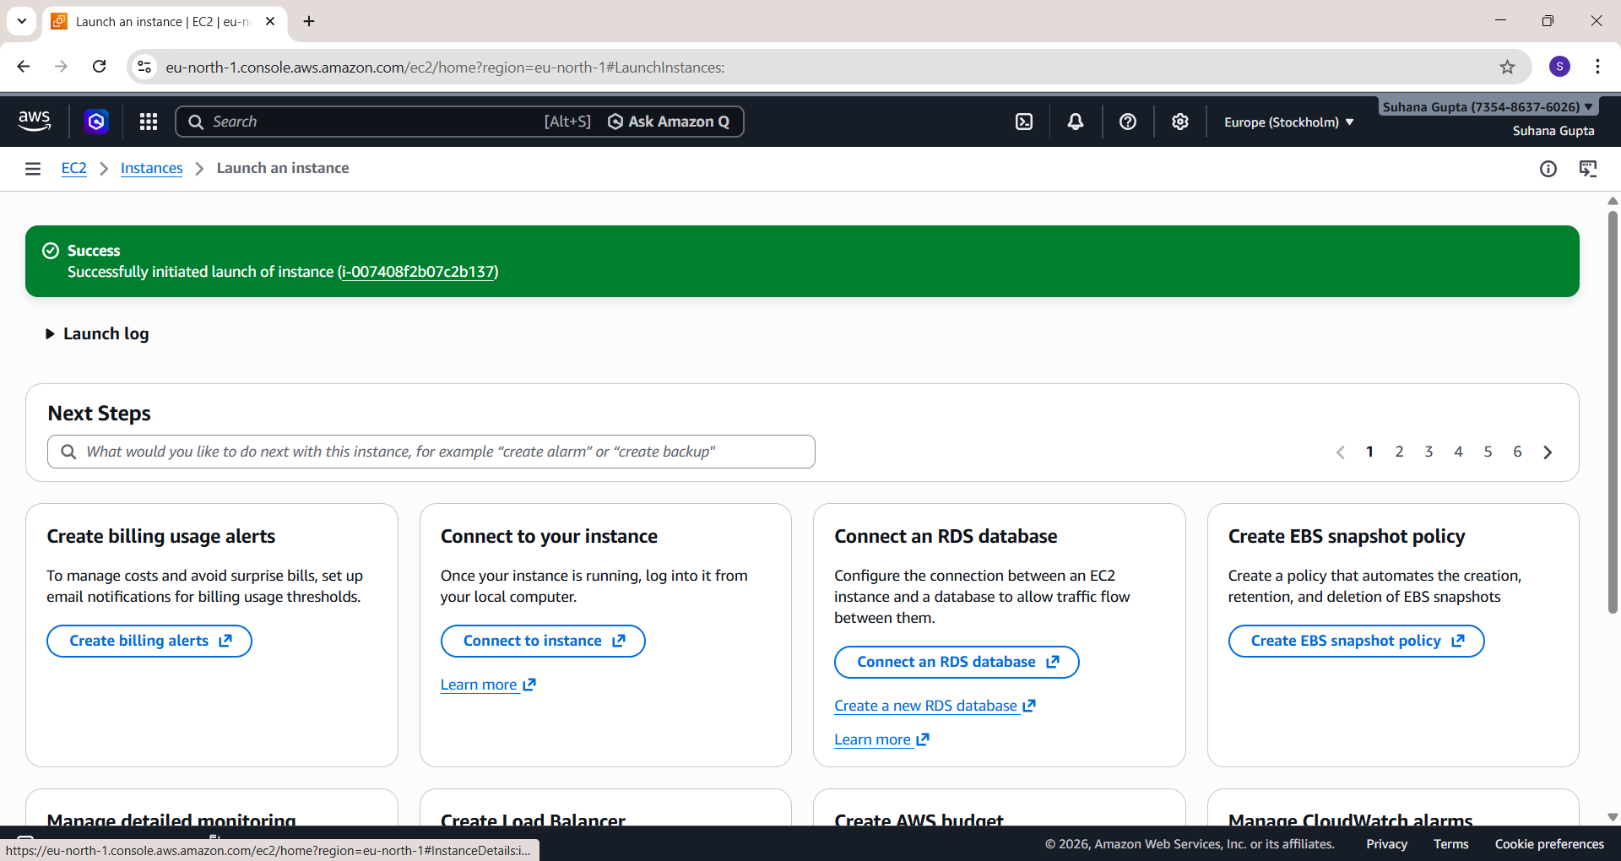
- Click on the instance ID and copy its public IPv4 address.
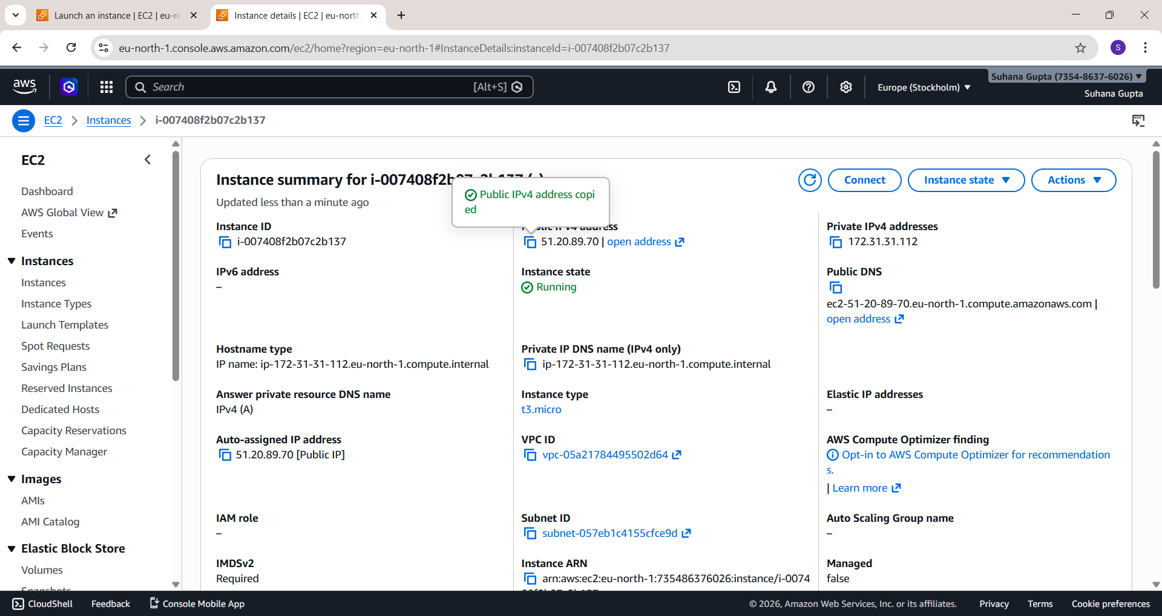
5.

Paste

into

Bitvise

SSH

Client

and

Login.

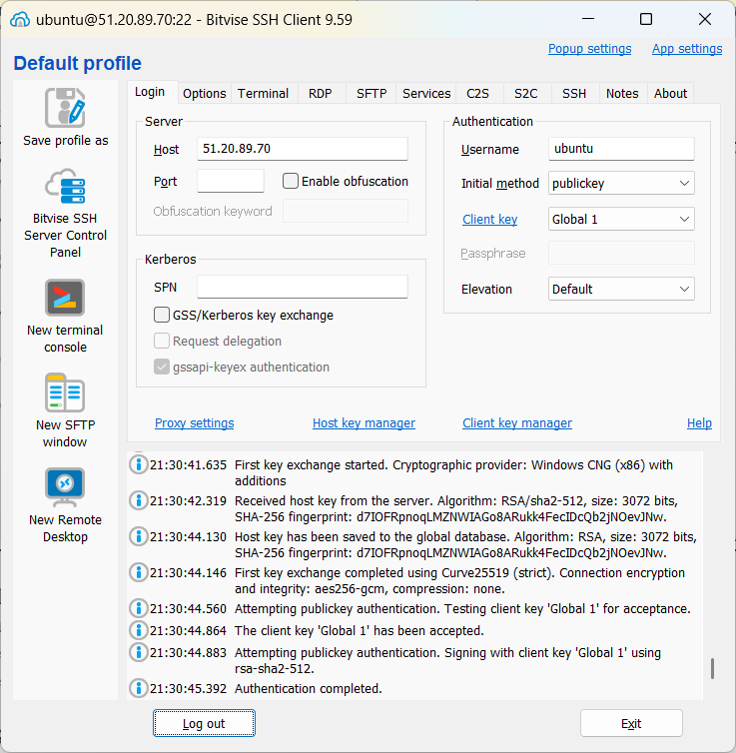
- Type the following commands in New STFP Terminal:
sudo apt-get update
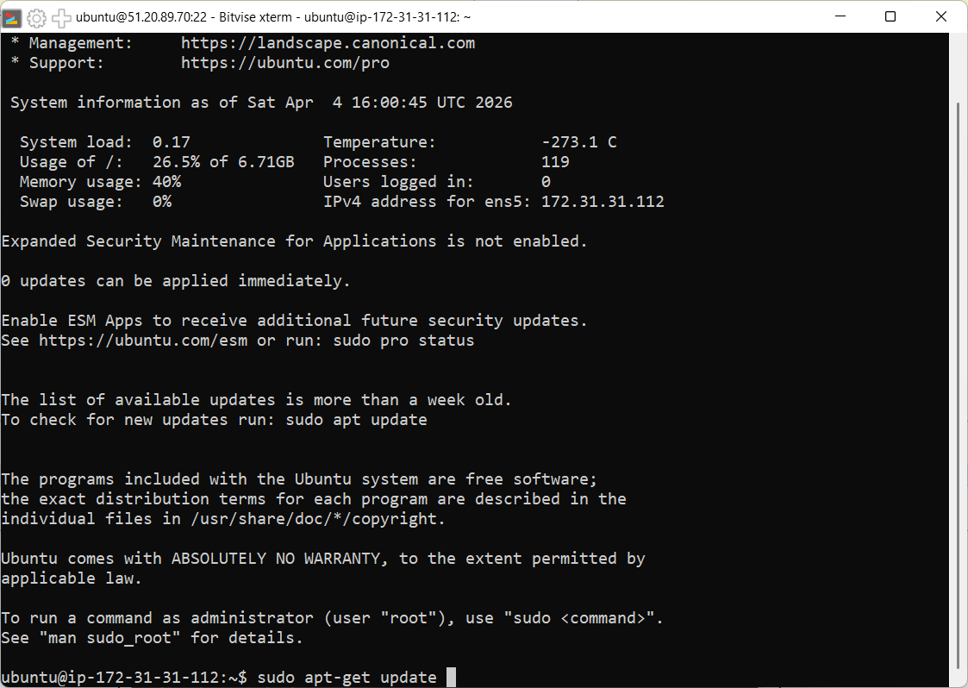
sudo apt-get upgrade
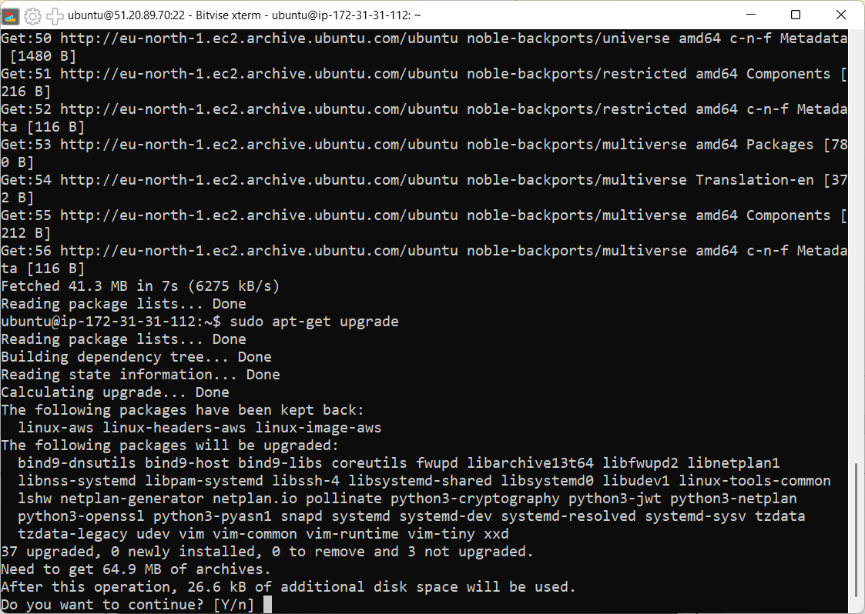
sudo apt-get install nginx
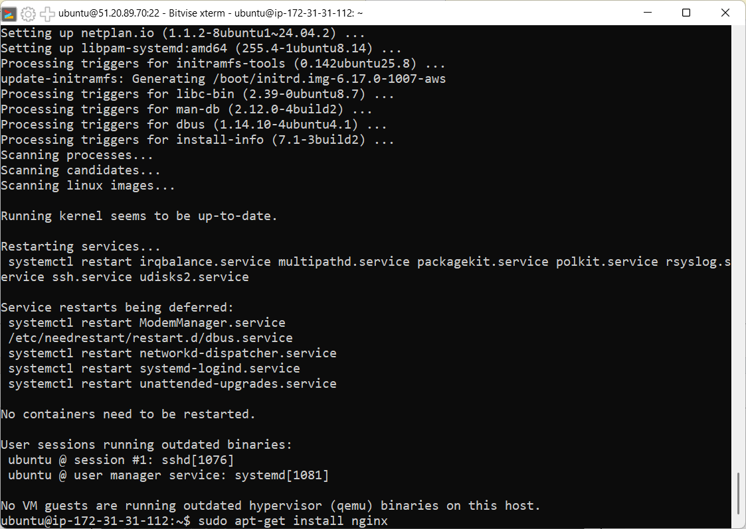
nginx -v
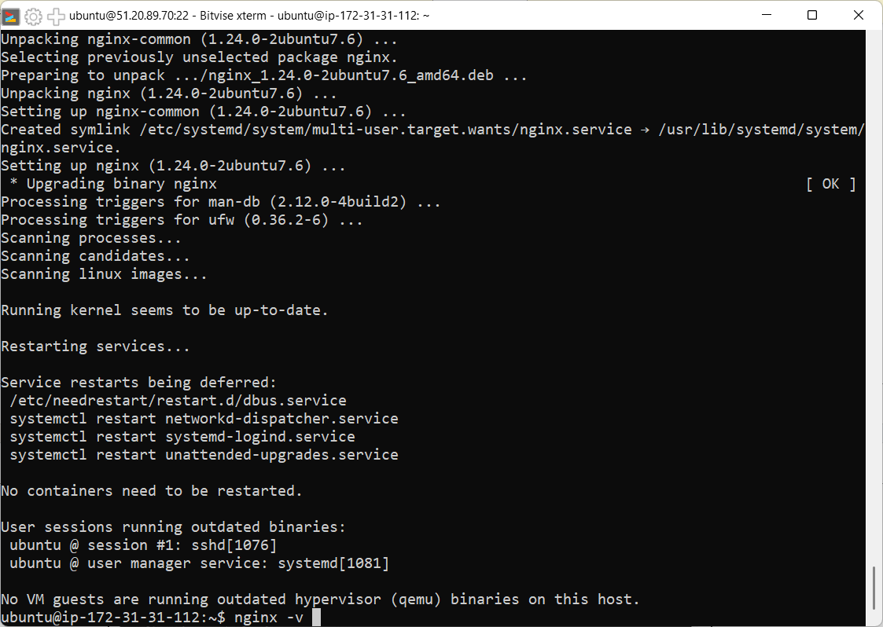
curl -SL https://deb.nodesource.com/setup_16.x|sudo -E bash-
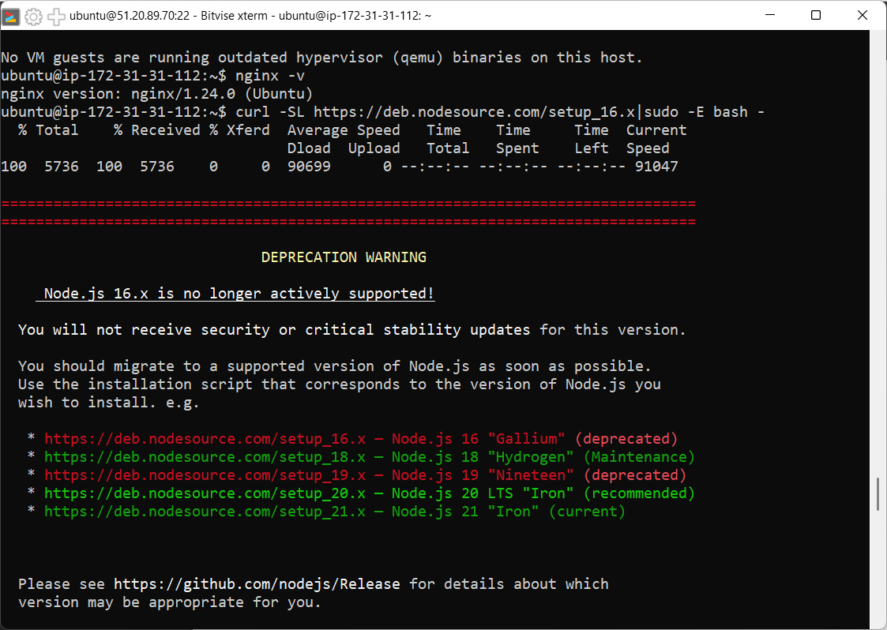
sudo apt install nodejs
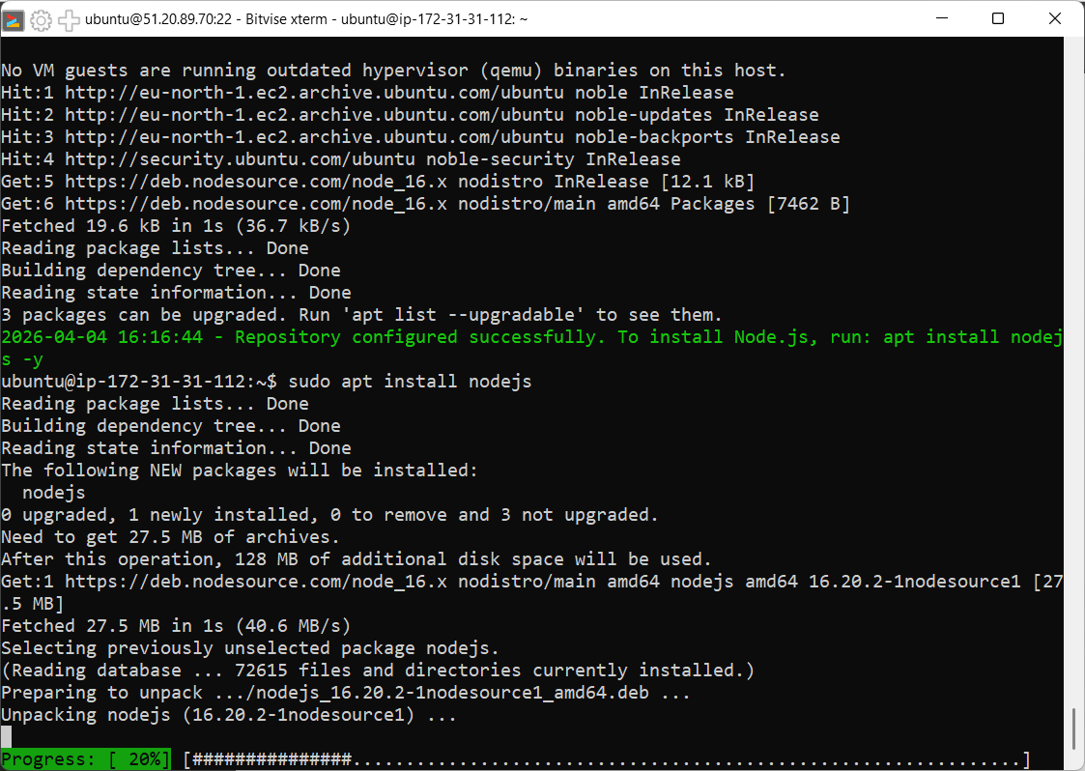
nodejs -v
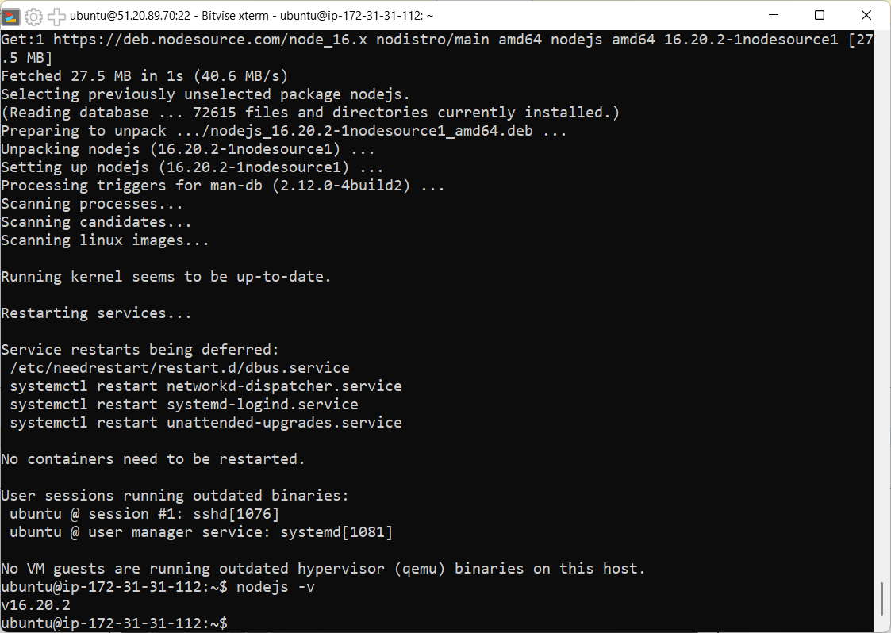

- Type: git clone https://github.com/Suhana-15/r2.git
npm install
node index.js
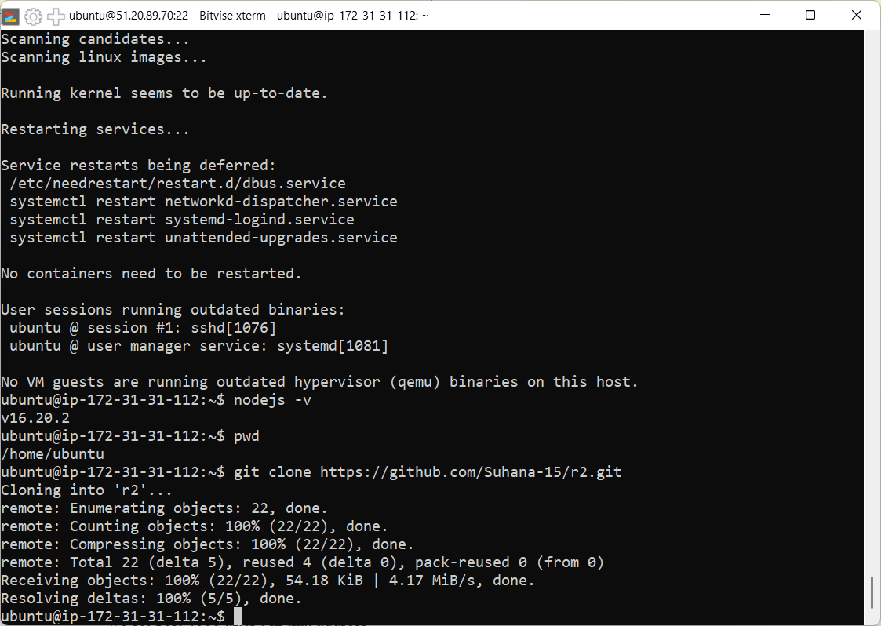
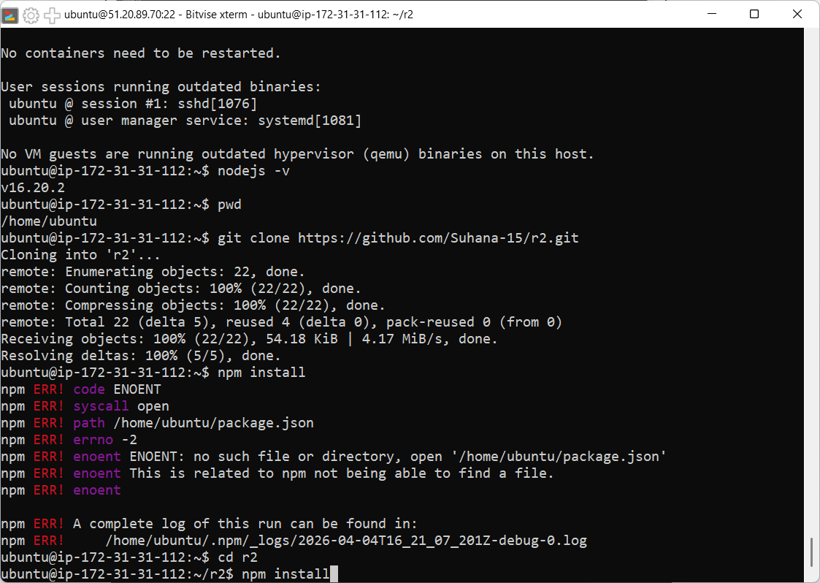
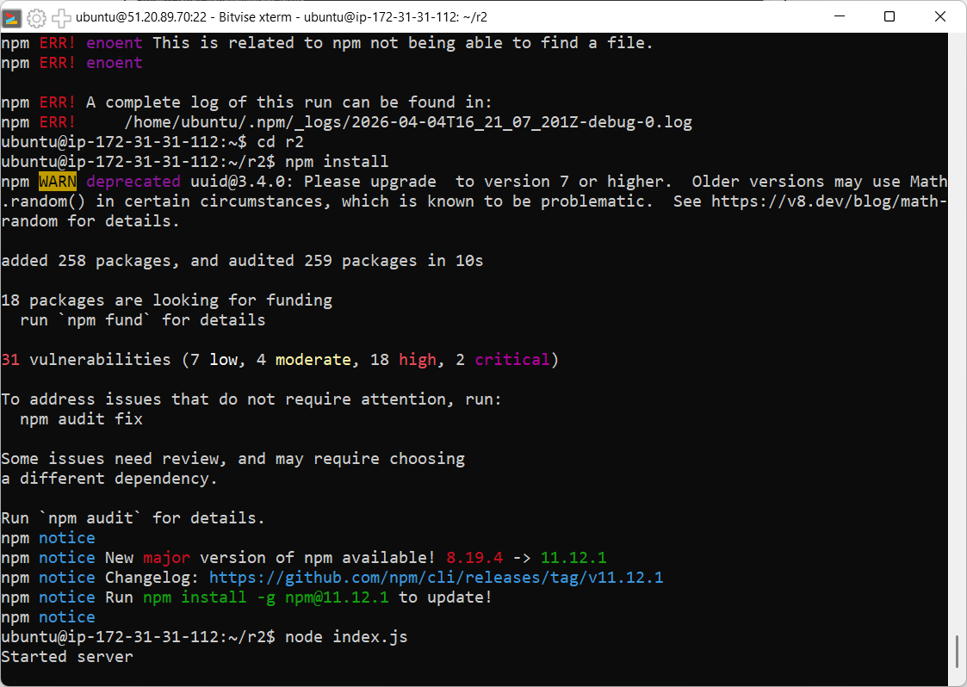
- Now we copy public IPv4 address and paste it in browser. Nginx window opens – then we set port 4000 after: in that address
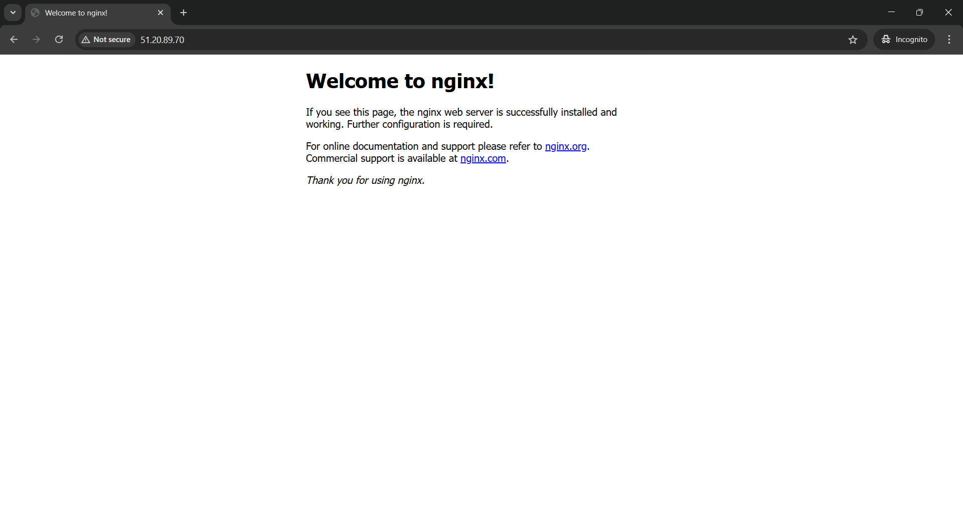
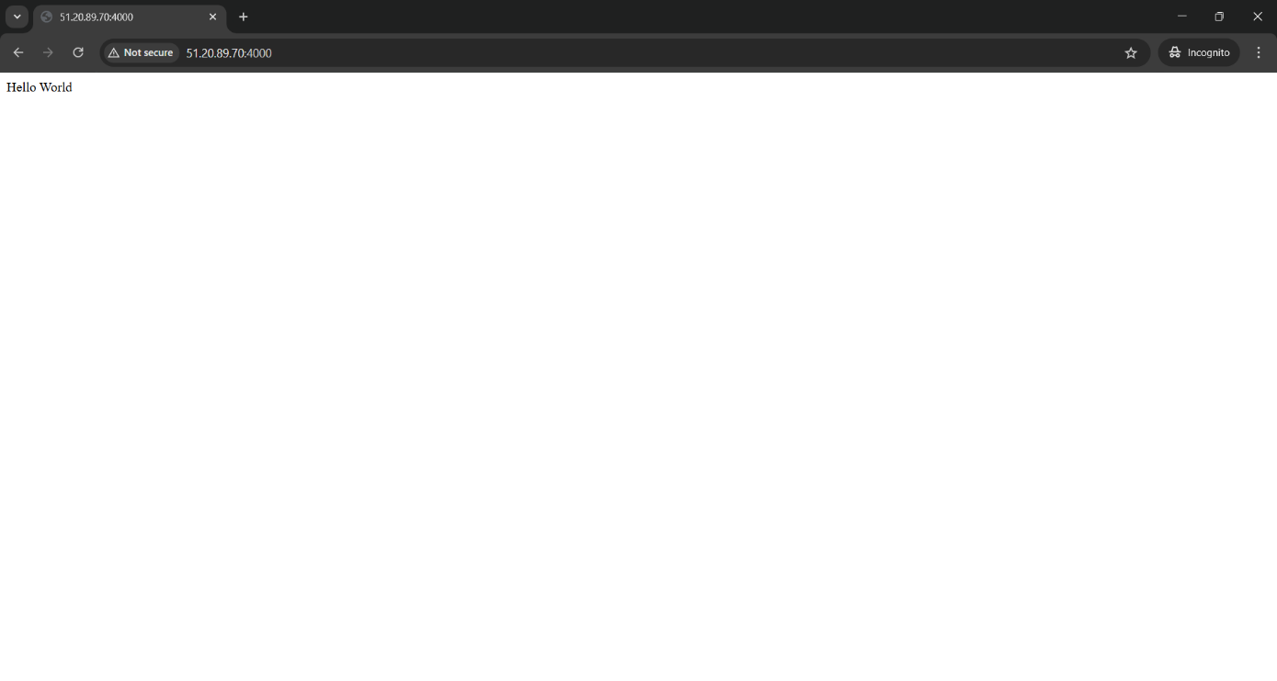
- Open another terminal. Type the following commands:
Cd / pwd
cd /etc/nginx/site-available/
sudo nano default.
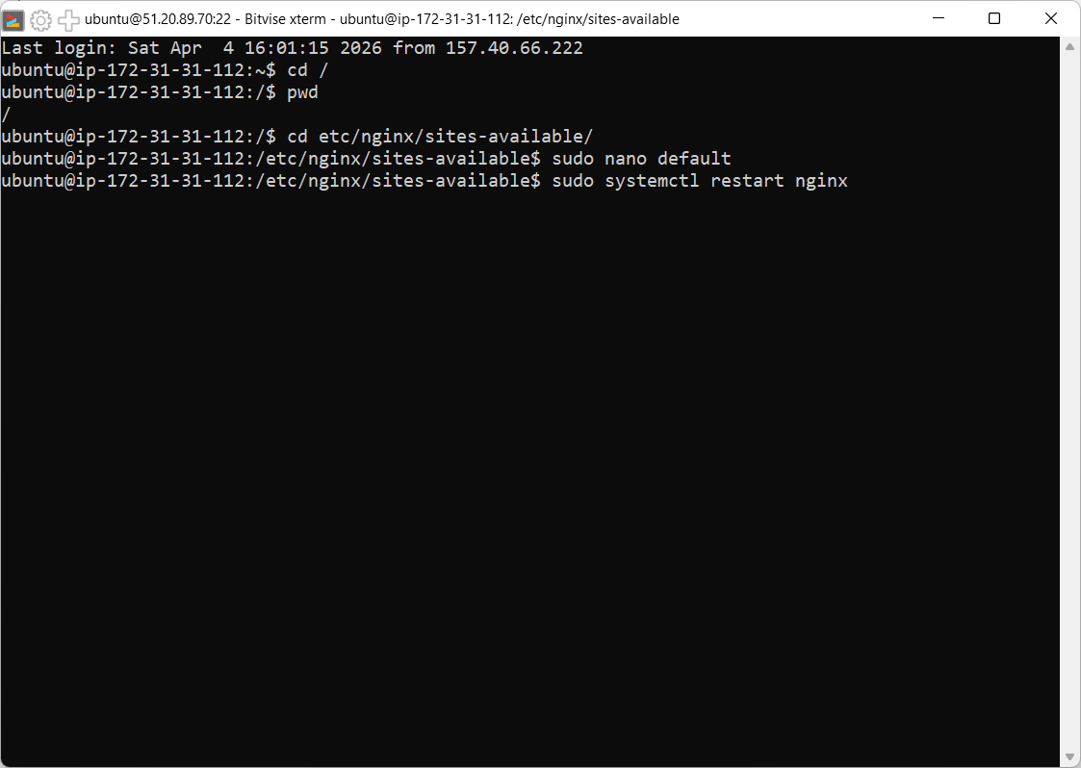
- Now in the nano editor go to location and paste the following code: Now back to bash shell:
location / {
proxy_pass http://localhost:4000;
proxy_http_version 1.1;
proxy_set_header Upgrade $http_upgrade;
proxy_set_header Connection 'upgrade';
proxy_set_header Host $host;
proxy_cache_bypass $http_upgrade;
}
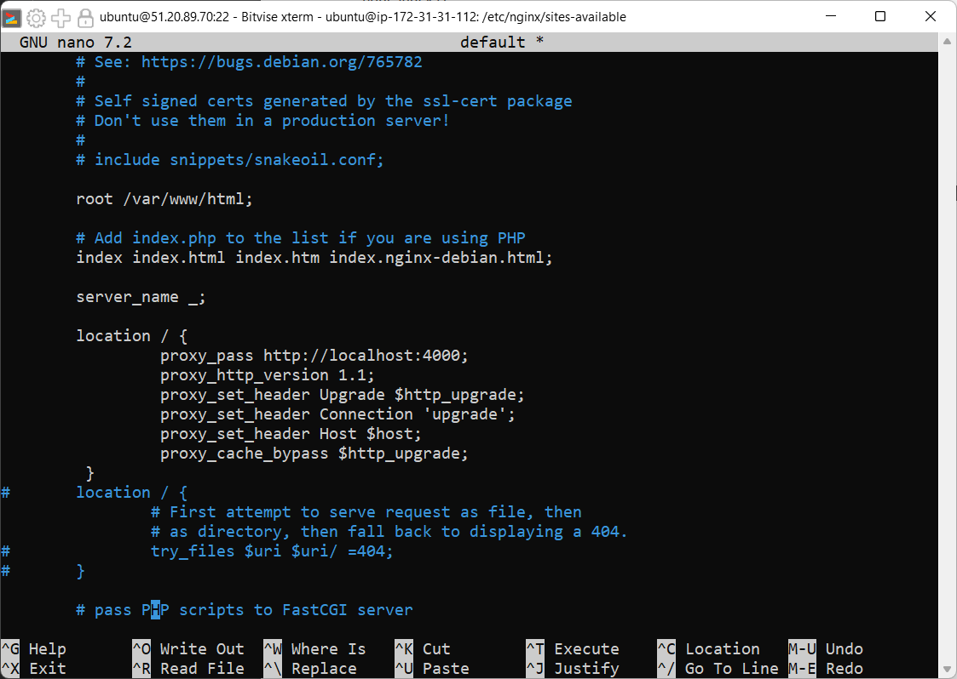
Type: sudo systemctl restart nginx

Then type: node index.js
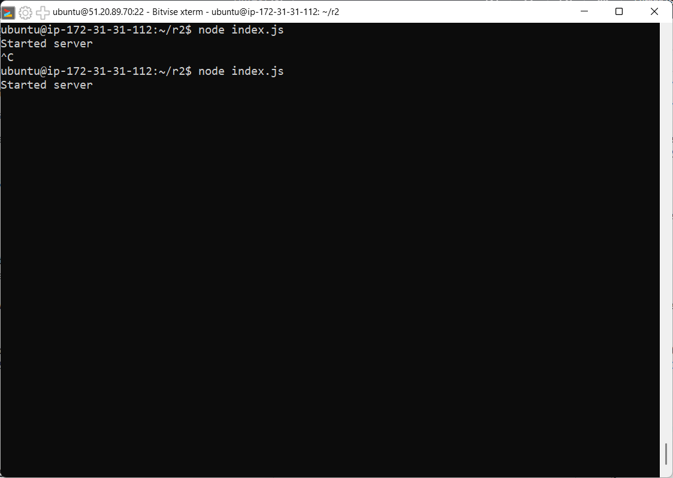
- Now copy the public ipv4 address and paste in browser. It will land directly to html page.
