Assignment : 6
Upload a static website on S3.
Step 1: Make three static HTML Page: index page, next page and about page, index page containing link to next page and about page.

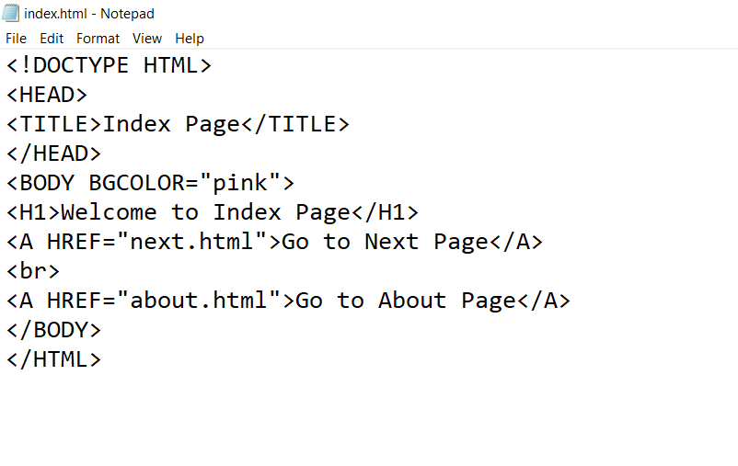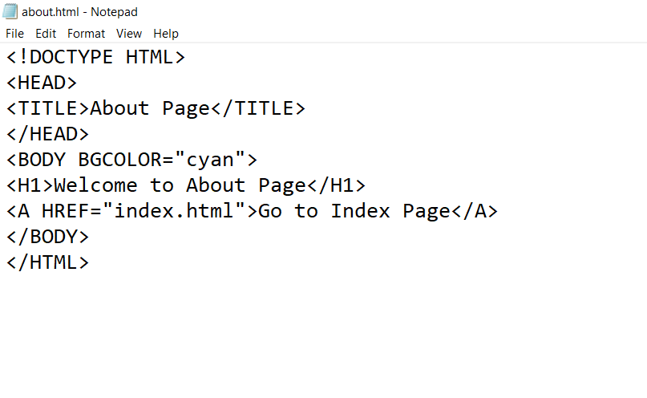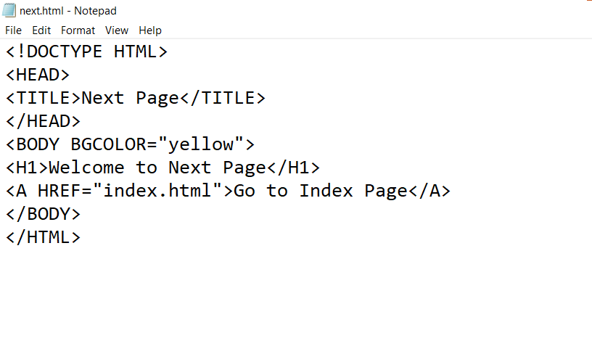
Step 2: Create a Public bucket.
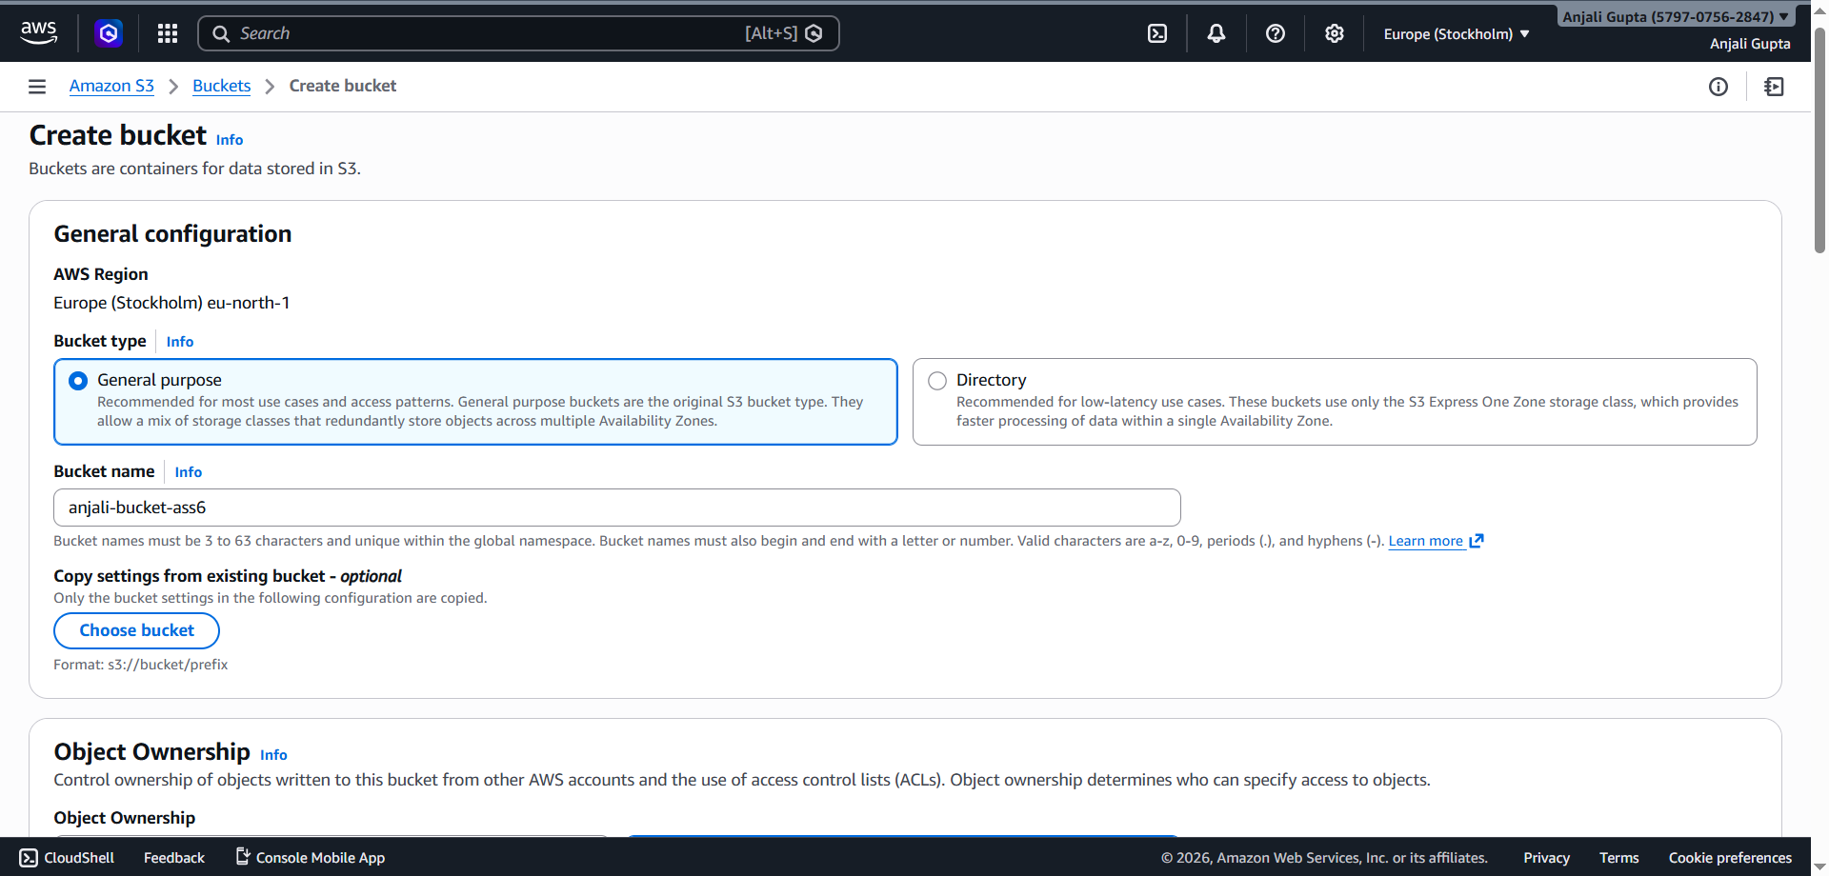

Step 3: Open the bucket and click on ‘Upload’.
0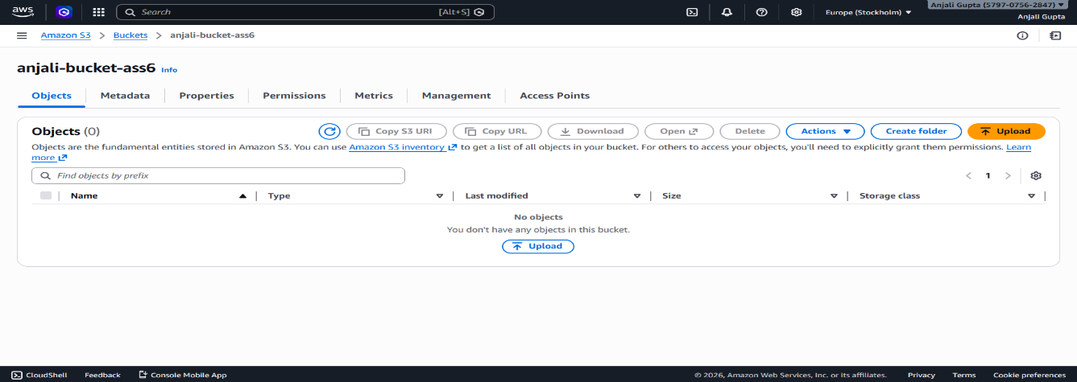
Step 4: Click on add files and select the HTML files.
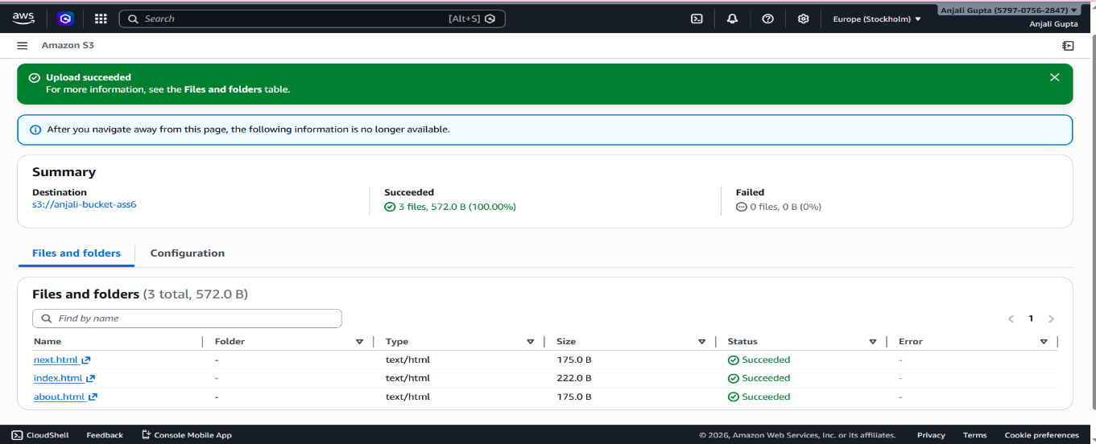
Step 5: In the S3 bucket, scroll down to the bottom where you’ll find S3 Static Website Hosting, click on Edit.
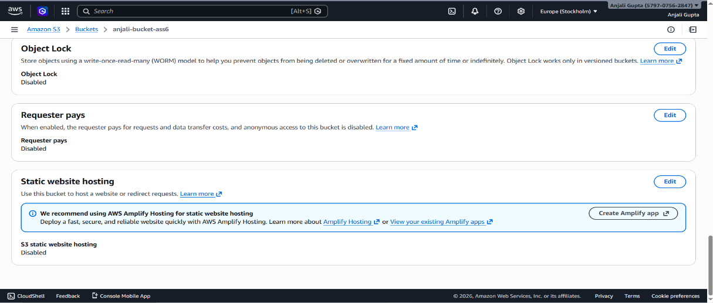
Step 6:’Enable’ the Static website hosting and name the HTML file. Afterwards click on Save changes.
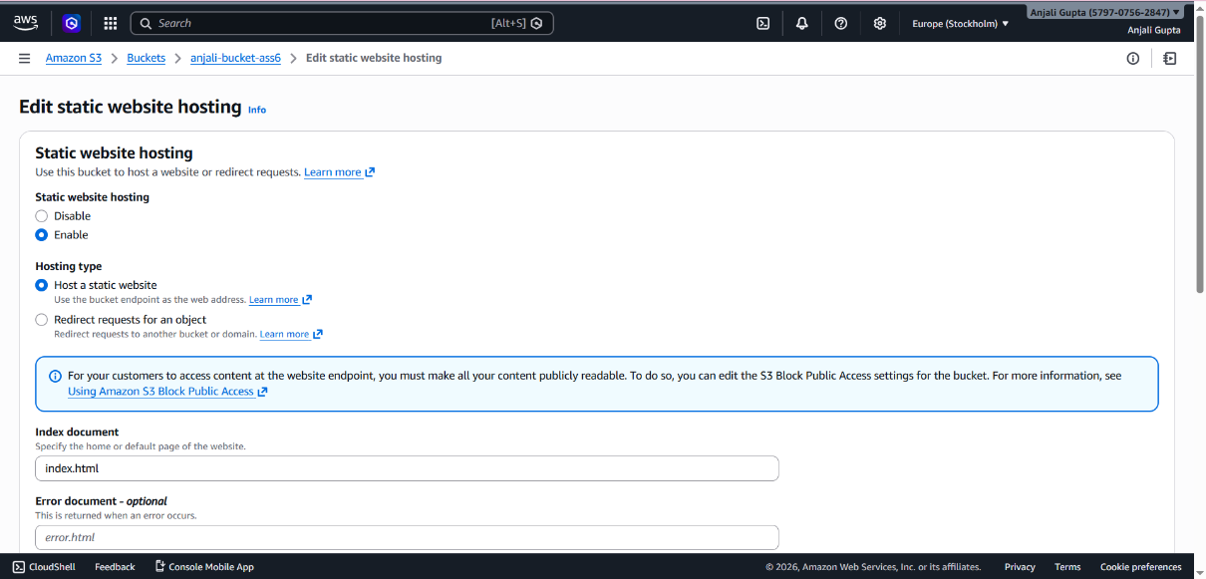
Step 7: Now go to the index file and click on ‘permissions’ to edit the ACLs.
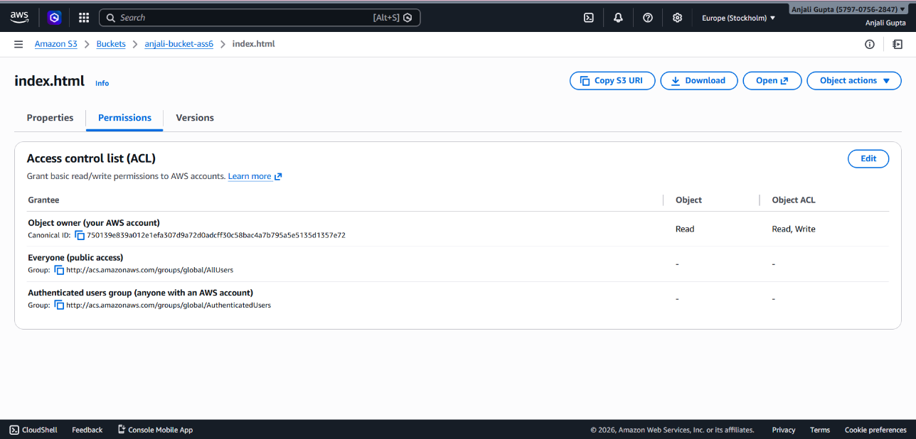
Step 8: Check the boxes to make it public. After that click on save changes. And do the same for Next page.
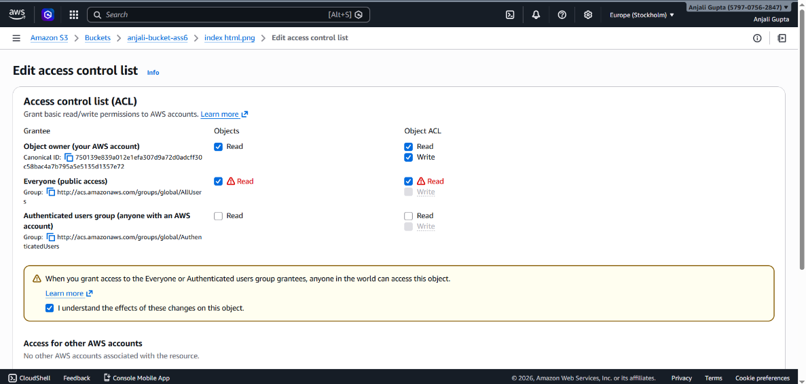

Step 9: Now navigate back to the bucket and copy the selected HTML page URL.
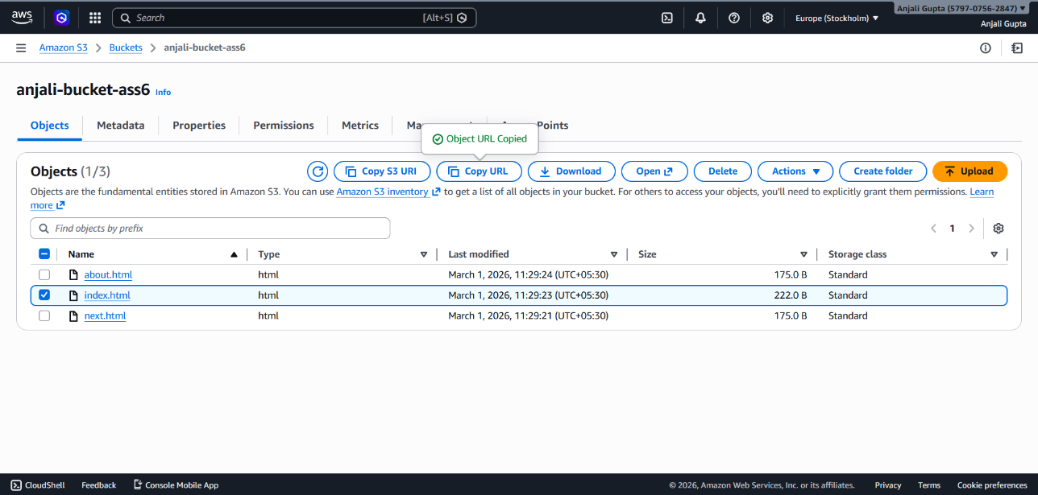
Step 10: Open the incognito window and paste the copied URL. The webpage should open as follows.
Index Page:
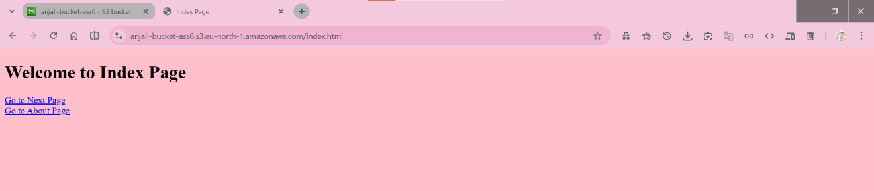
Next Page:
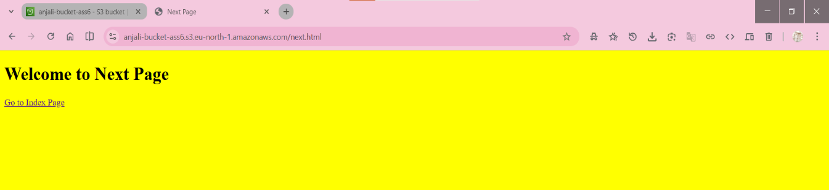
About Page:
