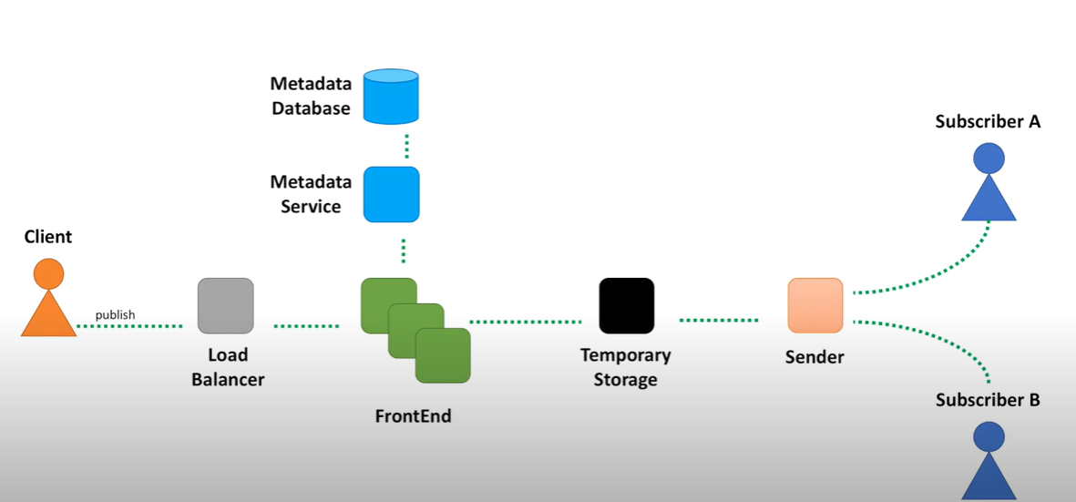

Functional Requirement:-
- Search works based on Product Keywords of different category.
- Send an email notification on matched keywords.
Non function requirement :-
- Highly scalable
- Fast response
Below is the system design. :-
Solution :-
We need to subscribe for the topic searched, and once the topic search is matched send the email notification.
Below are the details of the Blocks
- Client initiates the search request as a Restful API, where list of product keywords are sent to the server.
- We will have Load balancers so that multiple requests can be send to respective server based on different load balancers algorithm. Ex : AWS ELK etc.
- The request is sent to a Front end service. This service objective is to send the request to Metadata service. Which uses Elastic search to get the products using elastic search mechanism from the database and maintain the result cache for each product keyword in Metadata service’s cache and Metadata Database.
- The requests are event maintained Temporary storage.
- Sender picks the request from Temporary storage and gets the result from Metadata service cache if present or database and based on the query match and then send the broadcast to subscribers who has registered for the topic using Email notification service.
User information can be will stored in RDBS.
Search result can be stored in Cassandra as it can lots of read and writes and is fast and scalable.

